A climatology of Mesoscale Convective Systems over southern Africa

Mulalo Maphugwi^{1*}, Ross C. Blamey¹ and Chris J.C. Reason¹

¹Department of Oceanography, University of Cape Town, South Africa

Supplementary Material

Corresponding author address: Mulalo Maphugwi
Dept. of Oceanography,
University of Cape Town, Private Bag X3,
Rondebosch, 7701, South Africa
E-mail: mmaphugwi@gmail.com
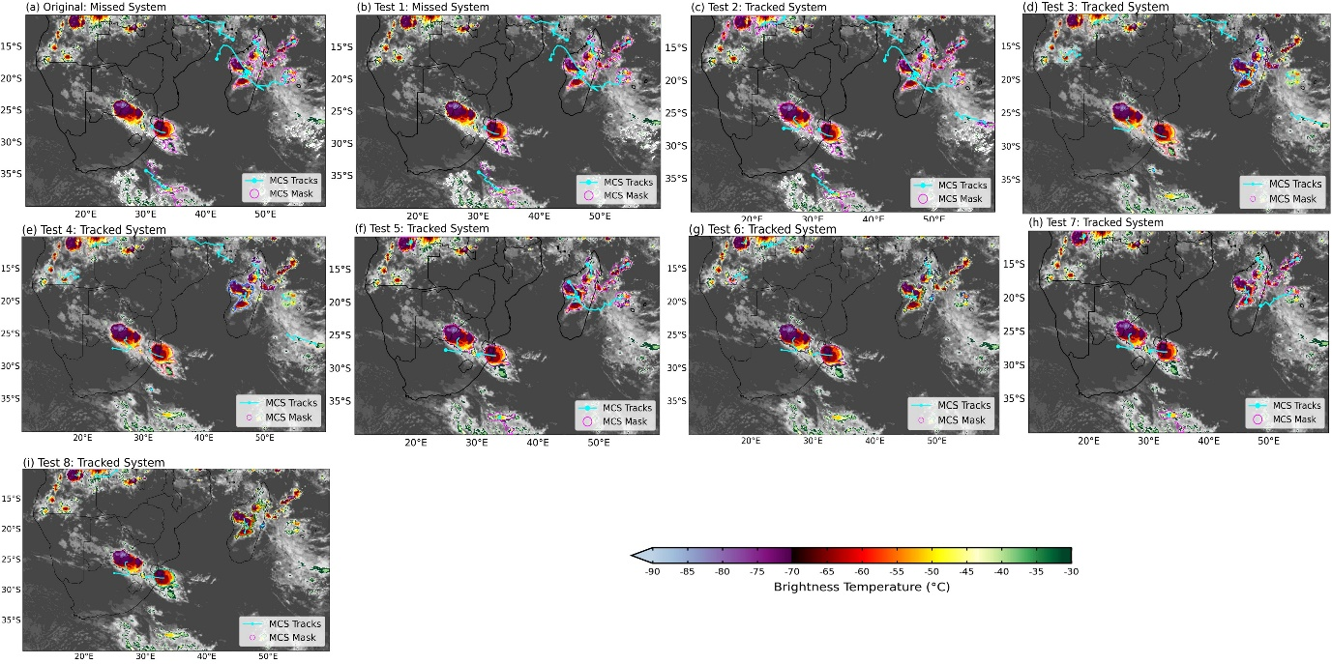Figure S1: An example of how the tracking of an MCS is sensitive to the parameters chosen from (a) Original settings and through to (i) with different sensitivity tests. Each panel shows the brightness temperature (shaded; °C) snapshot for 09 February 2024 (20:30 UTC). The cyan line represents the MCS track location and the line around the cloud represents the cloud should being tracked. The orange arrow identifies the MCS that is either tracked or not.

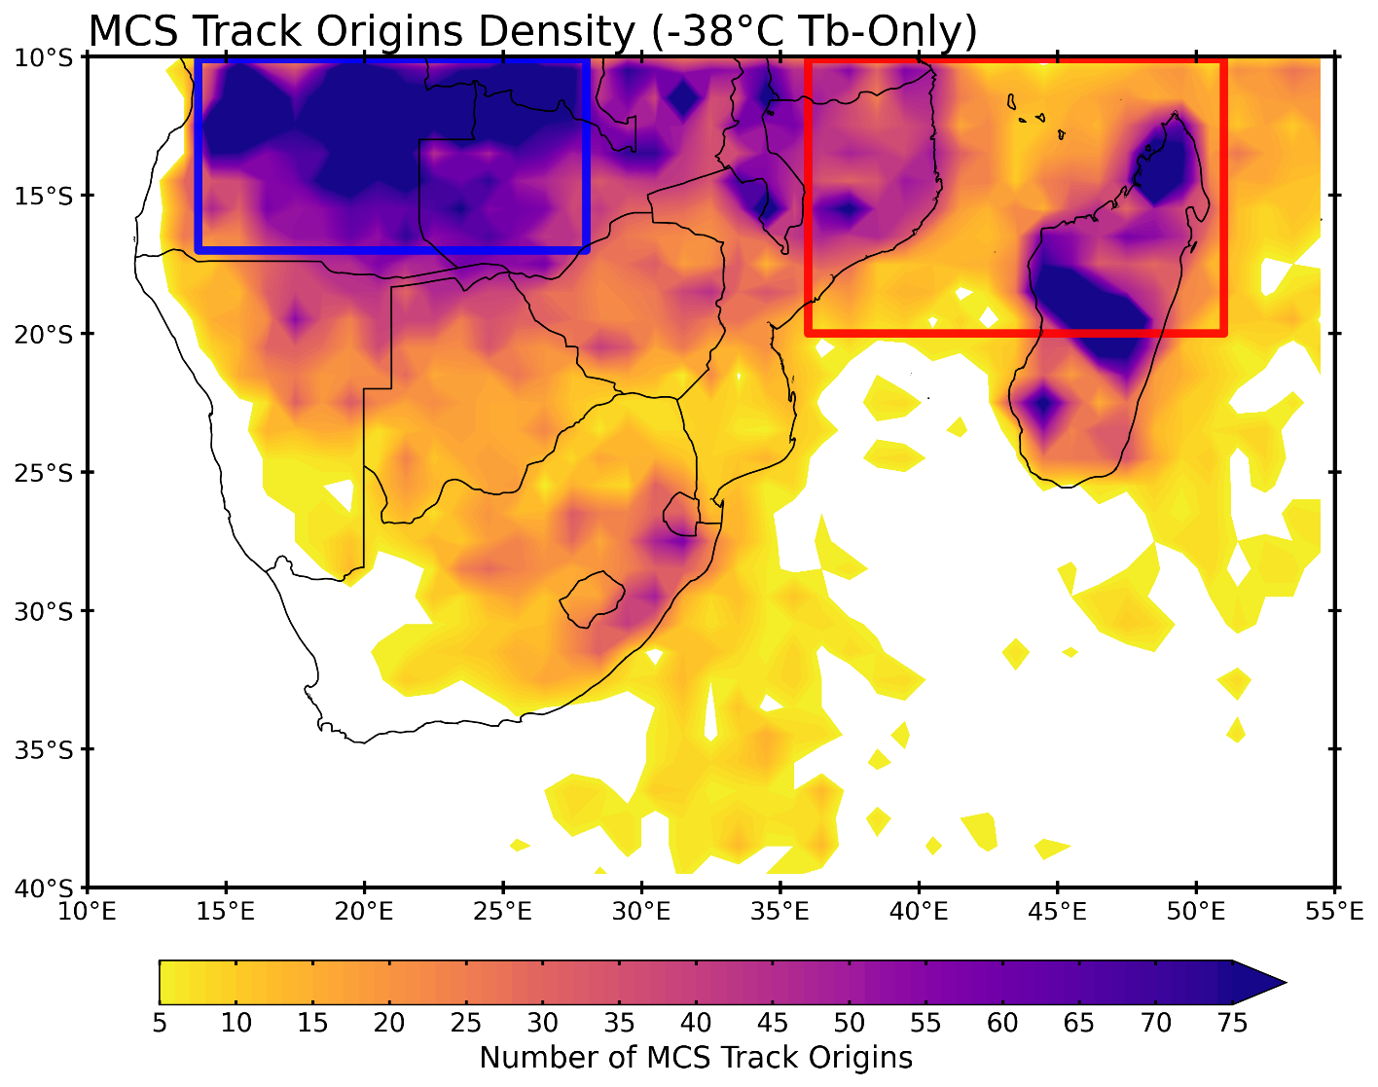Figure S2: MCS origin point spatial distribution over southern Africa shown as track density (i.e., number of MCS tracks originating in a 1° × 1° grid boxes) for the 2000/01 – 2023/24 climatological period for austral summer months (October – March) based on -38°C T_{b}-Only (Sensitivity Test 6). The Congo Air Boundary region is shown by the blue box and the Mozambique Channel region in red box, respectively.

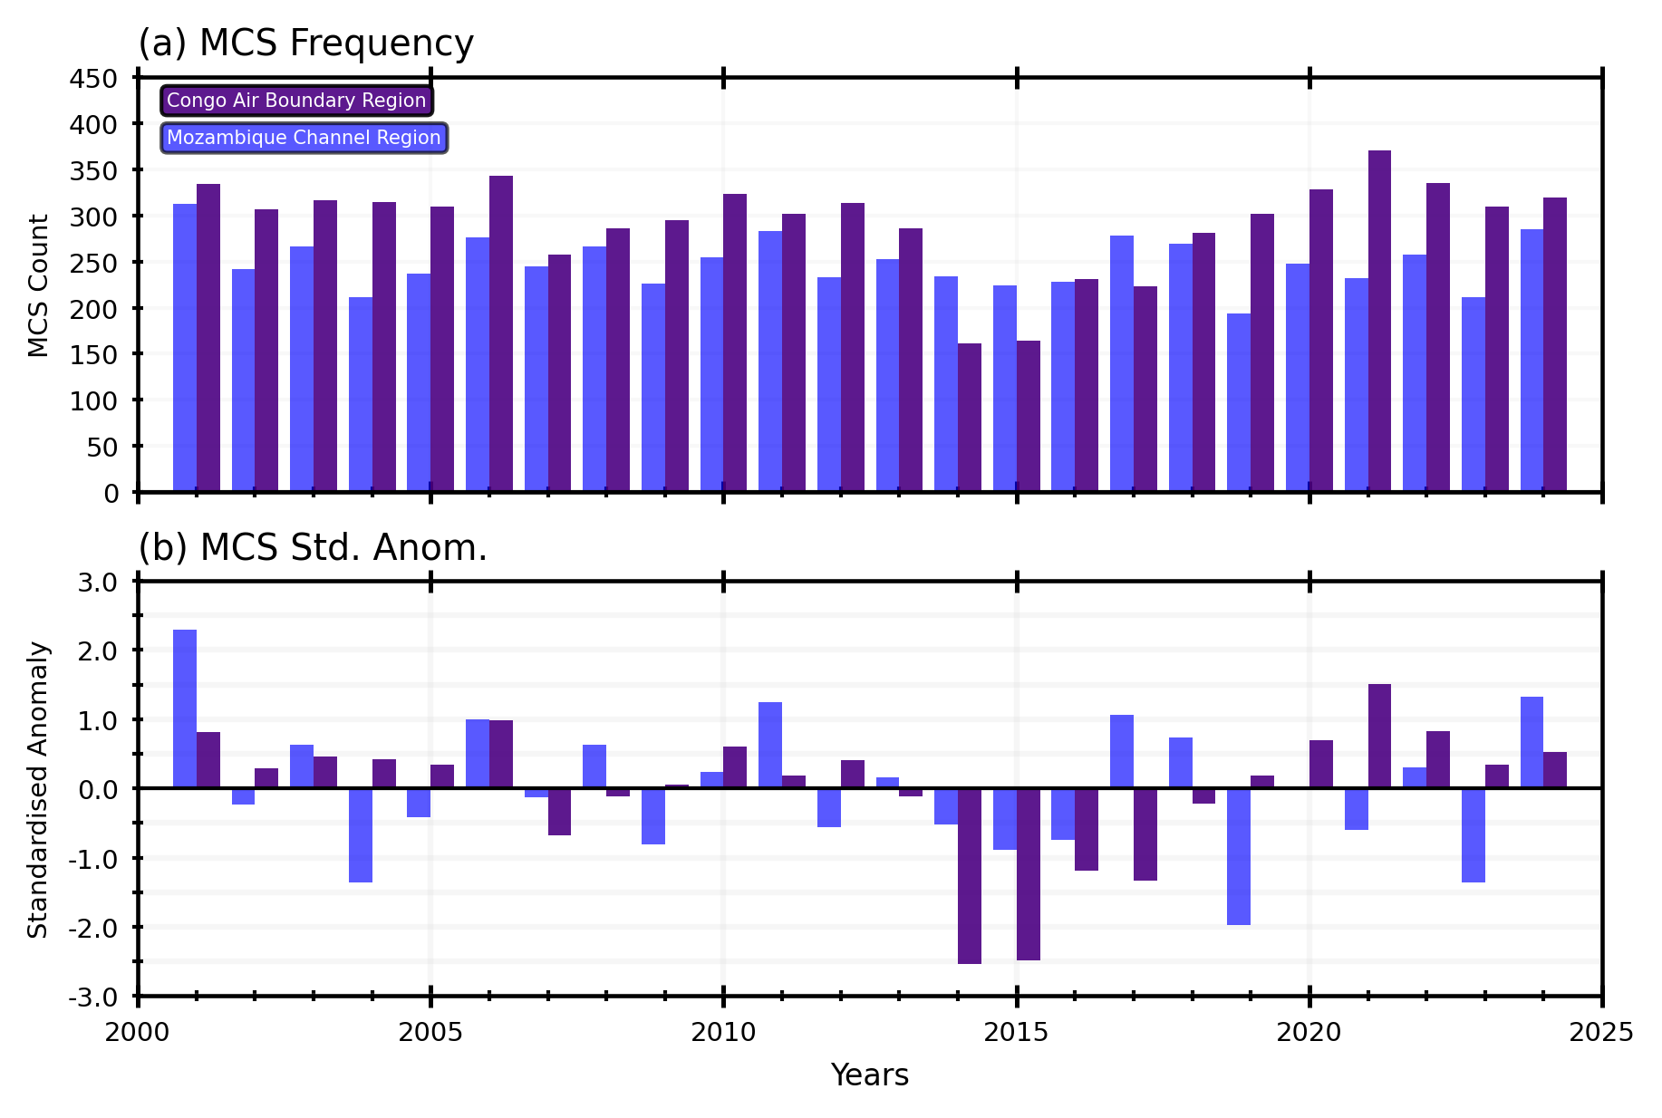Figure S3: Bar graphs showing (a) mean MCS count and (b) MCS standardised anomalies over the Congo Air Boundary in purple and Mozambique Channel region in blue. The first bar is ONDJFM in 2000/2001 and the last bar is ONDJFM in 2023/24.
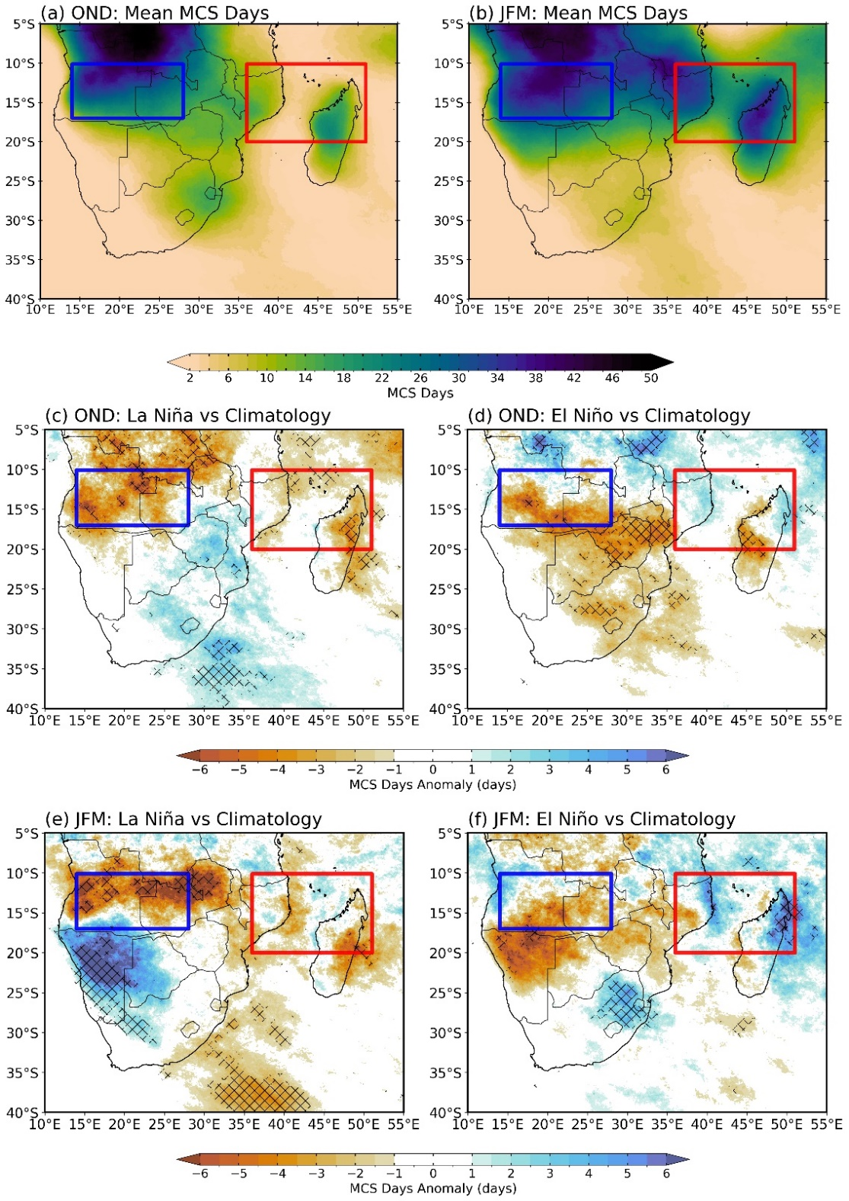
Figure S4: The mean number of MCS days that occur during the (a) Early (October – December, OND), and (b) Late (January – March; JFM) summer season. At each grid cell, a day was counted if at least one MCS cloud shield was present at any timestep. (c) and (d) are composites of anomalies in the MCS days during the five El Niño and La Niña early summers, while (e) and (f) is the same as (c and d) but for late summer season (JFM). The ENSO years used here are based in the Niño 3.4 region, for early summer EL Niño years considered are 2002/03, 2009/10, 2015/16, 2018/19, and 2023/24, and for La Niña years are considered are 2000/01, 2007/08, 2010/11, 2020/21 and 2021/22. For late summer EL Niño years considered are 2009/10, 2015/16, 2017/18, 2018/19, and 2023/24 while La Niña years are considered are 2005/06, 2007/08, 2010/11, 2020/21 and 2021/22
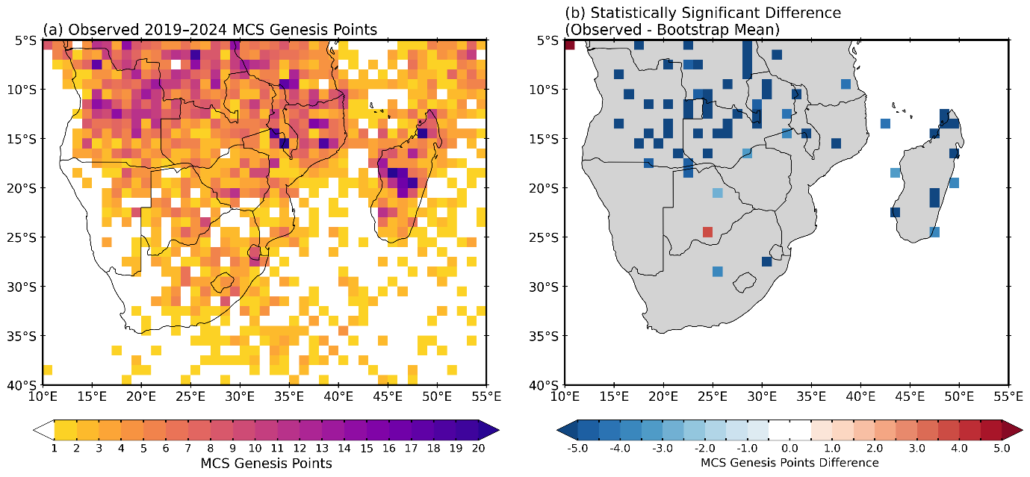Figure S5: (a) Spatial distribution of 1° × 1° MCS genesis density for the 2019–2023 period. Colors indicate the number of genesis events per grid cell. (b) Statistically significant departures of observed genesis density from the 24-year bootstrap mean (Observed − Bootstrap Mean). Significance is assessed using a fully non-parametric, two-tailed Monte-Carlo resampling test based on random 5-year selections from the full 24-year MCS dataset (10,000 iterations).

