Supplementary material
Plant and Soil

Breaking the trade-off between grain yield and protein in maize: a global meta-analysis of optimized nitrogen management and environmental drivers
Xiaojun Jiang ^{a, b*}, Xinglong Wang ^{a, b*}, Nan Jiang ^{a, b}, Wei Xiong ^{a, b}, Xi Luo ^{a, b}, Jing Huang ^{a, b#}
ª College of Life Sciences and Agri-forestry, Southwest University of Science and Technology, Mianyang 621010, China
^{b} Engineering Research Center of Biomass Materials, Ministry of Education, Mianyang 621010, China
# Correspondence Jing Huang, Tel: +86-0816-6089516, E-mail: huang.jing@swust.edu.cn
* These authors contributed equally to this study.

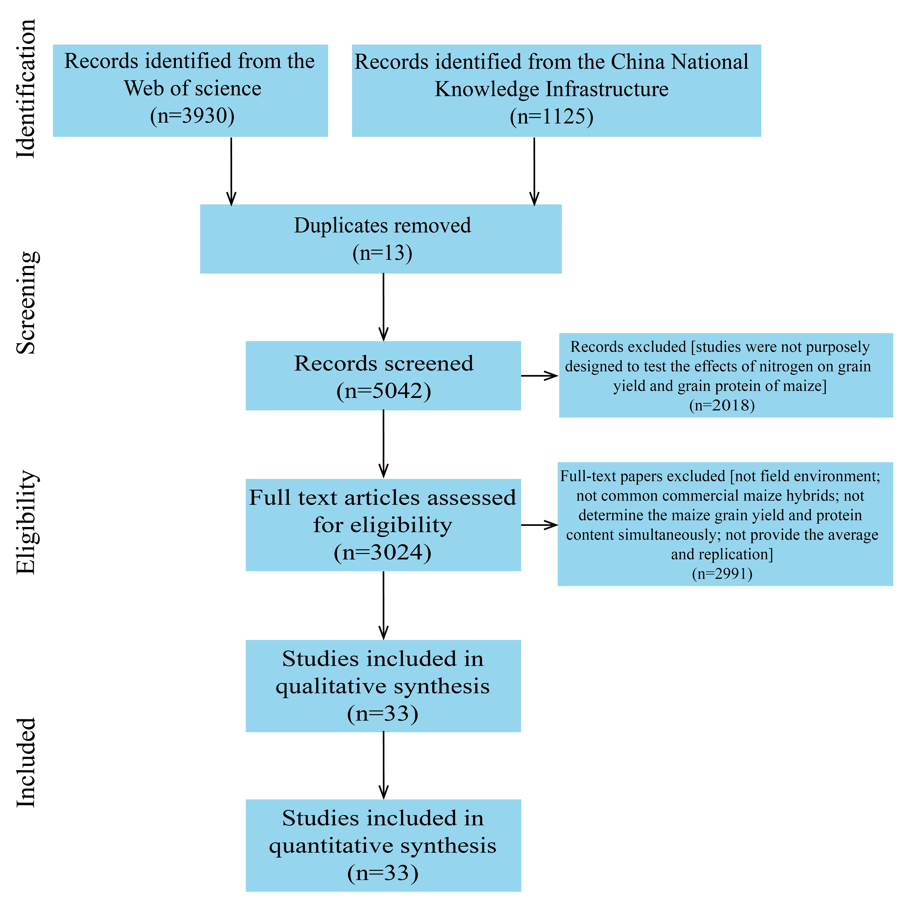
Fig. S1. Preferred Reporting Items for Systematic Reviews and Meta-Analyses diagram showing the process of locating publications included in the present meta-analysis.
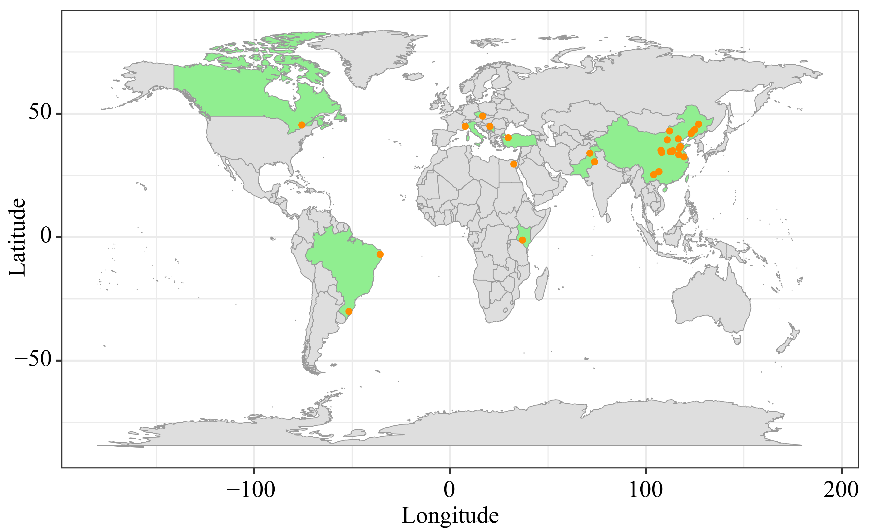
Fig. S2. Global distribution of field experiments included in this meta-analysis. The data set covered 699 paired observations from 33 published papers from 2005 to 2025.
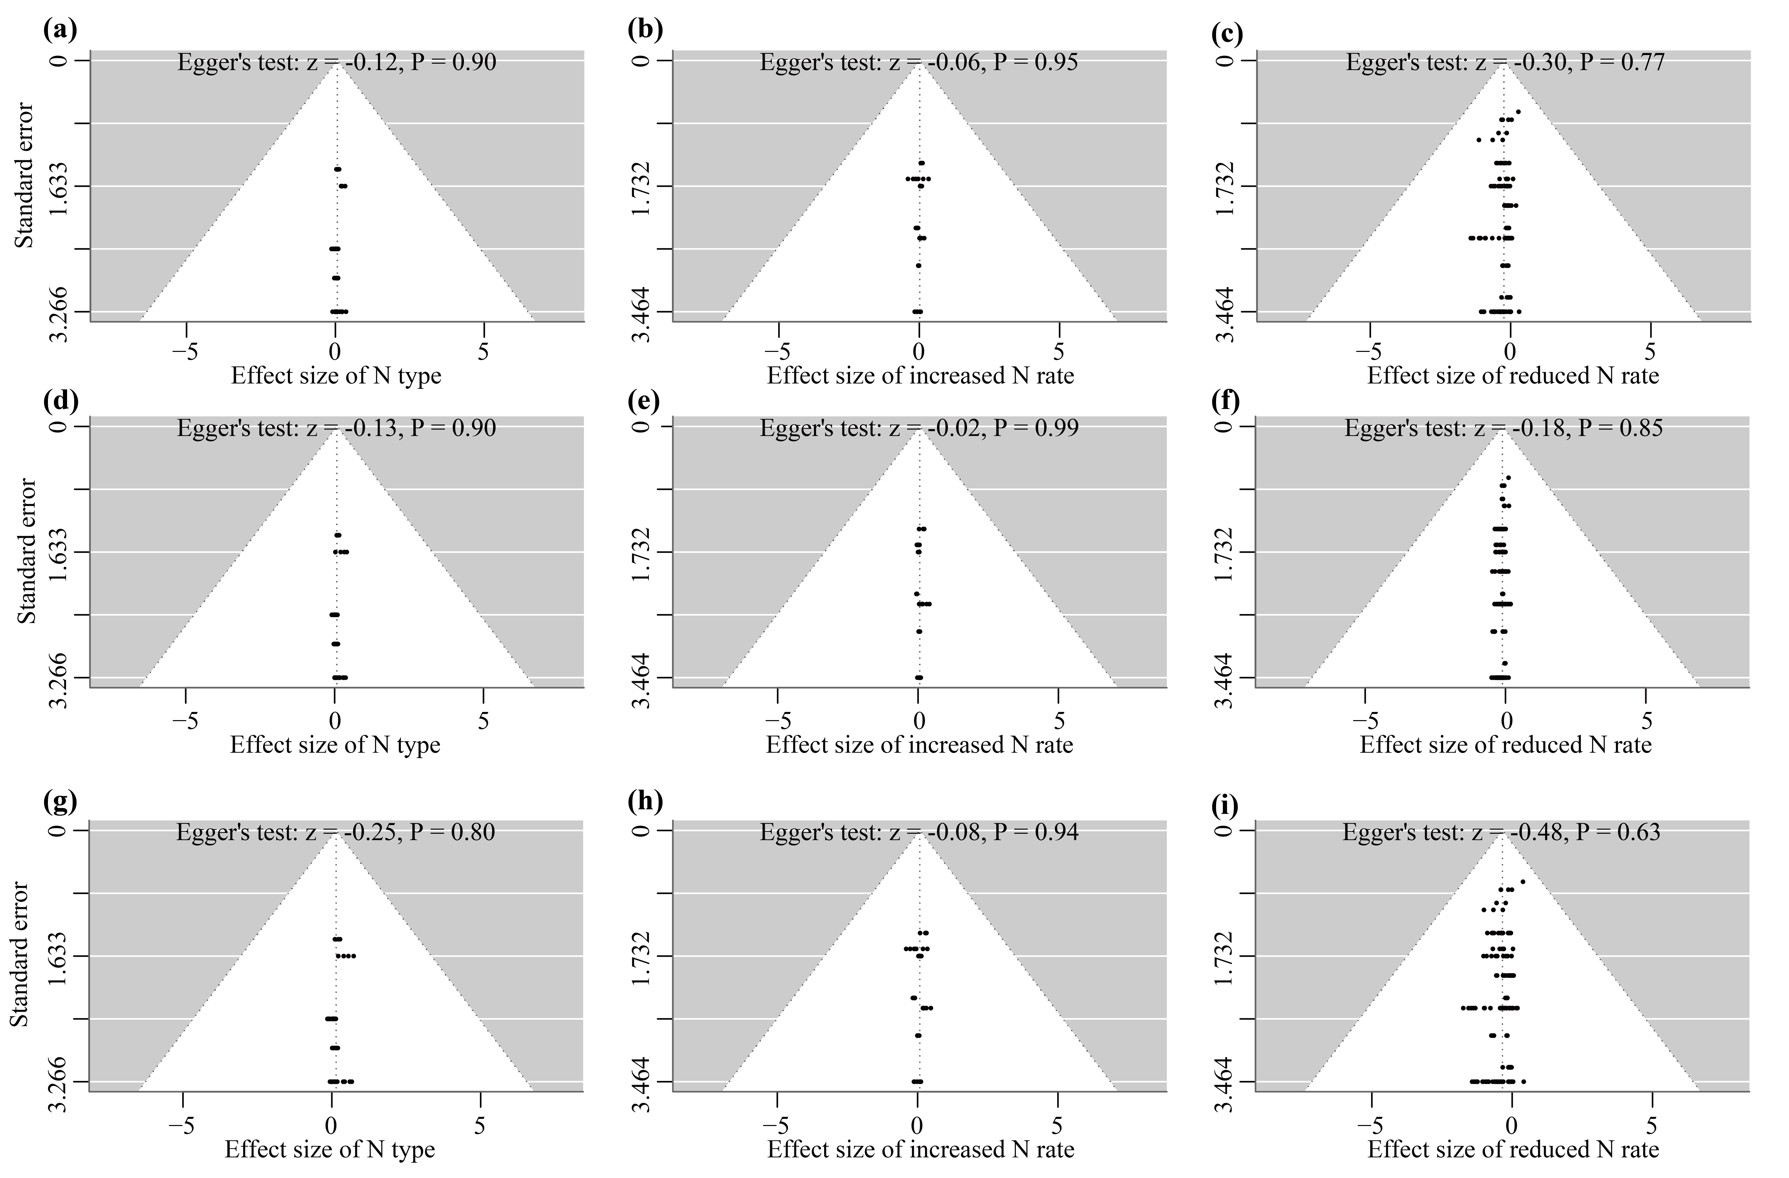
Fig. S3. Funnel plot showed the distribution of standard error of the effect size of maize grain yield, grain protein content and grain protein yield. (a) Effect size of N type on grain yield; (b) Effect size of increased N rate on grain yield; (c) Effect size of reduced N rate on grain yield; (d) Effect size of N type on grain protein content; (e) Effect size of increased N rate on grain protein content; (f) Effect size of reduced N rate on grain protein content; (g) Effect size of N type on grain protein yield; (h) Effect size of increased N rate on grain protein yield; (i) Effect size of reduced N rate on grain protein yield. The dots indicate the observed studies, the dashed lines that create a triangular area indicate the 95% confidence limits, and the vertical line represents the overall effect size. The P value of Egger's regression test more than 0.05 means that there is no publication bias.

Table S1. The description of nitrogen management practices for control and treatment.
N management practices | Control | Treatment | Reference
Optimized N fertilizer type | Urea | Non-urea N fertilizers, including ammonium N, nitrate N, controlled-release fertilizer and bio-based carriers’ fertilizer | Jiang et al., 2025
Increased N application rate | Suitable N fertilizer application rate for the local cropland | Higher than suitable N fertilizer application rate for the local cropland | Shao et al., 2024
Reduced N application rate | Suitable N fertilizer application rate for the local cropland | Lower than suitable N fertilizer application rate for the local cropland | Shao et al., 2024

Jiang, Y., Li, H., Ma, W., et al. (2024). A meta-analysis of the effects of nitrogen fertilizer application on maize (Zea mays L.) yield in Northwest China. Frontiers in Plant Science, 15, 1485237. https://doi.org/10.3389/fpls.2024.1485237.
Shao, H., Wu, X., Duan, J., et al. (2024). How does increasing planting density regulate biomass production, allocation, and remobilization of maize temporally and spatially: A global meta-analysis. Field Crops Research, 315, 109430. https://doi.org/10.1016/j.fcr.2024.109430.

