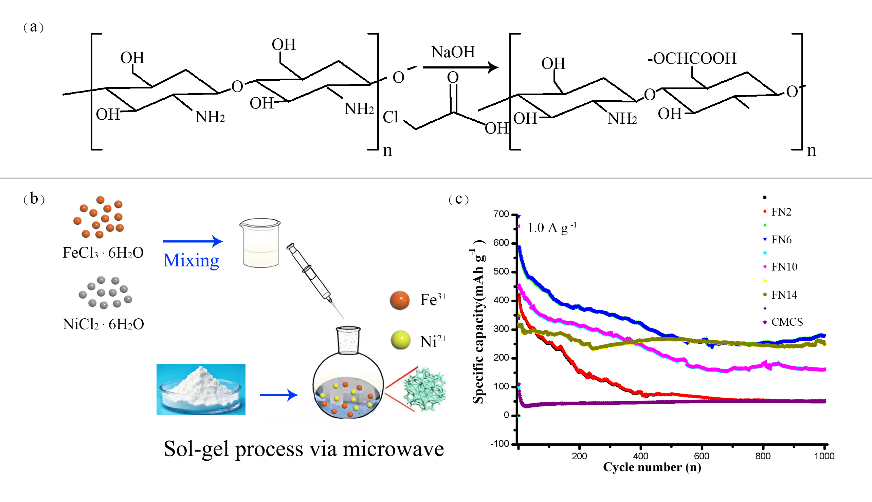
Scheme 1. Schematic illustration of the electrode materials preparation. (a) Schematic diagram of chemical reaction of chitosan modified with carboxylic groups, (b) preparation of electrode materials , and (c) cycle performance at 1.0 A g⁻¹.

