Supplementary Material:
Supplementary Figure S1 between mean NDVI and Solar radiation proxy:
Scatterplot illustrating the bivariate relationship between mean NDVI and the solar radiation proxy. Each point represents a sampled pixel, and the fitted regression line with confidence interval highlights the slight positive association between vegetation vigor and solar exposure.
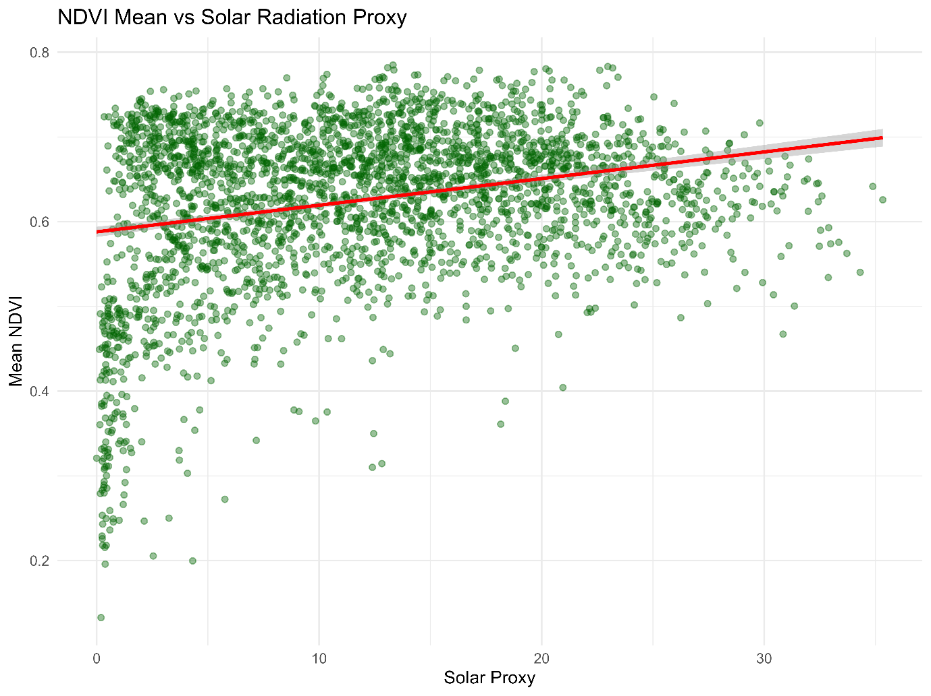
Figure 10: NDVI Mean vs Solar Radiation Proxy
Supplementary Figure S2. Diagnostic plots for the NDVI trend regression model:
Four diagnostic panels evaluating model assumptions: (A) residuals vs. fitted values, (B) Q-Q residuals, (C) scale location plot, and (D) residuals vs. leverage with Cook’s distance contours. These diagnostics confirm acceptable normality, variance structure, and influence patterns for the NDVI trend model.
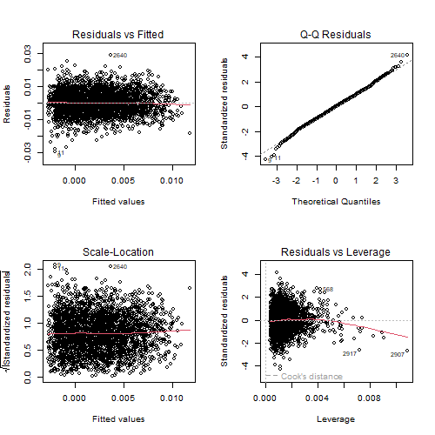
Figure 11: Diagnostic plots for the NDVI trend regression model.
Supplementary Figure S3. Diagnostic plots for the NDVI mean regression model:
Diagnostic plots assessing linearity, residual distribution, homoscedasticity, and influential observations for the NDVI mean model. The diagnostics indicate that the model is statistically robust and suitable for interpreting the relationship between mean NDVI and topographic predictors.
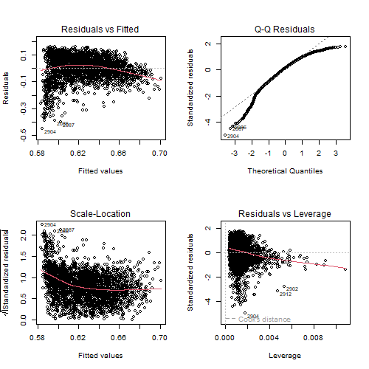
Figure 12: Diagnostic plots for the NDVI mean regression model.

