

A First Radio Astronomy Experiment
Measurements of Galactic Hydrogen with the
Table Top Radio Telescope :
(version: March 2022)

Peter Wilkinson, University of Manchester
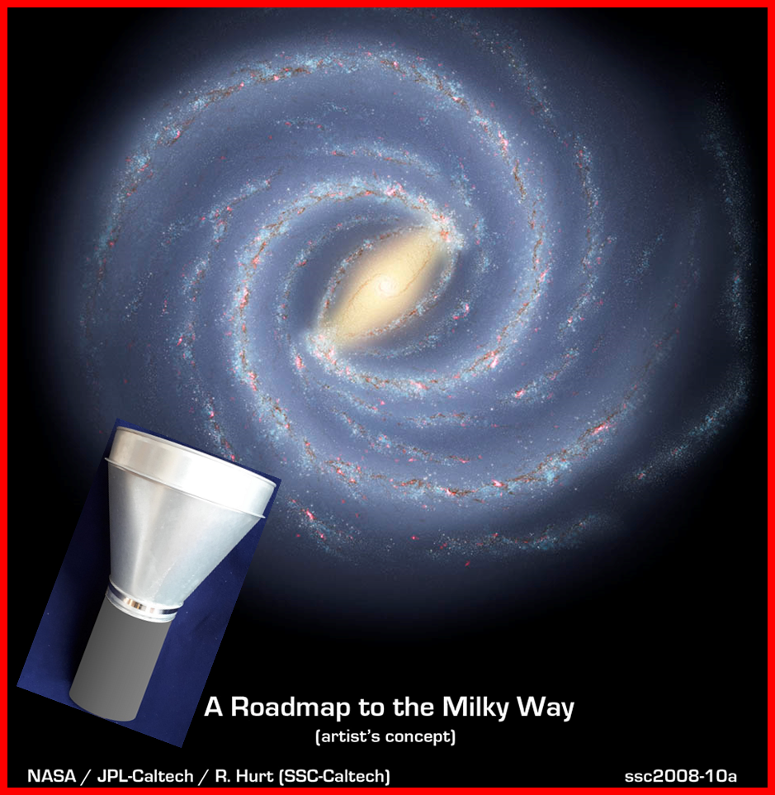

Note: This experiment requires a local Windows PC or laptop computer with access to a spreadsheet such as Microsoft Excel (or equivalent). It does not require access to the internet during the observations.

THIS PAGE INTENTIONALLY LEFT BLANK
+++++++++++++++++++++++++++++++++++++++++++++++++++++++++++++++++++++++++++
COMMENTS and UPDATES

There will always be ways to improve this script – often based on feedback from students.

Two ways to give feedback and/or receive advice
- via an email to me at: peter.wilkinson@manchester.ac.uk
- via social media: email me for information about joining

+++++++++++++++++++++++++++++++++++++++++++++++++++++++++++++++++++++++++++

++++++++++++++++++++++++++++++++++++++++++++++++++++++++++++++++++++++++++++
BEFORE STARTING
- Before beginning observations use the coordinate conversion calculator supplied on the pen drive to explore which regions of the galactic plane are accessible from your location, given the proposed starting date and time of day. The procedure is fully explained in Section 6.4.

- Staff or previous students at your institution may have already loaded the software for controlling the RTL-SDR onto the PC you are using. Check to see if this is the case before carrying out the instructions in Appendix A (Section A.1).
++++++++++++++++++++++++++++++++++++++++++++++++++++++++++++++++++++++++++++

Acknowledgements

The RTL-SDR dongle has been adapted for direct access to the digital data streams by the Osmocom (Open Source Mobile Communications) consortium: see https://osmocom.org/projects/rtl-sdr

I am particularly indebted to Mr. Peter East who provided the basis of the receiver design and wrote the data analysis software for the RTL-SDR from the Osmocom-derived binary data. Interested students should look under “Hydrogen Line” in his home page at http://www.y1pwe.co.uk for detailed information. Mr. East has developed three low-cost hydrogen line receivers of increasingly sophisticated design. For this introductory experiment we have adapted the first design making changes to the antenna and RF filter.

In developing this script I was greatly helped by two sets of Manchester Physics & Astronomy undergraduates: Matthew Curd & James Grant (2014) and Michael Cummings & HongYing (2015/2016) who carried out 4th year design projects under my supervision. They sorted out the software set-up, made many test and calibration observations and laid out a clear route for the initial data analysis in their reports.
THIS PAGE INTENTIONALLY LEFT BLANK
Contents
Page
Acknowledgements 3

THE BACKGROUND
1. Motivation 7
2. Aims of the Experiment 7
3. Overview of the script + videos to look at before starting 9
4. The 21cm Hydrogen Line 11
4.1 The “spin flip” transition 11
4.2 Distribution of hydrogen in the Galaxy 11
4.3 Structure of the 21cm line spectrum 13
4.4 Observations with 2-3m dishes (short videos) 15

5. The receiving system 17
5.1 The antenna 17
5.2 The “RF Box” 19
5.3 The RTL Software Defined Radio (SDR) receiver 19

THE EXPERIMENT

6. Initial preparations (indoors) 21
6.1 Software set-up and communicating with the RTL-SDR 21
6.2 Optimising the RTL-SDR gain setting 21
6.3 Obtaining the calibration load spectrum 25
6.4 Determining the availability of positions along the plane 27
6.5 Arrange a simple mount for the TTRT antenna 30

7. Observations of Galactic Hydrogen 31
7.1 Moving to an outside environment: some practical issues 31
7.2 Pointing the antenna and taking “sky” spectra along the plane 31
7.3 Explore the emission from high galactic latitudes 34
8. Interpreting the results 35
8.1 The rotation of the galaxy 35
8.2 Interpretation 37

9. Additional exercises (optional) 39
9.1 Testing the radiometer equation 39
9.2 The rotation curve of the galaxy from tangent point data 41
9.3 Hydrogen profiles from outside the solar circle 43
9.4 The mass of the Milky Way and its distribution 43

10. The summary report 45
Contents (continued)
Page
Appendix A: The software & its operation 47
A.1 Installing the software 48
A.2 Confirming communication between PC and RTL-SDR 50
A.3 Using .txt files in a spreadsheet 51
A.4 Normalising and annotating the hydrogen spectrum 53
A.5 Testing the radiometer equation (optional) 54

Appendix B: Coordinate Systems 55
B.1 Celestial Coordinates 55
B.2 Azimuth/Elevation Coordinates 57
B.3 Galactic Coordinates 58

Appendix C: Corrections to measured radial velocities (optional) 59
C.1 The Local Standard of Rest 59
C.2 The Motion of the Earth 59

Appendix D: Line profiles taken with large radio telescopes 60

Appendix F: Other places to look relating to sections 7-9 65

Appendix E: Photographs of the equipment 66
E1: Overall view of the whole TTRT arrangement 66
E2: The cantenna with its extension horn = “the antenna” 67
E3: The interior of the RF Box 67
E4: Connecting the RF Box to the antenna output 68
E5: Connecting the SMA cable to the RF Box 68
E6: The RTL-SDR dongle connected to a USB port on the laptop 68
E7: Connecting the RF load to the input of the RF Box 69
E8: An example antenna mount 69
E9: Pointing the antenna in elevation using a home-made protractor 70
E10: Using Google Earth Pro to check local Azimuth directions 70

Appendix G: Contents of the delivery box 71

Appendix H: Check list and trouble shooting 72

- Motivation

The Square Kilometre Array (SKA) project https://www.skatelescope.org/ is an international effort to build the world’s largest radio telescope. The first phase of the dish-based part, SKA1-MID, is being built in South Africa in the 2020s and SKA2-MID will extend into eight other African countries in the 2030s. To prepare the way it is vital to attract undergraduate students at African universities into radio astronomy. In the future some of you will join the scientists and engineers who will exploit and develop the SKA.

The study of atomic hydrogen in the universe is one of the prime scientific drivers for the SKA and the goal of A First Radio Astronomy Experiment is to enable students to make their own measurements of hydrogen in our Milky Way galaxy. Most introductory observations of the 21-cm hydrogen line make use of small (2-3m diameter) dishes but our kit is deliberately of “table top” dimensions. This low-cost approach enables multiple copies to be produced and distributed, thereby enabling many students to experience the hands-on thrill of collecting their own data from distant regions of our galactic home. We hope that you enjoy making these instructive radio astronomy observations as much as we did when putting when the experiment together!

This initiative is funded by the Development in Africa with Radio Astronomy (DARA) a joint UK-South Africa project: see https://www.dara-project.org/.

- Aims of the experiment

- To gain a basic appreciation of the structure of the Milky Way from observations of the 21-cm line radiation of atomic hydrogen – in particular by:
  - detecting galactic rotation with measurements of line frequencies at different positions along the galactic plane;
  - demonstrating the much lower intensity of the line emission away from the plane.
- To gain an understanding of a basic radio astronomy receiving system and to appreciate how “raw” data can be calibrated against a standard source of radio noise power.
- To appreciate the different coordinate systems used in astronomical observations.
- To produce a short report summarising the main outcomes identified in the text.

Note: this is not a quick “point and shoot” look at hydrogen in the Milky Way. To get the best out of the equipment demands careful attention to the script and a willingness to carry out and report systematic quantitative measurements – the characteristics of “real” scientific investigations. The optional work in Chapter 9 takes you one or two steps further.
THIS PAGE INTENTIONALLY LEFT BLANK
- Overview of this script and videos to look at before starting

In order that students with different backgrounds can run the experiment with the minimum of local support this script is quite extensive. It is, however laid out logically. Start with the first six boxes in the flowchart below before moving on to taking and interpreting data (Sections 6 to 8). Section 9 is optional and is aimed at students who want to take their understanding a step further.

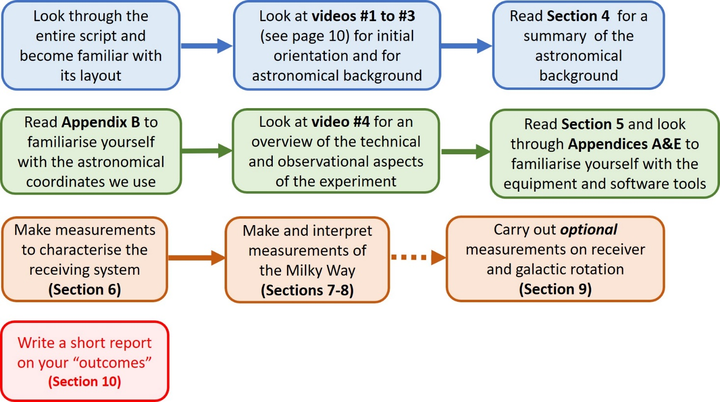

++++++++++++++++++++++++++++++++++++++++++++++++++++++++++++++++++++++++++++
The bedrock of science is the taking and reporting of systematic measurements. A report summarizing the main “outcomes” (identified throughout the script) is therefore a vital part of this work. Therefore, in addition to the results you produce on your local PC, take careful systematic notes of everything you do, including your mistakes, as you proceed though the experiment.
+++++++++++++++++++++++++++++++++++++++++++++++++++++++++++++++++

Videos to look at before starting

Students with no prior knowledge of radio astronomy start here:
#1 “Radio Astronomy in Five Minutes” (4m40s): does what it says! https://youtu.be/3EcrrLNlWdE

For astronomical background on this experiment:
#2 “Crash Course Astronomy” #37 “The Milky Way” (11m13s) a lively overview of our galaxy : https://www.youtube.com/watch?v=tj_QPnO8vpQ and is referred to in video #3

#3 DARA e-Seminar Series: “Observing the Milky Way with the Table Top Radio Telescope 1: Hydrogen Line Observations and the Structure of the Milky Way” . My introduction to the astronomical aspects of the experiment. https://www.youtube.com/watch?v=RQiLMxQHxr8

For technical and observational background on this experiment:

#4 DARA e-Seminar Series: “Observing the Milky Way with the Table Top Radio Telescope 2: Making Observations with the TTRT”. My introduction to the practical aspects of the experiment – it should make this script easier to follow.
https://www.youtube.com/watch?v=VjhcyCA3XDo

++++++++++++++++++++++++++++++++++++++++++++++++++++++++++++++++++++++++++++
Note: there are a minor changes in this script compared with the description in video#4. Any further updates will be posted on the TTRT Facebook group (see page 3)
++++++++++++++++++++++++++++++++++++++++++++++++++++++++++++++++++++++++++++

- The 21cm Hydrogen Line

4.1 The “spin flip” transition

We first take a brief look at the physics of the hydrogen line and the distribution of neutral (i.e. atomic) hydrogen in our galaxy.
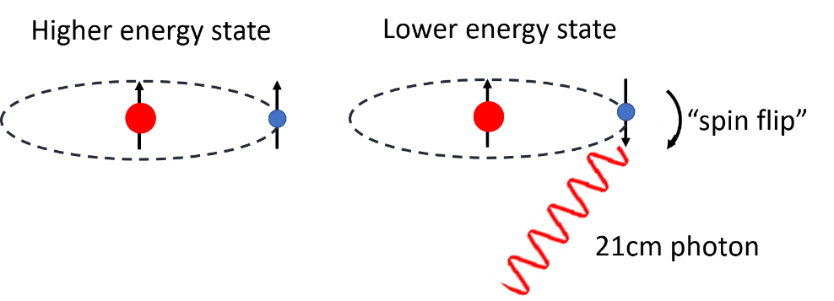

Figure 1: Schematic of the “spin flip” in atomic hydrogen giving rise to a 21cm photon

Hydrogen consists of a single proton orbited by a single electron; it is both the simplest and by far the most abundant chemical element (~74% by mass) in the universe. Most of the universe’s hydrogen is locked up in stars but significant amounts remain in interstellar space in the form of neutral atoms. These atoms emit a spectral line whose frequency is known, to exquisite accuracy, to be 1420.4057517667 MHz i.e. a wavelength of ~21.4 cm. Observations of this line with radio telescopes have provided, and will continue to provide, unique diagnostics about the universe and its contents.

The “21cm line” arises from a weak magnetic interaction between the quantized spins of the proton and electron. These spins can be oriented in either the same direction (parallel), or in opposite directions (anti-parallel), as shown highly schematically in Figure 1. There is a small energy difference between these two states, with the parallel state having higher energy than
the anti-parallel one. A transition between the two states, known as a spin-flip transition, results in a photon being emitted whose energy (~5.9 x 10⁻⁶ eV) is equal to the difference between the two states. The probability of a transition in an individual atom is very low, with a half-life of approximately 11 million years. However, due to the vast numbers of hydrogen atoms in interstellar space the 21cm radiation from our galaxy can be observed with simple apparatus.

4.2 Distribution of hydrogen in the galaxy

Establishing the structure of and motions within our galaxy is not straightforward because
our observing point lies inside the rotating disk of stars, gas and dust. However, radio waves pass unimpeded through the dust which obscures the visible light from stars and by studying the distances and velocities of neutral hydrogen clouds radio astronomers have made a major contribution to building up a Photograph of our spiral Galaxy as it would be seen perpendicular to the plane. An artist’s impression of the galactic disk, based on observations at many wavelengths, is shown in Figure 2. Figure 3 shows the result of observations of hydrogen made with the world’s largest radio telescopes. Since the column density of hydrogen is considerably higher looking into the galactic disk the 21cm emission is much easier to detect on the galactic plane.
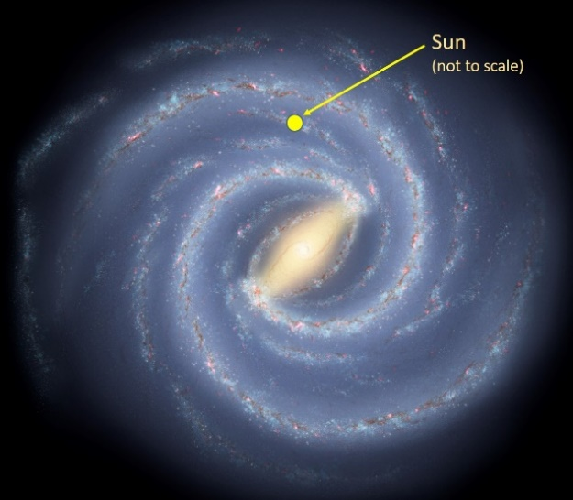

Figure 2 A schematic visualization of our Galaxy looking from above the plane. The spiral arms contain concentrations of stars, dust and hydrogen gas. The Sun lies ~8,150 parsecs (~26,600 light years) from the Galactic Centre and rotates around it at ~236 km/sec; its orbital period (one “galactic year”) is ~212 million Earth years. The Earth has completed 21 turns around the Galactic Centre since it was formed ~4.5 billion years ago.

http://www.spitzer.caltech.edu/images/1925-ssc2008-10b-A-Roadmap-to-the-Milky-Way-Annotated-
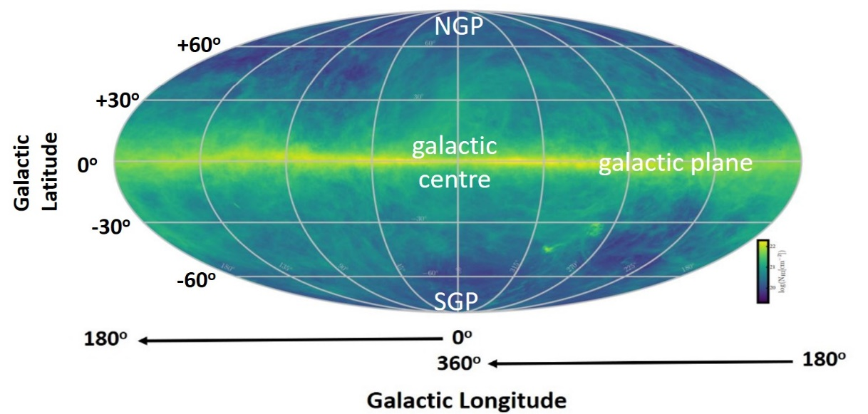
https://www.aanda.org/articles/aa/abs/2016/10/aa29178-16/aa29178-16.html

Figure 3 An all-sky map of the intensity of 21cm line emission made with some of the world’s largest radio telescopes in the HI4PI collaboration. The Sun lies in the disk of the Galaxy so the map is dominated by emission from the galactic plane; in this geometrical projection in galactic cooordinates the plane appears as the bright band across the centre. The bright “blobs” in the lower right quadrant are the nearby dwarf galaxies known as the Magellanic Clouds.

A useful website with information about our Galaxy can be found at: http://galaxymap.org/drupal/

4.3 Structure in the 21cm line spectrum

Because of the motion of the emitting atoms relative to the observer the hydrogen line does not appear at a single frequency but is spread out and shifted from its “rest” frequency of 1420.406 MHz. The spread is due to random motions within a cloud of gas and the shift is due to the overall or “bulk” motion of the cloud itself. The non-relativistic Doppler shift formula:

$∆f/f_{em }=v/c$ Equation 1

where Δf = |f_{em}-f_{obs}|, can be used to calculate the relative or radial velocity $v$ of gas along the line-of-sight. Here $f_{em}$ is the emitted (or rest) frequency of the line (1420.405 MHz), $f_{obs}$ is the observed frequency$, v$ is the velocity of the gas and $c$ is the speed of light. By convention
- if $f_{obs }$is below $f_{em }$the gas is moving away from the observer (receding) and the radial velocity is said to be positive;
- if $f_{obs }$is above $f_{em }$the gas is moving towards the observer (approaching) and the radial velocity is said to be negative.
Equation 1 shows that a frequency shift $∆f$= 100 kHz corresponds to a radial velocity $v$ of 21.1 km/s alternatively a radial velocity of 100 km/s corresponds to a frequency shift of 473.4 kHz.
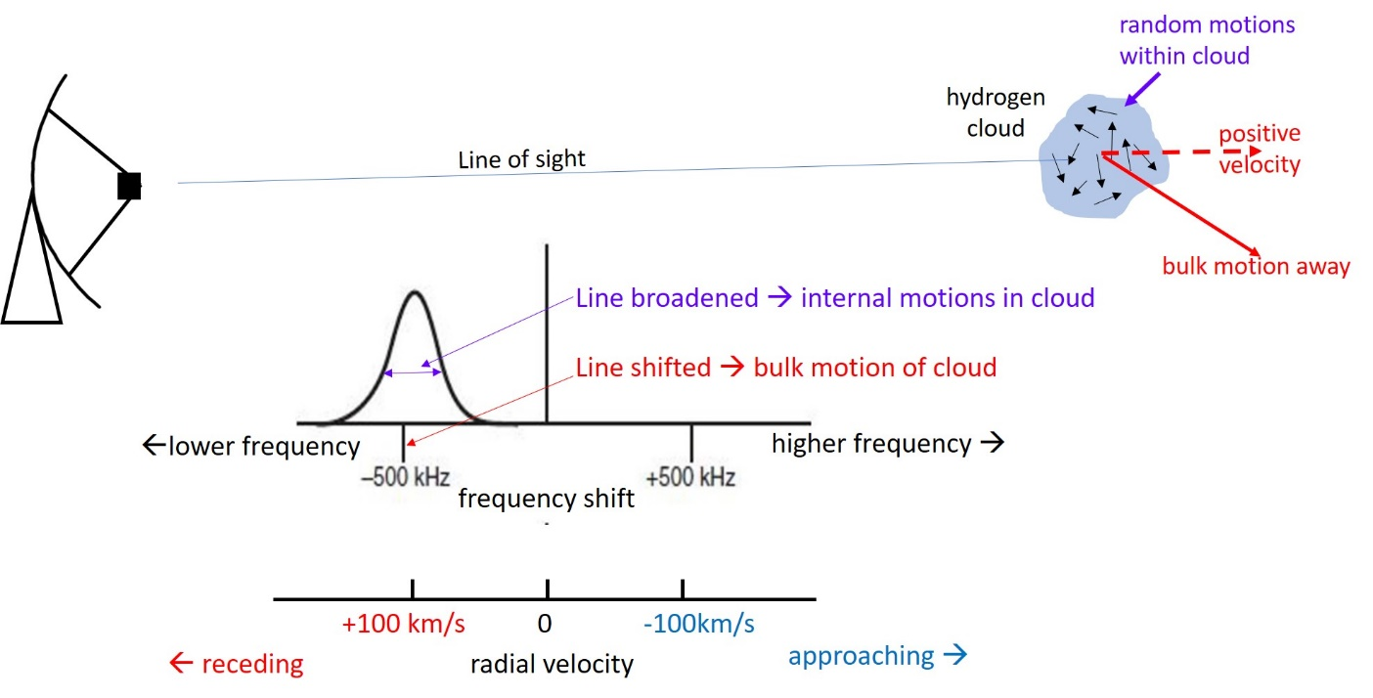

Figure 4 : The shape and central frequency of the 21cm line observed from a cloud of gas is determined by the Doppler effect arising from the cloud’s internal motions and overall radial velocity (which includes the motion of the telescope). Internal motions in the cloud (here with random velocities of 40 km/sec both towards and away from the observer) cause the line to be broadened while an overall recession of the cloud (here 100 km/s) along the line of sight shifts the line centre to a lower frequency (positive radial velocity).
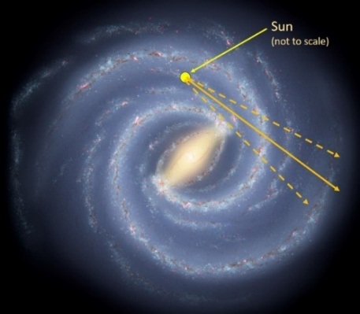

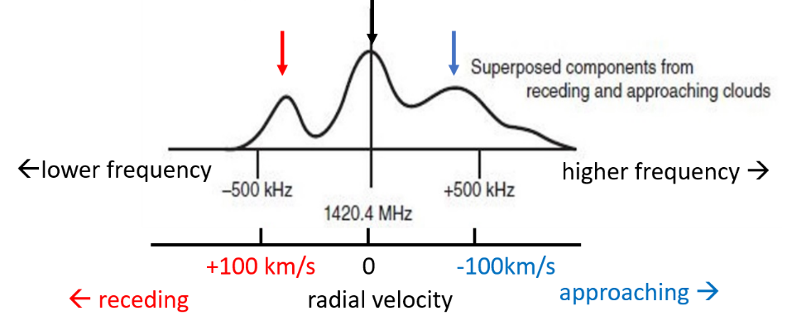

Fig 5: Top) A typical pointing direction through the galaxy encompasses gas clouds within a range angles (due to the finite reception beam of the antenna) at at different distances and hence with different radial velocities. Bottom) When several discrete clouds fall within the reception beam a composite spectrum with multiple peaks will be observed.

When a radio telescope scans around the plane systematic radial velocity shifts are seen in the spectra as well as varying individual features (see Figure 18). These shifts indicate that the entire Milky Way galaxy is rotating but exactly how? Several possibilities are illustrated in Figure 6. If the overall mass the galaxy was dominated by material near the Galactic Centre then the velocities of clouds further away from the Centre would be lower than those closer in – this is the Keplerian rotation exhibited by planets in the Solar System (V α 1/R^{1/2}; see section 9.4). If the galaxy rotated like a solid disk (like a CD or a vinyl record) cloud velocities would increase with distance from the Centre (V α R). Observations show that neither of these models fit the data and in fact orbital velocities throughout most of the galaxy are similar (V ~ constant). The result is that towards the Galactic Centre rotation periods are shorter, the angular velocities Ω=V/R are higher and gas clouds closer to the centre overtake those further out. This is called differential rotation and the basic formalism is discussed in Chapter 8.

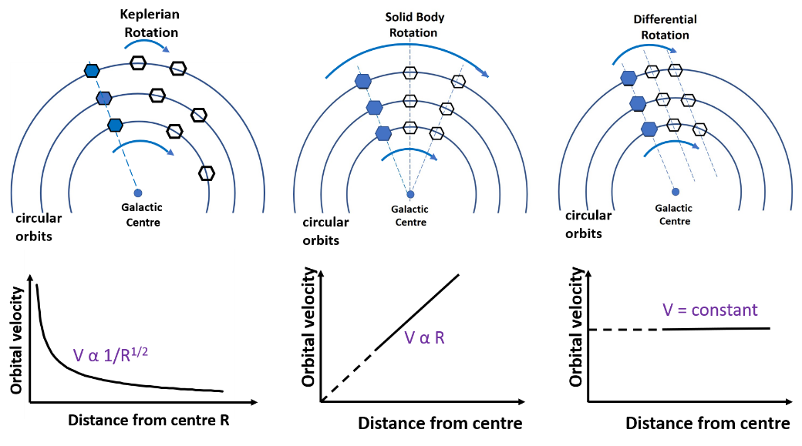

Figure 6 Schematic illustrations of a disk rotating in different ways; discrete clouds (depicted by hexagons) are on circular orbits at different distances R from the centre. In Keplerian rotation clouds closer to the centre have higher velocities V than those further out; in solid body rotation the reverse is true since points on a solid disk rotate faster the further away they are from the centre; in practice the orbital velocity is relatively constant as a function of distance (except near the Galactic Centre). Since clouds at larger distances, have further to travel they fall behind those orbiting closer to the centre. We say that the galaxy exhibits differential rotation.

In summary: the Sun is located part way out from the galactic centre and any given direction the observed hydrogen spectrum is the combination of the emission from all distances through the galaxy and within the angular reception beam of the antenna. As result of differential rotation these clouds have different radial velocities and the observed spectra usually show several peaks indicating concentrations of hydrogen at specific radial velocities. This observation, first made in the late 1950s, suggested that the galaxy possesses spiral arms. Figures 4, 5 and 6 summarise these ideas and in Sections 8 and 9 we explain galactic motions in more detail.

4.4 Observations with 2-3m dishes (short videos)
The following two videos will cement the ideas presented thus far.

- “Mapping the Galaxy with Radio Astronomy” (MIT Educational Video; 7m38s). An entertaining overview of the approach adopted in our experiment using a larger 2m parabolic dish antenna – with the much lower angular resolution TTRT antenna we cannot separate the spiral arms.
https://www.youtube.com/watch?v=-UrzmAa62ho

- “Our Galaxy @ 21cm” (2m 10s): a superb visual depiction of observations made with a 3.3m parabolic dish in a back garden in France. https://www.youtube.com/watch?v=HGwkZY4E64k.
THIS PAGE INTENTIONALLY LEFT BLANK
- The receiving system

Hydrogen line observations at the research level have been made since the 1950s, however increasingly low-cost ways of making such measurements are now available in the educational and amateur arena. An important development has been so-called Software Defined Radio (SDR) which allows one to replace some of the components of a classical receiver with integrated hardware under software control. The RTL-SDR receiver, which is used for this experiment, was originally aimed at a mass TV market. There are other, more sophisticated, SDR devices available but we have chosen the RTL-SDR for its low cost and because our mode of operation requires significant input from the student thereby providing insight into radio astronomical techniques. We now discuss the receiving system in the sections indicated in Figure 7 and shown in Photograph E1.
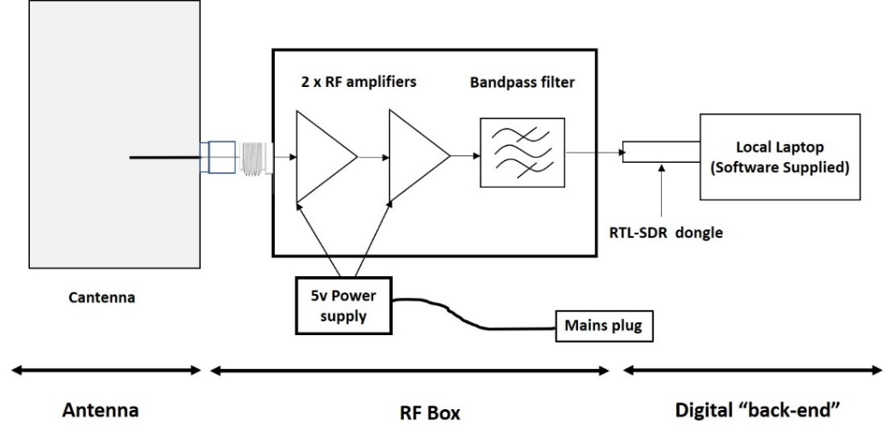

Figure 7: A schematic of the receiving system - the cantenna is shown without the horn and disconnected from the RF Box. The 5v power can also be supplied from the USB port of a PC.

5.1 The antenna

The term “radio telescope” usually brings to mind a large parabolic reflector – such reflectors with diameters up to 100m were used to produce the high resolution image shown in Figure 3. Fortunately much smaller collectors of radio emission can be used in an introductory experiment such as this – and they need not be 2-3m diameter parabolic reflectors. There are a multiplicity of possible designs - we have chosen the “cantenna” as being the simplest and most robust. Its disadvantage is its low angular resolution (~60º) so we have added an extension horn to decrease the beam size.

The cantenna consists of a metal cylinder (in radio engineering terms a circular waveguide) closed at one end whose diameter is appropriate for the chosen observing frequency; we used a section of commercial air-conditioning ducting with an end cap; the diameter is 160mm. To turn it into a radio antenna a copper probe is soldered onto an RF connector attached to the side of the can – as shown in Figure 8 and Photograph E2. The extension horn increases the aperture and therefore reduces the reception beam size (α 1/diameter); it is also a section of commercially available air conditioning ducting. In this arrangement, chosen for low-cost and ease of construction rather than RF performance, the length (~47mm) of the probe and its distance from the closed end (~85 mm) have to be carefully optimized for operation at 1420 MHz using professional-level test equipment.
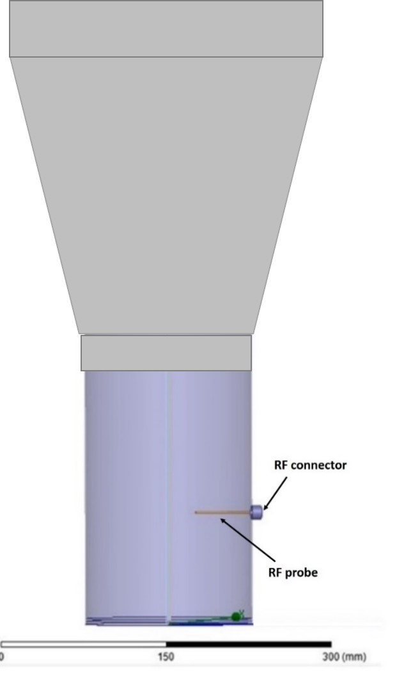
Angle (degrees)
normalised power

Figure 8: left) schematic of the cantenna+horn; right) the calculated power reception beam normalized to unity in the pointing direction; the width at half maximum is ~38º.

The right hand plot in Figure 8 shows the calculated reception beam of the cantenna i.e. its relative power sensitivity as a function of angle from the pointing direction. The “main beam” falls to half power about ± 19º from the axis so the half-power width is ~38º. Radiation collected by the main beam dominates the power input to the receiver. Notice, however, that in all other directions there is still low-level sensitivity and therefore the antenna picks up some radiation from its surroundings, in particular the “hot” (300K) ground.
5.2 The “RF Box”
The box contains three main components (see Photograph E3): two RF (Radio Frequency) amplifiers and one RF “bandpass” filter. The 5v DC power for the amplifiers is supplied via the socket on the box either i) by the small mains-driven power supply or ii) from a cable connecting to a USB port on a PC; the total power requirement of the RF box is ~0.25 watts.
The RF amplifiers: The RTL-SDR receiver, described in the next section, was designed to handle strong TV signals and does not provide enough amplification for work with the faint radio signals coming from the cosmos. A radio-astronomer’s “rule of thumb” is that the receiver must amplify the incoming astronomical signal by up to a factor 10¹⁰ (i.e. 100 dB) to enable useful measurements of the signal’s properties to be made. We therefore had to provide additional amplification before passing the signal on to the RTL-SDR. The two separate amplifiers indicated in Figure 7 and shown in Photograph E3 perform this task.
The RF “bandpass” filter: The hydrogen line falls in the most important internationally protected band for radio astronomy 1400-1427 MHz so there should be no other signals in the ~2 MHz band to which RTL-SDR receiver is sensitive. However, at most observing sites there will be powerful man-made signals outside the protected band – in particular due to mobile phones and cellular base stations at frequencies around 900 MHz and 1800 MHz. Such “out-of-band” signals can be sufficiently powerful to affect the performance of the RTL-SDR and hence must be filtered them out. The specially-designed bandpass filter in the RF Box (Photograph E3) passes a 30 MHz band centred on 1420 MHz and, most importantly, attenuates the 900 MHz and 1800 MHz mobile phone bands by a factor ~10⁷.

5.3 The RTL-SDR “software defined radio” receiver
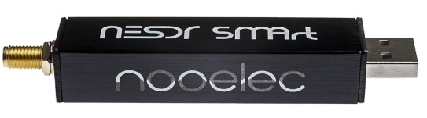
Figure 9: A typical RTL-SDR unit used in this experiment.
The input signal from the antenna enters from the left; the digitized output signal enters the PC via the USB port.

The RTL-SDR receiver is based on the generic R820T tuner/amplifier and RTL2832U digitizer chips. These are housed in a “dongle” which fits directly into a USB port on a PC or laptop (Figure 9 and Photograph E6). The RTL2832U turns the continuous analogue voltages into a time stream of digital samples using analogue-to-digital converter (ADC) circuits. The rate of time sampling can be varied but the amplitudes are quantised into 8-bit (1 byte) words giving 2⁸= 256 values. These units are well-suited as the basis of a hydrogen line receiver since: i) the frequency range over which the tuner works ( ~24 MHz to ~1.7 GHz) includes the hydrogen line rest frequency and its ~2 MHz bandwidth easily covers the Doppler spread of the line; ii) the data collection parameters can be controlled using the Osmocom software (Appendix A, Section A.1), iii) the digitized data can then be manipulated with bespoke software.
THIS PAGE INTENTIONALLY LEFT BLANK
THE EXPERIMENT

6. Initial Preparations

-----------These tasks can be carried out indoors, before taking HI data---------------
Before we can make measurements of galactic hydrogen it is important to check the performance of the receiving system – this involves:
- setting up the RTL-SDR with the PC (section 6.1 and Appendix A);
- optimizing the RTL-SDR’s internal gain settings (section 6.2);
- measuring the spectral response of the receiving system (section 6.3).
For tasks ii) and iii) we have to take some data, analyse it with the software supplied and then display and interpret the results.
The internal gain settings for different RTL-SDR units can differ slightly and both the gain and the frequency response are affected by the external temperature. Therefore:

- Plug the RTL-SDR into a USB slot in your PC and allow it to warm up for at least 10 minutes before taking any data.
- Shield the RTL-SDR from direct sunlight.
- Before starting a new series of observations (e.g. on a different day, particularly if the temperature is different ) check that the internal gain setting of the RTL-SDR is satisfactory (described in section 6.2).

6.1 Software set-up and communicating with the RTL-SDR

- Turn to Appendix A:
  - Read the introductory section and follow the instructions in the various A.1 sections to set up the software supplied on the pen drive.
(Check: has this already been done by staff or previous students?).
  - Read Section A.2: and run the programme rtl_test.exe to confirm communication has been established between the PC and the RTL-SDR and hence that you are ready to proceed with the experiment.

6.2 Optimising the RTL-SDR gain setting

Radio astronomy signals produce random noise voltages in the receiver chain (see Figure 10). The time-varying voltage has a mean of zero (i.e. statistically equally positive and negative) and the amplitude follows a Gaussian (or normal) probability density distribution – as indicated on the right of Figure 10. It is vital to set the overall receiver gain (the combination of the amplifiers in the RF Box and those in the RTL-SDR) correctly in order utilise the full amplitude range of the ADCs. To do this we take several sets of data, with different RTL-SDR gain settings, and examine the results.
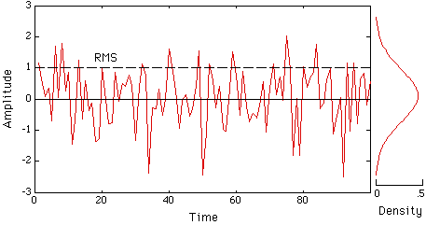
Image credit:http://www.comdis.wisc.edu/vcd202/gaussian.GIF
Figure 10: A random noise voltage and its amplitude probability density

STEP 1: Connect the RF Load
The gain optimisation should be carried out for the strongest input signal we encounter during the observations. This occurs when the RF Box is connected to the calibration “RF load”.
- Connect (i.e. screw on carefully until finger tight) the RF load to the type-N connector on the input of the RF box (see Photograph E7).
- Connect the SMA connector output on the RF Box into SMA connector on the RTL-SDR using the cable supplied (see Photograph E5)

STEP 2: Capture digital data
Use the program rtl_sdr.exe to capture digital data from the RTL-SDR. It outputs digital I/Q samples as a binary file which can then be analysed with other software.

- From within your working folder click on the command line prompt (cmd.exe) to open the command line and type (paying careful attention to spaces):
rtl_sdr.exe ./filename1.bin -f 1420.4e6 -s 2048e3 -g 22.9 -n 2e6 <rtn> or <enter>

Here:
- rtl_sdr.exe calls the application
- ./filename1.bin sets the name of the output binary file to be saved in the working directory; any name can be used but you must retain the .bin extension.
- -f 1420.4e6 sets the centre frequency of the data capture – in this case 1420.4 x 10⁶ Hz or 1420.4 MHz; this is the rest frequency of the hydrogen line and should not be changed.
- -s 2048e3 sets the sample rate and bandwidth to 2048 x 10³ Hz or 2.048 MHz; this is the default sample rate and should not be changed.
- -g 22.9 sets the RTL’s internal gain, 22.9 dB is just one of the possible values given in the list in Figure A.2.
- -n 2e6 sets the number of I/Q samples (here 2 x 10⁶) in the output binary file. By varying the number of samples you can change the length of time for which data are taken (the “integration time”) You will change this value during the experiment. Since each sample corresponds to 1/2.048x10⁶ seconds -n 2e6 = 2x10⁶ samples corresponds to 2048e3/2e6 = 0.9765625 seconds correspondingly -n 2e7 would give ~9.77 seconds of data

rtl-sdr.exe captures samples until the number specified has been reached and saves the output binary file in your working directory. At this point the command window will look like Fig. 11.
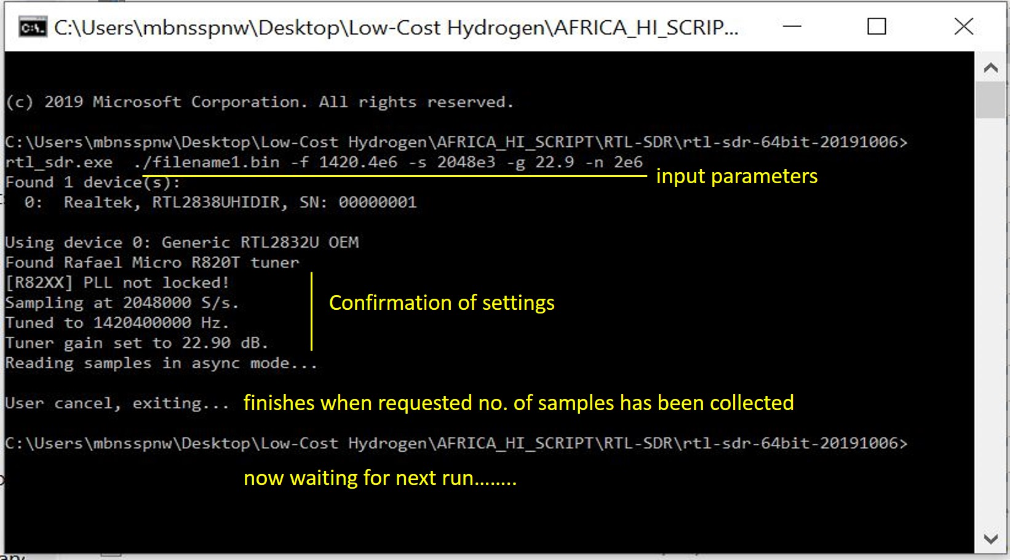

Figure 11. The commend line window after running rtl_sdr.exe. The inputs at the top of the window correspond to: centre frequency: 1420.4 MHz; sample rate: 2.048 MHz; RTL-SDR internal gain: 22.9 dB; samples taken for ~1 second (-n 2e6); output file: filename1.bin.

STEP 3: vary the RTL-SDR gain settings
- Take a series of data sets with ~1 second integrations (-n 2e6) with several gain settings chosen from those shown in the rtl-test.exe output in Figure A2 (hint: use a range between 20 and 30 dB). Make sure to identify each set of data with a different file name. Wait for the programme to finish each time before starting the next step.

STEP 4: Assemble the statistics of the digitized amplitudes
Use the programme amp_sts2.exe to collect the amplitude statistics of the data sets just taken. The output provides a diagnostic of the RTL-SDR ADC’s utilisation - the aim is to determine whether the ADC is being driven with the optimum receiver gain.
- Click on the command line prompt cmd.exe and on the command line type:

amp_sts2.exe filename1.bin filename1.txt <rtn> or <enter>

The output file name is arbitrary but must have the .txt extension. This text file records the power versus frequency spectrum in two columns and is suitable for analysing and plotting in a spreadsheet such as Excel (or equivalent) in step 5.

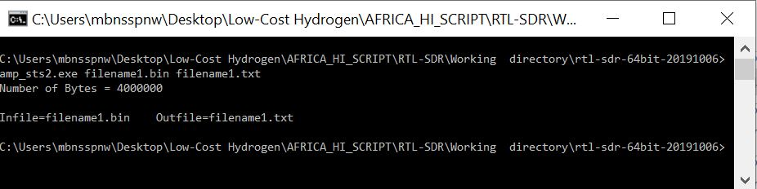

Figure 12. The commend line window after running amp_sts2.exe. showing input and output files

STEP5: Plot the amplitude statistics and determine the optimum RTL-SDR gain

OUTCOME #R1: Using a spreadsheet (instructions in Appendix A.3) plot out the amplitude statistics for each gain setting (as in Figure 13). Determine an optimum gain setting for the RTL-SDR.

Use this gain setting for all subsequent work during a given observing session but check it is correct (in particular not saturating as in the bottom plot in Fig 13) for any subsequent sessions in which the external conditions have changed. If the ADC amplitudes are saturated then the quantitative results will be affected.

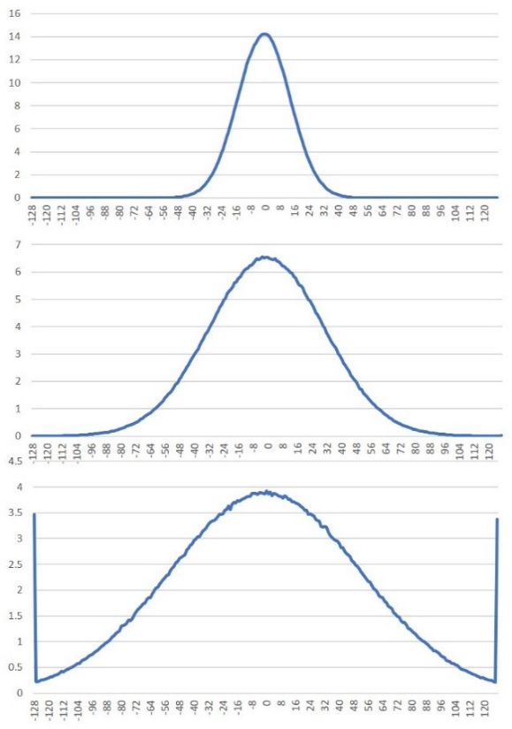
Fig 13: The amplitude statistics for three RTL-SDR gain settings. The horizontal axis is the ADC “byte value”. One byte contains 8 bits hence there are 2⁸ = 256 possible amplitude values, from -128 through 0 to +127, for each time sample which the ADC takes. The vertical axis is the normalised count for each byte value i.e. relatively how many times a particular amplitude is recorded in the set of samples.
Top) the receiver gain is too low; the gaussian distribution does not extend over the full amplitude range of the ADC.
Middle) the receiver gain is about optimum; the full amplitude range is being utilised
Bottom) the receiver gain is too high; the peaks at the ends show that the ADC’s amplitude range has been exceeded – it has been “saturated”.
Note: the location and annotation of the axes may differ depending on how you use the spreadsheet to make the plot.

6.3 Obtaining the calibration load spectrum

The power from the receiver as a function of frequency is called the output spectrum. When the antenna is pointed towards the sky the output spectrum is a combination of the incoming hydrogen line emission and the spectral response of the receiver chain itself. To reveal the correct hydrogen spectrum we must therefore measure the response of the receiver chain and remove it. The next step is, therefore, to take a spectrum with the RF load still connected to the receiver as in section 6.2.
If the overall receiver gain has been set correctly the power level of this spectrum is directly proportional the physical temperature of the load (in degrees K) and this allows us to calibrate the temperature scale of the hydrogen spectrum (see section 7.2).

STEP1: Capture digital data
- Click on the command line prompt (cmd.exe) and type on the command line:

rtl_sdr.exe ./system_spectrum.bin -f 1420.4e6 -s 2048e3 -g XX.X -n 1e8 <enter>
where XX.X is the optimum gain value you have just determined. The integration time, set by -n 1e8, corresponds to ~49 seconds (wait till the program has finished!) and is chosen for the 1st calibration of the “sky” data you will be taking in section 7.2. Again any output file name can be chosen provided the .bin extension is used.
STEP2: Form the power spectrum
The programme rafft22.exe creates a power vs. frequency spectrum via a Fast Fourier Transformation (FFT) of the time series of binary data and outputs and easily manipulated .txt format file.
- Click on the command line prompt (cmd.exe) and type on the command line:

rafft22.exe system_spectrum.bin system_spectrum.txt 256 <rtn> or <enter>
Here
- rafft22.exe calls the Fast Fourier Transform application.
- system_spectrum.bin specifies the input binary file produced by rtl_sdr.exe in the working directory – the name is arbitrary but must have the .bin extension
- system_spectrum.txt specifies the name of the output text file (the spectrum) saved in the working directory. Any name can be used providing the .txt extension is retained.
- 256 specifies the number of points in the spectrum; it is the default for this experiment and should not be changed.

Once rafft22.exe has finished (you will need patience for longer integration times!), the command window will appear as in Figure 14.
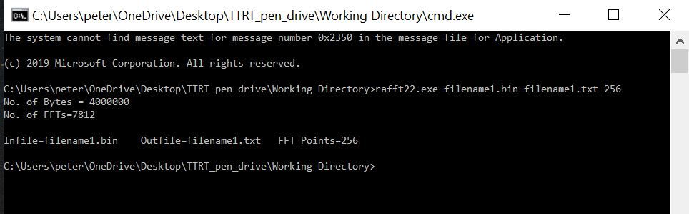
Figure 14 . The command window after running rafft22.exe on a small file (short integration time ) from rtl_sdr.exe. It shows the size of the output file (4,000,000 bytes); the number of FFT operations (7,812); the chosen names of the input binary file (filename1.bin) and output text file (filename2.txt) and the number of points (256) in the FFT spectrum.
STEP3: Plot the receiver spectrum
OUTCOME #R2: Using a spreadsheet (see the instructions in Appendix A.3) import the .txt file and plot the receiver spectrum in the form of a line graph as in Figure 14. Note that this .txt file will be needed for the calibration step in Section 7.

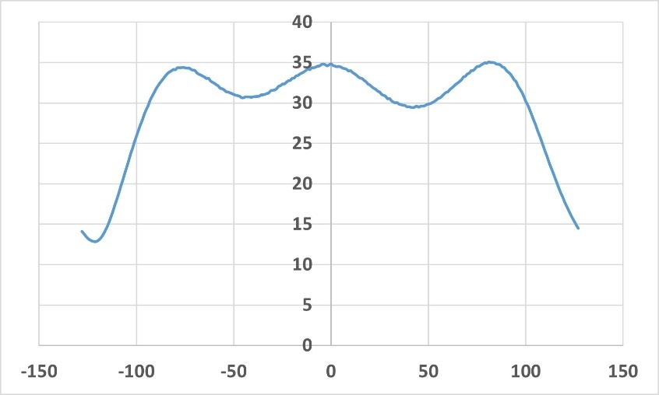
Figure 15: A raw receiver power spectrum taken with the RF load connected to the RF box. The FFT has split the 2.048 MHz band set by the sample rate into 256 x 8 kHz channels (the horizontal scale). With the correct gain setting the relative power in each channel (the vertical axis) should be similar to that shown here. If it is very different (e.g. factor of 2) re-check the gain setting. Note: the location and annotation of the axes may differ depending on how you use the spreadsheet to make the plot.

6.4 Determining the availability of positions along the plane
- Read Appendix B on Coordinate Systems
- Look at the explanation in video#4 on finding galactic positions
As described in Section 4 the emission from atomic hydrogen is most intense in directions along the galactic plane (galactic latitude b=0) which traces out a giant circle in the sky (see video #3) In the first part of the experiment we focus our attention on the plane. Although the antenna beam covers a significant range of angles the hydrogen signal will be dominated by clouds within a few degrees of the plane. It will, however, pick up hydrogen emission from regions of the plane on either side of the pointing direction.
Figure 16 represents the entire sky in terms of celestial coordinates i.e. Right Ascension and Declination (horizontal and vertical axes); the corresponding galactic coordinates (the curved lines) have then been added; the galactic plane is highlighted in yellow. Some specific points (the Galactic centre, the Galactic anti-centre and the Galactic poles) have been marked together with some representative longitude l points along the plane.
The TTRT antenna is pointed in terms of local horizon coordinates (Azimuth and Elevation or Az/El) and we have provided a convenient calculator to make the process of coordinate transformation from galactic coordinates (l,b) to local Az/El straightforward.
Before starting the observations use the coordinate conversion calculator DARA_Galactic_AzEl_Converter.exe supplied on the pen drive--you should have copied this program into your local working directory. Now you can use it to explore what sections of the galactic plane are accessible (i.e. above elevation 30 degrees) from your location at any particular date. The procedure is given below but also pay careful attention to the description in video #4.

Enter into the calculator window:
- A target point on the galactic plane: the galactic longitude l (0º to 360º) and latitude b (+90º to -90º): note that b = 0º for the plane, b=+90º for the North Galactic Pole and b=-90º for the South Galactic Pole.
- Your location on Earth: in this calculator the longitude (0º to 360º) increases Eastward thus 10ºE ≡ 10º and 10ºW ≡ 350º, the latitude is the usual (+90º to -90º).
- The offset (hours) of your local civil time zone from Universal Coordinated Time (UTC which is the equivalent to Greenwich Mean Time GMT). If unsure check it on the web.
- A date (for the year 2022 enter 22 etc.) and the local civil time (hours)
- Click on <run> and the pop-up window will give:
  - Right Ascension (hours) and Declination (degrees) of the chosen point; this can be cross-checked against Fig 16.
  - the Azimuth and Elevation of your chosen galactic position for your terrestrial location on that date and that time.
It is now useful to build up a picture of the best times of day for which you can observe useful sections of the plane on the given date. The favourable observing opportunities (i.e. elevations above 30º) move through a time “window” defined by the working day. Take time to run the calculator systematically as follows:
- Pick a date for the observations and run the calculator for a local time, say 09:00
  - Start at l=0 b=0 and repeat the calculation for 30º increments in l to l=330º;
  - Repeat this process for two different local times e.g. 13:00 and 16:00
  - Make tables of l and Az/El for local times 09:00; 13:00 and 16:00 for that date
  - If desired choose other dates and times and repeat the process.

Although the suggested the angle and time sampling is quite coarse you will readily see which times of the working day are best suited for observations. For illustration these calculations were run for a location close to Nairobi; the results are included in the Excel file Nairobi_3monthly positions.xlsx on the pen drive.

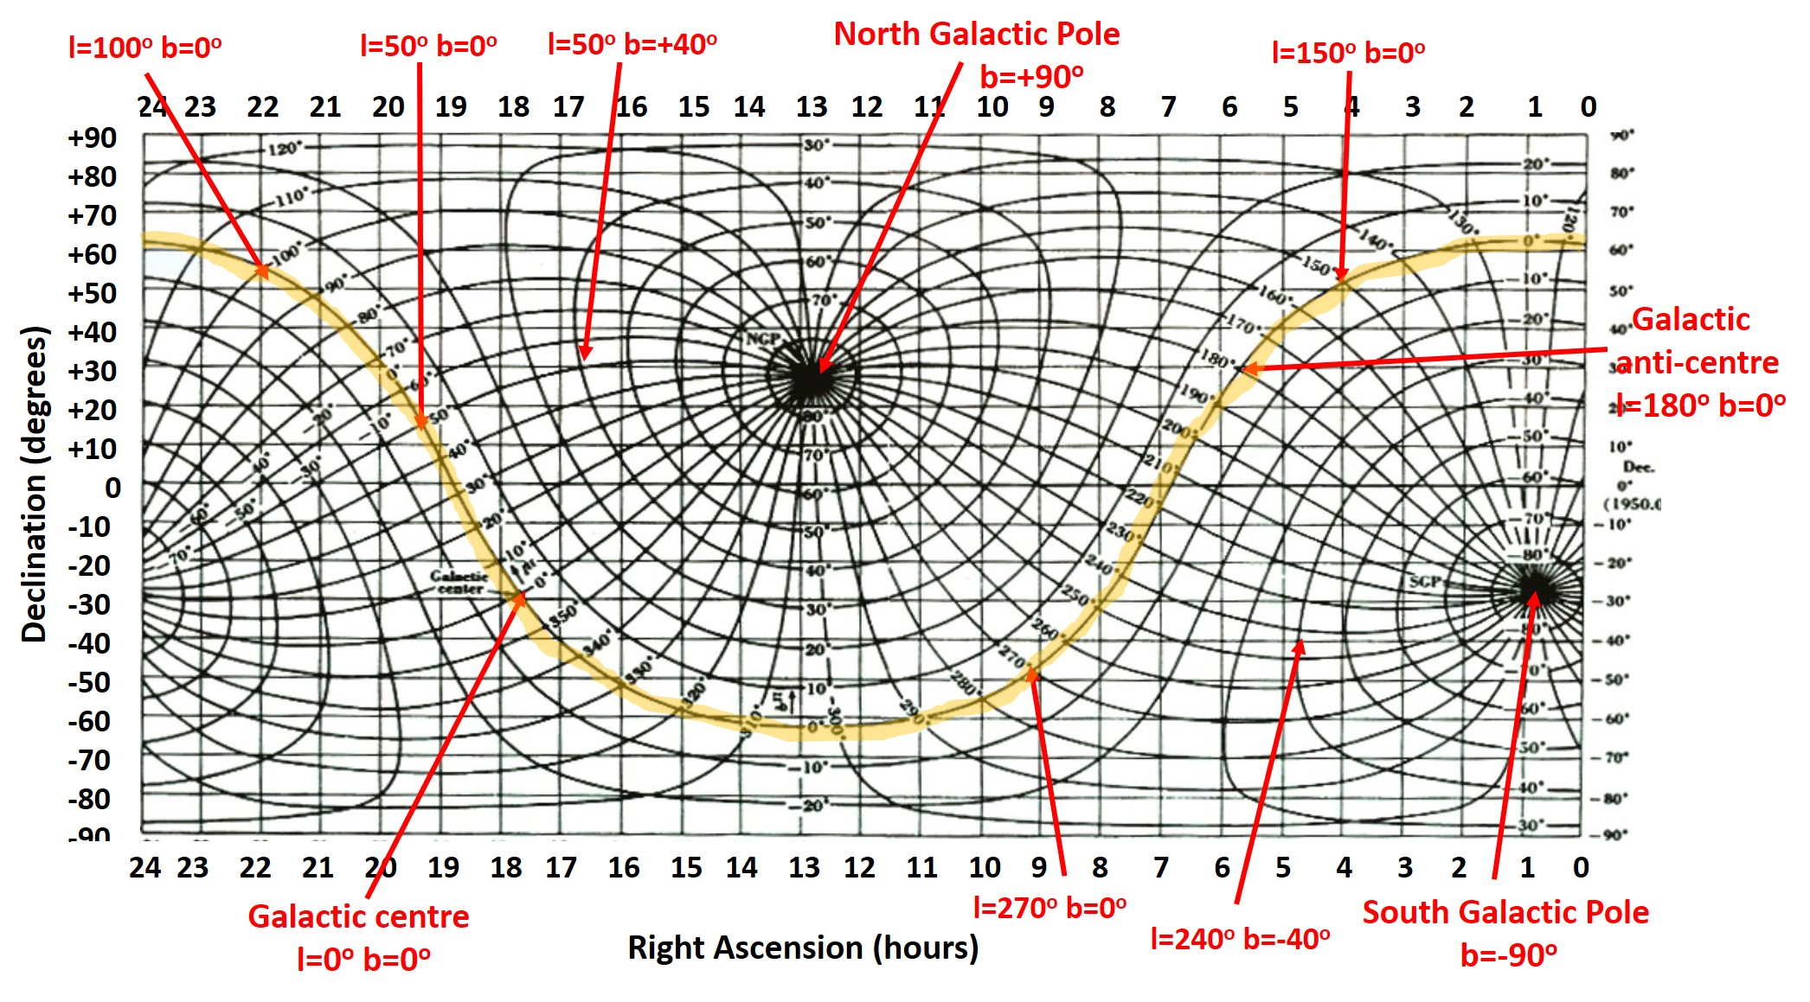
Figure 16 The celestial sphere in terms of RA/Dec with galactic (l,b) coordinates plotted on top; the galactic plane is highlighted in yellow.

6.5 Arrange a simple mounting structure for the TTRT antenna
The TTRT antenna needs to be positioned in Azimuth and Elevation. Since the positioning needs only to be accurate to about 5 degrees in each direction the solution can be very simple. Note that you are advised not to take data below elevation 30º which simplifies any design. Photograph E8 and the accompanying schematic drawing shows one possible arrangement which I constructed from spare pieces of wood; the elevation of the antenna can be adjusted with chocks of wood as indicated.
You may well be able to devise a better design for the mount . It is up to you or your institution to arrange this.

7. Observations of Galactic hydrogen

7.1 Moving to an outside environment: some practical issues
After you have found the times at which significant sections of the plane are accessible from your location you are ready to start the actual observations. This involves first taking the equipment outside to position with a clear view of the sky in many directions. In doing so pay careful attention to the following practical issues:
- Place the equipment on a sturdy, level, table:
  - Large enough to hold the antenna on your mounting arrangement (allowing room for azimuth rotation), the RF-Box and the laptop (allowing room for a sun-shield around the laptop, an open cardboard box is ideal – see video#4).
  - Made of non-magnetic material (i.e. wood or plastic) to avoid affecting magnetic compasses
- Pay attention to electrical safety
  - Arrange proper outdoor access to mains power for the:
    - The AC-DC power supply providing 5v to the RF-Box (if using)
    - The PC transformer supplying 19v to the local laptop
  - Do not attempt to observe in rain or otherwise wet conditions

7.2 Pointing the antenna and taking “sky” spectra along the plane

STEP1: connect the RF box to the antenna and point the antenna

- Disconnect the RF load and connect the antenna to the RF Box (see Photograph E4).
- Select a target longitude on the galactic plane and determine its Azimuth and Elevation as described in Section 6.4.
- Point the antenna to that Azimuth and Elevation using a protractor for Elevation (see Photograph E9). As advised in video#4 there are several options for Azimuth:
  - a magnetic compass – use the web to find the difference between true and magnetic N or S (the magnetic declination) for your location on Earth.
  - a smart phone compass app: take care to calibrate the phone as the app suggests; avoid using a phone in a case with a magnetic fastener, this can ruin the phone’s measurement of the Earth’s magnetic field.
  - Google Earth Pro: in the free PC application use the “ruler” to draw a line from your observing position to a recognizable point nearby – this is a very accurate check on compass or smart phone measurements (see Photograph E10).

STEP2: Take some test “sky data” and plot the “raw” sky spectrum

- Use rtl_sdr.exe as in Sections 6.2 and 6.3, to take “sky data” in your chosen position; for an initial test use -n 1e8 giving an integration time of ~49 seconds. Choose an appropriate output .bin file name and wait for the application to finish.
- Use rafft22.exe (as in Section 6.3) to form the “raw” sky spectrum. Choose an appropriate output .txt file name.
- Plot the .txt file as described in Section 6.3 and Appendix A.3

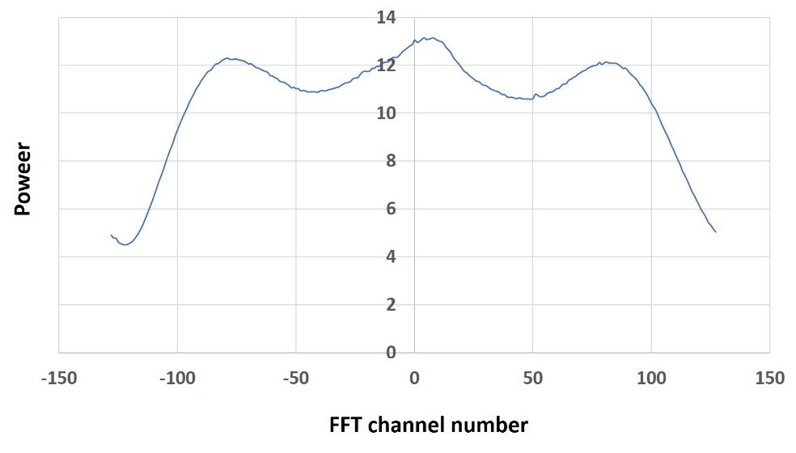
Fig 17: An example “raw” sky spectrum. The overall shape is due to the characteristics of the receiver (as shown in Figure 15) while the additional “bump” between FFT channels -10 and +20 is due to hydrogen.

STEP3: produce a normalised and calibrated spectrum

You may find it easier to take the laptop indoors to carry out the analysis in STEP 3 and hence to check that the test observation produced satisfactory results. Before moving on to STEP 4 and taking further sky data remember to allow the RTL-SDR to warm up for at least 10 mins after plugging it back into the USB port.

The receiver’s spectral response must now be removed from composite spectrum in Figure 17 units.
- Following the instructions in Section A.4 use a spreadsheet to divide the “raw” hydrogen line spectrum by the RF load spectrum taken in Section 6.3.
The arbitrary axes must now be converted into practical units. The horizontal axis should be in units of radial velocity (km/sec) and the vertical axis in units of radiometric temperature (degrees K).
- Follow the instructions in Section A.4 then plot and annotate the resulting calibrated spectrum.
Figure 18 shows a final calibrated spectrum. The vertical axis shows the overall radiometric temperature T_{sys} which is a measure of the power detected at the output of the receiver (see Section 9.1 for more explanation). In addition to the hydrogen emission the power comes from noise generated in the receiver itself, from the ground around the antenna, from the galaxy’s interstellar medium and from the Earth’s atmosphere. The average radiometric level will depend on the pointing direction and may vary significantly (see video#4).
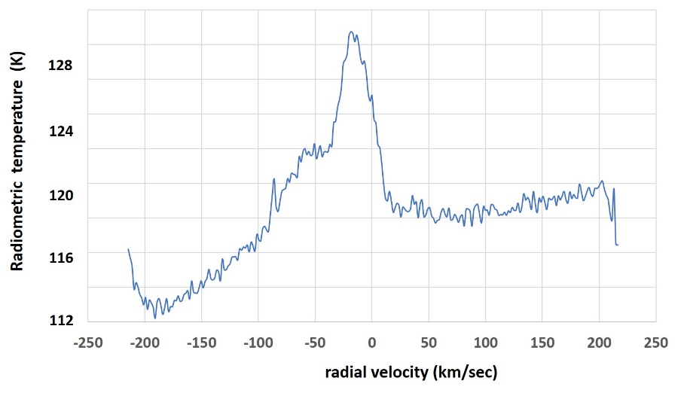

Figure 18: The spectrum in Figure 17 after calibration. The peak line temperature, compared to the radiometric temperature away from the line, is ~12K.
(Optional: see video#4 for a discussion about dealing with sloping spectral baselines)

Congratulations! you have observed the radio emission from huge numbers of hydrogen atoms located deep within our galaxy which “spin-flipped” many thousands of years ago. These “21cm photons” been travelling ever since and only a minuscule fraction were “lucky” enough to hit the mouth of the tiny TTRT antenna!

STEP 4: take data from a range of positions on the galactic plane
- Make observations of the hydrogen line for as many galactic longitudes as time allows – the separations in longitude should be at least 20º. Take care to give each data set a unique name.
- Plot each calibrated spectrum as in Figure 18.
Notice: how the line profile shifts in radial velocity along the galactic plane. This is due to the differential rotation of the galaxy – introduced in Section 4.2 and explained in more detail in Section 8.1

OUTCOME A1: Collect the labelled plots of all your spectra in a folder on the PC
7.3 Explore the emission from high galactic latitudes

The intensity of hydrogen emission falls off quickly away from the plane (see Figure 3) and we can demonstrate this with the TTRT.

STEP 1: take data from a position close to one of the galactic poles
- Point the antenna towards any galactic longitude l but at a galactic latitude b as close as possible to one of the galactic poles (b=±90º);
- Take data (as in Section 7.2) and form a labelled calibrated spectrum

The rms scatter in this spectrum should be the same as for the measurements along the plane but the hydrogen line will be much weaker.

OUTCOME A2: Compare your high latitude spectrum with any one from the galactic plane and measure the ratio between their peak line strengths (in degrees K).

============================================================================
OPTIONAL: To improve the detectability of the line at high latitudes take a spectrum with a 4x longer integration time i.e. ~196s (-n 4e8). As explained in Section 9.1 this will decrease the receiver noise level by a factor two compared with the data in section 7.2 and hence increase the “signal-to-noise ratio” by a factor two.
N.B. To calibrate this sky spectrum you will need to take a new calibration load spectrum with ~196s integration time.
===========================================================================

8. Interpreting the results
Figure 5 shows an artist’s impression of the galactic disk with a reception beam penetrating the galaxy. The spiral arms contain a series of hydrogen clouds with typical angular sizes of several degrees and so to investigate their distribution requires comparable resolution; for example a 3m diameter dish has a beamwidth of ~5 degrees. The TTRT antenna has a beamwidth of ~30 degrees and hence it “sees” the combined emission from clouds over a range of galactic longitudes and also weaker emission from off the plane. As a result it only provides blurred picture of the hydrogen distribution.
All is not lost! Whilst you cannot map out the spiral arms you will still see broad radial velocity effects due to the differential rotation of our galaxy and also see how much weaker the hydrogen emission is away from the plane.
Appendix D contains plots of professional data, taken at different galactic longitudes along the plane. These do show the changing structure of the hydrogen spectrum and the optional Section 9.2 shows how to derive the “rotation curve” of the “inner galaxy” from these data. Some important astrophysics then emerges in the optional Section 9.4.

8.1 The rotation of the galaxy
Some basic ideas were described in Figures 4,5 and 6 now we must turn them into a more quantitative picture. We do this with the idealized model of the galactic disk, shown in Figure 17. At this point take another look at the the galactic model described in video #3.
We use the following definitions:
R_{o} : Distance of Sun from Galactic Centre (known to be ~8.15 kpc)
V_{o} : Rotational velocity of Sun around the Galactic Centre (known to be ~236 km/sec)
R : Distance of gas cloud from Galactic Centre
V : Rotational velocity of a gas cloud at a distance R from the Galactic Centre
l : Galactic longitude
r : Distance of gas cloud from the Sun

V_{rad} the radial velocity of a cloud with respect to the Sun (footnote in section 4.2) is given by:

V_{rad} = V_{o} sin l – V Equation 2

The galaxy is conventionally divided into four quadrants of galactic longitude l :
Quadrant I = Oº < l < 9Oº
Quadrant II = 9Oº < l < 18Oº
Quadrant III = 18Oº < l < 270º
Quadrant IV = 27Oº < l < 36Oº
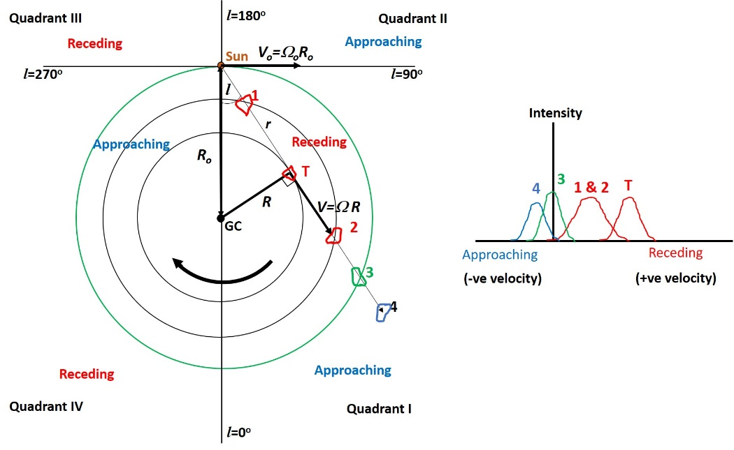

Figure 19 Left) A top-down view of the idealised rotating galactic disk with the Galactic quadrants
I-IV marked. The stars and gas are in circular orbits about the Galactic Centre (GC) and the angular velocity Ω = V/R increases towards the GC.
Right) A schematic hydrogen line spectrum looking in one particular direction; the lines at different radial velocities come from the discrete clouds whose locations are marked. Note the radial velocities of clouds 1 and 2 are the same and so their distance from the Sun is ambiguous without further evidence.

With Figures 4, 5 and 19 and Equation 2 in mind one can draw the following conclusions:

- For different pointing directions positive (receding) and negative (approaching) radial velocities are seen depending on whether the cloud is circulating inside or outside the “solar circle” (marked in green).
  - Outside the solar circle (called the “outer galaxy”) clouds complete their orbits more slowly than the Sun (Ω < Ω_{sun}) and hence are seen to be approaching in Quadrants I and II and receding in Quadrants III and IV.
  - Inside the solar circle (called the “inner galaxy”) clouds complete their orbits faster than the Sun (Ω > Ω_{sun}) and hence throughout Quadrant I are seen to be receding and throughout quadrant IV are seen to be approaching.

- Clouds in Quadrants II and III are always circulating outside the solar circle; in Quadrants I and IV clouds can lie inside or outside the solar circle.
- For any pointing direction in Quadrant I (as drawn in Figure 17) and Quadrant IV the maximum radial velocity observed V_{rad,max}, can be definitely identified as coming from a cloud at a tangent point such as T and this point will always be on the orbit which is closest to the Galactic Centre for that direction. Other clouds on that same orbit have a reduced component of their velocity along that line-of-sight and hence lower radial velocity (see video #3). Note that tangent points only exist in the inner galaxy i.e. in Quadrants I (0º < l < 90º) and IV (270º < l < 360º). We will make use of this idea in the optional Section 9.2.
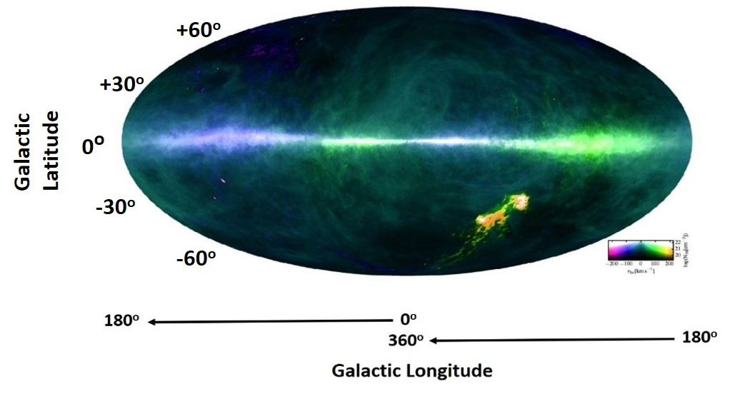

Figure 19: The same HI4PI hydrogen line survey shown in Figure 3 with radial velocities encoded in different colours; –ve radial velocities in blue/purple and +ve radial velocities in green. Longitude l = 0º (the Galactic Centre) is in the middle and l increases leftwards wrapping around at 180º (the Galactic anticenter) coming back to 360º = 0º. This view brings to life the variations in radial velocity as a function of l discussed above. The yellow/orange features are the “Magellanic Clouds” dwarf galaxies outside the Milky Way but gravitationally bound to it and which have higher radial velocities. https://www.mpifr-bonn.mpg.de/pressreleases/2016/13

8.2 Interpretation

- Examine the line profiles you collected in Section 7.2. The profiles will be spread across different radial velocities. With Figure 19 and the above discussion in mind:

OUTCOME A3: Explain why any of your profiles in Galactic Quadrants II (longitudes 90º - 180º) and III (longitudes 180º -270º) are concentrated on a particular side of zero velocity.

OUTCOME A4: In Quadrants I and IV there will be both negative and positive radial velocities; which velocities are associated with clouds inside and which from clouds outside the solar circle?

OUTCOME A5: What radial velocity do you expect for distant clouds whose orbital radius is the same as the Sun’s?

If you have the time and enthusiasm you can now carry out one or both of the additional exercises described in Section 9; otherwise jump to Section 10 for guidelines for producing the final summary report.

9. Additional exercises (optional)

The exercises in this section are intended to take you a step further both in radio astronomy technique and in your understanding of the Milky Way (see also video#3 for the latter):
- Section 9.1: introduces you to the use of the “radiometer equation”, which is vital for practical radio astronomy; it requires more data to be taken.
- Section 9.2: asks you to establish the rotation curve of the galaxy using the tangent point method; the data are professional hydrogen line profiles shown in Appendix D. No more observations are required.
- Section 9.3: asks you to consider the professional line profiles for directions outside the solar circle. No more observations are required.
- Section 9.4: based on your results in Section 9.2 you are asked to calculate a mass for the Milky Way (inner galaxy) and to consider the distribution of mass as a function of radial distance from the centre. No more observations are required.

9.1 Testing the radiometer equation
Before starting this section the reader is advised to look at the “Prologue” section in Chapter 1 of “Supplementary Material” to the 4th edition of “An Introduction to Radio Astronomy” by B.F. Burke, F.G. Smith and P.N. Wilkinson (see www.jb.man.ac.uk/ira4 ) which provides a set of summary notes on the basics of radio astronomy.
All natural radio signals are very weak and in order to detect them in the presence of noise one often has to integrate (add up) the receiver output for a long time so that the rms scatter in the output data (the output “noise level”) does not mask the desired signal. This brings us to the most important equation in radio astronomy: the “radiometer equation”
$ΔT_{rms}= \frac{T_{sys}}{√(Bτ)}$ Equation 3 where:
- ΔT_{rms} is the rms scatter in the receiver output (in degrees K);
- T_{sys} is the system temperature (in degrees K),
- B is the receiver bandwidth (in Hz)
- τ is the integration time (in seconds).
Therefore to reduce the rms scatter (the noise) in the output data we can:
- Reduce the system temperature or
- Use a wider band of frequencies or
- Increase the integration time or a combination of all three
The rms scatter decreases according to Equation 3 while the level of any incoming signal remains the same – hence decreasing the output noise from the receiver increases the signal-to-noise ratio and hence the detectability of a weak signal. With the TTRT equipment we cannot change T_{sys} or B but we can vary the integration time τ and measure its effect on the rms noise level.
- Take new data with the RF load connected (as in Section 6.3) for a series of scaled integration times, for example -n 1e6; -n 4e6; -n 1.6e7; -n 6.4e7 corresponding to integration times of 0.49; 1.95; 7.81 and 31.25 seconds respectively. Note that these choices are arbitrary, you just need to span a wide range of times. For each integration time take two independent sets of load data, one immediately after the other. Take care to give appropriate names to each of the independent data sets you produce.
- Following the instructions in Section A.5 use a spreadsheet to divide the power spectrum data from one member of the pair by the equivalent data from the other member and plot the result; it should show a scatter of points around 1 (ignore minor offsets from 1) as in Figure 20. As further explained in Section A.5 use a spreadsheet formula to calculate the rms scatter of these data.
- Collect together the rms scatter values for each of the different integration times (note that for the values suggested above the scatter should fall by a factor two between successive times.)
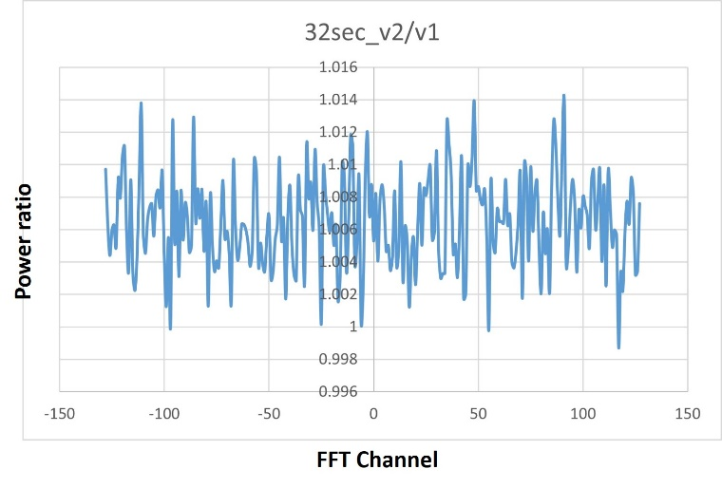
Fig 20 A plot of the ratio of power in one of a pair of RF load spectra divided by the other. The points should scatter around 1.

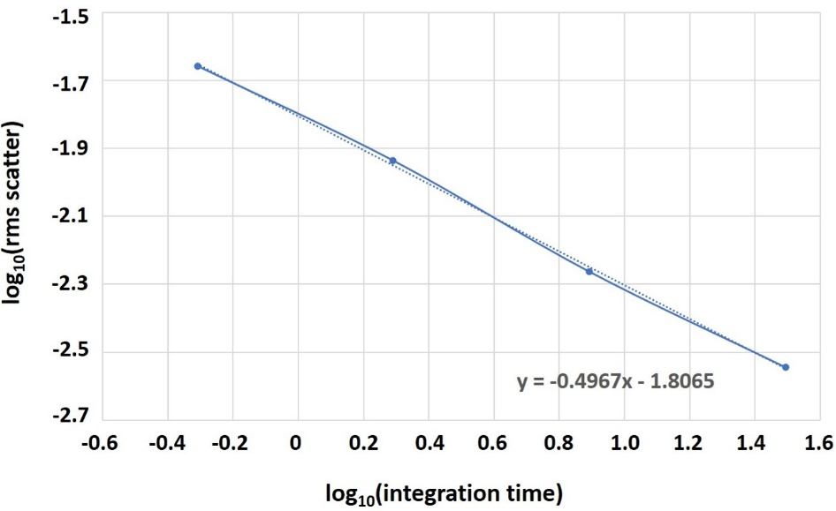

Fig 21 A plot of log₁₀(rms scatter) vs. log₁₀(integration time) for the power ratios of four pairs of load spectra. The dotted line is the best fit straight line between the points. Equation 3 predicts that the rms scatter should be proportional to 1/√𝜏 or 𝜏^{-0.5} hence the slope of the line should be close to -0.5.

OUTCOME R3: To provide a quantitative check of the radiometer equation use the spreadsheet to plot the logarithm of the rms scatter per pair vs the logarithm of the integration time. Fit a straight line to the points (in Excel “fit trendline”) and show the value of the slope.
9.2 The rotation curve of the inner galaxy from tangent point data
Background: Hydrogen line observations have been used since the 1950s to determine the space distribution of gas in the disk of the Milky Way. The main challenge is to determine the distances to the emitting clouds as the observations sweep around the galactic plane (see video #3). The interested student can find further descriptions of the geometry and observational methods in “Other places to look” (Appendix E).
As described in Section 8.1 and video #3 a vital step in the process of galactic mapping is to recognise that, at the tangent points, the distance of an emitting cloud can be established from simple geometry. And since we know that the radial velocity is a maximum at that point we can then determine the Milky Way's rotation curve i.e. V against R. From Figure 18 and Equation 2 we have:
R = R₀ sin l Equation 4
V = V_{rad,max} + V₀ sin l Equation 5

Hence, given prior knowledge of the Sun’s orbital parameters (R₀, V₀) and a series of measurements V_{rad},_{max} as a function of l, we can determine parts of the galactic rotation curve V vs R. Since TTRT antenna does not provide high enough angular resolution for this task we have provided a set of professionally-collected hydrogen profiles taken with large (>30 metre diameter) radio telescopes around the world.

STEP 1: Analyse the data in Appendix D

Appendix D contains a series of hydrogen line profiles taken with large research radio telescopes; their narrow reception beams enable the emission from discrete clouds to be distinguished. The profiles cover a range of galactic longitudes on the plane and on most of them both approaching and receding clouds are seen - as explained in Section 8.1. For use with the tangent point method we show the inner galaxy profiles on the plane at:

- l = 20º - 70º in Quadrant I and l = 340º - 290º in Quadrant IV

We have not included profiles closer to the Galactic Centre (where the motions become more chaotic) nor close to 90º and 270º (where the radial velocities are rather small). To avoid measurement ambiguity on each of the profiles we have marked (with the dotted lines) an estimate of the maximum radial velocity V_{rad,max} in the appropriate velocity direction, allowing for some smearing of the profiles due to the random motions of the atoms – as described in Figure 4.

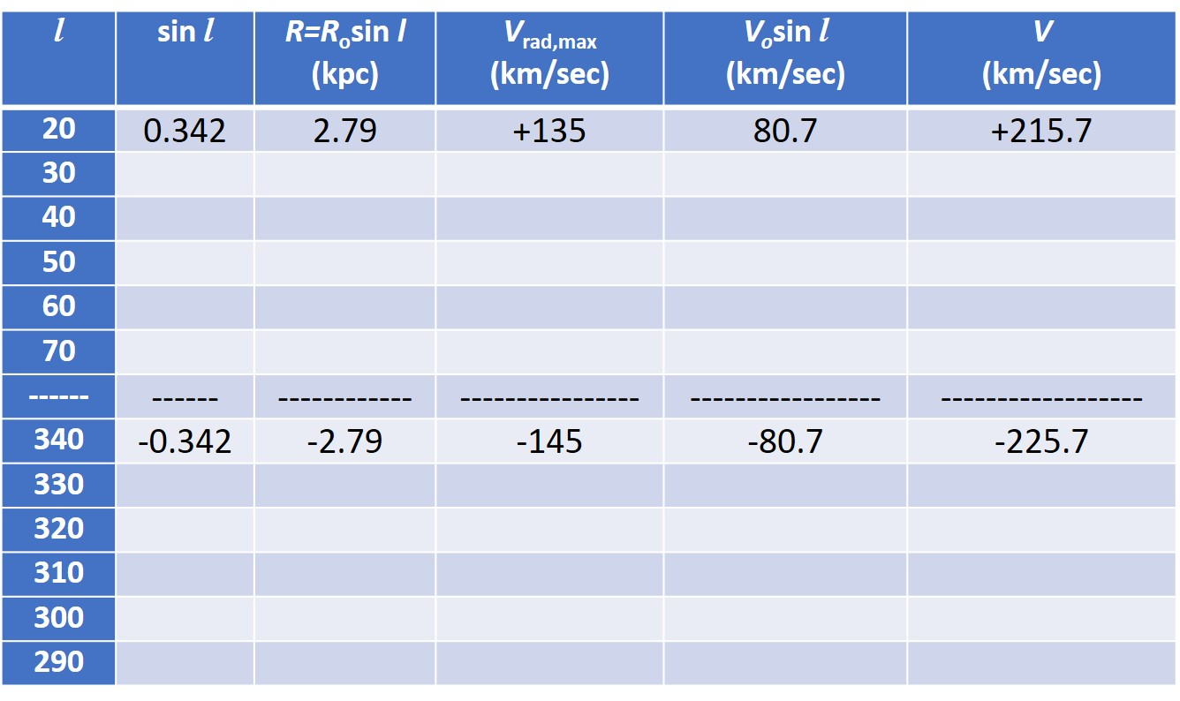

OUTCOME A6 create a table as above

- Use a ruler measure the maximum radial velocity V_{rad,max} for each value of l
- Use Equation 4 with R_{o} = 8.15 kpc to determine R for each value of l.
- Use Equation 5 with V_{o} = 236 km/sec to determine V for each value of l.
- Keep the results for the quadrants I and IV separate – as indicated in the table.

Notes:
- The first entries for the two quadrants have been included as examples.
- R and V have different signs in the two quadrants – retain the signs.

STEP 2: Plot the rotation curve of the inner galaxy

OUTCOME A7: Make a plot of V on the y-axis against R on the x-axis noting that a typical error bar on the estimate of V_{rad,max} is ±10 km/sec.

You should find that the rotation curve V vs. R is relatively “flat” on each side of the galaxy.

9.3 Hydrogen profiles from outside the solar circle

We have also included three other line profiles corresponding to orbits outside the solar circle

- l = 120º in Quadrant I and l = 210º in Quadrant IV
- l = 180º i.e. the Galactic “anticentre”.

At l = 120º the profile is virtually all due to approaching clouds while at l = 210º the clouds are all receding – as can be anticipated from the discussion in Section 8..

OUTCOME A8: why is the line profile at l = 180º centred on zero radial velocity ?

9.4 The mass of the Milky Way and its distribution

Using Newtonian gravitation we can use the rotation curve to determine the mass of our galaxy M_{R} which lies within the greatest distance R determined in the previous section. For a mass m in a circular orbit we can write:

F= $\frac{GM_{R}m}{R^{2}}$ = ma = $\frac{{mV}^{2}}{R}$
and hence $M_{R}$ $= \frac{{RV}^{2}}{G}$ Equation 6

STEP 1: referring to Section 9.2
OUTCOME A9: Taking the maximum value for R and the associated V in your table use Equation 6 to calculate M_{R} expressed in kg and then expressed in solar masses. Estimate an the error on this value.
N.B. before starting convert all measurements to S.I. units (metres, kg, seconds) noting that:
- 1 kiloparsec (kpc) = 3.26 x 10³ light years = 3.09 x 10¹⁹ metres
- Newton’s Gravitational Constant G = 6.673 x 10⁻¹¹ N m² kg⁻²
- 1 solar mass = 1.989 x 10³⁰ kg
Since the galaxy consists of billions of stars your result should not be too surprising. But the form of the rotation curve requires explanation. Rewriting Equation 6 gives:
$V=\sqrt{\frac{GM_{R}}{R}}$ Equation 7
and hence if the mass of the galaxy was concentrated in the densest regions close to the Galactic Centre (as in the Solar system where the mass is concentrated in the Sun) we would expect a relation approximately of the form V α R^{-1/2}. This is called Keplerian motion after Johannes Kepler who deduced three “Laws” of planetary motion based on the observations of Tycho Brahe.

In Section 9.2 you should have found that the rotation curve is actually “flat”, or even slightly rising, with R. If V does not depend on R then Equation 7 implies that M_{R} must be proportional to R i.e. the total amount of mass in and around the galaxy must increase along with R; this is despite the fact that the density of stars falls off with increasing R. This is shown schematically in Figure 19.
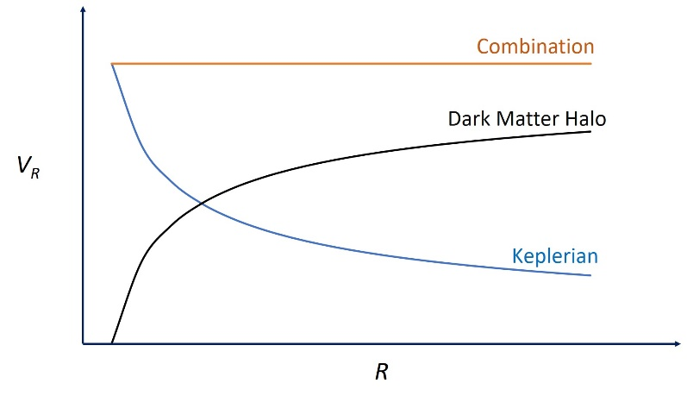

Figure 19: Schematic rotation curves. The fall off of the mass associated with stars, approximated by the Keplerian R^{-1/2} curve, is compensated by the increasing mass contribution from the hypothesized Dark Matter “halo” which extends much further from the Galactic centre than the stars.

It was the observation of flat rotation curves, most easily seen in nearby external galaxies, which led to the hypothesis that spiral galaxies are surrounded by a quasi-spherical “halo” of Dark Matter which beyond the distribution of stars. The current estimate of the Milky Way’s total mass is at least ~10¹² solar masses which is many times more than the value of M_{R} you will have derived for the inner galaxy. The Dark Matter halo must extend far beyond the Sun’s orbit around the Galactic centre.

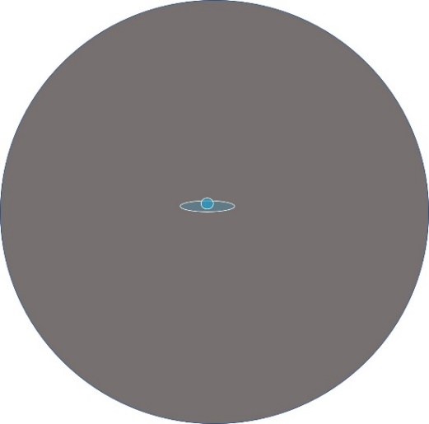

Figure 20: Schematic of the Milky Way galaxy, with a central bulge of stars, surrounded by a large Dark Matter Halo. The outer extent of the halo remains uncertain.

STEP 2: referring to Equation 7

OUTCOME A10: In a spherically symmetric halo how must the average mass density ρ_{R} vary as a function of R to account for the fact that the rotation curve is flat and hence M_{R} α R ?

10. The summary report

Contents
The concise report should be based on the OUTCOMES listed through the script and the careful notes you took as you conducted the experiment. You should include include:

- An introduction: a brief overview of the basic themes of the experiment.
- Summaries of your results: with comments on their accuracy/reliability (quantitatively where possible); do not be afraid to show some unsatisfactory spectra!
- Problems encountered: what did you find most difficult and what different choices would you make “next time”?
- A conclusion: what will you take away from this exercise?; what suggestions
do you have for improvements (including to this script)?

Summaries of the OUTCOMES

Radio techniques

R1: Amplitude statistics and optimum gain value for the RTL-SDR
R2: Plot of the receiver spectrum as in Figure 12.
R3: (optional) Graph of log(averaging time) vs log(rms scatter) with a fitted slope.

Astronomical results

A1: Labelled plots of the hydrogen spectra you took along the galactic plane
A2: A labelled plot of the high latitude spectrum and an estimate of the ratio of the line strength
on the plane to off the plane.
A3: Explain why your velocity profiles in Quadrants II and III are mainly on different sides of
zero radial velocity
A4: In Quadrants I and IV which velocities are associated with clouds inside and which with
clouds outside the solar circle?
A5: What is the expected radial velocity of clouds with same orbital radius as the Sun?
A6: (optional) A table of calculated results for Quadrants I and IV
A7: (optional) A plot of V_{R} against R
A8: (optional) Why is the line profile at l = 180º centred on zero radial velocity ?
A9: (optional) A calculation of M_{R} expressed both in kg and in solar masses.
A10 (optional) How must the average (dark) matter density vary with R?

THIS PAGE INTENTIONALLY LEFT BLANK
Appendix A: The software & its operation

This Appendix contains instructions on how to install and operate the software supplied on the pen drive.
- the Zadig open access software
  - zadig-2.4.exe provides the driver to allow the local PC to access the RTL-SDR dongle via a USB port
- the Osmocom open access software suite:
  - rtl_test.exe provides diagnostic information about the RTL-SDR digitizer
  - rtl_sdr.exe captures digitized data from the RTL-SDR
- the Analysis Tools software
  - amp_sts2.exe analyses the statistics of the digitized data allowing you to optimize the power gain operating point of the RTL-SDR.
  - rafft22.exe forms a power spectrum from the digitized data.
- the Coordinate Converter
  - DARA_Galactic_Az_El_Converter.exe converts galactic coordinates to azimuth and elevation for any location, date and time
This Appendix also contains instructions about loading and handling the text format data produced by amp_sts2 and rafft22 in the Microsoft Excel spreadsheet (or open source equivalent) on the local PC.
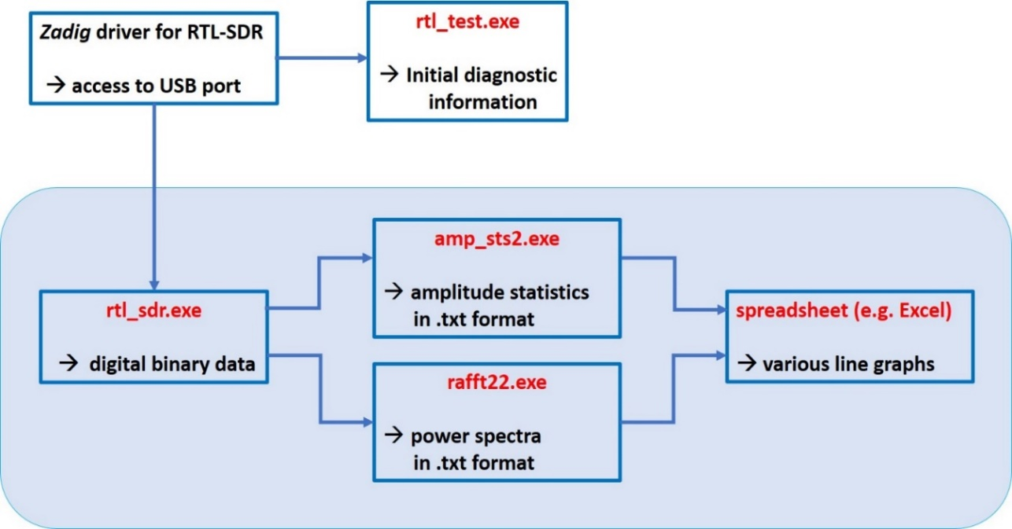
The chart below summarizes the flow of actions; the highlighted area shows the software you will interact with during the data taking part of the experiment.

Note: the software assumes that the Windows PC you are using operates in 64-bit rather than 32-bit mode. If the PC is less than 10 years old this is likely to be the case.
A.1 Installing the software
- Copy and paste the folders on the pen drive supplied with the kit onto the host PC.
Check that the installation has not already been done on the PC you are using.
- Confirm that following executables are present:
- zadig-2.4.exe
- rtl_test.exe
- rtl-sdr.exe
- amp_sts2.exe
- rafft22.exe
- Create a new folder on the local PC (giving it a unique name) to act as your “working directory”. In it you will place all the required software and all the output files created over the course of the experiment will appear there.

A1.1 The Zadig USB driver
zadig-2.4.exe is a Windows application which can replace any previously installed device driver with one appropriate for the RTL-SDR. Note that when zadig-2.4.exe is run on Windows, drivers are only replaced for the USB port occupied by the dongle at that time. Therefore, the following steps must be executed for each USB port you wish to use.
- Copy and paste zadig-2.4.exe into the working directory.
- Connect the RTL-SDR dongle to the local PC via a USB port.
- Once the dongle is recognised (you may need to try a different port) right click on zadig-2.4.exe and select “run as administrator”
  - On the menu bar, shown in Figure A1, select “Options” then “List All Devices” (you may need to also uncheck "Ignore Hubs or Composite Parents")
  - Open the central drop-down menu, shown in Figure A1, and select something like RTL2832UHIDIR or RTL2832U from the device list. You may alternatively see something like ”Bulk-In, Interface (Interface 0)", this is also a valid selection.

Figure A.1 The Zadig application window. The RTL dongle was selected in the drop down device menu and WinUSB was selected in the driver installation window using the arrows. The large installation button will either say “Replace driver” or “Reinstall Driver”.

4. The ‘Driver’ box shows the currently installed driver and the green arrow points to the
driver that will be installed. Use the arrows to the right of this box to select the
WinUSB (v6.1.7600.16385) driver. The Zadig window should now appear as in
Figure A.1 (the window may contain ”Bulk-In, Interface (Interface 0)”).

5. Select the large installation button, which will be labelled with either “Replace
Driver” or “Reinstall Driver”. Zadig will install the new driver leaving the RTL-SDR
ready to be used with the Osmocom software. Installation can take a little time.
For further guidance on Zadig see Zadig_advice.docx in the Zadig folder and http://www.rtl-sdr.com/rtl-sdr-quick-start-guide/. For the specific NESDR device see: https://support.nooelec.com/hc/en-us/articles/360005298053-NESDR-Installation-Guide

A.1.2 The Osmocom software
The Osmocom folder contains the two programs rtl_test.exe and rtl_sdr.exe. These programs are run via a “command-line” rather than via a graphical user interface (GUI). For convenient use place a “command prompt” in your working directory as follows:
- Navigate to C:\WINDOWS\System32 and copy and paste cmd.exe into your working directory (it’s often a long way down the list!)
You can then click on and open cmd.exe and call rtl_test.exe or rtl_sdr.exe (see below) with all the outputs appearing in the working directory. Note that command line operations may be cancelled at any time by typing Crtl+C.
A.1.3 The Analysis Tools
- Copy and paste rafft22.exe and amp_sts2.exe from the Analysis Tools folder into the working directory on local PC.
These programs are also run via the command line.

N.B If necessary you can download these programs directly from the following sites:
- Zadig driver installer: http://zadig.akeo.ie/ . Note that there will be a later version than zadig-2.4.exe.
- Osmocom RTLSDR library https://ftp.osmocom.org/binaries/windows/rtl-sdr/ select the latest version of the 64-bit.zip file and click on it to download the file to your PC; move rtl_test.exe and rtl-sdr.exe into your working directory.
- Analysis tools - see the description in the Word document RTLSoftwareToolsU3.docx. The download address is http://www.y1pwe.co.uk/RAProgs/NewSW4.zip which also listed at the end of the Word document. Pick out AMP_STS2.EXE and RAFFT22.EXE (capital letters in the download – this does not matter).
A.2 Confirming communication between PC and the RTL-SDR
+++++++++++++++++++++++++++++++++++++++++++++++++++++++++++++++++++++++++
This test only requires the RTL-SDR to be plugged into a USB port. As in Photograph E6 It does not need to be connected to the rest of the TTRT receiver.
+++++++++++++++++++++++++++++++++++++++++++++++++++++++++++++++++++++++++

- Open the command line prompt cmd.exe in the working directory, type rtl_test.exe and press return <rtn> or <enter>.

If the RTL-SDR is communicating with the PC the window will display useful information consisting of the:
- the device ID,
- the tuner ID,
- the list of the 29 internal gain values available (from 0 dB to 49.6 dB)
- the sample rate
- notification of any lost samples (a small number of bytes is often reported - ignore).
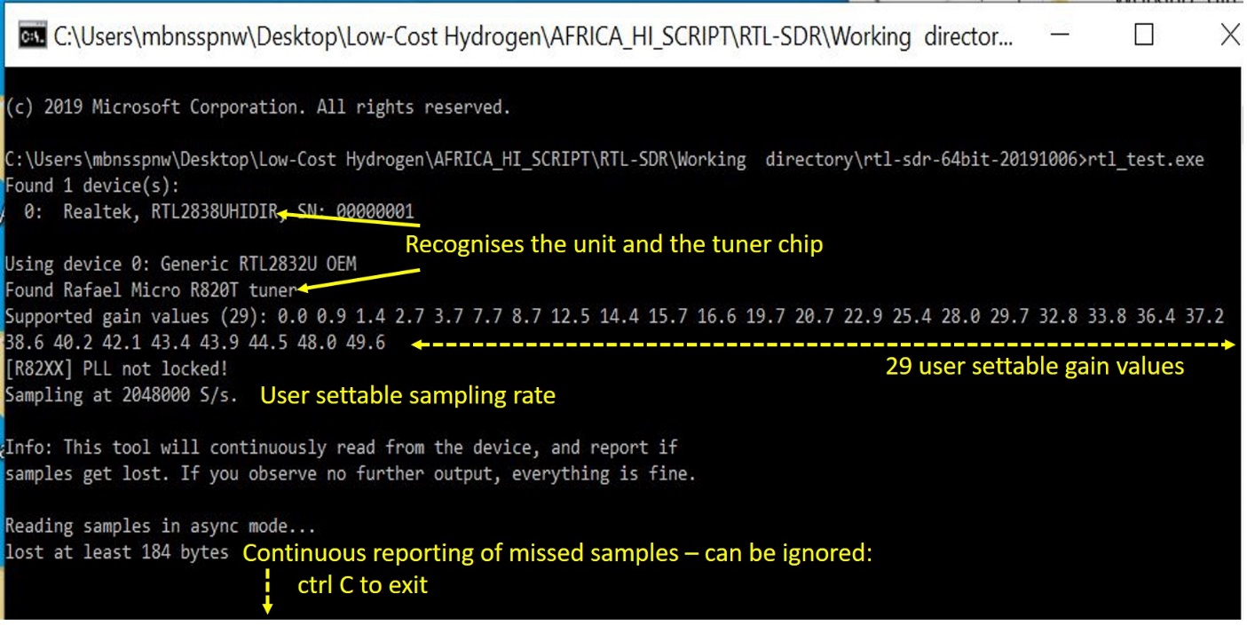

Figure A.2 The command line window after running rtl_test.exe. The application confirms the Realtek RTL2832U chip and Rafael Micro R820T tuner are present and operating correctly. Supported internal gain values (29) are shown along with the default sample rate of the RTL-SDR. The report of a small number of samples lost can be ignored.

A.3 Using .txt files in a spreadsheet
The initial procedure for importing .txt files into a spreadsheet is the same for both amp_sts2 and rafft22. In each case the files consist of two columns of plain text (numbers) separated by a space. Here we show a procedure for Microsoft Excel 2010. The input procedure is slightly different (usually easier) in later versions but you should be able to work this out for yourself given that the .txt file structure is so simple.
- Create a new Excel (or equivalent) spreadsheet.
- Select a cell (e.g. A1) on the spreadsheet with a single click of the mouse button.
- Navigate to the ‘Data’ tab and select ‘Get External Data from Text’ to open the Text
Import Wizard. See Figure A.6

Figure A.5. Screen capture showing the location of the “Data” tab and “Get external Data from Text” menu in Microsoft Excel 2010.

- Step 1 of 3: Select ‘Delimited’ and press “Next”. See Figure A.6.

Figure A.6. Screen capture of the first step in the Excel “Text Import Wizard”. “Delimited” is selected as data columns in text files are separated by spaces.

- Step 2 of 3: Select ‘Space’ as a delimiter and press next.

The data columns in the .txt files are separated by a space. Selecting “space” as a delimiter tells Excel to place the data into cells in two separate columns - see Figure A.7

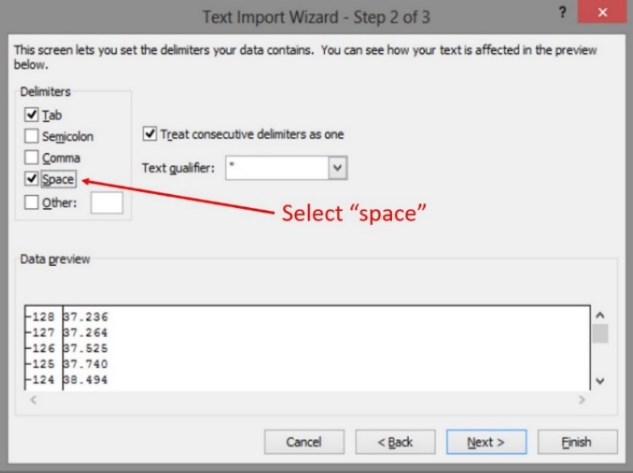
.

Figure A.7 . Screen capture of the second step in the Excel “Text Import Wizard”. The “Space” delimiter was selected to make data columns in the text file be imported into two separate columns.

Step 3 of 3: Select ‘General’ for Column data Format and press finish- see Figure A.8

An Import Data dialog box will open, here you can select where to import the data on
the current spreadsheet or open it as a new one. Once selected press ‘OK’.

Figure A.8. Screen capture of the final step in the Excel “Text Import Wizard”. The column data format was set to “General” as the input data is numeric.

The data should now be in two columns as follows - depending on the programme used:
- amp_sts2: The first column (A) is the ADC byte value, with 0 at the centre; the second column (B) is the normalised byte count in linear units (e.g. plotted as in Figures 13a to 13c)
- rafft22: The first column (A) is the FFT channel number, with 0 at the centre; the second column (B) is the spectral power expressed in linear units (e.g. plotted as in Figures 15 and 17)

The results can then be plotted: select columns A and B, and click on “Insert – Chart – Scatter with Smooth Lines”.

A.4 Normalising and annotating the axes of the hydrogen spectrum
To convert the raw hydrogen spectrum (as taken in Section 7.2) into a normalised and temperature calibrated spectrum as in Figure 18 we must divide the hydrogen spectrum by the load spectrum (as taken in Section 6.3). This is easily done in the spreadsheet.
- Into the spreadsheet containing the raw hydrogen spectrum, copy the load spectrum data (column B of the load spectrum sheet) into column C.
- Click on cell “D1”, and type “=B1/C1” and press return (this divides the first row of the hydrogen line signal by the load signal). Click and drag to apply this function to all the rows in column D (see Figure A.9).
- Plot out the normalised hydrogen spectrum by selecting columns A and D, and clicking on “Insert – Chart – Scatter with Smooth Lines”.

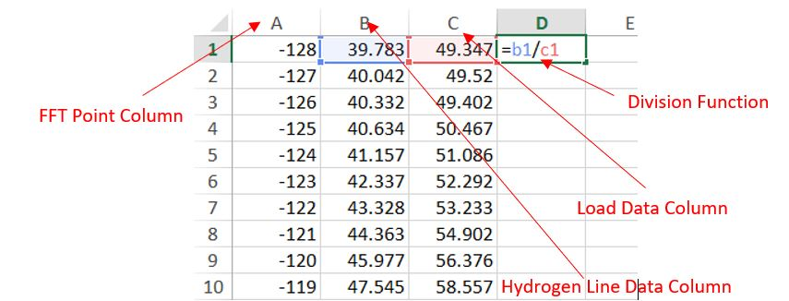
Figure A.9. In the sheet containing the raw sky spectrum and the RF load spectrum, input the “Division Function” to divide the hydrogen data by the load data for row 1.

N.B. The test data values in columns B and C may no be representative of the values in your observations.

The resultant pop-up chart is the hydrogen spectrum normalised with respect to the load. The y-axis will be relative output power values (less than 1) and the x-axis will be FFT spectral channels -128 to +127. As described in Section 7 we now need to convert the y-axis to radiometric temperatures in degrees Kelvin and the x-axis to radial velocities in km/sec.

- Add a new column E (with E1 = -A1*1.69); click and drag to apply this function to all the rows in column E. The multiplicative factor 1.69 arises as follows:
  - The spectrum covers 2048 x10⁶ Hz in 256 channels hence 1 channel covers 8 x 10³ Hz i.e. 8 kHz. In section 4.2 the conversion between radial velocity and frequency shift is given as 100 kHz ≡ 473.4 km/sec thus 8 kHz = 1.69 km/sec.
  - The negative sign gives the correct sign conversion from frequency to radial velocity (frequencies less than 1420.4 MHz correspond to positive radial velocities)

- Add a new column F (with F1 = D1*T) where T is the physical temperature of the calibration load during the measurements. Click and drag to apply this function to all the rows in column F.

- Plot column E on the x-axis and column F on the y-axis and add a descriptive title

A.5 Testing the radiometer equation (optional)

To investigate the radiometer equation (Section 9.1) we take pairs of RF load spectra with different integration time 0.5s, 2s, 8s, 32s (but these choices are arbitrary).

- Following a similar scheme to that described in Section A.4 divide the spectral data from one of the pairs by the data from the other.
- Calculate the standard deviation (i.e. the rms scatter) of the resulting data using the spreadsheet formula – this will be slightly different in each spreadsheet or version of the spreadsheet.
- Repeat the process for each of the pairs and save the value of the rms scatter for each integration time
- In the spreadsheet (see Fig A.10) calculate log₁₀(rms scatter) vs log₁₀(integration time)
- Plot the results – as in Figure 21.

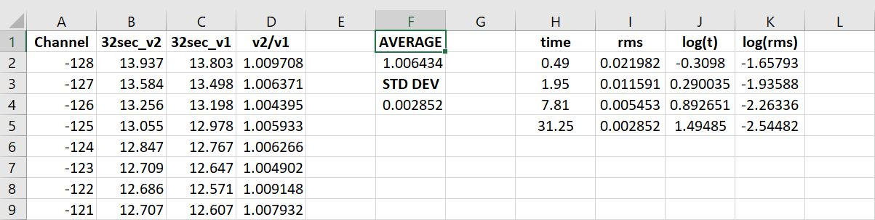
ratio of power spectra

power spectrum
data for τ=31.25s

Average and standard
deviation of the
ratio data for τ=31.25s s

times, rms deviations and their logarithms for four sets of ratio data

Fig A.10 The final spreadsheet containing the FFT channel number in row A: a pair RF load spectrum data for an integration time of 31.25 s in columns B and C and their ratio (see Section A.4) in row D. The average and standard deviation (the same as the rms scatter) of the data in row D are calculated with a spreadsheet formula. To the right are the results for all the integration times together with their logarithms.

Appendix B: Coordinate Systems

During your observations you will point the radio antenna towards a range of galactic coordinates. You are provided with a specially designed calculator (see Section 6.4) to make the required transformation from galactic to local horizon coordinates in one go - but as part of the educational experience you should become familiar with the different, commonly used, coordinate systems involved. Here we give a simplified introduction and provide references to several fuller descriptions available on the web.

B.1 Celestial Coordinates:
We view the heavens from a fixed point on the surface of the spinning Earth and the sky appears to us as an imaginary celestial sphere which rotates once per day. Figure B1 illustrates that:
- the sky rotates from East to West since the Earth spins in the opposite direction;
- over the course of a year the Earth completes one rotation around the Sun;
- the Earth’s spin axis is not perpendicular to the plane of its orbit but rather is tilted at an angle of 23º.5;
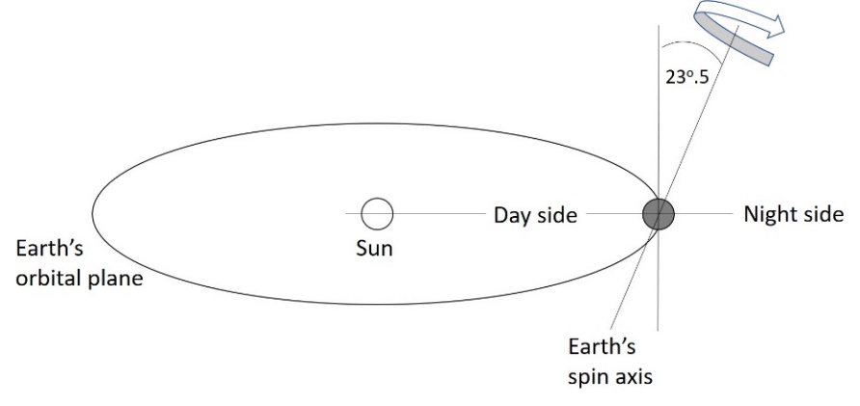
- at a given time of year part of the sky is accessible during daylight hours and part at night but six months later, when the Earth is at the other side of its orbit, the situation is reversed.
Figure B1: The Earth-Sun system shown at one point during the year

How then do astronomers assign fixed positions to objects or locations in the sky regardless of the motion of the Earth or the terrestrial position from which the observation is being made? They use celestial coordinates which are based on the orientation of the Earth’s spin axis as outlined in Figure B2.
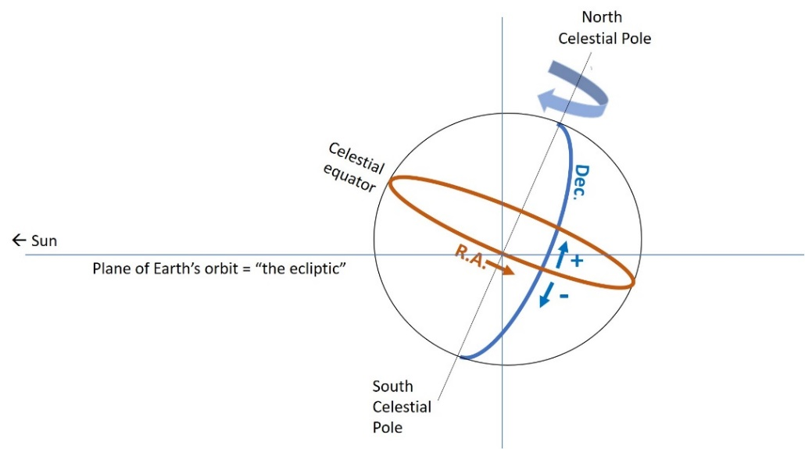
Figure B2: The celestial sphere and the basis of celestial coordinates. The sky appears to rotate E-W i.e. opposite to that of the Earth’s rotation.

- The point where the spin axis meets the imaginary celestial sphere above the Earth’s north pole is called the North Celestial Pole with the equivalent in the south being the South Celestial Pole. The projection of the Earth’s equator onto the imaginary celestial sphere forms the Celestial Equator.
- The plane of the Earth’s orbit around the Sun is called the “ecliptic” and marks the apparent track followed by the Sun as viewed from the surface of the rotating Earth.
- By direct analogy with latitude on the Earth’s surface, which is measured as an angle from the equator towards a pole, one component of a celestial position is the Declination (Dec) measured North (positive angles) or South (negative angles) from the celestial equator.
- Again by analogy with the Earth, celestial longitudes must be referred to a zero point. For the Earth this is the longitude of Greenwich UK; for the sky it is that position around the Earth’s orbit when the Sun moves into the northern hemisphere at the March equinox (i.e. in the northern Spring). Celestial longitude, known as Right Ascension or R.A., is measured eastward from this point. The R.A. can be quoted in degrees but for historical reasons it is usually quoted in terms of hours, minutes and seconds of time with 24h equivalent to 360º (i.e. 1h ≡ 15º).
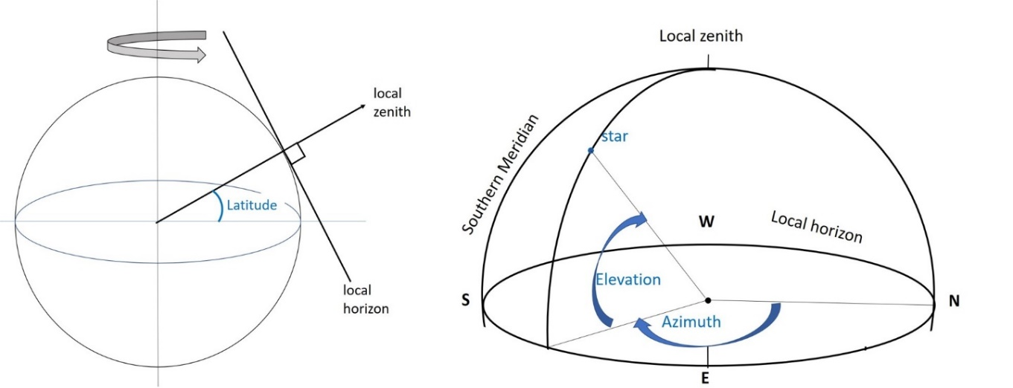
Figure B3: The basis of Azimuth/Elevation Coordinates.

Astronomical objects are therefore assigned R.A. and Dec coordinates and they are the same whatever the date or time of day or location of the observer. Of course an object with a given R.A. and Dec will move across the sky throughout the day and observers have to take account of this motion. There are many explanations of celestial coordinates on the web: a short, nicely illustrated, one is:
https://www.skyandtelescope.com/astronomy-resources/right-ascension-declination-celestial-coordinates/

B.2 Azimuth/Elevation coordinates:
A practical system for pointing a telescope is based on the local zenith and horizon – hence these are sometimes called “horizon coordinates” but more commonly “Az/El coordinates”. They change depending on where you are on the Earth’s surface, as illustrated in the left hand diagram of Figure B3. The local zenith appears overhead and so we perceive the imaginary celestial sphere as in the right hand diagram in Fig B3. Azimuth is measured from the North (0º) through the East (90º), South (180º) and West (270º) then back to North (i.e. 360 º).
Elevation is measured in degrees upwards from the horizon (0º) towards the zenith (90º). A short video about azimuth and elevation (in this case called altitude) can be found at:
https://www.youtube.com/watch?v=FHDq5LvPUIo
An excellent longer video about terrestrial and celestial coordinates can be found at:
https://www.youtube.com/watch?v=_uGoIqR1yLI
B.3 Galactic Coordinates:
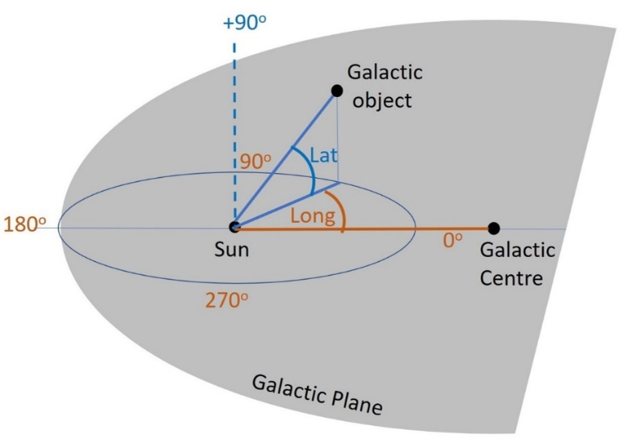
When studying our galaxy (as we do in these observations) astronomers adopt a third coordinate system which is based on the plane of the Milky Way as shown in Figure B4

Figure B4: The basis of Galactic Coordinates.

Galactic latitude (assigned the letter b) zero is defined by the plane of the galaxy. Positive latitudes are above the plane (as illustrated) and negative latitudes are below the plane. Galactic longitude (assigned the letter l) is measured in the Galactic Plane with the direction from the Sun to the Galactic Centre being defined as the zero point (i.e. coordinates l = 0; b=0) l then increases eastward (counter-clockwise).
An explanatory video on galactic coordinates with one extra level of detail can be found at: https://www.youtube.com/watch?v=FaBYbh2KJlQ

Appendix C: Corrections to measured radial velocities (optional)

C.1 The Local Standard of Rest
Our interpretation of radial velocity data has been based on the assumption that the Sun is in a circular orbit about the centre of the galaxy and remains exactly in the galactic plane during its orbit (Section 8.1 and Figure 17). In fact the Sun’s motion deviates slightly from these ideal assumptions and in order to refer observations to a fixed standard, astronomers have defined a virtual point which has the ideal properties. This is called the Local Standard of Rest (LSR) and is defined from the average of the motions of many nearby stars. The Sun’s “peculiar” motion with respect to the LSR must be taken into account for a precise interpretation of radial velocity data. With respect to the LSR the Sun is: i) moving towards the Galactic Centre and northwards out of the galactic plane; ii) rotating faster than the LSR. The overall “peculiar” velocity with respect to the LSR is ~18 km/sec towards l ~ 55º b = 25º (i.e. towards R.A ~18^{h} Dec ~30º).

C.2 The effect of the Earth’s motion
We also need to take into account the motion of the observer with respect to the Sun due to i) the Earth’s orbital motion (velocity ~30 km/s) ii) the Earth’s rotation about its axis (surface velocity ~0.5 km/s /sec).
These three velocities are illustrated in Figure B5 and their combination can range from about -40km/sec to about +40 km/sec depending on the direction to the source being observed and the time of year. All radio observatories have computer programs which calculate the correction and the one appropriate for the 100m Green Bank radio telescope in West Virginia USA can accessed from: http://www.gb.nrao.edu/~fghigo/gbt/setups/radvelcalc.html. ALSO https://www.narrabri.atnf.csiro.au/observing/obstools/velo.html
Since the specific location on the Earth only affects the small spin motion we can use these tools to correct radial velocities measured with the TTRT.
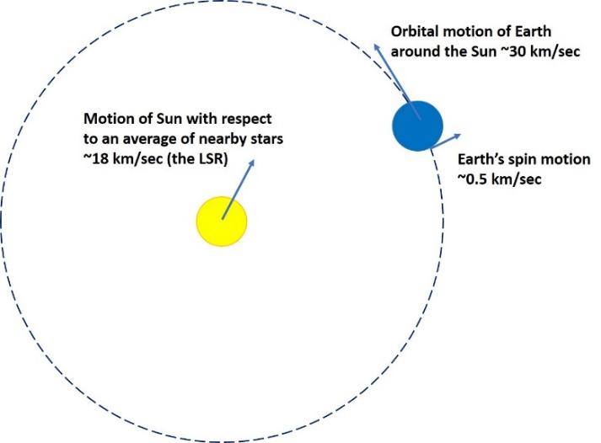

Figure B5: A 2-D projection of the main components of the motion of an observer on the Earth’s surface (3-D).

Appendix D: Line profiles taken with large radio telescopes

These profiles are used in the optional sections 9.2 – 9.4. Use the dotted lines to determine the maximum radial velocities V_{rad,max} for each longitude l. The radial velocities on the horizontal axis are in units of km/sec.
The first two sets of profiles (12 in total) were taken in directions which cover the inner galaxy (inside the Sun’s orbit; see Section 8.1 and Figure 17); they can be used to determine the rotation curve of the Milky Way using the tangent point method. They have been corrected for solar motion (end of Appendix C).
Because these lines of sight also extend into the outer galaxy (outside the sun’s orbit) both approaching (-ve radial velocities) and receding (+ve radial velocities) can be seen. On each profile we have marked with a dotted line (orange) the appropriate maximum radial velocity V_{rad,max} which you should use. Use a ruler to measure each V_{rad,max} and then follow the instructions in section 9.2 to build up the rotation curve.
The last set of three profiles are taken in directions towards the outer galaxy. The profiles at l = 120º and l =210º are shown for instructive purposes – but you are asked a question about the form of the profile at l = 180º.

These profile were downloaded from the web site hosted by the Argelander-Institut fur Astronomie (University of Bonn) https://www.astro.uni-bonn.de/hisurvey/AllSky_profiles/. See the References section below for full acknowledgements.

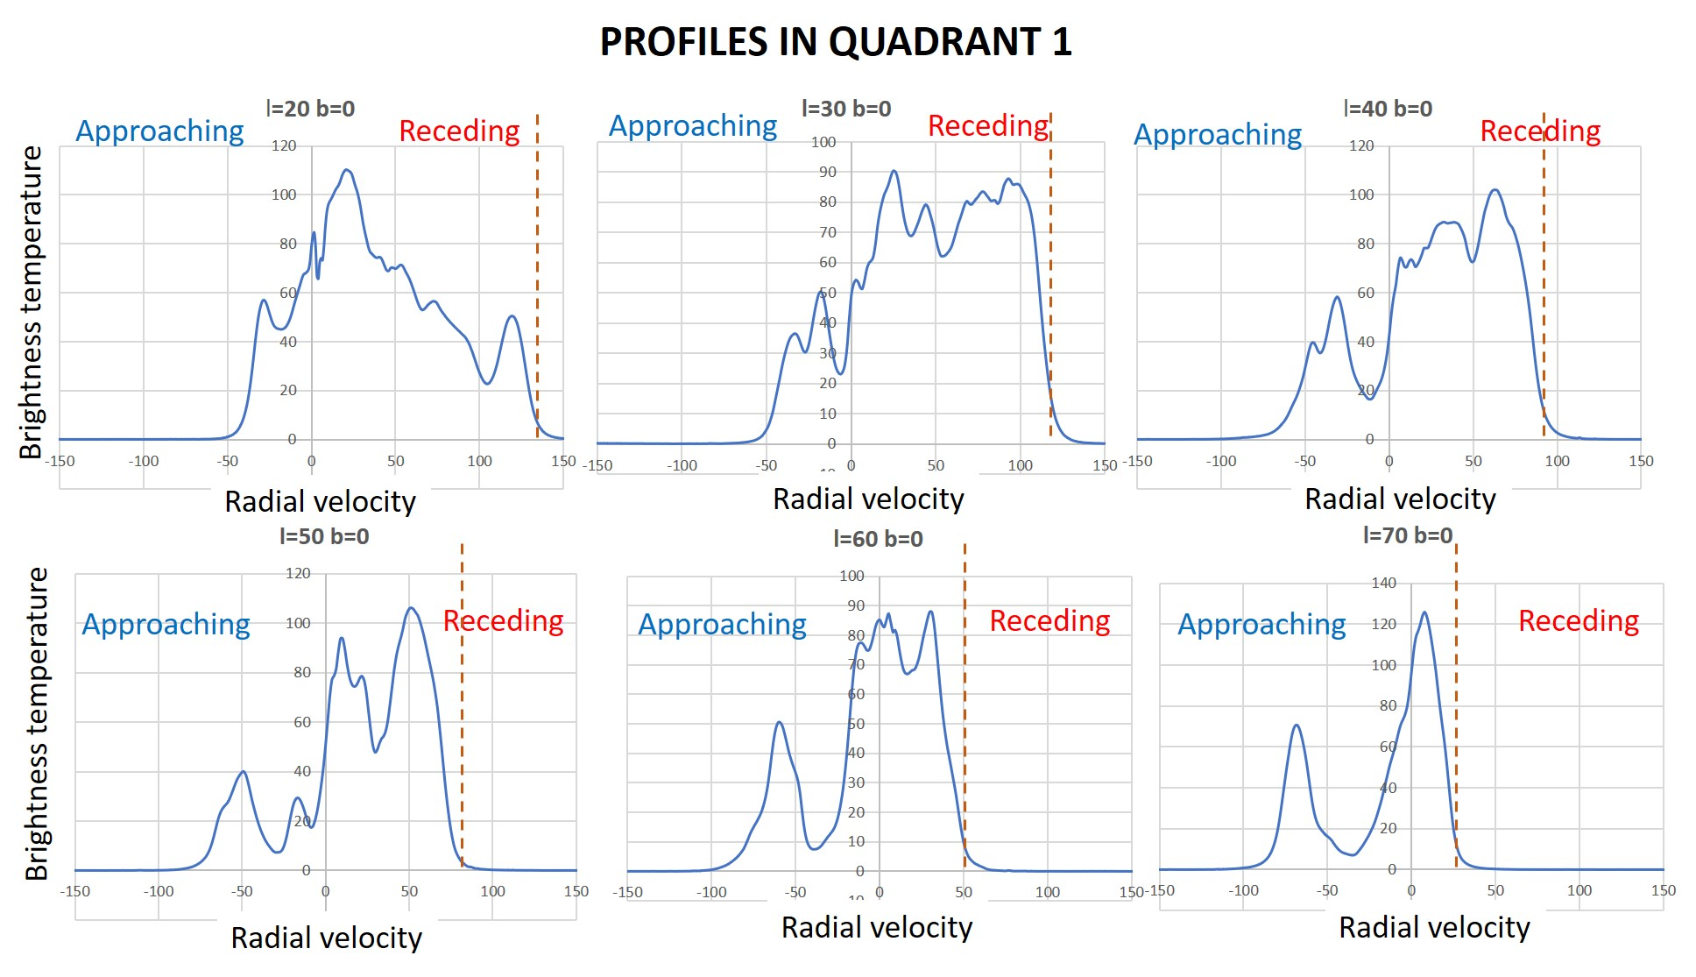
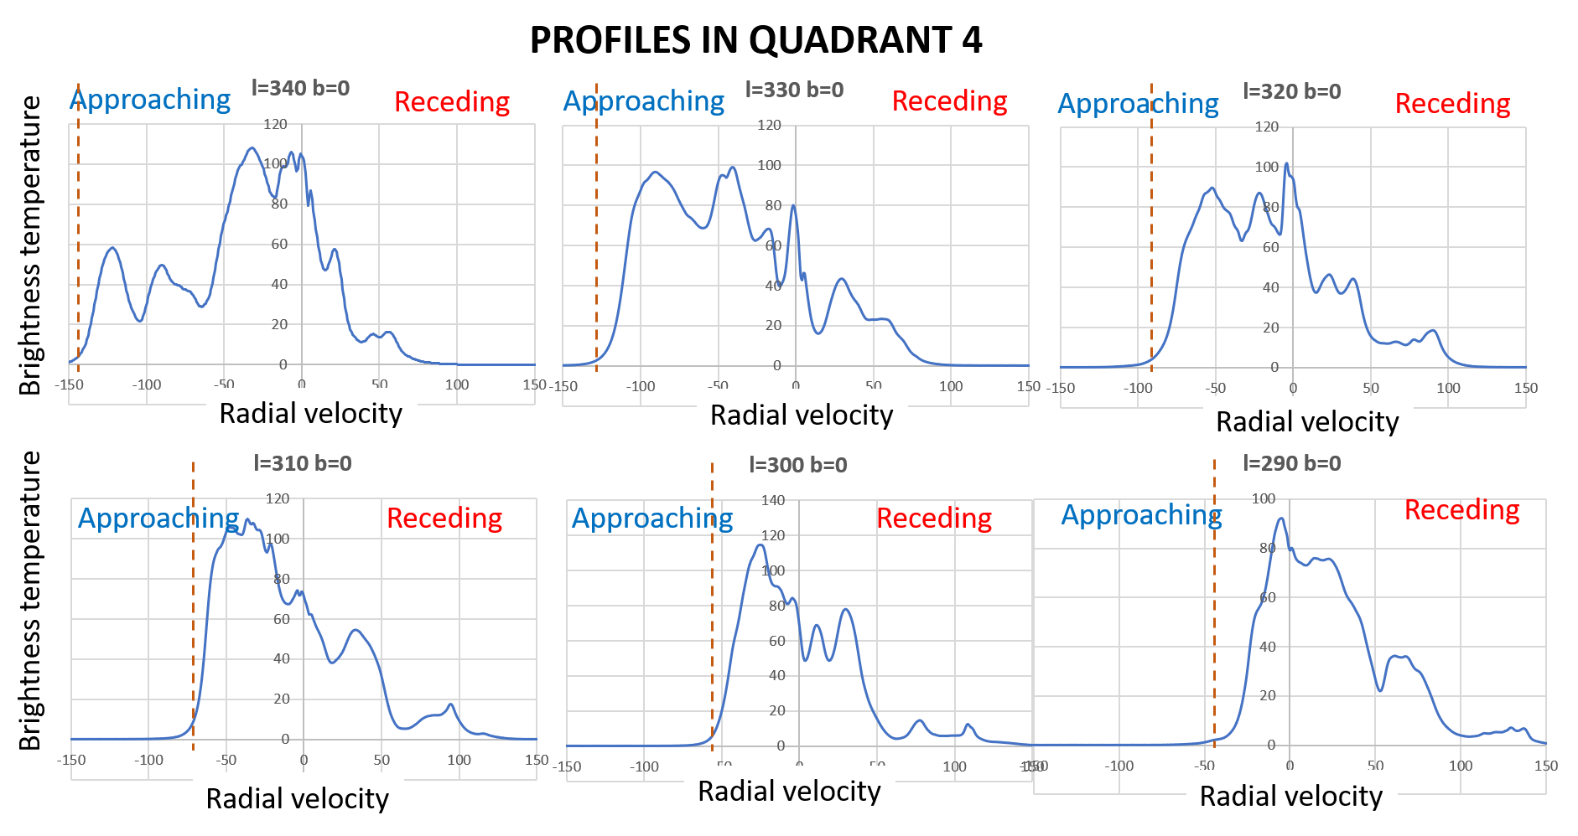
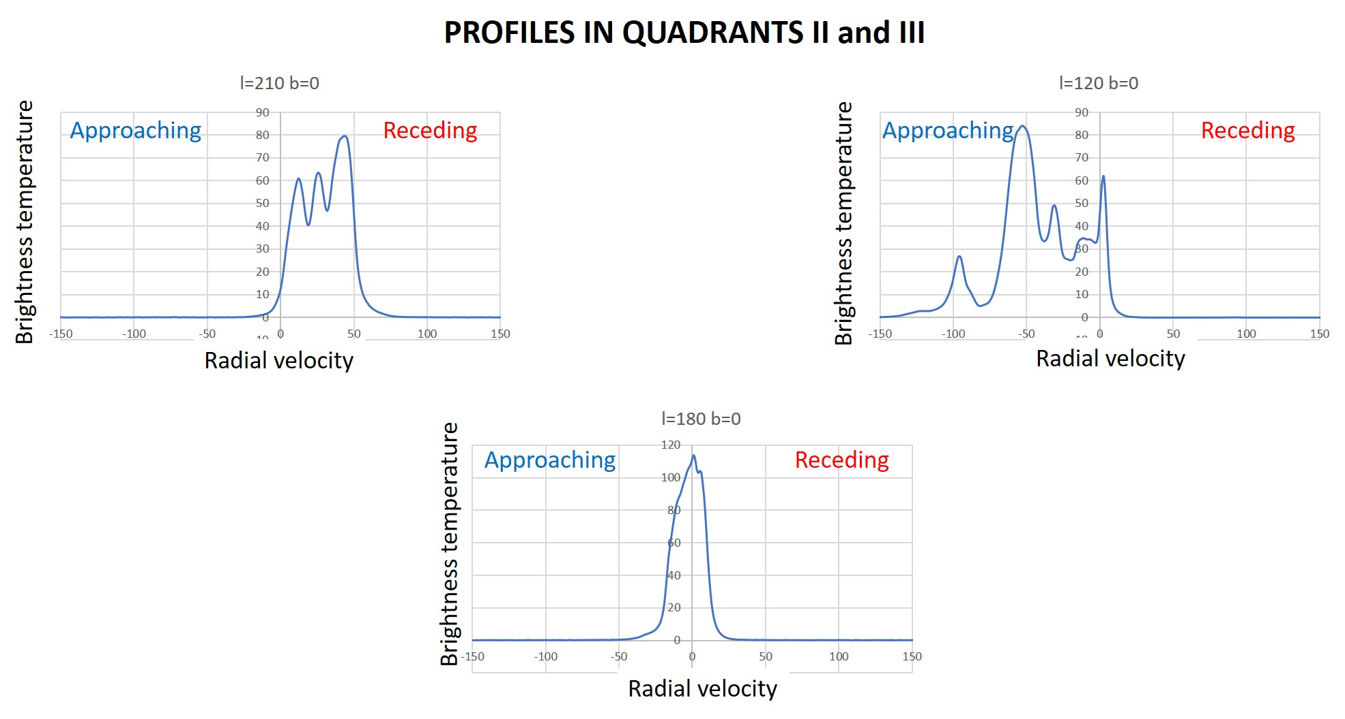

References for Appendix D

The Argeländer Institut für Radioastronomie web site (as above) requests the following full attributions for the use of these data:

HI4PI: HI4PI Collaboration, N. Ben Bekhti, L. Flöer, et al. (2016) A&A, 594, A116

HI4PI: a full-sky H i survey based on EBHIS and GASS

EBHIS: B. Winkel, J. Kerp, L. Flöer, P. M. W. Kalberla, N. Ben Bekhti, R. Keller and D. Lenz, (2016) A&A 585, A41 The Effelsberg-Bonn H i Survey: Milky Way gas

GASS: Kalberla, P.M.W. and Haud, U. (2015) A&A 578, A78

(Highlight: Gass: The Parkes Galactic All-Sky Survey. III)
Kalberla, P.M.W., McClure-Griffiths, N.M., Pisano, D. J. Calabretta, M. R., Ford, H. Alyson, Lockman, Felix J., Staveley-Smith, L., Kerp, J., Winkel, B., Murphy, T., Newton-McGee, K. (2010) A&A, 512, A14
(Highlight: Gass: The Parkes Galactic All-Sky Survey. II)

McClure-Griffiths, N. M.; Pisano, D. J.; Calabretta, M. R.; Ford, H. Alyson; Lockman, Felix J.; Staveley-Smith, L.; Kalberla, P. M. W.; Bailin, J.; Dedes, L.; Janowiecki, S , Gibson, B.K., Murpy, T., Newton-McGee, K. (2009) ApJS, 181, 398 (http://adsabs.harvard.edu/abs/2009ApJS..181..398M)

Data from the first data release are available at http://www.atnf.csiro.au/research/GASS/index.html

LAB Survey: Kalberla, P.M.W., Burton, W.B., Hartmann, Dap, Arnal, E.M., Bajaja, E., Morras, R., & Pöppel, W.G.L. (2005), A&A, 440, 775 (http://adsabs.harvard.edu/abs/2005A%26A...440..775K)

Depending on the region of the sky being studied, please cite, in addition to the Kalberla et al. (2005) reference, also the appropriate source of the material used:
- Hartmann & Burton 1997, Cambridge University Press, ISBN 0521471117
- Bajaja, E., Arnal, E.M., Larrarte, J.J., Morras, R., Pöppel, W.G.L., & Kalberla, P.M.W. 2005, A&A, 440, 767 (http://adsabs.harvard.edu/abs/2005A%26A...440..767B)
- Arnal, E. M., Bajaja, E., Larrarte, J. J., Morras, R., & Pöppel, W. G. L. 2000, A&AS, 142, 35
Observers were Dap Hartmann and W.B. Burton (Leiden University) for the Dwingeloo telescope, and E.M. Arnal, E. Bajaja, J.J. Larrarte, R. Morras, and W.G.L. Pöppel (Argentine Institute for Radio Astronomy) for the Villa Elisa telescope. Correction for stray radiation and combination of the data by P.M.W. Kalberla (Bonn University).

Webinterface created by Peter Kalberla
Appendix E: Other places to look relating to sections 7-9

- The Argeländer Institut für Radioastronomie provides a superb tutorial covering many aspects of galactic hydrogen observations and their interpretation it also connects to the site allowing spectra to be downloaded, as done in Appendix D
https://www.astro.uni-bonn.de/hisurvey/euhou/HI_Spirals_HowTo.pdf

- The EU-HOU network provides access to teaching material and allows member students to download hydrogen line data. http://www.euhou.net/

- Chalmers University’s 2.3m SALSA teaching radio telescopes (see https://vale.oso.chalmers.se/salsa/welcome). Observations with this system are well described in:

http://www.isisalighieri.go.it/duca/radio/radiosweden_0.pdf
http://www.astro.lu.se/Education/utb/ASTA33/radiosweden_ht17.pdf
These two scripts are complementary. Both give some history, a clear exposition of the theory of galactic rotation (taking it beyond Section 8.1) and describe how to determine the rotation curve from SALSA observations, including setting up the calculation in Excel. There is an extra section showing simple determinations of the local spiral arms. They also give a helpful explanation of the coordinate systems (complementing Appendix B).
- The free-to-use PICTOR 1.5m radio telescope system allows anyone to make hydrogen line drift scan observations see https://www.pictortelescope.com/ for full details.

- A description of galactic hydrogen observations using a rather similar system to the TTRT is written up in https://arxiv.org/abs/2202.11039. However the authors used only a frequency switching approach to remove the effect of the baseline ripples (Figure 15) rather than a thermal noise calibration source (section 6.3). In addition, going beyond our Section 8, the authors describe a method of extending the analysis of relative velocity measurements to beyond the solar circle.

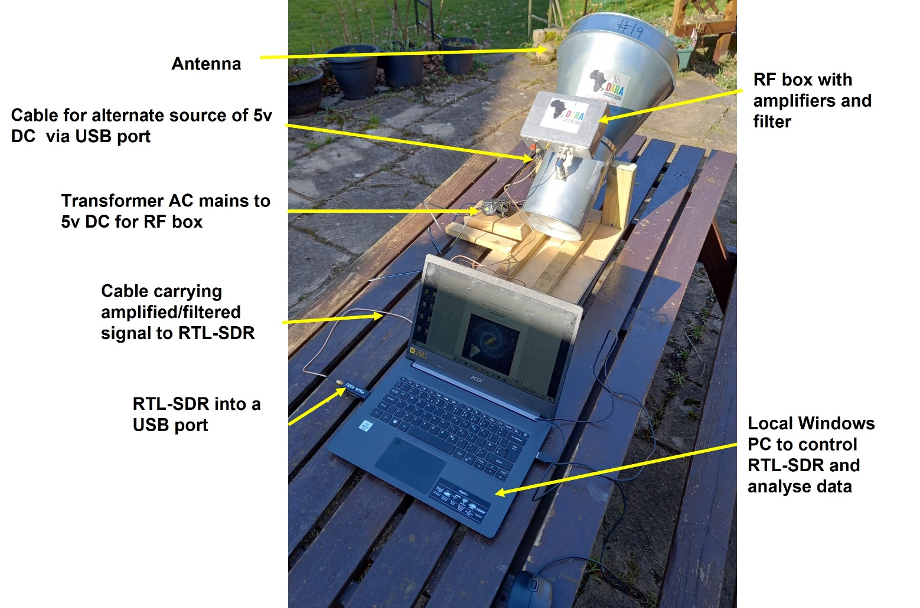
Appendix F: Photographs of the Equipment

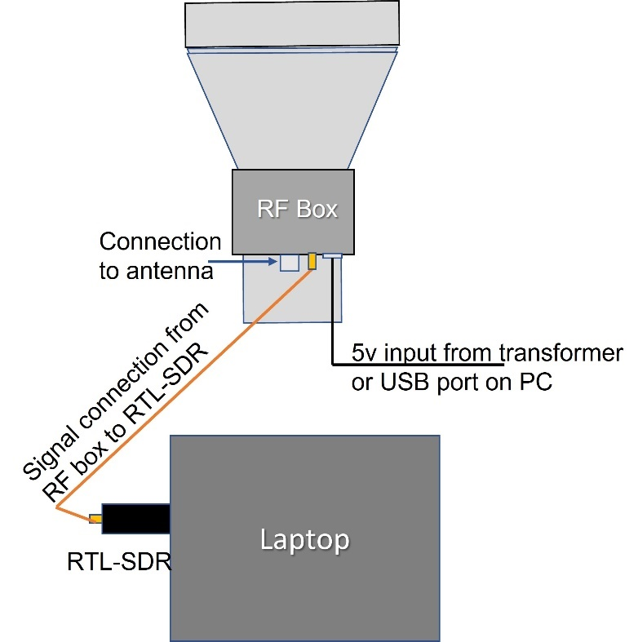

Photograph E1: Overall view of the TTRT arrangement ; below) schematic layout
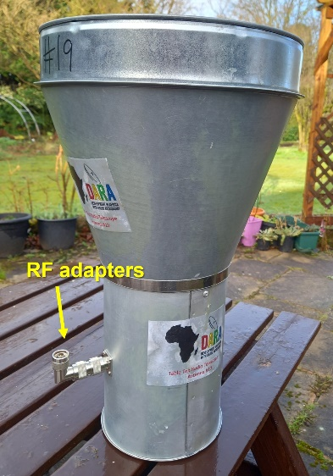
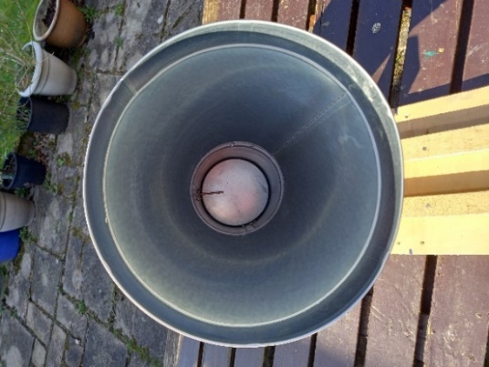
Photograph E2 Left) The cantenna with its extension horn = “the antenna”. Do not remove the RF adapters or change their configuration; the antenna is tuned with them in place like this.
Right) looking down into the horn; notice that the RF probe is perpendicular to the antenna wall.

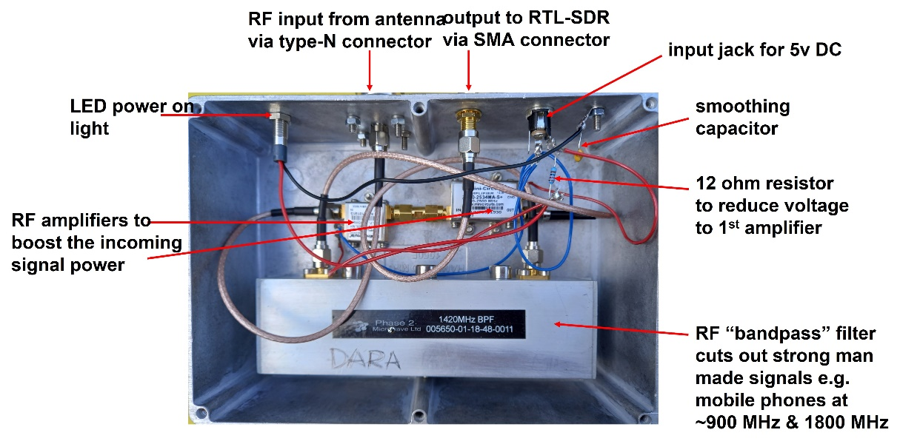
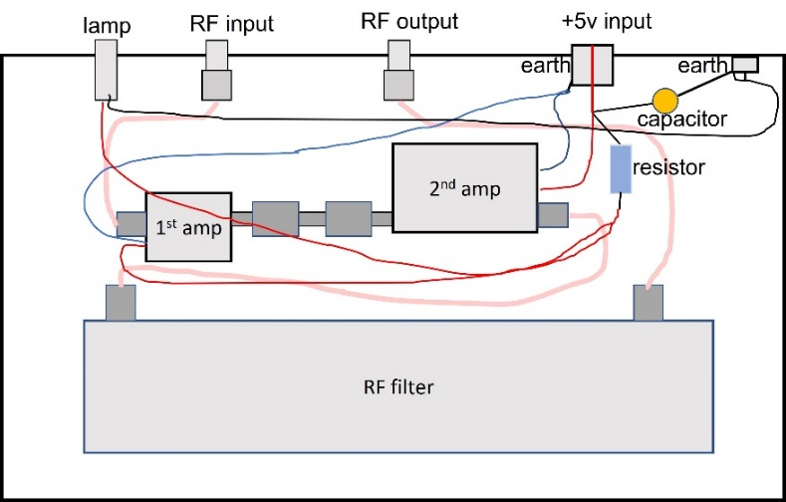

Photograph E3: the interior of the RF Box; below) schematic of connections

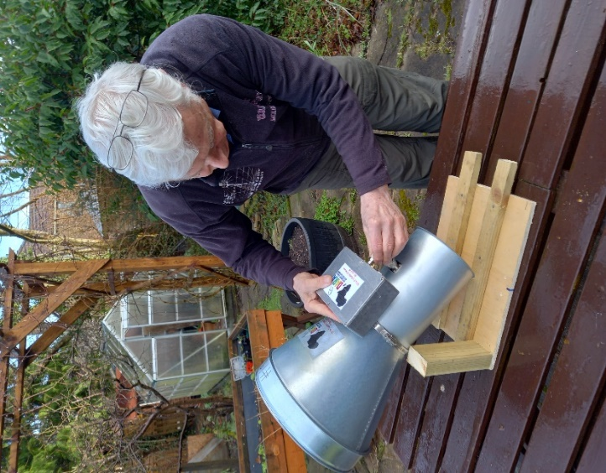
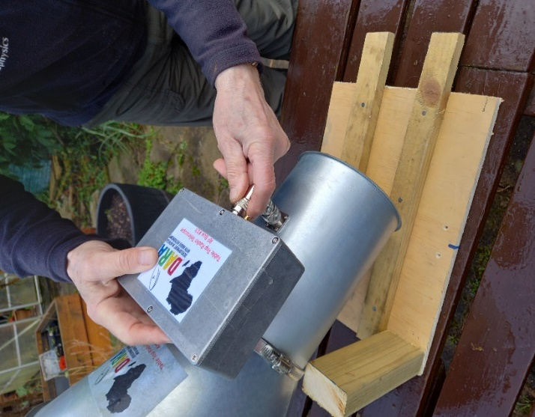

Photograph E4: Connecting the RF Box to the antenna output. The order of the adapters on the antenna is important for the antenna tuning; keep them screwed tightly together (fingers only!) - practice makes perfect!
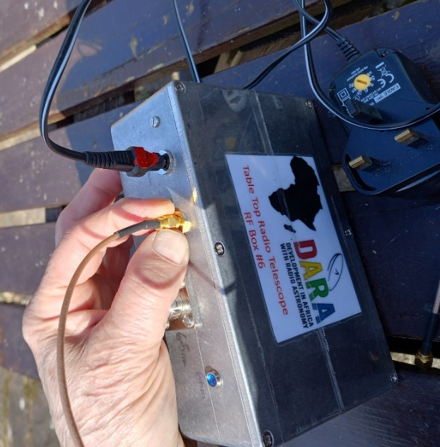
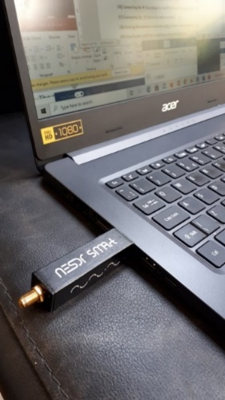

Left) Photograph E5: Connecting the SMA cable to the RF box; this cable carries the amplified signal to the RTL-SDR. Note the red paint on the 5v input plug; this is to indicate how to reassemble the plug if it should pull apart. The plug on the alternative USB cable will not come apart and does not need marking. The LED lamp (here a blue one) will illuminate when the plug is connected
Right) Photograph E6: The RTL-SDR dongle connected to a USB port on the laptop. Communication between the PC and the dongle can be established without connecting the cable to the RF-Box.

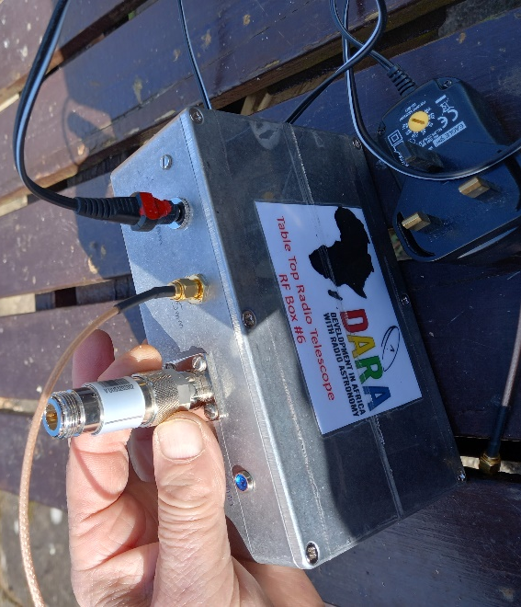
Photograph E7: Connecting the RF load to the RF Box prior to a calibration run.

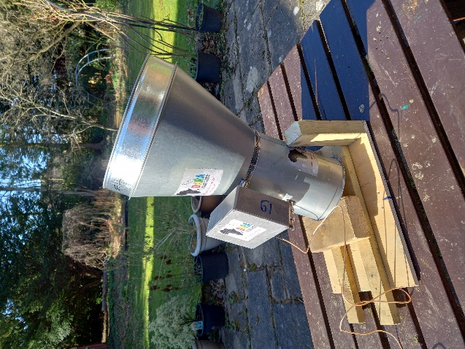
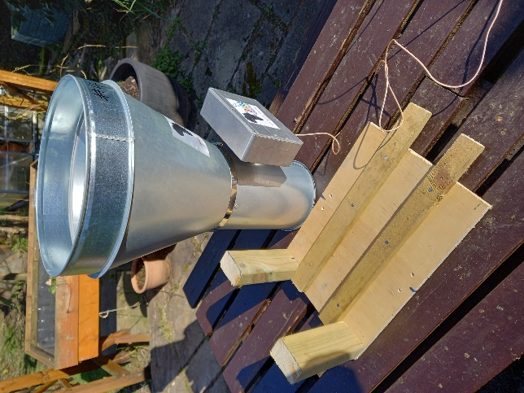

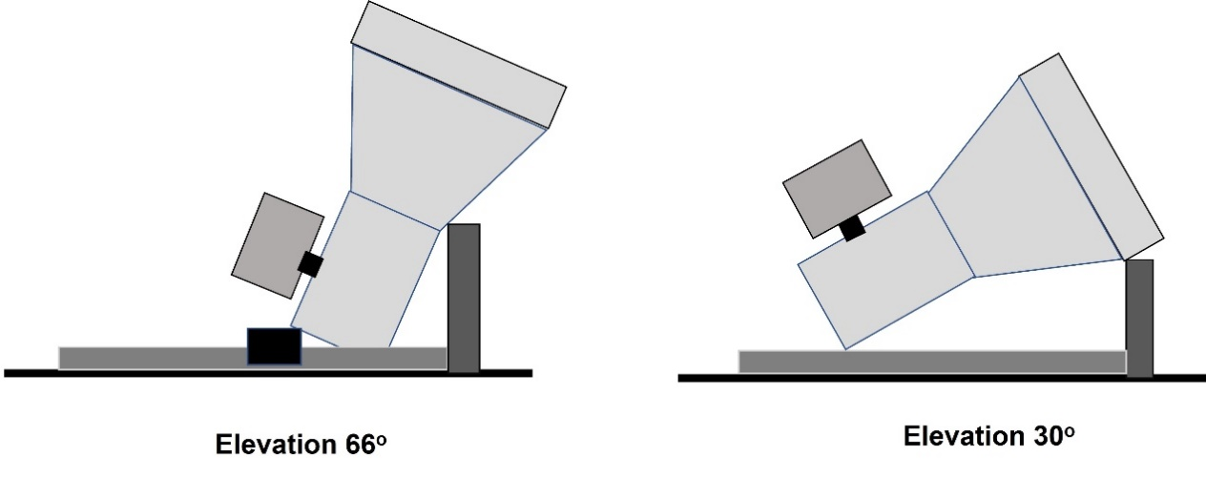

Photograph E8: Top) A simple wooden mount allowing the antenna to be pointed in elevation ; below) a schematic of this arrangement. You may be able to invent a better one!

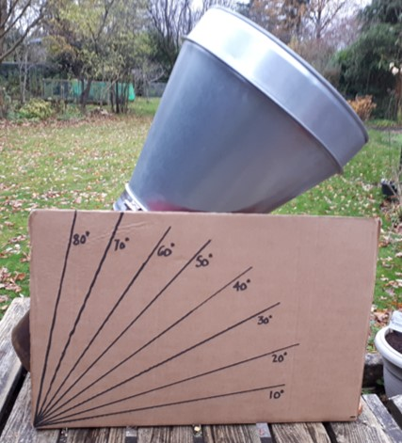
Photograph E9: Pointing the antenna in elevation using a home-made protractor. The elevation needs to be accurate to <5º hence markings every 10º are adequate. It may be helpful to draw a line on the side of the horn to indicate the main axis of the antenna.

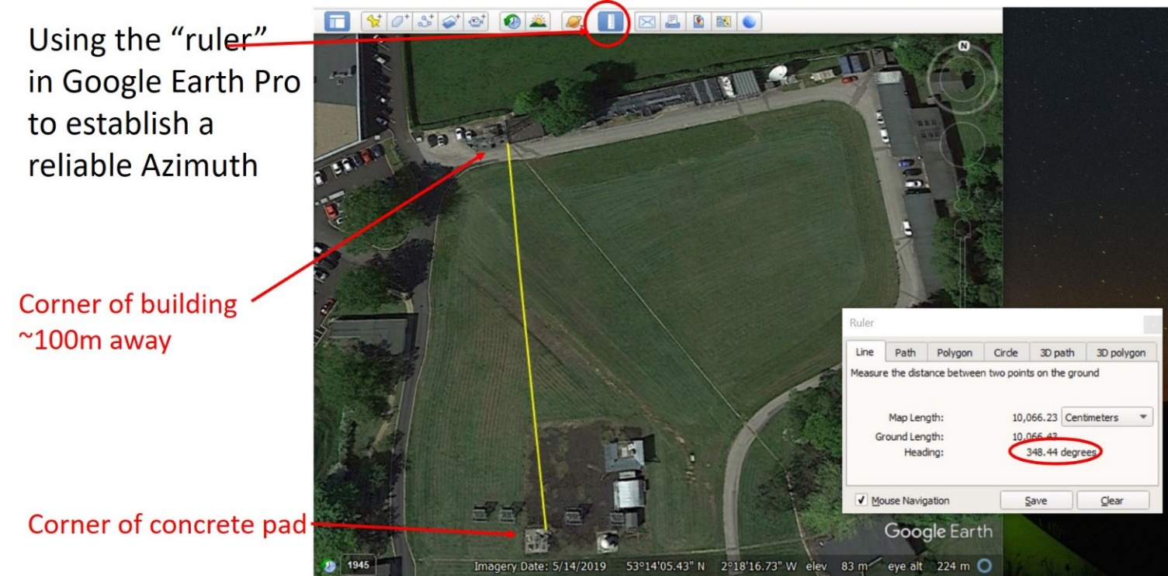

Photograph E10 : Using the ruler facility in Google Earth Pro to check local Azimuth directions (see video#4); the azimuth of the line between the corner of the concrete pad (bottom of the picture) and the corner of the building (top of the picture) is 348º.44.

Appendix G: Contents of Delivery Box
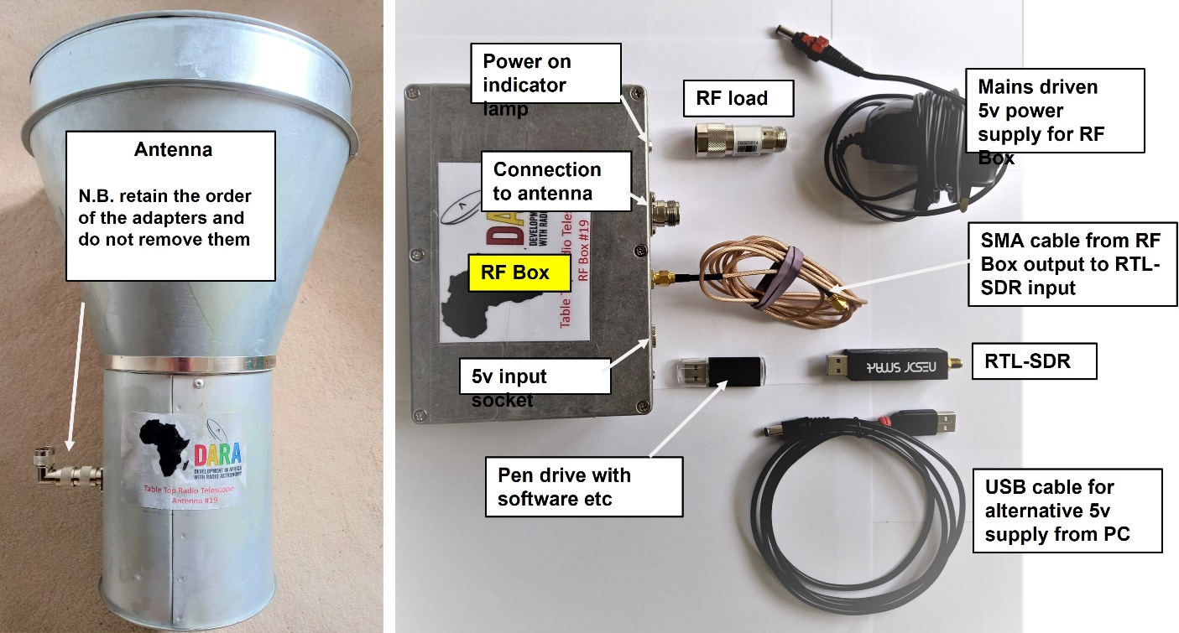

Appendix H: Check list and trouble shooting
Basic set-up
- The mounting table must be stable, level and large enough to mount the equipment without putting strain on the cables/connections.
- The antenna mount should be stable and not move during an observation.
- Avoid touching the probe in the cantenna – it should be perpendicular to the antenna wall (see photograph E2)
- Confirm that any mains electrical connection is safely established; do not observe in wet conditions.
Obtaining good data
- Maintain stable conditions
  - allow the RTL-SDR and the RF-Box to warm up for >10 mins after connecting them
  - shield both these components from direct sunlight
- Take the RF load calibration spectrum on the same day as you take sky spectra
  - use the same integration time for RF load calibration and sky spectra
- The outside environment matters !
  - The surroundings are much hotter than the radio sky (see video#4). Radiation leaking into the antenna from the side and to the rear adds unwanted power and increases the random noise in the spectra. Avoid taking data when:
    - Pointing at trees or vegetation – adds noise and decreases the HI signal
    - Pointing close to walls or within ~30º of the ground – adds noise
    - Walking in front of the antenna - adds noise and decreases the HI signal
- Double check your pointing direction !
  - Check that the local geographic positions and the dates and times entered into the Galactic-to-AzEl converter are correct.
  - Two people should independently check the demanded Az/El for the selected galactic coordinates. Mis-pointing is the most likely reason for poor results!

Trouble shooting
Symptom: the numerical data are zero or very low level
- Check that the DC power indicator light on the RF Box is lit.
- Check that the type-N connections, to the antenna and the RF Box, are finger tight
- Check that the SMA connections on the cable from the RF Box to the RTL-SDR are both finger tight.
- Check that the RTL-SDR dongle is firmly pushed into the USB port on the PC
  - run rtl_test.exe to confirm communication.
- Run the RF load test again with the established RTL-SDR gain setting
Symptom: command window reports: “DNS Server not authoritative for zone”
OR : “Can’t open file ………”
- Check that the command line instruction is typed exactly as per the script for that
particular data taking or analysis step; examine the:
  - programme name; spaces; file name(s), parameters

The word “experiment” originally meant testing the behaviour of a system under controlled conditions but it is now often used in the context of purely observational work.
For external support and guidance -see page 3
Any line of sight through the galaxy is largely transparent to 21cm radiation – hence in a given direction the more atoms per unit cross-sectional area the stronger will be the emission; this is quantified in the column density which has units cm⁻². Towards the galactic centre the hydrogen column density is over 10²⁵ cm⁻² but it is orders of magnitude less in other directions, especially away from the plane.
Formally the radial velocity is the difference between the velocity vectors of the observer and of the emitting gas projected onto the line joining them. Note that transverse motion at low (i.e. non-relativistic) velocities does not produce a measurable Doppler shift.
Rotation period = 2πR/V; rotation frequency f=V/2πR; angular frequency of rotation Ω=2πf=V/R
For examples see the references in Appendix E.
A good website to peruse is http://www.setileague.org/hardware/feedchok.htm
In radio astronomy we encounter ratios which span a large range. To make them easier to handle we convert them a logarithmic scale with units of decibels (or dB) defined as 10log₁₀(P1/P2). Thus if P1=100P2 then P1 is 20 dB greater than P2; if P1=0.01P2 then P1 is at -20dB with respect to P2 alternatively 20dB below P2.
Any high speed digital equipment e.g. a PC or a digital camera, is a source of radio frequency interference (RFI).
An excellent overview of “software defined radio” (SDR) is given in: https://youtu.be/xQVm-YTKR9s
Type-N: a robust RF connector developed in the 1940s.
SMA is short for “SubMiniature version A”: a type of small RF connector developed in the 1960s.
For an introduction to baseband I/Q sampling see http://whiteboard.ping.se/SDR/IQ
You will often retake data for a given comparison/test so make sure to give them different file names.
Note for engineers: the spectral ripple is mainly caused by the “anti-aliassing” filter ahead of the ADC.
Note that Figure 3 is plotted directly in terms of galactic coordinates and so the plane appears as a straight line across the centre.
You can of course seek to make observations at times outside the 9a.m. – 5 p.m. working day.
Requires linearity i.e. that a signal of twice the strength produces double the output; this will be the case as long as the gain is set correctly as in section 6.2.
For the interested student several excellent descriptions of observations with 2-3m class telescopes are available on-line – see the References section at the end of this script.
The locus of tangent points is a circle whose diameter is equal to the distance between the Sun and the Galactic Centre which goes through both the Sun and the Galactic Centre – convince yourself of this.
Video #3 describes where these values come from.
For transportability/flexibility it may be convenient to have the working directory on your own pen drive.
This is not shown in Figure B2 but is explained in the web material on the next page; the terminology Right Ascension is connected with the definition. Most astronomers never need to think about these issues in their day-to-day work.
These definitions arose because the positions of stars were most practically measured when the star passed through or “transited” the southern meridian (i.e. due south). Its time of transit and hence its Right Ascension, was measured with a wall clock. Since the sky rotates from East to West a star with a greater R.A. will transit later, hence R.A. is measured eastward from the zero point.
There is an additional subtlety which should be noted. Because the direction of the spin axis of the Earth varies with time, a phenomenon known as “precession”, the R.A. and Dec of a celestial object changes slightly from year to year. The effect is much too small to be of consequence for the TTRT.

