Supplementary Material
1.Supplementary Table S1. Operational definitions of CKM stages
CKM stage | Conceptual definition | Operational definition in this study (CHARLS 2011) | Main variables
Stage 0 | No CKM risk factors; normal metabolic profile, renal function, and no clinical CVD. | All of the following had to be present simultaneously: BMI <23 kg/m²; waist circumference <80 cm in women or <90 cm in men; fasting glucose <5.6 mmol/L; SBP <130 mmHg and DBP <80 mmHg; triglycerides <1.52 mmol/L; eGFRcr ≥60 mL/min/1.73m²; and no heart disease or stroke. | BMI, waist, fasting glucose, SBP, DBP, triglycerides, eGFRcr, heart disease, stroke
Stage 1 | Excess adiposity or adipose dysfunction / prediabetes. | Any one of the following: BMI ≥23 kg/m²; elevated waist circumference (women ≥80 cm, men ≥90 cm); prediabetes defined as fasting glucose 5.6-<7.0 mmol/L or HbA1c 5.7%-<6.5%. | BMI, waist, fasting glucose, HbA1c
Stage 2 | Metabolic risk factors or moderate-to-high-risk CKD. | Any one of the following: hypertension (SBP ≥130 mmHg, DBP ≥80 mmHg, or self-reported hypertension); diabetes (fasting glucose ≥7.0 mmol/L or self-reported diabetes); triglycerides >1.52 mmol/L; metabolic syndrome (at least 3 of elevated waist, hypertension, prediabetes, and hypertriglyceridemia); or eGFRcr 30-<60 mL/min/1.73m² or self-reported kidney disease. | SBP, DBP, hypertension, fasting glucose, diabetes, triglycerides, waist, HbA1c, eGFRcr, kidney disease
Stage 3 | Subclinical cardiovascular high-risk state in the setting of CKM. | Any one of the following: age ≥65 years plus stage 2 criteria, or eGFRcr 30-<45 mL/min/1.73m². | Age, eGFRcr, stage 2-related variables
Stage 4 | Clinical cardiovascular disease in the setting of CKM. | Self-reported heart disease or stroke. | Heart disease, stroke
2.Supplementary Table S2. Missingness of covariates before multiple imputation
Variable | Missing n | Missing % | Eligible for MI (<20%)
age | 0 | 0.0 | yes
gender | 4 | 0.07 | yes
education_group | 3 | 0.05 | yes
marriage_group | 0 | 0.0 | yes
hukou_group | 4 | 0.07 | yes
smoking_status | 23 | 0.4 | yes
drinking_status | 5 | 0.09 | yes
bmi | 35 | 0.61 | yes
waist | 18 | 0.31 | yes
sbp_mean | 43 | 0.75 | yes
dbp_mean | 35 | 0.61 | yes
hba1c_pct | 44 | 0.76 | yes
eGFRcr | 4 | 0.07 | yes
hypertension | 34 | 0.59 | yes
diabetes | 63 | 1.09 | yes
kidney_disease | 40 | 0.69 | yes
ckm_stage | 0 | 0.0 | yes

3.Supplementary Table S3. Baseline characteristics according to all-cause mortality status
Characteristics | Total (n=5,767) | No all-cause mortality  (n=4,990) | All-cause mortality  (n=777) | P-value
Age, years | 60.2 ± 9.8 | 58.7 ± 9.0 | 69.8 ± 9.5 | <0.001
BMI, kg/m² | 23.2 ± 3.7 | 23.4 ± 3.7 | 21.9 ± 3.6 | <0.001
Waist circumference, cm | 83.7 ± 12.5 | 83.8 ± 12.6 | 82.6 ± 12.3 | 0.007
Systolic blood pressure, mmHg | 112.6 ± 18.1 | 111.7 ± 17.6 | 118.5 ± 20.5 | <0.001
Diastolic blood pressure, mmHg | 74.7 ± 9.4 | 74.6 ± 9.3 | 75.7 ± 9.7 | 0.003
Fasting glucose, mg/dL | 102.2 (94.1, 113.0) | 102.1 (94.1, 112.5) | 103.5 (94.5, 117.5) | 0.010
HbA1c, % | 5.1 (4.9, 5.4) | 5.1 (4.9, 5.4) | 5.1 (4.8, 5.5) | 0.471
Triglycerides, mg/dL | 103.5 (74.3, 150.4) | 104.4 (74.3, 152.2) | 100.0 (71.7, 143.4) | 0.008
Creatinine, mg/dL | 0.76 (0.66, 0.88) | 0.76 (0.64, 0.87) | 0.80 (0.69, 0.95) | <0.001
Cystatin C, mg/L | 0.98 (0.86, 1.12) | 0.96 (0.85, 1.09) | 1.15 (0.99, 1.34) | <0.001
CRP, mg/L | 1.02 (0.54, 2.14) | 0.97 (0.52, 1.97) | 1.44 (0.70, 3.54) | <0.001
eGFR, mL/min/1.73 m² | 91.4 ± 14.9 | 92.7 ± 14.3 | 83.0 ± 16.4 | <0.001
NCCR | 0.136 (0.115, 0.160) | 0.137 (0.116, 0.161) | 0.134 (0.112, 0.159) | 0.073
CTI | 8.653 (8.139, 9.230) | 8.628 (8.113, 9.199) | 8.781 (8.304, 9.434) | <0.001
Gender, n (%) |  |  |  | <0.001
Male | 2,748 (48%) | 2,264 (45%) | 484 (62%)
Female | 3,015 (52%) | 2,723 (55%) | 292 (38%)
Education, n (%) |  |  |  | <0.001
Below High School | 5,256 (91%) | 4,508 (90%) | 748 (96%)
High School or Above | 508 (9%) | 480 (10%) | 28 (4%)
Marital status, n (%) |  |  |  | <0.001
Married | 4,990 (87%) | 4,438 (89%) | 552 (71%)
Unmarried | 777 (13%) | 552 (11%) | 225 (29%)
Hukou, n (%) |  |  |  | 0.866
Rural | 4,961 (86%) | 4,295 (86%) | 666 (86%)
Urban | 802 (14%) | 692 (14%) | 110 (14%)
Smoking status, n (%) |  |  |  | <0.001
Never | 3,469 (60%) | 3,118 (63%) | 351 (46%)
Former | 467 (8%) | 357 (7%) | 110 (14%)
Current | 1,808 (31%) | 1,504 (30%) | 304 (40%)
Drinking status, n (%) |  |  |  | <0.001
Never | 3,339 (58%) | 2,956 (59%) | 383 (49%)
Former | 487 (8%) | 377 (8%) | 110 (14%)
Current | 1,936 (34%) | 1,653 (33%) | 283 (36%)
Hypertension, n (%) |  |  |  | <0.001
No | 4,521 (79%) | 3,952 (80%) | 569 (74%)
Yes | 1,212 (21%) | 1,009 (20%) | 203 (26%)
Diabetes, n (%) |  |  |  | 0.077
No | 5,445 (95%) | 4,719 (96%) | 726 (94%)
Yes | 259 (5%) | 214 (4%) | 45 (6%)
Kidney disease, n (%) |  |  |  | 0.863
No | 5,397 (94%) | 4,667 (94%) | 730 (94%)
Yes | 330 (6%) | 287 (6%) | 43 (6%)
CKM stage, n (%) |  |  |  | <0.001
Stage 0 | 691 (12%) | 604 (12%) | 87 (11%)
Stage 1 | 1,394 (24%) | 1,241 (25%) | 153 (20%)
Stage 2 | 2,450 (42%) | 2,302 (46%) | 148 (19%)
Stage 3 | 1,232 (21%) | 843 (17%) | 389 (50%)

4.Supplementary Table S4. Incremental discrimination statistics after adding CTI and/or NCCR to the base model
old_model | new_model | auc_old | auc_new | auc_diff | delong_z | delong_p | continuous_nri | nri_ci_low | nri_ci_high | nri_p | idi | idi_ci_low | idi_ci_high | idi_p
Base | Base+CTI | 0.820 | 0.821 | 0.001 | 3.245 | 0.001 | 0.367 | 0.292 | 0.442 | 0.000 | 0.001 | 0.001 | 0.001 | 0.000
Base | Base+NCCR | 0.820 | 0.821 | 0.000 | 0.560 | 0.575 | 0.049 | -0.028 | 0.126 | 0.213 | 0.000 | 0.000 | 0.001 | 0.374
Base | Base+CTI+NCCR | 0.820 | 0.821 | 0.001 | 1.824 | 0.068 | 0.248 | 0.171 | 0.330 | 0.000 | 0.002 | 0.001 | 0.003 | 0.000
Base+CTI | Base+CTI+NCCR | 0.821 | 0.821 | 0.000 | 0.737 | 0.461 | 0.131 | 0.052 | 0.212 | 0.001 | 0.001 | 0.000 | 0.002 | 0.042
Base+NCCR | Base+CTI+NCCR | 0.821 | 0.821 | 0.001 | 3.232 | 0.001 | 0.484 | 0.407 | 0.563 | 0.000 | 0.001 | 0.001 | 0.002 | 0.000

5.Supplementary Figure S1. Subgroup analysis of the association between NCCR and all-cause mortality
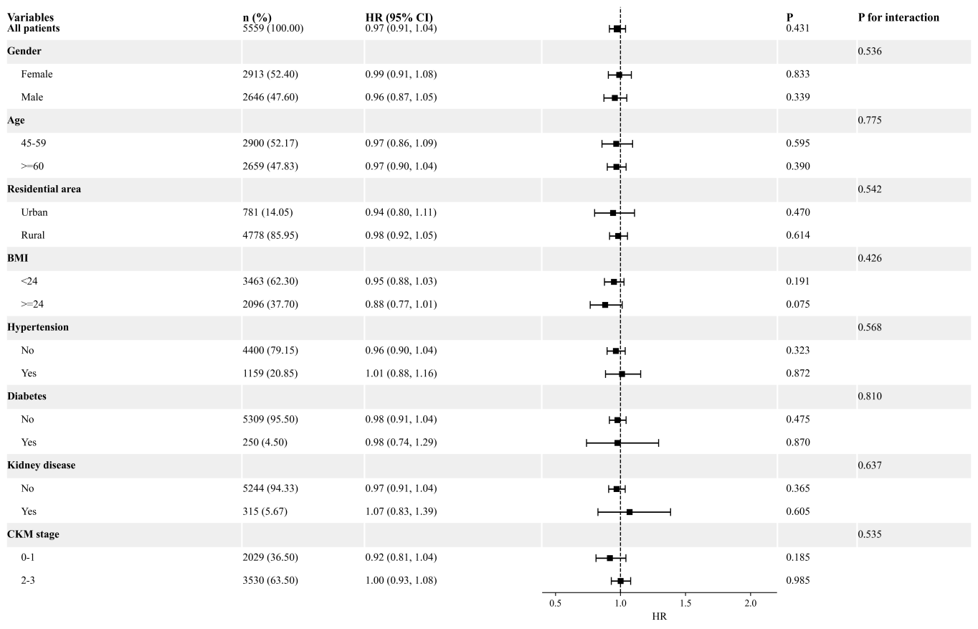

6.Supplementary Table S5. Sensitivity analyses for CTI, NCCR, and their joint groups
analysis | model | term | comparison | n | events | hr | ci_low | ci_high | p | hr_text | p_text
Complete-case Model 3 | CTI_binary | cti_high | High CTI vs low CTI | 5590 | 741 | 1.35 | 1.16 | 1.57 | <0.001 | 1.35 (1.16, 1.57) | <0.001
Complete-case Model 3 | NCCR_binary | nccr_low | Low NCCR vs high NCCR | 5590 | 741 | 1.22 | 1.06 | 1.42 | 0.007 | 1.22 (1.06, 1.42) | 0.007
Complete-case Model 3 | Joint_group | C(joint_group)[T.Q1] | Q1 vs Q2 | 5590 | 741 | 1.22 | 0.98 | 1.53 | 0.079 | 1.22 (0.98, 1.53) | 0.079
Complete-case Model 3 | Joint_group | C(joint_group)[T.Q3] | Q3 vs Q2 | 5590 | 741 | 1.63 | 1.33 | 1.99 | <0.001 | 1.63 (1.33, 1.99) | <0.001
Complete-case Model 3 | Joint_group | C(joint_group)[T.Q4] | Q4 vs Q2 | 5590 | 741 | 1.34 | 1.08 | 1.66 | 0.008 | 1.34 (1.08, 1.66) | 0.008
Exclude deaths within 2 years | CTI_binary | cti_high | High CTI vs low CTI | 5493 | 644 | 1.28 | 1.09 | 1.51 | 0.003 | 1.28 (1.09, 1.51) | 0.003
Exclude deaths within 2 years | NCCR_binary | nccr_low | Low NCCR vs high NCCR | 5493 | 644 | 1.22 | 1.04 | 1.42 | 0.015 | 1.22 (1.04, 1.42) | 0.015
Exclude deaths within 2 years | Joint_group | C(joint_group)[T.Q1] | Q1 vs Q2 | 5493 | 644 | 1.23 | 0.97 | 1.56 | 0.082 | 1.23 (0.97, 1.56) | 0.082
Exclude deaths within 2 years | Joint_group | C(joint_group)[T.Q3] | Q3 vs Q2 | 5493 | 644 | 1.54 | 1.24 | 1.91 | 0.000 | 1.54 (1.24, 1.91) | <0.001
Exclude deaths within 2 years | Joint_group | C(joint_group)[T.Q4] | Q4 vs Q2 | 5493 | 644 | 1.29 | 1.02 | 1.62 | 0.031 | 1.29 (1.02, 1.62) | 0.031
Additional adjustment for CKM stage | CTI_binary | cti_high | High CTI vs low CTI | 5590 | 741 | 1.38 | 1.18 | 1.62 | <0.001 | 1.38 (1.18, 1.62) | <0.001
Additional adjustment for CKM stage | NCCR_binary | nccr_low | Low NCCR vs high NCCR | 5590 | 741 | 1.23 | 1.06 | 1.42 | 0.006 | 1.23 (1.06, 1.42) | 0.006
Additional adjustment for CKM stage | Joint_group | C(joint_group)[T.Q1] | Q1 vs Q2 | 5590 | 741 | 1.22 | 0.98 | 1.53 | 0.076 | 1.22 (0.98, 1.53) | 0.076
Additional adjustment for CKM stage | Joint_group | C(joint_group)[T.Q3] | Q3 vs Q2 | 5590 | 741 | 1.67 | 1.35 | 2.06 | <0.001 | 1.67 (1.35, 2.06) | <0.001
Additional adjustment for CKM stage | Joint_group | C(joint_group)[T.Q4] | Q4 vs Q2 | 5590 | 741 | 1.37 | 1.09 | 1.71 | 0.006 | 1.37 (1.09, 1.71) | 0.006
Multiple imputation pooled | CTI_binary | cti_high | High CTI vs low CTI | 5767 | 777 | 1.35 | 1.16 | 1.56 | <0.001 | 1.35 (1.16, 1.56) | <0.001
Multiple imputation pooled | NCCR_binary | nccr_low | Low NCCR vs high NCCR | 5767 | 777 | 1.22 | 1.06 | 1.41 | 0.007 | 1.22 (1.06, 1.41) | 0.007
Multiple imputation pooled | Joint_group | C(joint_group)[T.Q1] | Q1 vs Q2 | 5767 | 777 | 1.26 | 1.01 | 1.57 | 0.038 | 1.26 (1.01, 1.57) | 0.038
Multiple imputation pooled | Joint_group | C(joint_group)[T.Q3] | Q3 vs Q2 | 5767 | 777 | 1.62 | 1.33 | 1.98 | <0.001 | 1.62 (1.33, 1.98) | <0.001
Multiple imputation pooled | Joint_group | C(joint_group)[T.Q4] | Q4 vs Q2 | 5767 | 777 | 1.38 | 1.12 | 1.70 | 0.003 | 1.38 (1.12, 1.70) | 0.003
Abbreviations: CKM, cardiovascular-kidney-metabolic syndrome; CTI, C-reactive protein-triglyceride-glucose index; NCCR, creatinine-cystatin C-to-weight ratio; MI, multiple imputation; NRI, net reclassification improvement; IDI, integrated discrimination improvement.

