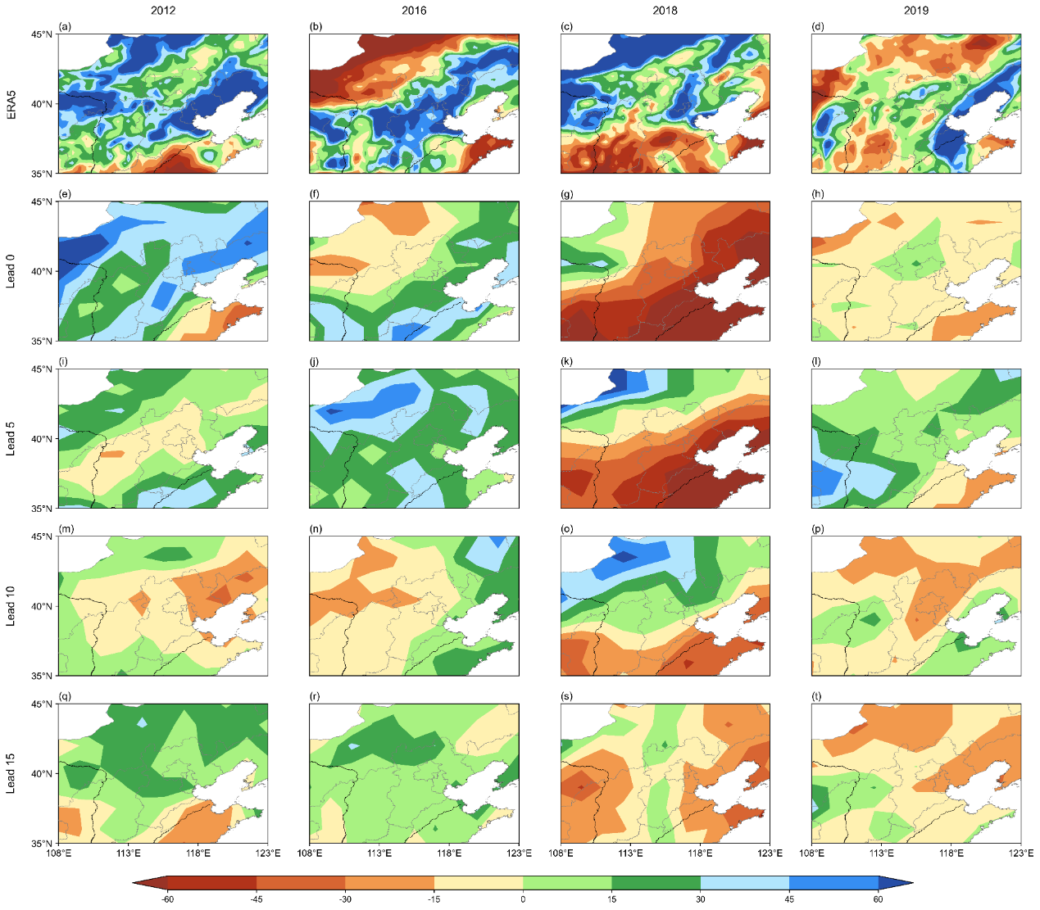
Fig. S1 (a–d) Observed and (e–t) ECMWF S2S forecasted precipitation anomaly percentage at different lead times (0, 5, 10, 15 days) for 2012, 2016, 2018, and 2019 during the main flood season over N-NC (units: %).
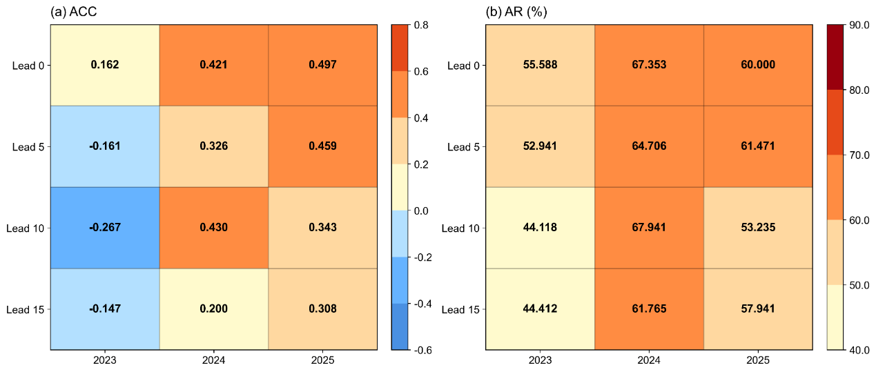
Fig. S2 (a) ACC and (b) AR (units: %) at different lead times (0, 5, 10, 15 days) for 2023, 2024, and 2025 during the main flood season over East Asia.

