Supplementary information
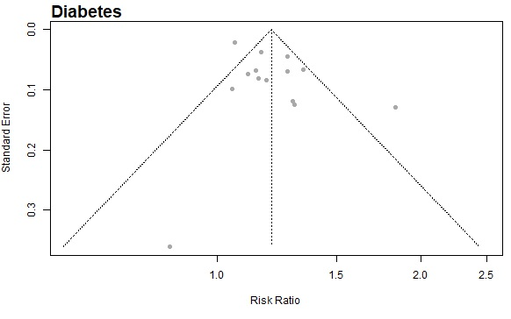
Supplementary figure 1. Funnel plot for the association between sugar sweetened beverages intake and diabetes among adults.

Supplementary table 1. Quality of evidence in included studies in the systematic review. Newcastle-Ottawa Scale (NOS).
Perspectives
Study | Selection |  |  |  | Comparability | Outcome |  |  | Score
Longitudinal Studies | Representativeness of the exposed cohort | Selection of the non-exposed cohort | Ascertainment of exposure | Demonstration that outcome of interest was not present at start of study | Comparability of cohorts on the basis of the design or analysis | Assessment of outcome | Was follow-up long enough for outcomes to occur? | Adequacy of follow up of cohorts | 0 to 9
Schulze et al., 2004 | C | A* | B* | A* | B* | B* | A* | D | 6
Dhingra et al., 2007 | D | A* | B* | A* | A* B* | B* | A* | D | 7
Boggs et al., 2013 | B* | A* | B* | A* | B* | C | A* | B | 6
Shin et al., 2018 | A* | A* | B* | A* | A* B* | A* | A* | C | 8
Garduno-Alanis et al., 2020 | A* | A* | B* | A* | A* B* | C | A* | B* | 8
Montonen et al., 2007 | B* | A* | B* | A* | A* B* | B* | A* | D | 8
Palmer et al., 2008 | A* | A* | B* | A* | B* | C | A* | B* | 7
Nettleton et al., 2009 | A* | A* | B* | A* | A* B* | A* | A* | D | 8
Odegaard et al., 2010 | B* | A* | B* | A* | A* B* | B* | A* | A* | 9
de Koning et al., 2011 | C | A* | B* | A* | B* | C | A* | D | 5
Romaguera et al., 2013 | A* | A* | B* | A* | A* B* | B* | A* | D | 8
Eshak et al., 2013 | B* | A* | B* | A* | A* B* | C | A* | C | 7
Fagherazzi et al., 2013 | C | A* | B* | A* | B* | C | A* | B* | 6
O’Connor et al., 2015 | A* | A* | B* | A* | A* B* | B* | A* | D | 8
Papier et al., 2017 | C | A* | B* | A* | A* B* | C | A* | C | 6
Drouin-Chartier et al., 2019 | C | A* | B* | A* | A* B* | C | A* | B* | 7
Hirahatake et al., 2019 | B* | A* | B* | A* | A* B* | A* | A* | B* | 9
Stern et al., 2019 | C | A* | B* | A* | B* | C | A* | B* | 6
Fung et al., 2009 | C | A* | B* | A* | B* | B* | A* | B* | 7
de Koning et al., 2012 | C | A* | B* | A* | B* | B* | A* | B* | 7
Eshak et al., 2012 | B* | A* | B* | A* | A* B* | B* | A* | C | 8
Keller et al., 2020 | B* | A* | B* | A* | A* B* | B* | A* | D | 8
Bernstein et al., 2012 | C | A* | B* | A* | A* B* | B* | A* | B* | 8
Larsson et al., 2014 | A* | A* | B* | A* | A* B* | B* | A* | D | 8
Micha et al., 2017 | A* | A* | B* | A* | A* | B* | A* | D | 7
Pase et al., 2017 | A* | A* | B* | A* | A* B* | B* | A* | B* | 9
Pacheco et al., 2020 | C | A* | B* | A* | B* | B* | A* | B* | 7

