Supplementary Information
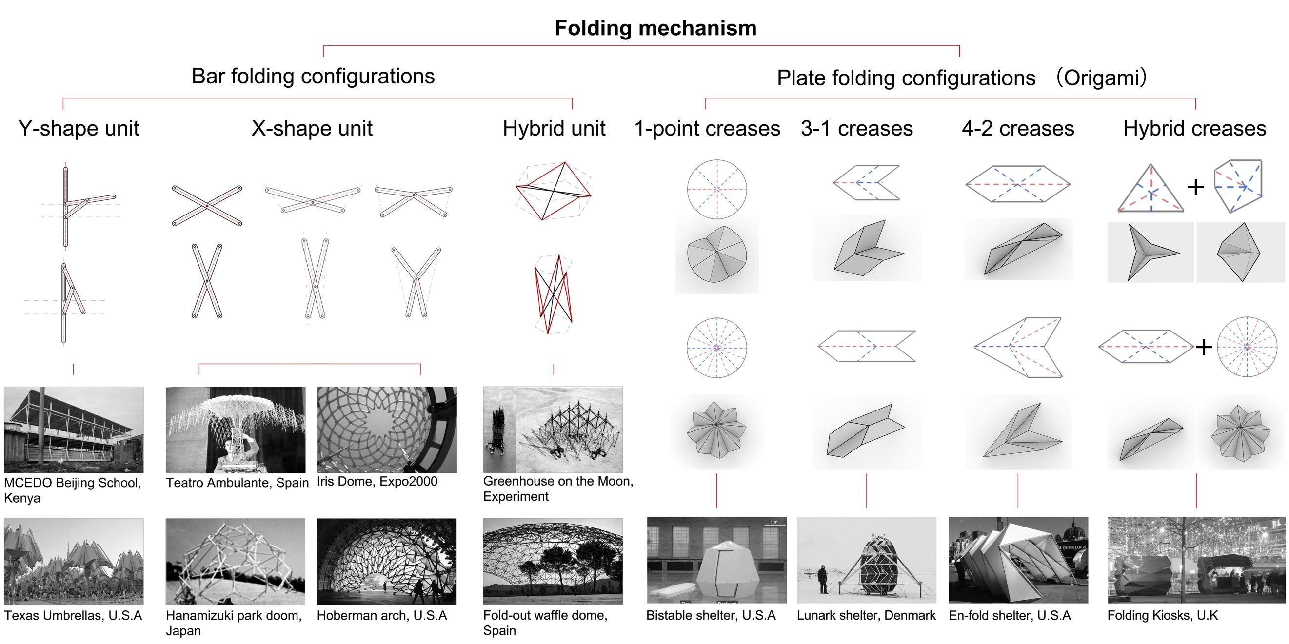
Info. 1 | Classification of deployable mechanisms and their engineering applications
A systematic classification of existing deployable systems, including bar-based scissor-hinge structures and plate-based origami, is presented to summarize their fundamental characteristics and limitations in engineering applications. These systems predominantly rely on end-hinged connections for both motion and load transfer, resulting in a single dominant load path and consequently low structural reliability. This limitation constrains their load-bearing capacity and practical applicability. This section establishes the theoretical background and motivates the research problem addressed in this work.
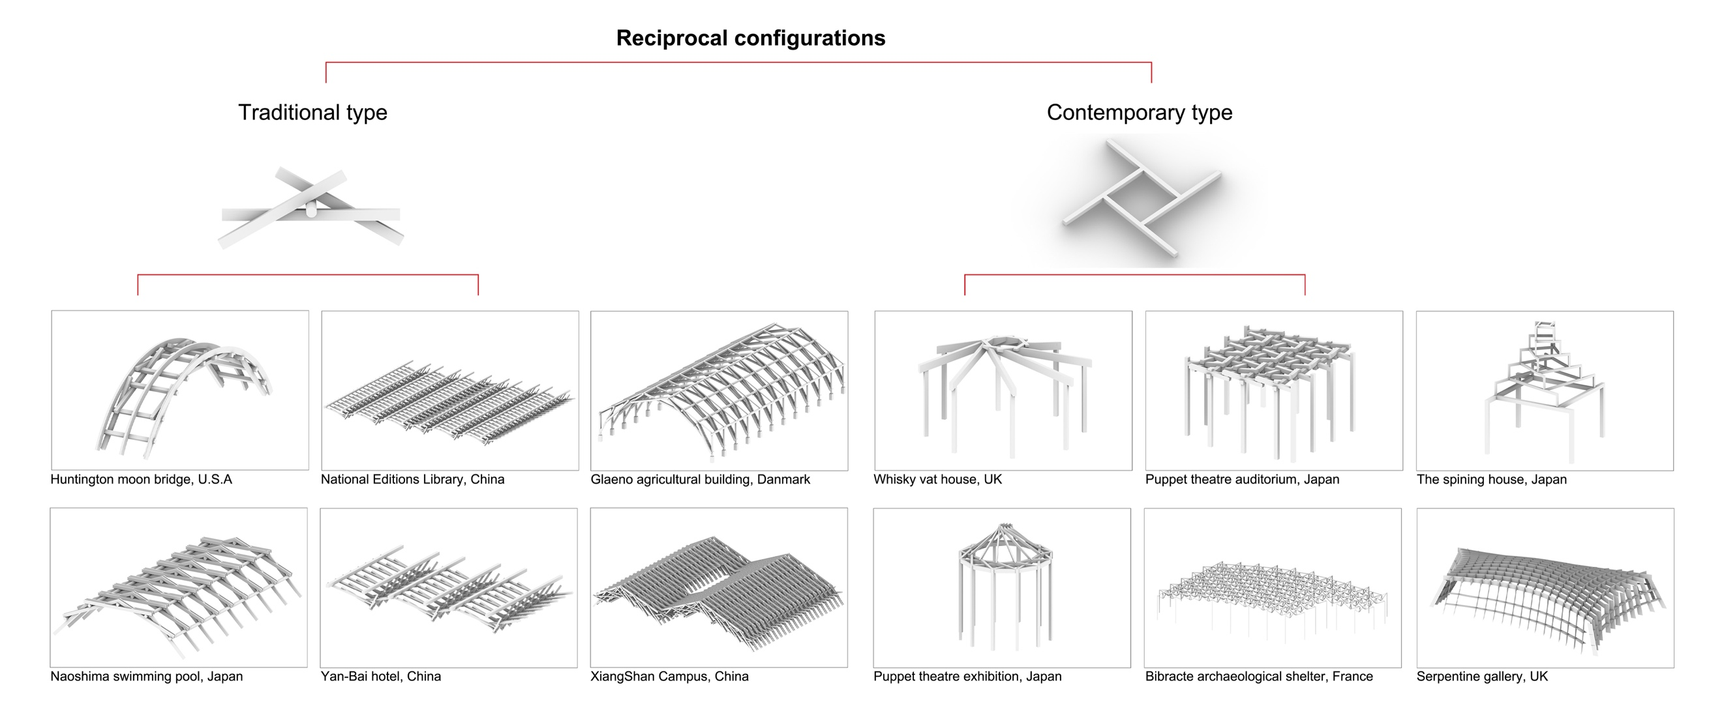
Info. 2 | Classification of reciprocal mechanisms and their engineering applications
This section presents a systematic classification of reciprocal structures, examining their geometric characteristics and applicability from both traditional and contemporary perspectives. Particular emphasis is placed on the role of “body connections” in establishing closed load-transfer loops and enabling distributed load sharing. These features highlight their potential for enhancing structural redundancy and mechanical performance, and provide the configurational basis for the coupled mechanism proposed in this work.
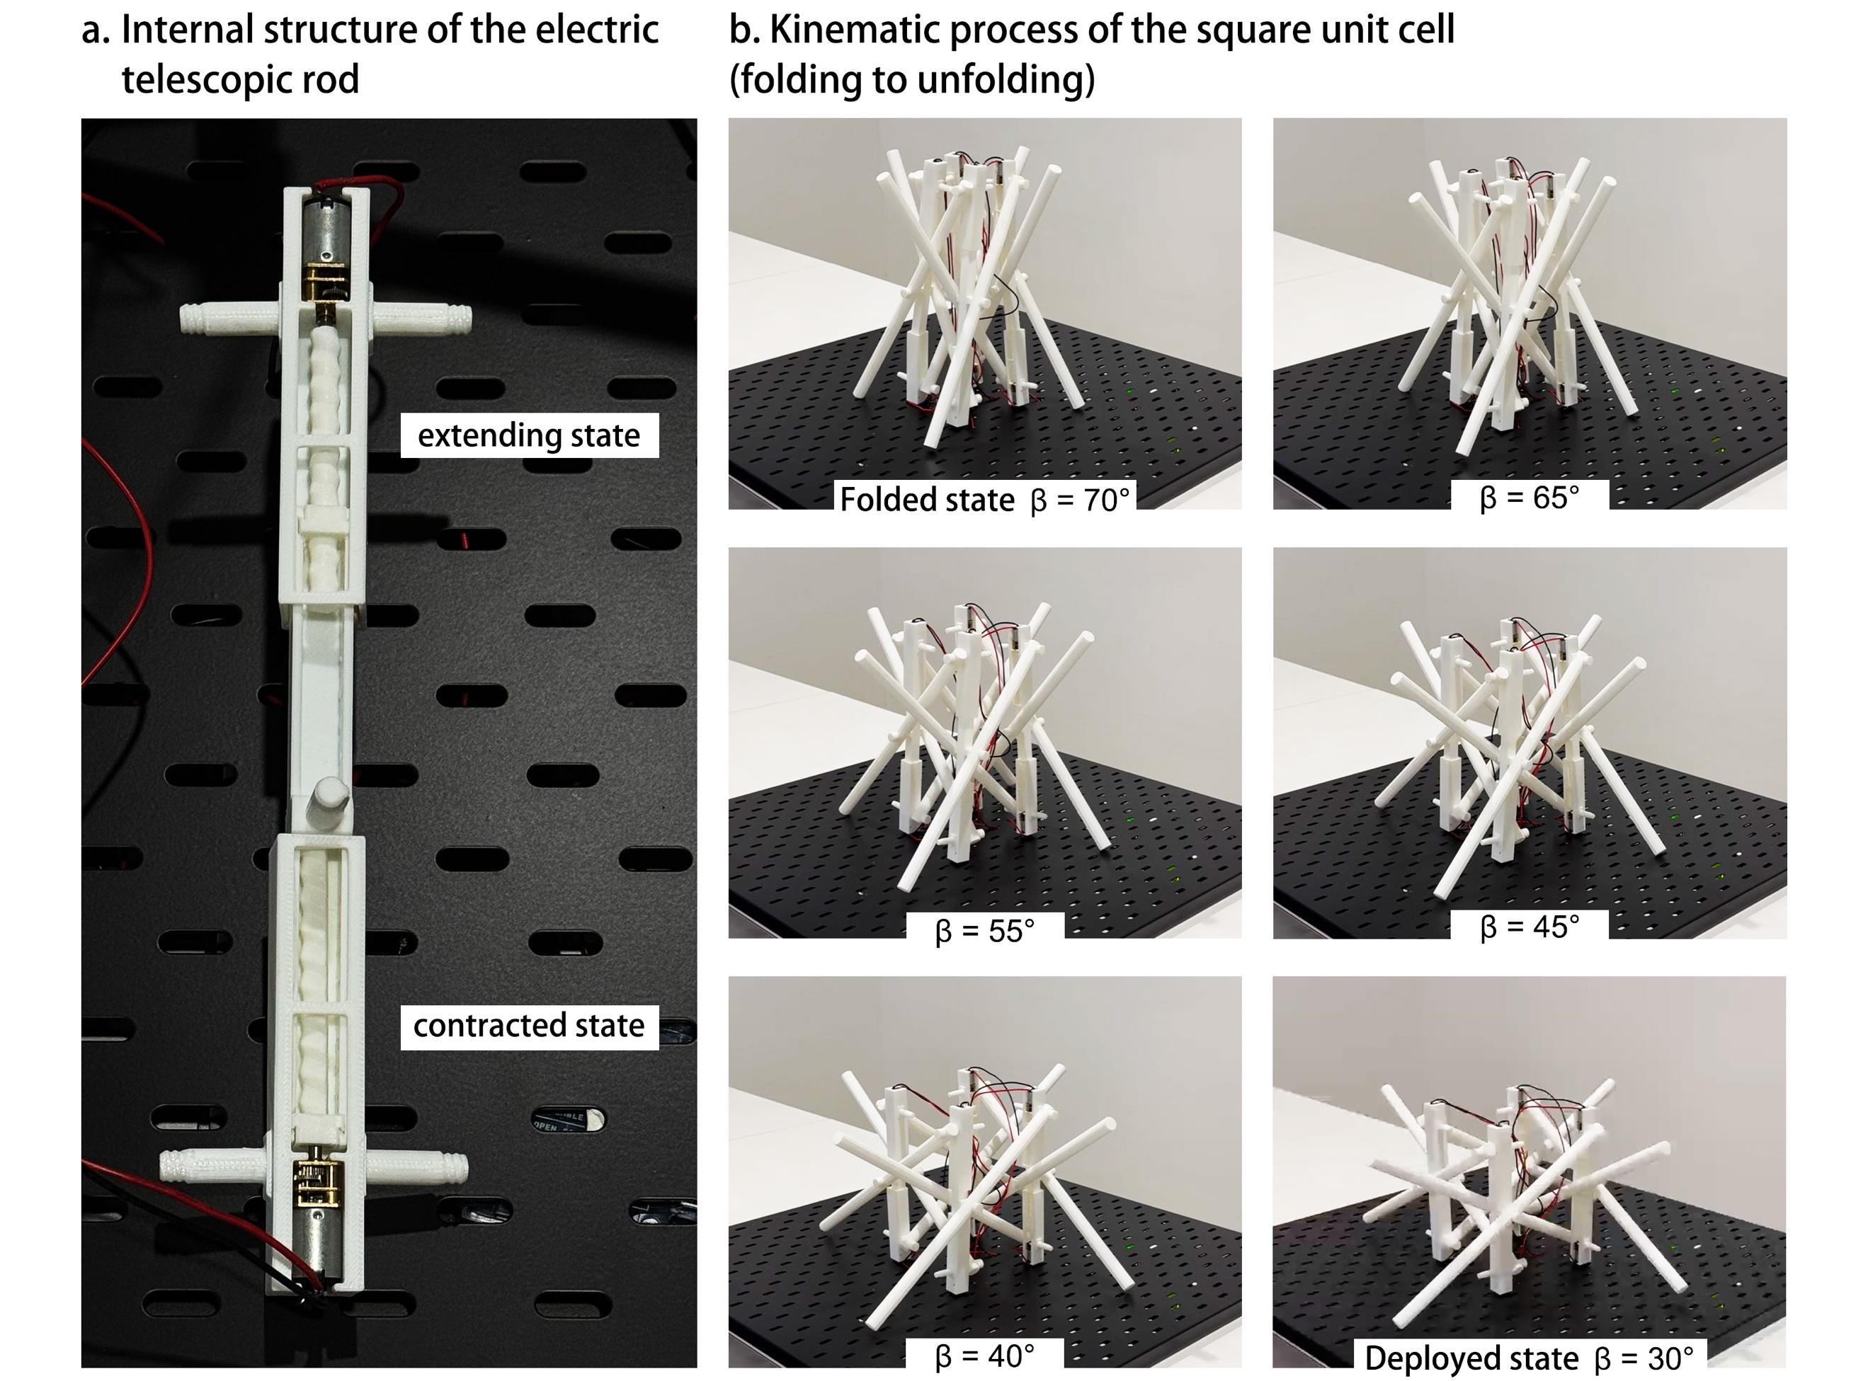
Info. 3 | Motor-driven deployment of a typical reciprocal-folding unit
A motor-driven experimental demonstration is presented to illustrate the dynamic reconfiguration mechanism of a representative reciprocal-folding unit, highlighting the critical role of telescopic members in controlling the deployment range and providing direct evidence for the controllability of the transformation process.
As shown, a quadrilateral RF unit undergoes folding and deployment under motor actuation. The system consists of 4 vertical telescopic members coupled with scissor-hinge elements. Each telescopic member is composed of three segments, with the upper and lower segments threaded into the central segment, and motors mounted at both ends. During actuation, the upper and lower segments rotate and progressively retract into the central segment, shortening the overall length of the telescopic members and driving the connected scissor-hinge units to deploy synchronously. The maximum and minimum lengths of the telescopic members define the geometric bounds of folding and deployment, enabling controlled reconfiguration (see Supplementary Video.1).
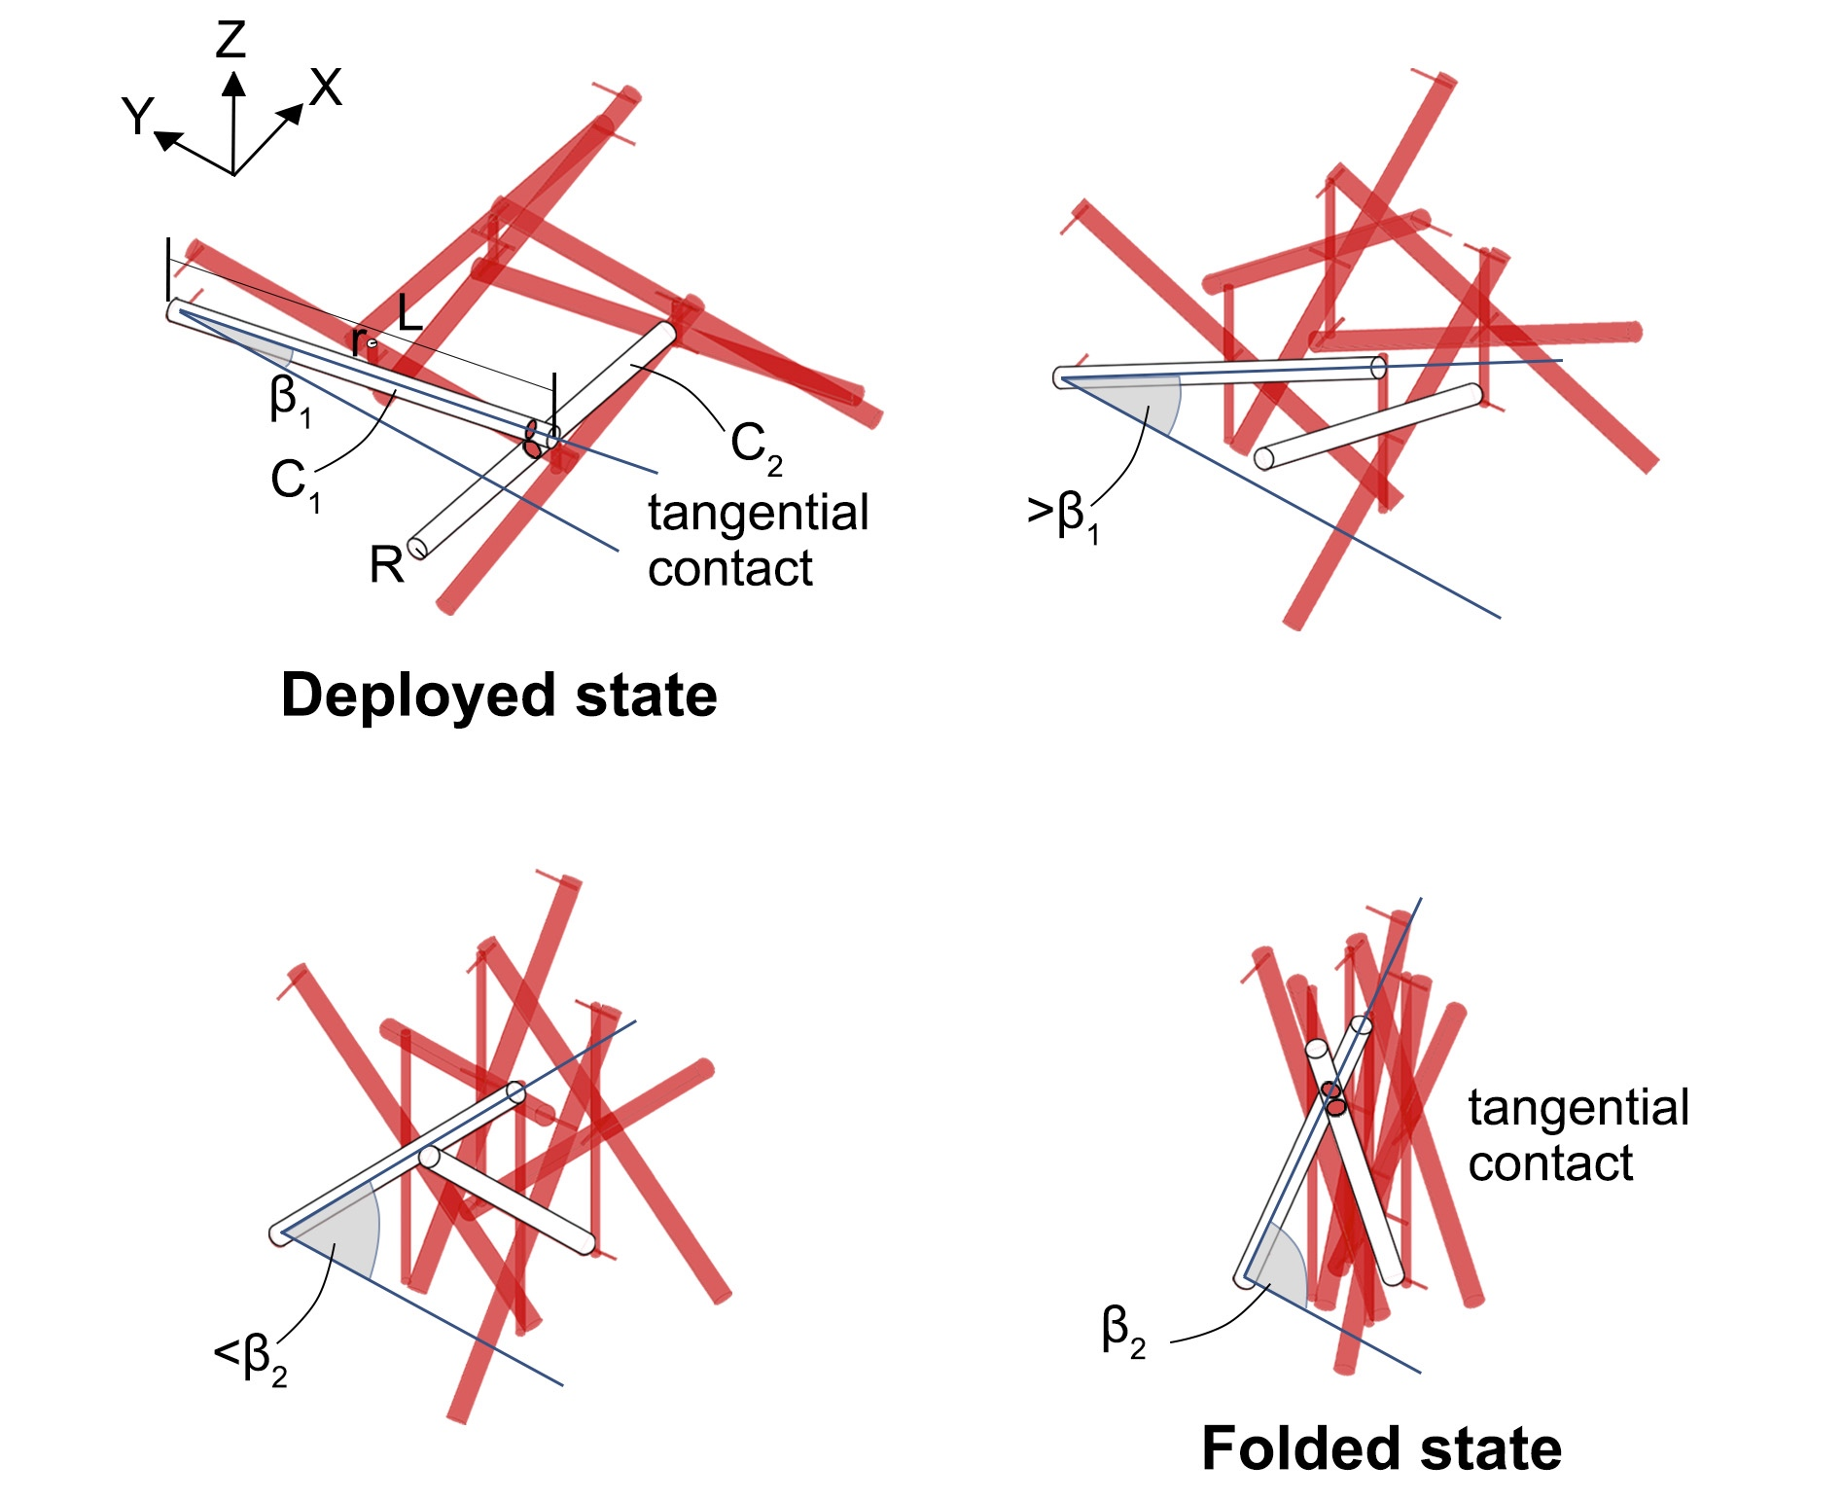
Info. 4 | Geometric compatibility and folding boundary derivation
The proposed configuration consists of multiple scissor-hinge units. To enable continuous reconfiguration, geometric compatibility must be maintained throughout the transformation process, such that member interference is avoided. However, in this configuration, two distinct geometric contact events occur between orthogonal X-shaped members during folding and deployment.
Taking two representative members, C₁ and C₂, as an example, the minimum distance between their centerlines exhibits a non-monotonic variation as the inclination angle β (with respect to the ground plane) increases from 0° to 90°. Critical states occur when the shortest distance between the two centerlines equals the sum of their radii (2R), corresponding to tangential contact between the tubular members.
To quantify this behavior, a three-dimensional coordinate system is established. Let the member length be L, inclination angle be β, member radius be R, and telescopic member radius be r. The parametric equations and direction vectors of the two centerlines are given as ($t∈R$):
$\vec{r_{1}}(t)=\left[\begin{aligned}t \\ R+r \\ -tanβ·t+Lsinβ\end{aligned}\right]$, $\vec{v_{1}}=\frac{d\vec{r_{1}}}{dt}=\left[\begin{aligned}1 \\ 0 \\ -tanβ\end{aligned}\right]$
$\vec{r_{2}}(s)=\left[\begin{aligned}\frac{L}{2}\cos{β}-R-r \\ s \\ -tanβ·s+Lsinβ\end{aligned}\right]$, $\vec{v_{2}}=\frac{d\vec{r_{2}}}{ds}=\left[\begin{aligned}0 \\ 1 \\ -tanβ\end{aligned}\right]$
The shortest distance between the two spatial lines is expressed as:
$$D\left(β\right)=\frac{\left|\left(\vec{r_{1}}-\vec{r_{2}}\right)·\left(\vec{v_{1}}×\vec{v_{2}}\right)\right|}{\left\|\vec{v_{1}}×\vec{v_{2}}\right\|}$$
This leads to the distance function:
$$D\left(β\right)=\frac{\left|\tan{β·\left(\frac{L}{2}\cos{β}-2R-2r\right)}\right|}{\sqrt{2\tan^{2}{β+1}}}$$
When $D\left(β\right)=2R$, geometric contact occurs. This equation admits two real solutions β₁ and β₂ (β₁<β₂) within the interval β ∈ (0°, 90°), corresponding to the onset and release of contact during the transformation process. The interval [$β_{1}$, $β_{2}$] therefore defines the geometrically admissible range of interference-free motion, establishing the theoretical boundary of deployability for the proposed configuration.
Analysis Tools | Software | Abaqus2020
Analysis Tools | Analysis Type | Dynamic, Explicit
Analysis Tools | Time Period | 0.05s
Material Properties | Material | PLA
Material Properties | Density | 1.24×10⁻⁹ton/mm³
Material Properties | Young's modulus | 2500MPa
Material Properties | Poisson ratio | 0.3
Material Properties | Plastic model | Yield Stress Plastic Strain  37.5 0  33 0.01  31 0.015  30 0.02  29 0.03  28 0.05  27.3 0.07  27.3 0.105
Loads & Boundary Conditions | Interaction | upper and lower rigid plates are in contact
Loads & Boundary Conditions | Tangential coefficient | 0.14
Loads & Boundary Conditions | Normal contact | hard
Loads & Boundary Conditions | Load | Lower plate fixed, upper plate descends at a constant speed of 0.33 m/s.
Mesh | Type | C3D10M
Mesh | Size | 1.5mm
Info. 5 | Finite element modelling parameters at the unit level
It should be noted that the finite element (FE) results show good agreement with experimental measurements in terms of overall trends, although the predicted values are slightly lower than those observed experimentally. This discrepancy can be primarily attributed to manufacturing-related effects and material characteristics.
First, due to the integrated additive manufacturing process, support structures are required during fabrication. Residual material after support removal may introduce additional load paths in the physical specimens, leading to enhanced stiffness and load-bearing capacity compared to the idealized numerical model. Second, the printed PLA exhibits a fiber-like anisotropic microstructure, whose mechanical properties are strongly influenced by printing orientation and layer deposition. This anisotropy is not fully captured in the FE model.
Despite these quantitative differences, the FE simulations accurately reproduce the key mechanical responses of the structure, including load–displacement trends, deformation modes, and failure evolution. Therefore, the model is considered sufficiently reliable for performance evaluation and design optimization.
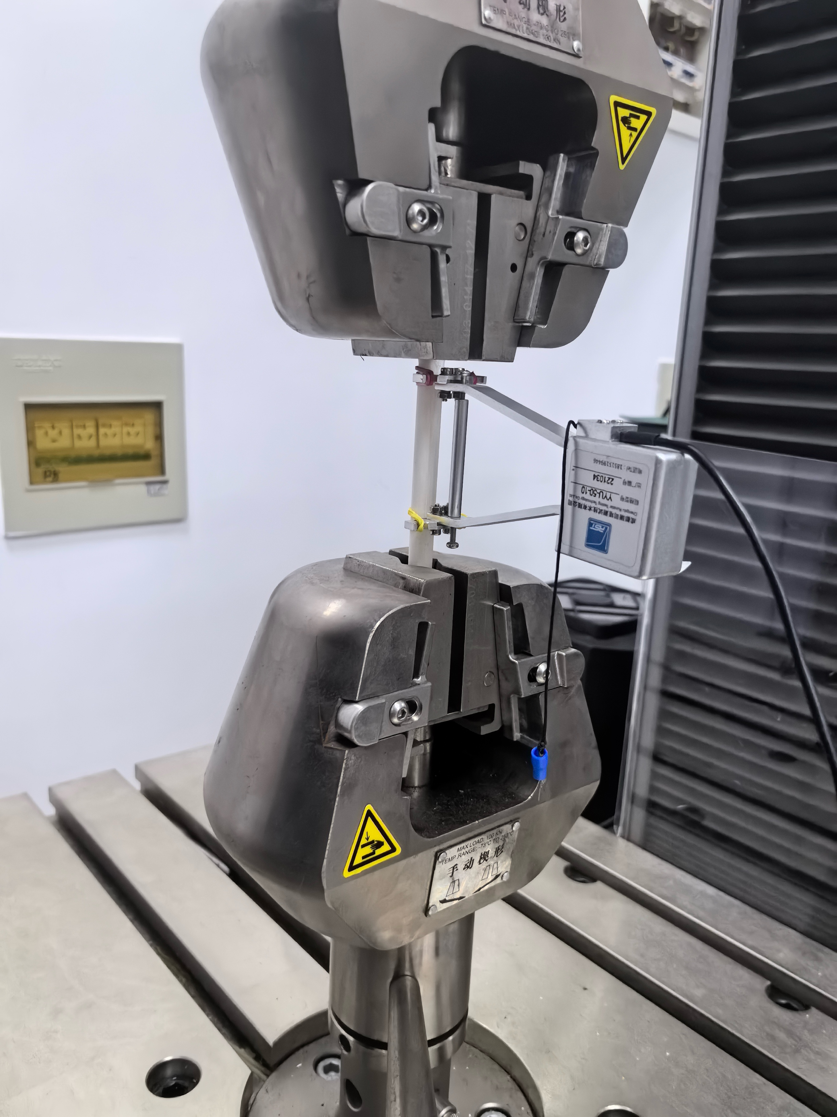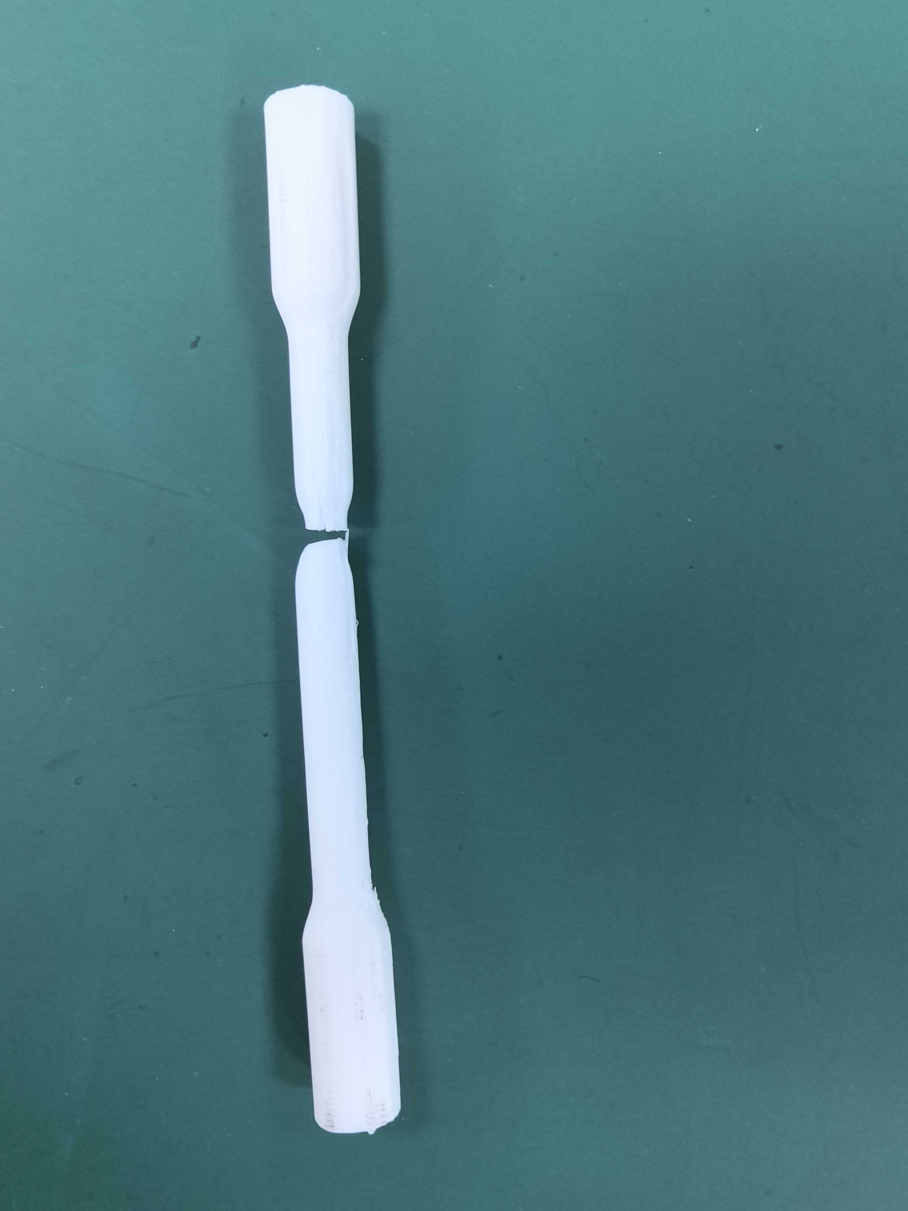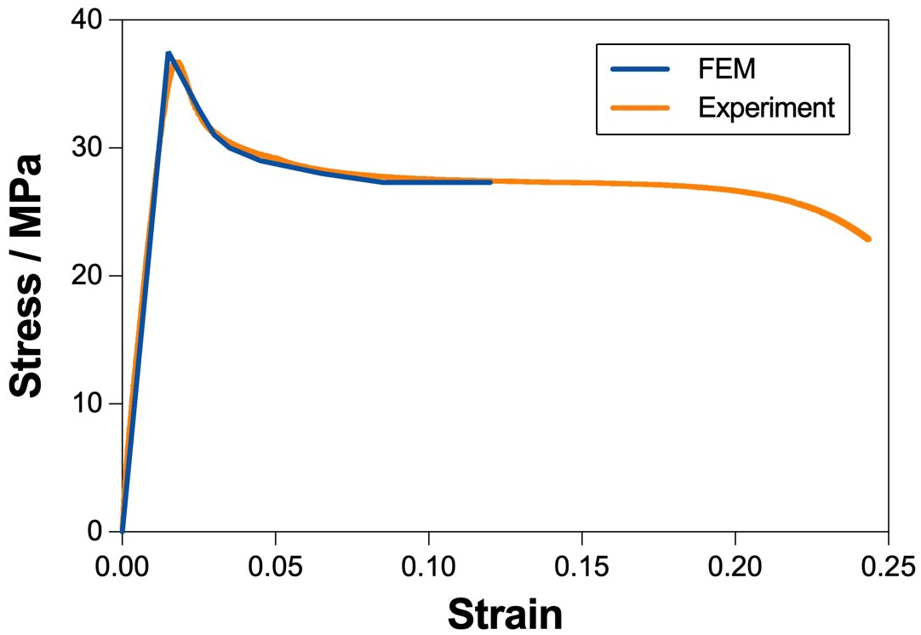
Info. 6 | Experimental characterization of material properties
A uniaxial tensile test was conducted to obtain the stress–strain response of the material, providing experimental calibration for the material parameters used in the numerical model and ensuring reliable inputs for subsequent mechanical analysis.
A standard dog-bone specimen made of PLA was tested under monotonic loading, and the corresponding stress–strain curve is shown. The result indicates an approximately linear stress–strain relationship in the initial stage, representing elastic behavior, followed by a peak tensile strength of approximately 36.5 MPa. Beyond the peak, the stress gradually decreases while the strain continues to increase (exceeding 0.25), demonstrating a clear ductile deformation response. This experimental result forms the basis for defining the material constitutive model in the finite element simulations, thereby improving the accuracy and reliability of the numerical analysis.
Info. 7｜刚接与铰接的实测对比
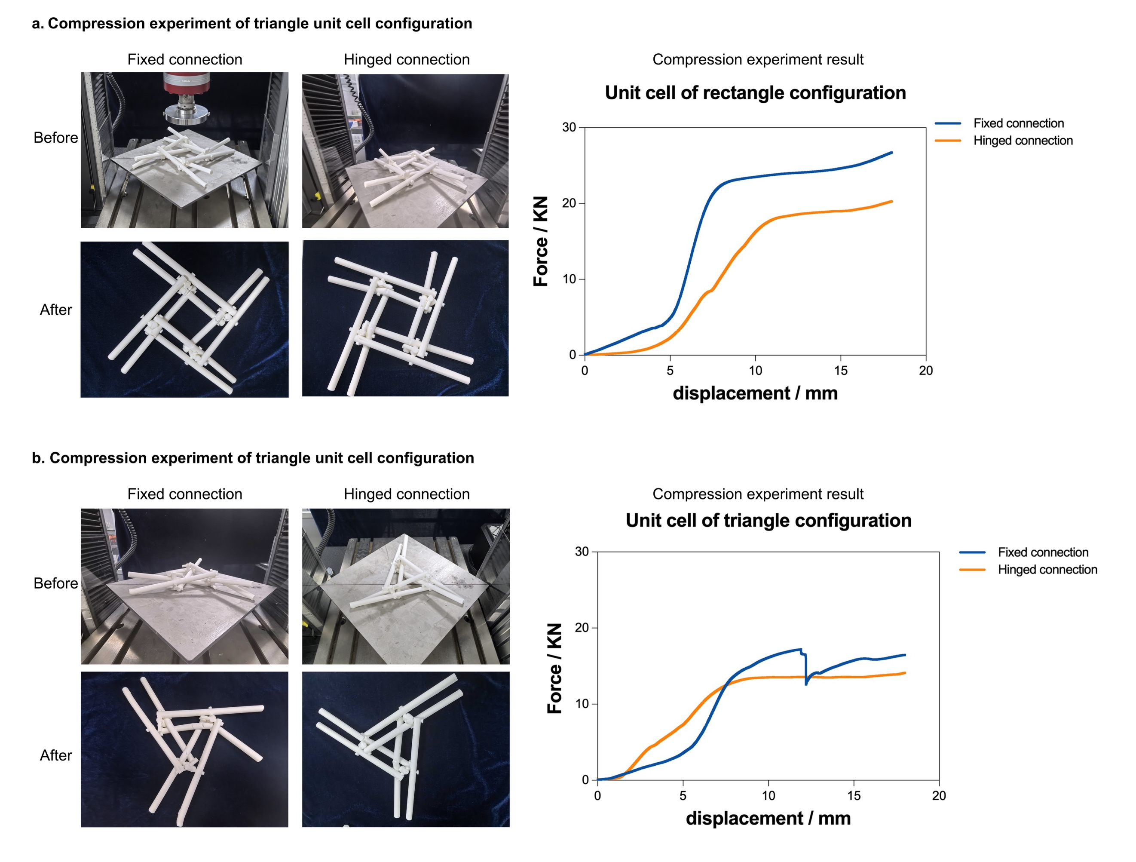
Info. 7 | Experimental comparison between rigid and hinged connections
Experimental comparisons were conducted to evaluate the influence of different connection assumptions on structural behavior, and to justify the adoption of rigid connections in the numerical model.
Thus, triangular and quadrilateral unit structures were fabricated using two different approaches:
(i) separately printed members assembled afterward, approximating hinged connections;
(ii) integrally printed structures, approximating rigid connections.
The results show that both configurations exhibit similar global load–displacement trends, while the integrally printed (rigid) configuration demonstrates a higher load-bearing capacity.
Based on these observations, rigid connections were adopted in the subsequent finite element analyses. This modelling simplification offers two key advantages. First, it effectively avoids contact nonlinearity, eliminating the need for complex contact definitions and thereby improving computational efficiency and numerical stability. Second, it removes uncertainties associated with assembly-induced gaps and friction, providing a well-defined boundary condition that allows the simulation to focus on the intrinsic structural response, thus enhancing the reliability and reproducibility of the results.
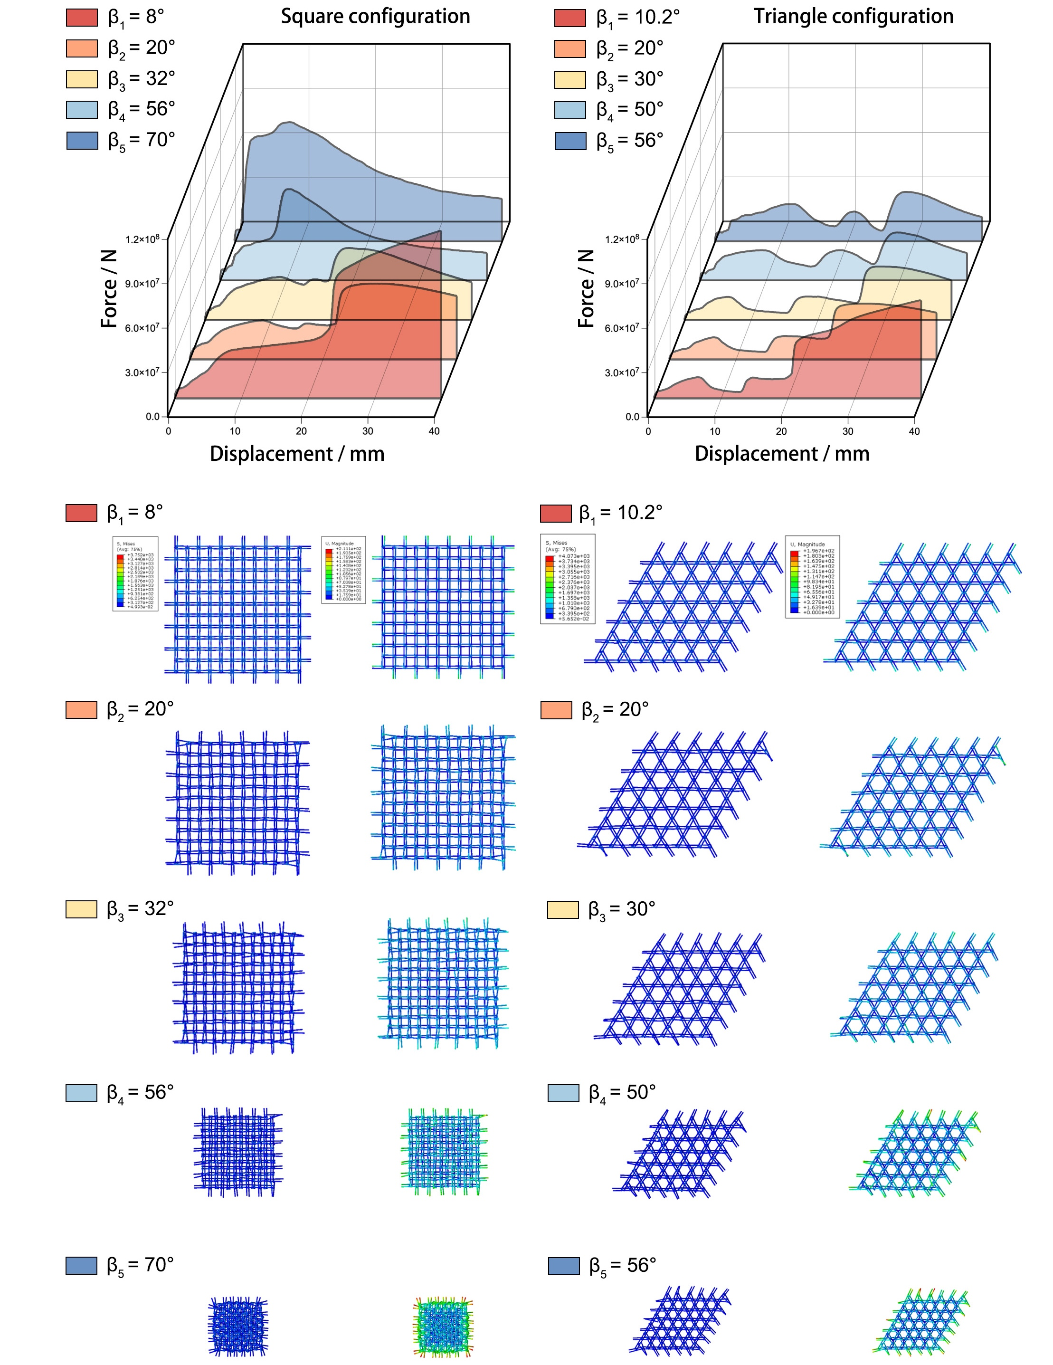
Info. 8 | Extended results of mechanical performance during deployment
In the numerical simulations, the telescopic members are assumed to be actively lockable at all deployment angles, thereby providing continuous structural support throughout the reconfiguration process.
As shown, the mechanical response and deformation characteristics of square and triangle configurations are compared across different deployment angles β. While variations in load-bearing capacity are observed between different topologies, the structural advantages introduced by the body connections remain consistent. In particular, the proposed mechanism significantly enhances load-bearing capacity in the deployed state and promotes a more uniform stress distribution.
These results indicate that the mechanical benefits of the proposed connection strategy are largely topology-independent, supporting its applicability across a wide range of structural configurations.
Analysis Tools | Software | ADMAS 2020
Analysis Tools | Analysis Type | Dynamics of rigid bodies
Analysis Tools | Time Period | 1s
Material Properties | Material | Steel
Material Properties | Density | 7850kg/m³
Material Properties | Young's modulus | 2×10⁵MPa
Material Properties | Poisson ratio | 0.3
Material Properties | Coefficient of friction | 0.05
Loads & Boundary Conditions | Pair element | Revolute pair and sliding pair
Loads & Boundary Conditions | Load | The drivable sliding pair applies a constant velocity of 50 mm/s.
Info. 9 | Parameters for multibody dynamic simulation
Multibody dynamic simulations were performed to provide computational validation of the key dynamic findings. A rigid-body model of the mechanism was constructed in Adams, incorporating geometric parameters of the structure and friction coefficients at critical contact interfaces.
The model was used to evaluate the required driving forces and power during motion, and to assess kinematic performance under dynamic conditions, including trajectory accuracy, motion stability, and interference-free behavior. These analyses confirm the feasibility of the proposed mechanism during dynamic reconfiguration and provide additional support for the theoretical model from a dynamic perspective.
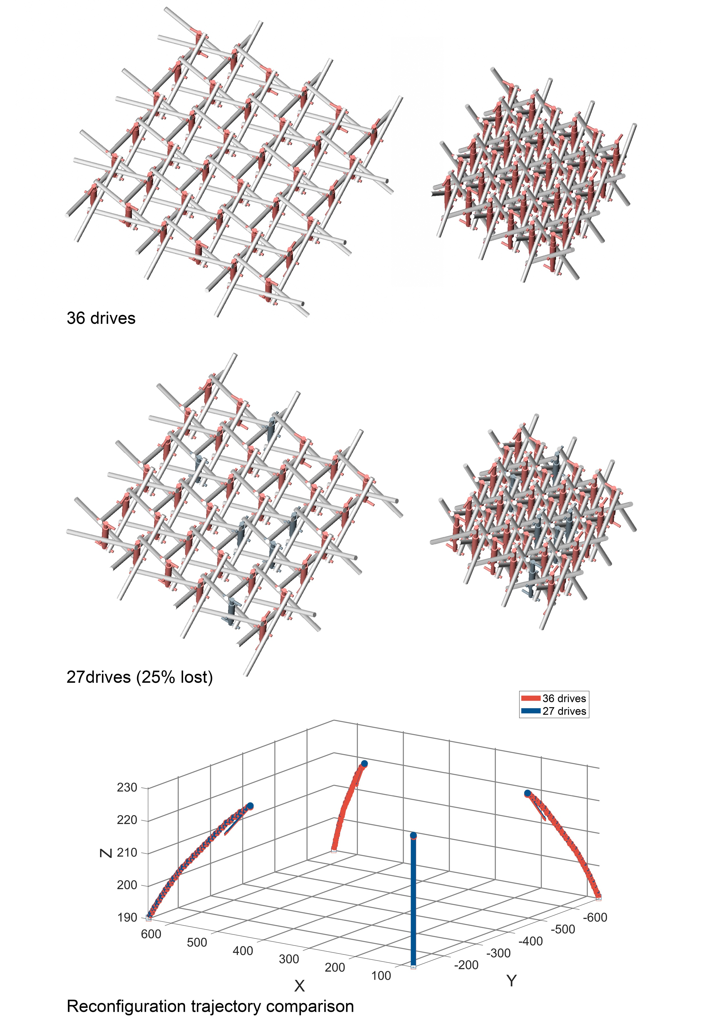
Info. 10 | Extended analysis of kinematic redundancy at the structural level
Building upon the unit-level analysis presented in the main text, this section further evaluates the kinematic redundancy of the proposed mechanism at the structural level. As shown, under full actuation (36 drives), the structure achieves a regular and symmetric deployment. When approximately 25% of the actuators fail (27 drives remain), the structure is still able to deploy globally, with only minor local geometric deviations and no loss of stability or interruption of motion.
A comparison of the reconstructed trajectories of key nodes further shows that the motion paths under partial actuation closely match those under full actuation, with only limited deviations. This indicates that the reconfiguration process does not rely on a single driving path, but instead is achieved through multi-path cooperative motion, allowing the remaining actuators to compensate for failed ones.
Overall, these results demonstrate that the proposed reciprocal–folding mechanism exhibits significant kenimatic redundancy at the structural level, enabling continuous and stable reconfiguration under partial actuation failure, thereby enhancing system reliability and engineering applicability. This behavior is also consistently observed in experimental demonstrations (see Supplementary Info.3 and Video.1).
Analysis Tools | Software | Abaqus2020
Analysis Tools | Analysis Type | Dynamic, Explicit
Analysis Tools | Time Period | 0.1s
Material Properties | Material | Steel
Material Properties | Density | 7.85×10⁻⁹ton/mm³
Material Properties | Young's modulus | 2×10⁵MPa
Material Properties | Poisson ratio | 0.3
Material Properties | Plastic model | Johnson-Cook  A=430 B=233.7 n=0.6428 m=0 Tmelt=1518.5 T0=20
Material Properties | Damage model | Johnson-Cook  d1=0.7 d2=0.5 d3=5 d4=-0.006 d5=0 =0.02
Loads & Boundary Conditions | Interaction | upper and lower rigid plates are in contact
Loads & Boundary Conditions | Tangential coefficient | 0.14
Loads & Boundary Conditions | Normal contact | hard
Loads & Boundary Conditions | Load | Lower plate fixed, upper plate descends at a constant speed of 1 m/s.
Mesh | Type | C3D10M
Mesh | Size | 15mm
Info. 11 | Parameter settings for redundancy analysis
To evaluate the structural redundancy under member-loss conditions, a finite element model at the structural level was developed in Abaqus, incorporating material nonlinearity and damage evolution to simulate failure behavior.
The material response was described using a Johnson–Cook constitutive model with an associated damage model, enabling the capture of large deformation and progressive failure. The upper and lower loading plates were defined with rigid constraints and displacement-controlled loading, respectively. Contact interactions were modeled using a hard contact formulation with friction. Structural defects were introduced by randomly removing a prescribed proportion of members, allowing systematic evaluation of load-bearing capacity and mechanical response under different damage scenarios. These parameter settings provide a consistent computational framework for the subsequent redundancy analysis.
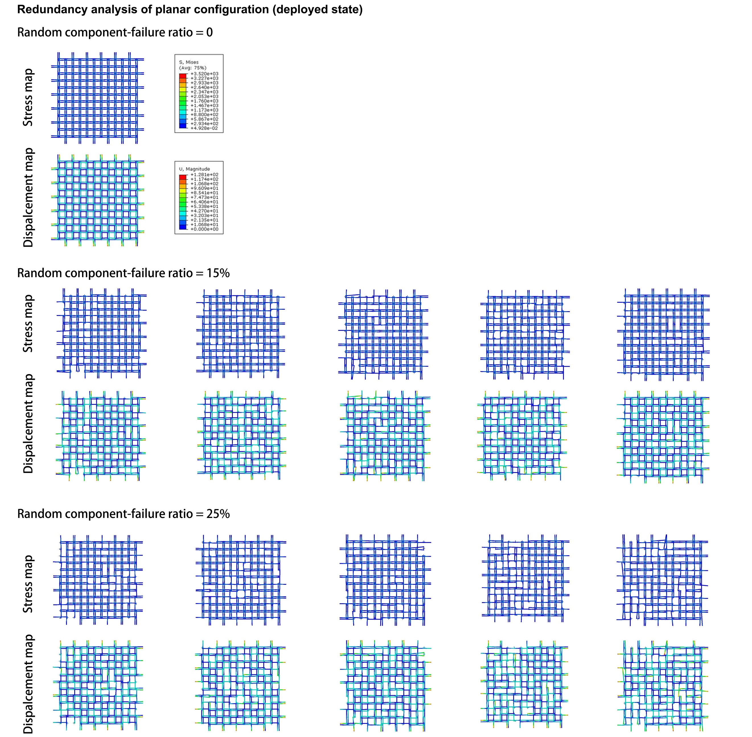
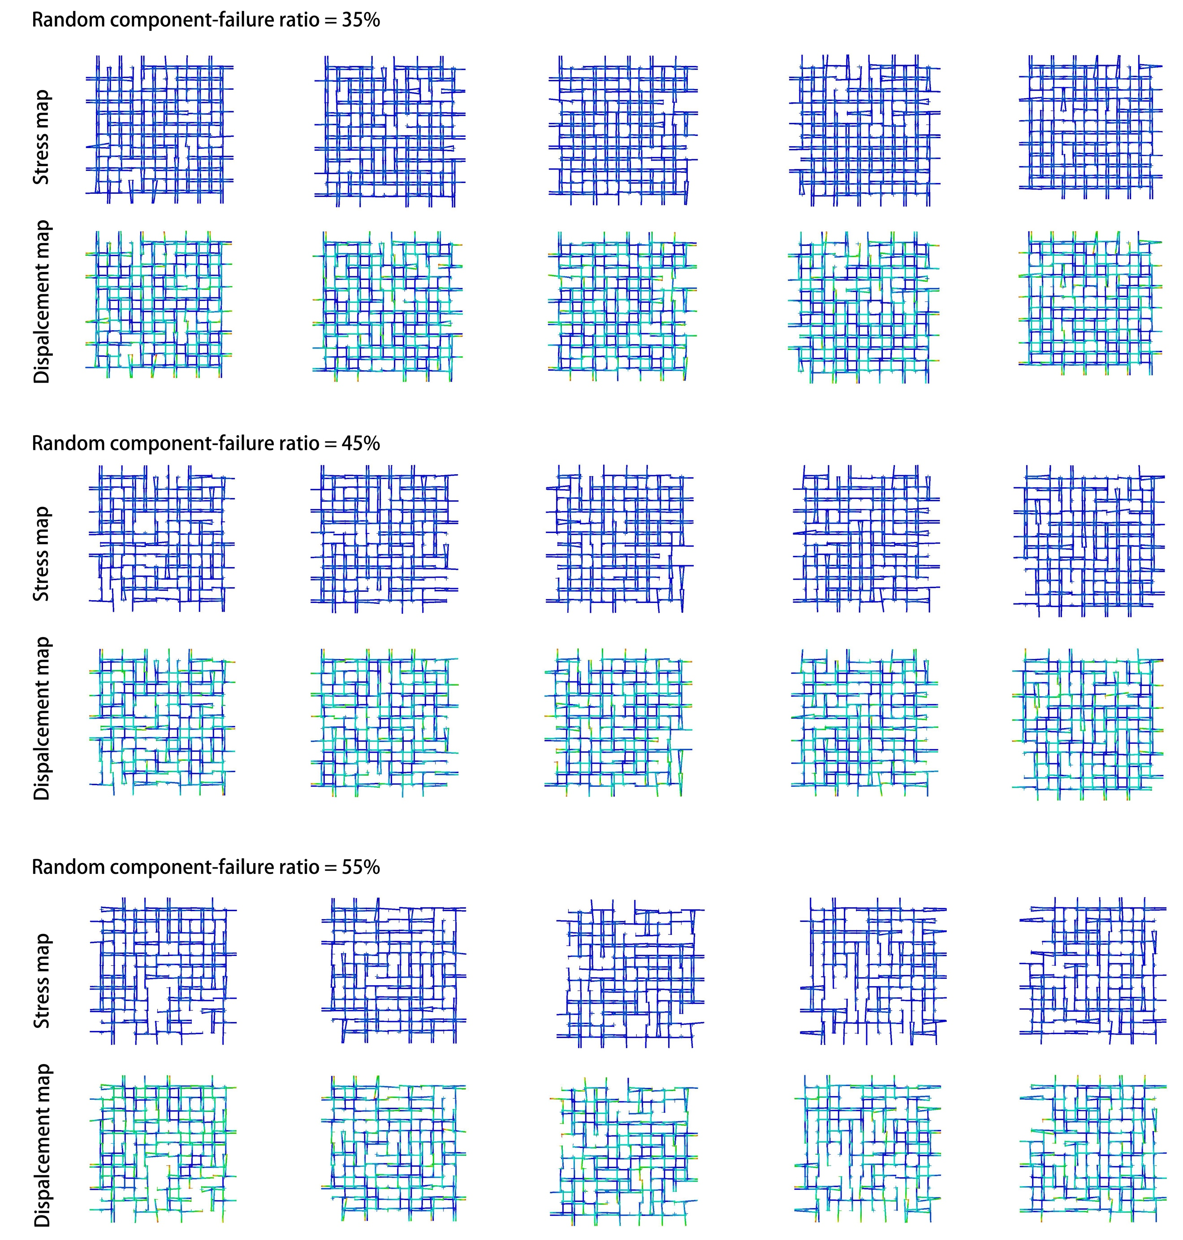
Info. 12 | Complete results of random member removal analysis
The results show that, in the initial loading stage (displacement < 15 mm), the mechanical responses of all defect cases closely follow that of the intact structure, indicating that effective load transfer and structural continuity are maintained despite member loss. As the proportion of removed members increases, the load-bearing capacity gradually decreases, while the overall response remains stable. At larger displacements (> 28 mm), a more pronounced reduction in load-bearing capacity is observed; however, all cases still retain a certain level of resistance.
Quantitatively, at a displacement of 15 mm, the structure with 25% of members removed retains approximately 74% of the load-bearing capacity of the intact configuration. Even with 45%-member loss, the structure maintains about 48% of its original capacity. These results demonstrate that the multi-path load transfer enabled by reciprocal connections can partially compensate for member loss, allowing the structure to adapt to local failures and exhibiting strong structural redundancy and robustness.
Displacement contour plots further reveal that failure is primarily concentrated at boundary regions and locations with missing members, characterized by compressive bending of the remaining elements. As the level of damage increases, local failure becomes more pronounced, accompanied by significant redistribution of stress flows and the emergence of alternative load paths. Nevertheless, under all defect scenarios, the structure maintains a stable compressive response, with continuous load–displacement behavior and no abrupt collapse.
This behavior can be attributed to the multi-support reciprocal system formed by mid-span (“body”) connections, which enables load redistribution across multiple pathways. When certain members fail, the remaining elements can take over their load-transfer functions, resulting in a controlled and progressive failure mode.
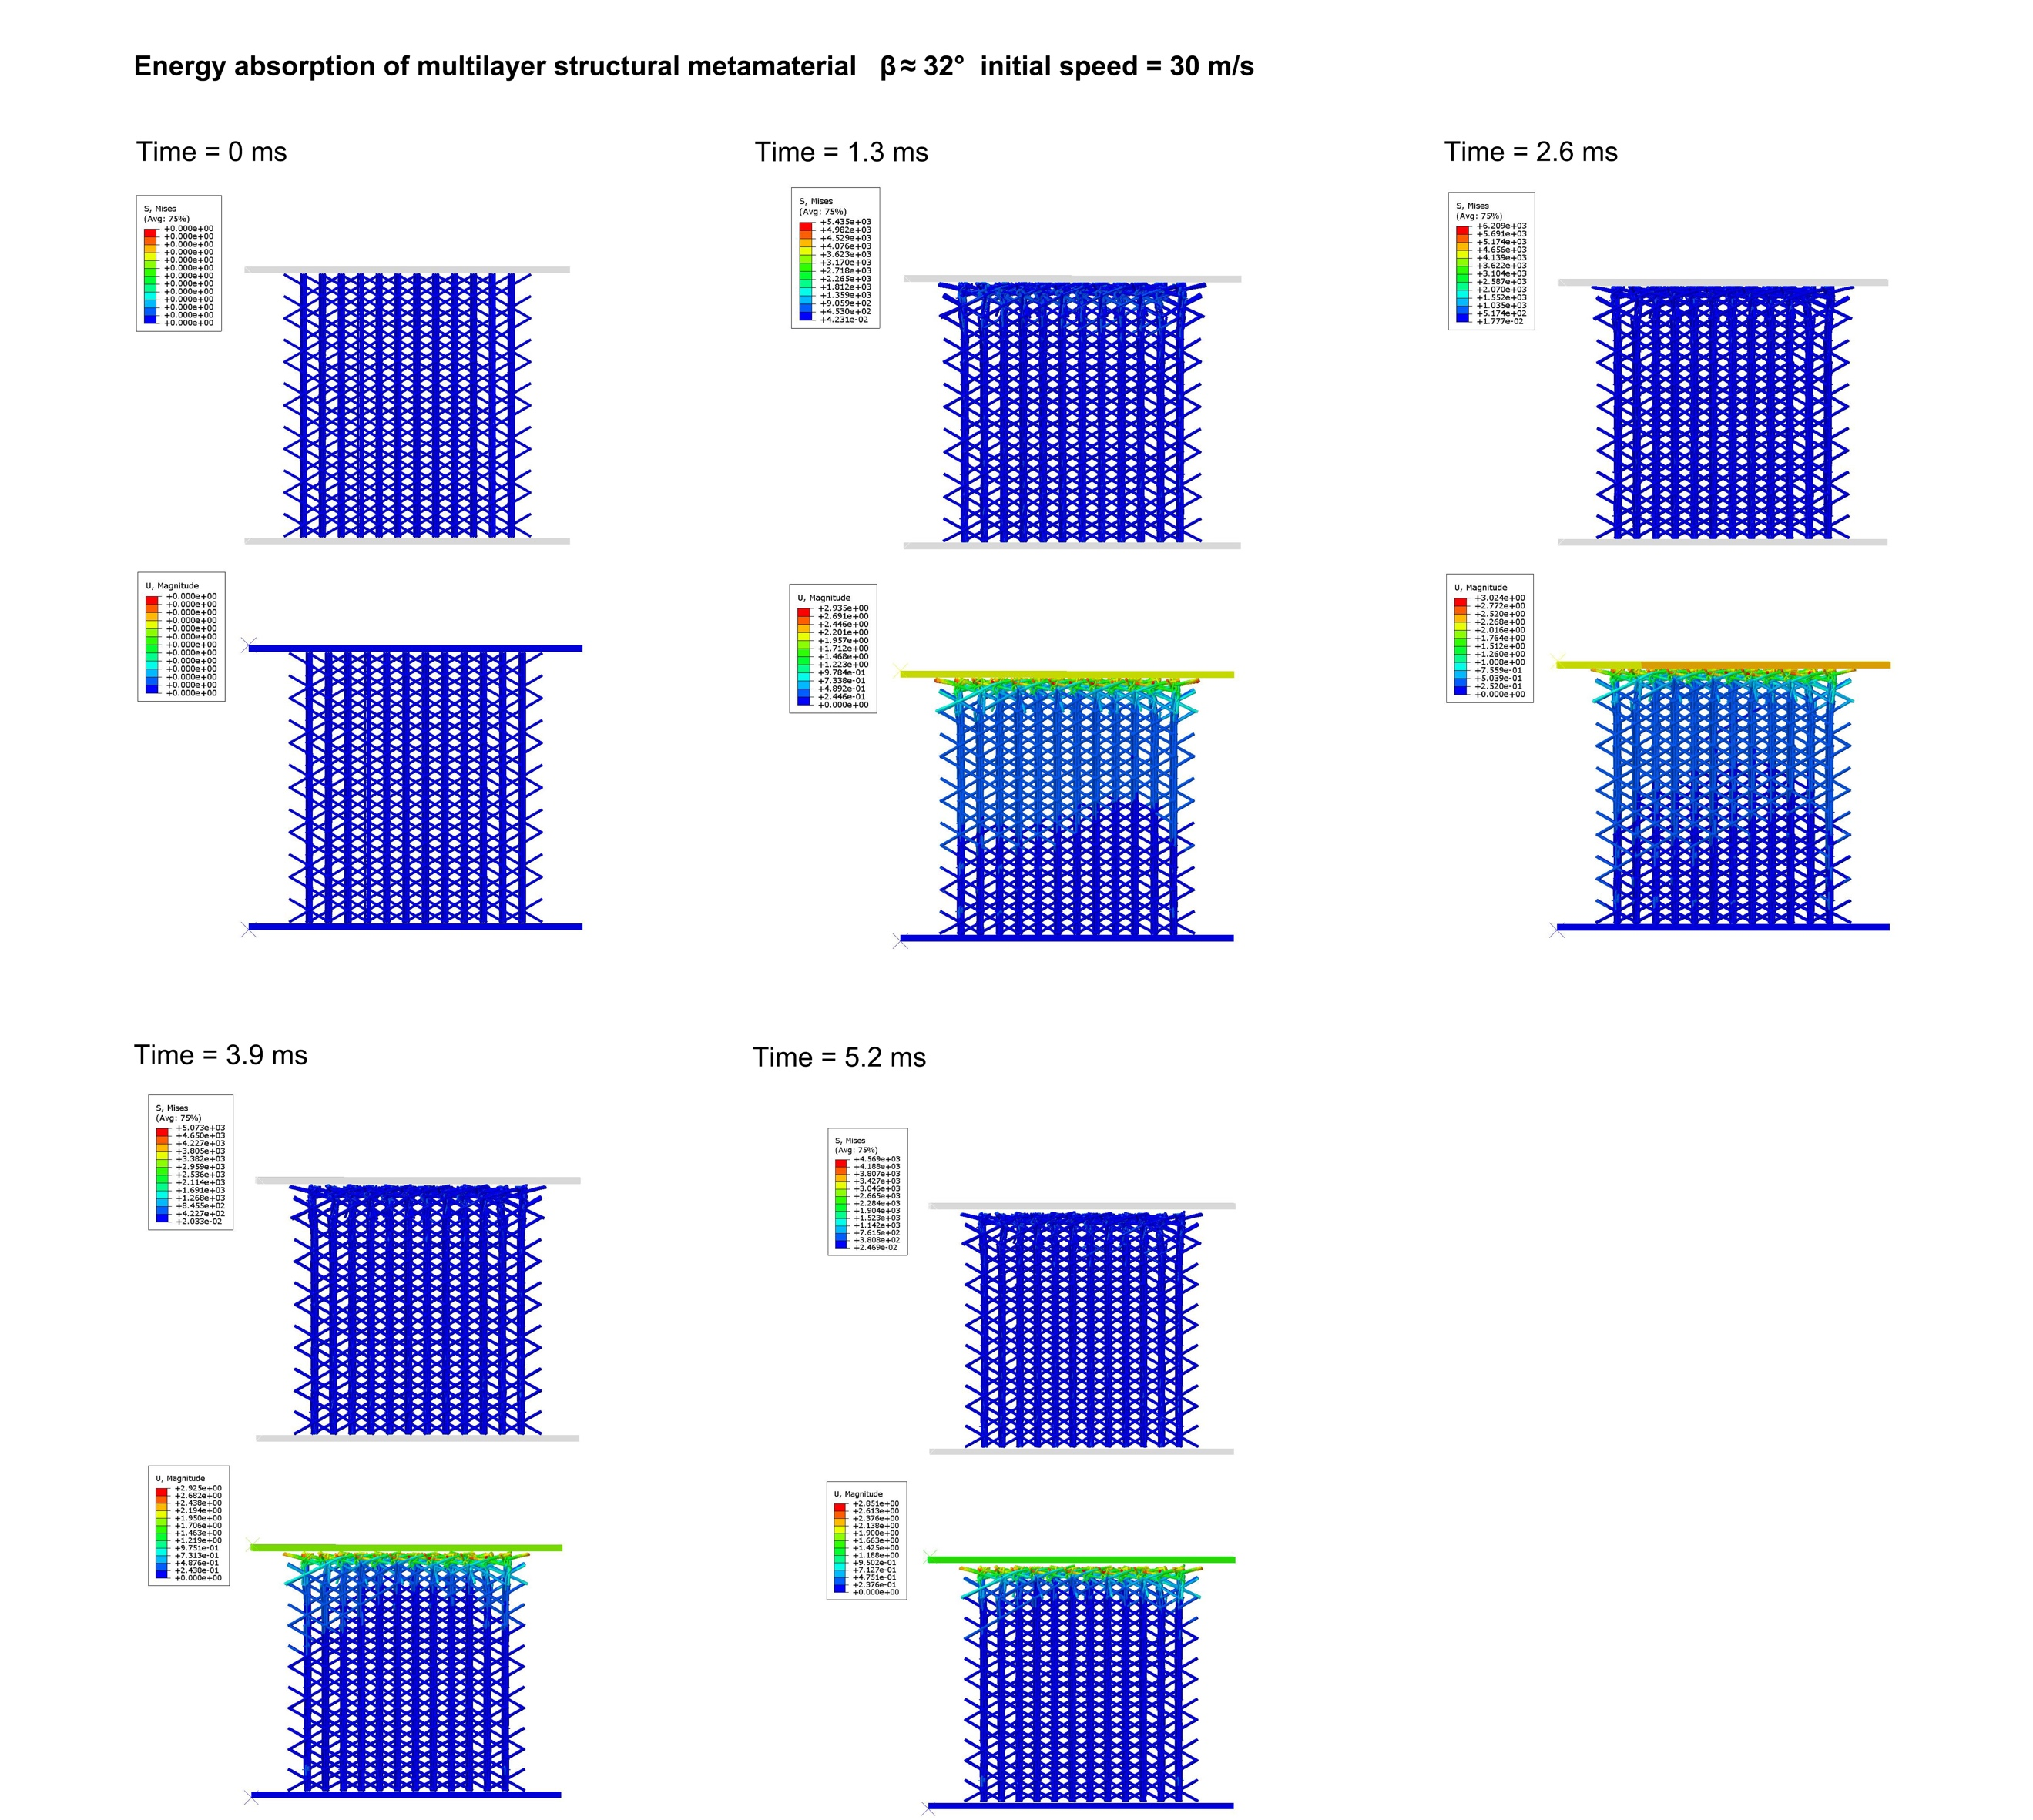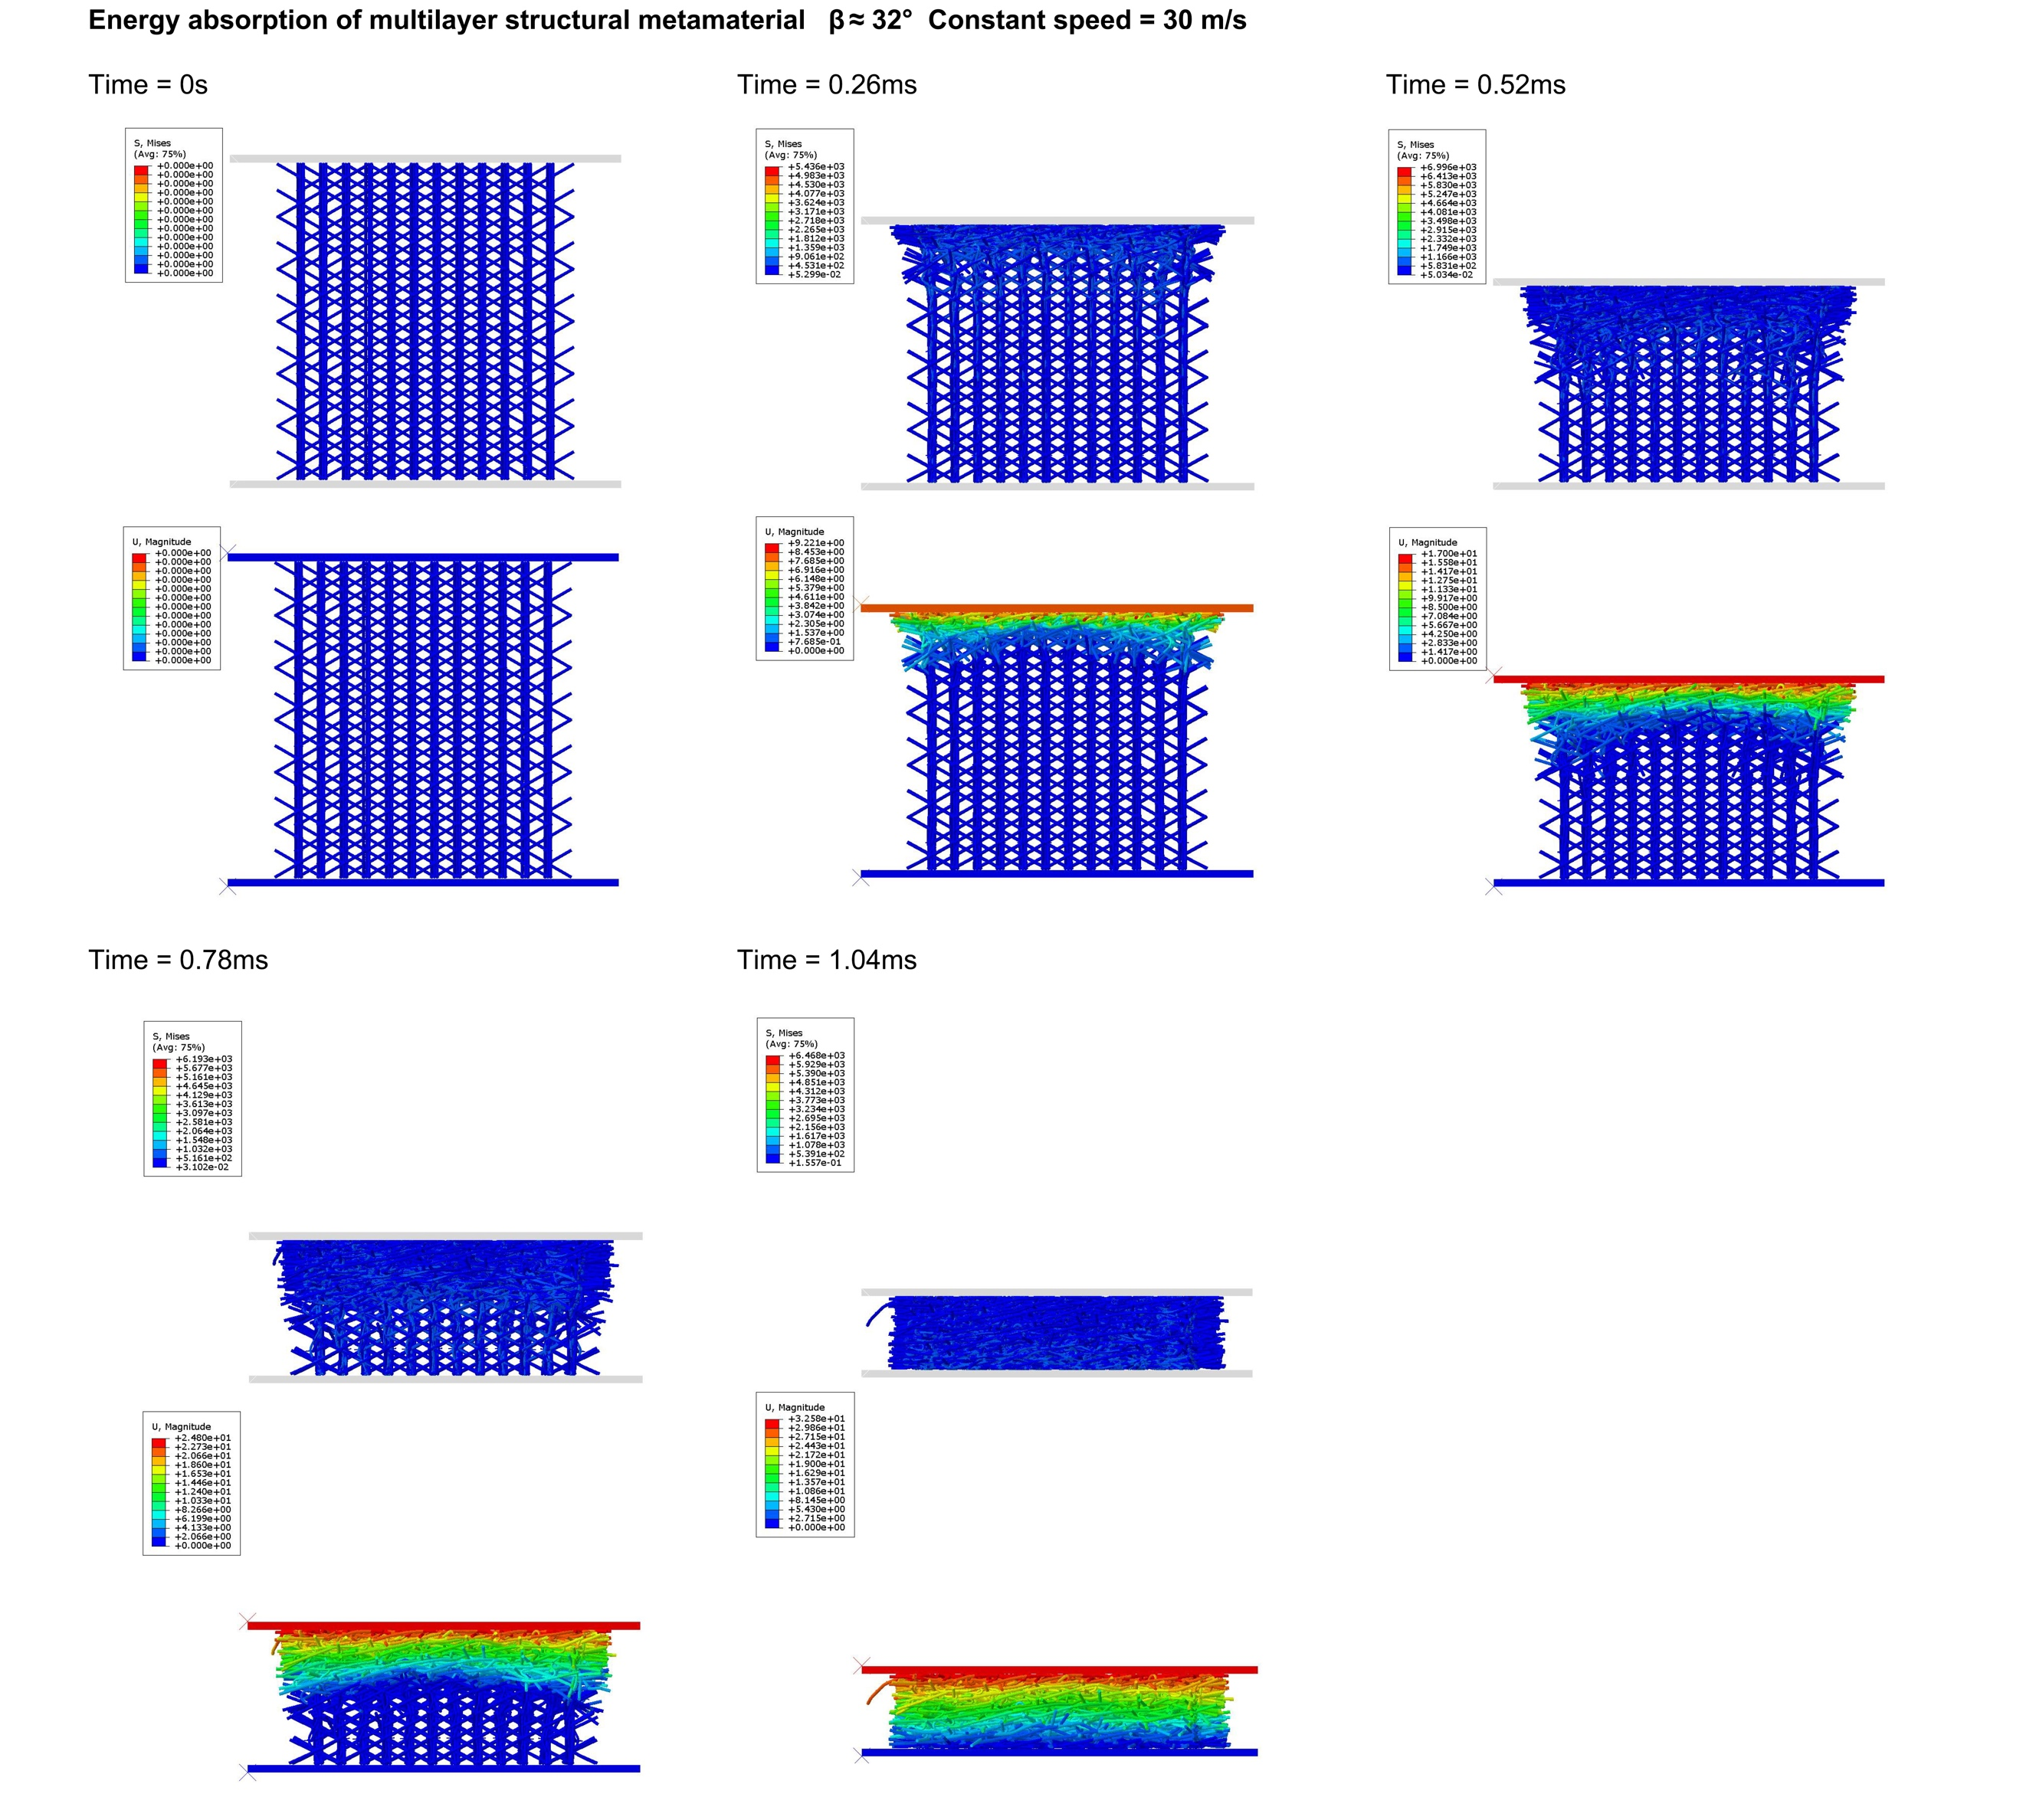
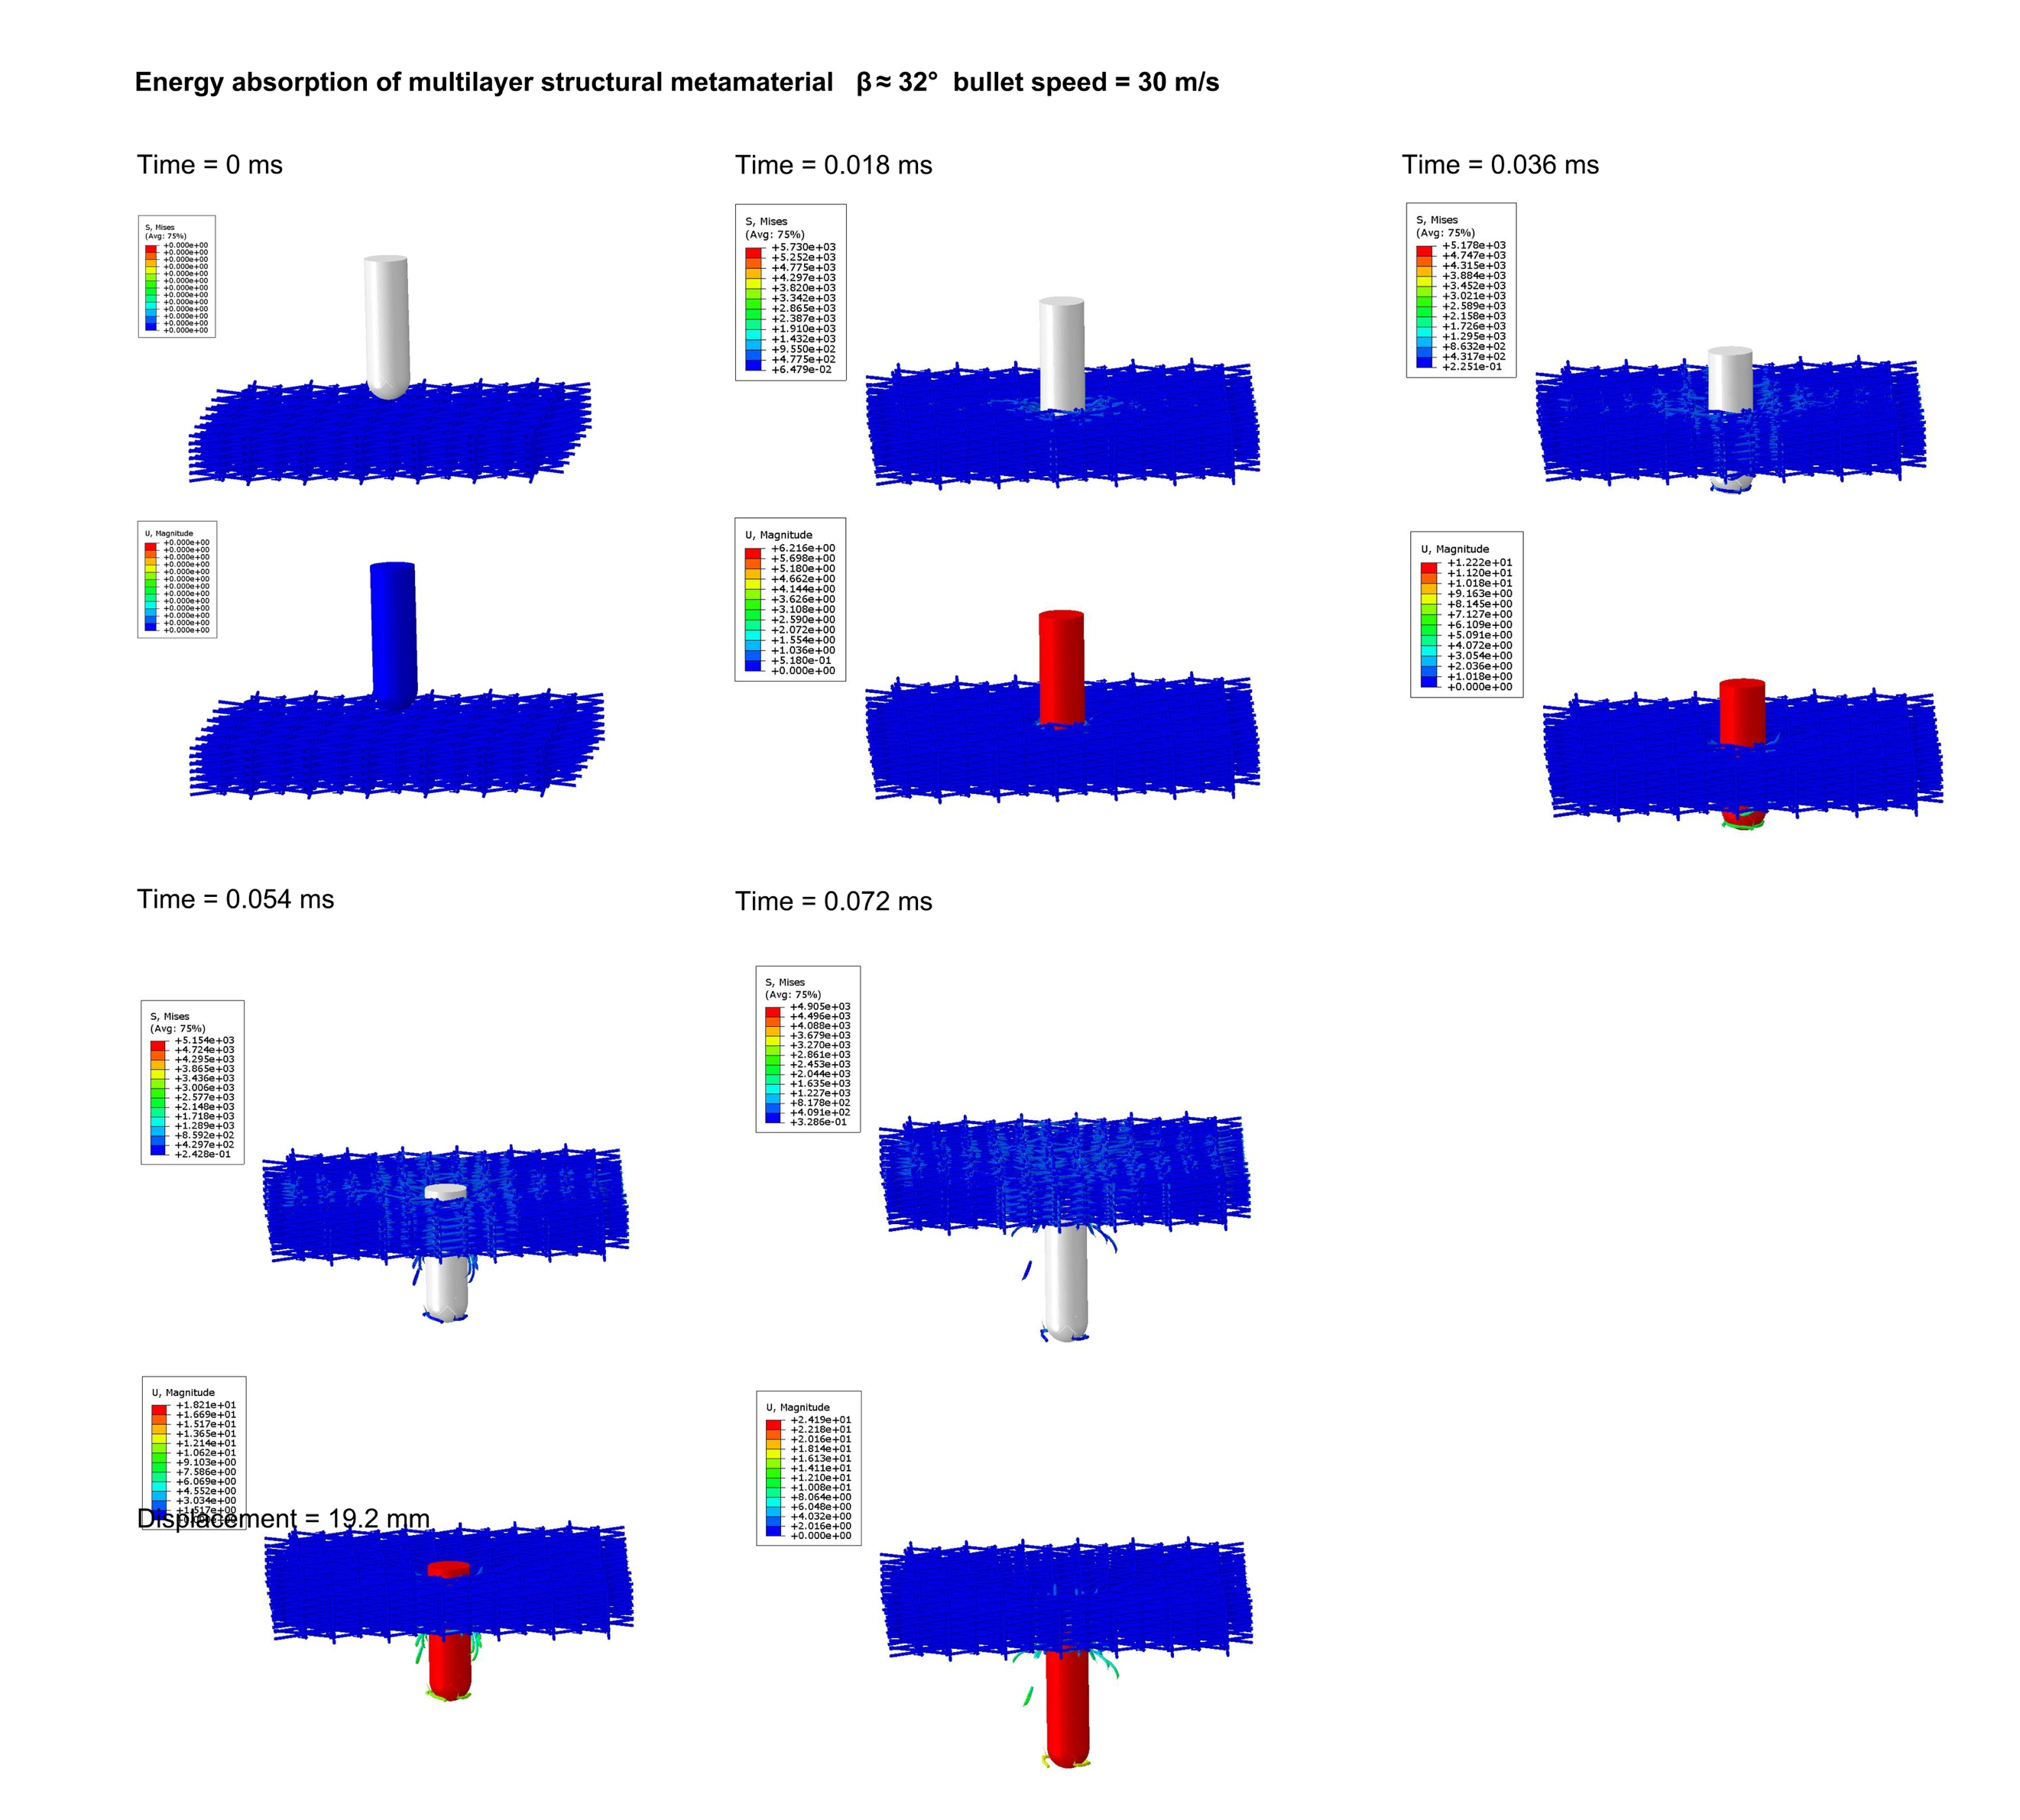
Info. 13 | Full-field impact response of the block-type metamaterial
A three-dimensional array of quadrilateral units was assembled to form a block-type structure, enabling evaluation of its energy absorption performance under impact loading and demonstrating its potential as a structural metamaterial. Each unit has dimensions of 41 mm × 41 mm × 41 mm. Three loading scenarios were considered:
(i) constant-velocity impact of the upper plate at 30 m/s, while the lower plate was fixed;
(ii) initial-velocity impact of the upper plate at 30 m/s, while the lower plate was fixed;
(iii) localized impact by a cylindrical projectile with an initial velocity of 30 m/s, while the lower plate was fixed.
The results show that the kinetic energy is primarily dissipated through structural deformation energy and interfacial frictional dissipation. The latter arises from contact, collision, and relative sliding between connected members, and is converted into heat, significantly enhancing the overall energy dissipation capacity. At the array level, neighboring units exhibit coordinated deformation, allowing impact energy to propagate progressively through the structure. This induces sequential plastic deformation and energy absorption across the array, effectively preventing localized energy concentration and resulting in a characteristic graded energy absorption behavior.
These mechanisms jointly mitigate the dynamic impact response of the structure. Notably, under constant-velocity impact, the protected component maintains a relatively low and stable load plateau during deformation, effectively suppressing peak impact forces and demonstrating superior impact resistance. Overall, the proposed structure exhibits robust energy absorption and distribution capabilities across different deployment states, highlighting its potential for multifunctional applications in impact mitigation and energy management.
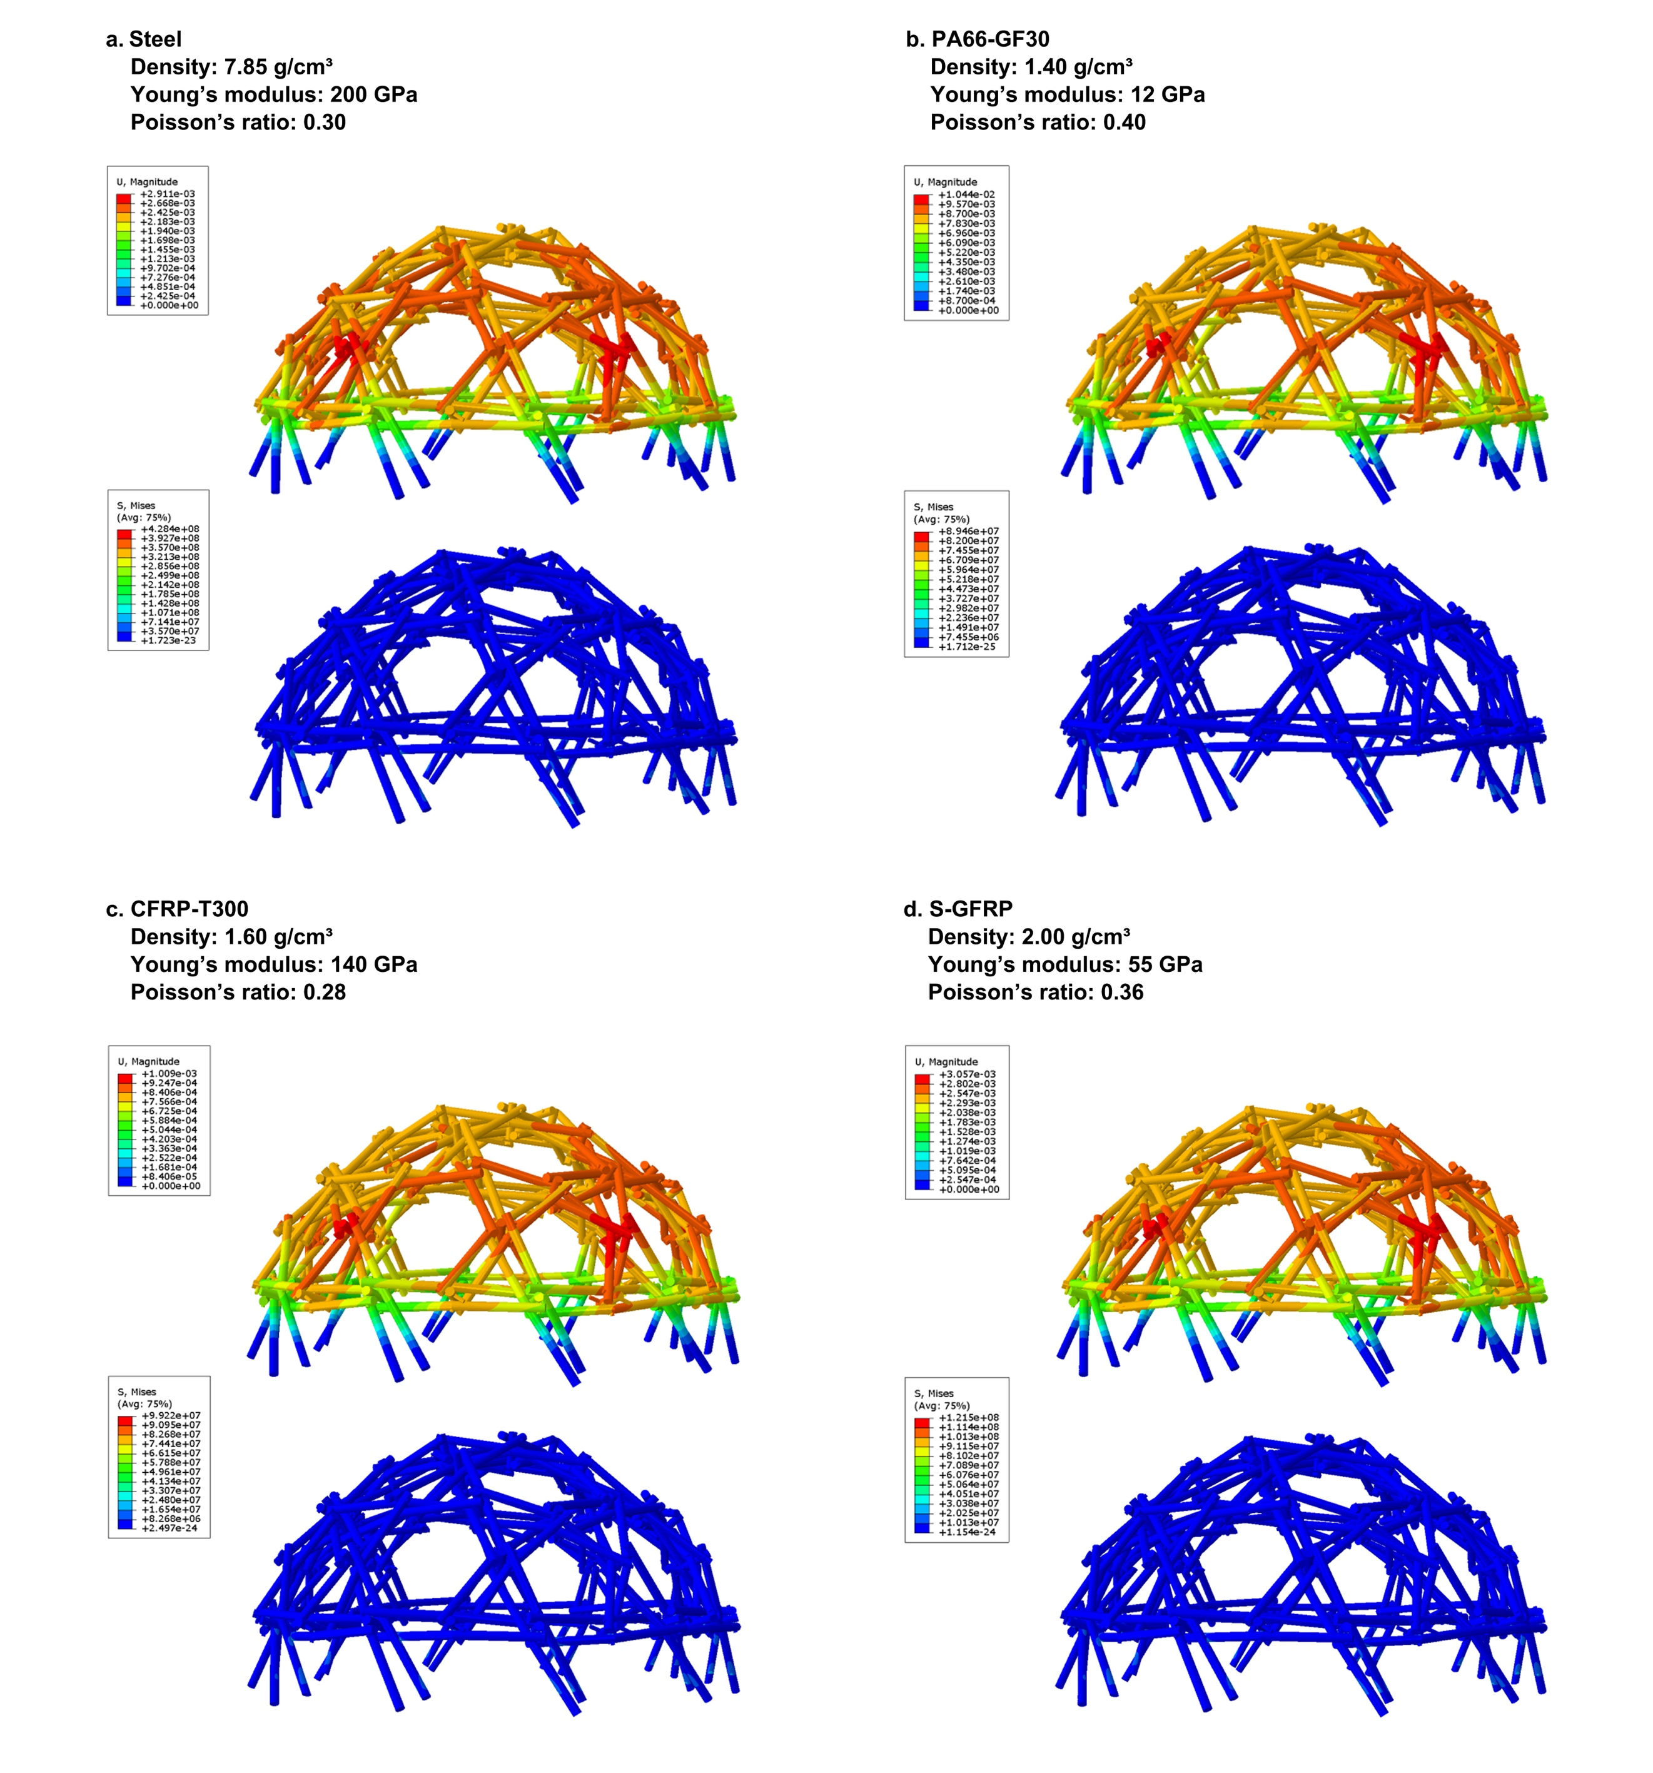
Info. 14 | Finite element analysis and experimental validation of large-scale curved structures under multiple material conditions
To evaluate the structural performance of the proposed reconfigurable mechanism at engineering scales, full-scale finite element (FE) simulations and scaled physical experiments were conducted on the deployed curved structure, representative of applications such as deployable domes and temporary protective systems.
For an 18 m span structure, the FE results show that under design loads, the stress distribution is overall uniform, and coordinated deformation is achieved across members due to the constraint effects of body connections, with no evident local stress concentration. The displacement field exhibits a smooth gradient, indicating a well-distributed structural response. Under various material parameter scenarios, the maximum displacement remains below 11 mm under combined dead and code-prescribed live loads, which is significantly lower than the allowable limit defined by building standards (JGJ 7-2010, L/400 = 45 mm). These results confirm the effectiveness and reliability of the structure in terms of load-bearing capacity and deformation control.
Compression tests (see Supplementary Video.2) on scaled physical models show that the structure undergoes stable and coordinated deformation in the initial loading stage, followed by brittle failure at critical states as the load increases. The experimental observations are consistent with the FE predictions in terms of overall response trends, indicating that the numerical model captures the essential mechanical behavior of the system.
Together, the full-scale simulations and scaled experiments demonstrate that the proposed reciprocal–folding mechanism significantly enhances mechanical coordination and deformation compatibility in large-scale curved structures. Combined with its inherent reconfigurability, the system shows strong potential for deployable surface structures under diverse geometric and loading conditions.
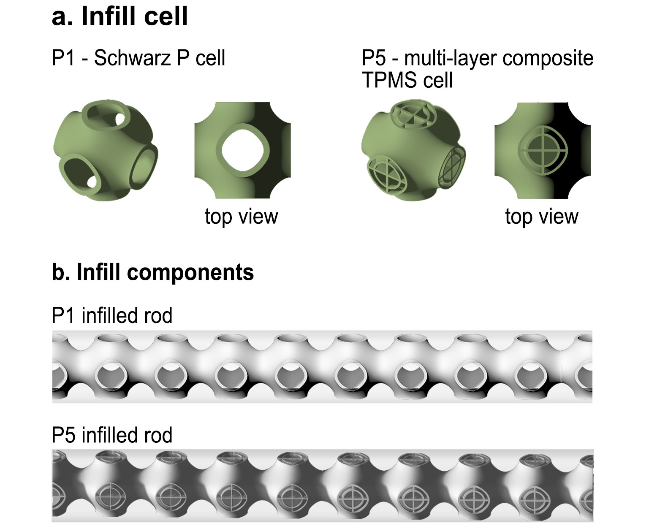
Info. 15 | Representative unit cells (P1 and P5) and their implementation as periodic lattice infill within cylindrical rods
The P1 unit is based on the Schwarz P minimal surface, a representative triply periodic minimal surface (TPMS) structure [40,41], whereas the P5 unit is a multilayer composite lattice that integrates beam, plate, and shell elements derived from TPMS architectures [42]. Both configurations form ordered and continuous internal networks analogous to biological trabecular structures, enabling efficient material distribution and enhanced mechanical performance.

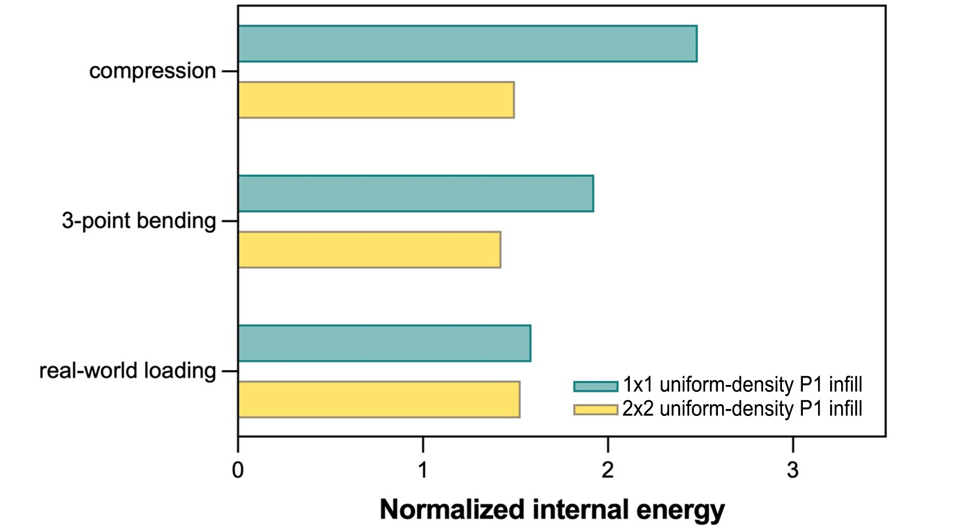
Info. 16 | Comparison of normalized strain energy between P1 and P5 structures
The mechanical performance of P1 and P5 infill strategies is evaluated using normalized internal energy under different loading conditions, including compression, three-point bending, and real-world body-connection scenarios. Under identical mass and loading conditions, lower internal energy indicates higher structural stiffness and load-bearing efficiency.
The results show that the P5 architecture consistently exhibits lower normalized internal energy than P1 across all loading conditions. This advantage is particularly pronounced under compression, while stable improvements are also observed in bending and real-world loading cases. Therefore, P5 is identified as the optimal base microstructure for subsequent design.

P1:
Generalized Zener ratio=2.7424
E_{min}=5568.8053 E_{max}=13683.9758
E_{xx}=5571.33 E_{yy}=5568.63, E_{zz}=5570.78
$υ$_{yz}=0.40, $υ$_{xz}=0.40, $υ$_{xy}=0.40
Gyz=5456.41, Gxz=5457.44, Gxy=5456.64
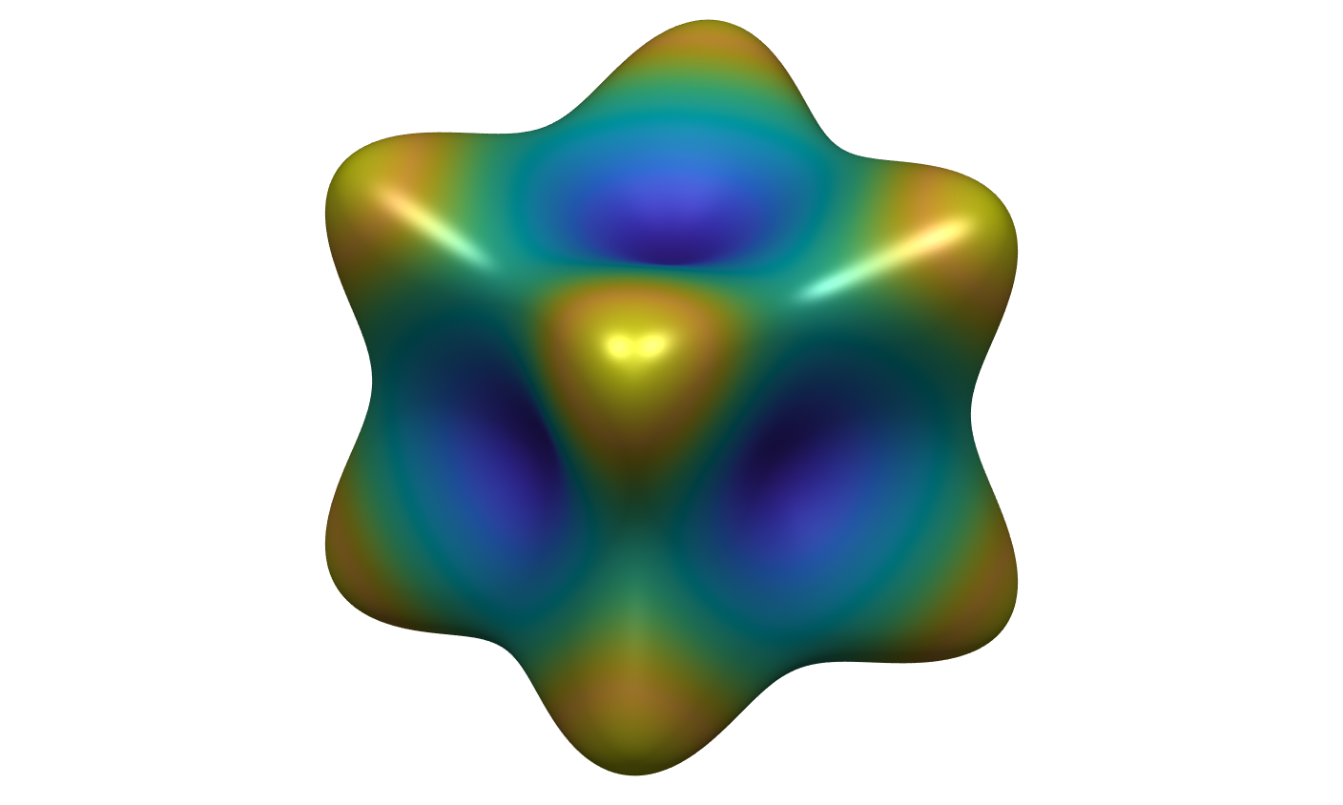
P5:
Generalized Zener ratio=0.9801
E_{min}=10695.1422 E_{max}=10879.5024
E_{xx}=10876.73, E_{yy}=10876.94, E_{zz}=10879.52
$υ$_{yz}=0.26, $υ$_{xz}=0.26, $υ$_{xy}=0.26
G_{yz}=4227.35, G_{xz}=4228.84, G_{xy}=4228.46
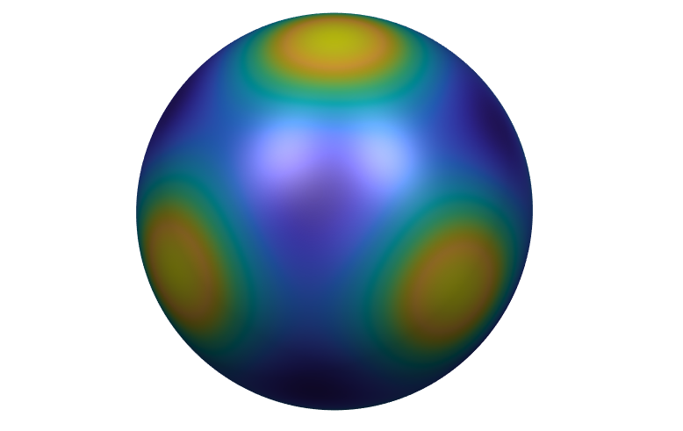
Info. 17 | Comparison of equivalent elastic moduli between P1 and P5 structures
A comparative analysis of the equivalent elastic moduli of the P1 and P5 metamaterial unit cells shows that the P5 structure exhibits clear advantages in both isotropy and stiffness efficiency. It demonstrates a more uniform distribution of elastic properties across different directions, approaching isotropic behavior, while achieving higher effective stiffness at the same relative density, thereby enabling improved mechanical performance.
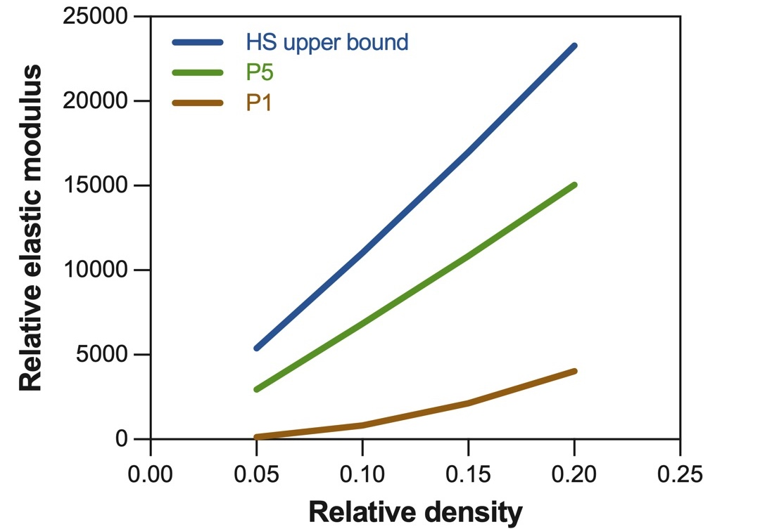
Info. 18 | Comparison with the Hashin–Shtrikman theoretical upper bound
The effective mechanical performance of different lattice configurations is evaluated against the Hashin–Shtrikman (HS) upper bound, which represents the theoretical maximum elastic modulus achievable for composite materials at a given relative density.
The results show that the P5 structure approaches the HS upper bound, indicating high stiffness efficiency enabled by its optimized material distribution and structural topology. In contrast, the P1 structure lies significantly below the theoretical limit, reflecting lower efficiency in stiffness utilization. Furthermore, the effective elastic modulus of the P5 structure exhibits an approximately linear relationship with relative density, suggesting a stable and scalable mechanical response.
Consequently, at the same relative density, the P5 configuration achieves a higher effective elastic modulus, leading to improved load-bearing performance in weight-constrained designs.

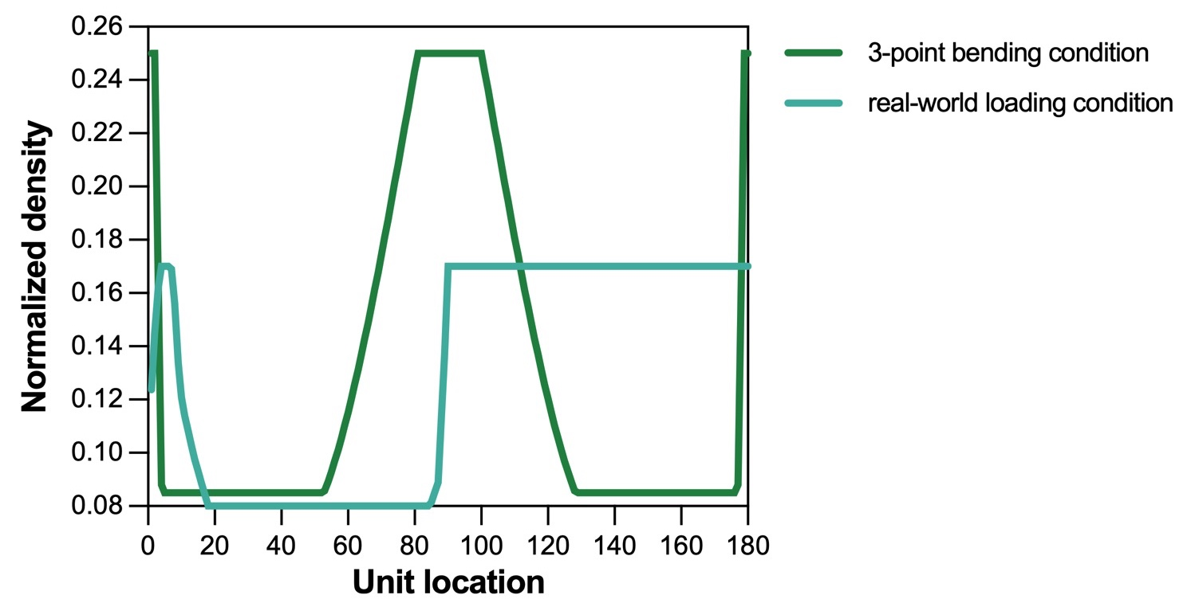
Info. 19 | Topology optimization and density mapping strategy
During topology optimization, a linking constraint is applied to enforce uniform density within each cross-section, ensuring that all elements in the same section share identical density values at each iteration. This results in a density distribution that varies along the longitudinal axis of the member.
To ensure manufacturability, the continuous density field is discretized into piecewise-constant segments. Specifically, the optimized density distribution is approximated as a series of equal-length segments along the axis, each assigned a constant density and realized through lattice arrays with corresponding wall thicknesses. The resulting axial density distribution after optimization is illustrated in the figure. This approach enables an effective transition from continuous optimization outputs to fabrication-ready geometries.
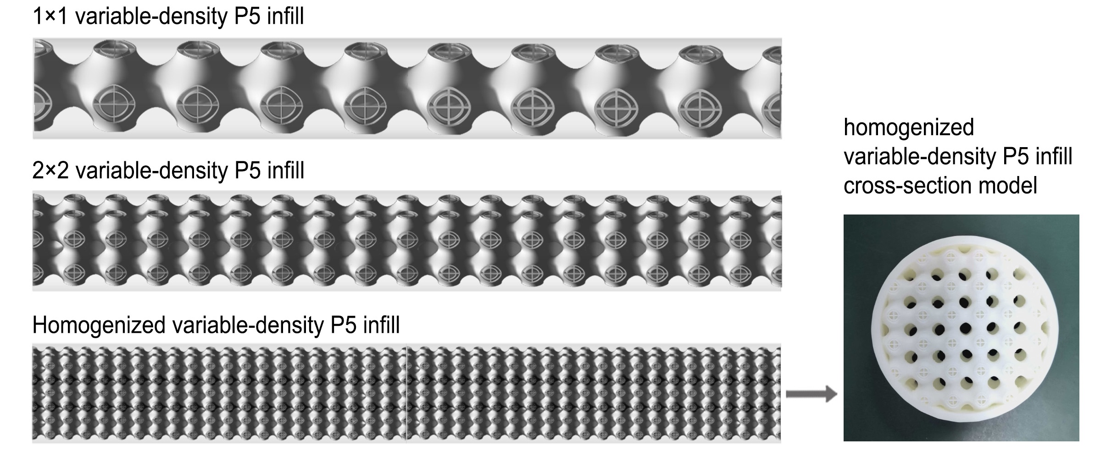
Info. 20 | Schematic of variable-density P5 infill with different sectional resolutions (3D and physical sectional models)
This figure illustrates variable-density P5 infill configurations at different sectional resolutions, including 1×1 unit cells, 2×2 lattice arrays, and homogenized infill representations. As the sectional resolution increases, the lattice distribution becomes finer, enabling a more accurate approximation of the continuous density field. Therefore, a homogenization approach is employed to transform the axially varying density distribution into an equivalent cross-sectional model, bridging the gap between discrete lattice representations and fabrication-ready geometries. The physical sectional model shown on the right further demonstrates the manufacturability of the proposed approach.
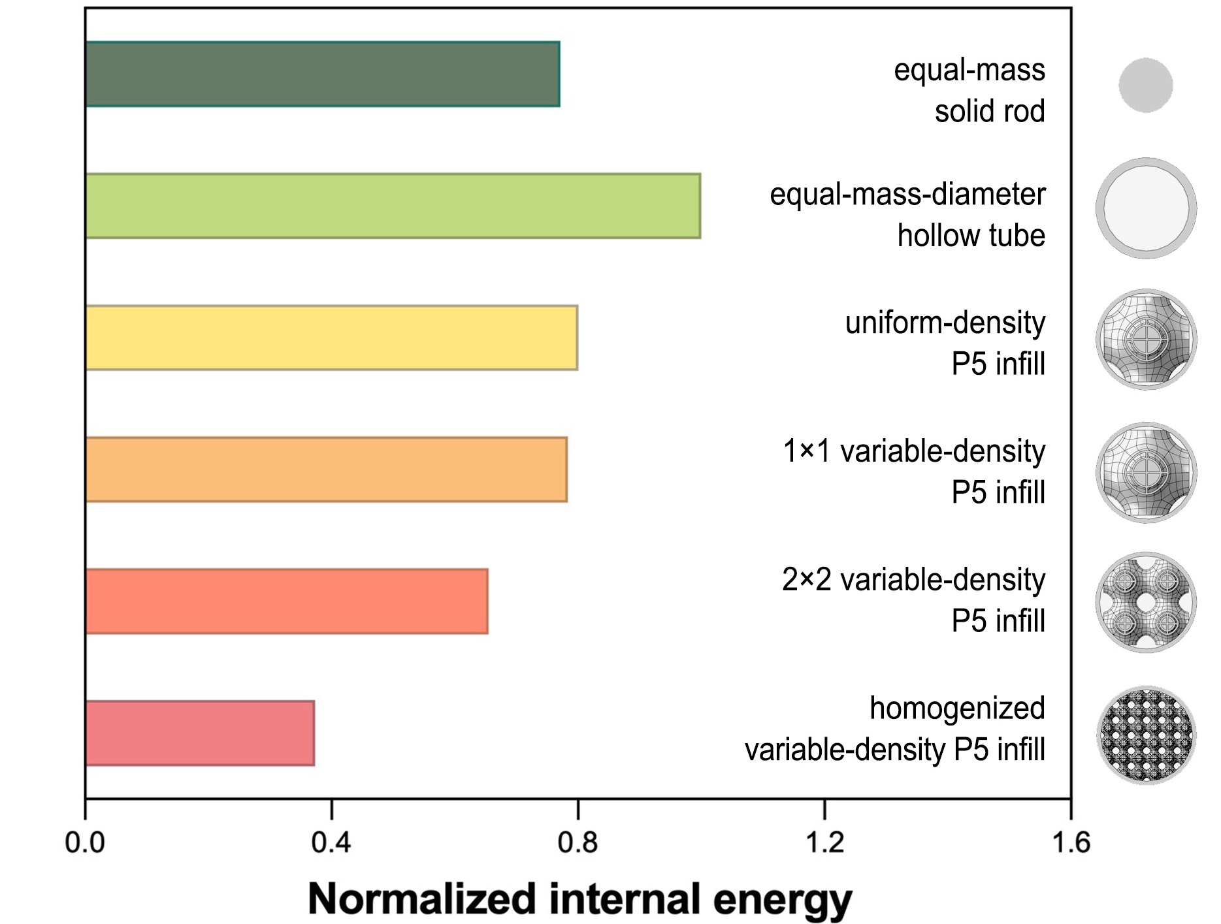
Info. 21 | Comparison of normalized internal energy for different rod configurations
The normalized strain energy is evaluated under real-world body-connection loading conditions to compare the mechanical performance of different rod configurations. Under equal-mass conditions, lower internal energy indicates higher stiffness and load-bearing efficiency.
The results show that increasing lattice resolution—from 1×1 and 2×2 configurations to homogenized variable-density infill—leads to a improved mechanical performance. Notably, even at a relatively coarse resolution (2×2), topology-optimized P5-filled rods outperform conventional configurations under the realistic loading condition, achieving stiffness improvements of approximately 21% over equal-mass solid rods and 50% over equal-mass, equal-diameter hollow tubes.
Furthermore, the homogenized variable-density P5 structure exhibits the lowest internal energy among all cases, demonstrating that the combination of topology optimization and density modulation effectively enhances stiffness and material efficiency under practical loading scenarios.
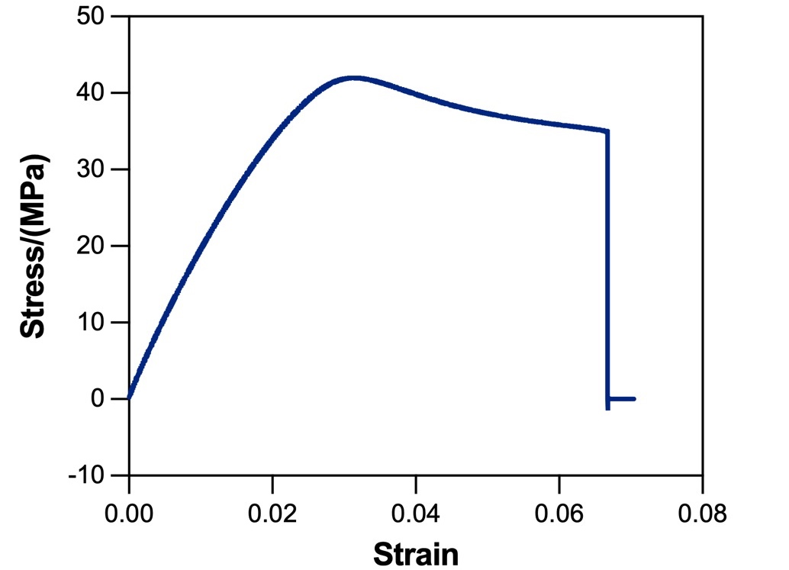
Info. 22 | Experimental material properties and printing parameters
Specimens in main text fig.3f were fabricated using stereolithography (SLA) additive manufacturing with a brittle photopolymer resin. Considering that different fabrication processes can induce variations in microstructure and thus affect mechanical properties, uniaxial tensile tests were conducted to characterize the material behavior under the specific printing conditions used in this study.
The resulting stress–strain curve is shown and was used to calibrate the material parameters in the finite element model. The material exhibits a characteristic elastic–plastic response during loading. These experimentally derived properties provide a reliable basis for defining the constitutive model, thereby improving the accuracy and credibility of the numerical simulations.
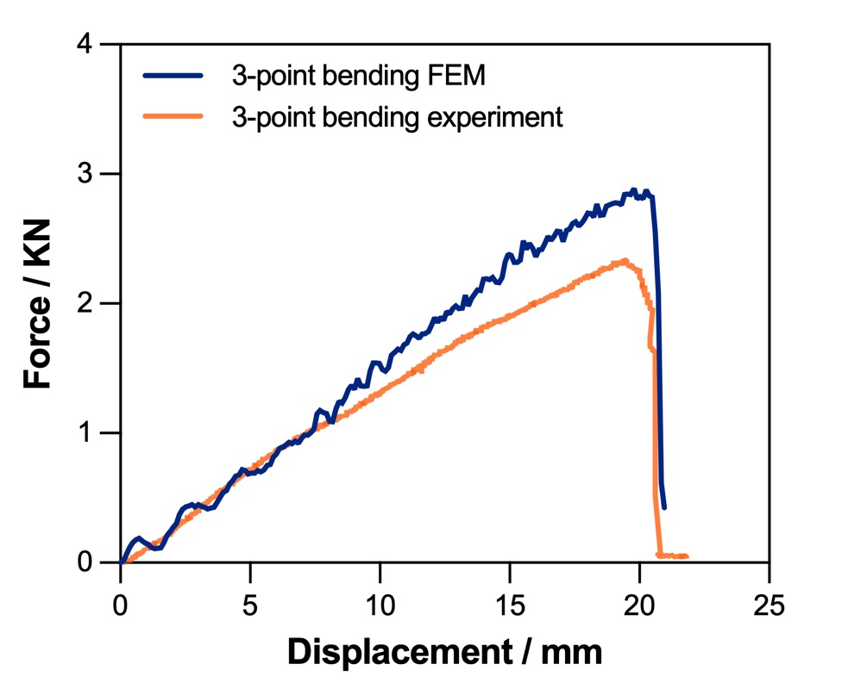
Info. 23 | Experimental validation of finite element analysis for metamaterial-filled members
Three-point bending tests were conducted on variable-density P5-filled members at a loading rate of 10 mm/min, and the results were compared with corresponding finite element simulations to validate the proposed design and modelling approach. The material constitutive model used in the finite element analysis is shown in Info. 22.
In finite element analysis, when boundary conditions are set with a fixed hinge support on one side and a rolling hinge support on the other, the model tends to appear stiffer due to factors such as contact deformation and gaps present in actual supports. As a result, when deformation is significant, the forces calculated by the finite element method for the same displacement tend to be slightly higher.
The finite element predictions show good agreement with experimental observations in terms of load–displacement response and deformation characteristics, demonstrating the model’s ability to accurately capture the mechanical behavior of the structure during loading. This validates the reliability of the numerical model for analyzing metamaterial-filled members (see Supplementary Info.21 & Fig. 3e in the main text).
Moreover, from an engineering perspective, structures in real-world applications are often subjected to unpredictable impacts and overloads. Conventional members tend to fail catastrophically under such conditions, exhibiting sudden fracture and fragmentation. In contrast, the metamaterial-filled members demonstrate a more ductile response and retain partial structural connectivity after failure. Combined with the system-level redundancy enabled by the reciprocal configuration, this behavior provides a critical time window for inspection and maintenance, thereby enhancing safety and reducing lifecycle costs. These features highlight the potential of the proposed design for future resilient and sustainable structural systems (see Supplementary Video.3).

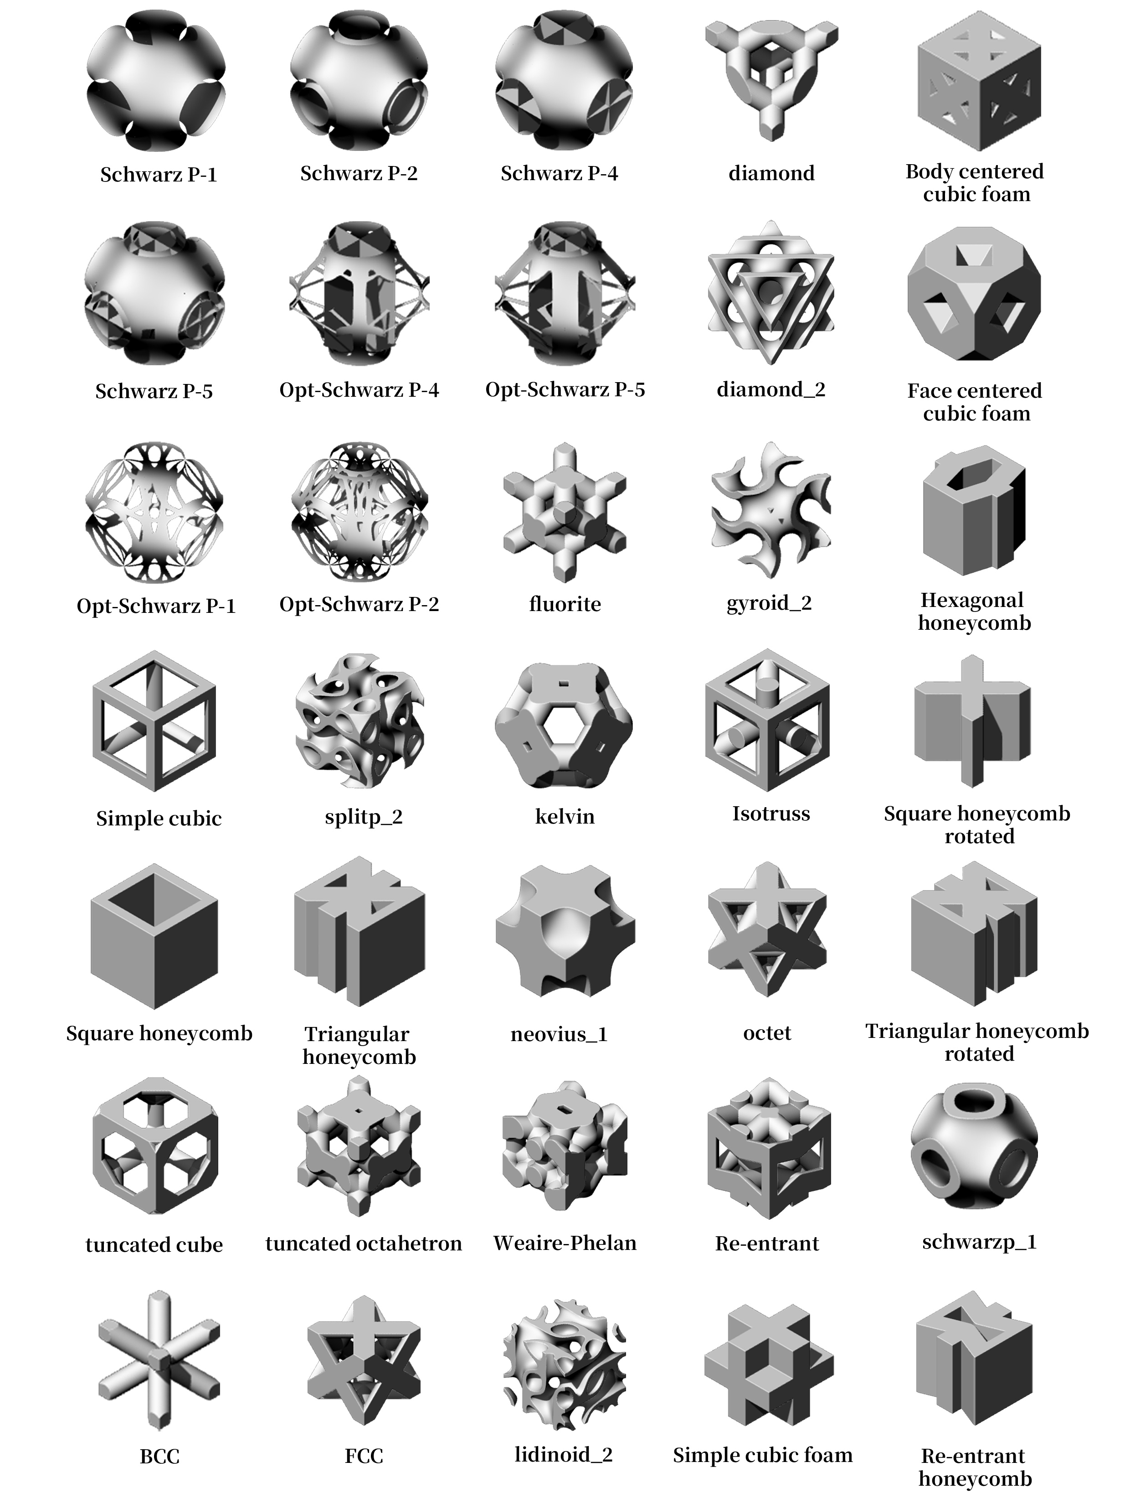
Info. 24 | Library of metamaterial lattice unit cells
This section presents a library of metamaterial lattice unit cells available for structural infill design, encompassing a range of topologies with distinct geometric and mechanical characteristics. The library provides a flexible design space, allowing lattice configurations to be selected and combined according to specific engineering requirements, such as load-bearing performance, weight reduction, and manufacturing constraints.
By introducing a lattice unit library, the proposed approach is extended from a single optimized configuration to a configurable design framework, enhancing its adaptability and scalability for diverse application scenarios.
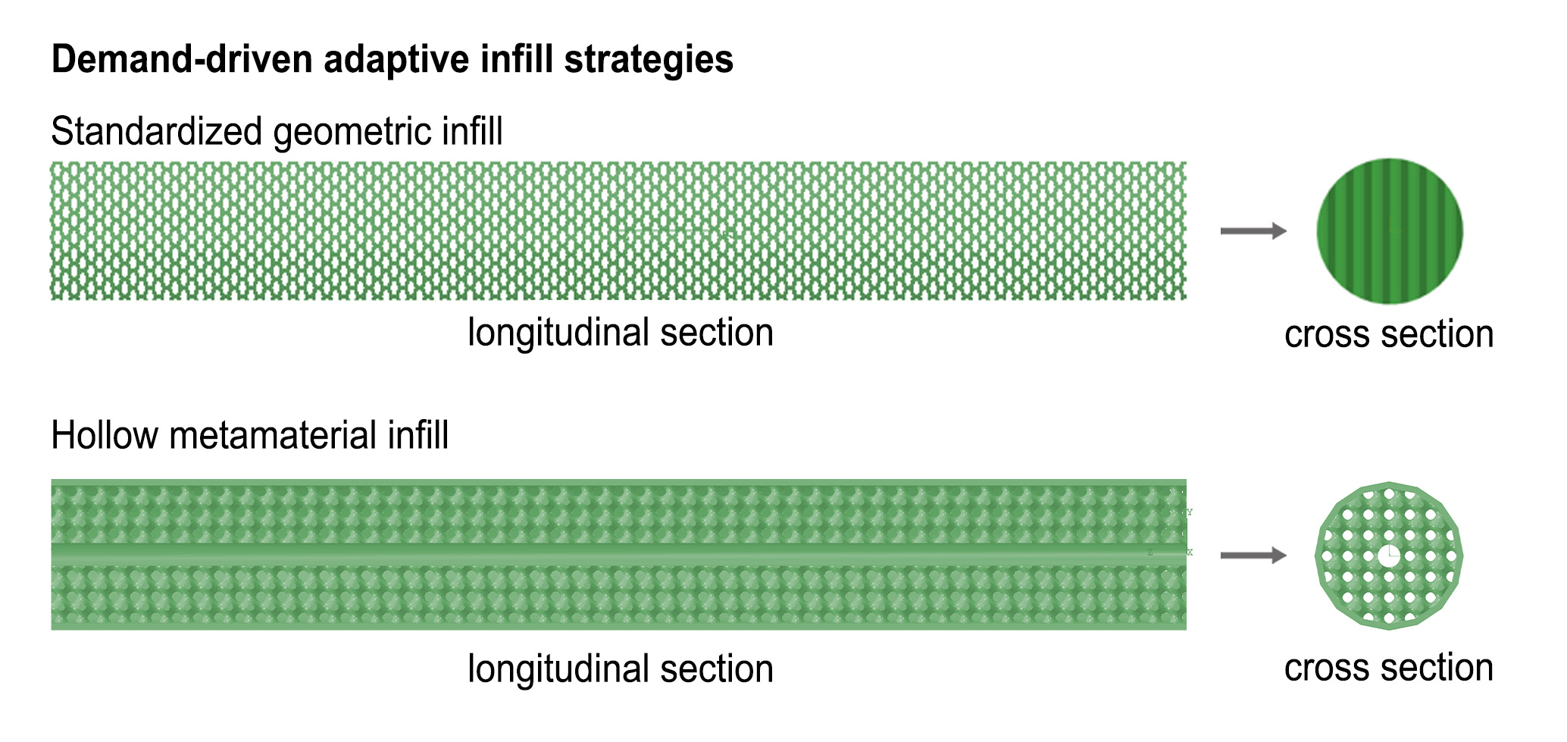
Info. 25 | Simplified configurations for engineering implementation
This section discusses simplified design strategies for metamaterial components under practical engineering constraints, such as manufacturing cost and fabrication efficiency. By adopting geometrically simpler lattice configurations or reducing unit complexity, it is possible to achieve more efficient production while maintaining essential mechanical performance.
In addition, these simplified configurations retain a degree of internal design flexibility, allowing for the integration of functional elements such as wiring, piping, or embedded components. This approach enables a balance between high-performance design and practical implementability, further enhancing the applicability and scalability of the proposed method in real-world engineering scenarios.
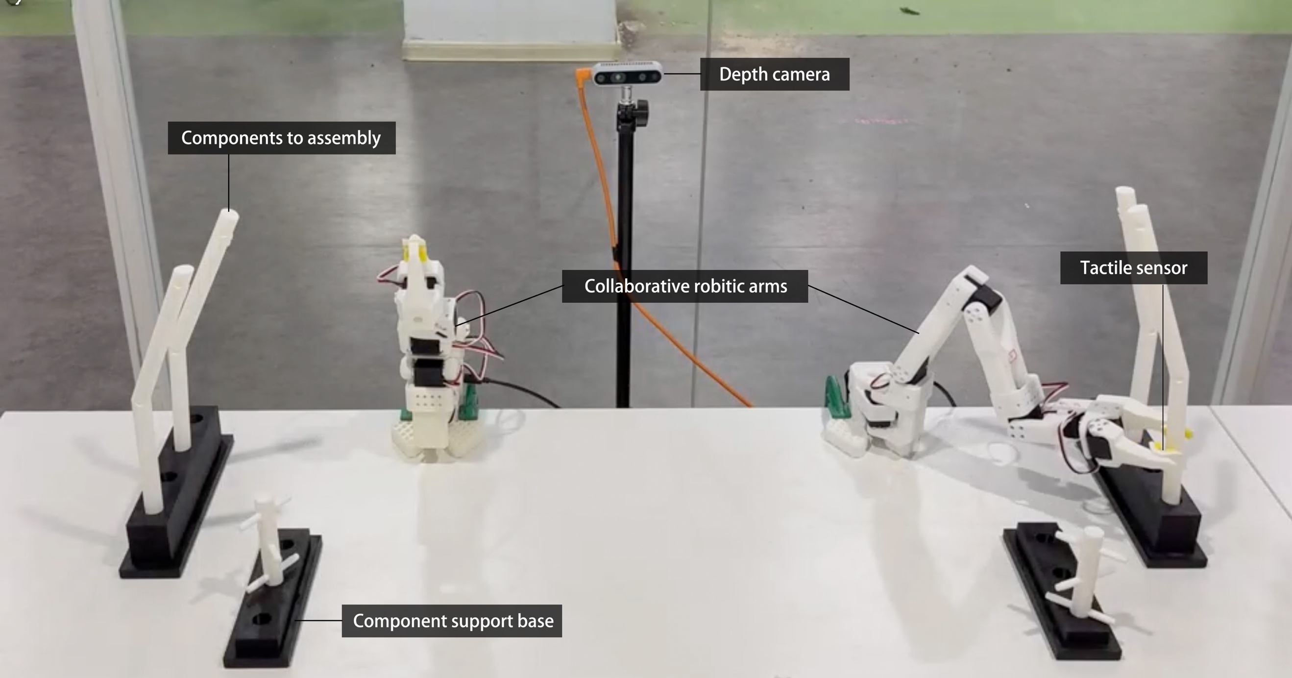
Info. 26 | Interface of the intelligent construction system
This section presents the overall interface and system configuration of the AI-driven construction platform. An Intel RealSense D435i depth camera is deployed in an eye-to-hand configuration to provide global visual perception and initial localization of the workspace.
At the execution level, the system integrates a pair of SO-ARM101 robotic arms equipped with custom-designed grippers and tactile sensors. This setup forms a vision–tactile multimodal perception system, enabling the robotic arms to autonomously perform precise operations such as component recognition, grasping, and insertion, thereby supporting high-accuracy assembly of complex structures.
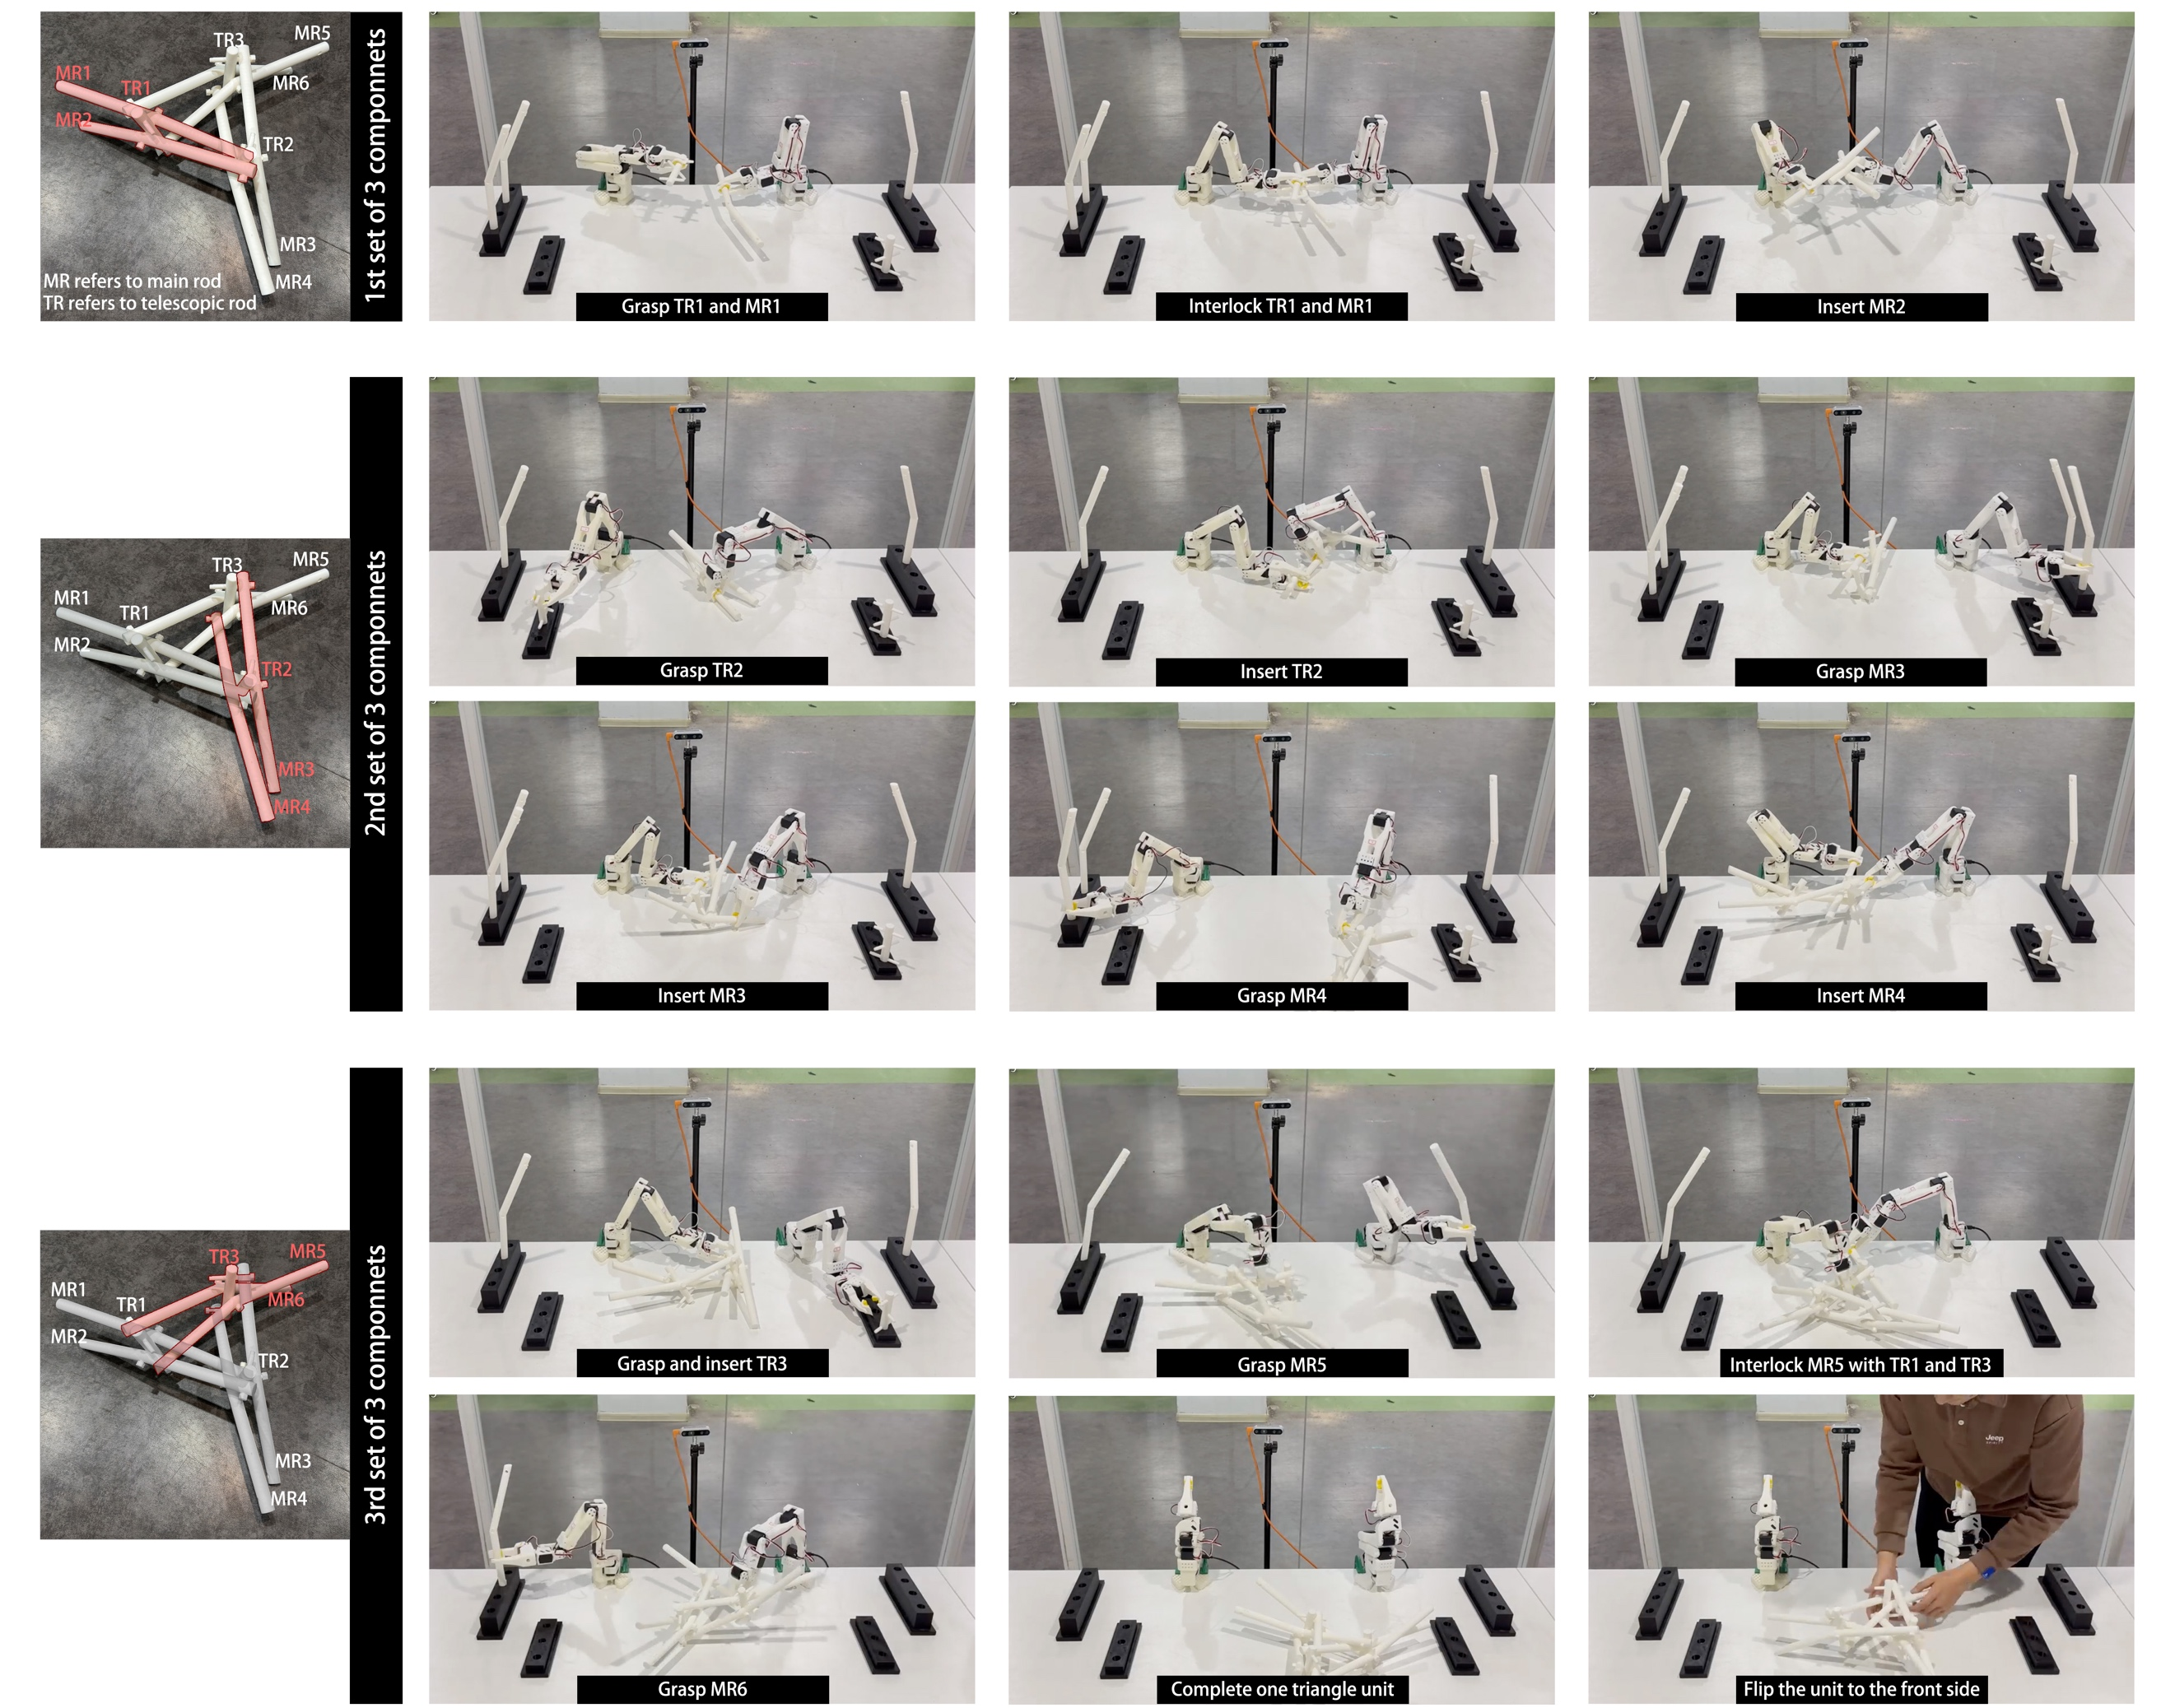
Info. 27 | Autonomous assembly strategy and implementation of structural units
This section presents an autonomous assembly framework based on a three-stage pipeline: human demonstration, simulation-based learning, and real-world execution (see Supplementary Video.4). To address the limitations of imitation learning (which requires extensive demonstrations) and reinforcement learning (which often suffers from poor generalization), a vision–tactile policy learning framework is proposed, integrating multimodal perception with reinforcement learning to enable precise robotic assembly. The method consists of three stages:
Stage 1: Human demonstration pretraining. Bimanual teleoperation is used to perform insertion tasks, and multimodal data—including visual point clouds, tactile signals, and robot pose information—are collected to pretrain a diffusion policy model.
Stage 2: Simulation-based fine-tuning. To overcome limited real-world demonstrations, a digital twin of the system is constructed in the Isaac Gym environment. High-fidelity tactile simulation is achieved using the TacSL library, generating vision–tactile point clouds and contact force distributions. The pretrained policy is further optimized using Diffusion Policy Policy Optimization (DPPO), improving stability and generalization.
Stage 3: Real-world deployment. The refined policy is transferred to the physical robotic system. Under multimodal vision–tactile perception, the robot executes insertion tasks through an iterative perception–adjustment loop. This approach overcomes the limitations of vision-only systems in handling occlusion, slippage, and contact uncertainty, significantly enhancing assembly accuracy and operational safety.
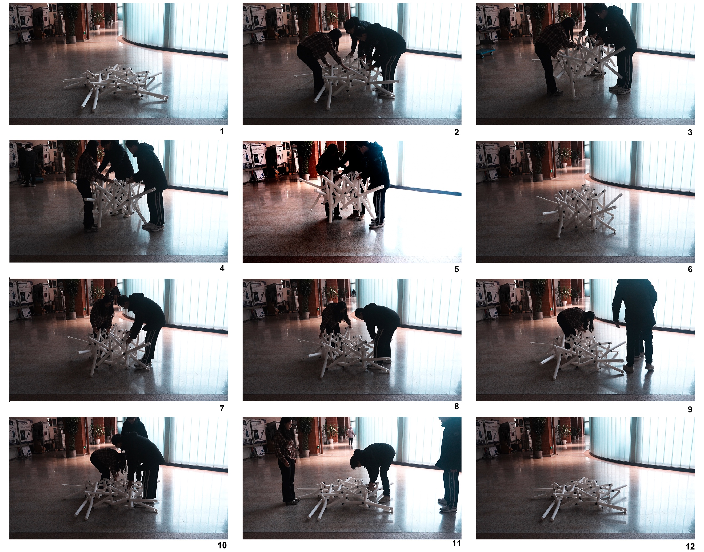
Info. 28 | Full-scale demonstration of a reciprocal-folding unit
This section presents the deployment process of the proposed reciprocal–folding configuration at full scale. This prototype is used to validate its geometric compatibility and kinematic feasibility under realistic conditions. Compared to scaled models, this experiment more accurately captures the effects of member dimensions, connection details, and manufacturing tolerances on structural reconfiguration.
The results show that the structure achieves continuous and controllable folding and deployment at full scale, without noticeable interference or jamming between members, and with stable motion trajectories. This demonstration confirms the practical feasibility of the proposed mechanism at the engineering scale and provides direct evidence for its applicability in real-world structural systems (see Supplementary Video.1).
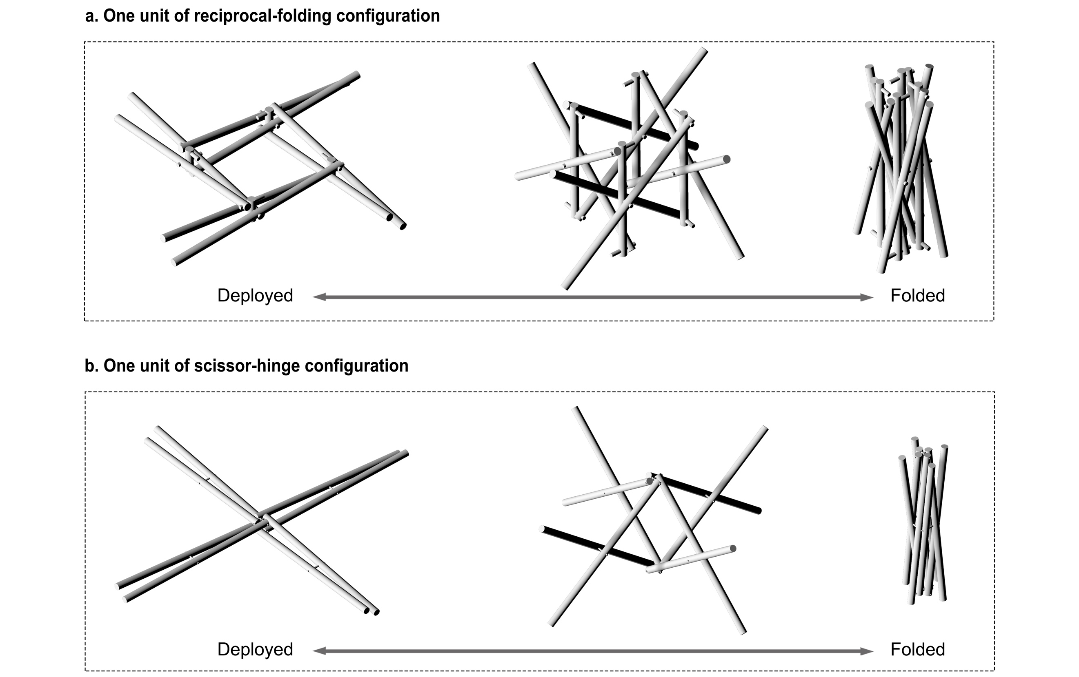
Info. 29 | Structural distinction between the proposed mechanism and scissor-hinge system
This section compares representative unit configurations to elucidate the relationship between structural complexity and geometric freedom in the proposed reciprocal–folding mechanism.
Although the reciprocal–folding configuration appears more spatially intricate at the global level, its nodal construction is significantly simplified. The connection strategy shifts from conventional end connections to body connections, where each joint involves only two intersecting members. This avoids the concentration of multiple members at a single node. In contrast, traditional scissor-hinge systems typically require at least four members to converge at each end joint, resulting in higher nodal complexity and stricter geometric constraints.
This transition from multi-member concentrated joints to distributed two-member connections effectively reduces constraints at the nodal level and redistributes structural complexity into the spatial configuration. As a result, the combinatorial freedom between units is significantly enhanced, enabling flexible topological expansion and supporting continuous evolution from triangular and quadrilateral to higher-order polygonal configurations, as well as adaptation to complex curved geometries.
The proposed mechanism thus exhibits a characteristic of global complexity with local simplicity: by simplifying nodes and distributing connections, it achieves greater geometric freedom and system scalability, offering a promising pathway for the generation of complex reconfigurable structures.
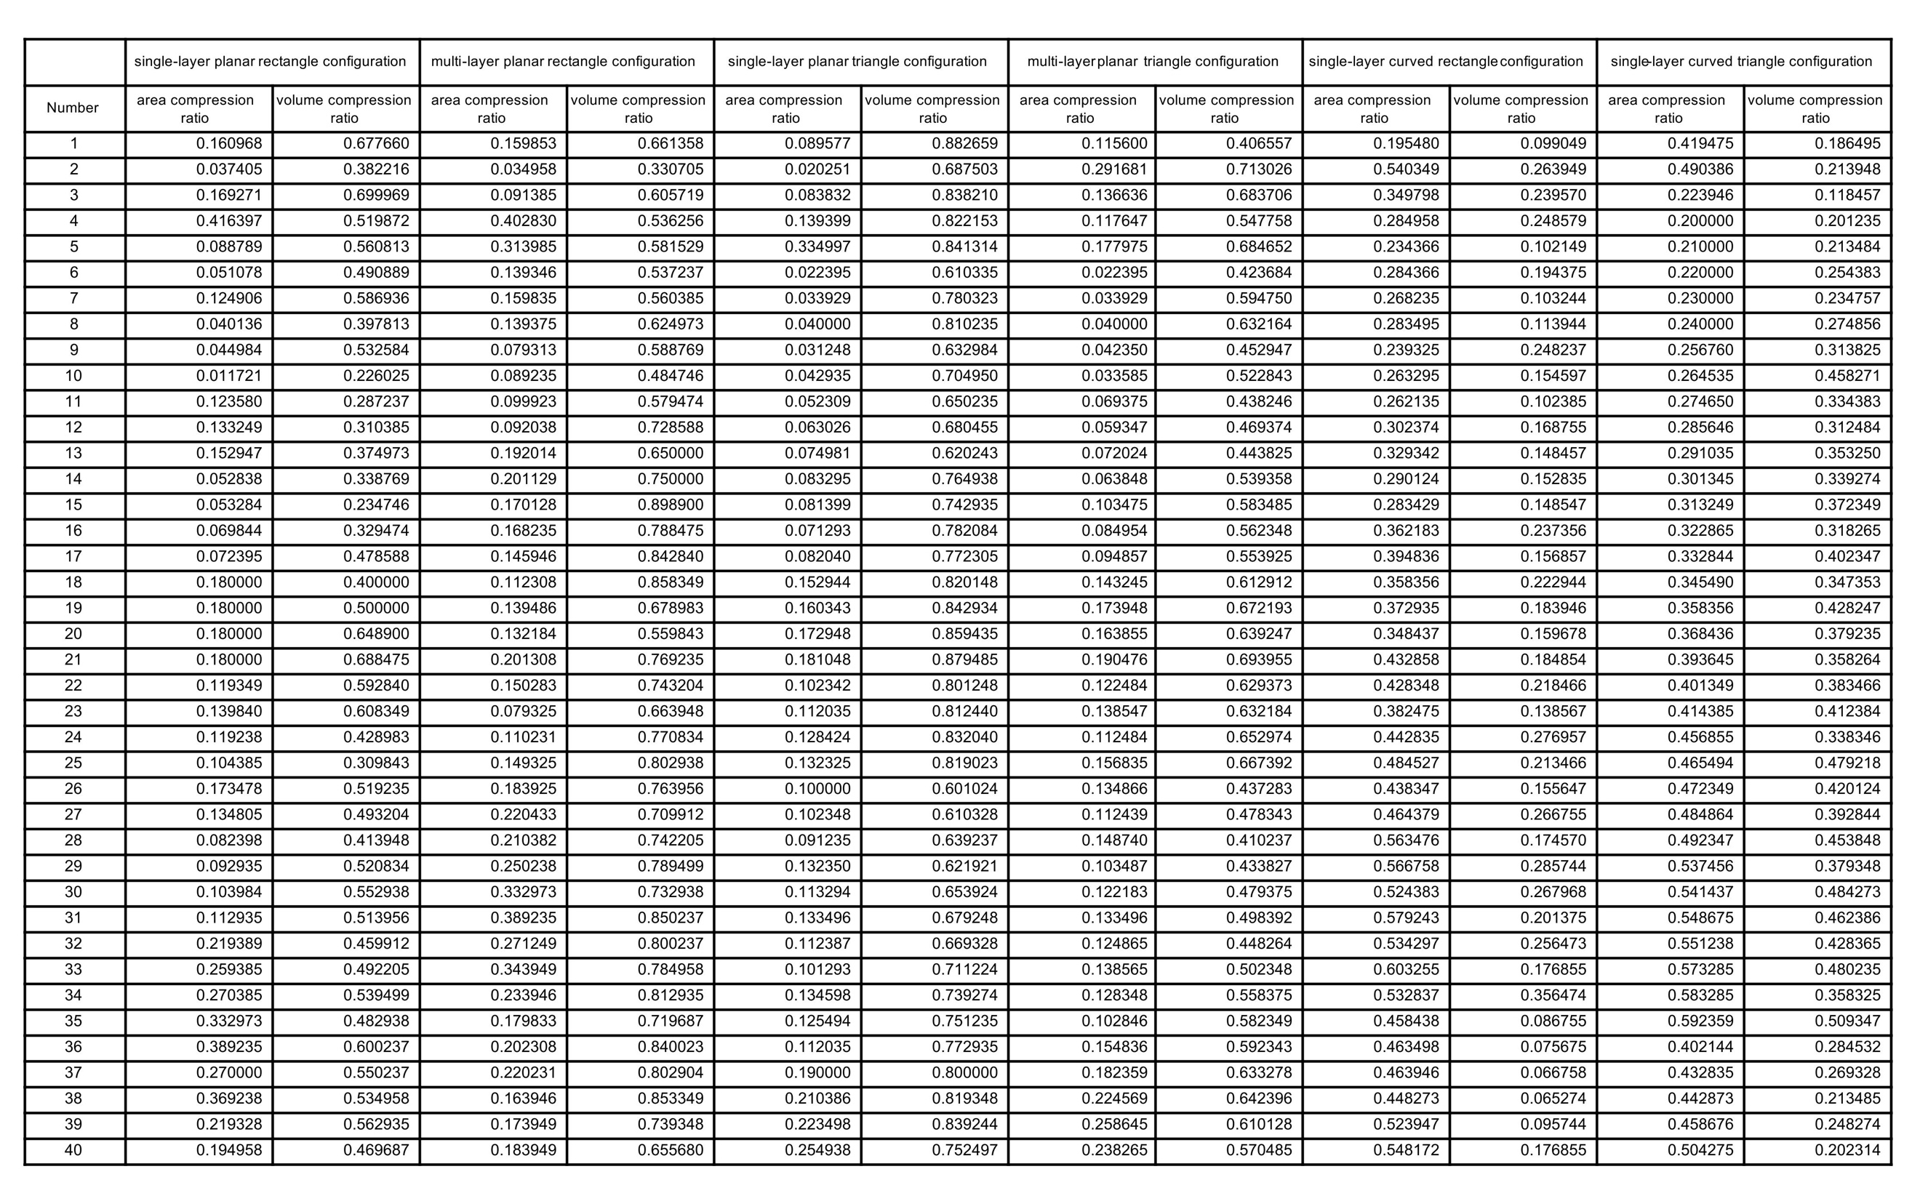
Info. 30 | Area and volume compression ratios of different configurations (first 40 cases)
This section presents the area and volume compression ratios of the proposed mechanism across different configuration parameters. The data are generated through parametric modeling and are used to quantitatively evaluate the spatial compression capability under varying topological and geometric conditions.
This dataset highlights the variation in compression efficiency across different configurations, demonstrating the adaptability of the mechanism across multiple scales and application scenarios.
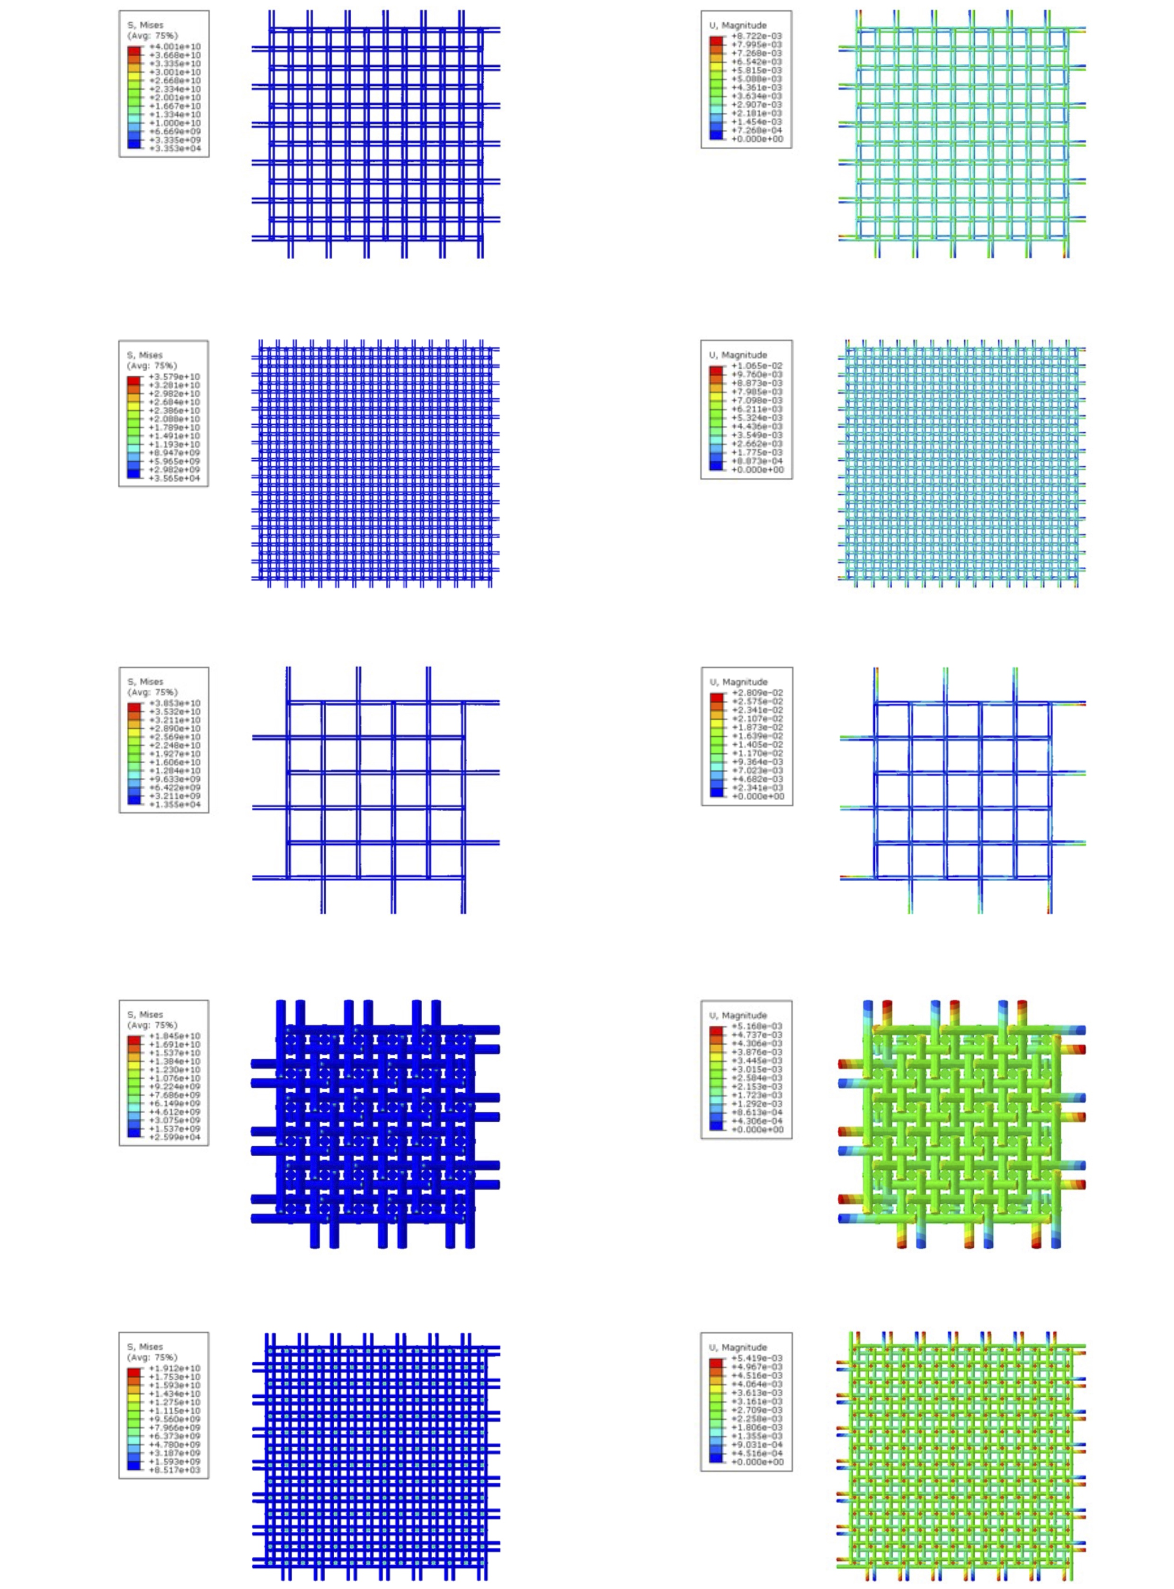
The Reciprocal-folding structures
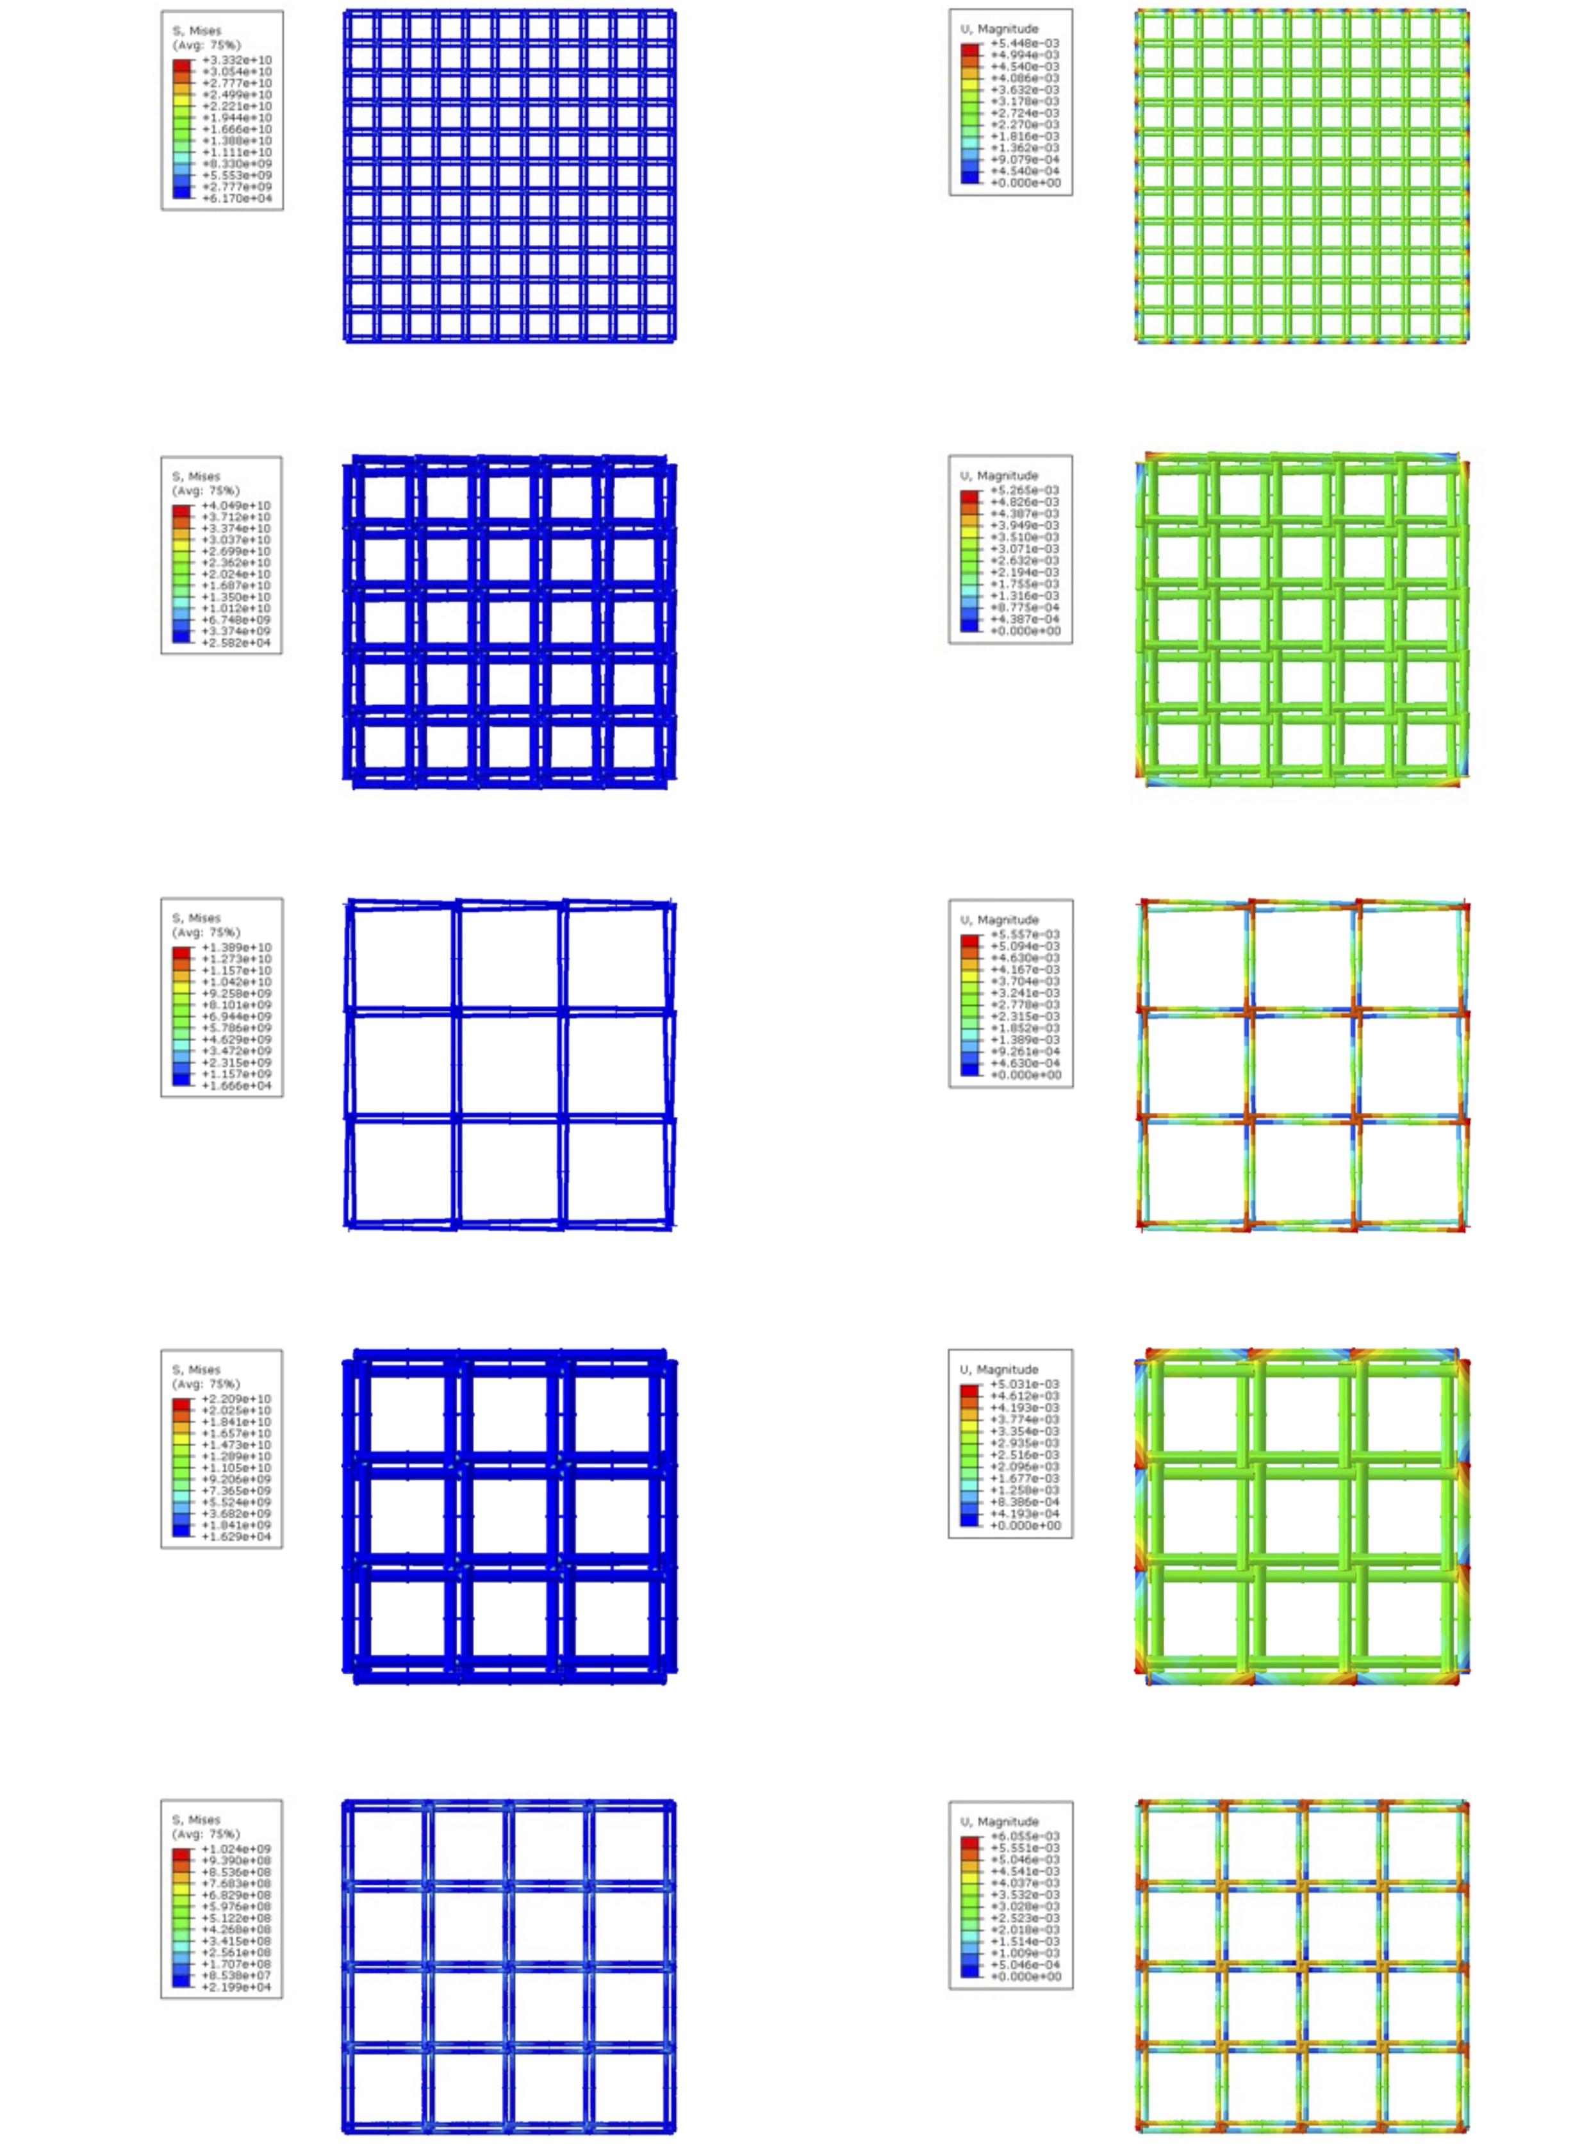
Scissor-hinge structures
Info. 31 | Representative finite element contour plots of typical configurations for the proposed mechanism and scissor-hinge structures (first 10 cases)
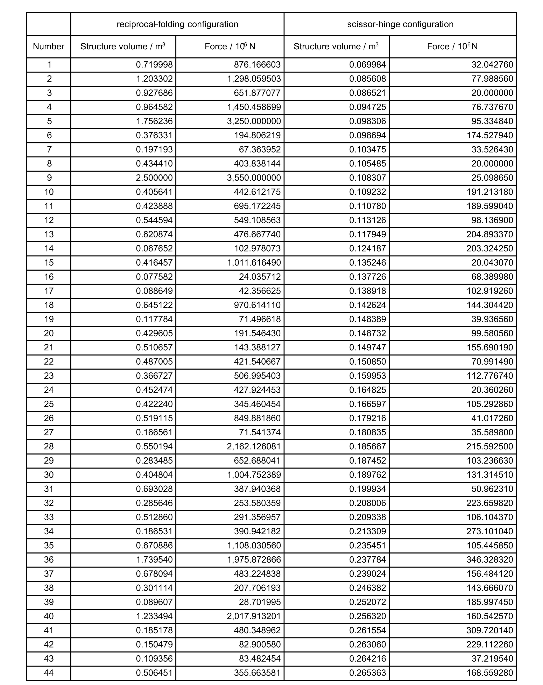
Info. 32 | Structural analysis data of the proposed mechanism and scissor-hinge structures (first 40 cases)
Category | Quantitative contribution | Value
Structural redundancy | Retained load-bearing capacity at 45% member loss (displacement = 15 mm) | 48%
Structural redundancy | Retained load-bearing capacity at 25% member loss (displacement = 15 mm) | 74%
Kinematic redundancy | Power compensation with 1 actuator failure (out of 4), while maintaining full deployment capability | +22%
Kinematic redundancy | Power compensation with 2 actuator failures (out of 4), while maintaining full deployment capability | +40%
Kinematic redundancy | Power compensation with 3 actuator failures (out of 4), enabling partial deployment | +64%
Transformability | Range of area compression ratio | 5%–82%
Transformability | Range of volume compression ratio | 7%–81%
Structural performance | Maximum displacement of 18 m span curved structure under design load | 11 mm
Structural performance | Average load-bearing advantage over scissor-hinge structures at equal structural mass | +55%
Lightweight and high-strength | Stiffness improvement of 2×2 P5-filled members over equal-mass solid rods | +21%
Lightweight and high-strength | Stiffness improvement of 2×2 P5-filled members over equal-mass, equal-diameter hollow rods | +50%
Lightweight and high-strength | Increase in plastic plateau (three-point bending) of homogenized P5-filled members over equal-mass solid rods | +43%
Lightweight and high-strength | Increase in plastic plateau (three-point bending) of homogenized P5-filled members over equal-mass, equal-diameter hollow rods | +20%
Lightweight and high-strength | Energy absorption improvement of 1×1 P5-filled members over equal-mass, equal-diameter hollow rods | +8%
Lightweight and high-strength | Energy absorption improvement of 1×1 P5-filled members over equal-diameter solid rods with +70% mass | +28%
Lightweight and high-strength | Energy absorption improvement of 2×2 P5-filled members over equal-mass, equal-diameter hollow rods | +44%
Lightweight and high-strength | Energy absorption improvement of 2×2 P5-filled members over equal-diameter solid rods with +70% mass | +70%
Info. 33 | Summary of quantitative advantages of the reciprocal–folding reconfigurable mechanism

