Appendix 1: Post-Surgery Therapy Protocol ACL Rehabilitation protocol

Stage | W e e k | Warm-up | Physiotherapy  Treatment | Range of motion (ROM) exercises (nº of repetitions x nº of series, seconds of rest between series) | Muscle activation excercises (nº of repetitions x nº of series, seconds of rest between series) | Full body resistance band exercises (nº of repetitions x nº of series, seconds of rest between series) | Gait training
Stage 1 | 1 | 10’ min walking crutches | Home excercise program (HEP)
Stage 1 | 2 | 10’ min walking crutches
Stage 2 | 3 | 10’min cyclo | - 4-way patellar movilizations  - Tibio-femoral joint movilizations  - Scar movilization | -Supine knee extension stretch (10x2, 30”)  - Heel slides (10x2, 30”)  - Seated/ standing soleus/gastroc stretch  (10x2, 30”) | - SAQ  (10x2, 30”)  - LAQ  (10x2, 30”)  - Gluteus bridge  (10x2, 30”)  - Side lying leg raises  (10x2, 30”) |  | - Marching with crutches (forward, backward, lateral)  - Tip-toe walking  - Heel walking
Stage 2 | 4 | 10’min cyclo | - 4-way patellar movilizations  - Tibio-femoral joint movilizations  - Scar movilization | -Supine knee extension stretch (10x2, 30”)  - Heel slides (10x2, 30”)  - Seated/ standing soleus/gastroc stretch  (10x2, 30”) | - SAQ  (10x2, 30”)  - LAQ  (10x2, 30”)  - Gluteus bridge  (10x2, 30”)  - Side lying leg raises  (10x2, 30”) |  | - Marching with crutches (forward, backward, lateral)  - Tip-toe walking  - Heel walking
Stage 2 | 5 | 10’min cyclo | - 4-way patellar movilizations  - Tibio-femoral joint movilizations  - Scar movilization | -Supine knee extension stretch (10x2, 30”)  - Heel slides (10x2, 30”)  - Seated/ standing soleus/gastroc stretch  (10x2, 30”) | - SAQ  (10x2, 30”)  - LAQ  (10x2, 30”)  - Gluteus bridge  (10x2, 30”)  - Side lying leg raises  (10x2, 30”) | - Double leg squats  (10x2, 30”) | - Marching (forward, backward, lateral)  - Tip-toe walking  - Heel walking
Stage 2 | 6 | 10’min cyclo | - 4-way patellar movilizations  - Tibio-femoral joint movilizations  - Scar movilization | -Supine knee extension stretch (10x2, 30”)  - Heel slides (10x2, 30”)  - Seated/ standing soleus/gastroc stretch  (10x2, 30”) | - SAQ  (10x2, 30”)  - LAQ  (10x2, 30”)  - Gluteus bridge  (10x2, 30”)  - Side lying leg raises  (10x2, 30”) | - Double leg squats  (10x2, 30”)  - Forward lunges  (10x2, 30”) | - Marching (forward, backward, lateral)  - Tip-toe walking  - Heel walking
Stage 3 | 7 | 10’min cyclo + 5’min elliptical workout | - Continue ROM excercises and streches as needed | - Isometric knee extension  (10x3, 30”)  - Side plank hip thrust  (10x3, 30”) | - LAQ  (10x2, 30”)  - Knee extension machine  (10x2, 30”) | - Double leg squats  (10x2, 30”)  - Forward lunges  (10x2, 30”)  - Reverse lunges  (10x2, 30”) | - Marching (forward, backward, lateral)  - Zig-zag stepping  - Side stepping
Stage 3 | 8 | 10’min cyclo + 5’min elliptical workout | - Continue ROM excercises and streches as needed | - Isometric knee extension  (10x3, 30”)  - Side plank hip thrust  (10x3, 30”) | - LAQ  (10x2, 30”)  - Knee extension machine  (10x2, 30”) | - Double leg squats  (10x2, 30”)  - Single leg squats  (10x2, 30”)  - Forward lunges  (10x2, 30”)  - Reverse lunges  (10x2, 30”) | - Marching (forward, backward, lateral)  - Zig-zag stepping  - Side stepping
Stage 3 | 9 | 10’min cyclo + 8’min elliptical workout | - Continue ROM excercises and streches as needed | - Isometric knee extension  (10x3, 30”)  - Side plank hip thrust  (10x3, 30”) | - LAQ  (10x3, 30”)  - Knee extension machine  (10x3, 30”) | - Double leg squats  (10x2, 30”)  - Single leg squats  (10x2, 30”)  - Forward lunges  (10x2, 30”)  - Reverse lunges  (10x2, 30”)  - Step ups and downs  (10x2, 30”) | - Marching (forward, backward, lateral)  - Zig-zag stepping  - Side stepping
Stage 3 | 10 | 10’min cyclo + 8’min elliptical workout | - Continue ROM excercises and streches as needed | - Isometric knee extension  (10x3, 30”)  - Side plank hip thrust (10x3, 30”) | - LAQ  (10x3, 30”)  - Knee extension machine  (10x3, 30”) | - Double leg squats  (10x2, 30”)  - Single leg squats  (10x2, 30”)  - Forward lunges  (10x2, 30”)  - Reverse lunges  (10x2, 30”)  - Step ups and downs  (10x2, 30”) | - Marching (forward, backward, lateral)  - Zig-zag stepping  - Side stepping
Stage 4 | 11 | 10’min cyclo + 10’min elliptical workout | - Continue ROM excercises and streches as needed | - Isometric knee extension  (10x3, 30”)  - Side plank hip thrust  (10x3, 30”) | - LAQ  (10x4, 30”)  - Knee extension machine  (10x4, 30”) | - Double leg squats  (10x3, 30”)  - Single leg squats  (10x3, 30”)  - Forward lunges  (10x3, 30”)  - Reverse lunges  (10x3, 30”)  - Step ups and downs  (10x3, 30”) | -Dynamic agility  -Acceleration  -Deceleration  -Change of direction
Stage 4 | 12 | 10’min cyclo + 10’min elliptical workout | - Continue ROM excercises and streches as needed | - Isometric knee extension  (10x3, 30”)  - Side plank hip thrust  (10x3, 30”) | - LAQ  (10x4, 30”)  - Knee extension machine  (10x4, 30”) | - Double leg squats  (10x3, 30”)  - Single leg squats  (10x3, 30”)  - Forward lunges  (10x3, 30”)  - Reverse lunges  (10x3, 30”)  - Step ups and downs  (10x3, 30”) | -Dynamic agility  -Acceleration  -Deceleration  -Change of direction
Stage 4 | 13 | 10’min cyclo + 10’min elliptical workout | - Continue ROM excercises and streches as needed | - Isometric knee extension  (10x3, 30”)  - Side plank hip thrust  (10x3, 30”) | - LAQ  (10x4, 30”)  - Knee extension machine  (10x4, 30”) | - Double leg squats  (10x3, 30”)  - Single leg squats  (10x3, 30”)  - Forward lunges  (10x3, 30”)  - Reverse lunges  (10x3, 30”)  - Step ups and downs  (10x3, 30”) | -Dynamic agility  -Running  -Acceleration  -Deceleration  -Change of direction  -Pivoting
Stage 4 | 14 | 10’min cyclo + 10’min elliptical workout | - Continue ROM excercises and streches as needed | - Isometric knee extension  (10x3, 30”)  - Side plank hip thrust  (10x3, 30”) | - LAQ  (10x4, 30”)  - Knee extension machine  (10x4, 30”) | - Double leg squats  (10x3, 30”)  - Single leg squats  (10x3, 30”)  - Forward lunges  (10x3, 30”)  - Reverse lunges  (10x3, 30”)  - Step ups and downs  (10x3, 30”) | -Dynamic agility  -Running  -Acceleration  -Deceleration  -Change of direction  -Pivoting

* Patients will be instructed on appropiate effusion management including application of ice and compression (10-15min), as well as elevation of the knee above the level of the heart (as needed throughout the day).

* All exercises will start to become more activity and work specific, as well as include reactionary and perturbation challenges in order to prepare the subject for return to activity and work.

* All patients will attend three weekly supervised sessions for 14-16 weeks with a total of 42-48 sessions (during the first two weeks, no rehabilitation sessions will be helded, patients will only perform the Home Exercise Program).

* In the event that a patient needs to continue rehabilitation beyond week 14, the exercise protocol will be the same as specified in week 14, until the rehabilitation program is completed.

* The duration of the sessions will range from 45 to 60 min, with the intensity increasing weekly through an increase in the number of repetitions, the intensity ot the excercises, the diffulty of the exercises or reduction in rest times. Exercise intensity will be progressively increased if the participant report less than a 7 on the rating of perceived effort scale (Table 1).

0 | No effort
1 | Extremely Easy
2
3 | Easy
4
5 | Somewhat hard
6
7 | Hard
8
9 | Very hard
10 | Maximal effort

Table 1. Rating of perceived effort

The scale begins at 0, which is defined as no physical effort is taking place. This can be linked to the perception of effort sitting on an exercise machine but not having to exert any effort to complete the activity. The scale ends at 10, which is described as the maximum effort. This can be linked to the perception of effort when, despite putting forth as much exertion as you can, you cannot physically complete the activity being attempted.

STAGE 1: Home Exercise Program (HEP) (0-2 weeks post-surgery)

Time: initiate as soon as possible post-surgery (6-12 hours) and end 2 weeks postsurgery

Description of Stage: This stage will include one session focussed on education for the Home Exercise Program taught by the physiotherapist: effusion management, pain control, muscle contraction activation, improving range of motion, strengthening knee and walking with crutches. This session will be taught few hours after the surgery, once the effects of anesthesia have worn off. This information is also provided in an informative brochure with clear and comprenhsive infographic.

Each session of the HEP will take approximately 20 minutes. Patient is encouraged to complete at least two sessions daily, one in the morning and one in the afternoon.

Goals:
1- ROM from full active knee extension to at least 90 degrees knee flexion
2- Minimal to no effusion
3- Maximum subjective pain raiting of <4/10 during daily activities
4- Walking with partial weight-bearing with the aid of crutches and going up and down stairs

Range of motion excercises (ROM):

- 4-way patellar mobilizations
- Tibial-femoral joint mobilizations for flexion and extension
- Supine knee extension stretch
- Seated knee flexion stretch

Muscle activation excercises:

- SAQ
- LAQ
- Supine SLR

Gait training excersises:

- Weight shifting (side-to-side and front-to-back)
- Marching (forward, backward, lateral)
- Tip-toe walking
- Heel walking

STAGE 2: 3-6 weeks post-surgery

Time: initiate 2 weeks postsurgery and end 6 weeks postsurgery

Description of stage: effusion management, improving range of motion, and strengtheningn post-surgery with the goal of returning to walk without crtuches. It includes 3 weekly sesiones of 60 minutes each. The sessions are complemented with the Home Exercise Program by patients themselves as many times per day as they needed.

Goals:
1- Range of motion from full active knee extension to full knee flexion (at least 120 degrees knee flexion)
2- Minimal effusion
3- Maxium subjective pain raiting of <4/10 durin typical activities of daily living
4- Normalize walking pattern without crutches

STAGE 3: 7-10 weeks post-surgery

Time: initiate when all goals of stage 2 have been achieved. On average, this will begin 6-8 weeks after surgery

Description of stage: progression of strengthening, propioception exercises, and functional mobility. It also includes 3 weekly sesiones of 60 minutes each. The sessions are complemented with the Home Exercise Program by patients themselves as many times per day as they needed.

Goals:
1- Full ROM
2- No effusion
3- Maxium subjective pain raiting of <4/10 durin rehabilitation exercises and no pain with gait or other daily activities
4- Strenght progression

STAGE 4: 11-14 weeks post-surgery

Time: initiate when all goals of stage 3 have been achieved. On average, this will begin 10-12 weeks after surgery

Description of stage: progression of strengthening, propioception exercises, and functional mobility in order to prepare for return to full activity and work. It also includes 3 weekly sesiones of 60 minutes each. The sessions are complemented with the Home Exercise Program by patients themselves as many times per day as they needed.

Goals:
1- Progress from double limb to single limb impact control
2- Develop proper technique and appropiate neuromuscular control with dynamic movement patterns
3- Eliminate fear an apprehension with work-specific activities
4- Return to full activity

Description of the initial position and final position of the rehabilitation exercises using BRF device:

Warm-up:

- Cyclo

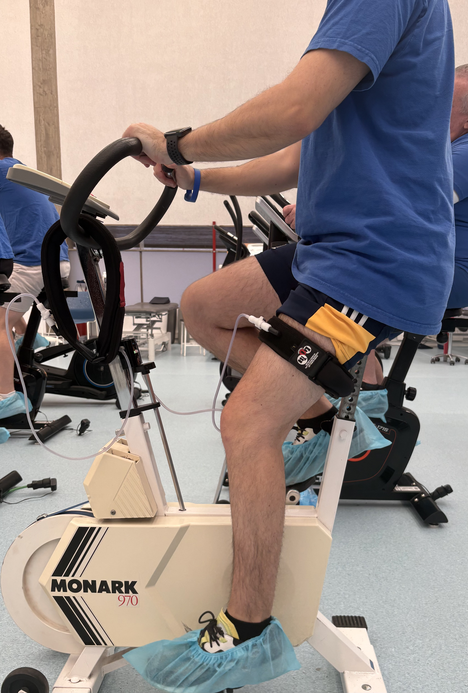

- Elliptical work-out

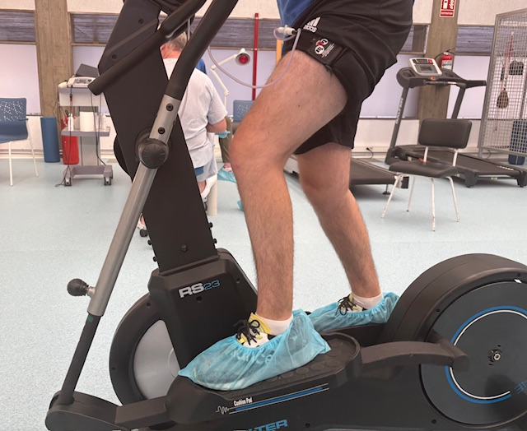

ROM exercises:
- Supine knee extension stretch

Initial position Final position

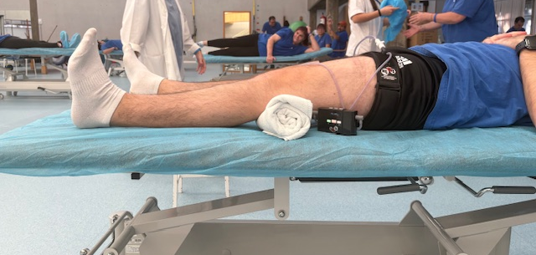
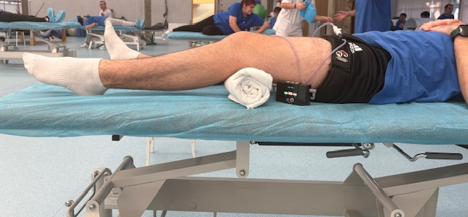

- Heel slides

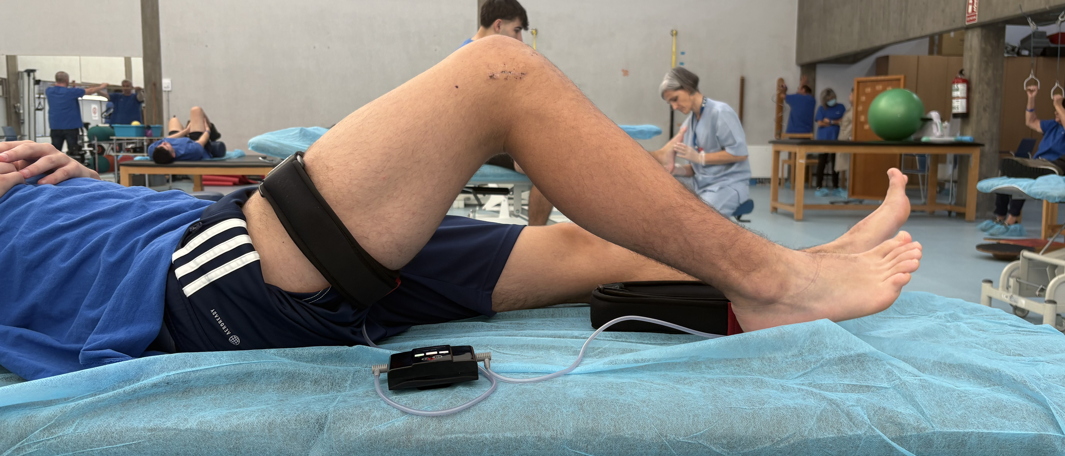
Initial position Final position
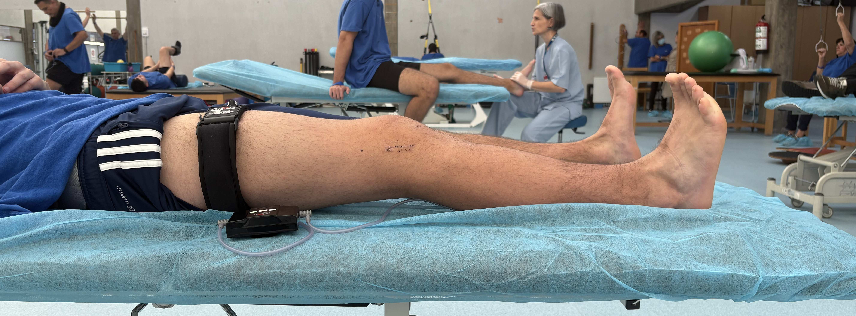

- Seated/ standing soleus/gastroc stretch

Initial position Final position

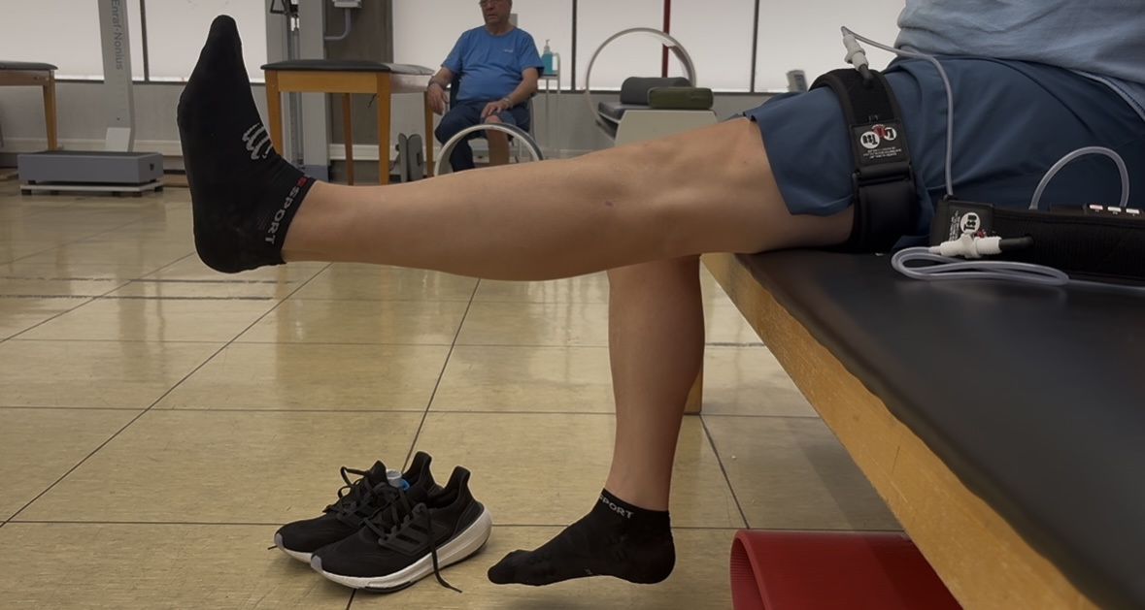
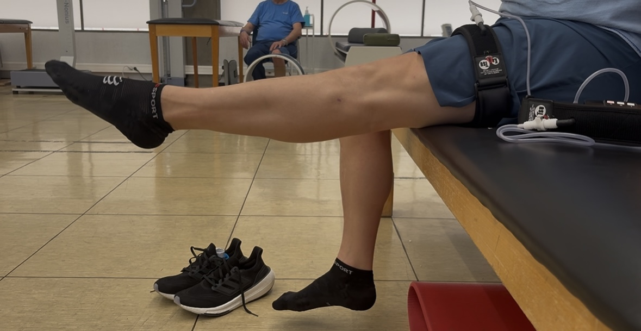

- Isometric knee extension

Initial position Final position
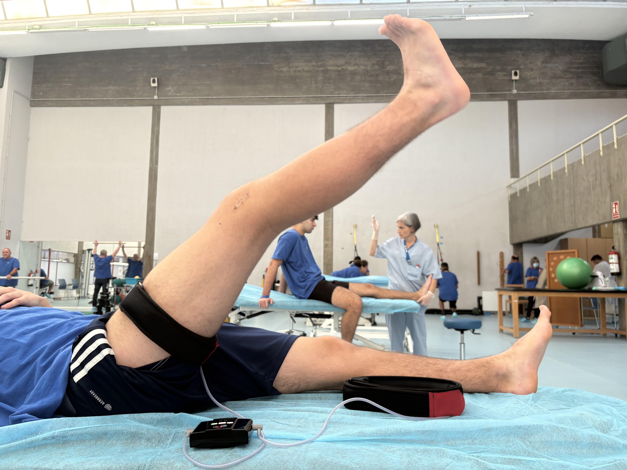

- Side plank hip thrust

Initial position Final position
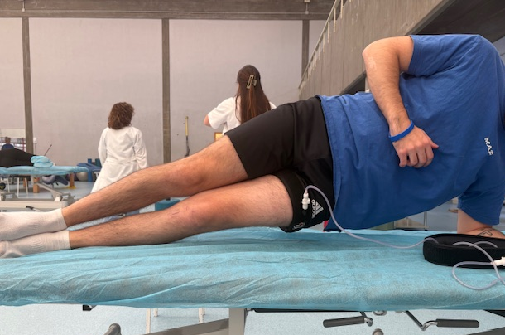
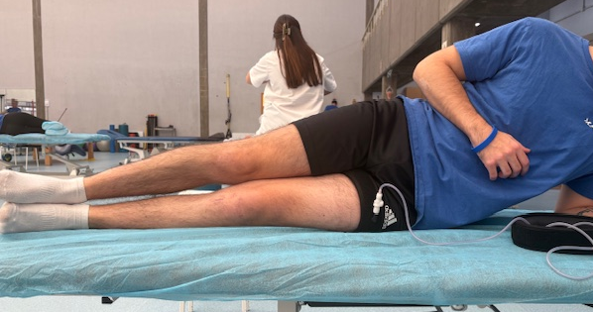

- Side plank hip thrust + knee flexion

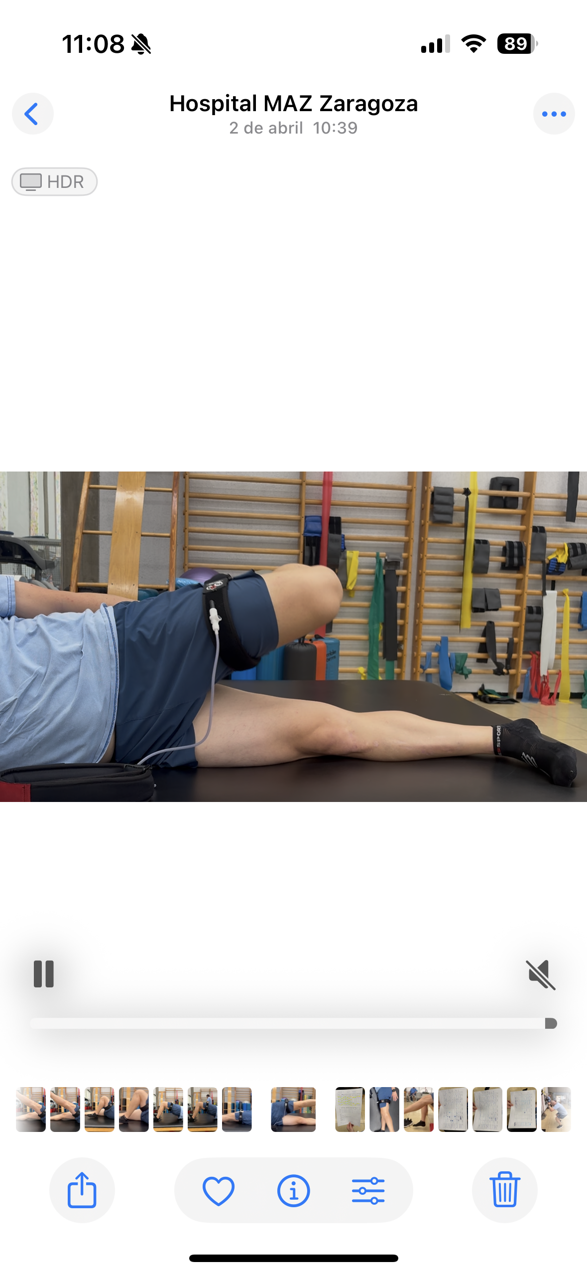
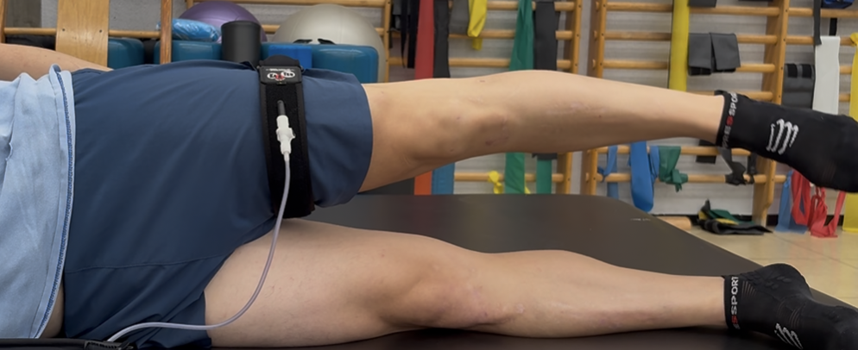
Initial position Final position

Muscle activation excercises:

- Isometric knee extension [Short arc quadriceps (SAQ)]

Initial position Final position
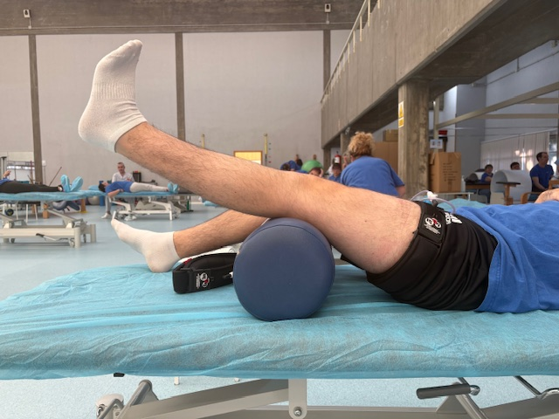
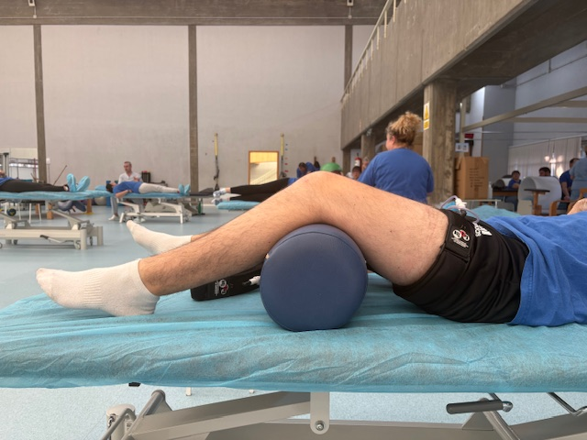

- Seated knee extension [Long arc quadriceps (LAQ)]

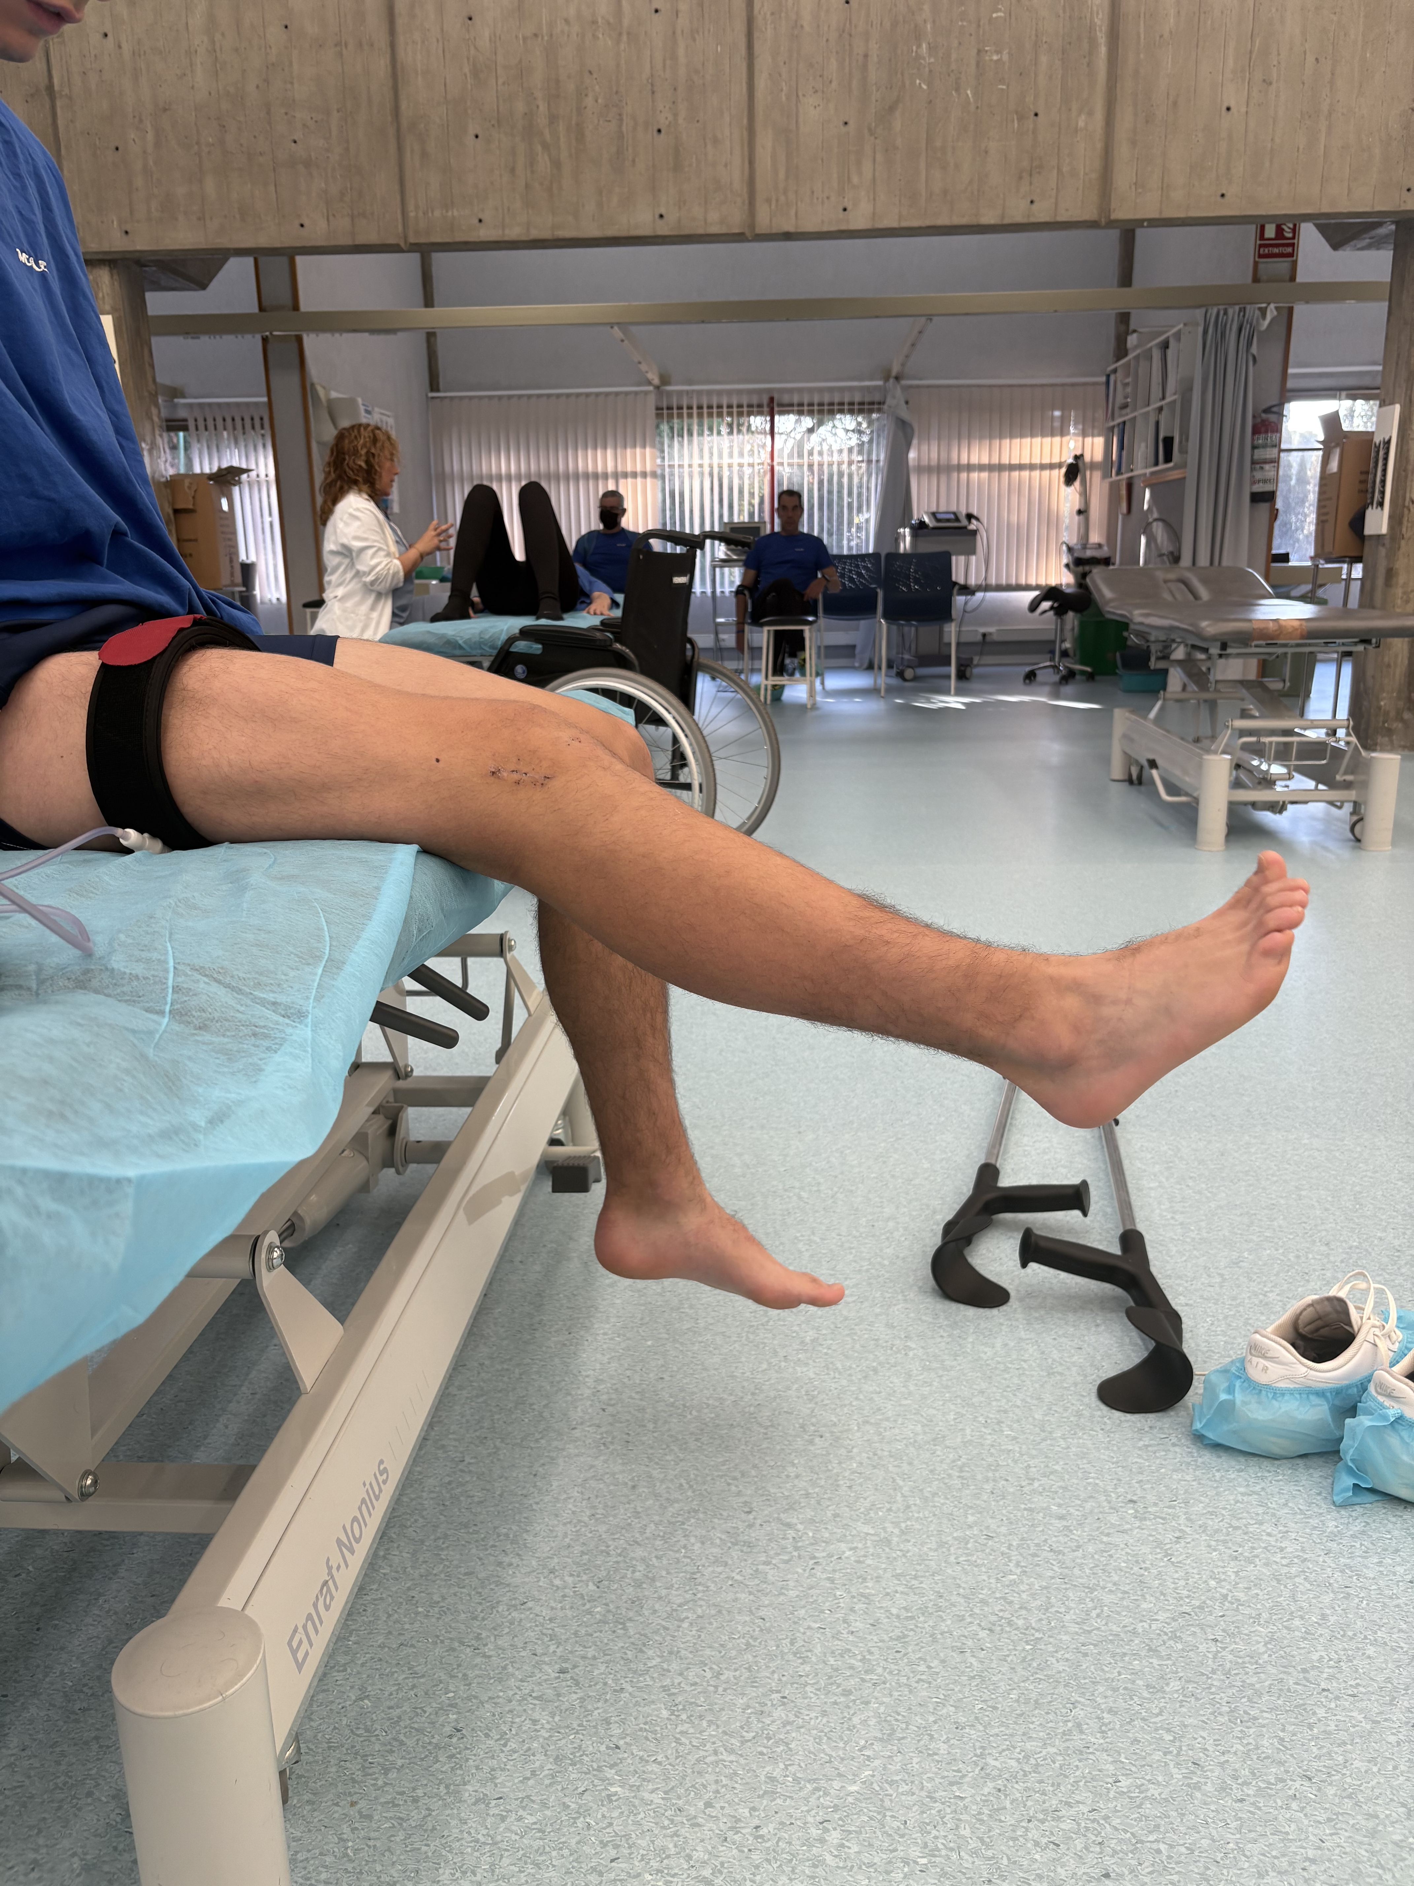
Initial position Final position

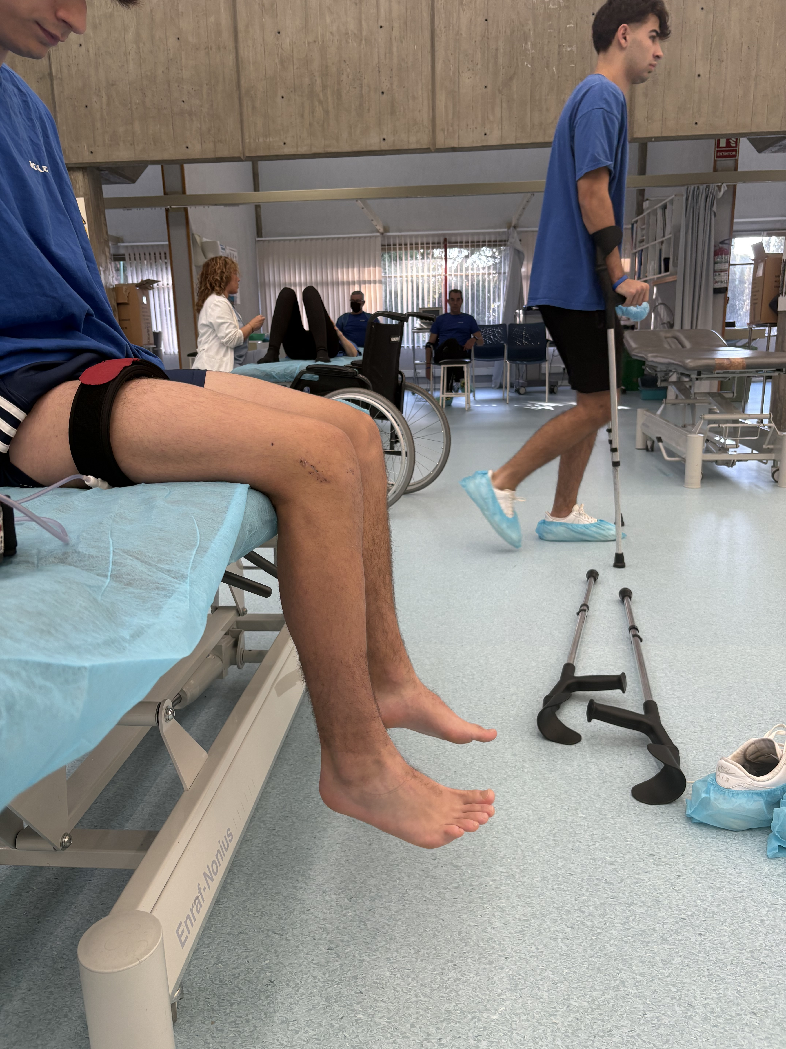

- Gluteus bridge

Initial position Final position
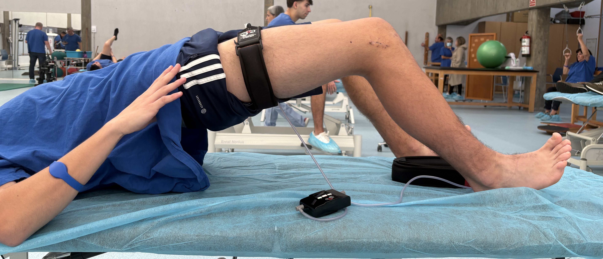
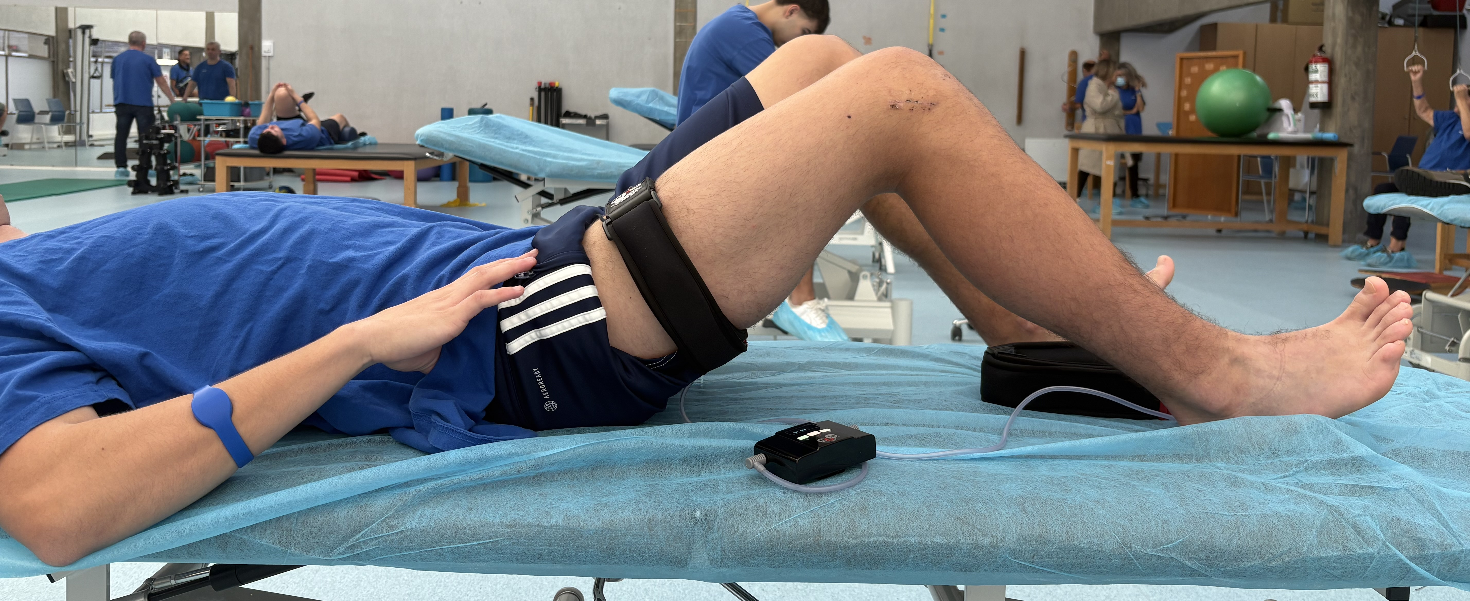
- Side lying leg raises

Initial position Final position
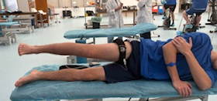
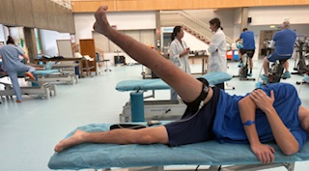

- Knee extension machine

Initial position Final position

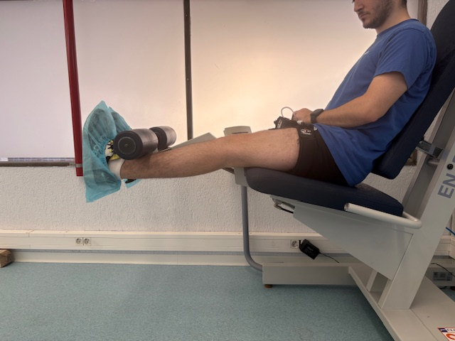
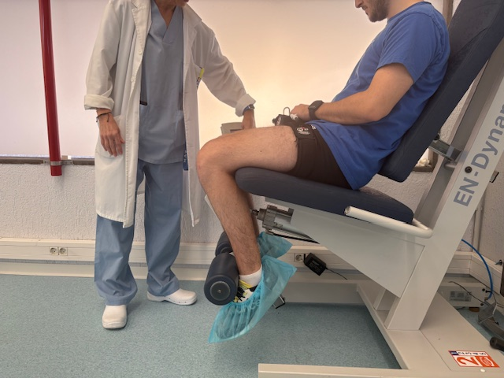

Full body resistance band exercises:

- Double leg squats

Initial position Final position
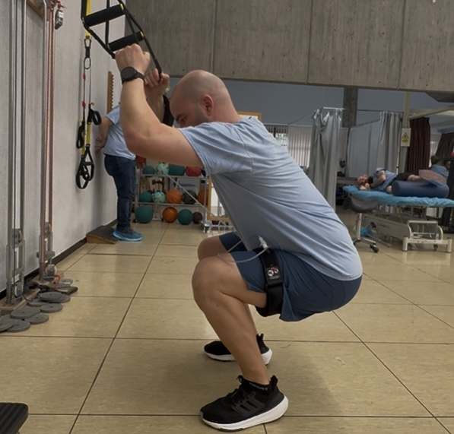
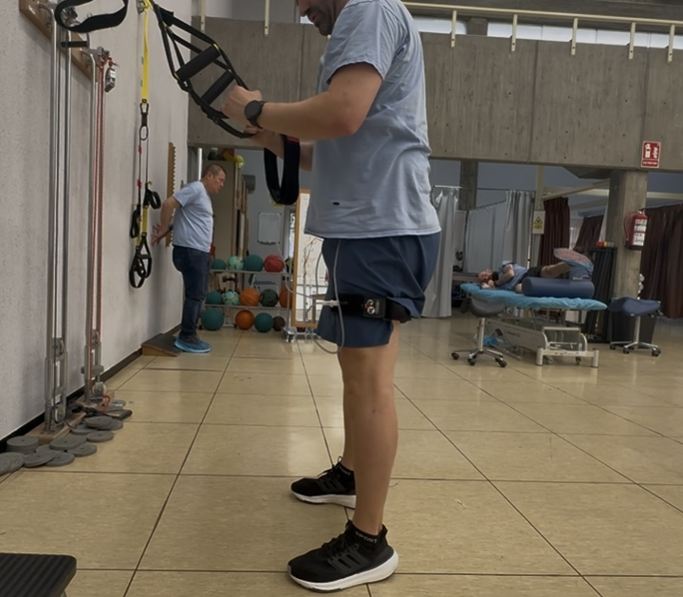

- Single leg squats

Initial position Final position

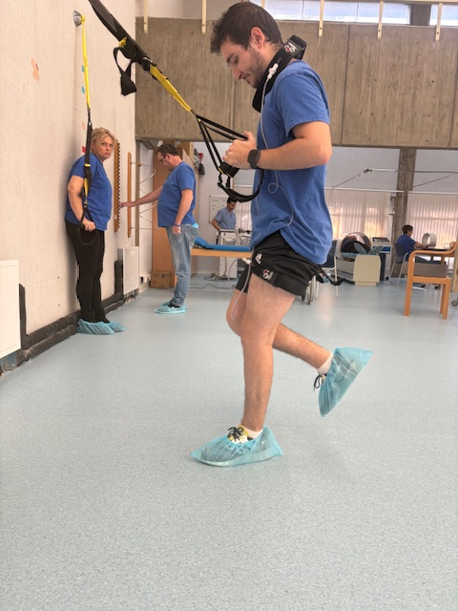
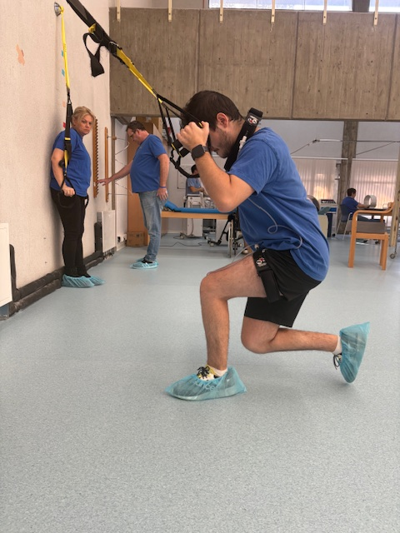

- Forward lunges

Initial position Final position
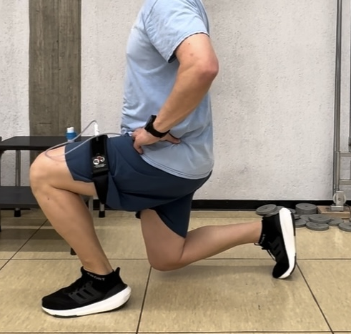
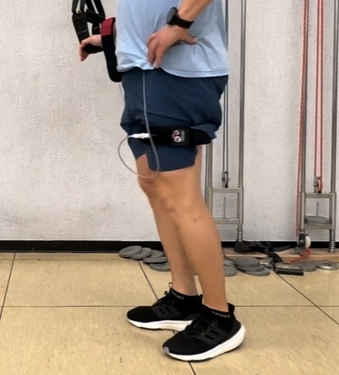

- Reverse lunges

Initial position Final position
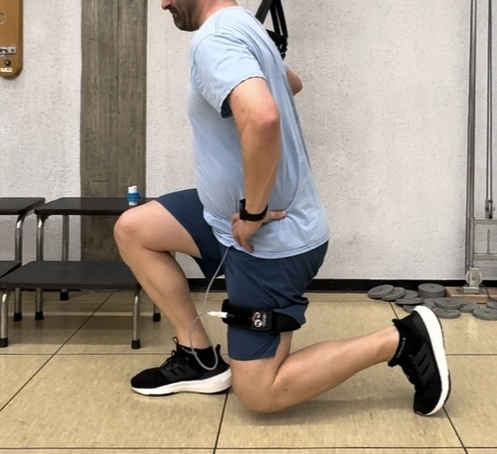

- Step ups and downs

Initial position Final position
