Storage capacity of tanks
Benzene dispersion

Number of loading times

Minimum permissible distance between the gas station and the residential areas
using the software AERMOD

Storage tank 96,000 L
Maximum loading of 1,328 times per year
Permissible distance 30 m

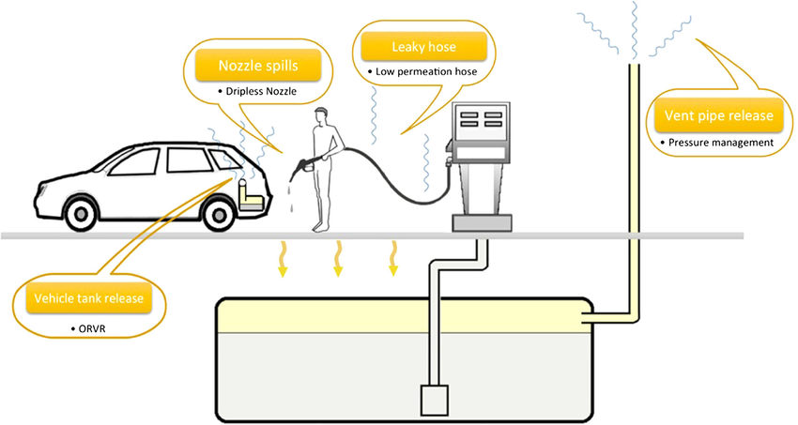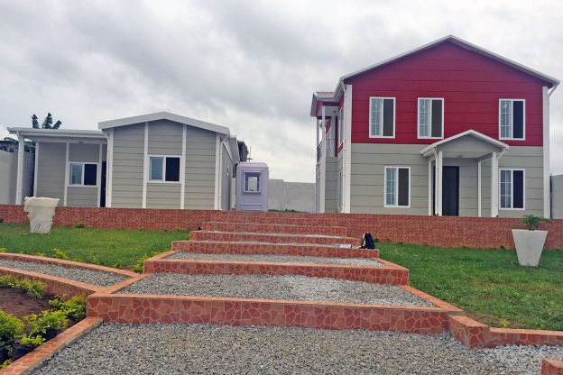
Permissible distance 40 m
Storage tank 128,000 L
Maximum loading of 1,834 times per year

