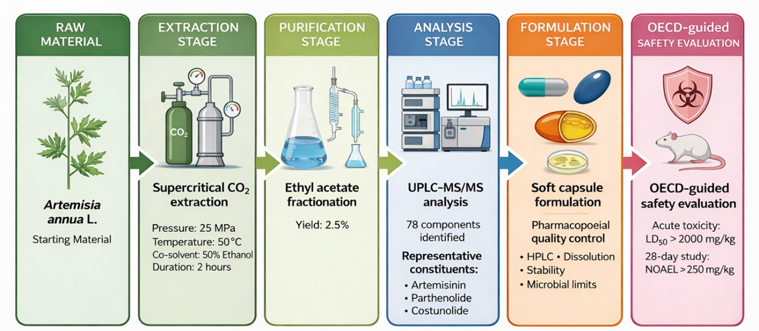

Graphical Abstract. Schematic overview of the development, characterization, and safety evaluation of Artemisia annua soft capsules

