Table:1S Experimental design of the seed germination tests
Parameter for seed germination | Germination Test
Test Plant species | Ricinus communis L.
Pretreatment | 1% Hydrogen peroxide solution for 5min
Temperature | 25 ±1℃
Light Type | Natural Sunlight
Type of Material | Plastic pots
Quantity of Soil Sample | 1.5 kg/pot
Total number of seeds potted | 20 seeds/pot
Total Replicates | 3
Water control and dilution of water | Deionized water
Duration of experiment | 4 weeks (28days)
Pesticide concentration | 100mg/kg and 200mg/kg

Table:2S Raw data of Production of IAA by bacterial sp. C-78 at different time intervals (48, 72, and 96h). A) Tryptophan supplemented with CP(100mg) and B) Tryptophan supplemented with CP(200mg) , Values are expressed as Mean ± SD (n = 3) at different time intervals during chlorpyrifos degradation
A.
Trp (µg/mL) | Time (h) | CP1 | CP2 | CP3 | Mean ± | SD
50 | 48 | 12.1 | 11.8 | 12.5 | 12.13 ± | 0.35
50 | 72 | 18.2 | 17.9 | 18.5 | 18.20 ± | 0.30
50 | 96 | 20.5 | 20.1 | 21.0 | 20.53 ± | 0.45
100 | 48 | 20.3 | 19.8 | 20.7 | 20.27 ± | 0.45
100 | 72 | 28.5 | 27.9 | 29.1 | 28.50 ± | 0.60
100 | 96 | 32.0 | 31.5 | 32.8 | 32.10 ± | 0.65
150 | 48 | 25.6 | 24.9 | 26.2 | 25.57 ± | 0.65
150 | 72 | 35.2 | 34.5 | 36.0 | 35.23 ± | 0.75
150 | 96 | 40.5 | 39.8 | 41.2 | 40.50 ± | 0.70

Trp (µg/mL) | Time (h) | CP1 | CP2 | CP3 | Mean ± | SD
50 | 48 | 8.6 | 8.2 | 9.0 | 8.60 ± | 0.40
50 | 72 | 12.5 | 12.0 | 13.0 | 12.50 ± | 0.50
50 | 96 | 14.2 | 13.8 | 14.8 | 14.27 ± | 0.50
100 | 48 | 14.5 | 14.0 | 15.1 | 14.53 ± | 0.55
100 | 72 | 20.8 | 20.1 | 21.5 | 20.80 ± | 0.70
100 | 96 | 24.0 | 23.2 | 24.8 | 24.00 ± | 0.80
150 | 48 | 18.9 | 18.2 | 19.5 | 18.87 ± | 0.65
150 | 72 | 26.5 | 25.8 | 27.3 | 26.53 ± | 0.75
150 | 96 | 30.2 | 29.5 | 31.0 | 30.23 ± | 0.75
B.
A.

C-42
C-38
C-15
C-35
C-17
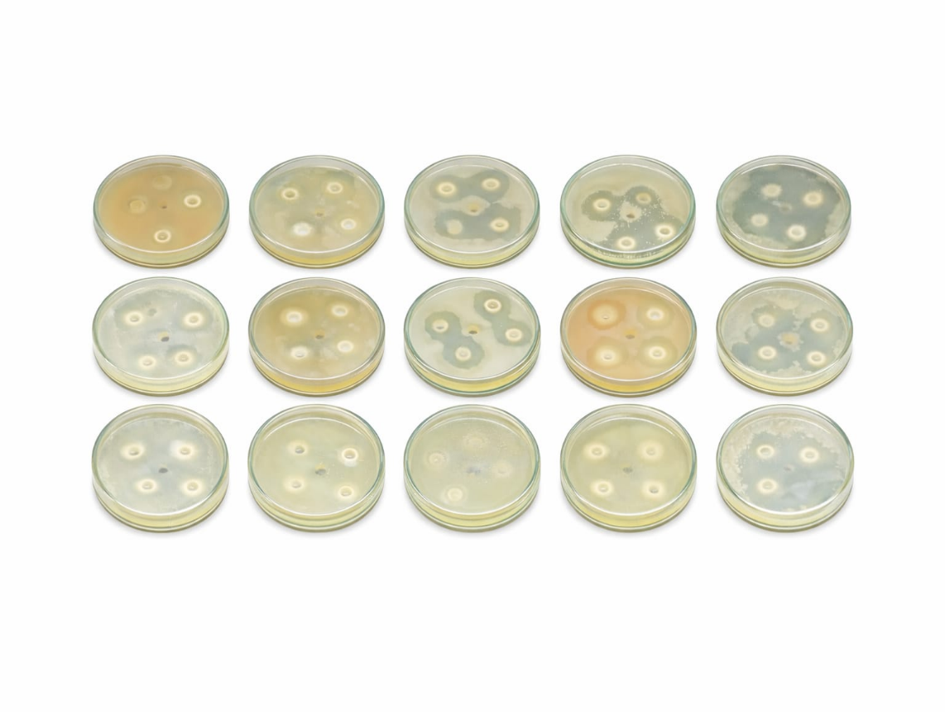
C-60
C-58
C-62
C-55
C-80
C-78
C-72
C-68
C-65
C-45

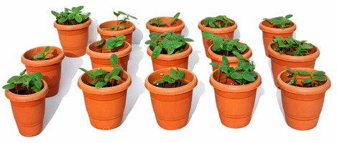
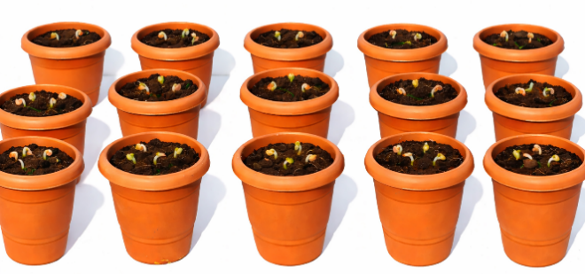
B.
Day-14
Day-7
Day-28
Day-21
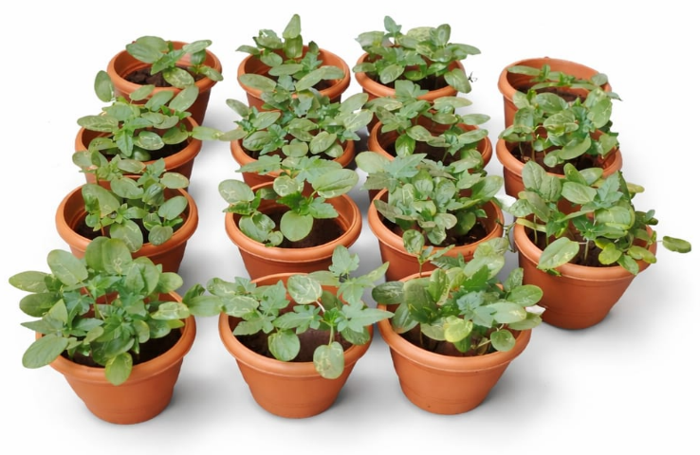
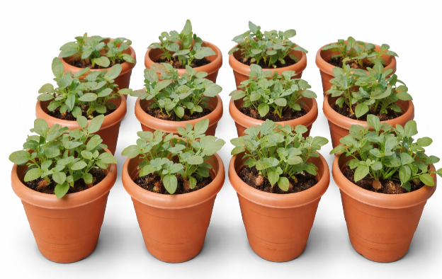

C.
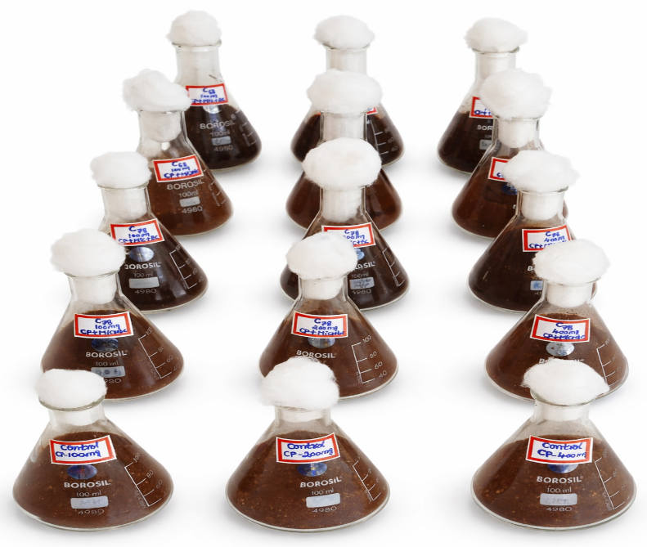

Figure 1S Preliminary screening of : A) Potential CPF tolerant bacterial strain through MIC assay B) Potting experimental trials for screening of potential CPF-degrading plant Ricinus communis L. C) CPF degradation ability in soil under in-vitro conditions by selected isolated strains
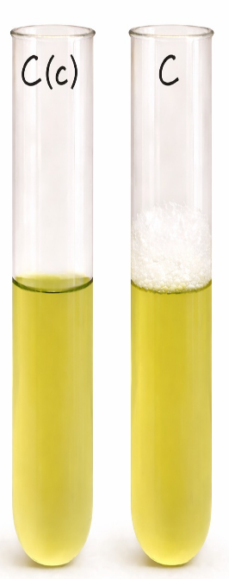
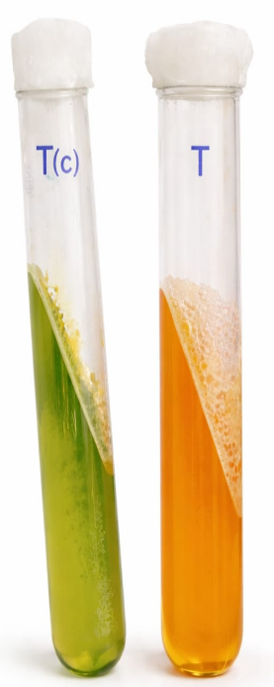
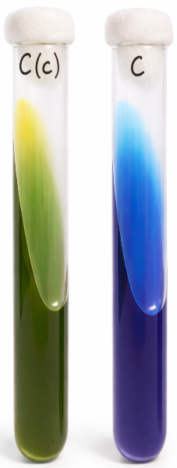
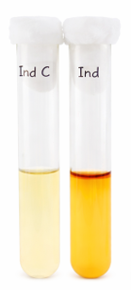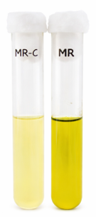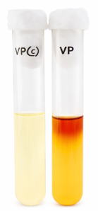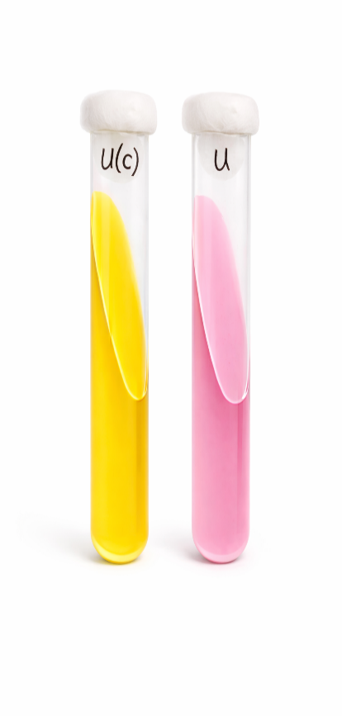
Indole
Urease
Citrate
Voges proskauer
Methyl red

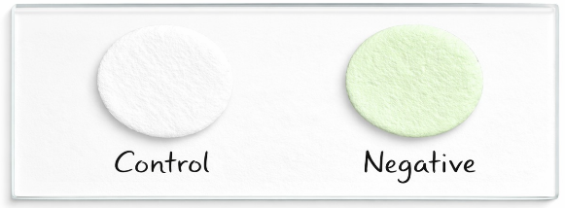
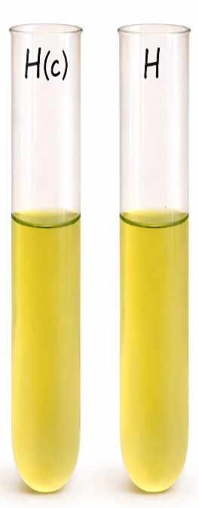

Oxidase
Triple sugar iron
H₂S
Catalase

Figure 2S The biochemical characterization for the isolate C-78(klebsiella pneumoniae), including Indole production, Methyl red (MR), Voges proskauer (VP), citrate utilisation, Urease, Triple sugar iron test, Catalase, oxidase, and H₂S test.
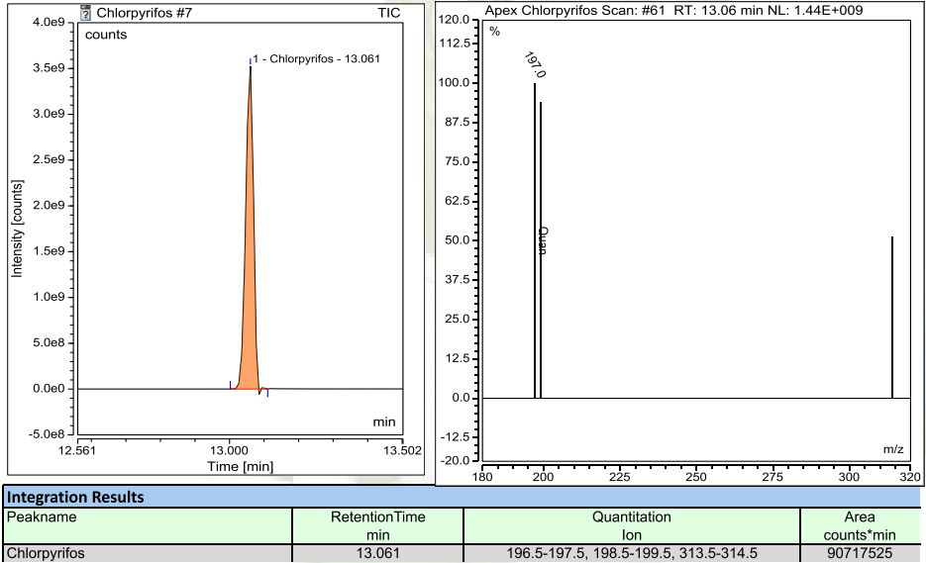

Figure 3S GC-MS chromatogram of Standard Chlorpyrifos

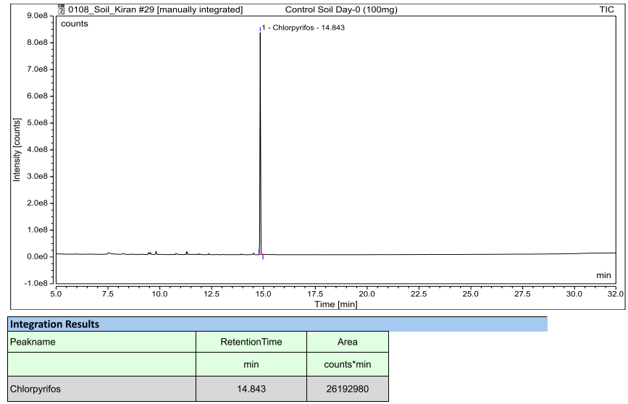

Figure 4S GC-MS chromatogram of Day-0 CP-100mg soil sample

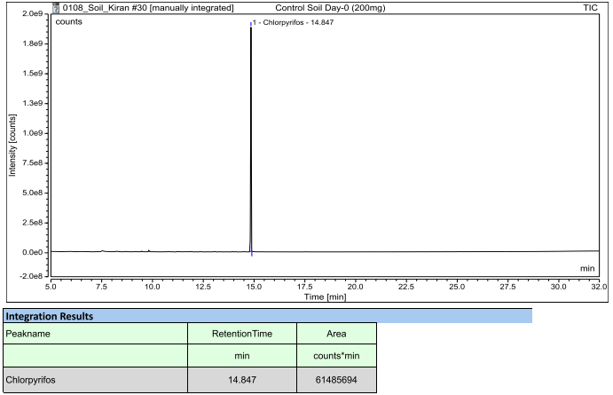
Figure 5S GC-MS chromatogram of Day-0 CP-200mg soil sample

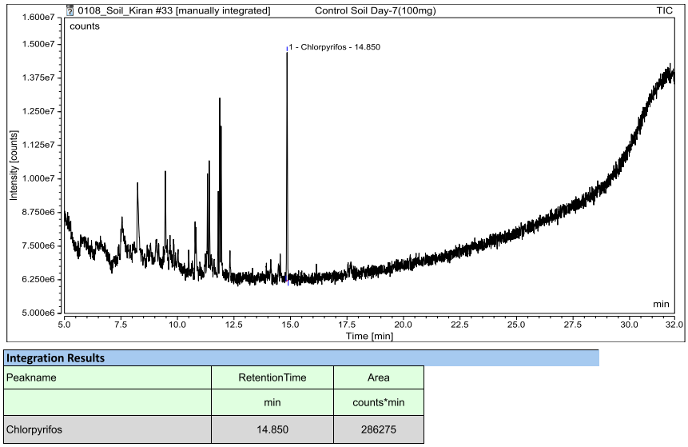
Figure 6S GC-MS chromatogram of Day-7 CP-100mg soil sample

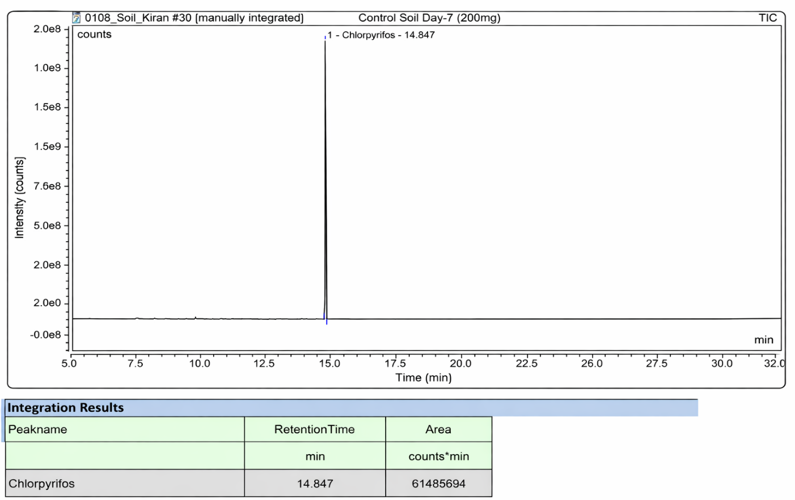
Figure 7S GC-MS chromatogram of Day-7 CP-200mg soil sample
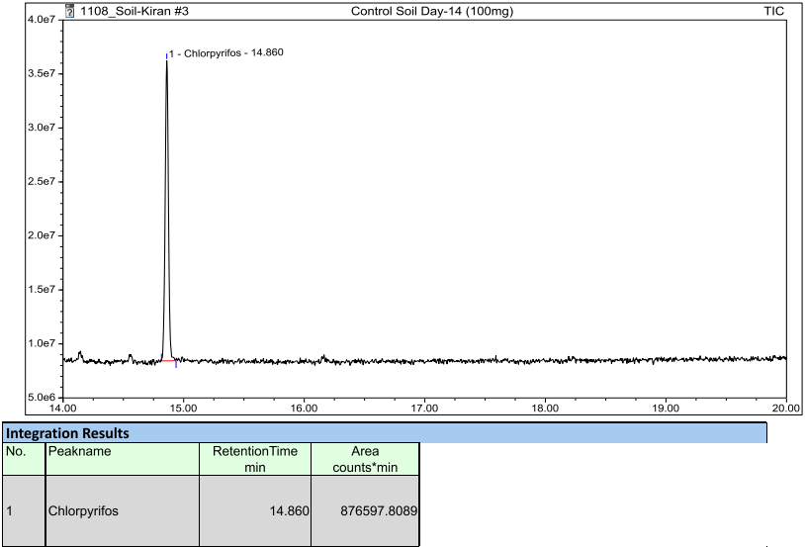
Figure 8S GC-MS chromatogram of Day-14 CP-100mg soil sample
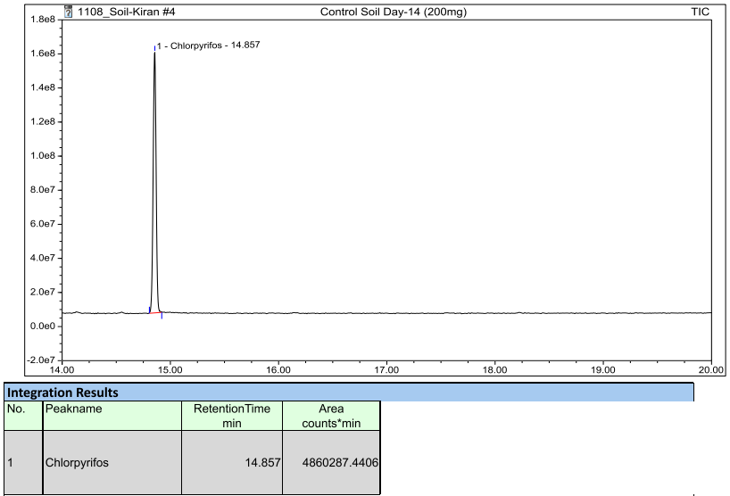
Figure 9S GC-MS chromatogram of Day-14 CP-200mg soil sample
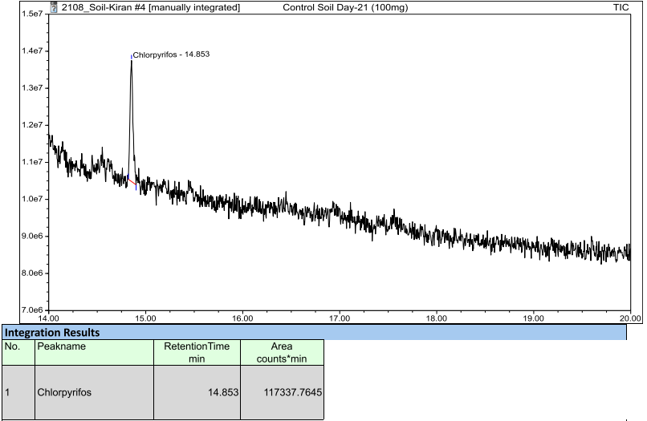
Figure 10S GC-MS chromatogram of Day-21 CP-100mg soil sample

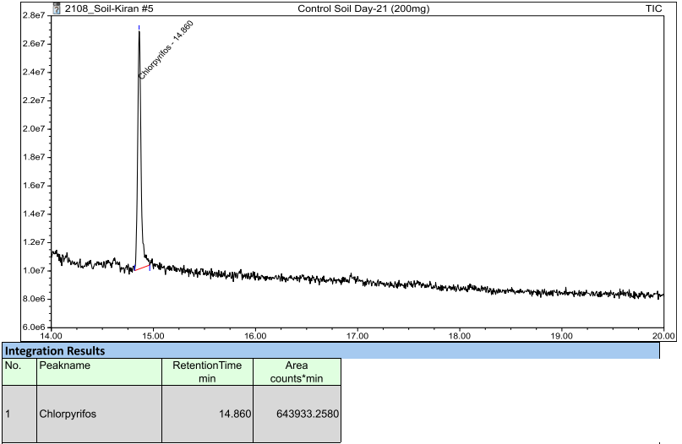
Figure 11S GC-MS chromatogram of Day-21 CP-200mg soil sample
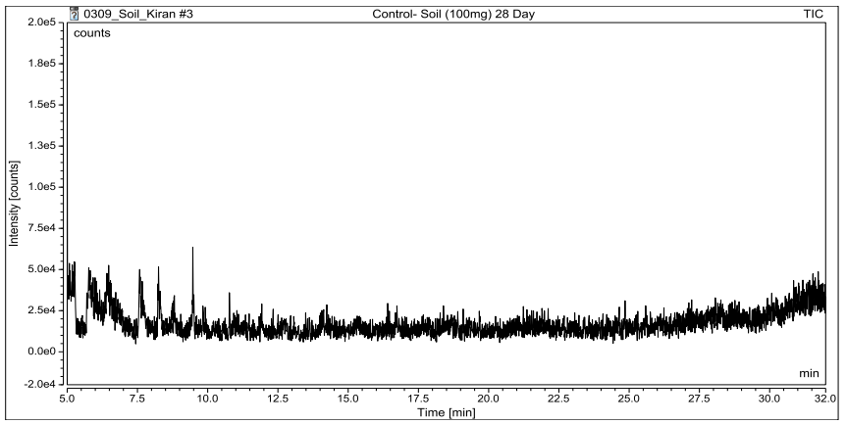

Figure 12S GC-MS chromatogram of Day-28 CP-100mg soil sample

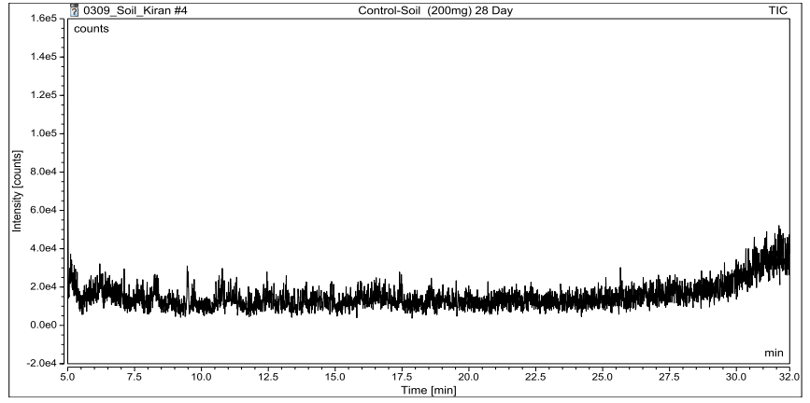

Figure 13S GC-MS chromatogram of Day-28 CP-200mg soil sample

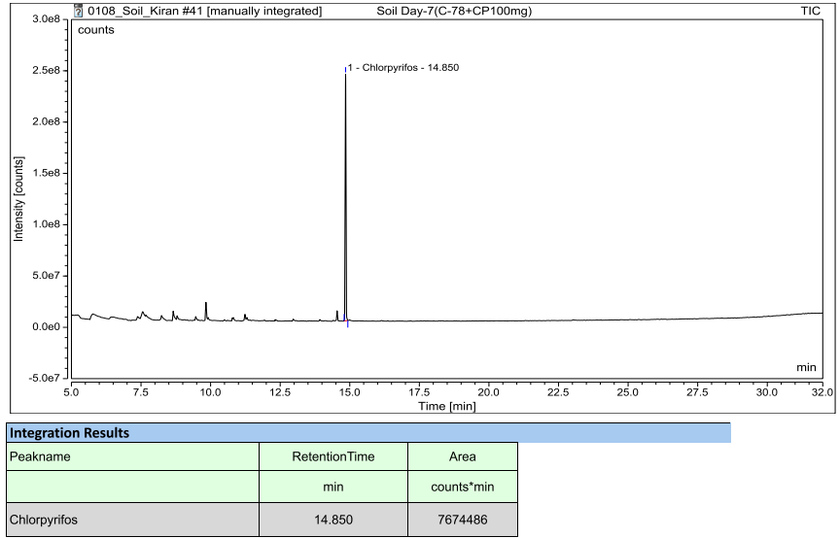
Figure 14S GC-MS chromatogram of Day-7 (C-78 + CP-100mg) soil sample

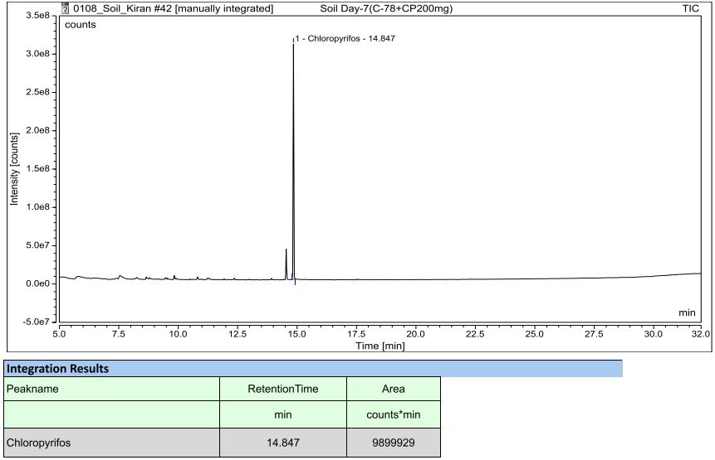
Figure 15S GC-MS chromatogram of Day-7 (C-78 + CP-200mg) soil sample
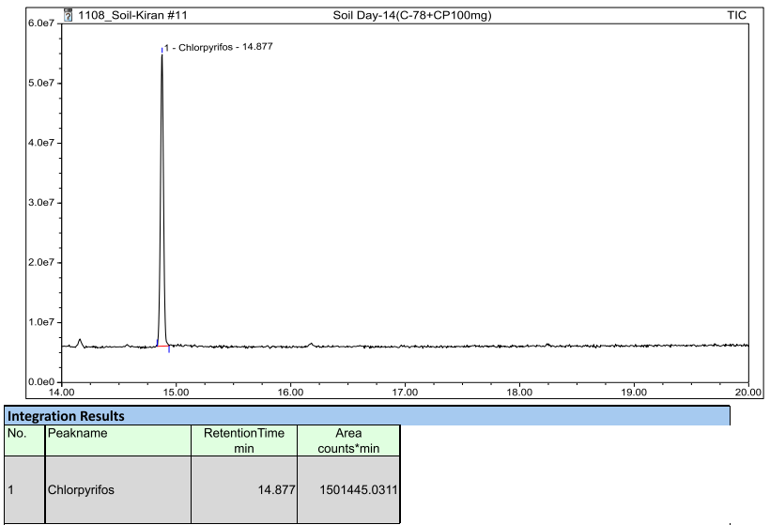
Figure 16S GC-MS chromatogram of Day-14 (C-78 + CP-100mg) soil sample
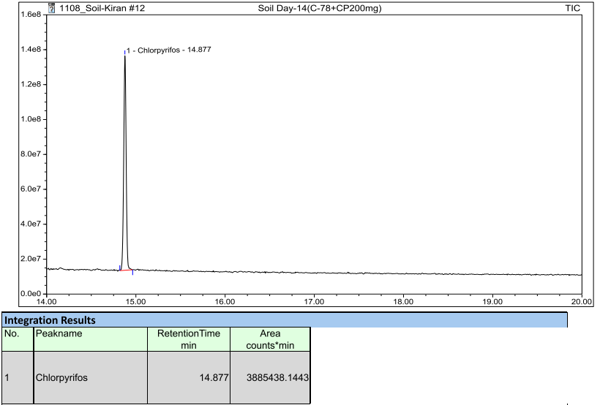
Figure 17S GC-MS chromatogram of Day-14 (C-78 + CP-200mg) soil sample

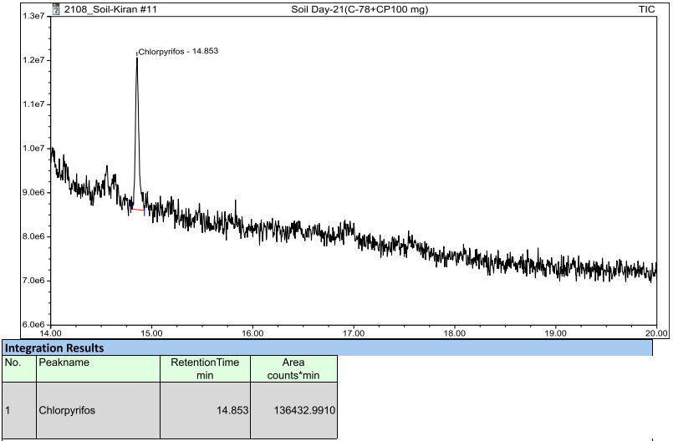
Figure 18S GC-MS chromatogram of Day-21 (C-78 + CP-100mg) soil sample
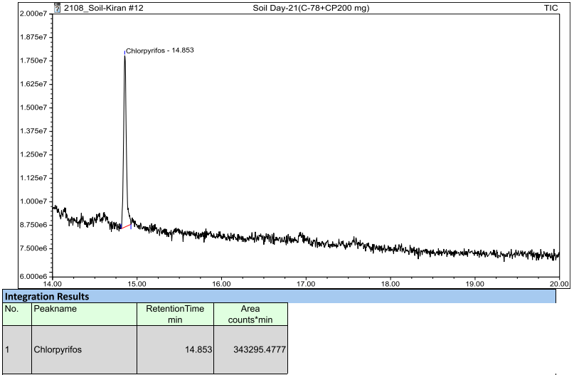
Figure 19S GC-MS chromatogram of Day-21 (C-78 + CP-200mg) soil sample

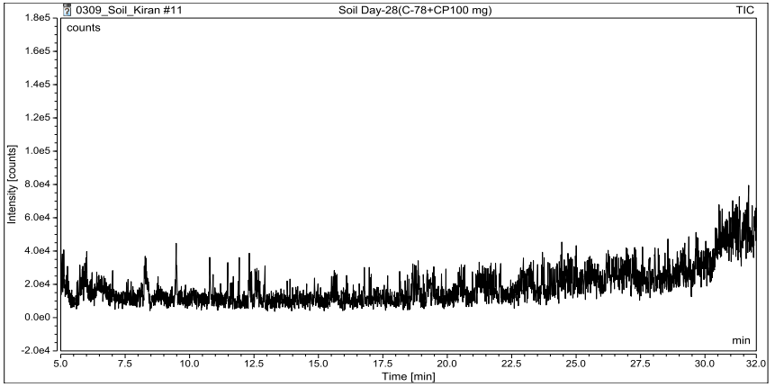

Figure 20S GC-MS chromatogram of Day-28 (C-78 + CP-100mg) soil sample

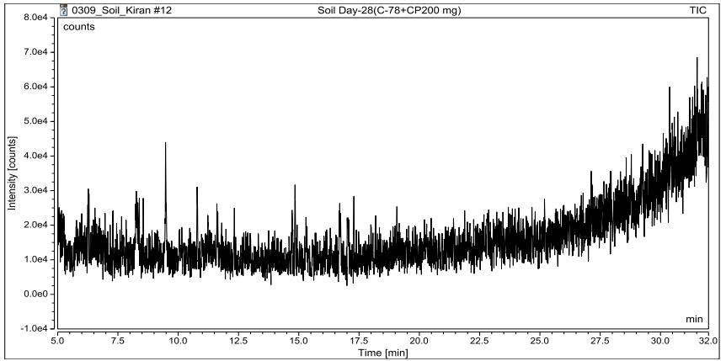

Figure 21S GC-MS chromatogram of Day-28 (C-78 + CP-200mg) soil sample
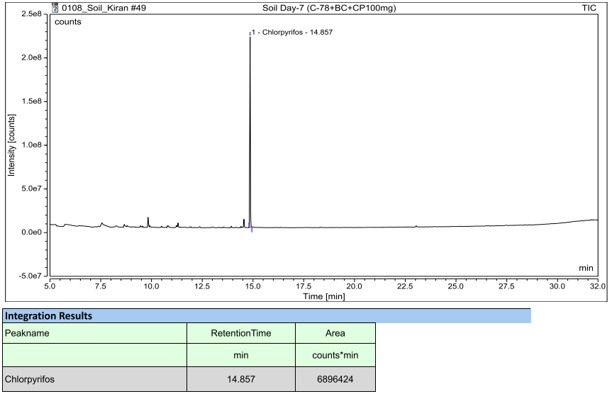
Figure 22S GC-MS chromatogram of Day-7 (C-78 +BC+ CP-100mg) soil sample

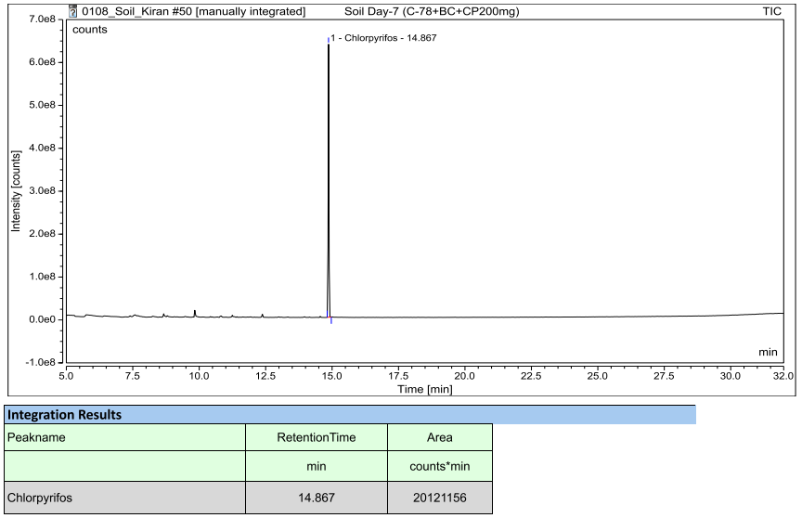
Figure 23S GC-MS chromatogram of Day-7 (C-78 +BC+ CP-200mg) soil sample
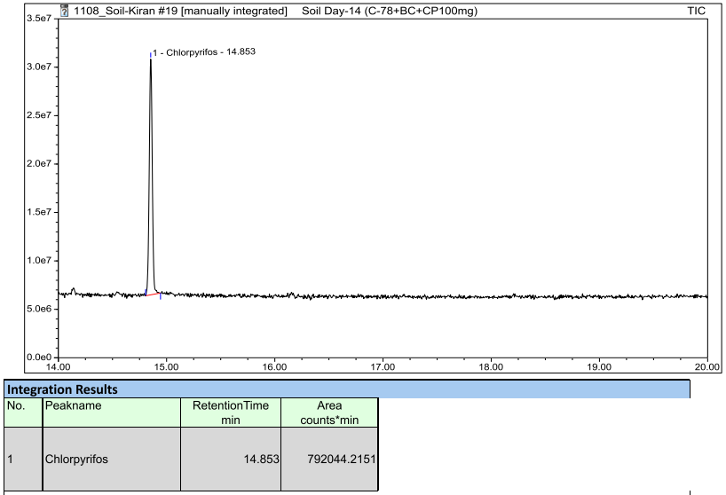
Figure 24S GC-MS chromatogram of Day-14 (C-78 +BC+ CP-100mg) soil sample
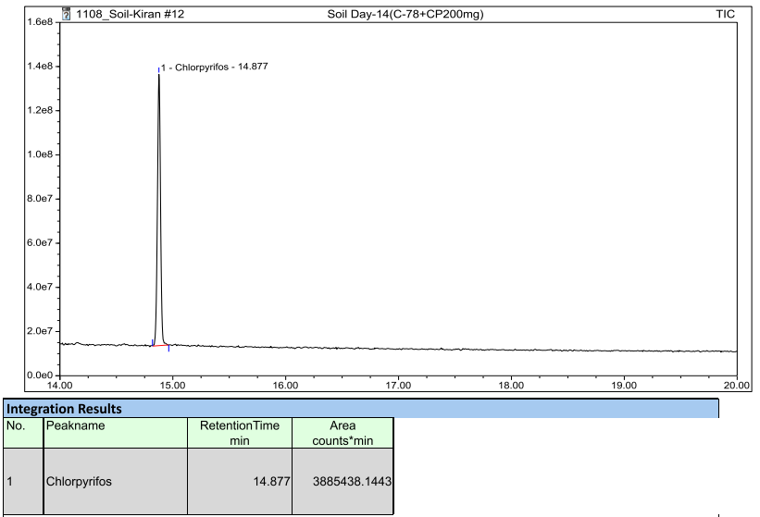
Figure 25S GC-MS chromatogram of Day-14 (C-78 +BC+ CP-200mg) soil sample
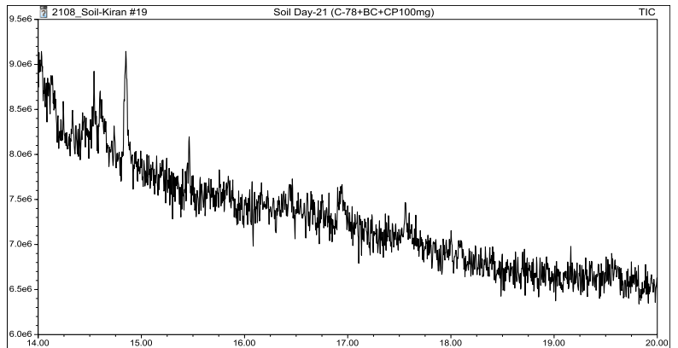

Figure 26S GC-MS chromatogram of Day-21 (C-78 +BC+ CP-100mg) soil sample

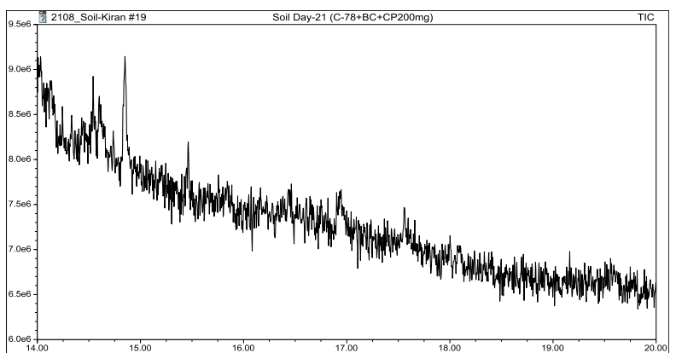

Figure 27S GC-MS chromatogram of Day-21 (C-78 +BC+ CP-200mg) soil sample

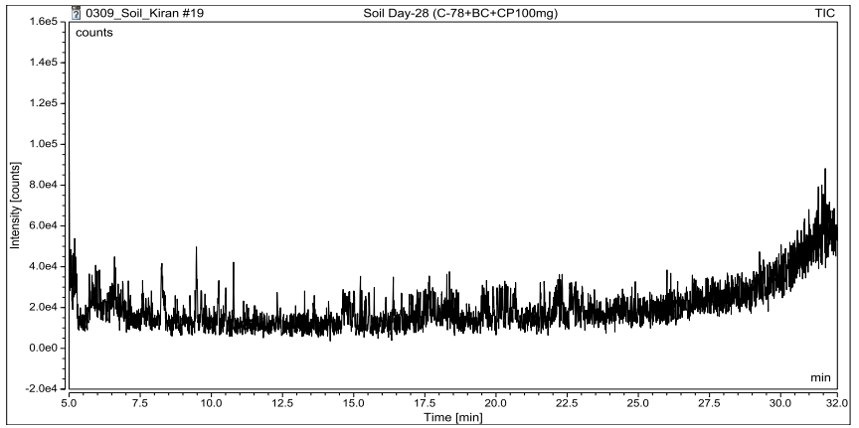

Figure 28S GC-MS chromatogram of Day-28 (C-78 +BC+ CP-100mg) soil sample

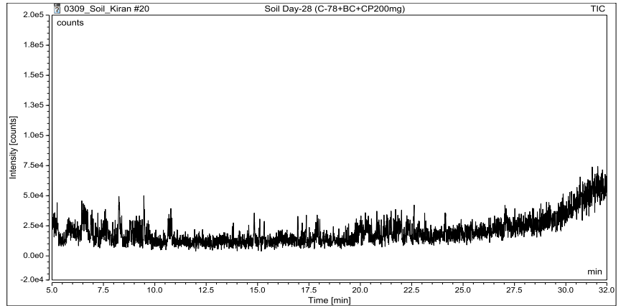

Figure 29S GC-MS chromatogram of Day-28 (C-78 +BC+ CP-200mg) soil sample

