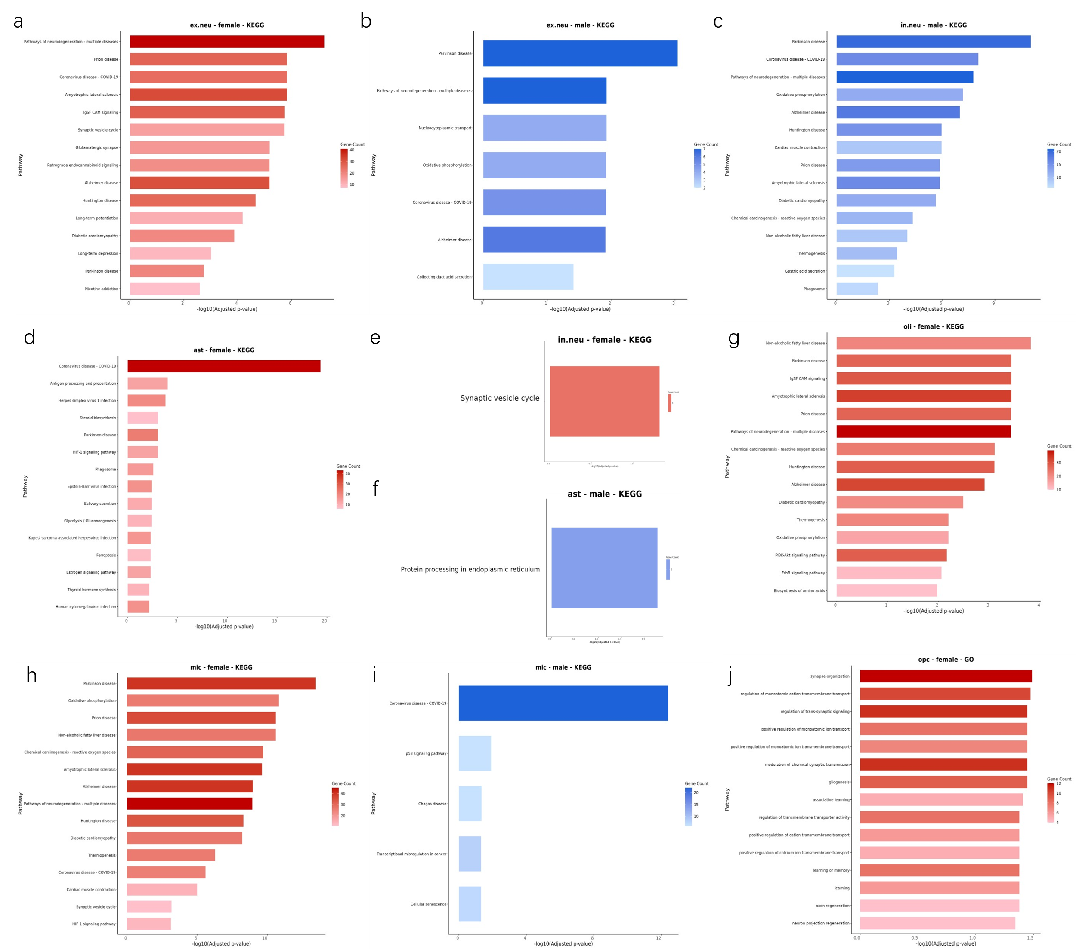
Figure S1. KEGG Pathway Enrichment Analysis of Sex-specific DEGs across major cell types
(a–j) Bar plots representing the top significantly enriched KEGG pathways for specific cell populations and gender-stratified groups. The y-axis lists the names of the enriched KEGG pathways. The x-axis indicates the statistical significance, represented as -log10(adjusted p-value). The color gradient of the bars corresponds to the Gene Count (number of enriched genes in each pathway), with darker red or blue indicating a higher number of genes involved. Specific panels highlight pathways related to neurodevelopmental disorders, synaptic vesicle cycles, and protein processing in the endoplasmic reticulum. All enrichments were considered statistically significant at an adjusted p-value < 0.05.

