Supplement
Supplement 1: Results of the farmer survey.
To provide useful frost-related information for users, a survey was conducted in 2023 among farmers in Kaminoyama City, Yamagata Prefecture. A total of 28 responses were collected. Kaminoyama City is known for fruit cultivation and experienced significant late frost damage in 2021. The survey is outlined as follows:

Question (a):
How do you perceive the frequency of JMA frost advisories?
Answer:
① So much
② Much
③ Appropriate
④ Little
⑤ So little
⑥ Other

Question (b):
If you answered ‘So much’ or ’Much’ in Question (a), please respond to the following: Why do you think JMA frost advisories are issued too frequently? (multiple answers allowed)
Answer:
① Air temperature does not decrease because wind conditions are not calm.
② Air temperature does not decrease because weather conditions are cloudy or rain.
③ Frost does not occur even when air temperature decreases.
④ Other

Question (c):
In addition to frost information, are predicted leaf and bud temperatures useful as direct indicators of frost damage?
① Very useful
② Useful
③ Useless
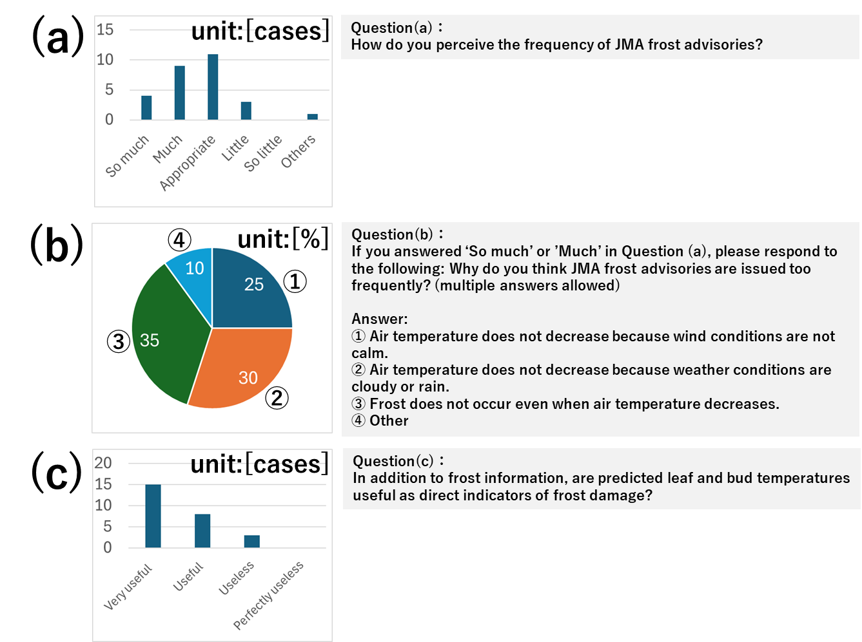
④ Perfectly useless
Fig. S1. Results of the farmer survey.

