Tables
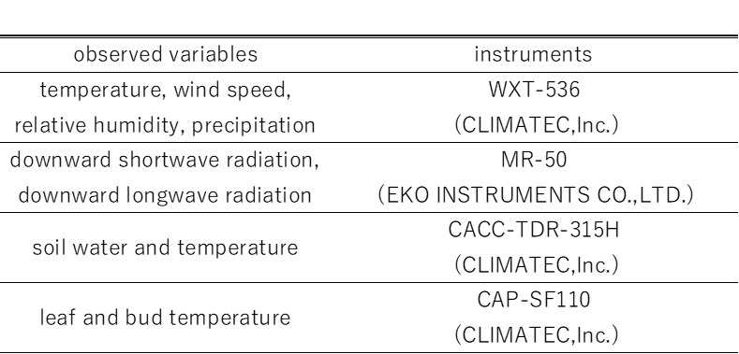
Table 1 List of observed variables and the instruments used.

