- Supplementary Information -
Direct N₂O Emissions Constrain the Net Climate Benefits of Anammox Based Nitrogen Removal
Yuqing Yan^{1,2}, Lin Du^{1,2}, Jun-Jie Zhu^{1,2}, Mark A. Zondlo¹, Ruqiao Emma Shen³, Krishna R. Pagilla⁴, Zhiyong Jason Ren^{1,2*}
¹Department of Civil and Environmental Engineering, Princeton University, Princeton, NJ 08544, USA
²Andlinger Center for Energy and the Environment, Princeton University, Princeton, NJ 08544, USA
³ Jacobs Consultancy Canada Inc. Toronto, ON M5H 3T9, Canada
⁴ Department of Civil and Environmental Engineering, University of Nevada Reno, NV, 89557, USA
*Email: zjren@princeton.edu

1. Meta-data structure, ∆CI calculation parameters and mainstream/side-stream separation
Table S1: (a) Keywords used for literature mining; (b) Metadata of literature-based emission factor of novel nitrogen removal processes with operational parameters and process information (see “Supplementary_Tables.xlsx”)
Table S2: Energy saving calculation parameters.
(a) Stoichiometric change in oxygen demand
Nitrogen Removal Mechanism | Overall Reaction (methanol as carbon source) | O_{2,req} (kg_{O2}/kg TN_{removed}) | C_{,req} (kg_{C}/kg TN_{removed})
Partial Nitrification / Anammox (PNA) | Partial Nitrification: NH₄⁺ + 1.5O₂ → NO₂⁻ + 2H⁺ + H₂O  Anammox: NH₄⁺ + 1.32NO₂⁻ → 1.02N₂ + 0.26NO₃⁻ + 2.03H₂O | 2.22 | 0
Partial Nitrification (PN) | Partial Nitrification: NH₄⁺ + 1.5O₂ → NO₂⁻ + 2H⁺ + H₂O | 3.43 | 0
Anammox (AMX) | Anammox: NH₄⁺ + 1.32NO₂⁻ → 1.02N₂ + 0.26NO₃⁻ + 2.03H₂O | 0 | 0
Partial Denitrification / Anammox (PdNA) | Nitrification: NH₄⁺ + 2O₂ → NO₃⁻ + 2H⁺ + H₂O  Partial Denitrification: CH3OH + 3NO₃⁻ → 3NO2⁻ + CO2 + 2H2O  Anammox: NH₄⁺ + 1.32NO₂⁻ → 1.02N₂ + 0.26NO₃⁻ + 2.03H₂O | 2.96 | 0.185
Nitrification / Anammox (NiA) | Nitrification: NH₄⁺ + 2O₂ → NO₃⁻ + 2H⁺ + H₂O  Anammox: NH₄⁺ + 1.32NO₂⁻ → 1.02N₂ + 0.26NO₃⁻ + 2.03H₂O | 2.96 | 0
Simultaneous Partial Nitrification, ANAMMOX and Denitrification (SNAD) | Partial Nitrification: NH₄⁺ + 1.5O₂ → NO₂⁻ + 2H⁺ + H₂O  Anammox: NH₄⁺ + 1.32NO₂⁻ → 1.02N₂ + 0.26NO₃⁻ + 2.03H₂O  Denitrification: 5CH₃OH + 6NO₃⁻ → 3N₂ + 5CO₂ + 7H₂O + 6OH⁻ | 2.22 | 0.091
Partial Denitrification (PD) | Partial Denitrification: CH3OH + 3NO₃⁻ → 3NO2⁻ + CO2 + 2H2O | 0 | 0.185
Thiosulfate-Driven Denitritation-anammox (TDD-AMX) | Partial Nitrification: NH₄⁺ + 1.5O₂ → NO₂⁻ + 2H⁺ + H₂O  Partial Denitrification: NO₃⁻ + 0.4 S₂O₃²⁻ + 0.8 H⁺ → NO₂⁻ + 0.8 S + 0.4 SO₄²⁻ + 0.4 H₂O  Anammox: NH₄⁺ + 1.32NO₂⁻ → 1.02N₂ + 0.26NO₃⁻ + 2.03H₂O | 0 | 0
Partial Nitritation, Anammox and Methane-dependent nitrite/nitrate reduction reactions (PNAM) | Partial Nitrification: NH₄⁺ + 1.5O₂ → NO₂⁻ + 2H⁺ + H₂O  Anammox: NH₄⁺ + 1.32NO₂⁻ → 1.02N₂ + 0.26NO₃⁻ + 2.03H₂O  Methane-driven Denitrification: 5 CH₄ + 8 NO₃⁻ → 4 N₂ + 5 CO₂ + 6 H₂O + 8 OH⁻ | 2.22 | 0
Nitrification / Denitrification (NDN) | Nitrification: NH₄⁺ + 2O₂ → NO₃⁻ + 2H⁺ + H₂O  Denitrification: 5CH₃OH + 6NO₃⁻ → 3N₂ + 5CO₂ + 7H₂O + 6OH⁻ | 4.57 | 0.71

(b) Oxygen transfer rate estimated based on aeration technology
Aeration Type | Reactor | OTR (kgO2/kWh) | Source
Medium-Bubble Diffuser | Moving Bed Biofilm Reactor (MBBR) | 1.4-1.9 | ¹
Medium-Bubble Diffuser | Integrated Fixed-Film Activated Sludge (IFAS) | 1.4-1.9 | ¹
Fine-Bubble Diffuser | Bubble Column Reactor (BCR) | 2-2.5 | ²
Fine-Bubble Diffuser | Sequencing Batch Biofilm Reactor (SBBR) | 2-2.5 | ²
Fine-Bubble Diffuser | Sequencing Batch Reactor (SBR) | 2-2.5 | ²
Fine-Bubble Diffuser | Completely Stirred Tank Reactor (CSTR) | 2-2.5 | ²
Fine-Bubble Diffuser | Continuous-Flow Biofilm Reactor (CFBR) | 2-2.5 | ²
Coarse-Bubble Diffuser | Gas Lift Reactor (GLR) | 0.8-1.2 | ²
Coarse-Bubble Diffuser | Attached-Film Expanded Bed (AFEB) | 0.8-1.2 | ²
Surface Aerator | Rotating Biological Contactor (RBC) | 1.5-2.1 | ³
Non-aerated/Passive Diffusion | Down-flow Hanging Sponge (DHS) | - | -
Non-aerated/Passive Diffusion | Upflow Fixed-bed Anammox Reactor (UFAR) | - | -
Non-aerated/Passive Diffusion | Upflow Anaerobic Sludge Blanket (UASB) | - | -
Non-aerated/Passive Diffusion | Expanded Granular Sludge Bed (EGSB) | - | -
Non-aerated/Passive Diffusion | Trickling Filter (TF) | - | -
Non-aerated/Passive Diffusion | Membrane Biofilm Reactor (MBfR) | - | -
Membrane-based | Membrane Aerated Biofilm Reactor (MABR) | 4-6 | ^{4, 5}
Membrane-based | Membrane Bioreactor (MBR) | 3.04-4.26 | ³

Table S3: EF_{scope-2} based on region and study year.
Country | Database | Dated
Australia | NGAF https://www.dcceew.gov.au/climate-change/publications/national-greenhouse-accounts-factors-2025 | 2014-2025
Austria | EEA https://www.eea.europa.eu/en/analysis/indicators/greenhouse-gas-emission-intensity-of-1?activeAccordion=ecdb3bcf-bbe9-4978-b5cf-0b136399d9f8 | 1990, 2000, 2010, 2023
Belgium |  | 1990, 2000, 2010, 2023
Denmark |  | 1990, 2000, 2010, 2023
France |  | 1990, 2000, 2010, 2023
Germany |  | 1990, 2000, 2010, 2023
Ireland |  | 1990, 2000, 2010, 2023
Italy |  | 1990, 2000, 2010, 2023
Netherlands |  | 1990, 2000, 2010, 2023
Spain |  | 1990, 2000, 2010, 2023
Sweden |  | 1990, 2000, 2010, 2023
Brazil | B3 report https://b3.com.br/data/files/1F/50/2C/57/95DE59109B3D0D59AC094EA8/Inventario de Emissoes Gases de Efeito Estufa_2024_Eng_v02 _VF_.pdf | 2024
China | MEE https://www.mee.gov.cn/xxgk2018/xxgk/xxgk01/202412/t20241226_1099413.html | 2021, 2022
Japan | REI https://www.renewable-ei.org/en/activities/column/REupdate/20240814_1.php | 1990-2022
Malaysia | MyEnergyStatus https://myenergystats.st.gov.my/documents/d/guest/grid-emission-factor-gef-in-malaysia | 2017-2022
South Korea | Kim et al., 2025 https://www.eeer.org/journal/view.php?doi=10.4491/eer.2024.596 | 2023
Switzerland | Romano et al., 2024 https://www.sciencedirect.com/science/article/pii/S0360544224031748#fig1 | 2017-2021
Thailand | TGGO https://ghgreduction.tgo.or.th/en/premium-t-ver-download/download/6966/3801/32.html. | 2020, 2021
The United States | eGrid https://www.epa.gov/egrid/data-explorer | 2018-2023

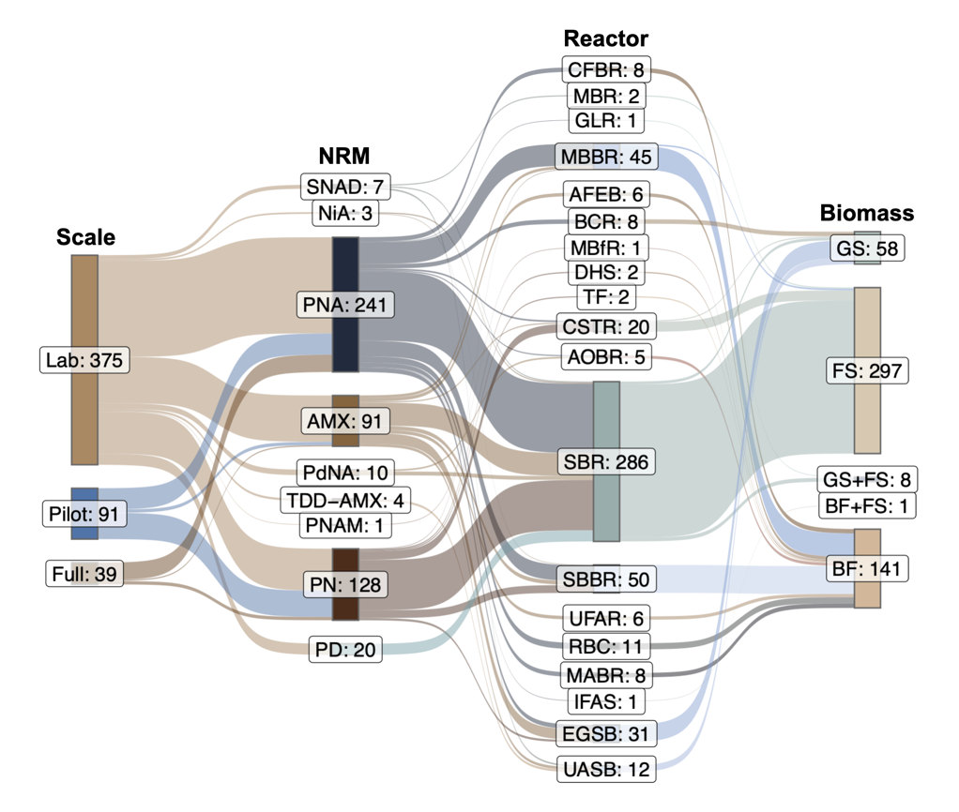
Figure S1: Structure of collected data across system scale, nitrogen removal mechanism (NRM), reactor configuration and biomass form. NRM: Partial Nitrification / Anammox (PNA), Partial Nitrification (PN), Anammox (AMX), Partial Denitrification / Anammox (PdNA), Nitrification / Anammox (NiA), Simultaneous partial Nitrification, ANAMMOX and Denitrification (SNAD), Partial Denitrification (PD), Thiosulfate-Driven Denitritation-anammox (TDD-AMX), Partial Nitritation, Anammox and Methane-dependent nitrite/nitrate reduction reactions (PNAM). Reactor: Sequencing Batch Reactor (SBR), Sequencing Batch Biofilm Reactor (SBBR), Stirred Tank Reactor (CSTR), Attached-Film Expanded Bed (AFEB), Membrane Aerated Biofilm Reactor (MABR), Moving Bed Biofilm Reactor (MBBR), Upflow Anaerobic Sludge Blanket (UASB), Expanded Granular Sludge Bed (EGSB), Down-flow Hanging Sponge (DHS), Gas Lift Reactor (GLR), Integrated Fixed-Film Activated Sludge (IFAS), Rotating Biological Contactor (RBC), Membrane Biofilm Reactor (MBfR), Membrane Bioreactor (MBR), Continuous-Flow Biofilm Reactor (CFBR), Upflow Fixed-bed Anammox Reactor (UFAR), Bubble Column Reactor (BCR). Biomass: Flocculent Sludge (FS), Biofilm (BF), Granular Sludge (GS), Granular Sludge + Flocculent Sludge (GS+FS), Biofilm + Flocculent Sludge (BF+FS).
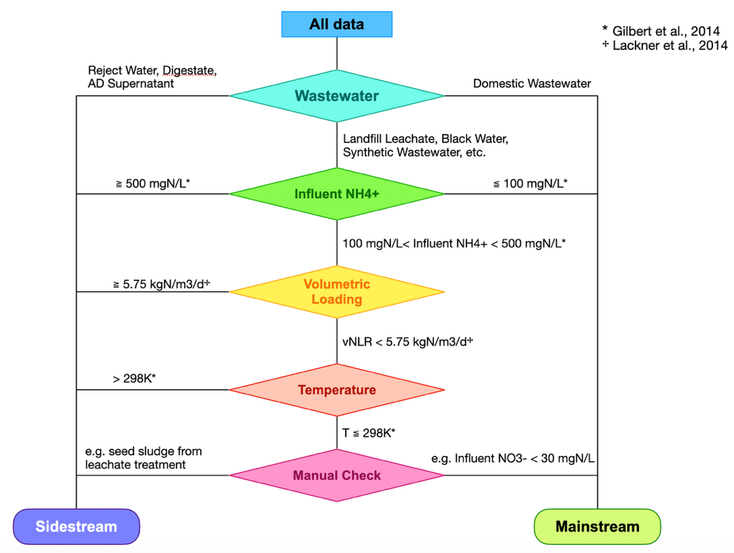
Figure S2: Wastewater type differentiation.
2. EF* summary for PD and AMX
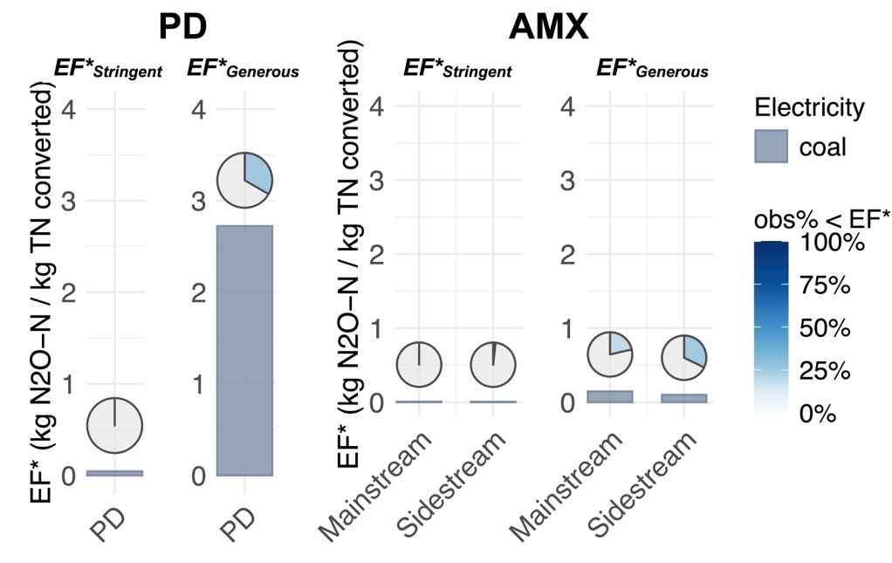
Figure S3: EF* and portions of observations lower than EF* for PD and AMX.
3. Correlation Analysis
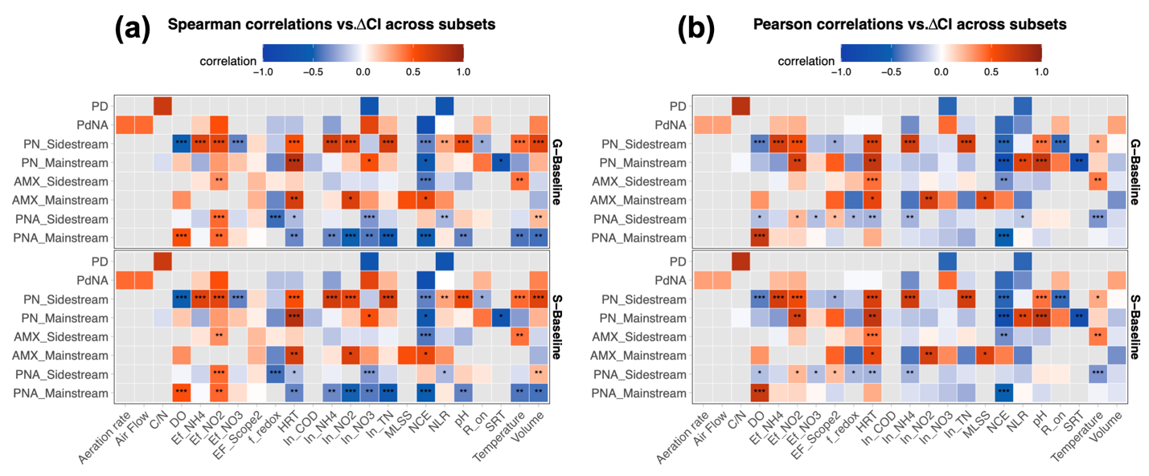
Figure S4: Correlation with ∆CI across processes. (a) Pearson’s correlation. (b) Spearman’s correlation.

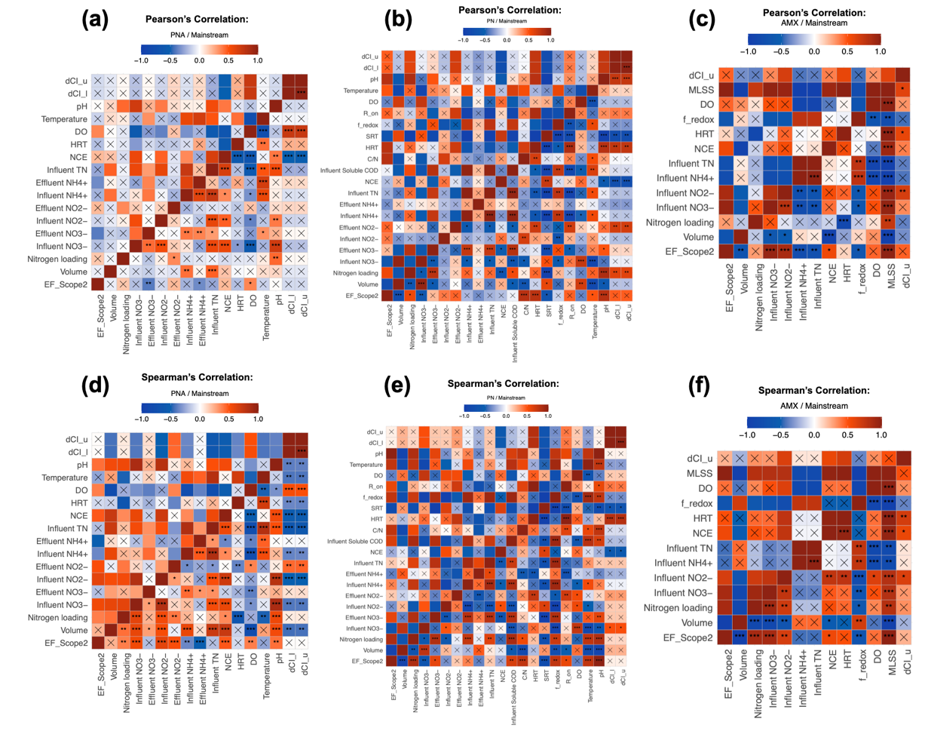
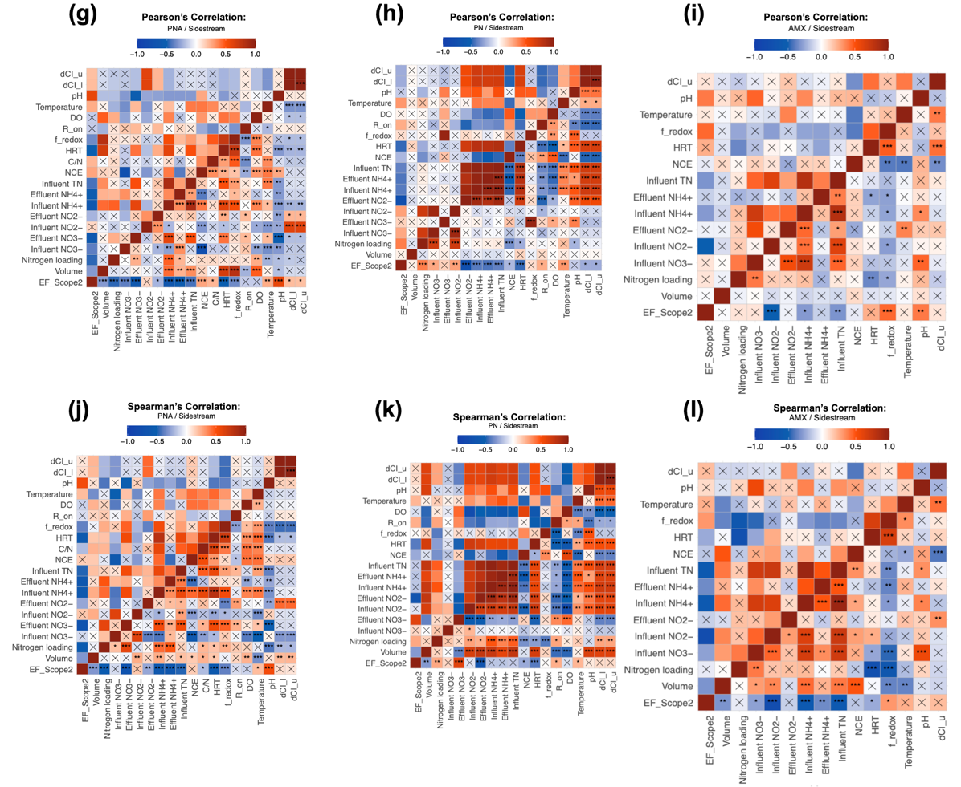
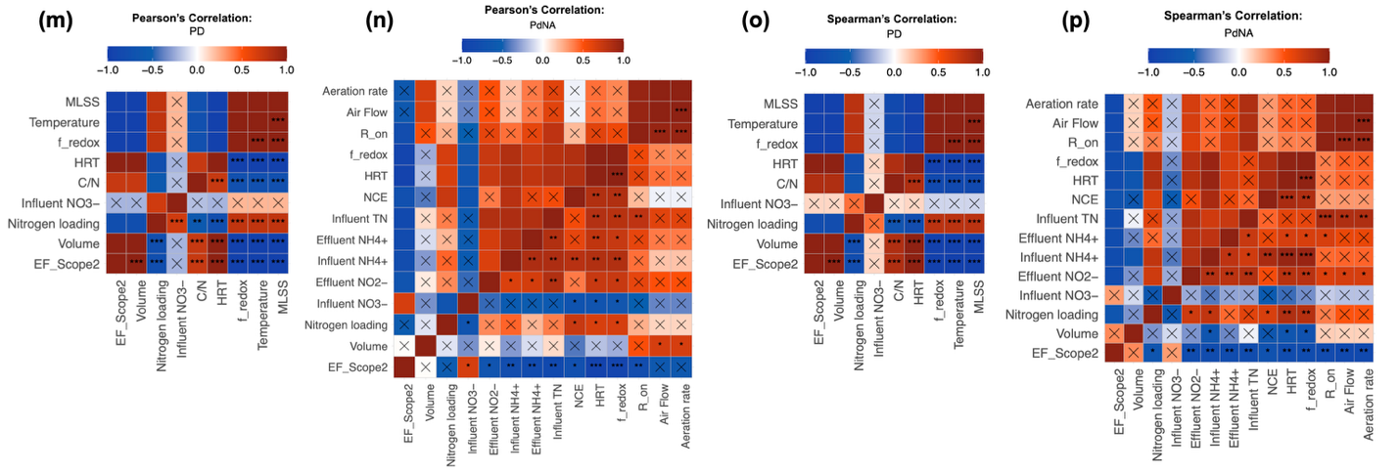
Figure S5: Pairwise correlation among all the variables with less than 30% missing values for each group of data with both Pearson’s and Spearman’s correlation.
4. Mixed-effects Regression
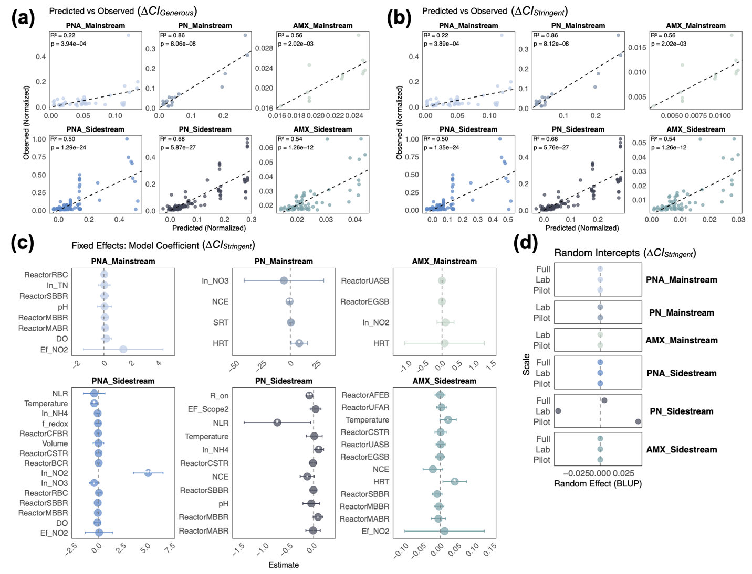
Figure S6: Mixed effects regression evaluation. (a) Group-specific regression performance for ∆CI_{Generous}. (b) Group-specific regression performance for ∆CI_{Stirngent}. (c) Fixed effects for model predictors of ∆CI_{Stirngent}. (d) Random effect for the system scale in predicting ∆CI_{Stirngent}.
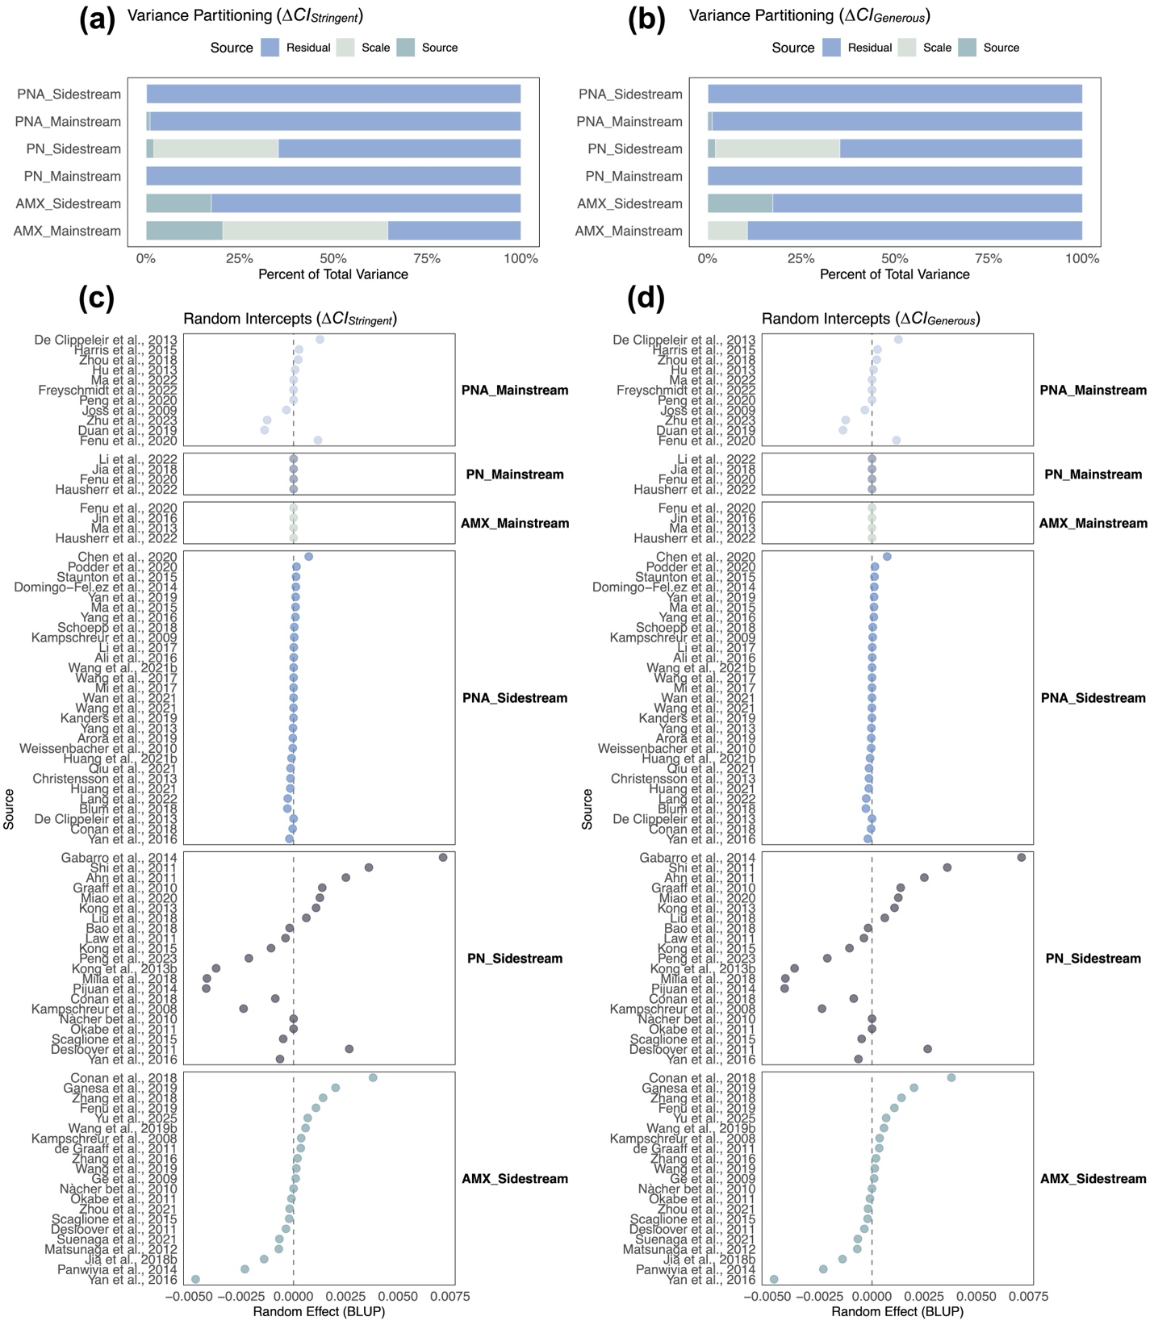
Figure S7: Variance partitioning of random variables in predicting (a) ∆CI_{Stirngent} and (b) ∆CI_{Generous}. Random effect for the system scale in predicting (c) ∆CI_{Stirngent} and (d) ∆CI_{Generous}.

1. Daigger GT, Boltz JP. Oxygen Transfer in Moving Bed Biofilm Reactor and Integrated Fixed Film Activated Sludge Processes. Water Environment Research 90, 615-622 (2018).

2. Drewnowski J, Remiszewska-Skwarek A, Duda S, Łagód G. Aeration Process in Bioreactors as the Main Energy Consumer in a Wastewater Treatment Plant. Review of Solutions and Methods of Process Optimization (2019).

3. Bratu I, Stamelaki A. "Reduction of energy consumption by replacing surface aerators with fine bubble aeration in Slobozia Wastewater Treatment Plant, Romania". Revista Romana de Inginerie Civila/Romanian Journal of Civil Engineering 14, 151-167 (2023).

4. Shukla BK, Sharma P, Goel A. Application of Membrane Aerated Biofilm Reactors in Treatment of Municipal and Industrial Wastewater: Present Trends, Challenges and Future Prospects. Letters in Applied NanoBioScience 14, 17 (2024).

5. Guglielmi G, Coutts D, Houweling D, Peeters J. Full-scale application of mabr technology for upgrading and retrofitting an existing WWTP: Performances and process modelling. Environmental Engineering and Management Journal 19, 1781-1789 (2020).

