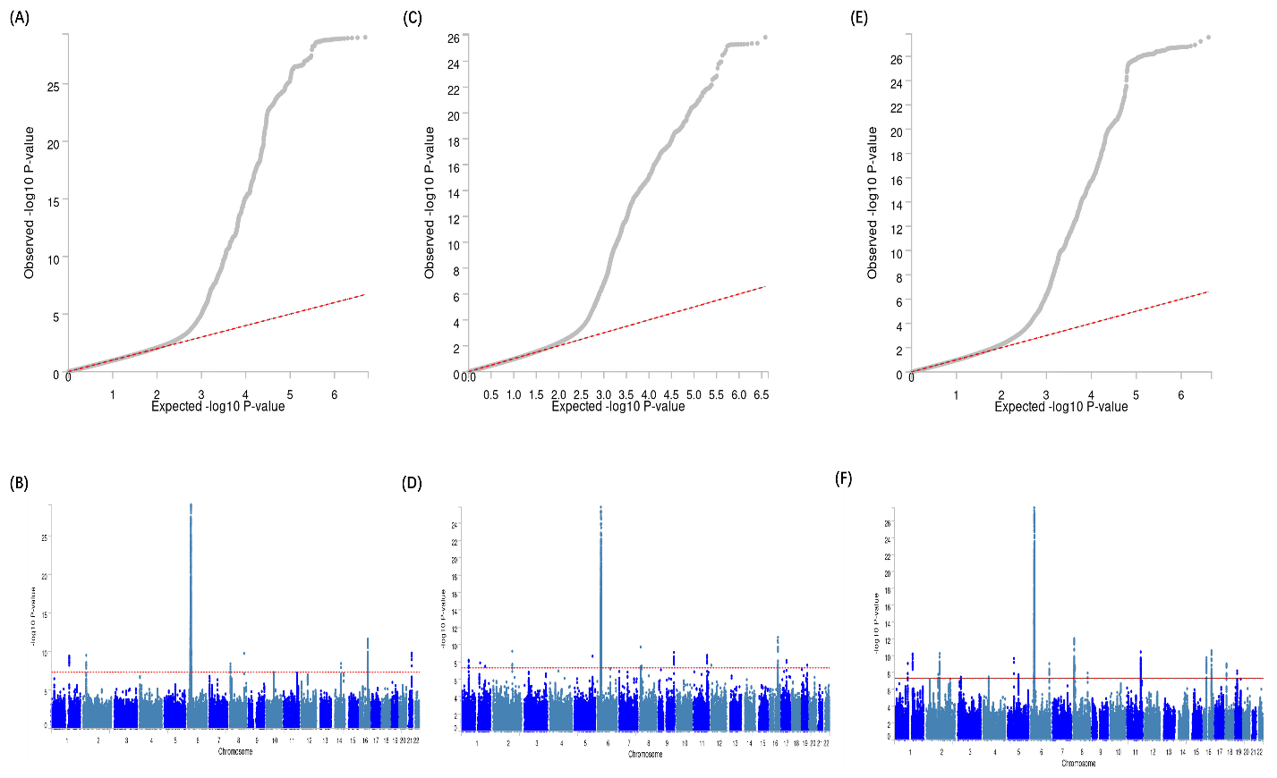

Figure S1. QQ and Manhattan plot of the PLACO results. Note: Red line represents the significance of 5×10⁻⁸. Abbreviations: GlycA, Glycoprotein acetyls; RA, Rheumatoid arthritis; AS, Ankylosing spondylitis; PsA, Psoriatic arthritis.

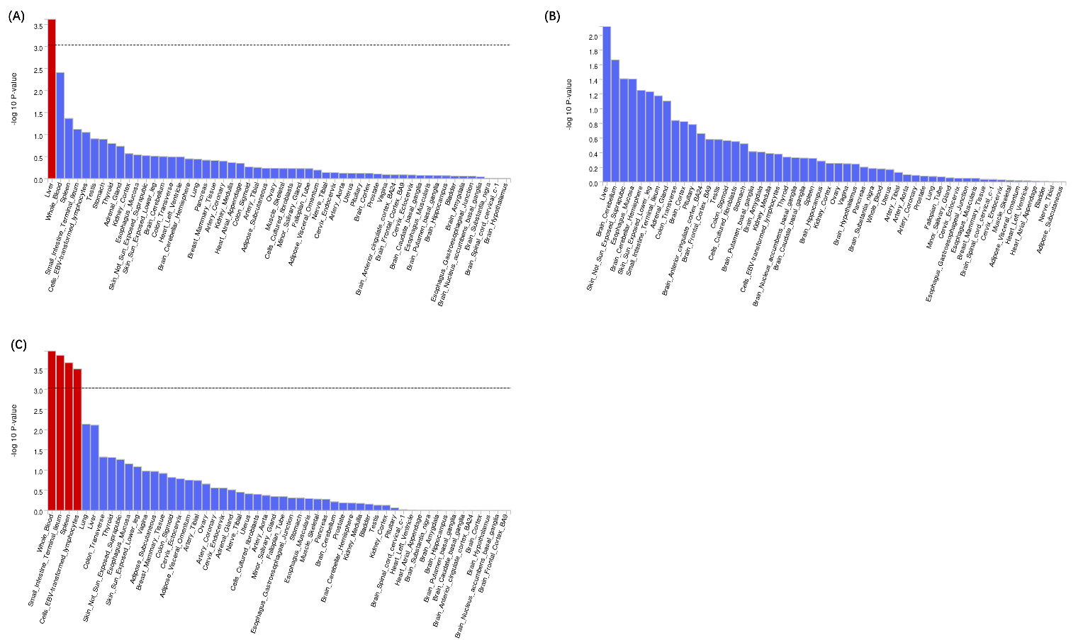

Figure S2. Figure S11. Gene-set enrichment for identified pleiotropic genes. Red panels represent significant tissues after Bonferroni adjustment. Abbreviations: DEG, differentially expressed genes.

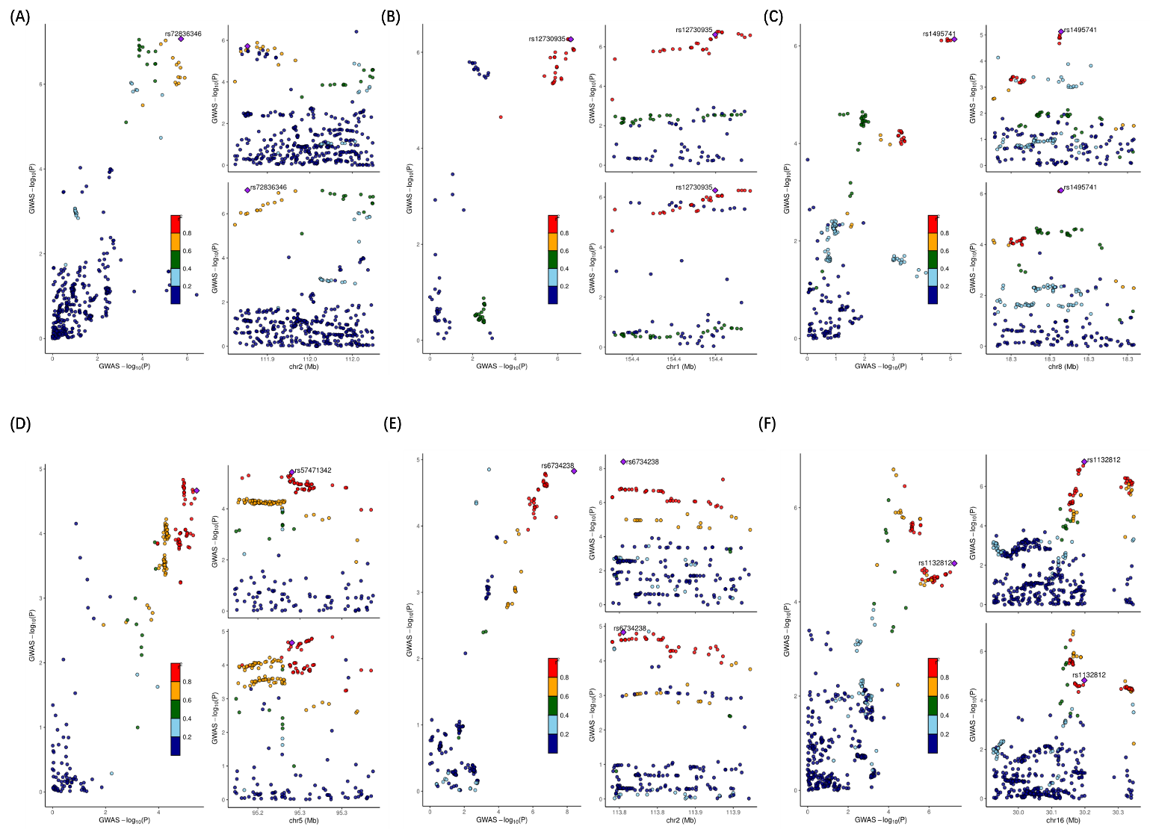

Figure S3. Regional plots of each colocalized locus (PP.H4 > 0.7) identified for corresponding trait pair (GlycA&RA) by using the PLACO. Note: PP.H4 was posterior probability of H4 calculated by coloc analysis.

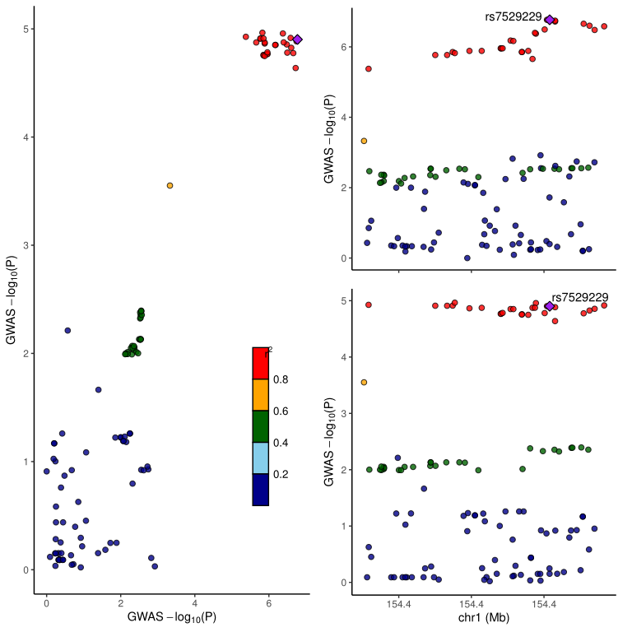

Figure S4. Regional plots of each colocalized locus (PP.H4 > 0.7) identified for corresponding trait pair (GlycA&PsA) by using the PLACO. Note: PP.H4 was posterior probability of H4 calculated by coloc analysis.

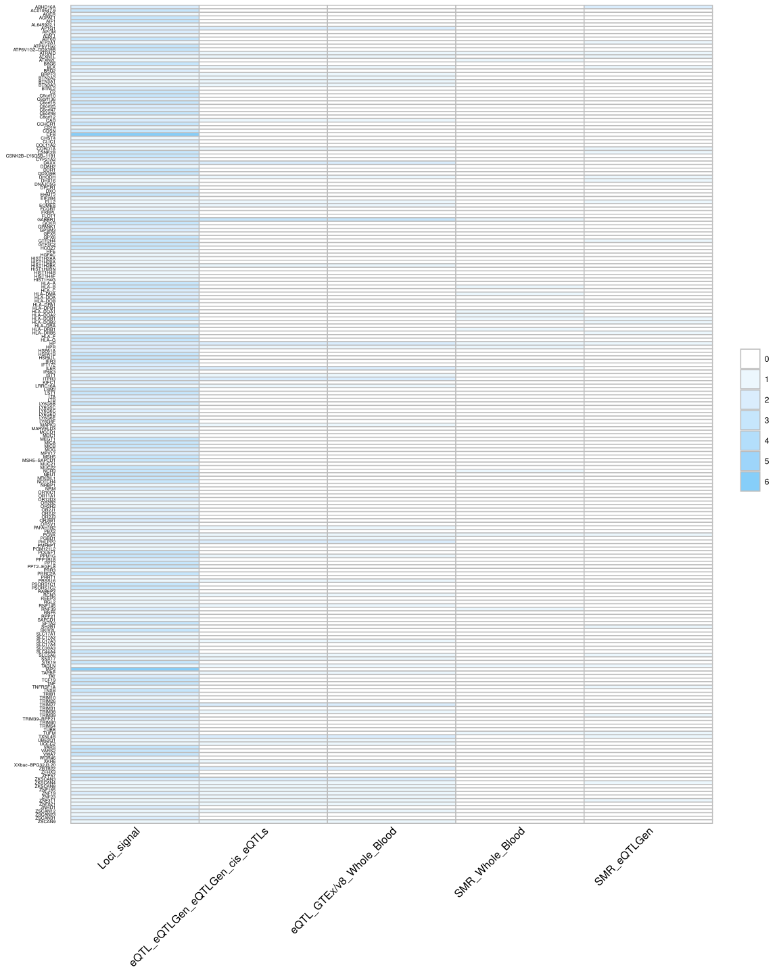
Figure S5. Overview of pleiotropic genes for the IA and GlycA. Note: The signals represent hits of genes across different trait pairs. Abbreviations: eQTL expression quantitative trait loci; SMR summary-based Mendelian randomization

