Hierarchical Clustering Dendrogram of Physician Phenotypes

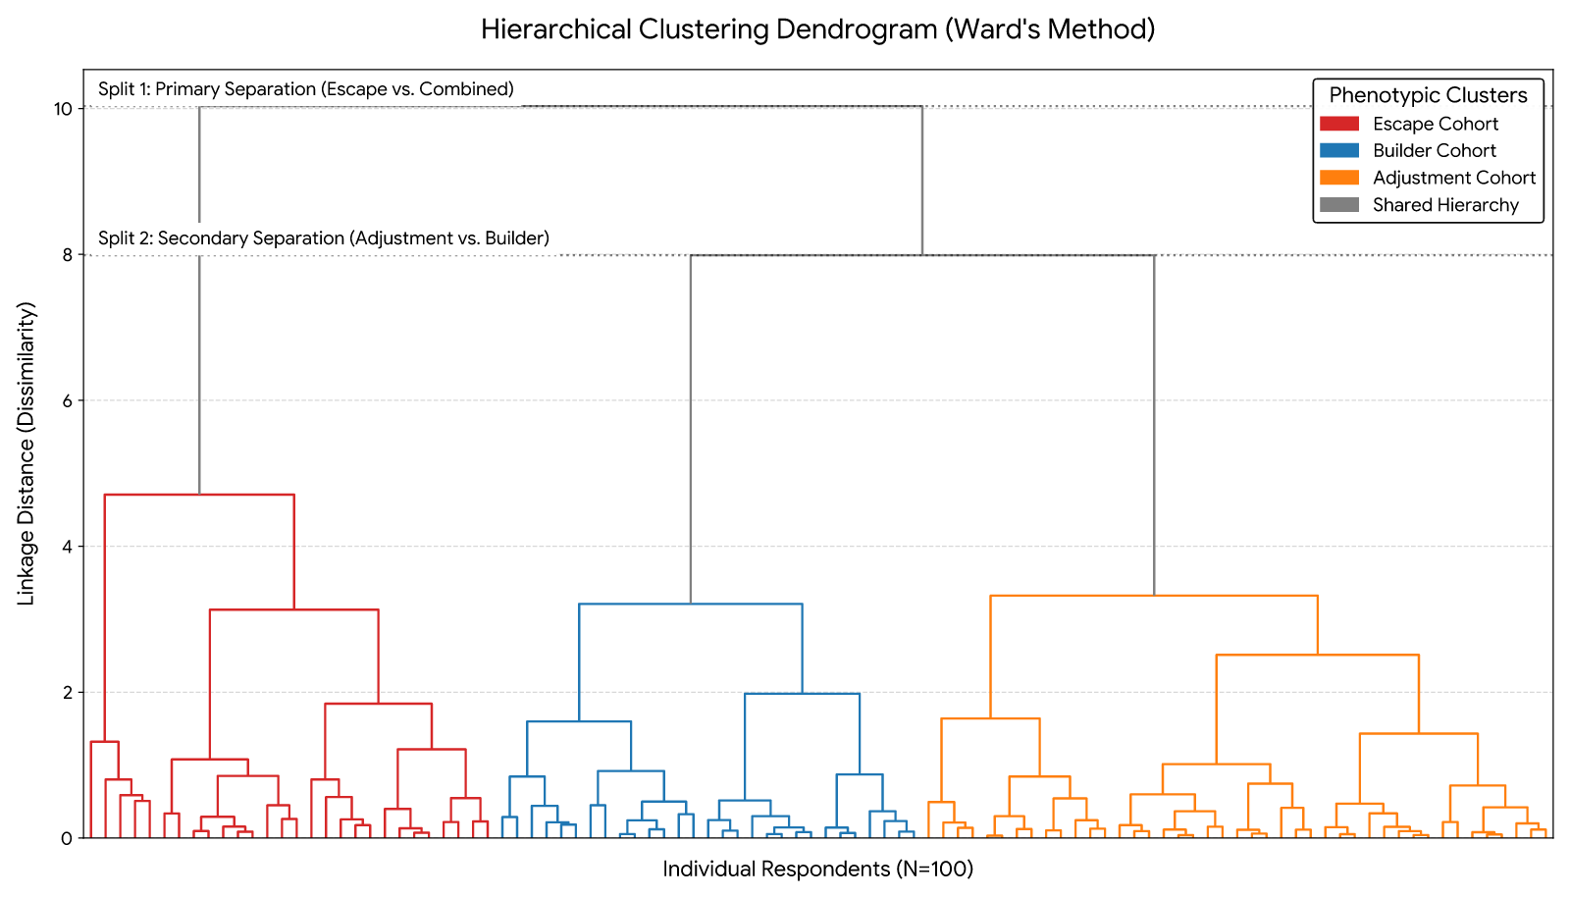
Footer

