Carboxymethylcellulose ameliorates high-fat diet-associated colitis through the reduction of deoxycholic acid and restoration of mitochondrial complex I in macrophages
Limei Shao^{1#}, Linglong Ji^{1#}, Wenle Liu^{1#}, Wei Lv¹, Yingying Liu¹, Tian He¹, Jing Li¹, Qinghua Tan¹, Ling Liu¹*
¹ Department of Gastroenterology and Hepatology, West China Hospital, Sichuan University, Chengdu, China
# These authors contributed equally to this work.

*Corresponding Author:
Ling Liu
Guo Xue Lane 37#, Chengdu 610041, China
Email address: lingzipurple@163.com, liulinggi@scu.edu.cn

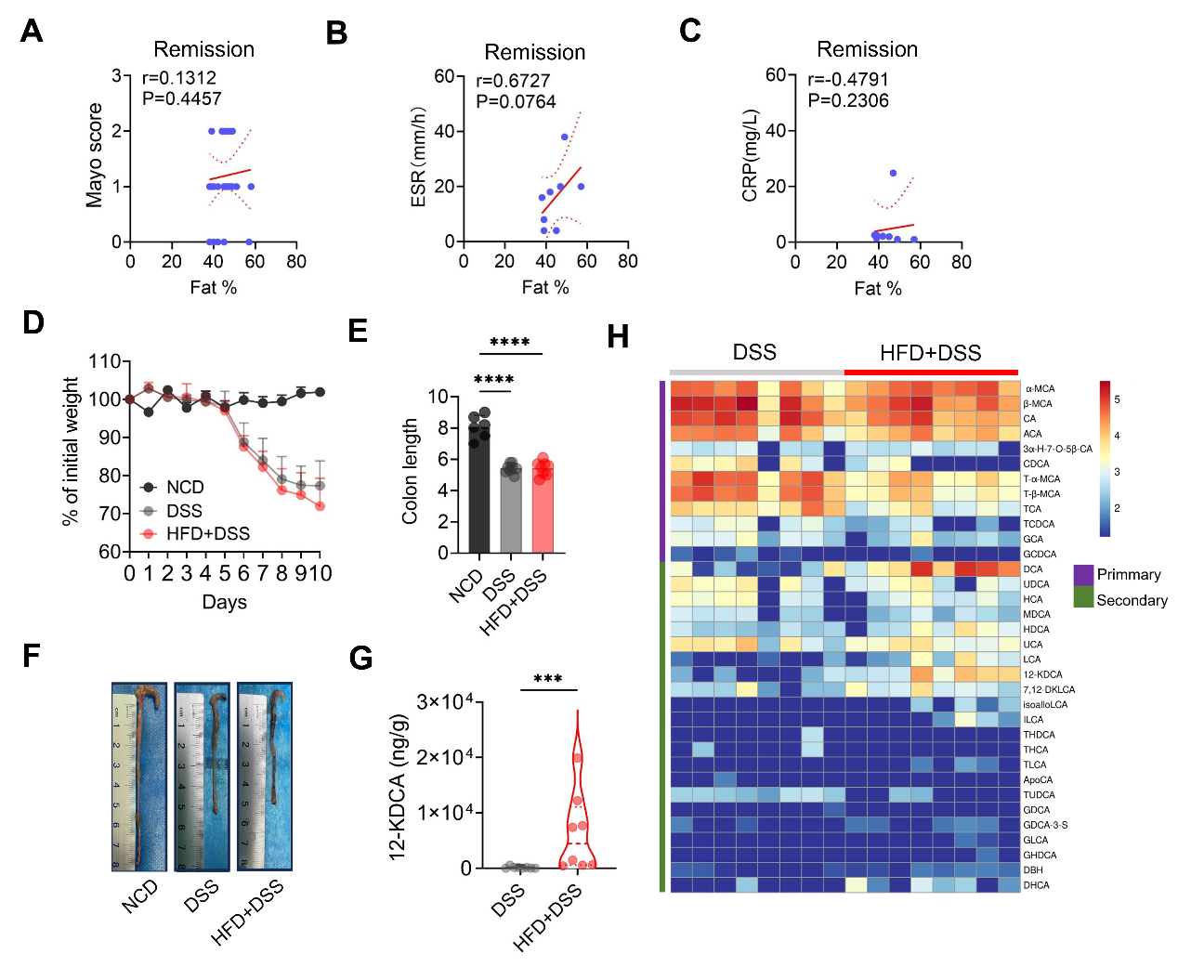
Fig. S1. HFD alters colonic BA metabolism in mice with colitis. (A-C) Spearman correlation analysis evaluating the correlations between dietary fat intake and Mayo score, ESR, and CRP in patients with UC in remission. (D-H) Mice were fed an HFD or normal chow diet (NCD) for 4 weeks, followed by 2.5% DSS administration for 7 days and a 3-day water recovery period, n=6-8/group. (D) Body weight changes. (E) Colon length quantification. (F) Representative images of colons. (G) 12-KDCA levels. (H) Heatmap showing levels of all detected BAs in the cecal contents of mice. ***P < 0.01, ****P < 0.0001.
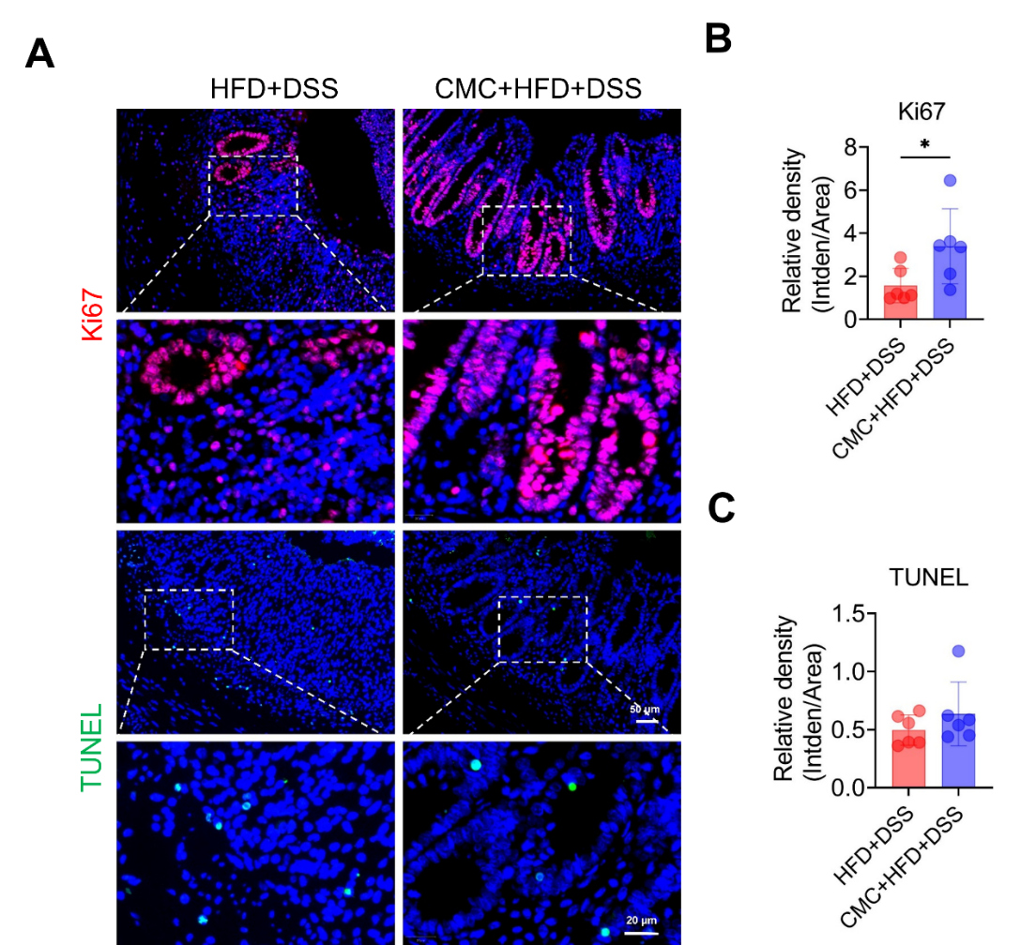
Fig. S2. The effect of CMC on colonic mucosal cell proliferation and apoptosis in HFD-associated colitis mice. Mice were fed an HFD with or without 1% (w/v) CMC in drinking water for 4 weeks, followed by 2.5% DSS administration for 7 days and a 3-day water recovery period, n=6/group. (A) Representative immunofluorescence staining images of Ki67 and TUNEL (scale bars: 50 μm; 20 μm). (B) Quantification of relative fluorescence intensity of Ki67-positive cells. (C) Quantification of relative fluorescence intensity of TUNEL-positive cells. *P < 0.05.
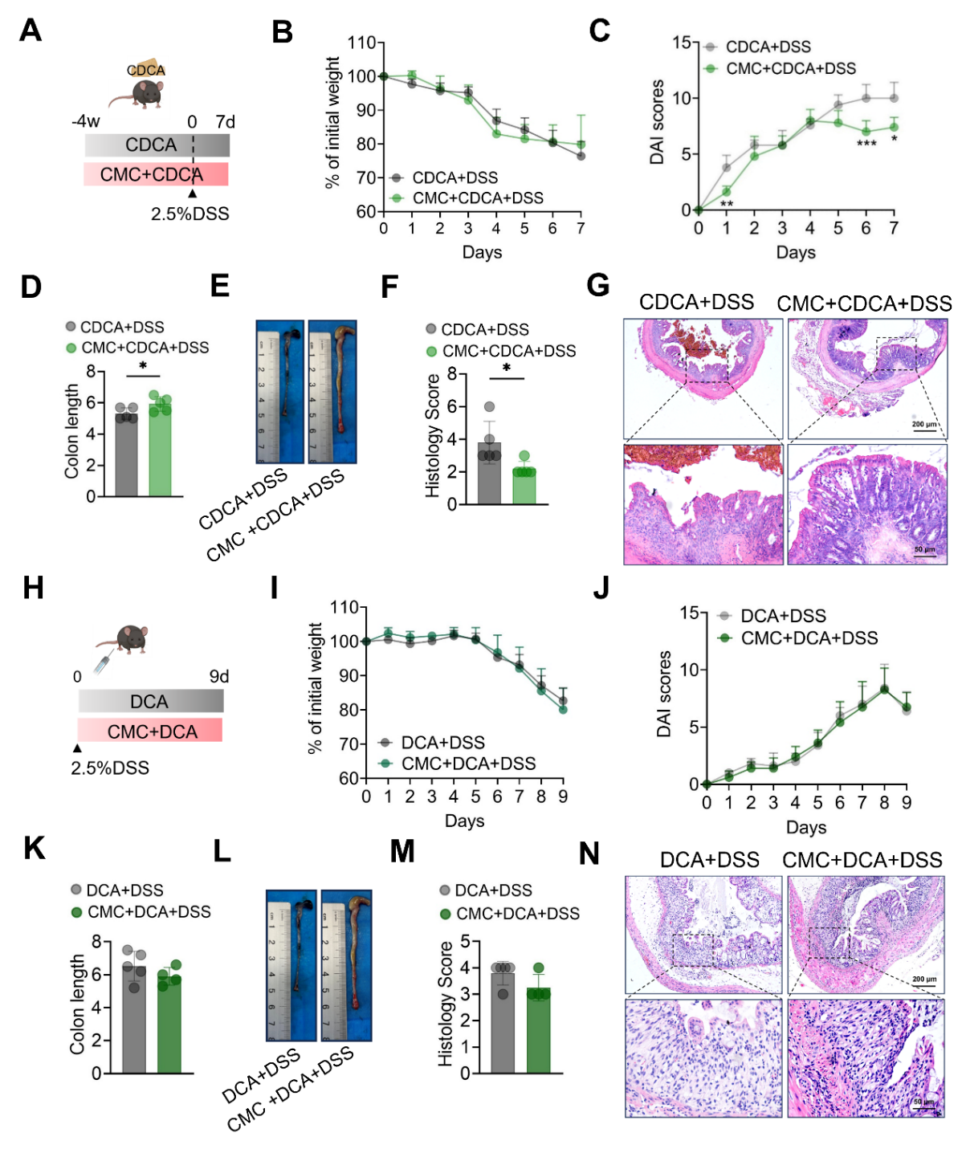
Fig. S3. CMC ameliorates CDCA-associated colitis but not DCA-associated colitis. (A-G) Mice were fed a diet containing 0.2% (w/w) CDCA with or without 1% (w/v) CMC in drinking water for 4 weeks, followed by 2.5% DSS administration for 7 days, n=5/group. (A) Schematic diagram of the mouse model. (B) Body weight changes. (C) DAI scores. (D) Colon length quantification and (E) representative images of colons. (F) Colon histopathological scores and (G) representative images of H&E-stained colon sections (scale bars: 200 μm; 50 μm). (H-N) During 2.5% DSS treatment, mice received enemas with 4 mM DCA alone or 4 mM DCA combined with 1% (w/v) CMC, n=4-5/group. (H) Schematic diagram of the mouse model. (I) Body weight changes. (J) DAI scores. (K) Colon length quantification and (L) representative images of colons. (M) Colon histopathological scores and (N) representative images of H&E-stained colon sections (scale bars: 200 μm; 50 μm). *P < 0.05, **P < 0.01, ***P < 0.001.
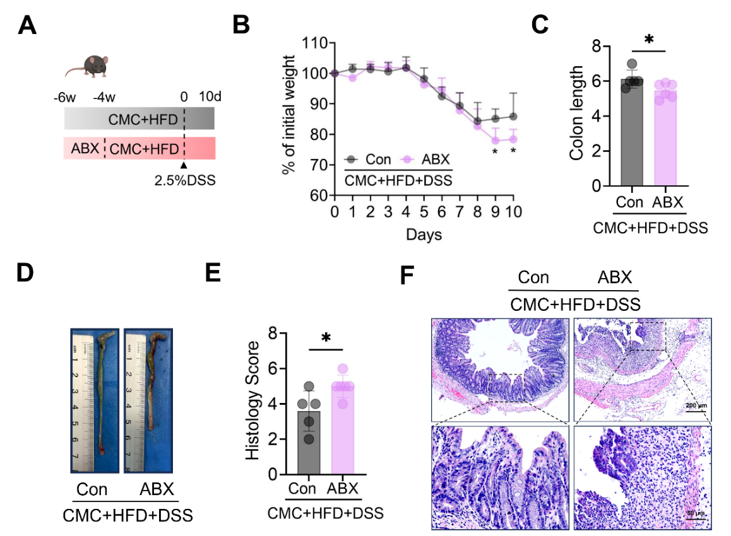
Fig. S4. The effect of CMC on HFD-associated colitis depends on the gut microbiota. Mice received an antibiotics cocktail (ABX) or control treatment for 2 weeks to deplete the gut microbiota, then were fed an HFD with or without 1% (w/v) CMC in drinking water for 4 weeks, followed by 2.5% DSS administration for 7 days and a 3-day water recovery period, n=5-6/group. (A) Schematic diagram of the mouse model. (B) Body weight changes. (C) Colon length quantification and (D) representative images of colons. (E) Colon histopathological scores and (F) representative images of H&E-stained colon sections (scale bars: 200 μm; 50 μm). *P < 0.05.
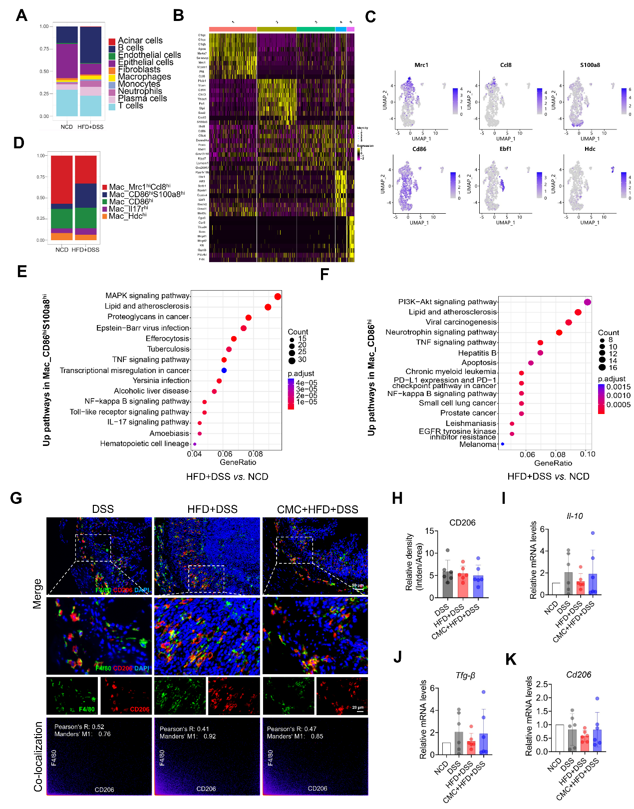
Fig. S5. CMC does not alter M2 polarization of colonic macrophages in HFD-associated colitis mice. (A-F) Mice were fed an HFD for 4 weeks, followed by 2.5% DSS administration for 7 days, and colon tissues were collected for scRNA-seq, with normal chow diet (NCD) mice as controls. (A) Stacked bar plot showing cell cluster proportions in the HFD+DSS and NCD groups. (B) Heatmap showing gene expression in macrophage subpopulations. (C) UMAP plots showing expression of marker genes in macrophage subpopulations. (D) Stacked bar plot showing cell cluster proportions of each macrophage subpopulation in the HFD+DSS and the NCD groups. (E) KEGG pathway enrichment bubble plots in CD86^{hi}S100a8^{hi} and (F) CD86^{hi} macrophage subpopulations (HFD+DSS vs. NCD, P adjust < 0.05, top 15). (G-K) Mice were fed an HFD with or without 1% (w/v) CMC in drinking water for 4 weeks, followed by 2.5% DSS administration for 7 days and a 3-day water recovery period, n=6/group. (G) Representative immunofluorescence staining images of colonic F4/80 (macrophage marker) and CD206 (M2 macrophage marker), and colocalization analysis of F4/80⁺ and CD206⁺ macrophages (Pearson's R values and Manders' M1 represent the intensity of colocalization) (scale bars: 50 μm; 20 μm). (H) Quantification of relative fluorescence intensity of CD206⁺ macrophages. (I-K) mRNA expression of (I) Il-10, (J) Tgf-β, and (K) Cd206 in colonic mucosa, normalized to the NCD group.
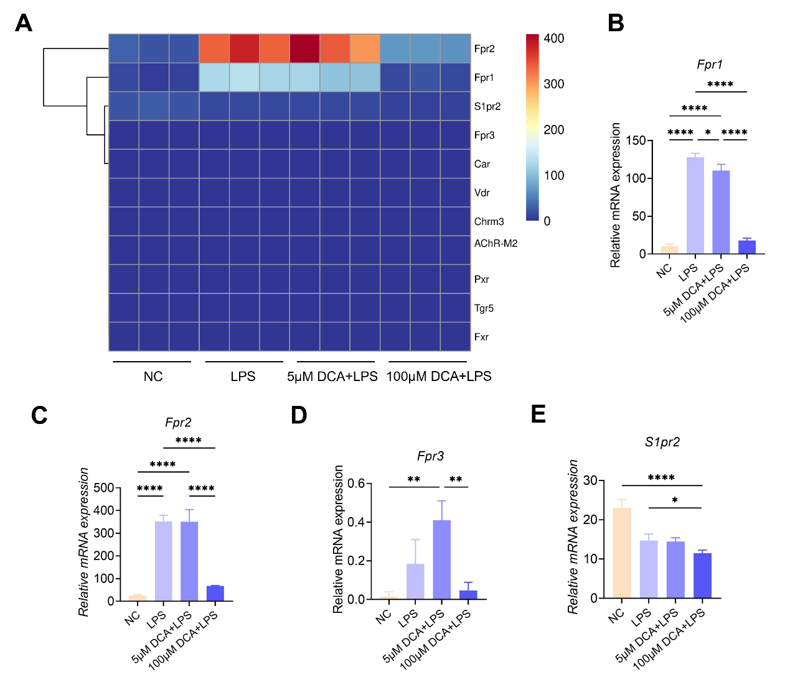
Fig. S6. DCA regulates BA receptor expression in BMDMs. Mouse bone marrow-derived macrophages (BMDMs) were incubated with 5 μM or 100 μM DCA combined with 1 μg/mL LPS for 4 h, and RNA-seq was performed. (A) Heatmap showing expression levels of BA receptor genes. (B-E) mRNA expression levels of BA receptors Fpr1, Fpr2, Fpr3, and S1pr2. *P < 0.05, **P < 0.01, ****P < 0.0001.

