Supplementary File A: Data Collection Tools

Demographic survey for parents in street situations (Phase 1 and 3)

This section asks general information about you and your family. Please remember that your responses are for our research purposes only. They are strictly confidential.

PARENT INFORMATION

- Participant ID: _________

- What is your sex?
- Male
- Female
- Prefer not to say

- How old are you in years? _______________________________

- Do you have a mobile phone?

- Yes
- No

- If YES, what is your mobile phone number? ____________________________

- What do you use your mobile phone for? _______________________

- Do you use WhatsApp?
- Yes
- No

- (In response to question #7) Why/why not? _________________________

- Do you use mobile money?
- Yes
- No

- (In response to question #9) Why/why not? _________________________

- What is your HIGHEST level of schooling?
- No schooling
- Pre-primary 1-2
- Primary (Grade 1-6)
- Junior Secondary (Form 1-3)
- Senior Secondary (Form 4-6)
- Undergraduate studies, not finished
- Undergraduate studies, finished

- How well can you read?
- Cannot read at all
- Can read but with lots of difficulty
- Can read with a little difficulty
- Can read easily

- Please describe where you live and/or sleep

_______________________

- Do you currently have paid work?
- Yes, full-time
- Yes, part-time
- Not working but looking for a job
- Not working by choice
- Part-time student
- Full-time student
- Other (please explain): ___________________

- Does anyone else in your family have paid work? [e.g. partner/husband/wife, sibling, etc.]
- Yes, full-time
- Yes, part-time
- Not working but looking for a job
- Not working by choice
- Part-time student
- Full-time student
- Other (please explain): ___________________

- What is the main source of income for your family?
- No household income
- Money earned from selling products or services
- Salaries and/or wages
- Remittances (money sent from someone else)
- Government pensions and grants
- Other sources of income _____________________

- Which of the following do you have? Please check all that apply.
- Access to a shelter, with 4 walls and a roof
- Access to water
- Electricity
- Working radio
- Working television
- Mobile phone
- Refrigerator
- Working computer
- Electric fan
- Three or more books
- Diapers
- Toys
- Soap
- Healthy food

- How often, if ever, do you drink alcohol?
- Never
- 1-3 times per week
- 4-7 times per week
- More than once a day

- How often, if ever, do you use glue to get high?
- Never
- 1-3 times per week
- 4-7 times per week
- More than once a day

- How many adults aged 18 and older not including you live with you at least 4 nights per week? _________________________________________________________

- How many adults are women not including you? ______________________________

- How many children under the age of 18 live with you at least 4 nights per week? __________________________________________________________________

- How many children do you take care of between the ages of 0 and 17?
________________________________________________________________________

- How many of these children are girls? _____________________________________

- How many of these children are your biological children? _____________

- If your children do not live with you, where do they live? ___________________________________________

- Do your children all have the same biological father/mother?

- Yes
- No
- I don’t know
- Prefer not to say

- If NO, how often do they see their biological father/mother?
- Never
- 1-2 times per week
- 3-4 times per week
- 5+ times per week
- Other (please explain): __________________

Many families struggle to have enough to eat. The next questions are about challenges you might face with feeding yourself and your family.

- Please describe a typical meal for you and your family

__________________

- In the past week, about how many meals did you consume per day?
- Less than one meal per day
- One meal per day
- Two meals per day
- Three meals or more per day

- Where do you find your food? ________________________

- Do you ever run out of money to buy food for your family?
- Yes
- No

- If YES, has it happened in the past 14 days?
- Yes
- No

- Do you ever cut the size of meals or skip any meals because there is not enough food in the house?
- Yes
- No

- If YES, has it happened in the past 14 days?
- Yes
- No

- Do you or any of your children go to bed hungry because there is not enough food to eat?
  - Yes
  - No

- If YES, has it happened in the past 14 days?
- Yes
- No

CHILD INFORMATION

For the following questions, if you have more than one child less than 18 years old, answer for your youngest child within the age range. For example, if you have four children aged 2, 3, 5, 6 years old, answer for your 2 years old child.

- What is your child’s sex?
- Male
- Female
- Prefer not to say

- What is your relationship to this child?
- Biological mother
- Biological father
- Stepmother
- Stepfather
- Partner of parent
- Grandmother
- Grandfather
- Other relative or in-law
- Other non-relative (describe): ____________________

- What is the birth order of this child in your family?
- First
- Second
- Third
- Forth
- Other _____________________________

- Do you live with your child?
- Yes
- No

- If NO, where does your child live?

- (Ask only if respondent is not the biological father): Is your child’s biological father part of this household?
- Yes
- No

- If NO. Can you tell us where he is?
- Works away from home to provide financial support to family
- Uninvolved in family life
- Lives elsewhere, but is involved in family
- Death
- Don’t Know
- Other _____________________

- (Ask only if respondent is not the biological mother): Is your child’s biological mother part of this household? (Single select: 1 = yes; 0 = no)
- Yes
- No

- If NO. Can you tell us where she is?
- Works away from home to provide financial support to household
- Uninvolved in household life
- Lives elsewhere, but is involved in household
- Death
- Don’t Know
- Other _____________________

In lots of families many grown-ups who live together share in the responsibility of looking after children. They help with meals, take them to school or the clinic, supervise during playtime, help getting dressed, help with homework or help with discipline.

- Does your child have another parent, guardian or caregiver who helps take care of them?
- Yes
- No

- Is your child at daycare/school?
- Yes
- No
- If NO, what is the reason why you child is not in daycare/school? _________________
_________________________________________________________________________

In-Depth Interview Guide for Parents in Street Situations (Phase 1)

The Malezi Bora na Maisha Mazuri program is a positive parenting program that was developed with and for street-connected mothers in 2018. It is a 12-session in-person program that helps parents learn how to have good relationships with their children and their partners, manage their child’s behaviour, help their children grow up into good people, and to manage the daily stresses of parenting.

The purpose of this study is to better understand how we can improve the lives of street-connected children and families by refining the Malezi Bora na Maisha Mazuri program to include street-connected fathers.

Specifically, we are trying to understand: (1) what it means to be a parent on the streets in Eldoret and how it may be different for mothers and fathers, and (2) important considerations for engaging men in the Malezi Bora na Maisha Mazuri program and how to make it relevant for both male and female caregivers. With this information, we plan to adapt the program for the inclusion of both female and male caregivers who raise their children on the streets.
Your individual responses will be strictly confidential to the research team and your personal information will not be divulged to any outside party, including other study participants.
Background
- Tell me about yourself.
- Where is your home? Where do you live?
- How did you end up living in the streets?
- Describe your typical day living in the street.
  - Prompt: How long do you spend at the “base”?
  - Prompt: What do you normally do?
- What makes you to continue living on the streets?
- In the next five years, what do you want your life to look like?

Parenting
- What does it mean to you to be a mother/father?
  - Prompt: What do you like most about being a mother/father?
  - Prompt: How do your child (ren) make you feel?
  - Prompt: What gives you a sense of happiness or satisfaction?
  - Prompt: Did you want to have child (ren)? Why/Why not?
- What are your roles as a mother?
  - Prompt: What do you think should be the roles of a father/mother?
- Describe your relationship with your child(ren).
- What do you do when you spend time with your child (ren)? What type of activities do you do?
- When your child does something they shouldn’t be doing, how do you discipline them?
- Can you explain what a typical day in your life as a parent looks like?
- What influences the way you parent? (E.g. cultural or family values, culture of the street community, ethnic group, experiences as a child etc.)
  - Prompt: How, if at all, has your relationship with your own parents impacted your actions as a parent?
- How does your relation with the streets impact your actions as a parent?
- Who, if anyone, do you share parenting responsibilities with?
- Prompt: What responsibilities do they have?
- Prompt: Why do you share these responsibilities?
- Prompt: In what ways are your parenting styles the same or different?
- Prompt: What challenges do you both face in sharing parenting responsibilities?
- What are the greatest challenges you face as a parent in the streets?
- How do you deal with these challenges?

Relationships
- Please describe any romantic relationship you have/have had.
- Prompt: How did you meet?
- Prompt: How long have you been /were you together?
- Prompt: Where do/did they live/reside?
- Prompt: Describe their relationship with your child (ren).
- Prompt: Do you/ have you ever had previous/more than one partner?
- If YES-what is your relationship with them now?
- Prompt: How do they make you feel?
- How do you approach disagreements with your partner?
- How would you like to approach disagreements with your partner?
- Prompt: How can the Malezi Bora program help with this?

Adapting the Malezi Bora na Maisha Mazuri Programme
- What do you think about including mothers and fathers together in a parenting program?
  - Prompt: What do you think would be the benefits of including both mothers and fathers in the same program?
  - Prompt: What do you think would be the challenges?
  - Prompt: Who would have the most difficulty attending a program and why?
  - Prompt: Would you feel comfortable attending the program with your current partner/boyfriend/husband?
- What are the things that could help fathers join and stay in the programme? What about mothers?
- What do you think are the challenges to getting fathers to participate?
  - Prompt: How can we overcome these challenges?
- How can we design the programme so that it is safe for all participants involved?
  - Prompt: Single sex sessions? Combination of single sex plus mixed? Mothers and fathers together for every session?
- What topics do you think would be important to include?
  - Prompt: Gender socialization? What about topics that influence one’s ability to parent, such as financial management? Job seeking? Supporting HIV disclosure?

Interview Guide for In-Depth Interviews with Community Service Providers (Phase 2)
Thank you for participating in this study. This study aims to gather input from community members and practitioners who offer services and supports to street-connected young people, about content and delivery considerations for engaging male caregivers in the Malezi Bora na Maisha Mazuri program.
The Malezi Bora na Maisha Mazuri program is a positive parenting program that was developed with and for street-connected mothers in 2018. It is a 12-session in-person program that helps parents learn how to have good relationships with their children and their partners, manage their child’s behaviour, help their children grow up into good people, and to manage the daily stresses of parenting.

The purpose of this study is to better understand how we can improve the lives of street-connected children and families by refining the Malezi Bora na Maisha Mazuri program to include street-connected fathers.

Specifically, we are trying to understand: (1) what it means to be a parent on the streets in Eldoret and how it may be different for mothers and fathers, and (2) important considerations for engaging men in the Malezi Bora na Maisha Mazuri program and how to make it relevant for both male and female caregivers. With this information, we plan to adapt the program for the inclusion of both female and male caregivers who raise their children on the streets.
Your individual responses will be strictly confidential to the research team and your personal information will not be divulged to any outside party, including other study participants.
- What type of organisation do you work for/with?:
  - Community-based non-profit
  - Faith-based organization
  - Childcare institution/care home
  - Education institution/school
  - Government
  - Legal organization
  - Healthcare institution
  - Criminal justice organization/police
  - Other (please explain): _____________
- Please briefly describe your experience working with street-connected young people
  - Prompt: How long have you worked with this population and in what capacity?
  - Prompt: Have you ever worked with street-connected parents? If so, what has been your experience?
- What would encourage fathers to enrol in the Malezi Bora na Maisha Maruzi programme? Please explain
- What barriers might exist in getting fathers to enrol in the programme?
  - Prompt: Why might they decide not to enrol?
- What factors may facilitate male caregivers’ continuous attendance in programme sessions?
- What barriers may impact their continuous attendance?
- What factors may facilitate male caregivers’ active participation in the program sessions (e.g. whether they participate in group discussions, partake in role plays, engage in at-home practice, etc.)?
- What barriers may exist to male caregivers’ active participation?
- What factors may facilitate male caregivers’ implementation/use of their newly learned behaviours from participating in the Malezi Bora na Maisha Mazuri programme?
- What factors may serve as barriers to male caregivers’ implementation/use of their newly learned behaviours from participating in the programme?
- What topics/content areas should be included in a the Malezi Bora na Maisha Mazuri program?
- What challenges may arise in offering a programme for both mothers and fathers who live and work on the streets?
- What strategies would you suggest for mitigating these challenges?

Focus Group Discussion Guides for Parents in Street Situations (Phase 3)

First Focus Group Guide

Prior to beginning the FGD, facilitators will review the information outlined in the participant consent form and will remind participants to keep everything shared within the FGD confidential.

Aim: To (a) improve the relevance and acceptability of programme sessions for mothers and fathers, (b) identify what participants would like to learn in a parenting programme, and (c) identify challenges and opportunities for engaging fathers and mothers in the Malezi Bora programme.

Approach: The FGD uses an open-ended approach to soliciting views and feedback from participants in an unbiased and nonjudgmental manner. Facilitators should guide the focus groups along the following information and accompanying questions while allowing the discussion to evolve as themes emerge that are important to participants.

First, we would like you to give an overview about the structure of the Malezi Bora na Maisha Mazuri programme, then ask you some questions about it.
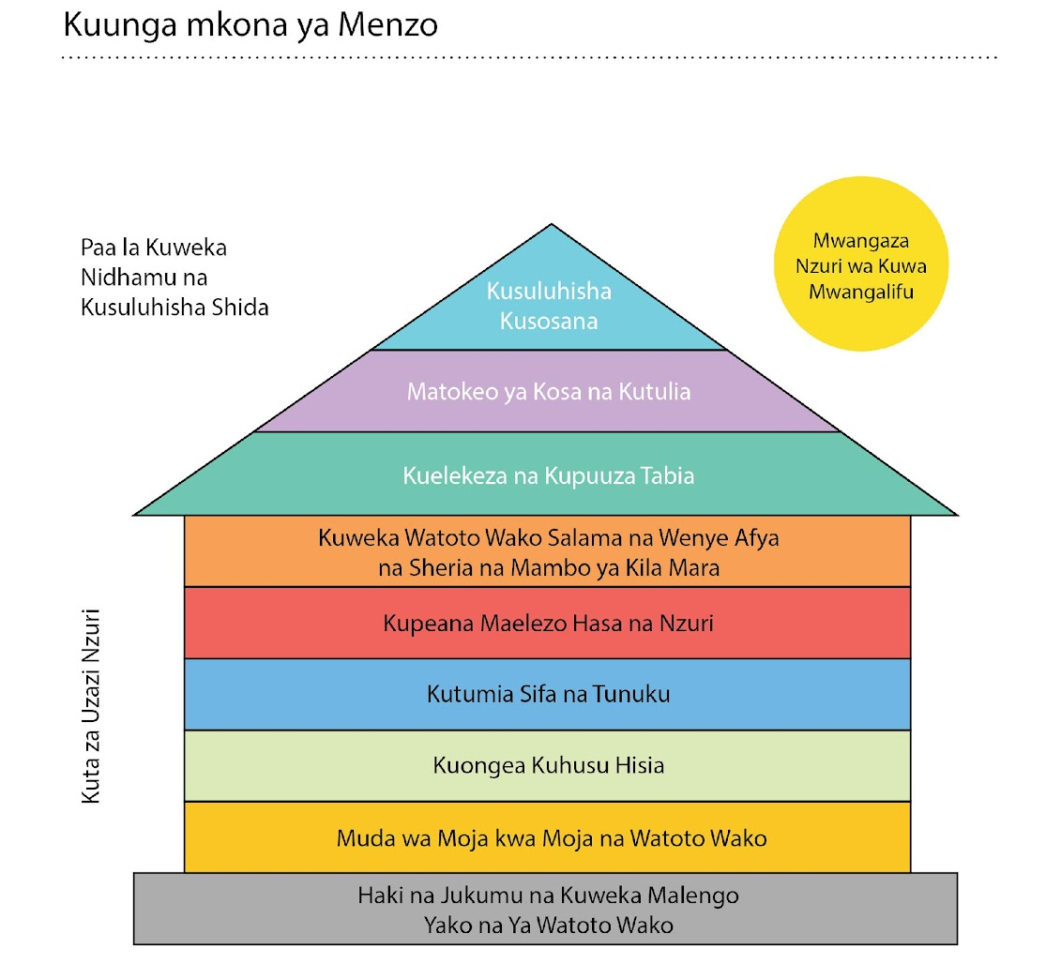

BUILDING A MENZO OF SUPPORT

Malezi Bora na Maisha Mazuri uses a Menzo to show why it is important for parents to build a strong, positive relationship with their children.
The foundation is about upholding the rights and responsibilities of children and parents and setting parenting goals, while the walls are about building positive relationships with your children.
The foundation and walls are what support good parenting. They are the most important part of the program.
As we move to the roof, we focus on dealing with difficult behaviour, using discipline, and problem-solving difficult situations within the family.
When parents spend more time building positive relationships with their children, they often need to spend less time managing difficult behaviours. This is because the more time that parents spend playing with, and praising, their children, the less often their children will misbehave.
And if parents can keep themselves and their children healthy while also building strong relationships, they will be on the right track for fulfilling the rights and responsibilities of themselves and their children.
These skills make parents and children feel supported and loved.
If the walls of the Menzo are strong, the roof will be easier to maintain.
Finally, the “Sunshine of Positive Attention” symbolizes the importance of children receiving as much positive attention as possible from their parents.
The important goal of this program is to increase positive parenting behaviour by:
- Increasing parenting knowledge and skills
- Improving positive parenting practices
- Decreasing harsh discipline
- Improving child behaviour and wellbeing
- Improving caregiver mental and physical health, and social support
- Improving knowledge and use of social, health, and legal services for intimate partner violence, family planning, and family illness; and for upholding the rights of the child
- Improving engagement in early childhood learning

Program Sessions
There are 12 sessions in the program. Within each of these sessions, there are group discussions, stories, illustrated stories, role plays, and other activities. The purpose of each session is to work together to come up with solutions to parenting challenges, and to support one another in raising children in a positive way.

Session 1 is the foundation of the Menzo of Support.

It introduces the program to parents, establishes common ground rules and has parent set goals for the program and for themselves, and focuses on the rights and responsibilities of children and parents.

Discussion topics for session 1 include:
- What are children’s rights?
- How can we protect the rights of our children?
- What are your rights as parents?
- Setting goals as a parent that are positive, specific, and realistic

Session 2 is on spending one-on-one time with your child

In Session Two, we help parents discover that by playing with their children, they will build a positive relationship with them.
Play is very important for children. It helps them develop healthy minds and to learn. If a parent shows that what their child is doing is important to them too, it improves their relationship with their child.
Discussion topics include:

- Engaging in play with your child, where your child leads the play
- Playing at your child’s level and pace
- Playing collaborative games with your children rather than competitive ones
- How playing helps build positive relationships with your child

Session 3 is on talking about feelings

In Session Three, we help parents understand how to talk about their own feelings, and their children’s feelings.
Discussion topics include:
- Identifying your own emotions and connecting them with your body (e.g. how do you physically feel when you are happy? Sad? Angry?)
- Naming and acknowledging your children’s feelings so you know how to respond to them
- Talking about our feelings and our children’s feelings
- Helping parents cope with anger and frustration (parenting can be difficult!)

Session 4 is on Praising and Rewarding our children

In Session Four, we learn how to use praise and reward behaviours we want more of from our children.
Discussion topics include:
- What it means to praise and reward our children, and why it’s important
- How to praise our children for good behaviour (e.g. “You’ve done a great job…” or, “Thank you for…”)
- How to reward our children for good behaviour (e.g. rewarding them by not having them do a chore)
- The types of behaviours we should we praise and reward
- Creating “Good Parenting Partners”, which are people in the program that offer peer support throughout the program, and continue to do so once it is over

Session 5 is on giving specific, positive and realistic instructions to our children

In Session five, we learn how to give specific, positive, and realistic instructions to our children so that they know what is expected of them.
Discussion topics include:
- How to give effective instructions (e.g. give one instruction at a time, use positive language, praise your child after following the instruction, etc.)
- Key steps for giving instructions
- Practicing giving positive instructions

(show a short roleplay here)

Session 6 is on keeping ourselves and our children safe and healthy with rules and routines

In Session Six, we learn how to create rules and routines to help our children feel safe and secure, and to help keep our children and ourselves healthy.
Discussion topics include:
- Why rules are important for our children
- How to create rules for our children
- Creating rules for yourself, to keep yourself safe (e.g. to prevent sexually transmitted infections, violence, etc.)
- Establishing routines for our health (e.g. to keep track of vaccines, clinic appointments, contraception, etc.)
- The importance of routines for our children
- How to establish routines for our children (e.g. regular sleeping times)

Session 7 is on redirecting negative behaviours

In Session Seven, we learn how to redirect children from potential negative behaviours to positive behaviours, in order to avoid the problem behaviours happening to begin with. It involves distracting children when they are about to engage in a negative behaviour (e.g. if they are about to fight with their sibling, you can redirect them to a different, positive activity).
Discussion topics include:
- What behaviours to redirect
- How to redirect negative behaviours to positive ones
- When distractions work, and when they do not

(show a roleplay here)

Session 8 is on ignoring negative attention-seeking behaviours

In Session Eight, we learn how ignore negative attention seeking behaviours and demanding behaviours. When parents pay attention to problem behaviours, they teach their children to do more and more of the things we do not want them to do. By ignoring attention-seeking behaviours (e.g. crying for a candy), we instead encourage the child to behave positively (with lots of praise for the good behaviour!).
Discussion topics include:
- Reasons for ignoring negative attention seeking behaviours
- Which behaviours can be ignored
- How to ignore negative attention seeking behaviours
- Calming strategies for yourself, when you are ignoring your child’s behaviour

(show roleplay here)

Session 9 is on using consequences

In Session Nine, we will learn how to use consequences to help children listen to instructions and rules. When re-directing or ignoring bad behaviour is not possible (e.g. if your child is breaking a rule you created together, like hitting their sibling when they shouldn’t be), consequences can be a good option for encouraging positive behaviour. Consequences are not punishments. Instead, they are opportunities for children to learn that their actions have an impact on themselves and others. An example of a consequence would be, “If you come home after dark, you cannot play with your friends tomorrow”.
Discussion topics include:
- When to use consequences (e.g. depending on the age of the child consequences may be necessary when children do not follow instructions or rules, or they show aggressive or destructive behaviours)
- How to avoid using consequences (e.g. by making it easy for children to follow instructions, by giving them a chance to do what they are asked before using a consequence, etc.)
- How to use consequences effectively (e.g. following through with the consequence, praising your child when they follow the instruction, etc.)

Session 10 is on using a ‘cool down’ for aggressive behaviours

In Session ten, we will learn how to use “cool down” with our children as a consequence for aggressive behaviours. Sometimes children lose control of their emotions and act in an aggressive or dangerous way. A cool down helps a child calm down from a situation where they got carried away and acted aggressively, by removing them from the situation for a few minutes, allowing them to take a pause, calm down, and reflect about their actions.
Discussion topics include:
- What a cool down is (i.e. 4 minutes of quiet time, away from the activity they were engaged in)
- When to use a cool down (e.g. when a child forgets a rule that is an aggressive or destructive behaviour)
- How to use a cool down to manage aggressive or destructive behaviour
- How to explain cool down to your child
- What to do when your child refuses cool down or leaves cool down early

(show a roleplay here)

Session 11 is on resolving conflicts in the family

In Session Eleven, we will learn how to resolve conflicts in our family. We will learn how to help children resolve conflicts in a constructive way, and how to resolve conflicts we have within our own relationships. This will involve learning ways to stay calm, to think about the problem we want to solve, and to use positive communications skills to come up with a solution together to the challenge we are facing.
Discussion topics include:
- Helping your child identify the problem (e.g. trouble playing with a friend), and have them suggest solutions
- Why it’s important to involve children in resolving their conflicts
- Talking about difficult issues with your child (e.g. illnesses), and how to prepare for challenging conversations
- Talking about challenging issues with your partner (e.g. on finances, family planning, stress, etc.) and how to problem solve together

Finally, Session 12 is about reflecting and moving on

In Session twelve, we will reflect on parents’ experiences during the program, and identify ways of continuing to support ourselves and one another as parents.
Discussion topics include:
- Reviewing what you learned
- Reflecting on what you have learned and how it has impacted you, your children, and your family
- How helpful the program has been
- Ways you can continue to support your children and improve as parents

In addition to the Malezi Bora program, there are sessions from other programs that we can include as well. For example:

- Resolving conflict in the family (e.g. identifying sources of conflict and how to overcome them with your partner)
- Family planning (what it is, what it does, and why it could be important for your family)
- Thinking about your own parents, and what you learned from them that you’d like to carry forward with your own children, as well as what you learned from them that you would not like to carry forward with your own children
- What it means to be a mother and a father
- How you can share responsibilities with your partner when raising your children
- Alcohol and drug use (what the effects of drugs and alcohol are on you and your family, and how they may impact your parenting and your children)

Finally, in addition to these 12 sessions on parenting skills, the program includes the following components:
- A pre-program visit, to understand each family’s specific needs
- Take-away activities after each session, where parents are given parenting skills to practice outside the program
- Consultations for each parent between program sessions
- Final celebration or graduation ceremony at the end of the program, where participants who complete the program are given a certificate.

Questions for Focus Group #1

Objectives | Questions
To improve the relevance and acceptability of program session to mothers and fathers | - After hearing about the program, what, if anything, do you think you would you enjoy about the program?  - How could this differ for fathers vs mothers?  - Are there any sessions/topics you think you’d like?  - Are there any sessions you’d like to know more about?  - What wouldn’t you enjoy about this program?  - Are there any sessions/topics that you would not like?  - How could this differ for fathers vs mothers?  - Were there any sessions you thought were confusing?  - Do you have any other thoughts or concerns about the content?
To identify what they would like to learn. | - What about the program should be changed to make it more relevant to the needs of parents in the streets?  - What’s missing from what you heard so far?  - Is there any other information you’d like to learn about to support you in your role as a parent?  - Is there any other information you’d like to learn about to support you in your role as a partner?
Identify challenges and opportunities for engaging parents in the program. | - What challenges may arise in engaging fathers in this program?  - Are there specific sessions/topics that may be harder to engage fathers than others? Please explain.  - What challenges may arise in engaging mothers in this program?  - Are there specific sessions/topics that may be harder to engage mothers than others? Please explain.  - What things might make fathers and mothers want to attend this session?

Thank you for your time today!

Second Focus Group Guide

Prior to beginning the FGD, facilitators will review the information outlined in the participant consent form and will remind participants to keep everything shared within the FGD confidential.

Aim: To (a) improve the relevance and acceptability of the content and delivery of programme activities to both mothers and fathers, and (b) identify challenges and opportunities for engaging parents in a refined Malezi Bora programme.

Approach: The FGD uses an open-ended approach to soliciting views and feedback from participants in an unbiased and nonjudgmental manner. Facilitators should guide the focus groups along the following information and accompanying questions while allowing the discussion to evolve as themes emerge that are important to participants.

Now that you have a general overview of the program and what topics it covers, we would like to share with you specific parts of the program to see if you would enjoy them, and to gather any thoughts you have on how they can be improved.

Activity 1: Malezi Bora Session 2: One-on-One Time
Illustrated story 1: One-on-one time

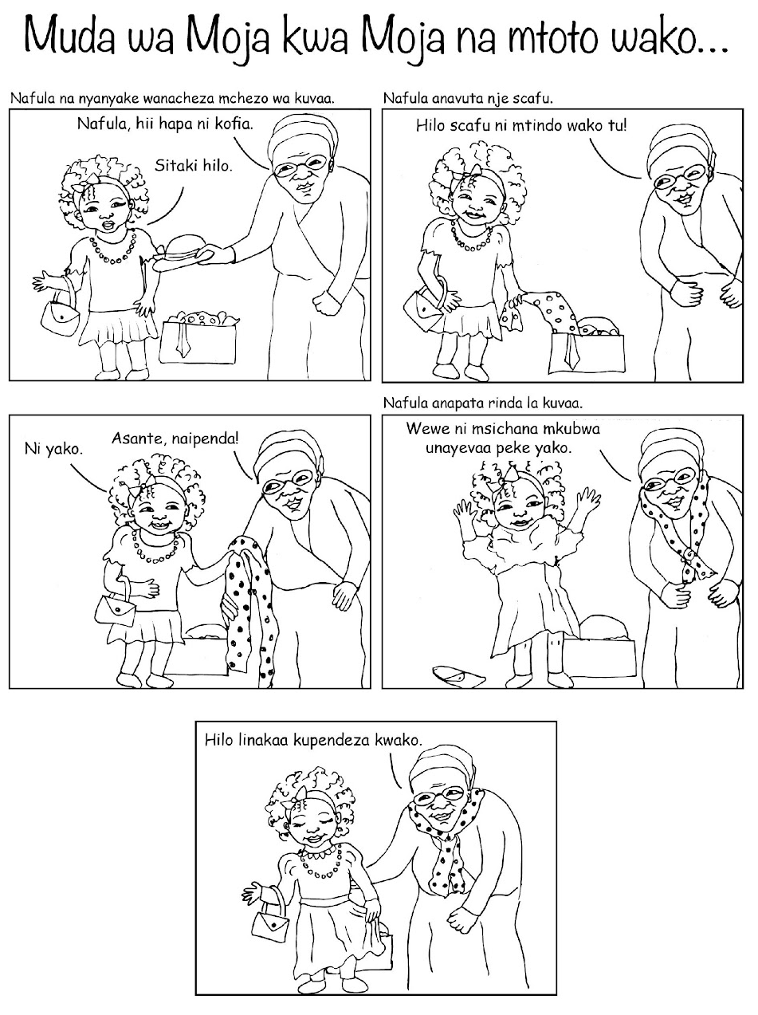

Discussion questions for Illustrated Story:
- How does Nafula’s Granny show attention to her?
- How does her Granny play with Nafula without controlling the game?
- How does this make Nafula feel?

Objectives | Questions for Activity 1
To improve the relevance and acceptability of the content and delivery this activity to mothers and fathers | - How relevant to their lives do you think fathers and mothers will find this material?  - How does this differ by gender, if at all?  - How relevant is it to your life?  - Do you have any suggestions for ways to make this information more useful to you and other families in street situations?  - How do did you enjoy the delivery of this activity?  - How else would you like to learn this material?  - How else would you improve this activity?
Identify challenges and opportunities for engaging parents in this session. | - Do you foresee any challenges with fathers engaging in this activity? What about mothers?  - What things might make fathers and mothers want to engage in this activity?

Activity 2: Malezi Bora Session 7: Redirecting Negative Behaviours

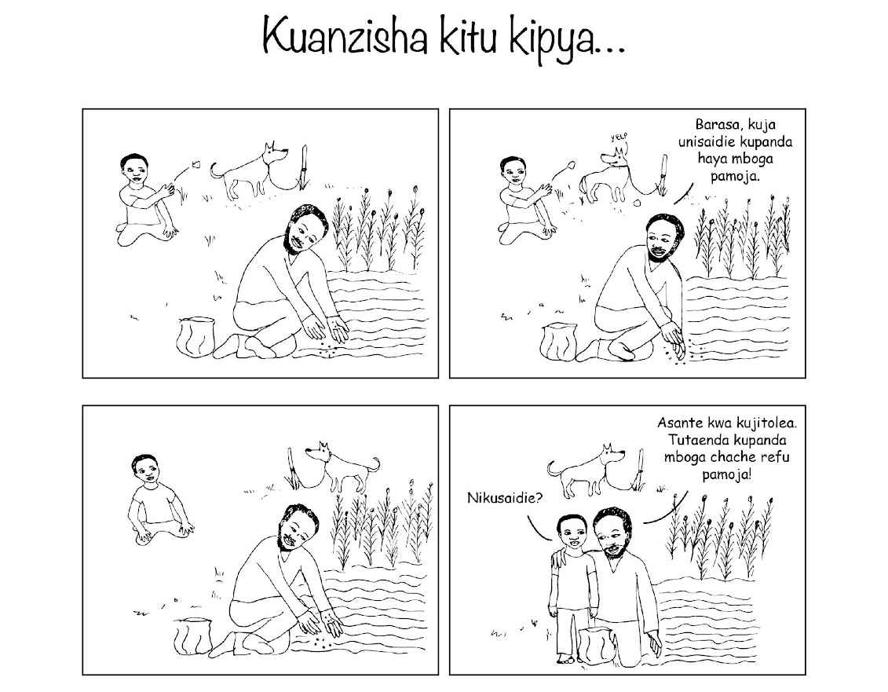
This story introduces parents to the skill of redirecting negative child behaviour to a positive behaviour. Here, Barasa’s father redirects his behaviour to something helpful.

Discussion questions for Illustrated Story (from program manual):
- How does the Father redirect Barasa’s attention?
- What would have happened if the Father said “Stop throwing stones at the dog!”
- What would have happened if the Father did not redirect Barasa to an alternative activity?
- Should the Father give the command again?

Building Blocks

Be attentive! Notice when your child is about to behave badly and redirect!
Ignore the negative behaviour and bring attention to a positive alternative behaviour.
Stay calm and speak in a clear voice when redirecting behaviour.
Praise your child when he or she listens!

Objectives | Questions for Activity 2
To improve the relevance and acceptability of the content and delivery this activity to mothers and fathers | - How relevant to their lives do you think fathers and mothers will find this material?  - How does this differ by gender, if at all?  - How relevant is it to your life?  - Do you have any suggestions for ways to make this information more useful to you and other families in street situations?  - How do did you enjoy the delivery of this activity?  - How else would you like to learn this material?  - How else would you improve this activity?
Identify challenges and opportunities for engaging parents in this session. | - Do you foresee any challenges with fathers engaging in this activity? What about mothers?  - What things might make fathers and mothers want to engage in this activity?

Activity 3: Resolving Conflict (from Bandebereho Session 15)

The purpose of this activity is to discuss the common topics or sources of conflict between spouses/partners and how identifying these sources can help to avoid or reduce conflict within the family.

- Divide the group into two smaller groups.

- Ask each group to discuss the question: “What are the top three topics or sources of conflict between spouses in this community?”

- Give each group 5 minutes to discuss. 3. Once the groups have finished their discussions, ask them to come back to the circle. Ask each group to share the top three sources of conflict that they identified

- Next, ask each group to prepare a role play depicting a conflict or disagreement in a couple using one of the topics they identified. If both groups identified similar sources of conflict, ask each group to role play a different source of conflict. Allow each group 5 minutes to prepare their role play.

- After 5 minutes, invite everyone back to the circle and ask each group to present their role play.

- After the role plays, start a group discussion using the questions below:
  - What do you think about the role plays that were presented?
  - Are there any other common sources of conflict that you feel are important to mention?
  - Why or how do these scenarios lead to conflict?
  - How does conflict between parents impact the relationship between partners? Their relationships with their children?
  - What can be done to address the common causes of disagreement between partners?

Objectives | Questions for Activity 3
To improve the relevance and acceptability of this session to mothers and fathers | - How did you enjoy that activity?  - How did you enjoy the use of role play?  - How did you enjoy the discussion?  - How relevant to their lives do you think fathers and mothers will find this material?  - How does this differ by gender, if at all?  - How relevant is it to your life?  - Do you have any suggestions for ways to make this information more useful to you and other families in street situations?  - How would you improve this activity?
Identify challenges and opportunities for engaging parents in this session. | - Do you foresee any challenges with fathers engaging in this activity? What about mothers?  - What things might make fathers and mothers want to engage in this activity?

Activity 4: Gender (From Parenting for Respectability Session 6)

The goals of this activity are to: (a) Improve our understanding of how gender norms can be harmful to both women and men, girls and boys , and (b) improve our awareness that many characteristics of men and women can be shared by both sexes

- Invite two volunteers to draw a large box on the flipchart paper- leaving space to write outside the box. Then ask one to draw a picture of a woman inside her/his box, and the other a picture of a man inside her/ his box.

- When everyone is seated ask the group what comes to mind when they hear the words “being man”, then “being woman.” What behaviour or attributes are the people encouraging for both men and women?

- Write the responses besides each picture. Ensure some of the following words are included: For men, “father”, “decision-maker”, “bread winner”, “provider”, “strong”, “courageous”, “leader” etc. And for women, “mother”, “weak”, “carer” etc. Also ensure some biological traits are included as well, such as “beard”, “penis”, “breasts”, “pregnancy”, “birth” etc.

- Ask participants to reflect on the responses and identify the natural/ biological and social/learned characteristics in each box

- Ask the questions below:
  - What things do men do that make them appear to act like women? (Encourage them to discuss positive attributes)
  - What things do women do that make them appear to behave like men? (Encourage them to discuss positive attributes)

- Write these besides the picture of both the man and the woman

Discussion questions:
  - What differences are created by our society?
  - Which ones could be changed, how and what happens? (relate this to parenting for respectability)

Objectives | Questions for Activity 4
To improve the relevance and acceptability of this session to mothers and fathers | - How did you enjoy that activity?  - How did you enjoy writing and drawing?  - How did you enjoy the discussion?  - How relevant to their lives do you think fathers and mothers will find this material?  - How does this differ by gender, if at all?  - How relevant is it to your life?  - Do you have any suggestions for ways to make this information more useful to you and other families in street situations?  - How would you improve this activity?
Identify challenges and opportunities for engaging parents in this session. | - Do you foresee any challenges with fathers engaging in this activity? What about mothers?  - What things might make fathers and mothers want to engage in this activity?

Activity 4: Family Planning Role Play (from Bandebereho Session 9)

  - Explain to the group that they are going to be discussing the impact and benefit of family planning on a family’s long-term goals.

  - Tell the group that you are going to tell them a short story:

“Chris and Silas are brothers, and so they decided to get married on the same day: Chris married Justine and Silas married Louise.

In the first year of marriage the two couples each had their first child.

After the first child, Louise and Silas make the decision to use family planning to plan the timing and spacing of their children.

But Chris and Justine decide not to use family planning and in the second year of marriage, Chris and Louise had their second child.

Five years after being married, Louise and Silas have two children, while Chris and Justine have four.”

  - Divide the participants into 2 groups to develop roleplays. The first group will develop a role-play about Louise and Silas, who use family planning. The second group will develop a role-play about Chris and Justine, who do not use family planning. The role-play should show the impact that using family planning, or not using it, has on the family’s development.

  - Give the groups 10 minutes to prepare their role-plays. Explain that not all participants have to act in the role-play, but they should contribute ideas in the creation of the role-play.

Discussion Questions
    - What did you notice, or what impacted you as you were watching these role-plays?
    - Is there something wrong in having a large family?
    - Should people plan how many children they want to have and space them, meaning take time (two to three years) before having another child?
    - In what ways can men contribute to family planning?
    - Why do some men (and some women) ignore the issue of family planning?
    - What effects can lack of family planning have on a family?
    - What are the benefits of planning your family?
    - Is it easy or hard to discuss family planning with your partner? Why?
    - What could make it easier to discuss with your partner about family planning?

Objectives | Questions
To improve the relevance and acceptability of this session to mothers and fathers | - How did you enjoy that activity?  - How did you enjoy content on family planning?  - How did you enjoy the use of role plays?  - How relevant to their lives do you think fathers and mothers will find this material?  - How does this differ by gender, if at all?  - How relevant is it to your life?  - Do you have any suggestions for ways to make this information more useful to you and other families in street situations?  - How would you improve this activity?
Identify challenges and opportunities for engaging parents in this session. | - Do you foresee any challenges with fathers engaging in this activity? What about mothers?  - What things might make fathers and mothers want to engage in this activity?

Third Focus Group Guide

Prior to beginning the FGD, facilitators will review the information outlined in the participant consent form and will remind participants to keep everything shared within the FGD confidential.

Aim: To gather participants views about the important delivery and logistic considerations for refining the Malezi Bora programme.

Approach: The FGD uses an open-ended approach to soliciting views and feedback from participants in an unbiased and nonjudgmental manner. Facilitators should guide the focus groups along the following information and accompanying questions while allowing the discussion to evolve as themes emerge that are important to participants.

Who?
  - Are there certain people who would benefit most from the Malezi Bora program? (e.g. based on age, gender, community, etc.). Why/why not?
  - How can we recruit people to participate?
    - Are there community/neighbourhood dynamics that we should be aware of? Please explain.
    - Is it possible to make the program open to anyone, no matter what community/neighbourhood they live in? No matter what their relationship status? Please explain.
  - How can we encourage fathers to participate?
  - What do you think are the challenges to getting fathers to participate?
    - How can we overcome these challenges?

How?

  - Where would be the best place to hold the Malezi Bora program? Why?
  - Would a pre-program visit be useful? (i.e. to touch base with families before starting the program?)
  - Should group sessions be separated by gender (i.e. a separate group session for fathers and mothers)? If so, for all sessions, or just some? What approach do you think is most appropriate?
  - The program is currently 12 sessions long, but would you prefer it be longer? Shorter?
    - How long should each session be?

When?
  - What would be the best time of day to hold these sessions? Is it the same or different for mothers and fathers? Why/why not?
  - Which days of the week would be the best time to hold these sessions? Is it the same or different for mothers and fathers? Why/why not?

What?
  - How do you feel about completing practice activities (i.e. take-away activities) outside of the program?
    - What challenges may arise?
    - What would make it possible to complete take-away activities to you learn as much as possible from the program? How might this be different for fathers and mothers?

  - What sorts of activities would you like to have included in a parenting program?
    - How do you feel about songs or games? Dance and play?
    - How do you feel about the use of role playing or drama or acting? What about the use of drawing and other artwork?
    - Would it help if there are instances that parents are given the chance to practice together?

Full programme practice session

Prior to beginning this practice session, facilitators will review the information outlined in the participant consent form and will remind participants to keep everything shared within the session and the succeeding FGD confidential.

The programme practice session outlined below was intended to simulate programme activities based on feedback from prior FGD and interviews with parents, and interviews with community service providers. Activities are drawn from the original Malezi Bora programme, as well evidence-based activities from Bandebereho, Indashyikirwa, and Parenting for Respectability.

Part 1: Ground Rules and Trust Building (Malezi Bora Session 1)
Total time for all Part 1 activities: 45 min

EMOTIONAL CHECK-IN (5 min)

At the beginning of the session, invite the parents to go around the circle and share how they
are feeling this morning.

Parents should describe their emotion, where they feel it in their body, and what thoughts are
associated with it.

Example: “I am anxious. I feel it in my shoulders. I am worried about having enough money this
month for food,” or “I am excited. I feel it in my chest.”

PHYSICAL EXERCISES (5 min)

Instruct parents in a series of movements moving through the body from head to toe.
If someone needs to sit down, one should encourage him or her to participate as best as they can from a sitting position. It is also very important to make sure the movements are smooth and the breath is relaxed. It is also important that the participants’ bodies are relaxed – especially arms, legs, neck, shoulders, and face.

Encourage parents to do the physical exercises each day on their own. Parents can do it first thing in the morning.

Facilitator note: Remind participants to Breathe in a relaxed way
while doing the physical exercise!

EXPECTATIONS (15 min)

Guide participants to respond to the following question:

- What do you want to learn about in relation to parenting?

Facilitator note: Make sure you clarify those that the programme will be able to achieve. It is likely that there will be some expectations or topics that will not be covered during the group sessions. Explain to the group that although some of their expectations or desires may not be directly discussed during the group meetings, they should use the group and its members as an opportunity to seek advice, to discuss important matters, or to learn from each other.

Thank the group for sharing their expectations. Tell the group that sharing these
expectations is an important first step towards making positive changes in their lives
and relationships. Through our discussion, we can develop realistic expectations of
what will be accomplished during our time together. Knowing each other’s desires for this group will also enable us to better help each with the problems we are facing.

GROUND RULES – THINGS THAT WILL HELP US WORK TOGETHER (20 min)

Establish Ground Rules to help make the programme a safe place to learn together.
Ask the participants the following question:

What will help you feel comfortable, respected, safe and supported in the group? In other words, what will enable you participate freely in the programme?

When discussing Ground Rules, you should use the following format:
- Parents share as a group.
- You lead the discussion while your co-facilitator writes rules and comments on the flip
chart to keep for later reference.
- Make sure Ground Rules describe a positive behaviour.
- You can prompt parents for rules around specific issues, for example:
  - Arriving on time
  - Cell phone use
  - Respecting other participants
  - Arriving and remaining sober
- You can repeat back what you hear and explore the rule to make sure everyone in the
- group agrees and understands.
- For example, if someone mentions Respect, ask what that means to them. What sort of
behaviour shows Respect?
- Make sure everyone agrees and has the opportunity to contribute before moving on to
another suggestion.

Facilitator note: If someone does not want to commit to the ground rules,
ask them why. Allow the group to discuss any of the concerns that participants have about a particular agreement. Suggest that the rules be changed or removed, depending on the desires of the group. Ask the group: “Are there alternative ground rules that you would
feel more comfortable with?”

MIRROR GAME – MODELING BEHAVIOUR

This activity helps parents learn that children will mirror the behaviour they see in their parents, including negative and harmful behaviours, so it is important for parents to be positive role models in their children’s lives.

Suggestions for facilitating the Mirror Game:
- Everyone finds a partner.
- Partners stand facing each other, about arm’s length apart.
- It is important that they watch each other closely the entire time.
- The partners choose who is going to go first. That person will be the facilitator. The other person will be the mirror.
- When the facilitator moves, his/her partner does exactly what the facilitator does as if he/she is a mirror.
- Encourage the group to move slowly at first and gradually expand the movement exploring different body parts and levels.
- Always remind parents to watch carefully.
- After about a minute, switch who is leading. The facilitator now becomes the mirror and the mirror becomes the facilitator.
- Switch back and forth a few times. You can change and instruct them to include mirroring facial expressions.

Share the following message with parents:

We are models for our children.
Whether they are aware of it or not, children imitate adults – especially when they can see by example the benefits of reacting in a certain way.
When children see us behaving with respect, kindness, patience, and love – towards them and towards others, they will begin to behave like that too.

PART 2: PRAISING OUR CHILDREN (Malezi Bora Session 4)
Time for activity: 25 min
Group composition: men and women together

This story shows a father praising his child using specific words linked to the child’s behaviour. (spend 5 min going over story)
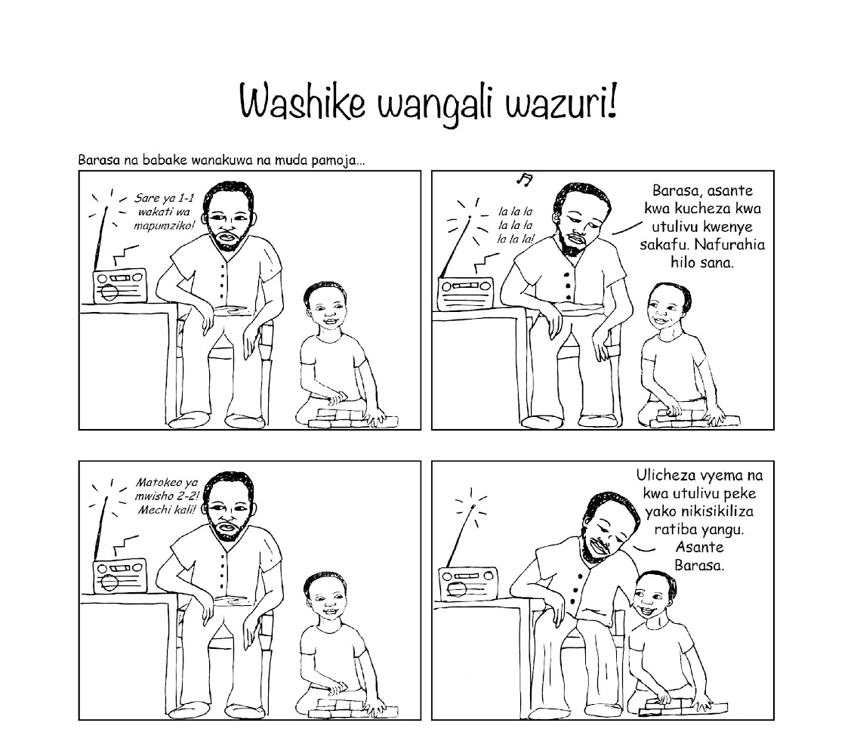

Questions for Illustrated Story: (5-10 min)
- How does his Father encourage Barasa to play quietly?
- How does he specifically label Barasa’s good behaviour?
- What might have happened if he ignored Barasa?

DISCUSSION QUESTIONS– WHY WE SHOULD PRAISE OUR CHILDREN (15 min)
- Why should you praise your child’s good behaviour?
- What does your child learn when receiving attention and praise for good behaviour?

Possible suggestions for why we should praise and reward our children:
- Praise motivates the child to do the behaviour again.
- Praise boosts confidence. Children will look for other behaviours to receive praise.
- Children feel appreciated by parents.
- Children like being praised and will feel good about their behaviour.
- Children put effort into doing good things and being helpful.
- Children feel noticed, acknowledged, appreciated, and special.
- Children will praise others, including parents (Mirroring Building Block).
- Parents feel good about themselves.
- Praise strengthens positive relationship between children and parents.

PART 3: RESOLVING CONFLICTS (Bandebereho session 15.2)
Time for activity: 45 min
Group composition: men and women together

Purpose: To reflect on some of the positive and negative ways that we react when we are
angry and to practice non-violent ways to react that can help to resolve or avoid conflict.

1. Explain that the purpose of this activity is to think about how people react when they
have a disagreement with their spouse/partner, and what they can do when they feel
angry.

2. Tell the group that you want them to imagine they have a disagreement with their partner, and ask the following questions: (5-10 min)

- What are some of the negative ways of reacting when we are angry?
- What are some of the positive ways of reacting when we are angry?
- Where do we learn these ways of reacting when we are angry?
- Do our own parents influence the way that we react? Do we use the same methods as they did?
- Does anger often lead to violence? Does it have to?
- Is it easier to control our anger with some people compared with others? (For example, with your neighbor vs someone in your family)

5. Explain that how we communicate our frustration during an argument or
disagreement can contribute to the situation getting out of control, or make it less
likely that the conflict will be resolved.

Types of communication can include:
- Aggressive communication: Asking for what you want or saying how you feel in a threatening, sarcastic, challenging, or humiliating way.
- Assertive communication: Asking for what they want or saying how they feel in an honest and respectful way, so it does not infringe on another person’s rights or put him or her down.
- Passive communication: Expressing their own needs and feelings so weakly that they will not be heard

Ask the group the following questions: (5 min)

- Which type of communication style do men usually use in an argument?
- What type of communication style do women usually use?
- How do these communication styles contribute to conflict?

6. Brainstorm with the group some of the practical ways that they can control their anger. (10 min)

Ask the group:

Can anyone think of techniques/strategies that can be used when someone is angry, so that it does not lead to violence or make the conflict worse?

Some examples may include: Sheet:

Step away from the situation, leave or take a walk (“to take a breath of fresh air”):
To calm down, walk away and count to 10, breathe deeply, walk
around, or do a physical activity. This will “cool your head” and clarify
your ideas. It is also important that people who are angry share
their feelings with the other person involved. For example, you can
say “I am very angry right now and I need to leave. I need to do
something now like go for a walk, so I can release my anger. When I
cool down and feel calm, I would like to talk and resolve this.”

Use words to express your feelings without attacking:
Express anger without “attacking.” For example, “I am angry
because…” or “I would like you to know…” Another example: if your
partner is late to meet you somewhere, you could yell something
like, “You fool, you’re always late, and I have to wait for you all the
time.” Or you can use words without attacking or offending. For
example, say, “I am upset because you were late. I wish you had
arrived at the scheduled time or warned me that you were going to
be late.”

8. Break the bigger group into 4 groups of 5. Ask each group to come up with a role play where two volunteers act out a situation in which the couple comes to a mutual agreement, considering the methods discussed above, or other non-violent forms of
conflict resolution. (5-10 min)

9. Ask 1-2 groups to volunteer to act out their role play in front of the wider group. (5 min)

10. After the volunteers have presented the role-play, open the discussion to the bigger group using the questions below.

Group Discussion Questions: (10-15 min)

- Is it generally difficult to express frustration or anger without using violence? Why or why not? How does this differ for men and women?
- If you are having a disagreement with your partner, who can you turn to for advice? We often know how to avoid a conflict without using violence, but sometimes this does not happen. Why?
- Are the methods we discussed for preventing arguments from leading to violence useful or realistic? Why or why not?
- Can anyone provide an example in which they disagreed strongly with their partner on something, but resolved it without yelling or using violence?
- Is it easy to talk to our partners about the problems we face as husbands/wives, mothers/fathers?
- What does a healthy, respectful relationship look like?
- How could relationships improve if men and women communicated their expectations and feelings with their partners, before an issue leads to a disagreement or conflict?

Thank the participants for sharing their experiences and ideas. Close the activity by sharing the key message:

“Communication is a key part of healthy relationships. We have a responsibility to control ourselves when we feel angry or upset. Communicating our feelings is more effective than violence at resolving conflicts. Developing an effective communication style is key in any successful relationship as well as in parenthood!.”
READ

PART 4: “THROW THE DRUNK BALL” (from Indashyikirwa Session 17.2 and Bandebereho Session 16.1)
Time for activity: 35 min
Group composition: men and women separate

Explain what the game is about, and clarify that people use alcohol for several reasons but they may never take time to analyse those reasons and the problems associated.

  - Explain that you appreciate everyone in the group for who they are and know that they are people of good character but this activity is to help us become better or deal with some issues regarding drinking that have been challenging them.

  - Ask participants to stand in a circle.

  - Explain that we will pass (throw) a ball from one person to another. Whoever receives the ball has to give one reason ((positive or negative) why parents use alcohol or drugs. Make it clear that right now they are only focusing on the “reasons” for alcohol use, not the consequences.

  - Encourage the participants to start the activity by tossing the ball to someone. Let the participants toss the ball until everyone has received the ball or until the group can think of no more reasons.

  - Stop the participants and explain that they will now toss the ball and when they receive it, they have to say one “problem” or “consequence” caused by excessive drinking or drug use. They can include immediate problems for the mother/father as well as long-term consequences for his family.

  - Let the participants toss the ball until everyone has received the ball or until the group can think of no more consequences. After everyone has finished tossing the ball, ask everyone to sit down in the circle and open the discussion using the questions below:

  - Ask participants to join 2-3 groups for 10 minutes and discuss the questions below, and let the group decide on about 2-3 issues they can share with the rest. (10 min)

Discussion questions (10 min)
- What are the signs that one is engaged in problematic/excessive/risk drinking/drug use?
- How does it influence marital violence?
- How could you help your partner to control the problem of excessive drinking/drug use?

Close the activity by highlighting the following:
- Alcohol and drinking have many different meanings and uses for men and women, including some that are positive and others that are negative.
- Heavy use/risk drinking of alcohol creates serious problems for individuals including medical problems and even death, and in families it contributes to violence and conflicts between partners. It also perpetuates poverty (e.g., money spent in bars).
- In addition, living in an alcoholic family also suggests that children are more vulnerable to child abuse, including incest and being battered.

PART 5: FAMILY PLANNING (Bandebereho Session 9)
Time for activity: 40 min
Group composition: men and women together

  - Explain to the group that they are going to be discussing the impact and benefit of family planning on a family’s long-term goals.

  - Tell the group that you are going to tell them a short story: (5-10 min)

“Chris and Silas are brothers, and so they decided to get married on the same day: Chris married Justine and Silas married Louise.

In the first year of marriage the two couples each had their first child.

After the first child, Louise and Silas make the decision to use family planning to plan the timing and spacing of their children.

But Chris and Justine decide not to use family planning and in the second year of marriage, Chris and Louise had their second child.

Five years after being married, Louise and Silas have two children, while Chris and Justine have four.”

  - Divide the participants into 2 groups to develop roleplays. The first group will develop a role-play about Louise and Silas, who use family planning. The second group will develop a role-play about Chris and Justine, who do not use family planning. The role-play should show the impact that using family planning, or not using it, has on the family’s development. (10 min)

  - Give the groups 10 minutes to prepare their role-plays. Explain that not all participants have to act in the role-play, but they should contribute ideas in the creation of the role-play.

Discussion Questions (20)
    - What did you notice, or what impacted you as you were watching these role-plays?
    - Is there something wrong in having a large family?
    - Should people plan how many children they want to have and space them, meaning take time (two to three years) before having another child?
    - In what ways can men contribute to family planning?
    - Why do some people ignore the issue of family planning?
    - What effects can lack of family planning have on a family?
    - What are the benefits of planning your family?
    - Is it easy or hard to discuss family planning with your partner? Why?
    - What could make it easier to discuss with your partner about family planning?

5. Fourth Focus Group Guide
Time for activity: 1-1.5 hours
Group composition: men and women separate

Prior to beginning the FGD, facilitators will review the information outlined in the participant consent form and will remind participants to keep everything shared within the FGD confidential.

Aim: To gather participant views about the content and delivery of the programme practice session to (a) improve the relevance and acceptability of the content and delivery of programme activities to both mothers and fathers, and (b) identify challenges and opportunities for engaging parents in a refined Malezi Bora programme.

Approach: The FGD uses an open-ended approach to soliciting views and feedback from participants in an unbiased and nonjudgmental manner. Facilitators should guide the focus groups along the following information and accompanying questions while allowing the discussion to evolve as themes emerge that are important to participants.

Programme Acceptability
Objective | Questions
To understand what they liked/didn’t like about the session | - Did you enjoy this session? Why/why not?  - Which topics did you enjoy the most and why? The least?  - What activities (e.g. role plays, stories, etc.) did you enjoy the most and why? The least?  - How did you enjoy the delivery of the session?
Father Engagement
Objective | Questions
To explore ways to enhance father engagement | - Do you think fathers would want to participate in this program? Please explain.  - How do you think this session can be improved to engage fathers?  - What about the content could be improved?  - What about the activities could be improved?  - What about the facilitation could be improved?  - What would motivate you to attend?  - What challenges do you think might arise if this program is delivered to other street-connected parents? How might this differ for fathers and mothers?
Group Composition
Objective | Questions
To understand how men and women worked together in the session, and how to make it a safe and comfortable space for everyone | - How did you feel about working together as men and women in the session?  - What was the dynamic?  - How did the dynamic differ depending on the activity?  - How could the dynamic be improved?  - Are there parts of the session you’d prefer to do with others from the same gender? Parts you’d like to be mixed-gender (i.e. both mothers and fathers)? Please explain.  - Who would you choose to do this programme with (e.g. your current partner, biological parents of your children, ex-partners, other family members, neighbors, any caregivers, etc.)  - What would make you feel safe (and comfortable) in a programme that engages both mothers and fathers?
Creating an Impactful Programme
Exploring how to make the programme impactful for families in street situations | - What changes to your parenting would you like to see?  - What changes to your relationship with your partner would you like to see?  - What changes to your family life would you like to see?

6. Focus Group Guide with past Malezi Bora participants

Prior to beginning the FGD, facilitators will review the information outlined in the participant consent form and will remind participants to keep everything shared within the FGD confidential.

Aim: To gather participant views about (a) the relevance and acceptability of new and existing programme content and delivery for both mothers and fathers, and (b) identify challenges and opportunities for engaging parents in a refined Malezi Bora programme.

Approach: The FGD uses an open-ended approach to soliciting views and feedback from participants in an unbiased and nonjudgmental manner. Facilitators should guide the focus groups along the following information and accompanying questions while allowing the discussion to evolve as themes emerge that are important to participants.

We would like you to give an overview about the structure of the Malezi Bora na Maisha Mazuri program, then ask you some questions about it.

BUILDING A MENZO OF SUPPORT

Malezi Bora na Maisha Mazuri uses a Menzo to show why it is important for parents to build a strong, positive relationship with their children.

The foundation is about upholding the rights and responsibilities of children and parents and setting parenting goals, while the walls are about building positive relationships with your children.

The foundation and walls are what support good parenting. They are the most important part of the program.

As we move to the roof, we focus on dealing with difficult behaviour, using discipline, and problem-solving difficult situations within the family.

When parents spend more time building positive relationships with their children, they often need to spend less time managing difficult behaviours. This is because the more time that parents spend playing with, and praising, their children, the less often their children will misbehave.

And if parents can keep themselves and their children healthy while also building strong relationships, they will be on the right track for fulfilling the rights and responsibilities of themselves and their children.

These skills make parents and children feel supported and loved.

If the walls of the Menzo are strong, the roof will be easier to maintain.

Finally, the “Sunshine of Positive Attention” symbolizes the importance of children receiving as much positive attention as possible from their parents.

The important goal of this program is to increase positive parenting behaviour by:

- Increasing parenting knowledge and skills
- Improving positive parenting practices
- Decreasing harsh discipline
- Improving child behaviour and wellbeing
- Improving caregiver mental and physical health, and social support
- Improving knowledge and use of social, health, and legal services for intimate partner violence, family planning, and family illness; and for upholding the rights of the child
- Improving engagement in early childhood learning

Program Sessions

There are 12 sessions in the program. Within each of these sessions, there are group discussions, stories, illustrated stories, role plays, and other activities. The purpose of each session is to work together to come up with solutions to parenting challenges, and to support one another in raising children in a positive way.

Session 1 is the foundation of the Menzo of Support.

It introduces the program to parents, establishes common ground rules and has parent set goals for the program and for themselves, and focuses on the rights and responsibilities of children and parents.

Discussion topics for session 1 include:

- What are children’s rights?
- How can we protect the rights of our children?
- What are your rights as parents?
- Setting goals as a parent that are positive, specific, and realistic

Session 2 is on spending one-on-one time with your child

In Session Two, we help parents discover that by playing with their children, they will build a positive relationship with them.
Play is very important for children. It helps them develop healthy minds and to learn. If a parent shows that what their child is doing is important to them too, it improves their relationship with their child.

Discussion topics include:

- Engaging in play with your child, where your child leads the play
- Playing at your child’s level and pace
- Playing collaborative games with your children rather than competitive ones
- How playing helps build positive relationships with your child

Session 3 is on talking about feelings

In Session Three, we help parents understand how to talk about their own feelings, and their children’s feelings.

Discussion topics include:

- Identifying your own emotions and connecting them with your body (e.g. how do you physically feel when you are happy? Sad? Angry?)
- Naming and acknowledging your children’s feelings so you know how to respond to them
- Talking about our feelings and our children’s feelings
- Helping parents cope with anger and frustration (parenting can be difficult!)

Session 4 is on Praising and Rewarding our children

In Session Four, we learn how to use praise and reward behaviours we want more of from our children.

Discussion topics include:

- What it means to praise and reward our children, and why it’s important
- How to praise our children for good behaviour (e.g. “You’ve done a great job…” or, “Thank you for…”)
- How to reward our children for good behaviour (e.g. rewarding them by not having them do a chore)
- The types of behaviours we should we praise and reward
- Creating “Good Parenting Partners”, which are people in the program that offer peer support throughout the program, and continue to do so once it is over

Session 5 is on giving specific, positive and realistic instructions to our children

In Session five, we learn how to give specific, positive, and realistic instructions to our children so that they know what is expected of them.

Discussion topics include:

- How to give effective instructions (e.g. give one instruction at a time, use positive language, praise your child after following the instruction, etc.)
- Key steps for giving instructions
- Practicing giving positive instructions

(show a short roleplay here)

Session 6 is on keeping ourselves and our children safe and healthy with rules and routines

In Session Six, we learn how to create rules and routines to help our children feel safe and secure, and to help keep our children and ourselves healthy.

Discussion topics include:

- Why rules are important for our children
- How to create rules for our children
- Creating rules for yourself, to keep yourself safe (e.g. to prevent sexually transmitted infections, violence, etc.)
- Establishing routines for our health (e.g. to keep track of vaccines, clinic appointments, contraception, etc.)
- The importance of routines for our children
- How to establish routines for our children (e.g. regular sleeping times)

Session 7 is on redirecting negative behaviours

In Session Seven, we learn how to redirect children from potential negative behaviours to positive behaviours, in order to avoid the problem behaviours happening to begin with. It involves distracting children when they are about to engage in a negative behaviour (e.g. if they are about to fight with their sibling, you can redirect them to a different, positive activity).

Discussion topics include:

- What behaviours to redirect
- How to redirect negative behaviours to positive ones
- When distractions work, and when they do not

(show a roleplay here)

Session 8 is on ignoring negative attention-seeking behaviours

In Session Eight, we learn how ignore negative attention seeking behaviours and demanding behaviours. When parents pay attention to problem behaviours, they teach their children to do more and more of the things we do not want them to do. By ignoring attention-seeking behaviours (e.g. crying for a candy), we instead encourage the child to behave positively (with lots of praise for the good behaviour!).

Discussion topics include:

- Reasons for ignoring negative attention seeking behaviours
- Which behaviours can be ignored
- How to ignore negative attention seeking behaviours
- Calming strategies for yourself, when you are ignoring your child’s behaviour

(show roleplay here)

Session 9 is on using consequences

In Session Nine, we will learn how to use consequences to help children listen to instructions and rules. When re-directing or ignoring bad behaviour is not possible (e.g. if your child is breaking a rule you created together, like hitting their sibling when they shouldn’t be), consequences can be a good option for encouraging positive behaviour. Consequences are not punishments. Instead, they are opportunities for children to learn that their actions have an impact on themselves and others. An example of a consequence would be, “If you come home after dark, you cannot play with your friends tomorrow”.

Discussion topics include:

- When to use consequences (e.g. depending on the age of the child consequences may be necessary when children do not follow instructions or rules, or they show aggressive or destructive behaviours)
- How to avoid using consequences (e.g. by making it easy for children to follow instructions, by giving them a chance to do what they are asked before using a consequence, etc.)
- How to use consequences effectively (e.g. following through with the consequence, praising your child when they follow the instruction, etc.)

Session 10 is on using a ‘cool down’ for aggressive behaviours

In Session ten, we will learn how to use “cool down” with our children as a consequence for aggressive behaviours. Sometimes children lose control of their emotions and act in an aggressive or dangerous way. A cool down helps a child calm down from a situation where they got carried away and acted aggressively, by removing them from the situation for a few minutes, allowing them to take a pause, calm down, and reflect about their actions.

Discussion topics include:

- What a cool down is (i.e. 4 minutes of quiet time, away from the activity they were engaged in)
- When to use a cool down (e.g. when a child forgets a rule that is an aggressive or destructive behaviour)
- How to use a cool down to manage aggressive or destructive behaviour
- How to explain cool down to your child
- What to do when your child refuses cool down or leaves cool down early

(show a roleplay here)

Session 11 is on resolving conflicts in the family

In Session Eleven, we will learn how to resolve conflicts in our family. We will learn how to help children resolve conflicts in a constructive way, and how to resolve conflicts we have within our own relationships. This will involve learning ways to stay calm, to think about the problem we want to solve, and to use positive communications skills to come up with a solution together to the challenge we are facing.

Discussion topics include:

- Helping your child identify the problem (e.g. trouble playing with a friend), and have them suggest solutions
- Why it’s important to involve children in resolving their conflicts
- Talking about difficult issues with your child (e.g. illnesses), and how to prepare for challenging conversations
- Talking about challenging issues with your partner (e.g. on finances, family planning, stress, etc.) and how to problem solve together

Finally, Session 12 is about reflecting and moving on

In Session twelve, we will reflect on parents’ experiences during the program, and identify ways of continuing to support ourselves and one another as parents.

Discussion topics include:

- Reviewing what you learned
- Reflecting on what you have learned and how it has impacted you, your children, and your family
- How helpful the program has been
- Ways you can continue to support your children and improve as parents

In addition to the Malezi Bora program, there are sessions from other programs that we can include as well. For example:

- Resolving conflict in the family (e.g. identifying sources of conflict and how to overcome them with your partner)
- Family planning (what it is, what it does, and why it could be important for your family)
- Thinking about your own parents, and what you learned from them that you’d like to carry forward with your own children, as well as what you learned from them that you would not like to carry forward with your own children
- What it means to be a mother and a father
- How you can share responsibilities with your partner when raising your children
- Alcohol and drug use (what the effects of drugs and alcohol are on you and your family, and how they may impact your parenting and your children)

Questions for Focus Group #1

Objectives | Questions
To identify what they would like to learn. | - What about the program should be changed to make it more relevant to the needs of both mothers and fathers in the streets?  - Is there any other information you’d like to learn about to support you in your role as a parent?  - Is there any other information you’d like to learn about to support you in your role as a partner?
Identify challenges and opportunities for engaging parents in the program. | - What challenges may arise in engaging fathers in this program?  - Are there specific sessions/topics that may be harder to engage fathers than others? Please explain.  - What challenges may arise in engaging mothers in this program?  - Are there specific sessions/topics that may be harder to engage mothers than others? Please explain.  - What might make fathers and mothers want to attend this programme?

We’d now like to see what you think about two new activities that were not in the original Malezi Bora programme.

Resolving Conflict (from Bandebereho Session 15)

The purpose of this activity is to discuss the common topics or sources of conflict between spouses/partners and how identifying these sources can help to avoid or reduce conflict within the family.

- Divide the group into two smaller groups.

- Ask each group to discuss the question: “What are the top three topics or sources of conflict between spouses in this community?”

- Give each group 5 minutes to discuss.

- Once the groups have finished their discussions, ask them to come back to the circle. Ask each group to share the top three sources of conflict that they identified

- Next, ask each group to prepare a role play depicting a conflict or disagreement in a couple using one of the topics they identified. If both groups identified similar sources of conflict, ask each group to role play a different source of conflict. Allow each group 5 minutes to prepare their role play.

- After 5 minutes, invite everyone back to the circle and ask each group to present their role play.

- After the role plays, start a group discussion using the questions below:
  - What do you think about the role plays that were presented?
  - Are there any other common sources of conflict that you feel are important to mention?
  - Why or how do these scenarios lead to conflict?
  - How does conflict between parents impact the relationship between partners? Their relationships with their children?
  - What can be done to address the common causes of disagreement between partners?

Objectives | Questions for Activity 3
To improve the relevance and acceptability of this session to mothers and fathers | - How did you enjoy that activity?  - How did you enjoy the use of role play?  - How did you enjoy the discussion?  - How relevant to their lives do you think fathers and mothers will find this material?  - How does this differ by gender, if at all?  - How would you improve this activity for families in street situations?
Identify challenges and opportunities for engaging parents in this session. | - Do you foresee any challenges with fathers engaging in this activity? What about mothers?  - What things might make fathers and mothers want to engage in this activity?

Gender (From Parenting for Respectability Session 6)

The goals of this activity are to: (a) Improve our understanding of how gender norms can be harmful to both women and men, girls and boys , and (b) improve our awareness that many characteristics of men and women can be shared by both sexes

- Invite two volunteers to draw a large box on the flipchart paper- leaving space to write outside the box. Then ask one to draw a picture of a woman inside her/his box, and the other a picture of a man inside her/ his box.

- When everyone is seated ask the group what comes to mind when they hear the words “being man”, then “being woman.” What behaviour or attributes are the people encouraging for both men and women?

- Write the responses besides each picture. Ensure some of the following words are included: For men, “father”, “decision-maker”, “bread winner”, “provider”, “strong”, “courageous”, “leader” etc. And for women, “mother”, “weak”, “carer” etc. Also ensure some biological traits are included as well, such as “beard”, “penis”, “breasts”, “pregnancy”, “birth” etc.

- Ask participants to reflect on the responses and identify the natural/ biological and social/learned characteristics in each box

- Ask the questions below:
  - What things do men do that make them appear to act like women? (Encourage them to discuss positive attributes)
  - What things do women do that make them appear to behave like men? (Encourage them to discuss positive attributes)

- Write these besides the picture of both the man and the woman

Discussion questions:
  - What differences are created by our society?
  - Which ones could be changed, how and what happens? (relate this to parenting for respectability)

Objectives | Questions for Activity 4
To improve the relevance and acceptability of this session to mothers and fathers | - How did you enjoy that activity?  - How did you enjoy writing and drawing?  - How did you enjoy the discussion?  - How relevant to their lives do you think fathers and mothers will find this material?  - How does this differ by gender, if at all?  - How would you improve this activity for parents in street situations?
Identify challenges and opportunities for engaging parents in this session. | - Do you foresee any challenges with fathers engaging in this activity? What about mothers?  - What things might make fathers and mothers want to engage in this activity?

Delivery and Logistics

Who?
  - Are there certain people who would benefit most from the Malezi Bora program? (e.g. based on age, gender, community, etc.). Why/why not?
  - How can we recruit people to participate?
    - Are there community/neighbourhood dynamics that we should be aware of? Please explain.
    - Is it possible to make the program open to anyone, no matter what community/neighbourhood they live in? No matter what their relationship status? Please explain.
      - Who would you choose to attend the programme with? (e.g. your current partner? Any person who is a father/mother? Someone else you share parenting responsibilities with?)
  - How can we encourage fathers to participate?
  - What do you think are the challenges to getting fathers to participate?
    - How can we overcome these challenges?

How?

  - Where would be the best place to hold the Malezi Bora program? Why?
  - Would a pre-program visit be useful? (i.e. to touch base with families before starting the program?)
  - Should group sessions be separated by gender (i.e. a separate group session for fathers and mothers)? If so, for all sessions, or just some? What approach do you think is most appropriate?

When?
  - What would be the best time of day to hold these sessions? Is it the same or different for mothers and fathers? Why/why not?
  - Which days of the week would be the best time to hold these sessions? Is it the same or different for mothers and fathers? Why/why not?

What?
  - How do you feel fathers will respond to the programme activities (e.g. role plays, story-telling, take-away activities, etc.)? What about mothers?
    - What challenges may arise? How might this differ for mothers vs. fathers?

