APPENDIX

Employee Attachment and Performance Questionnaire
Dear Respondent,
With respect, this questionnaire is designed for a research study examining the relationship between employees' attachment levels based on the C10 model and their performance in healthcare services. We kindly request that you respond to the items with careful consideration. Please note that providing an email address is optional.
Thank you very much for your cooperation.
Gender: □ Female □ Male
Marital Status: □ Single □ Married
Age: □ 20-30 years □ 31-40 years □ 41-50 years □ Over 50 years
Educational Qualification: □ High School Diploma □ Associate Degree □ Bachelor's Degree □ Master's Degree □ Doctorate
Years of Service: □ 1-5 years □ 6-10 years □ 11-15 years □ 16-20 years □ 21-25 years □ Over 25 years
Email Address:
No. | Statements | Always | Often | Sometimes | Rarely
1 | Employees adhere to regulations and administrative discipline.
2 | Employees feel responsible for the tasks they accept and accountable for their outcomes.
3 | Employees work honestly without supervision from superiors.
4 | Employees are dedicated to their work and strive to deliver it with optimal quality.
5 | Employees follow up on assigned tasks to ensure successful outcomes and maintain motivation.
6 | Employees are serious about their work, value it, and endeavor to resolve work-related issues.
7 | Employees treat clients and applicants with respect and strive to address their concerns.
8 | Employees demonstrate self-sacrifice and altruism in emergencies or when humanitarian issues arise.
9 | Employees strive to enhance their professional knowledge.
10 | Employees accept their mistakes.
11 | Employees endeavor to maintain confidentiality in professional matters.
12 | Employees respect their colleagues' rights, show consideration, and foster a sense of cooperation.
13 | Employees strive to transfer their professional knowledge to others.
14 | Employees avoid wasting time and engaging in unproductive activities.
15 | Employees take care of work equipment and practice economy in their use.

Staff-Specific Questionnaire
Dear Respondent,
With respect, this questionnaire is designed for a research study examining the relationship between employees' attachment levels based on the C10 model and their performance in healthcare services. We kindly request that you respond to the items with careful consideration. Please note that providing an email address is optional.
Thank you very much for your cooperation.
Email Address (if desired): ....
Employee Gender: □ Female □ Male
Employee Marital Status: □ Single □ Married
Employee Age: □ 20-30 years □ 31-40 years □ 41-50 years □ Over 50 years
Employee Educational Qualification: □ High School Diploma □ Associate Degree □ Bachelor's Degree □ Master's Degree □ Doctorate
Employee Years of Service: □ 1-5 years □ 6-10 years □ 11-15 years □ 16-20 years □ 21-25 years □ Over 25 years
Questionnaire
Please indicate your level of agreement or disagreement with each of the following statements by marking an 'X'.
 | Statements | Very High | High | Somewhat | Low | Very Low
1 | Employees have access to superiors when needed.
2 | There are good and friendly relationships between employees and managers.
3 | Managers dedicate time to establishing communication with employees.
4 | Opportunities for employees to meet with managers are readily available.
5 | Career advancement paths in the organization are clear and specified, with opportunities for employee progression.
6 | Managers and supervisors are selected and appointed from within the organization.
7 | There are growth and advancement paths for every individual based on their job preferences.
8 | The organization provides growth and advancement opportunities; it is sufficient to demonstrate effort and competencies.
9 | The internal communication and information system in the organization is effective, and employees are aware of the nature and rationale of objectives.
10 | Employees are kept informed about the organization's status to the extent necessary.
11 | Employees are informed and briefed about the organization's goals, plans, and strategies.
12 | Employees know what the organization's goals, plans, and strategies are, and in which direction the organization is moving toward those goals.
13 | Expectations from employees are clearly defined, and employees are aware of dos and don'ts as well as the organization's position.
14 | Honesty and candor exist in the organization.
15 | I receive constructive and useful feedback from my superior regarding my behavior and performance, and I know how well they align or differ from my superior's expectations.
16 | I know exactly what my superior and the organization expect from me.
17 | Good behaviors and desirable performances of employees are appreciated in the organization.
18 | Managers possess strong skills for appreciating and encouraging employees to work harder.
19 | Managers strive to foster a culture of commitment and diligence in the organization.
20 | When we provide good services to clients, we receive attention and encouragement.
21 | I feel that I participate and share in the organization's destiny to the extent I deserve.
22 | Managers are participatory and receptive to participation; employees' ideas and suggestions are heard.
23 | Managers welcome employees' ideas, and employees participate in certain matters.
24 | At my workplace, I can vote, express opinions, and participate.
25 | Managers exercise appropriate control and supervision over tasks, and employees enjoy autonomy and independence where necessary.
26 | Controls are not excessive to the point of creating destructive stress in employees.
27 | Controls are not used solely to detect errors, shortcomings, and faults.
28 | Most colleagues perform their work with such quality and seriousness that supervision is truly unnecessary.
29 | Teamwork is promoted in the organization.
30 | Managers strive to strengthen the spirit of cooperation among employees.
31 | Employees trust each other, assist one another, and there is a positive collaborative environment in the organization.
32 | There is no jealousy, negative competition, or destructive conflicts in the workplace.
33 | The organization is reputable, credible, and well-known.
34 | I take pride in working for such an organization.
35 | Family and friends know the organization well and have a positive mental image of it.
36 | I like the organization; if I had a choice, I would select this organization again.
37 | Managers are committed to their promises, and employees trust the organization and managers.
38 | The organization's managers possess the necessary technical and managerial competencies, which further enhance employees' trust in them.
39 | I am optimistic about the organization's future and work there with confidence and peace of mind.
40 | I trust the senior managers' competence and qualifications to advance the work and ensure the organization's success.

Data output
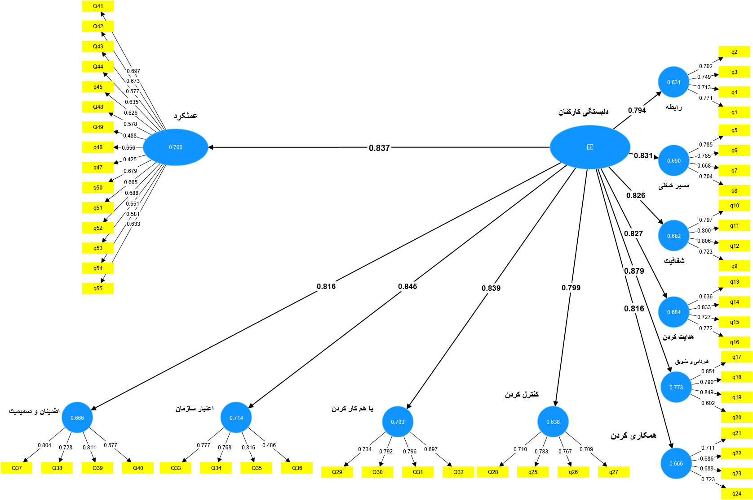

Table 1: Reliability and Validity Metrics
Construct | Cronbach's Alpha | Composite Reliability (rho_a) | Composite Reliability (rho_c) | Average Variance Extracted (AVE)
confidence | 0.712 | 0.735 | 0.823 | 0.542
Organizational Credibility | 0.784 | 0.718 | 0.810 | 0.524
Collaboration | 0.749 | 0.754 | 0.842 | 0.572
Employee Attachment | 0.957 | 0.959 | 0.960 | 0.584
connection | 0.714 | 0.715 | 0.824 | 0.539
clarity | 0.788 | 0.793 | 0.863 | 0.612
Performance | 0.880 | 0.884 | 0.900 | 0.578
congratulate | 0.779 | 0.805 | 0.859 | 0.608
Career Path | 0.718 | 0.719 | 0.826 | 0.544
convey | 0.731 | 0.747 | 0.832 | 0.556
contribute | 0.659 | 0.661 | 0.796 | 0.693
Control | 0.729 | 0.731 | 0.831 | 0.552

 | confidence | Credibility | Collaboration | Attachment | connect | clarity | Performance | congratulate | Career Path | convey | contribute | Control
confidence | 0.736
Credibility | 0.702 | 0.724
Collaboration | 0.678 | 0.716 | 0.756
Attachment | 0.616 | 0.645 | 0.639 | 0.764
connect | 0.542 | 0.589 | 0.641 | 0.704 | 0.734
clarity | 0.560 | 0.622 | 0.621 | 0.626 | 0.669 | 0.782
Performance | 0.689 | 0.705 | 0.675 | 0.637 | 0.608 | 0.620 | 0.760
congratulate | 0.702 | 0.712 | 0.712 | 0.679 | 0.665 | 0.681 | 0.701 | 0.780
Career Path | 0.576 | 0.654 | 0.623 | 0.631 | 0.717 | 0.733 | 0.672 | 0.689 | 0.737
convey | 0.652 | 0.704 | 0.676 | 0.627 | 0.617 | 0.660 | 0.633 | 0.701 | 0.664 | 0.745
contribute | 0.710 | 0.650 | 0.632 | 0.516 | 0.602 | 0.636 | 0.742 | 0.667 | 0.638 | 0.583 | 0.832
Control | 0.697 | 0.633 | 0.612 | 0.709 | 0.537 | 0.614 | 0.750 | 0.704 | 0.582 | 0.579 | 0.691 | 0.743

Variable | R-square | R-square adjusted
confidence | 0.666 | 0.665
Credibility | 0.714 | 0.713
Collaboration | 0.703 | 0.703
Connect | 0.631 | 0.630
Clearity | 0.682 | 0.681
Performance | 0.700 | 0.699
congratulate | 0.773 | 0.772
Career Path | 0.690 | 0.689
convey | 0.684 | 0.683
contribute | 0.666 | 0.665
Control | 0.638 | 0.637

Variable | f-square
Employee Engagement -> confidence | 1.996
Employee Engagement -> Credibility | 2.497
Employee Engagement -> Collaboration | 2.371
Employee Engagement -> Connect | 1.711
Employee Engagement -> Clearity | 2.146
Employee Engagement -> Performance | 2.334
Employee Engagement -> congratulate | 3.407
Employee Engagement -> Career Path | 2.224
Employee Engagement -> convey | 2.165
Employee Engagement -> Collaboration | 1.992
Employee Engagement -> Control | 1.760

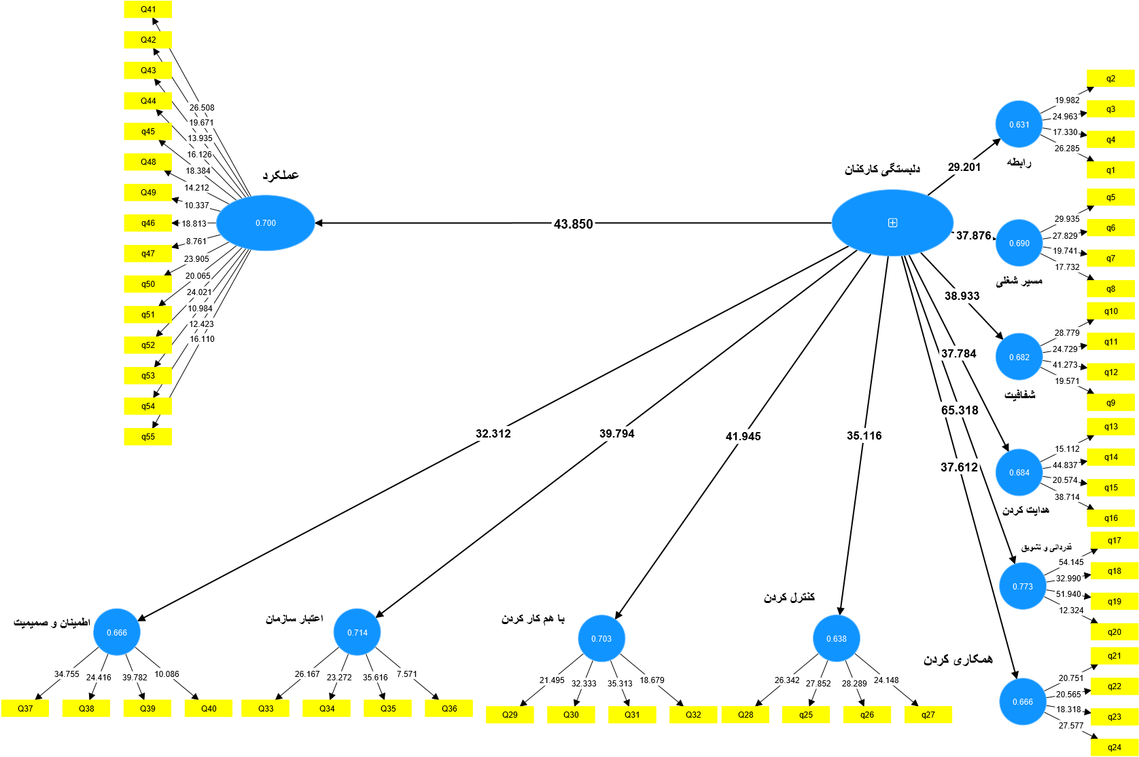

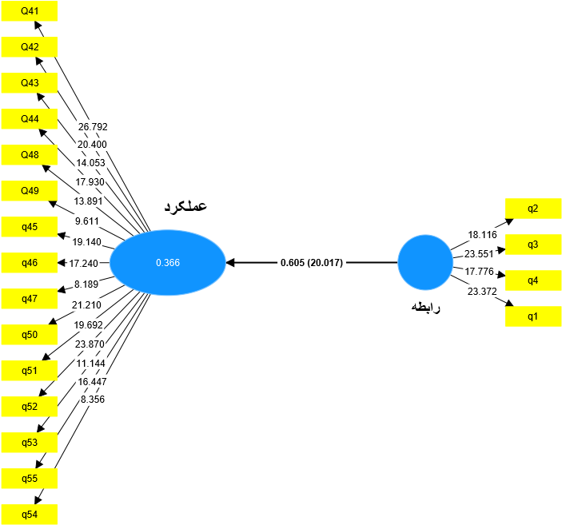

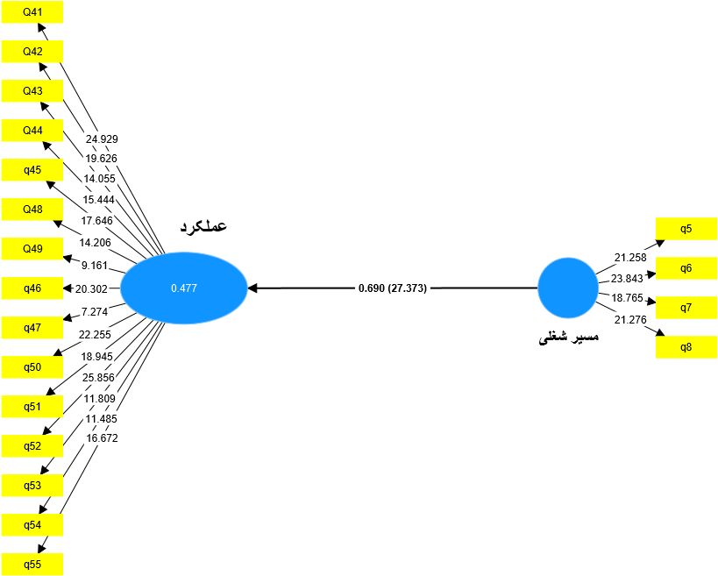

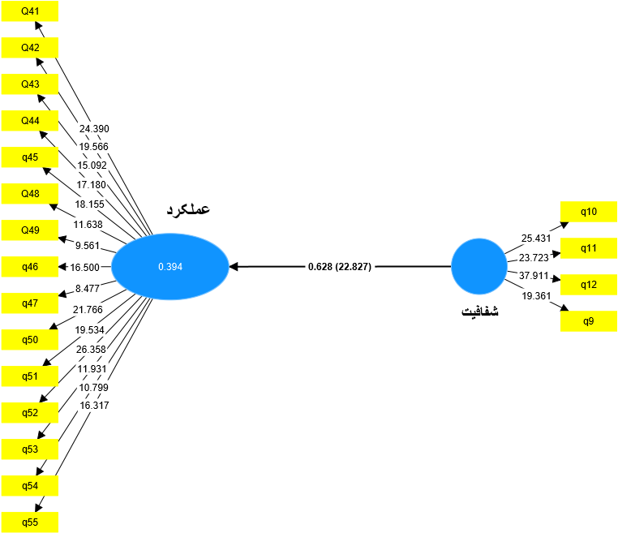

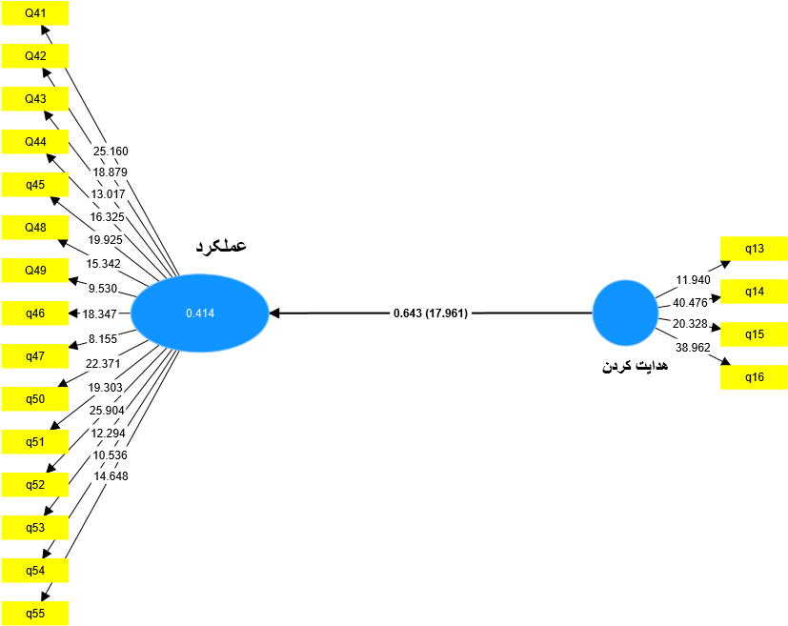

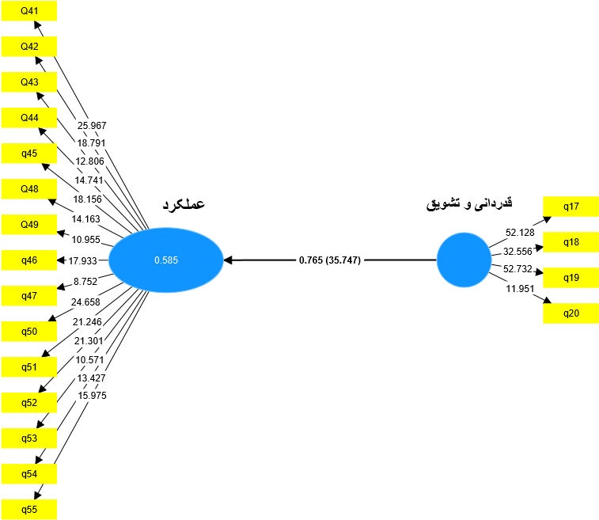

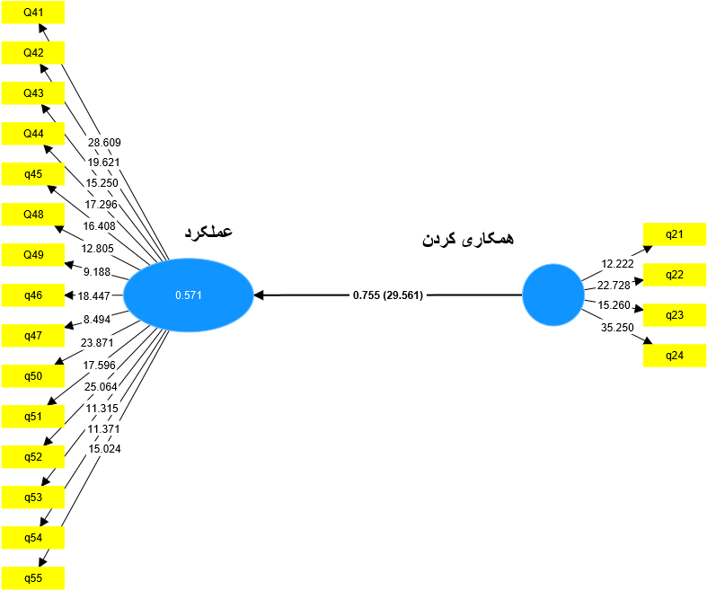

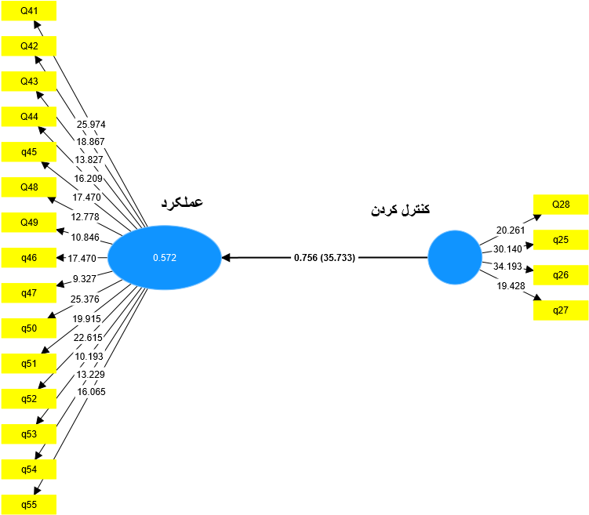

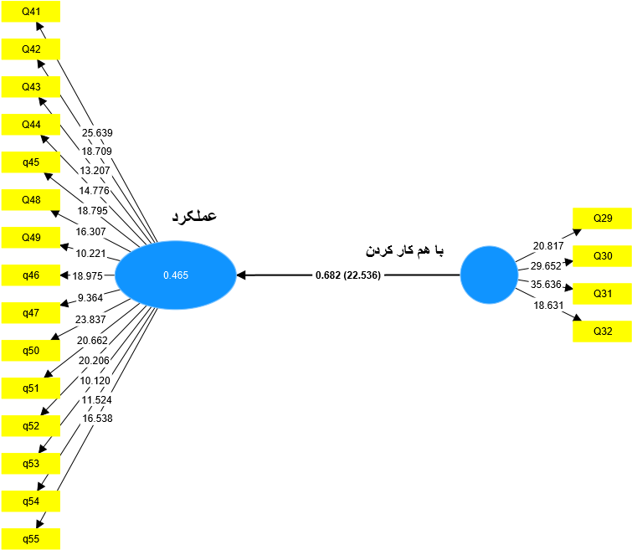

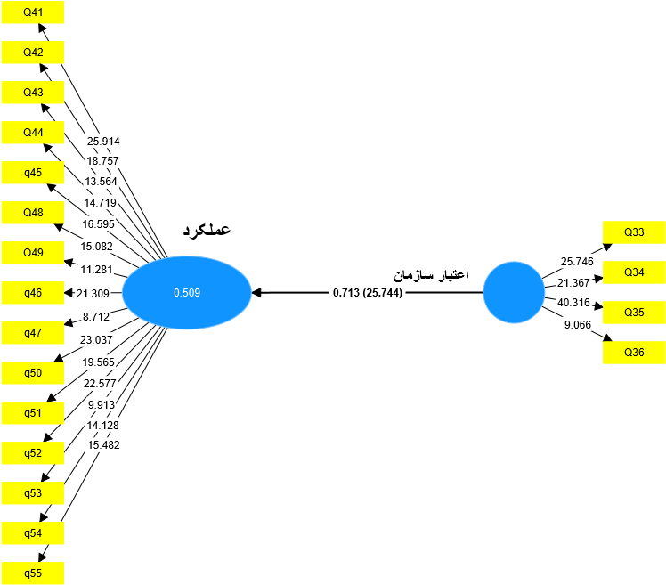
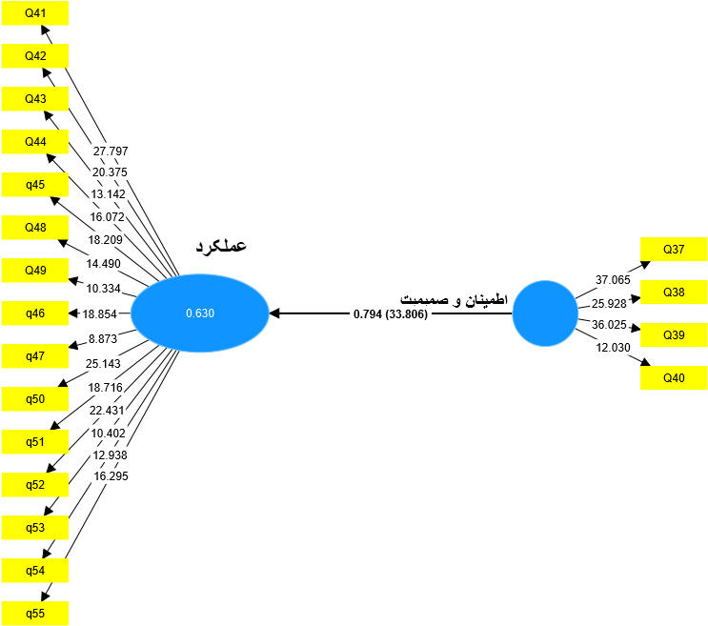

 | SSO | SSE | Q² (=1-SSE/SSO)
confidence | 1456/000 | 941/492 | 0.353
Credibility | 1456/000 | 924/580 | 0.365
Collaboration | 1456/000 | 882/958 | 0.394
connection | 1456/000 | 972/296 | 0.332
clarity | 1456/000 | 863/739 | 0.407
Performance | 5460/000 | 4057/256 | 0.257
congratulate | 1456/000 | 738/487 | 0.462
Career Path | 1456/000 | 922/834 | 0.366
convey | 1456/000 | 911/341 | 0.371
contribute | 1456/000 | 989/262 | 0.321
Control | 1456/000 | 950/720 | 0.347

gender
 |  |  | Frequency |  | Percent |  | Valid Percent |  | Cumulative Percent
Valid | 1.00 |  | 129 |  | 59.4 |  | 59.4 |  | 59.4
Valid | 2.00 |  | 88 |  | 40.6 |  | 40.6 |  | 100.0
Valid | Total |  | 217 |  | 100.0 |  | 100.0
m.s
 |  |  |  | Frequency |  | Percent |  | Valid Percent |  | Cumulative Percent
Valid |  | 1.00 |  | 34 |  | 15.7 |  | 15.7 |  | 15.7
 |  | 2.00 |  | 183 |  | 84.3 |  | 84.3 |  | 100.0
 |  | Total |  | 217 |  | 100.0 |  | 100.0

age

 |  |  |  | Frequency |  | Percent |  | Valid Percent |  | Cumulative Percent
Valid |  | 1.00 |  | 5 |  | 2.3 |  | 2.3 |  | 2.3
 |  | 2.00 |  | 67 |  | 30.9 |  | 30.9 |  | 33.2
 |  | 3.00 |  | 133 |  | 61.3 |  | 61.3 |  | 94.5
 |  | 4.00 |  | 12 |  | 5.5 |  | 5.5 |  | 100.0
 |  | Total |  | 217 |  | 100.0 |  | 100.0
edu
 |  |  | Frequency |  | Percent |  | Valid Percent |  | Cumulative Percent
Valid | 1.00 |  | 2 |  | .9 |  | .9 |  | .9
Valid | 2.00 |  | 2 |  | .9 |  | .9 |  | 1.8
Valid | 3.00 |  | 172 |  | 79.3 |  | 79.3 |  | 81.1
Valid | 4.00 |  | 37 |  | 17.1 |  | 17.1 |  | 98.2
Valid | 5.00 |  | 4 |  | 1.8 |  | 1.8 |  | 100.0
Valid | Total |  | 217 |  | 100.0 |  | 100.0

w.e
 |  | Frequency | Percent | Valid Percent | Cumulative Percent
Valid | 1.00 | 14 | 6.5 | 6.5 | 6.5
Valid | 2.00 | 31 | 14.3 | 14.3 | 20.7
Valid | 3.00 | 69 | 31.8 | 31.8 | 52.5
Valid | 4.00 | 62 | 28.6 | 28.6 | 81.1
Valid | 5.00 | 36 | 16.6 | 16.6 | 97.7
Valid | 6.00 | 5 | 2.3 | 2.3 | 100.0
Valid | Total | 217 | 100.0 | 100.0

Descriptive Statistics
 | N | Mean | Std. Deviation | Skewness |  | Kurtosis
 | Statistic | Statistic | Statistic | Statistic | Std. Error | Statistic | Std. Error
gender | 119 | 1.4202 | .49567 | .328 | .222 | -1.925 | .440
d1 | 119 | 3.8950 | .67216 | -1.228 | .222 | 2.556 | .440
d2 | 119 | 2.8487 | .66321 | .434 | .222 | .025 | .440
d3 | 119 | 3.5357 | .50974 | -1.350 | .222 | 4.390 | .440
d4 | 119 | 3.3971 | .63146 | -.529 | .222 | 1.064 | .440
d5 | 119 | 3.0525 | .82266 | -.122 | .222 | -.088 | .440
d6 | 119 | 3.2017 | .76488 | -.495 | .222 | .745 | .440
d7 | 119 | 3.1555 | .66223 | -.192 | .222 | 1.707 | .440
d8 | 119 | 3.2542 | .69424 | -.515 | .222 | .634 | .440
d9 | 119 | 3.4559 | .77408 | -.184 | .222 | .344 | .440
d10 | 119 | 3.1155 | .91236 | -.206 | .222 | .055 | .440
am | 119 | 3.6303 | .57479 | .205 | .222 | .167 | .440
Valid N (listwise) | 119

