Pre-Tampon Training Group:
The questionnaire is being filled out by:
Name: Age: _________
Special Considerations:
Preparing for use of a tampon:
Have you started having periods? Yes No
Do you know what a tampon is? Yes No
- Do you feel ready to use a tampon: Yes No Maybe
- Do you think you will start using a tampon during your next period? Yes No Maybe
- Who or what introduced you to using a tampon?
- Why do you want to start using a tampon?
- How do you like to learn new things? (Circle all that apply)
  - Written instructions
  - Videos
  - Practice
  - Talking to friends, family, teachers, coaches
- What are the feelings you have about using a tampon?
Self-Care Questions:
Do you think you will be successful with using a tampon independently: Yes No
Why?
- Are you independent with the following (circle yes/no)
  - Showering
    - Yes No Comments:
  - Toileting
    - Yes No Comments: ______
  - Dressing
    - Yes No Comments:
  - Current management of period
    - Yes No Comments: ______
How motivated are you to start to use a tampon?
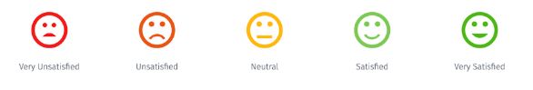
0_________________3_________________5_________________8______________________10
Not motivated Somewhat motivated Very Motivated

