Supplementary material
Seasonal air–sea coupling drives tropical Atlantic multidecadal variability and its impact

Contents:
- Supplementary Text 1
- Supplementary Tables 1-5
- Supplementary Figures 1-15

Supplementary Text 1 | First-order linear decomposition of the net surface heat-flux term
We consider the mixed-layer temperature tendency term associated with net surface heat-fluxes:
$$F = \frac{Q_{net}-q_{d}}{ρc_{p}H}.$$
Here,
- $Q_{net}=Q_{SW}+Q_{LW}+Q_{LHF}+Q_{SHF}$,
- $q_{d}$represents the shortwave radiation penetrating below the mixed-layer depth $H$,
- $ρ$is seawater density, and
- $c_{p}$is the specific heat capacity of seawater.

The penetrative shortwave flux at depth $H$is parameterised as
$$q_{d}=Q_{SW}\left[Re^{-H/γ_{1}}+(1-R)e^{-H/γ_{2}}\right].$$
Define
$$A(H)=Re^{-H/γ_{1}}+(1-R)e^{-H/γ_{2}}.$$
Thus,
$$F=\frac{Q_{net}-Q_{SW}A(H)}{ρc_{p}H}.$$

Linearisation about the monthly mean state
We decompose each variable into monthly mean and anomaly:
$$Q=\overset{‾}{Q}+δQ,H=\overset{‾}{H}+δH.$$
Using a first-order Taylor expansion about $\left(\overset{‾}{Q} , \overset{‾}{H}\right)$, the anomaly of $F$is
$$δF≈\frac{∂F}{∂Q}∣_{\overset{‾}{H}}δQ+\frac{∂F}{∂H}∣_{\overset{‾}{Q},\overset{‾}{H}}δH.$$

Contribution from surface heat flux anomalies
The partial derivative with respect to the flux components gives
$$δF_{flux}=\frac{δQ_{SW}\left[1-A(\overset{‾}{H})\right]+δQ_{LW}+δQ_{LHF}+δQ_{SHF}}{ρc_{p}\overset{‾}{H}}.$$
Substituting $A(\overset{‾}{H})$,
$$\boxed{δF_{flux}=\frac{δQ_{SW}\left[1-Re^{-\overset{‾}{H}/γ_{1}}-(1-R)e^{-\overset{‾}{H}/γ_{2}}\right]+δQ_{LW}+δQ_{LHF}+δQ_{SHF}}{ρc_{p}\overset{‾}{H}}}$$
This term represents the direct effect of surface flux anomalies.

Contribution from mixed-layer depth anomalies
The derivative with respect to $H$ yields
$$\frac{∂F}{∂H}=-\frac{{\overset{‾}{Q}}_{net}}{ρc_{p}{\overset{‾}{H}}^{2}}-\frac{{\overset{‾}{Q}}_{SW}A(\overset{‾}{H})}{ρc_{p}{\overset{‾}{H}}^{2}}-\frac{{\overset{‾}{Q}}_{SW}A^{'}(\overset{‾}{H})}{ρc_{p}\overset{‾}{H}},$$
where
$$A^{'}(\overset{‾}{H})=-\frac{R}{γ_{1}}e^{-\overset{‾}{H}/γ_{1}}-\frac{1-R}{γ_{2}}e^{-\overset{‾}{H}/γ_{2}}.$$
Thus, the MLD contribution becomes
$$\boxed{δF_{MLD}=-\left[\frac{δH {\overset{‾}{Q}}_{net}}{ρc_{p}{\overset{‾}{H}}^{2}} + \frac{δH {\overset{‾}{Q}}_{SW}\left(Re^{-\overset{‾}{H}/γ_{1}}+(1-R)e^{-\overset{‾}{H}/γ_{2}}\right)}{ρc_{p}{\overset{‾}{H}}^{2}} + \frac{δH {\overset{‾}{Q}}_{SW}\left(\frac{R}{γ_{1}}e^{-\overset{‾}{H}/γ_{1}} + \frac{1-R}{γ_{2}}e^{-\overset{‾}{H}/γ_{2}}\right)}{ρc_{p}\overset{‾}{H}}\right]}$$
This term represents the indirect effect of MLD variability through both geometric dilution ($1/H$) and changes in penetrative shortwave absorption.

Final first-order decomposition
Combining both contributions,
$$\boxed{δ\left(\frac{Q_{net}-q_{d}}{ρc_{p}H}\right)=δF_{flux}+δF_{MLD}}$$

$$δ\underset{Flux term}{\underbrace{\left(\frac{Q_{net}-q_{d}}{ρc_{p}H}\right)}}=\underset{Due to flux anomaly}{\underbrace{\frac{δQ_{SW}\left[1-Re^{\frac{-\overline{H}}{γ_{1}}}-\left(1-R\right)e^{\frac{-\overline{H}}{γ_{2}}}\right]+δQ_{LW}+δQ_{LHF}+δQ_{SHF}}{ρc_{p}\overline{H}} }}-\underset{Due to MLD anomaly}{\underbrace{\frac{δH\overline{Q_{net}} }{ρc_{p}{\overline{H}}^{2}}+\frac{δH\overline{Q_{SW}}\left[R e^{\frac{-\overline{H}}{γ_{1}}}+\left(1-R\right)e^{\frac{-\overline{H}}{γ_{2}}}\right]}{ρc_{p}{\overline{H}}^{2}} +\frac{δH\overline{Q_{SW}}\left[\frac{R}{γ_{1}}e^{\frac{-\overline{H}}{γ_{1}}}+\frac{1-R}{γ_{2}}e^{\frac{-\overline{H}}{γ_{2}}}\right]}{ρc_{p}\overline{H}} }}$$

Higher-order nonlinear terms (e.g., $δQ δH$, $\left(δH)^{2}\right.$) are neglected under the first-order approximation.

Supplementary Table 1 | Difference in mean SST tendency between extended and more recent (data-rich) periods in observational datasets.
Differences in mean SST tendency (extended minus more recent (data-rich) period) for HadISST, ERSST, and COBE, with p-values estimated using 10,000 bootstrap samples.

Dataset | Δ mean (extended − recent) | p-value
HadISST | −1.4418 × 10⁻³ | 0.466
ERSST | −3.7228 × 10⁻⁴ | 0.958
COBE | −2.3954 × 10⁻³ | 0.554

Supplementary Table 2 | Classification of CMIP6 models by seasonality of tropical AMV
CMIP6 models are classified into high-, low-, and negative-seasonality categories based on the sign and magnitude of the difference between summer and winter SST tendency during tropical AMV development (see Results; three groups: high-seasonality models (upper half of the positive models), low-seasonality models (lower half of the positive models), and negative-seasonality models (Fig. 1c)). The table lists all analysed models and the number of models in each category.

Category | CMIP6 Models | Number of models
High-seasonality models | ACCESS-ESM1-5; AWI-CM-1-1-MR; IPSL-CM6A-LR; BCC-CSM2-MR; MPI-ESM1-2-HR; MIROC6; HadGEM3-GC31-MM; HadGEM3-GC31-LL; MPI-ESM-1-2-HAM; EC-Earth3-CC; EC-Earth3-Veg-LR; GFDL-CM4; CMCC-CM2-SR5; ICON-ESM-LR | 14
Low- seasonality models | CanESM5; GFDL-ESM4; NorCPM1; CNRM-CM6-1; CESM2; FGOALS-f3-L; CESM2-FV2; MRI-ESM2-0; NorESM2-LM; MPI-ESM1-2-LR; CNRM-ESM2-1; UKESM1-0-LL; CESM2-WACCM-FV2 | 13
Negative- seasonality models | ACCESS-CM2; E3SM-1-0; FGOALS-g3 | 3

Supplementary Table 3 | Trade-wind and associated climate variables relationship across models
Correlation coefficient between wind stress anomaly and other variables across models. Bold letters mark values significant at the 90% level.

 | Relative MLD change | Latent heat flux anomaly | Shortwave radiation anomaly | Surface net heat-flux anomaly | Cloud cover anomaly
High-seasonality models | 0.8 | -0.75 | -0.32 | -0.64 | 0.5
Low-seasonality models | 0.32 | -0.43 | 0.16 | -0.07 | -0.34
Negative-seasonality models | 0.89 | -0.97 | -0.82 | -0.96 | -0.13

Supplementary Table 4 | Cloud–shortwave relationships across models
Correlation coefficient between shortwave radiation anomaly and cloud cover anomaly across models. Bold letters mark values significant at the 90% level.

High-seasonality models | Low-seasonality models | Negative-seasonality models
-0.69 | -0.64 | -0.58

Supplementary Table 5 | Peak lag of the tropical AMV response to extratropical variability in CMIP6 models
The table lists the lag (in years) at which the maximum tropical AMV response is identified for each CMIP6 model, based on the lead-lag correlation between the extratropical AMV index and tropical SST anomalies (see Results). Positive values indicate that the tropical AMV lags the extratropical AMV, while negative values indicate that it leads.
CMIP6 Model | Peak lag (years) | CMIP6 Model | Peak lag (years) | CMIP6 Model | Peak lag (years)
ACCESS-CM2 | 0 | EC-Earth3-CC | 2 | MPI-ESM1-2-HR | 1
ACCESS-ESM1-5 | 0 | EC-Earth3-Veg-LR | 2 | MPI-ESM1-2-LR | 3
AWI-CM-1-1-MR | 2 | FGOALS-f3-L | 0 | MRI-ESM2-0 | 4
BCC-CSM2-MR | 2 | FGOALS-g3 | 1 | NorCPM1 | 2
CESM2 | 1 | GFDL-CM4 | 3 | NorESM2-LM | 1
CESM2-FV2 | 5 | GFDL-ESM4 | 2 | UKESM1-0-LL | 2
CESM2-WACCM-FV2 | 3 | GISS-E2-1-G | 17
CMCC-CM2-SR5 | 3 | HadGEM3-GC31-LL | 2
CNRM-CM6-1 | 2 | HadGEM3-GC31-MM | 2
CNRM-ESM2-1 | 0 | ICON-ESM-LR | 2
CanESM5 | 0 | IPSL-CM6A-LR | 1
CanESM5-CanOE | −13 | MIROC6 | 1
E3SM-1-0 | 4 | MPI-ESM-1-2-HAM | 2

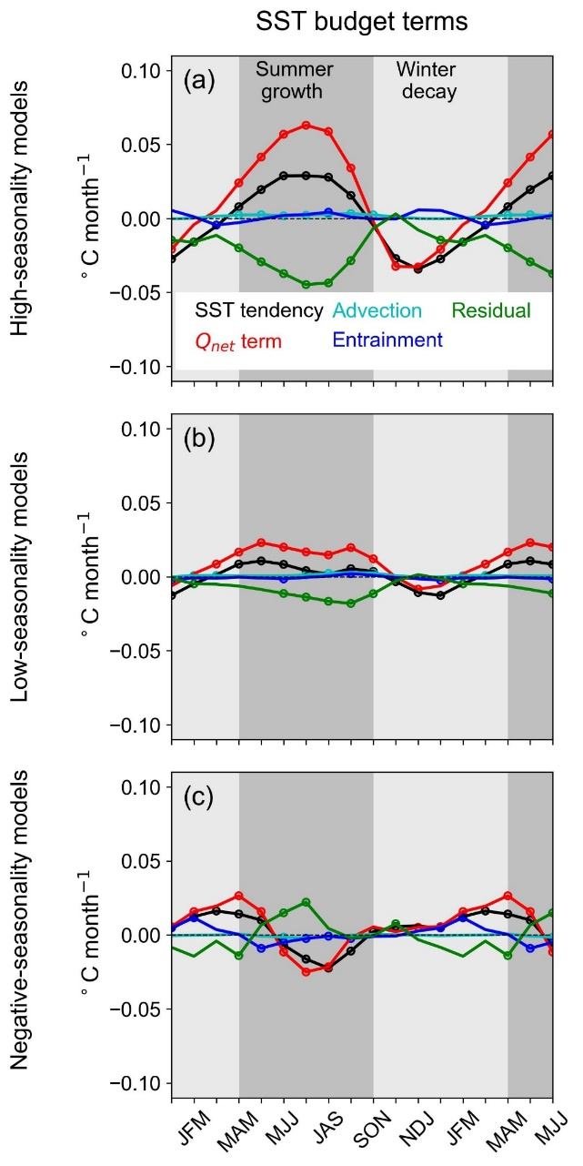

Supplementary Figure 1 | SST budget of internal tropical AMV in coupled models
a, Seasonality of SST budget terms ($°C month^{-1}$) derived from Equation (1), showing SST tendency (black), net surface heat-flux term ($Q_{net}$ term; red), horizontal advection (cyan), entrainment (blue), and the residual (green) during tropical AMV development, averaged over the five years preceding the peak. b, c, The middle and lower rows show the same analysis for the low-seasonality and negative-seasonality model groups, respectively. Dark and light grey shading indicate growth (positive SST tendency) and decay (negative SST tendency) phases. Positive flux values indicate ocean warming. Circles mark values significant at the 90% confidence level.

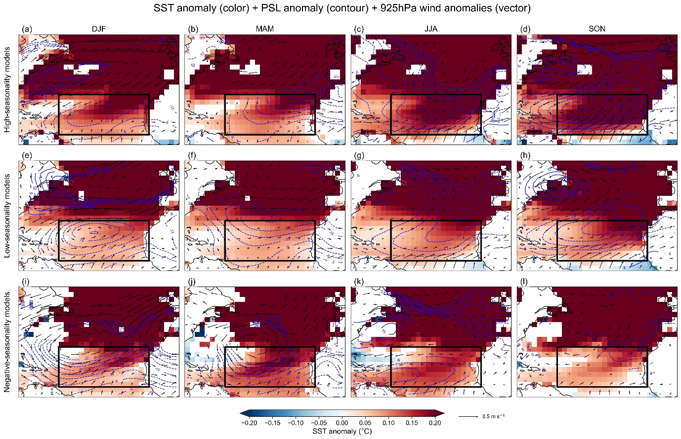

Supplementary Figure 2 | Seasonal maps for SST and atmospheric anomalies across model groups
Seasonal maps of SST anomalies (shading; $°C$), sea level pressure anomalies (contours;$Pa$; dashed contours denote negative anomalies), and anomalous 925-hPa winds (vectors; $m s^{-1}$) are shown for three groups of climate models (rows) during tropical AMV development, averaged over the five years preceding the peak. Columns correspond to December-February (DJF), March-May (MAM), June-August (JJA), and September-November (SON). Values that are not significant at the 90% confidence level, are masked. The black box indicates the tropical Atlantic region used in the analysis.

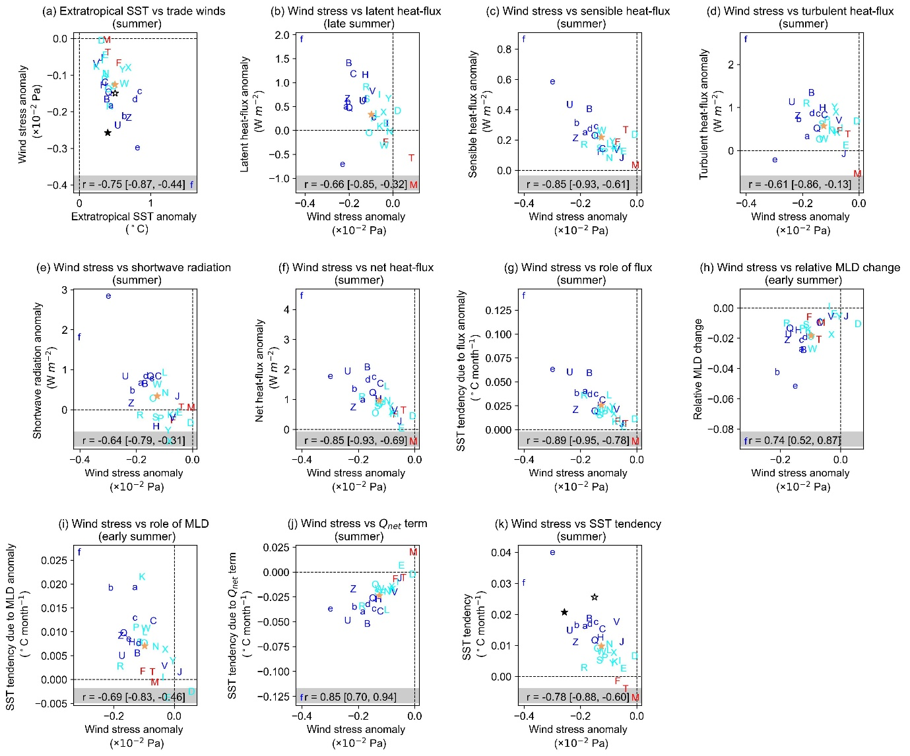
Supplementary Figure 3 | Processes driving model diversity of internal tropical AMV during summer
Scatter plots show inter-model relationships among key variables during the growth phases of tropical AMV, averaged over the five years preceding the peak. a, Summer extratropical SST anomalies versus tropical wind-stress anomalies. b–f, Summer (b, late summer; c–f, summer) wind-stress anomalies versus latent, sensible, turbulent, shortwave, and net surface heat-flux anomalies. g, Summer wind-stress anomalies versus the flux-driven SST tendency. h, Early-summer wind-stress anomalies versus relative mixed-layer depth changes. i, Early-summer wind-stress anomalies versus the mixed-layer-depth contribution to SST tendency. j, Summer wind-stress anomalies versus the net surface heat-flux driven SST tendency. k, Summer wind-stress anomalies versus SST tendency. Positive heat-flux values indicate ocean warming. Pearson correlation coefficients (r) are shown in each panel, with values in square brackets indicating the 90% confidence interval. Blue, cyan, and red letters indicate high-, low-, and negative-seasonality models. The black star marker represents observational estimates using HadISST over the extended period (1983–2024) combined with wind stress anomalies from 20CRv3 (1883–2015), while the open star marker represents observational estimates using HadISST over the more recent (data-rich) period (1950–2024) combined with wind stress anomalies from ERA5 (1940–2024). The brown star marker presents the multi-model mean value.

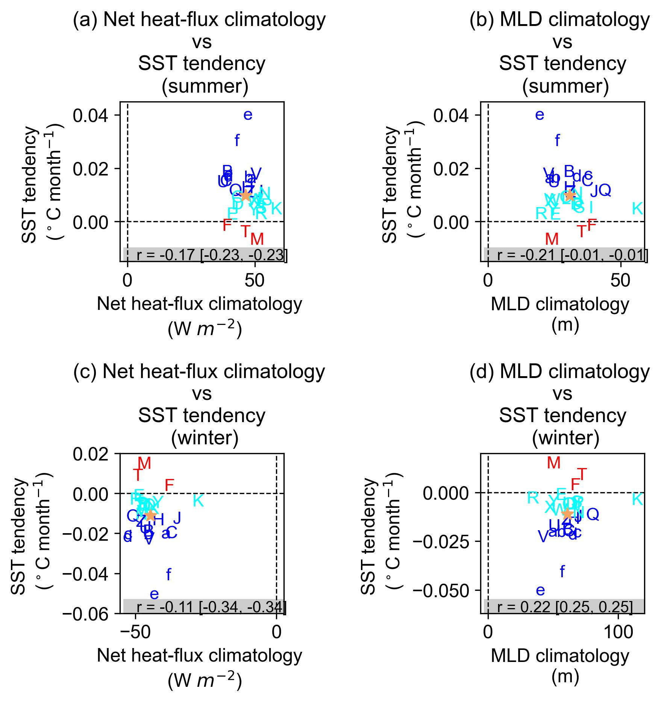
Supplementary Figure 4 | Climatological mean-state differences do not explain model diversity in internal tropical AMV.
Scatter plots show inter-model relationships between key climatological variables and tropical AMV growth and decay, averaged over the five years preceding the peak. a, Summer net surface heat-flux climatology versus summer SST tendency of tropical AMV. b, Summer mixed-layer depth climatology versus summer SST tendency of tropical AMV. c-d, as in a-b, but for winter. Positive heat-flux values indicate ocean warming. Pearson correlation coefficients (r) are shown in each panel, with values in square brackets indicating the 90% confidence interval. Blue, cyan, and red letters denote high-, low-, and negative-seasonality models, respectively. The brown star marks the multi-model mean.

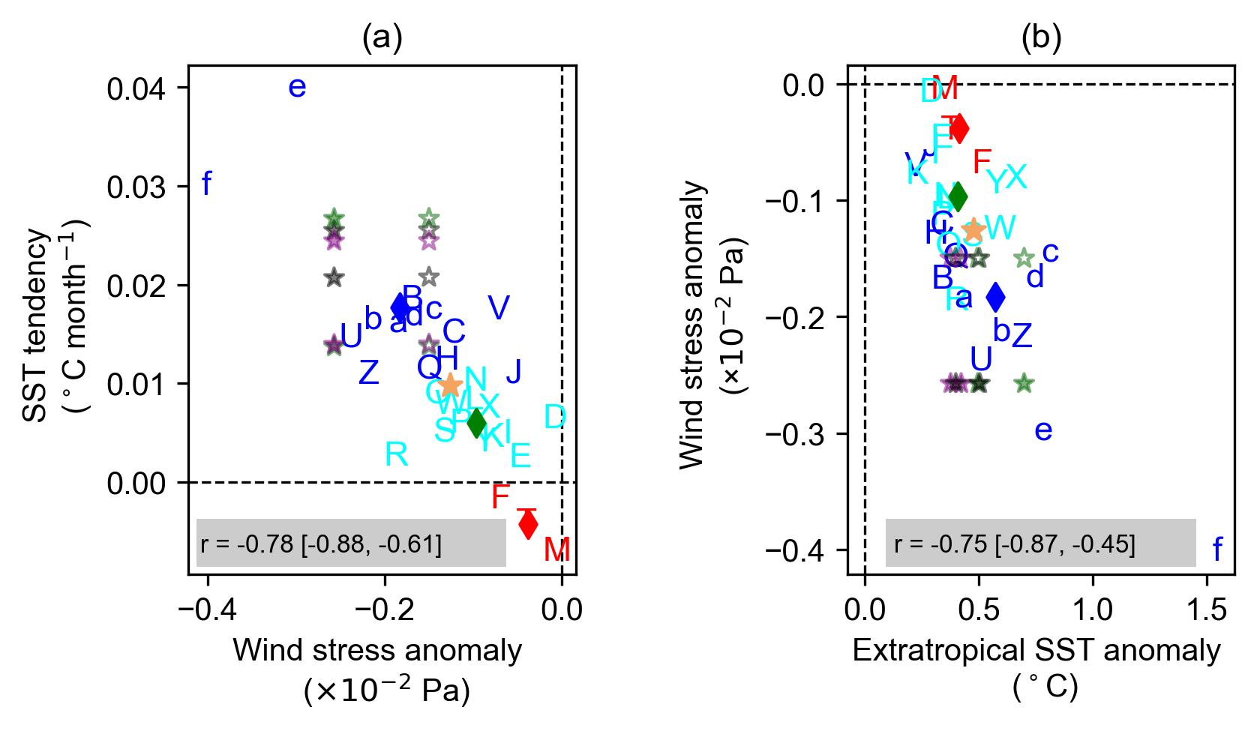

Supplementary Figure 5 | Extratropical-tropical teleconnection driving model diversity in seasonality of internal tropical AMV.
Scatter plots illustrating inter-model relationships among key variables during the growth phase of tropical AMV development, averaged over the five years preceding the peak. a, Summer wind-stress anomalies ($Pa$) versus SST tendency ($°C month^{-1}$). b, Summer tropical wind-stress anomalies ($Pa$) versus summer extratropical SST anomalies ($°C$). The solid star marker represents combination of observational estimates using HadISST, ERSST, and COBE2 over the extended period (1983–2024) and more recent (data-rich) period (1950-2024) combined with wind stress anomalies from 20CRv3 (1901–2024), and from ERA5 (1940–2024). The brown star marks the multi-model mean value, with diamonds mark the multi-model mean of each group. Pearson correlation coefficients (r) are shown in each panel, with values in square brackets indicating the 90% confidence interval. Blue, cyan, and red letters indicate high-, low-, and negative-seasonality models.

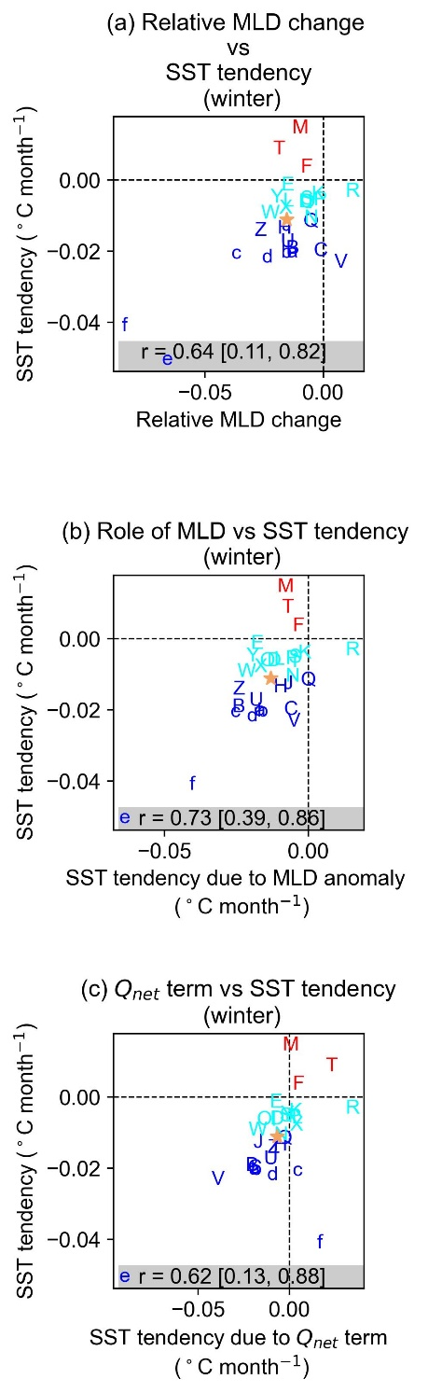
Supplementary Figure 6 | Processes driving model diversity of internal tropical AMV during winter
Scatter plots show inter-model relationships among key variables during the decay phase of tropical AMV, averaged over the five years preceding the peak. a, Wintertime relative mixed-layer depth changes versus SST tendency. b, Winter mixed-layer–depth driven SST tendency versus SST tendency. c, Winter net surface heat-flux driven SST tendency versus SST tendency. The brown star marker presents the multi-model mean value. Pearson correlation coefficients (r) are shown in each panel, with values in square brackets indicating the 90% confidence interval. Blue, cyan, and red letters indicate high-, low-, and negative-seasonality models.

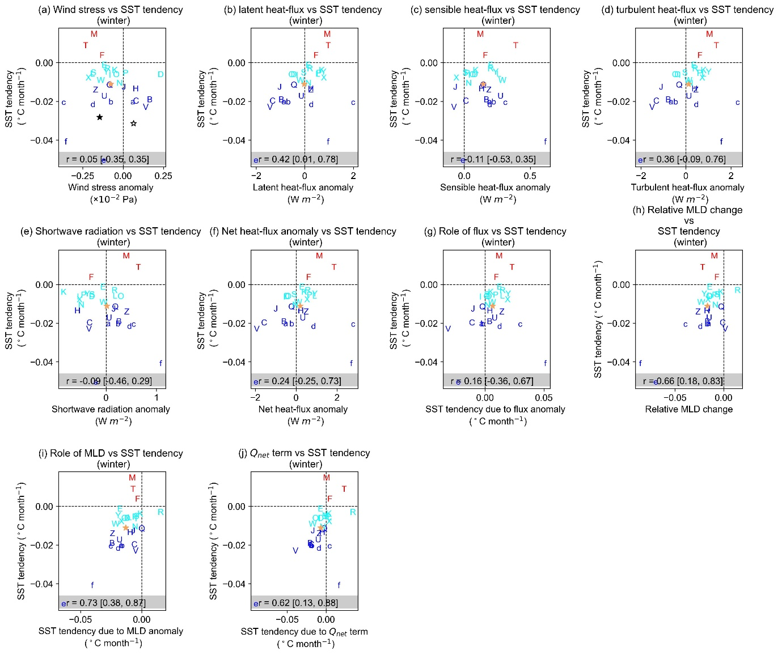

Supplementary Figure 7 | Inter-model relationships among winter processes associated with diversity in internal tropical AMV decay
Scatter plots show inter-model relationships among key variables during the decay phases of tropical AMV, averaged over the five years preceding the peak. a, Winter tropical wind-stress anomalies versus tropical SST tendency. b–f, Winter latent, sensible, turbulent, shortwave, and net surface heat-flux anomalies versus tropical SST tendency. g, Winter flux-driven SST tendency versus tropical SST tendency. h, Relative mixed-layer depth changes versus tropical SST tendency. i, Winter mixed-layer–depth driven SST tendency versus tropical SST tendency. j, Winter net surface heat-flux driven SST tendency versus tropical SST tendency. Positive heat-flux values indicate ocean warming. Pearson correlation coefficients (r) are shown in each panel, with values in square brackets indicating the 90% confidence interval. Blue, cyan, and red letters indicate high-, low-, and negative-seasonality models. The black star marker represents observational estimates using HadISST over the extended period (1983–2024) combined with wind stress anomalies from 20CRv3 (1883–2015), while the open star marker represents observational estimates using HadISST over the more recent (data-rich) period (1950–2024) combined with wind stress anomalies from ERA5 (1940–2024). The brown star marker presents the multi-model mean value.

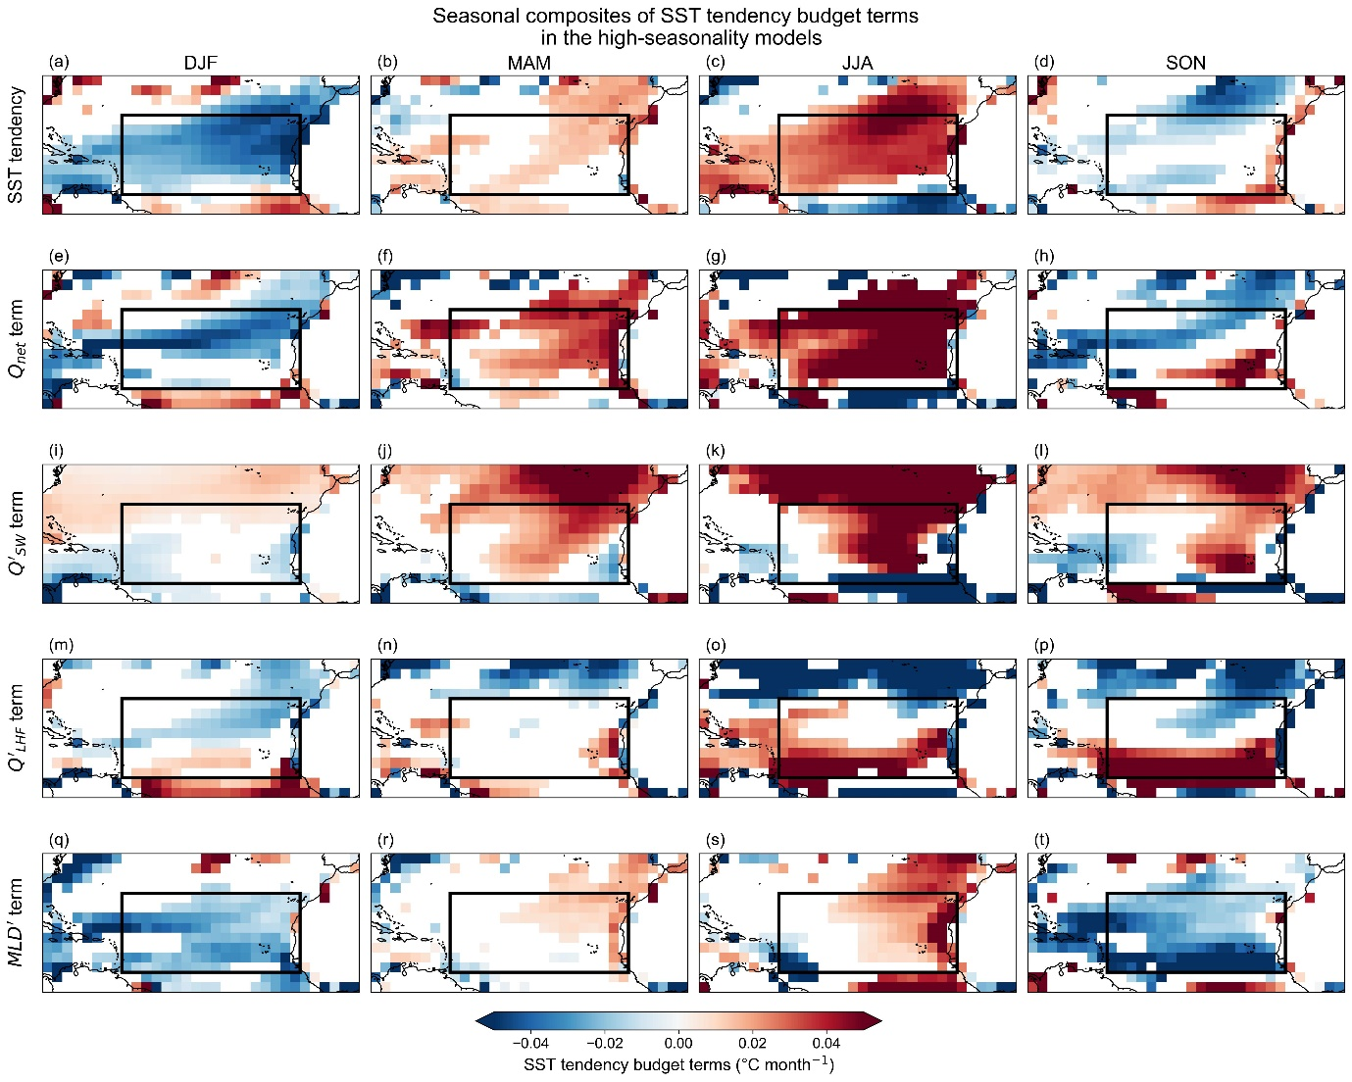

Supplementary Figure 8 | Seasonal maps for SST Budget in the high-seasonality models
Seasonal maps of SST budget terms ($°C month^{-1}$) derived from Equation (1) are shown for high-seasonality models during the development phase of tropical AMV, averaged over the five years preceding the peak. Rows show, from top to bottom, SST tendency, net surface heat-flux term ($Q_{net}$), shortwave radiation anomaly term ($Q_{SW}^{'}$ term), latent heat-flux anomaly term ($Q_{LHF}^{'}$ term), and mixed-layer depth anomaly term ($MLD^{'}$ term). Columns correspond to December-February (DJF), March-May (MAM), June-August (JJA), and September-November (SON). Values that are not significant at the 90% confidence level are masked. The black box indicates the tropical Atlantic region used in the analysis.

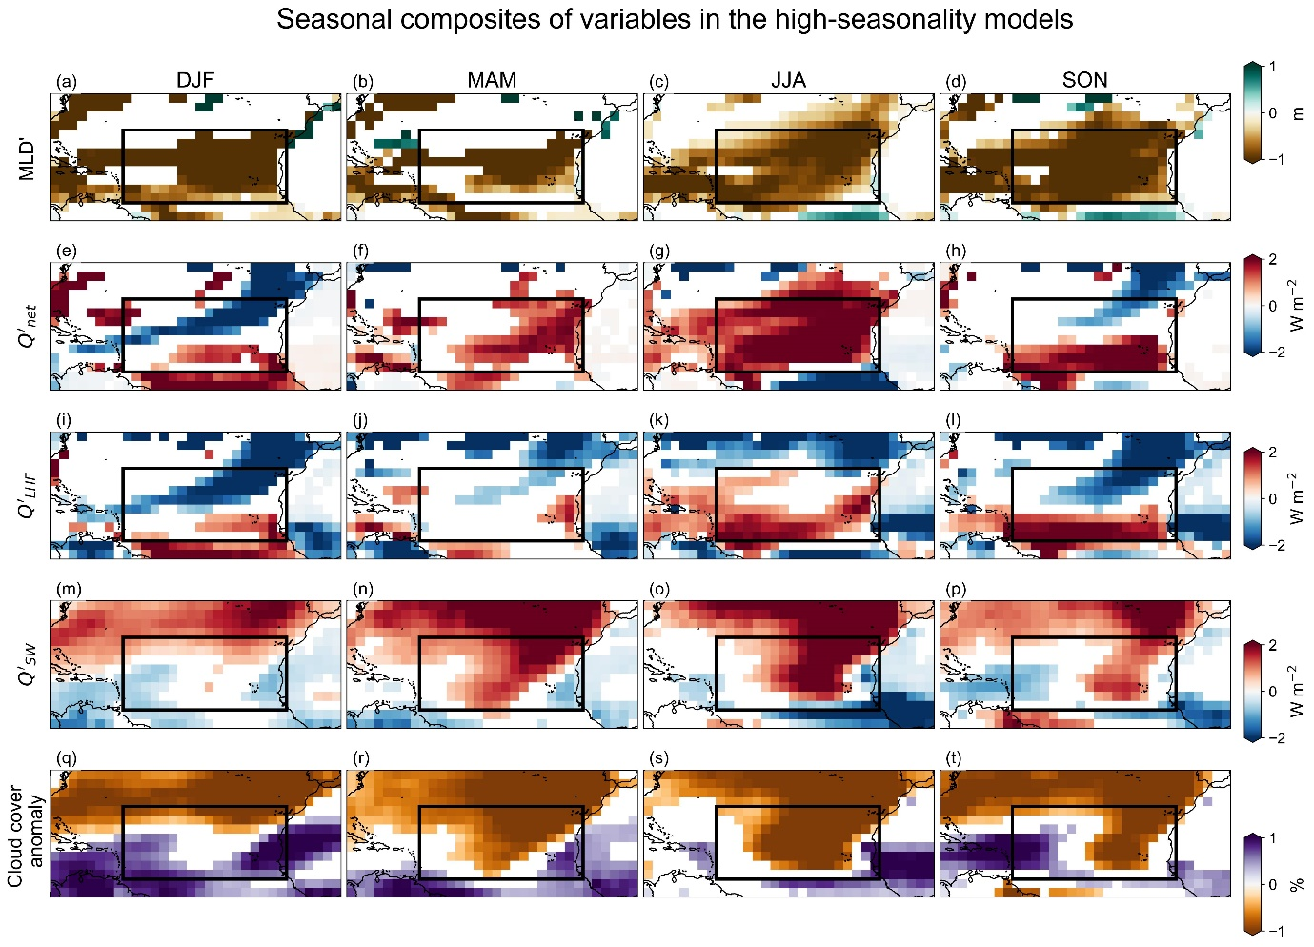

Supplementary Figure 9 | Seasonal maps of mixed-layer depth, cloud cover and surface heat-flux anomalies in the high-seasonality models

Seasonal maps of mixed-layer depth anomalies ($MLD^{'}$, $m$), net surface heat-flux anomalies ($Q_{net}^{'}$, $W m^{-2}$), latent heat-flux anomalies ($Q_{LHF}^{'}$, $W m^{-2}$), shortwave radiation anomalies ($Q_{SW}^{'}$, $W m^{-2}$), and cloud-cover anomalies ($\%$) are shown for the high-seasonality models in rows during the development phase of tropical AMV, averaged over the five years preceding the peak. Columns correspond to December-February (DJF), March-May (MAM), June-August (JJA), and September-November (SON). Values that are not significant at the 90% confidence level are masked. The black box indicates the tropical Atlantic region used in the analysis.

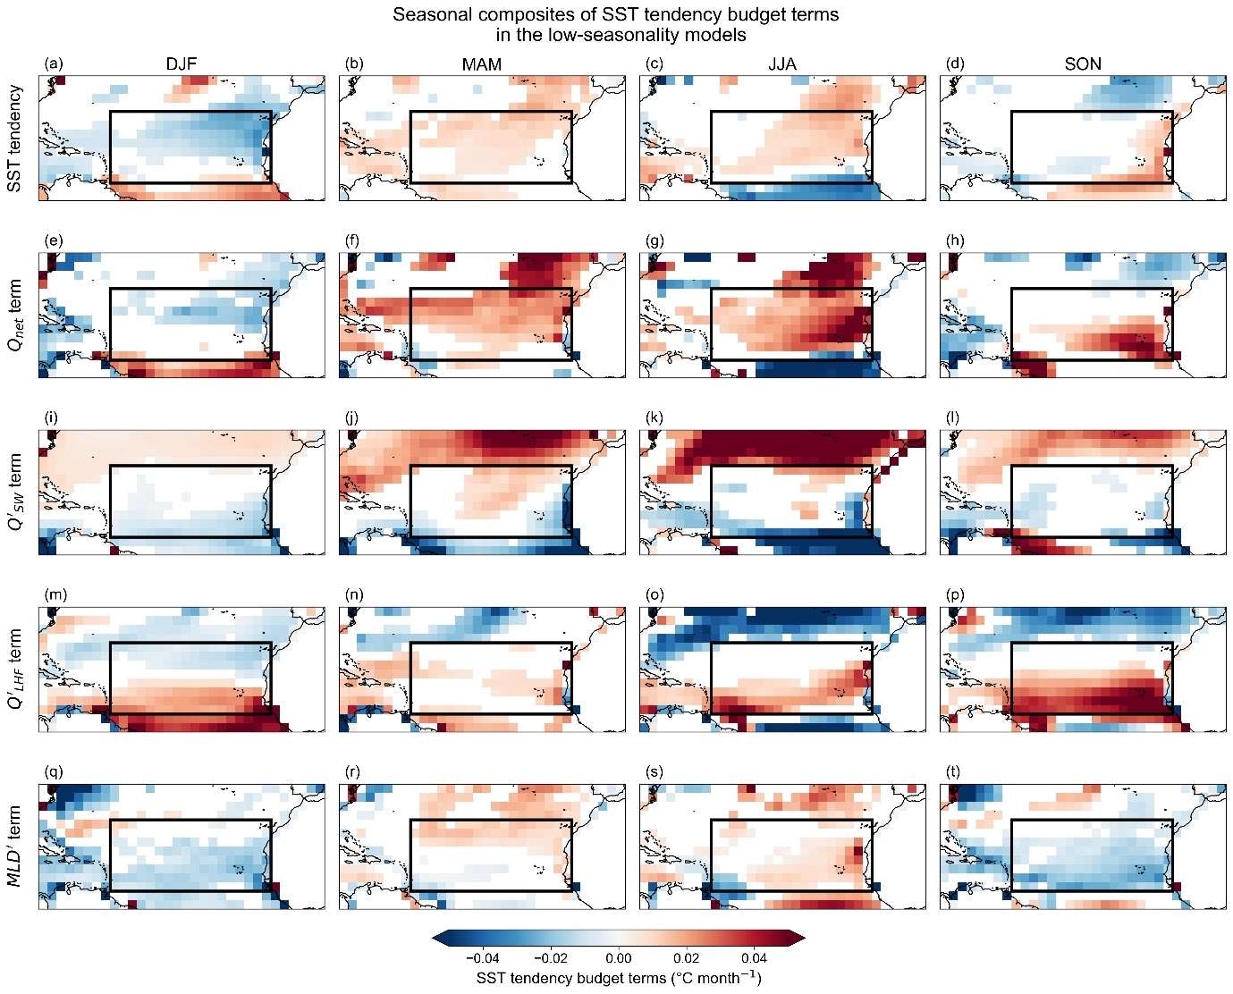

Supplementary Figure 10 | Seasonal maps for SST Budget in the low-seasonality models
Seasonal maps of SST budget terms ($°C month^{-1}$) derived from Equation (1) are shown for low-seasonality models during the development phase of tropical AMV, averaged over the five years preceding the peak. Rows show, from top to bottom, SST tendency, net surface heat-flux term ($Q_{net}$), shortwave radiation anomaly term ($Q_{SW}^{'}$ term), latent heat-flux anomaly term ($Q_{LHF}^{'}$ term), and mixed-layer depth anomaly term ($MLD^{'}$ term). Columns correspond to December-February (DJF), March-May (MAM), June-August (JJA), and September-November (SON). Values that are not significant at the 90% confidence level are masked. The black box indicates the tropical Atlantic region used in the analysis.

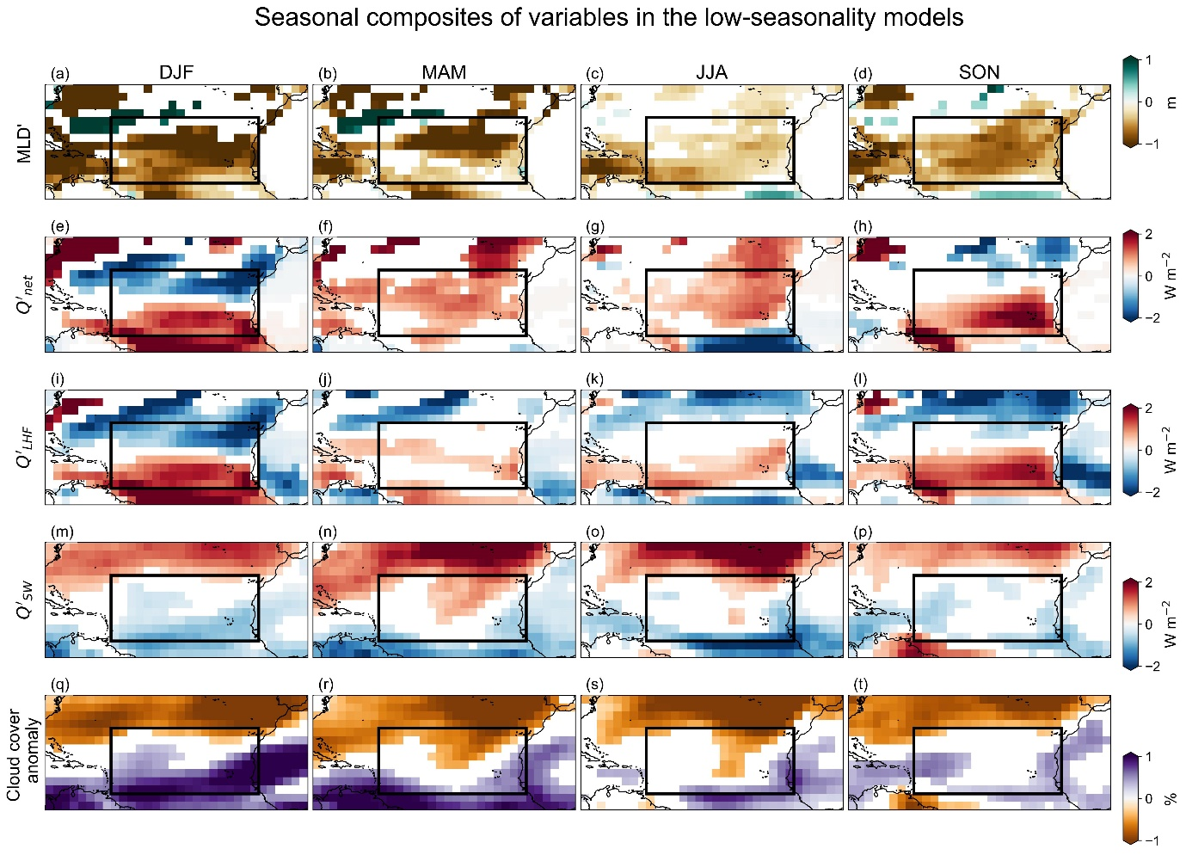

Supplementary Figure 11 | Seasonal maps of mixed-layer depth, cloud cover and surface heat-flux anomalies in the low-seasonality models

Seasonal maps of mixed-layer depth anomalies ($MLD^{'}$, $m$), net surface heat-flux anomalies ($Q_{net}^{'}$, $W m^{-2}$), latent heat-flux anomalies ($Q_{LHF}^{'}$, $W m^{-2}$), shortwave radiation anomalies ($Q_{SW}^{'}$, $W m^{-2}$), and cloud-cover anomalies ($\%$) are shown for the low-seasonality models in rows during the development phase of tropical AMV, averaged over the five years preceding the peak. Columns correspond to December-February (DJF), March-May (MAM), June-August (JJA), and September-November (SON). Values that are not significant at the 90% confidence level are masked. The black box indicates the tropical Atlantic region used in the analysis.

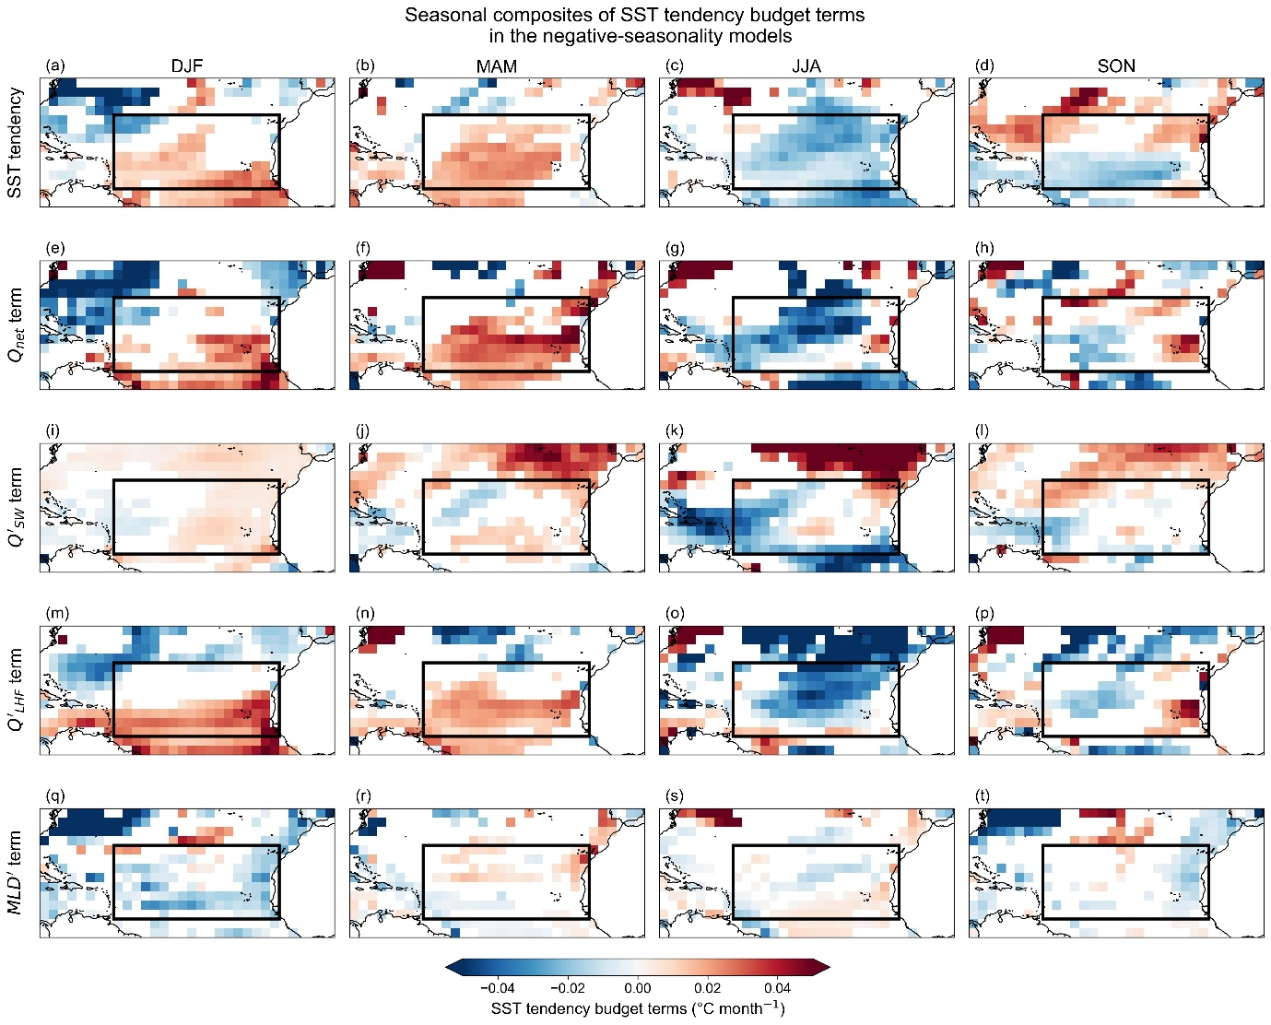
Supplementary Figure 12 | Seasonal maps for SST Budget in the negative-seasonality models

Seasonal maps of SST budget terms ($°C month^{-1}$) derived from Equation (1) are shown for negative-seasonality models during the development phase of tropical AMV, averaged over the five years preceding the peak. Rows show, from top to bottom, SST tendency, net surface heat-flux term ($Q_{net}$), shortwave radiation anomaly term ($Q_{SW}^{'}$ term), latent heat-flux anomaly term ($Q_{LHF}^{'}$ term), and mixed-layer depth anomaly term ($MLD^{'}$ term). Columns correspond to December-February (DJF), March-May (MAM), June-August (JJA), and September-November (SON). Values that are not significant at the 90% confidence level are masked. The black box indicates the tropical Atlantic region used in the analysis.

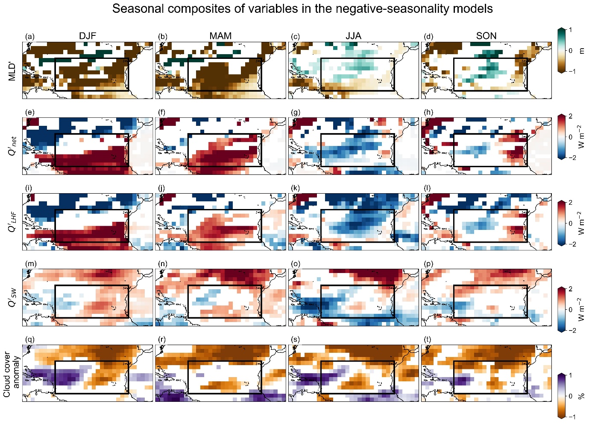

Supplementary Figure 13 | Seasonal maps of mixed-layer depth, cloud cover and surface heat-flux anomalies in the negative-seasonality models

Seasonal maps of mixed-layer depth anomalies ($MLD^{'}$, $m$), net surface heat-flux anomalies ($Q_{net}^{'}$, $W m^{-2}$), latent heat-flux anomalies ($Q_{LHF}^{'}$, $W m^{-2}$), shortwave radiation anomalies ($Q_{SW}^{'}$, $W m^{-2}$), and cloud-cover anomalies ($\%$) are shown for the negative-seasonality models in rows during the development phase of tropical AMV, averaged over the five years preceding the peak. Columns correspond to December-February (DJF), March-May (MAM), June-August (JJA), and September-November (SON). Values that are not significant at the 90% confidence level are masked. The black box indicates the tropical Atlantic region used in the analysis.

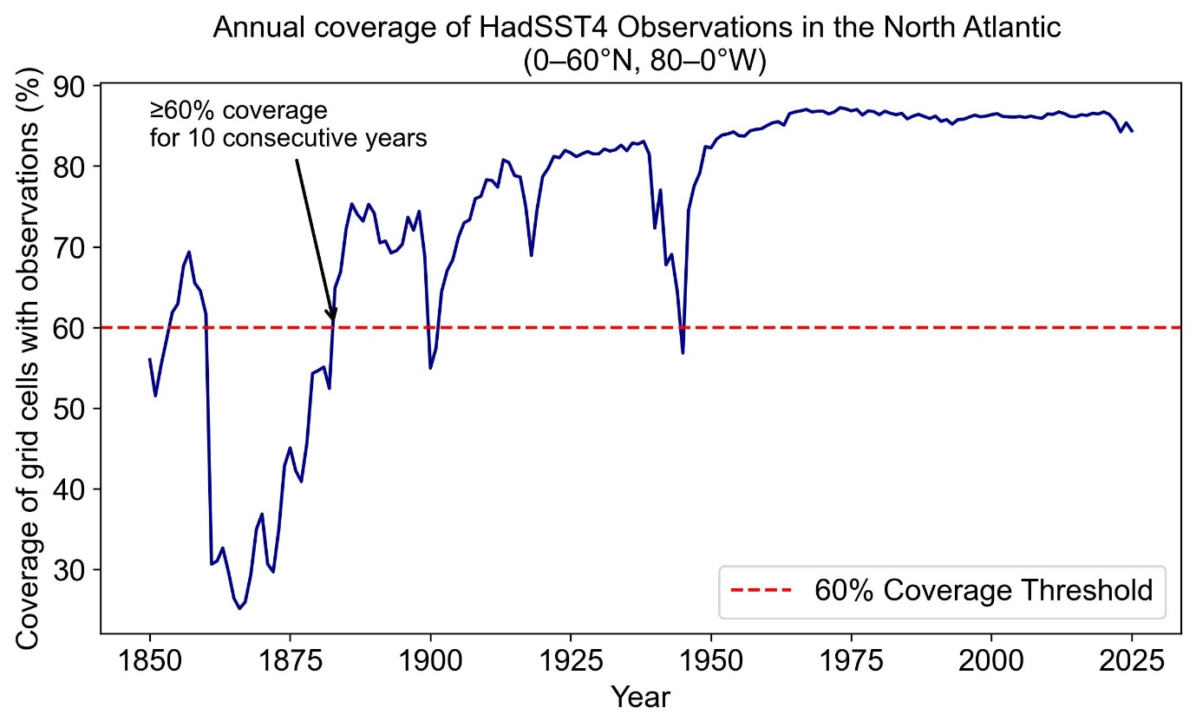

Supplementary Figure 14 | Annual coverage of HadISST observations in the North Atlantic

Annual coverage of grid cells with HadISST observations ($\%$) over the North Atlantic (0–60°N, 80°W–0°). The black arrow marks the year 1883, from which observational coverage exceeds 60% for at least 10 consecutive years.

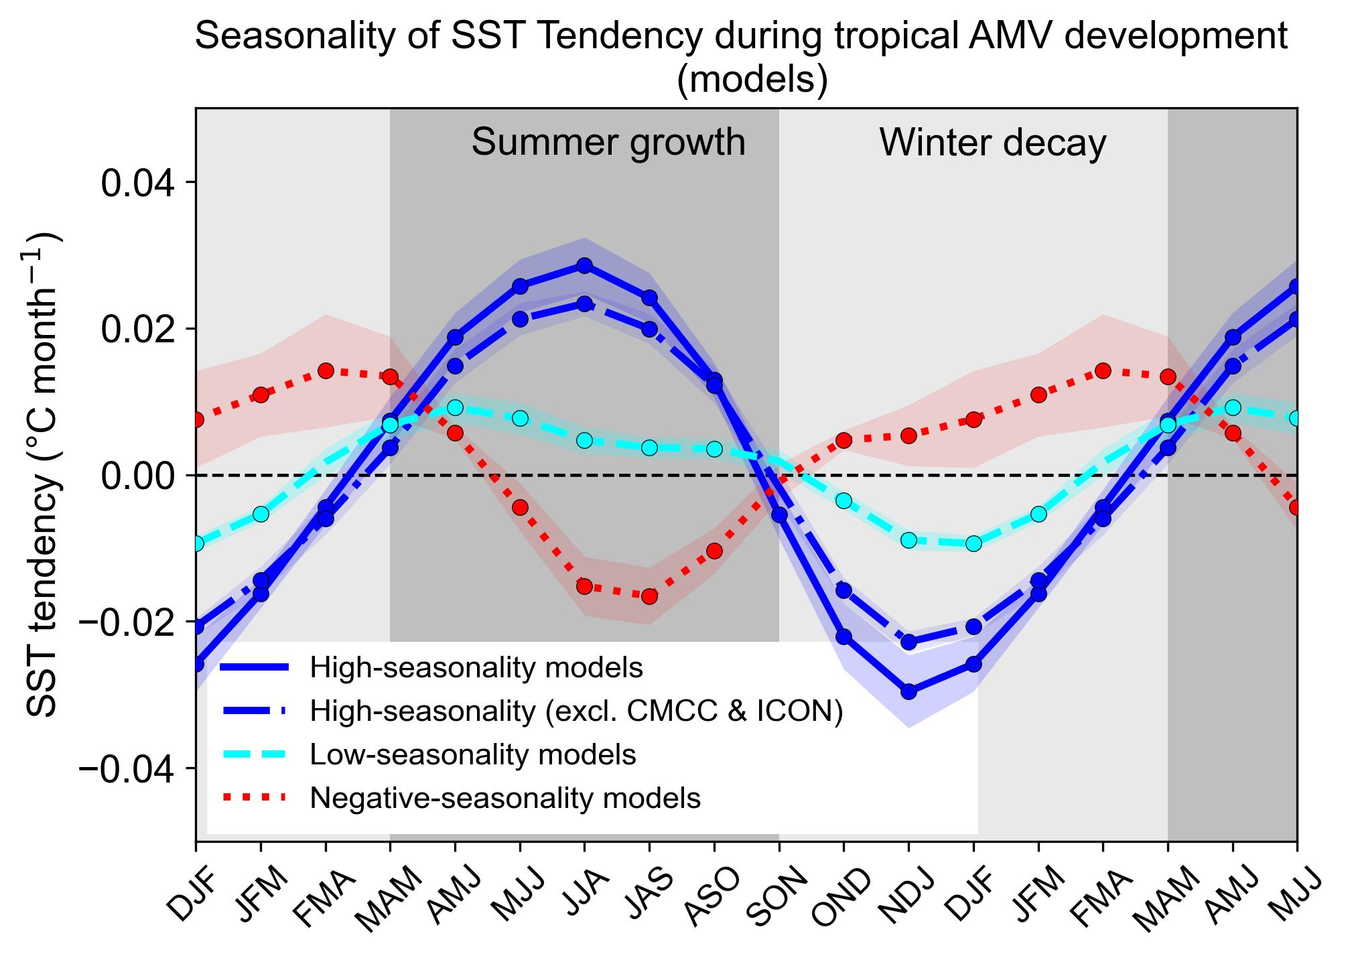

Supplementary Figure 15 | Seasonality of internal tropical AMV in coupled models
Seasonal SST tendency is shown for high-seasonality models (solid blue), high-seasonality models excluding two models (CMCC-CM2-SR5 and ICON-ESM-LR) with exceptionally strong seasonality (dotted blue; see Results), low-seasonality models (cyan), and negative-seasonality models (red). Shading indicates the standard error across models. Circles mark values significant at the 90% confidence level.

