Appendix 1 Data collection between 16 Dec 2019 and 19 Dec 2019
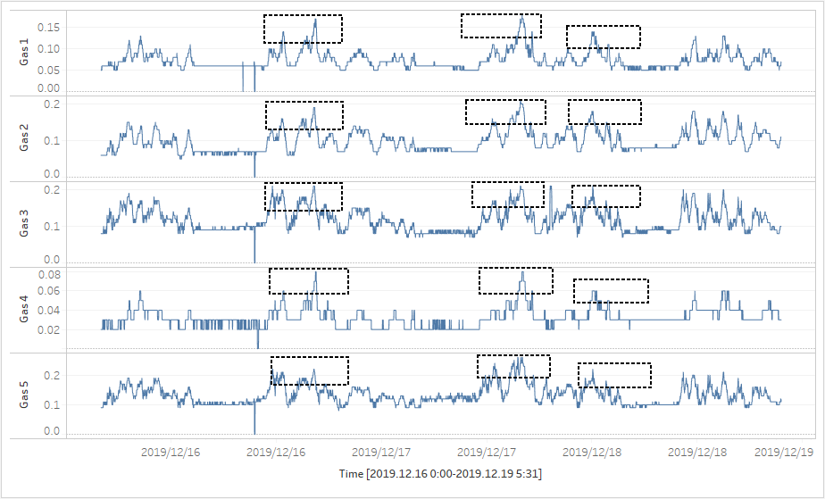

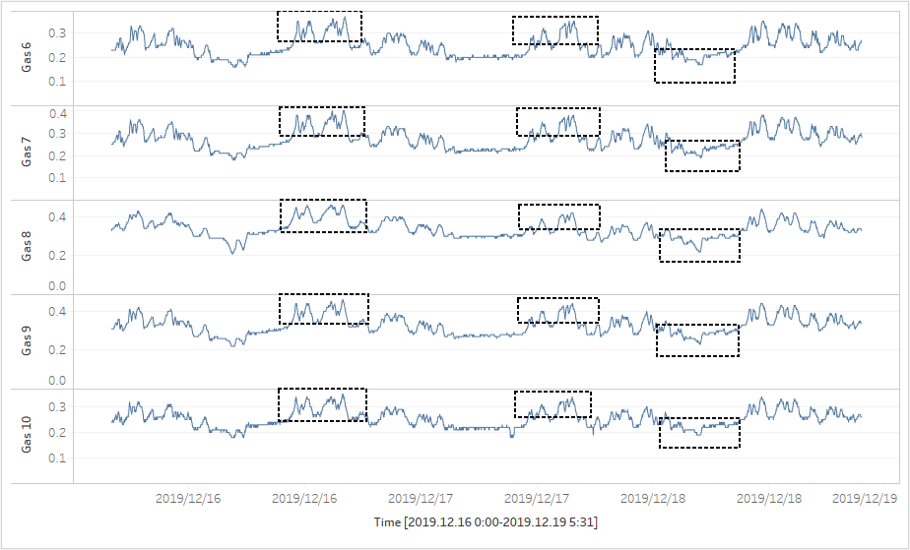

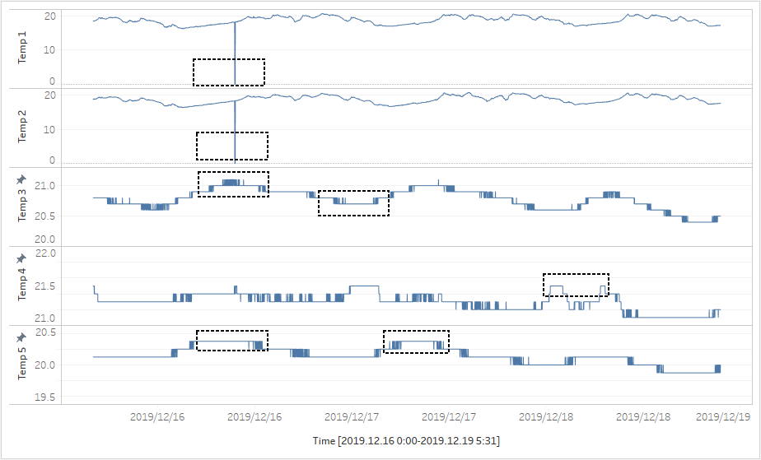

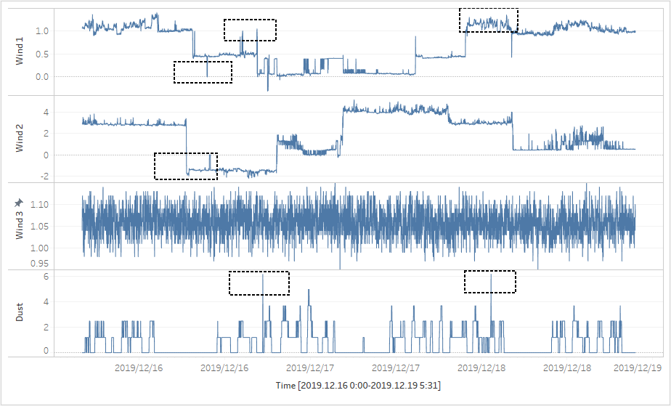

Appendix 2 Correlation analysis table between Gas and Temperature
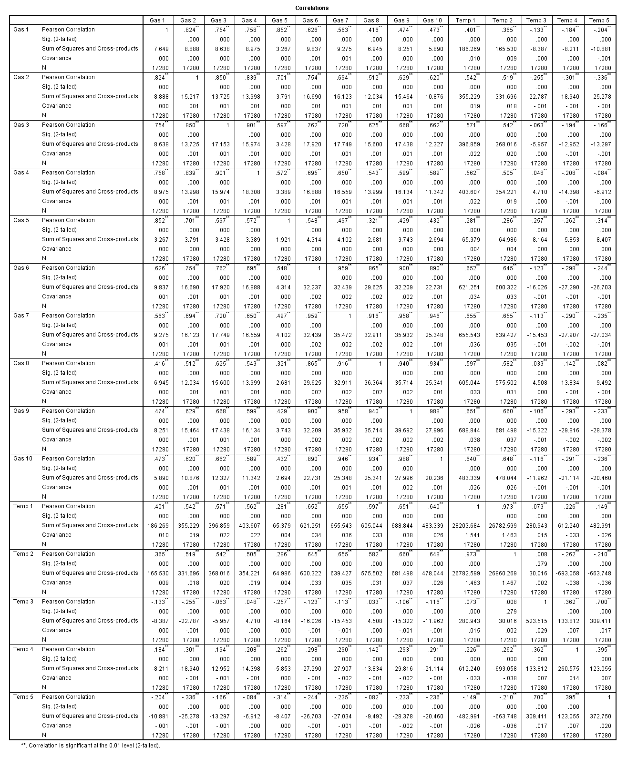

Appendix 3 Correlation analysis table between Gas and Wind
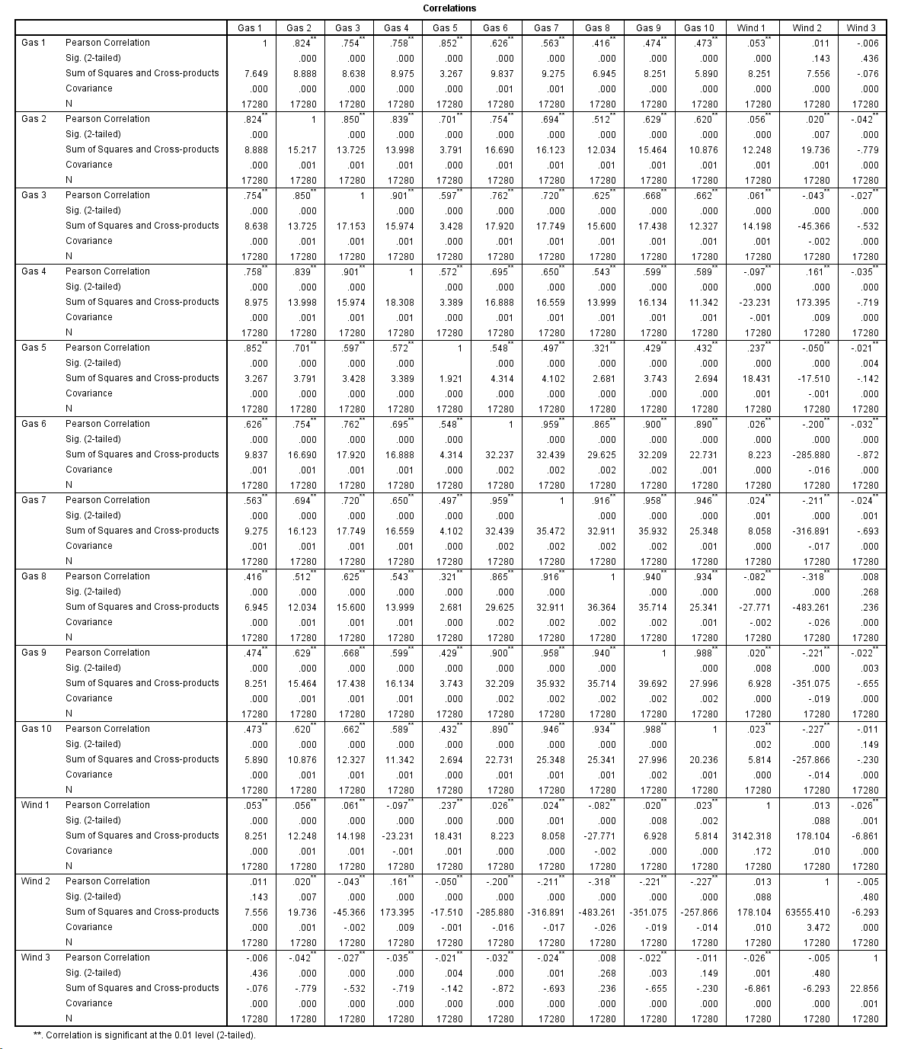

Appendix 4 Correlation analysis table between Gas and Dust
