Supplementary Fig. S1
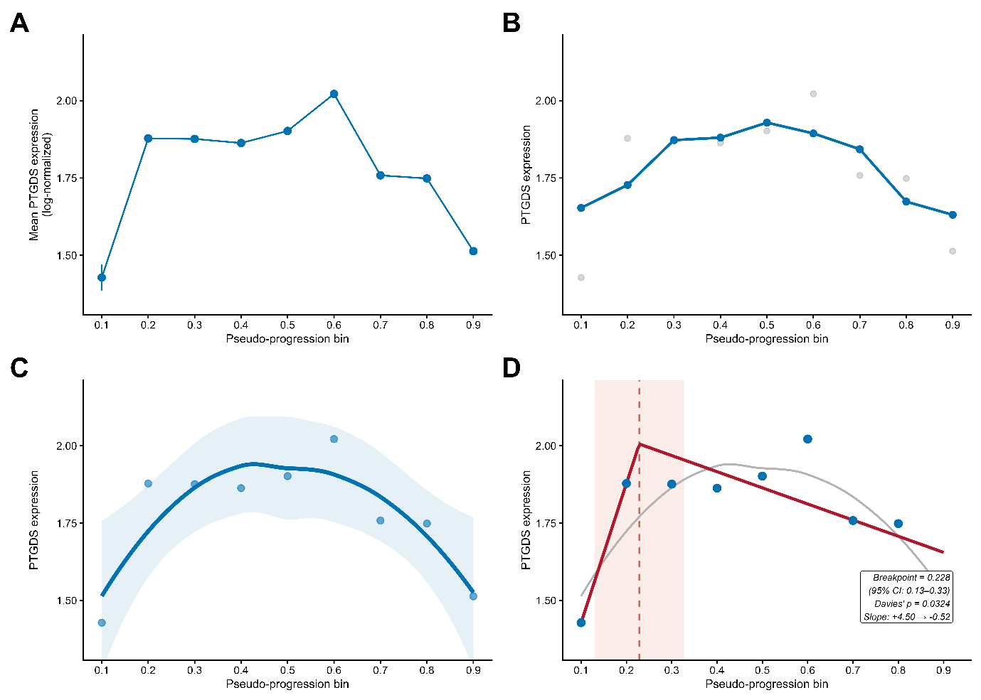
Statistical validation of the biphasic PTGDS trajectory and inflection point. A. Unsmoothed bin-level mean PTGDS expression (± SEM) across nine pseudo-progression bins (Bins 0.1–0.9) in SEA-AD astrocytes. The raw trajectory shows an initial rise from Bin 0.1 to a peak at Bin 0.6 (raw mean = 2.02), followed by progressive decline. B. Three-bin centered moving average (blue) used for lagged cross-correlation analyses (Table 3). Gray points indicate unsmoothed values. C. LOESS regression (span = 1.0) with 95% confidence interval confirming the biphasic trajectory: compensatory upregulation through mid-progression followed by exhaustion-phase decline. D. Segmented regression identifying a statistically significant slope change (breakpoint) at Bin 0.23 (95% CI: 0.13–0.33; Davies’ test p = 0.032), with a steep ascending slope (+4.50) preceding the breakpoint and a gradual declining slope (−0.52) thereafter. The gray curve shows the LOESS fit for reference. *Data derived from astrocytes (n = 428–14,108 cells per bin) across 84 SEA-AD donors.

Supplementary Fig. S2
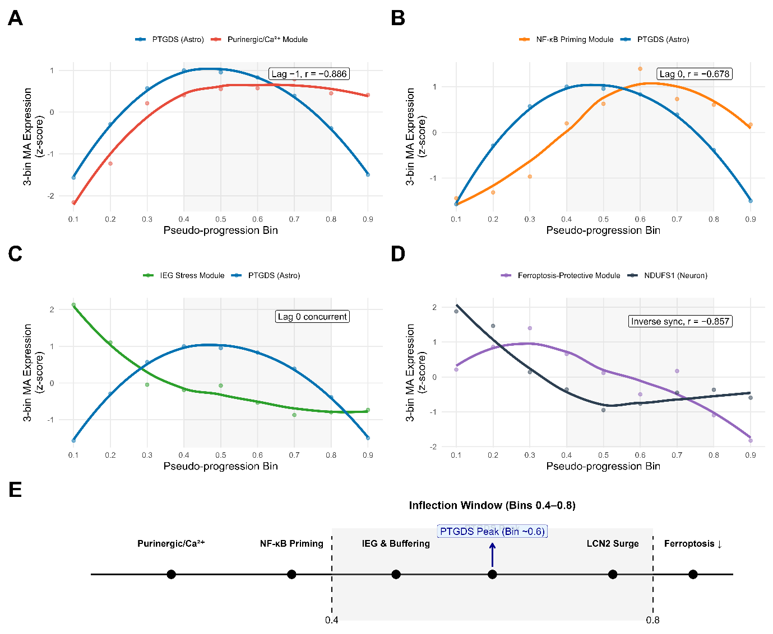
Module-level mechanistic dissection of the astrocyte–neuron cascade in SEA-AD pseudo-progression. Module-level trajectories of key astrocyte programs relative to PTGDS across pseudo-progression bins (3-bin moving average of log-normalized expression). The inflection window (Bins 0.4–0.8) is highlighted in gray. Lagged cross-correlation values are indicated in boxed annotations. A. Purinergic/Ca²⁺ module leads PTGDS by one bin (Lag −1, r = −0.886), indicating sensing–compensation coupling. B. NF-κB priming module shows concurrent to modestly leading dynamics with PTGDS (Lag 0, r = −0.678 within inflection window; Lag −1, r = −0.706 across full trajectory), representing inflammatory priming associated with PTGDS modulation. C. Immediate early gene (IEG) stress module shows concurrent trajectory with PTGDS (Lag 0), reflecting tight compensatory coupling. D. Ferroptosis-protective module declines in parallel with loss of neuronal NDUFS1, consistent with coordinated metabolic–trophic stress across the inflection window. E. Temporal sequence of module activation along pseudo-progression, highlighting the inflection window (Bins 0.4–0.8) with dashed lines. PTGDS peak occurs at Bin ~0.6, demarcating the transition from compensatory to post-inflection destabilization phase. Expression values are z-score normalized within each trajectory to enable direct visual comparison of relative temporal dynamics across modules with different absolute expression levels. Lagged cross-correlation values refer to the inflection window analysis (Bins 0.4–0.8; Table 3).

Supplementary Fig. S3
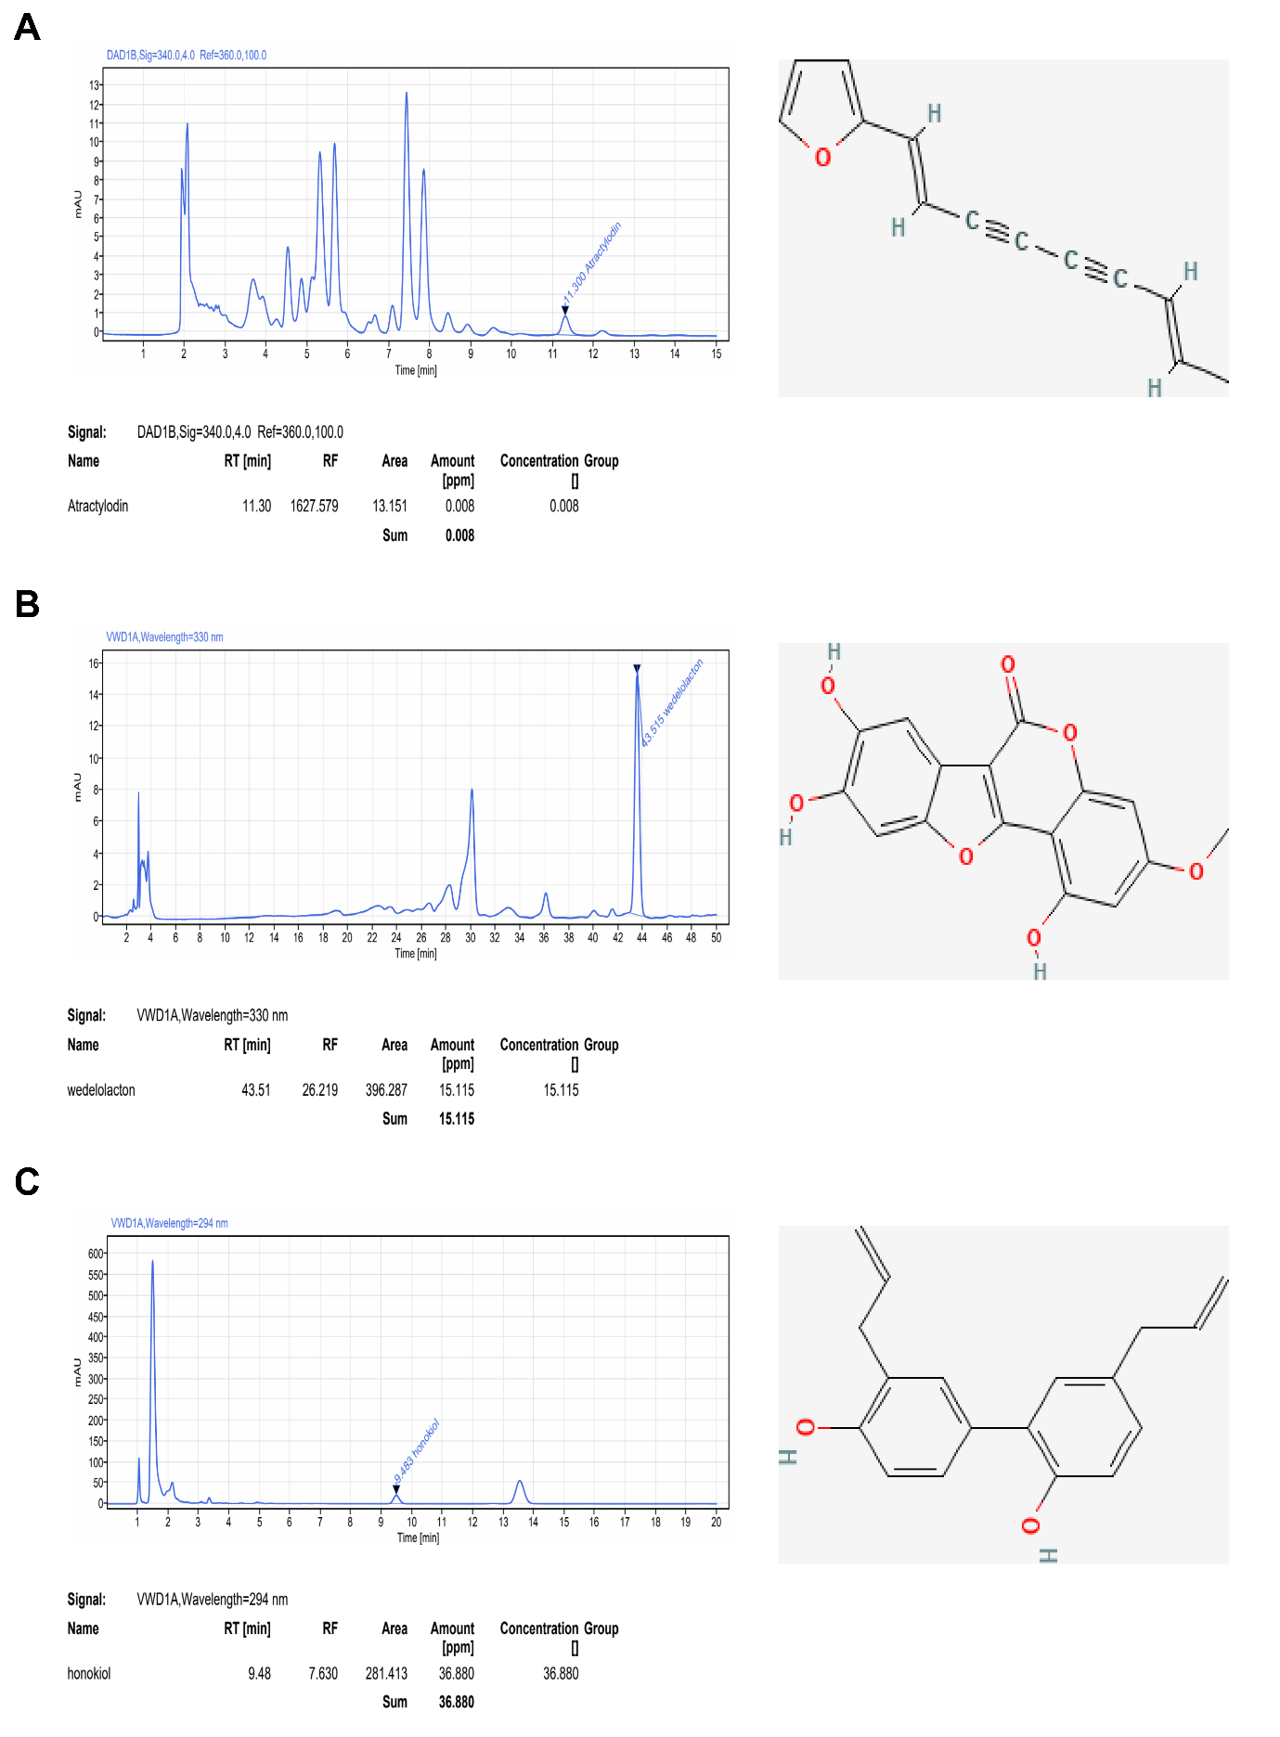
Chemical standardization of BXP-101. HPLC-DAD chromatograms and chemical structures of the three major marker compounds in BXP-101: A. Atractylodin, B. Wedelolactone, and C. Honokiol. The tables below each chromatogram summarize the retention time (RT), peak area, and standardized concentration groups, ensuring batch-to-batch chemical consistency of the multi-component formulation.

Supplementary Fig. S4
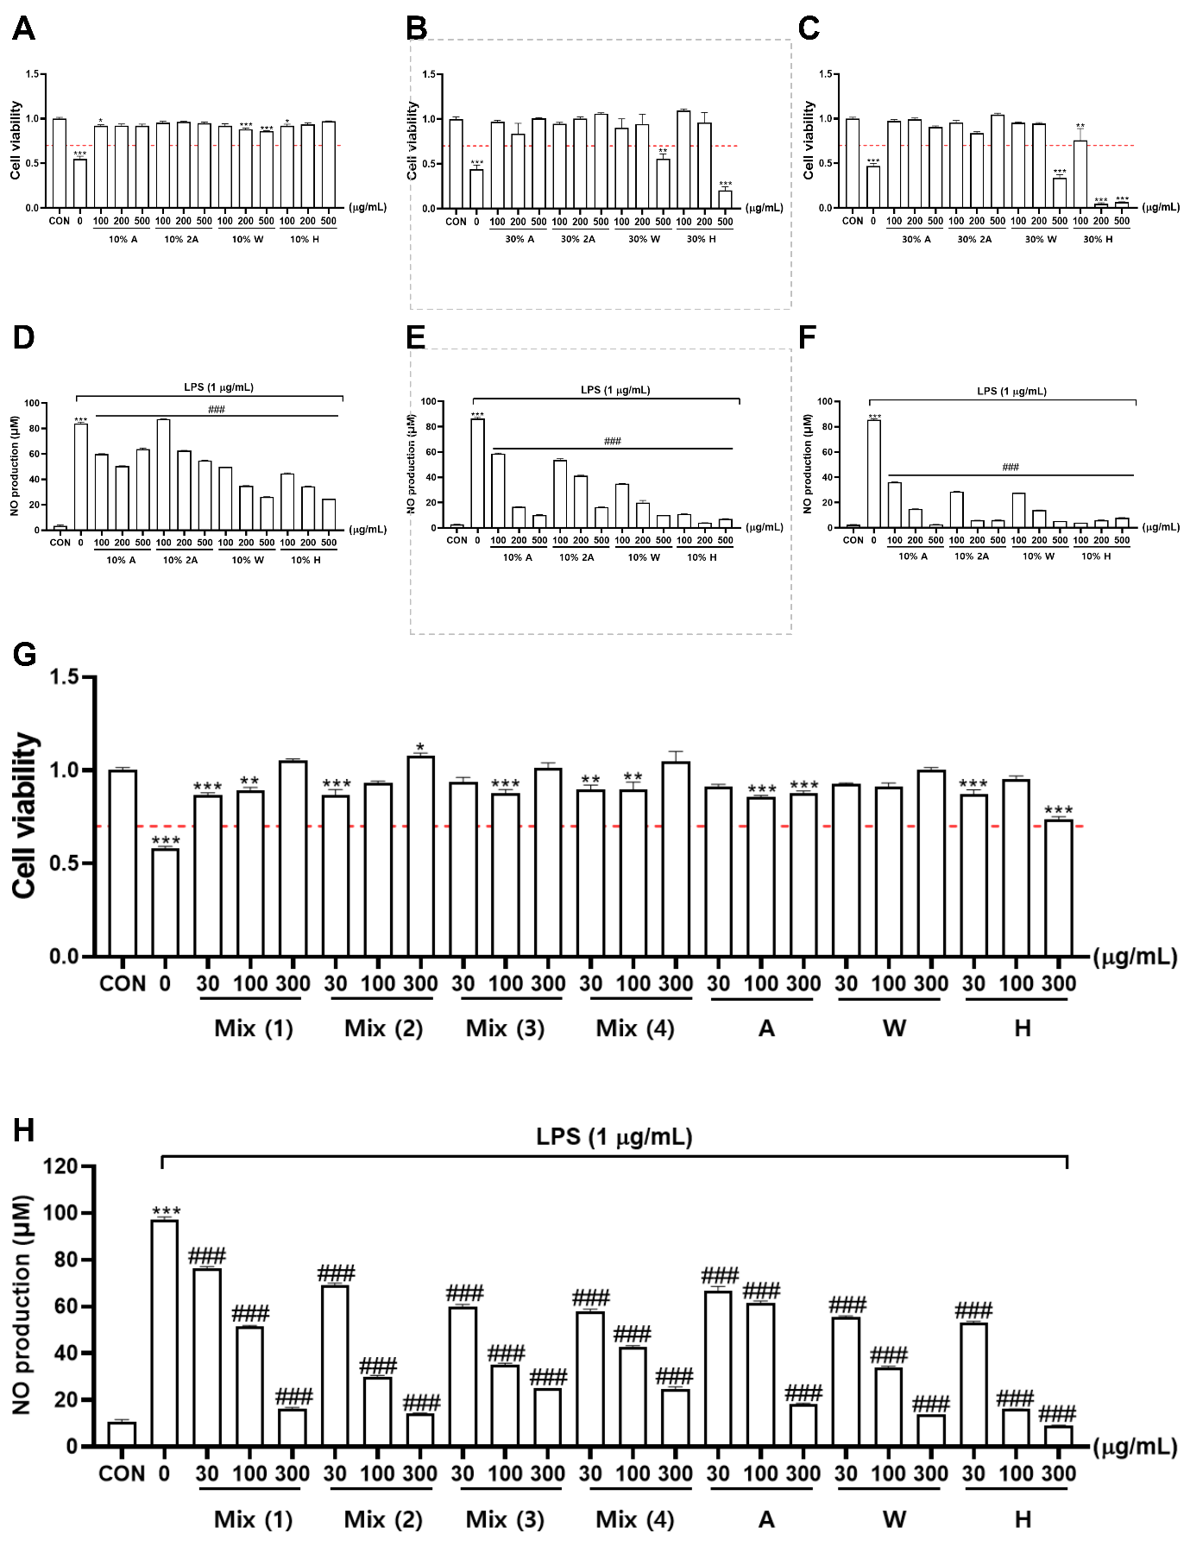
In vitro validation of BXP-101: Non-cytotoxic anti-inflammatory synergy in BV-2 microglia. A–C. MTT cell viability assays for individual constituents (Atractylodin, Wedelolactone, Honokiol) in BV-2 cells (100–500 μg/mL). The red dashed line denotes the 70% viability threshold for non-toxicity. D–F. Dose-dependent inhibition of LPS-induced (1 μg/mL) nitric oxide (NO) production by individual constituents. G. Comparative viability of BV-2 cells treated with BXP-101 Mix (1–4) vs. single components, showing preserved viability up to 300 μg/mL for the optimized Mix (4). H. Synergistic anti-inflammatory effect of BXP-101 Mix (4) at 300 μg/mL, significantly outperforming individual constituents in suppressing NO production. Data represent mean ± SEM (n = 3 independent experiments). Statistical significance was determined by one-way ANOVA with Tukey’s post-hoc test. *p < 0.05, **p < 0.01, ***p < 0.001 vs. Control (CON); ###p < 0.001 vs. LPS-only group.

Supplementary Fig. S5
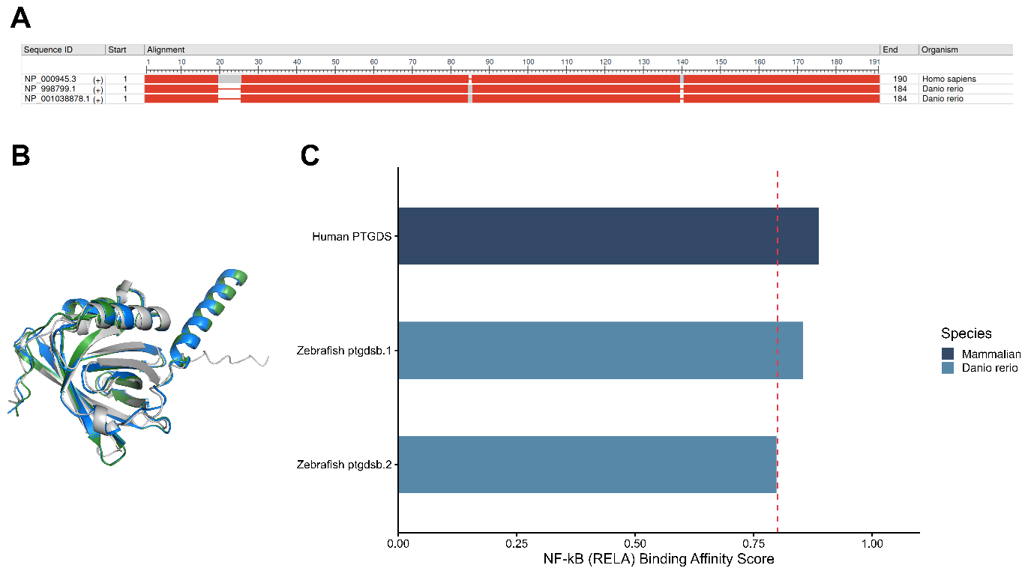
Evolutionary conservation and structural homology of PTGDS. A. Multiple sequence alignment of human PTGDS and zebrafish Ptgdsb.1/2. Red blocks indicate conserved residues, with the upper bar showing the conservation degree. Pairwise identity between human PTGDS and zebrafish Ptgdsb.1 is 85.6% (BLASTP). B. Structural superimposition of AlphaFold2-predicted PTGDS models. Zebrafish Ptgdsb.1 (marine) and Ptgdsb.2 (forest) show high similarity to human PTGDS (gray), with RMSD values of 1.10 Å and 1.23 Å, respectively. C. NF-κB (RELA) binding affinity scores for human and zebrafish ptgdsb promoters. The dashed red line denotes the significance threshold (0.8). *Data represent mean ± SEM of computational binding iterations. p < 0.05.
Supplementary Fig. S6
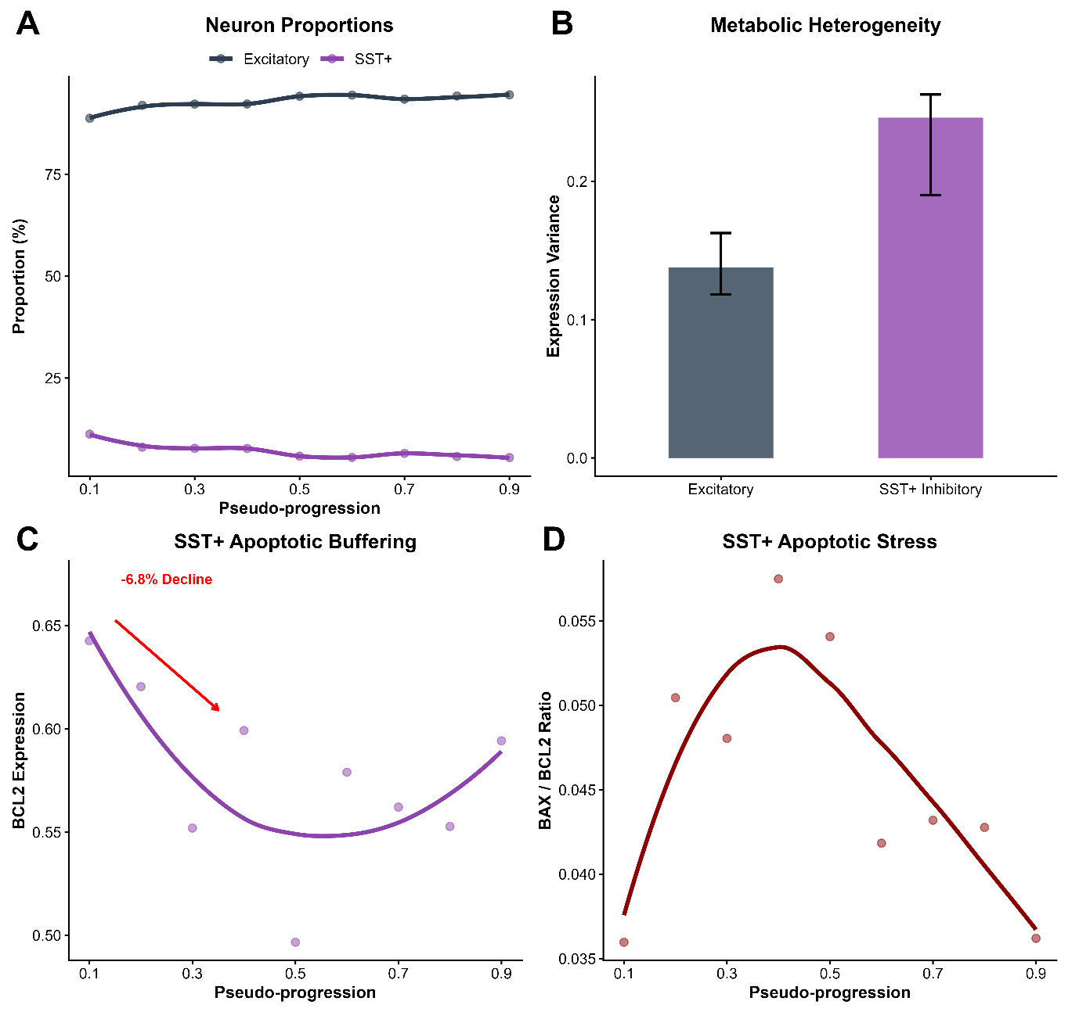
Differential vulnerability and apoptotic buffering capacity across neuronal subtypes. A. Proportional changes of excitatory neurons and SST⁺ inhibitory interneurons across pseudo-progression bins. SST⁺ neurons exhibit a progressive decline (from 11.24% to 5.49% as a fraction of excitatory + SST neurons (donor-level Spearman ρ = −0.32, p = 0.003)), while excitatory neuron proportion increases correspondingly. B. Comparison of NDUFS1 expression variance, reflecting increased metabolic heterogeneity in SST⁺ neurons under post-inflection stress. C. Trajectory of anti-apoptotic marker BCL2 in SST⁺ neurons, showing a 6.8% decline during the early window (Bins 0.1–0.4). D. Early elevation of the BAX/BCL2 ratio within the SST⁺ population, indicating transient apoptotic stress and diminished buffering capacity during post-inflection destabilization.

Supplementary Fig. S7
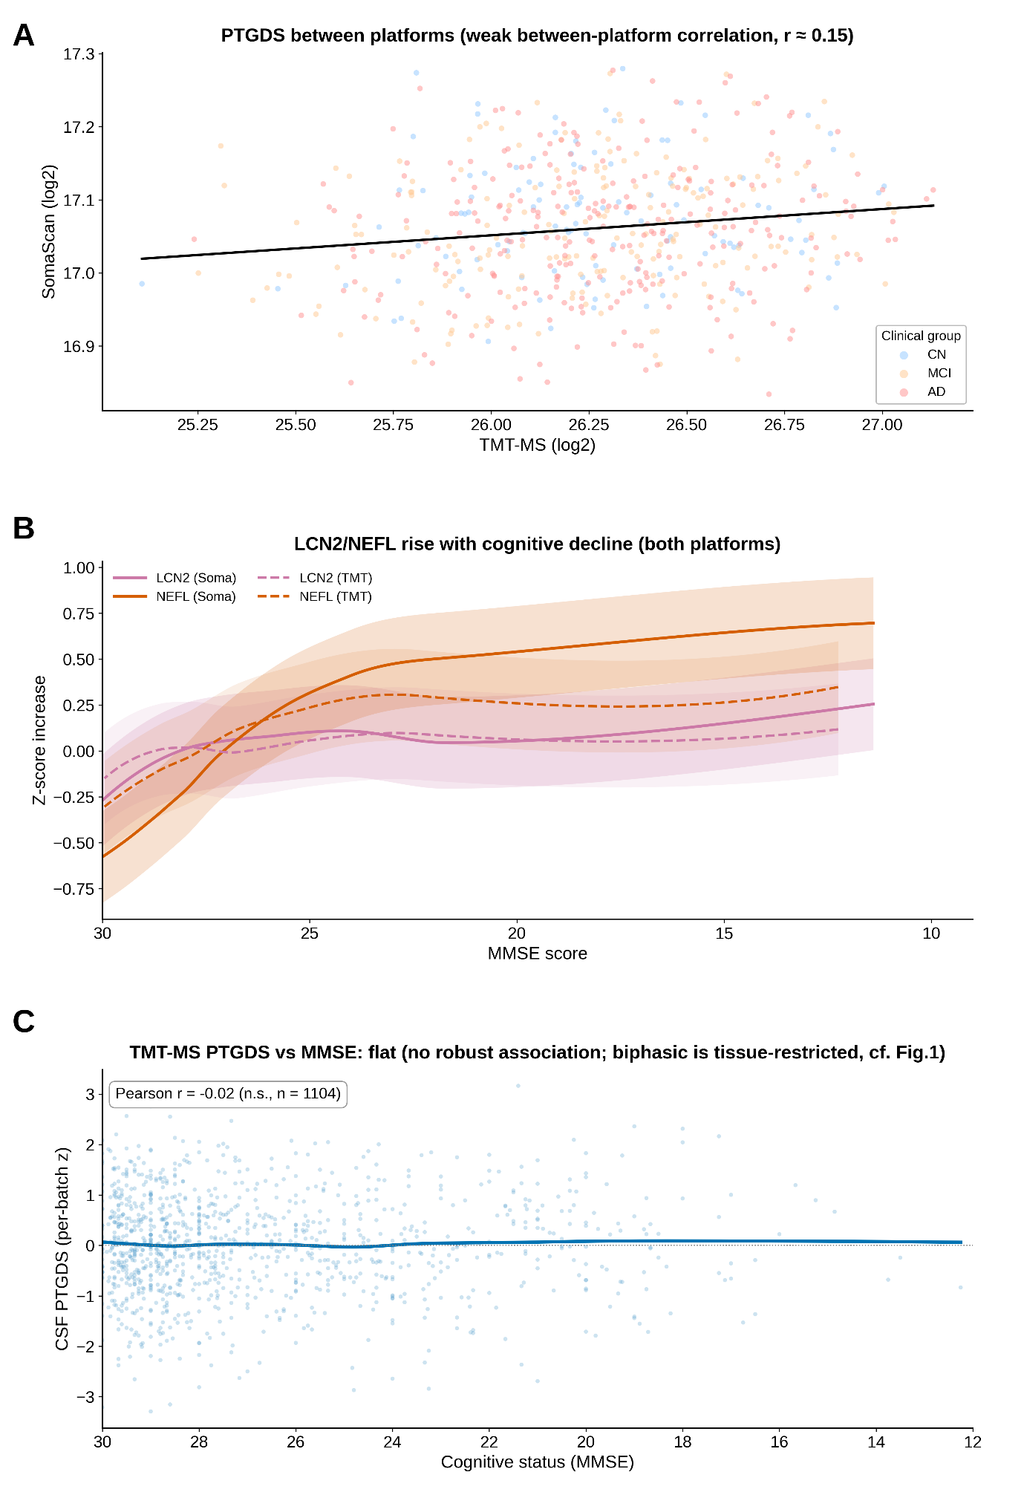
Cross-platform comparison of CSF biomarkers (ADNI; TMT-MS and SomaScan). A. Platform-level comparison (PTGDS). At the individual-sample level, CSF PTGDS shows only weak correlation between TMT-MS and SomaScan (Pearson r ≈ 0.15, n = 580; below the threshold for cross-platform concordance); the panel reflects population-level distribution only, and upstream PTGDS is therefore considered tissue-restricted (cf. Fig. 1). B. CSF LCN2 and NEFL increase with progression on both platforms; NEFL is the strongest positive control (vs pathology axis r = +0.48 [TMT], clearing the |r| > 0.3 threshold; +0.24 [SomaScan], sub-threshold). C. Cognitive-decline inflection. CSF NEFL rises strongly with cognitive decline (the strongest CSF signal; r = −0.35), though a discrete breakpoint is not sharply localized; CSF PTGDS does not show a robust biphasic peak, consistent with the biphasic signal being restricted to brain tissue.

Supplementary Fig. S8
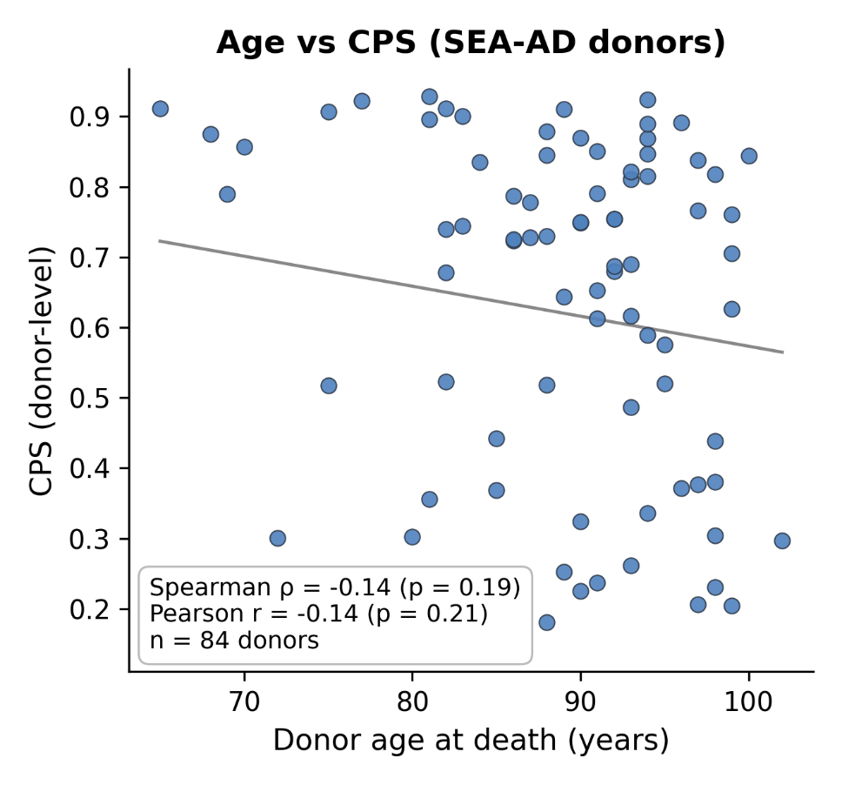
Donor age at death is not correlated with pseudo-progression (CPS) in SEA-AD. Donor-level scatter of chronological age at death versus CPS across all 84 SEA-AD donors (median age 90 years, range 65–102; ages uncensored). Spearman ρ = −0.14 (p = 0.19); Pearson r = −0.14 (p = 0.21). The weak, non-significant association confirms that CPS indexes neuropathological disease progression rather than chronological age; the astrocytic PTGDS inflection (CPS 0.47) therefore reflects disease-stage dynamics within a uniformly aged cohort rather than an age-driven change.
Supplementary Table S1. Quality control metrics and bin-to-Braak stage mapping
A. Bin-resolved cell type counts across pseudo-progression
CPS Bin | Astrocyte | Exc. Neuron | SST+ Neuron | Microglia | Subtotal (4 types) | Total (all cells) | Approx. Braak Stage
0.1 | 428 | 8,434 | 1,068 | 851 | 10,781 | 15,939 | ~I–II
0.2 | 4,787 | 70,700 | 6,195 | 3,462 | 85,144 | 132,173 | ~I–II
0.3 | 7,299 | 67,516 | 5,673 | 3,425 | 83,913 | 126,683 | ~I–II
0.4 | 5,360 | 69,473 | 5,816 | 3,130 | 83,779 | 125,139 | ~III–IV
0.5 | 4,691 | 48,108 | 2,981 | 3,203 | 58,983 | 89,488 | ~III–IV
0.6 | 5,326 | 58,576 | 3,434 | 3,016 | 70,352 | 103,978 | ~III–IV
0.7 | 11,656 | 113,320 | 7,922 | 6,823 | 139,721 | 211,778 | ~V–VI
0.8 | 14,108 | 139,850 | 8,563 | 8,804 | 171,325 | 257,308 | ~V–VI
0.9 | 13,764 | 95,712 | 5,557 | 6,191 | 121,224 | 178,422 | ~V–VI
Note: Cell counts represent nuclei passing quality control from the SEA-AD middle temporal gyrus snRNA-seq atlas (84 donors). Exc. Neuron = all excitatory neuron subclasses (L2/3 IT, L5 ET, L6 CT, L6b, NP). SST+ Neuron = somatostatin-positive inhibitory interneurons. Subtotal includes the four analyzed cell types; Total includes all cell types in the atlas (oligodendrocytes, OPCs, endothelial, etc.). The tilde (~) prefix denotes approximate correspondence; Braak stage mapping is heuristic and does not imply direct pathological equivalence.
B. Quality control criteria
Parameter | Criterion / Value
Minimum genes per nucleus | ≥ 500
Maximum mitochondrial read fraction | < 20%
Doublet removal method | Scrublet-based (Wolock et al., 2019)
Atlas version | SEA-AD MTG snRNA-seq (2024-02-13)
Brain region | Middle temporal gyrus (MTG)
Total donors | 84
Total nuclei (post-QC) | 1,240,908
C. CPS-to-Braak stage mapping with aggregated cell counts
Braak Stage (approx.) | CPS Bins | Total Cells | Astrocyte | Exc. Neuron | SST+ Neuron | Microglia
~I–II (Preclinical) | 0.1–0.3 | 274,795 | 12,514 | 146,650 | 12,936 | 7,738
~III–IV (Prodromal MCI) | 0.4–0.6 | 318,605 | 15,377 | 176,157 | 12,231 | 9,349
~V–VI (Dementia) | 0.7–0.9 | 647,508 | 39,528 | 348,882 | 22,042 | 21,818
Total | — | 1,240,908 | 67,419 | 671,689 | 47,209 | 38,905
Note: CPS-to-Braak mapping is an approximate heuristic alignment for interpretive purposes: CPS 0.1–0.3 corresponds approximately to Braak stages I–II (preclinical to early symptomatic), CPS 0.4–0.6 to Braak III–IV (prodromal MCI spectrum), and CPS 0.7–0.9 to Braak V–VI (dementia). This mapping does not imply direct pathological equivalence, as CPS is derived from transcriptomic pseudo-progression rather than neuropathological staging. The tilde (~) prefix is used throughout to emphasize the approximate nature of this correspondence.

Supplementary Table S2. Antibody & Primer Resources
Resources used for immunofluorescence staining and quantitative RT-PCR (qRT-PCR) in zebrafish and murine experiments.
A. qRT-PCR Primer Sequences — Zebrafish (Danio rerio)
Gene | Symbol | Dir. | Sequence (5'→3') | Tm (°C) | bp | Role / Panel
ptgdsb.1 | ptgdsb.1 | F | AATGACAATGACATGCGCGT | 63 | 154 | Fig. 2F — astrocytic PTGDS (compensatory induction)
 |  | R | ACTGCCTGAACTTCTCCTTCA
ptgdsb.2 | ptgdsb.2 | F | GCCACATTTGACAAGTACGC | 63 | 127 | Fig. 2F — PTGDS paralogue
 |  | R | ACTGCCTGAACTTCTCCTTCA
ngfr | ngfr | F | TGTGTGCAGTGTCCTCCAG | 64 | 125 | Fig. 2F/H — Neurogenic marker
 |  | R | ACCTGGCATTTGTCTGTGTG
bdnf | bdnf | F | AGGAGTTGCTTGAGGTGGAA | 64 | 121 | Fig. 2F — Neurotrophic support
 |  | R | GAGGCATACAGGTCAACGTC
gfap | gfap | F | CGGCTGGAGATTGAGAGAGA | 60 | 108 | Reactive gliosis marker
 |  | R | GGTGTTGAGGTTATTTTCTGCCTC
tnf-α | tnfa | F | AGGAACAAGTGCTTATGAGCCATGC | 60 | 157 | Fig. 2G — Pro-inflammatory
 |  | R | AAATGGAAGGCAGCGCCGAG
il-1β | il1b | F | AGTAACCTGTACCTGGCCTGCAGC | 61 | 159 | Fig. 4C — Pro-inflammatory
 |  | R | GGTGTTTATGGAGCTGCCGGTCTC
il-6 | il6 | F | AAGGGGTCAGGATCAGCAC | 61 | 95 | Fig. 2G — Pro-inflammatory
 |  | R | GCTGTAGATTCGCGTTAGACATC
cox2 (ptgs2a) | ptgs2a | F | AACTAGGATTCCAAGACGCAGCATC | 60 | 207 | Fig. 3 — Network pharmacology hub
 |  | R | AAATAAGAATGATGGCCGGAAGG
creb | creb | F | GCACCACCATCCTGCAGTAT | 64 | 116 | Fig. 2F — Synaptic plasticity
 |  | R | AGTGCGGATCTGATAAGCCTG
dlg4 (psd-95) | dlg4 | F | TGTCAGTCTGCAGGTGATGA | 64 | 151 | Fig. 2F — Synaptic integrity
 |  | R | GTGTGAGAGCTCTACCTGCC
nestin | nes | F | AGCCAGCGTCAGGTACAG | 60 | 247 | Fig. 2C/D — Neural progenitor
 |  | R | TGTATGTTGCCACCTCCAGT
rplp0 | rplp0 | F | CTGAACATCTCGCCCTTCTC | 60 | 161 | Reference gene
 |  | R | TAGCCGATCTGCAGACACAC
Note: Zebrafish (Danio rerio) primers designed by Primer3; verified by NCBI Primer-BLAST. qRT-PCR: CFX96 Touch (Bio-Rad). Conditions: 95°C 3 min; 40 cycles of 95°C 10 s + Tm 30 s + 72°C 20 s. Relative expression normalized to rplp0 (2⁻ΔΔCt). Tissue collected at 14 dpf and 21 dpf.
B. Antibodies for Whole-Mount Immunofluorescence (WIF) — Zebrafish
Target | Description | Host | Supplier | Cat. No. | Dilution | Application / Panel
Primary Antibodies
GFAP | Anti-GFAP [ZRF-1] — Astrocyte Marker | Mouse | Abcam | ab154474 | 1:200 | Reactive gliosis; WIF (Fig. 2C)
NGFR (p75NTR) | Anti-p75NTR Neurotrophin Receptor Antibody | Rabbit | Merck | 07-476 | 1:100 | Neurogenic marker; WIF (Fig. 2D)
BLBP (FABP7) | Anti-BLBP antibody | Rabbit | Abcam | ab32423 | 1:200 | Astrocyte progenitor; WIF (Fig. 2C)
Nestin | Anti-Nestin antibody, clone 10C2 | Mouse | Merck | MAB5326 | 1:200 | Neural progenitor; WIF (Fig. 2D)
Secondary Antibodies
Anti-Rabbit IgG (TRITC) | Goat Anti-Rabbit IgG H&L (TRITC) | Goat | Abcam | ab6718 | 1:500 | 2° for Rabbit 1° (BLBP, NGFR) → Red channel
Anti-Mouse IgG (AF488) | Goat Anti-Mouse IgG H&L (Alexa Fluor® 488) | Goat | Abcam | ab150113 | 1:500 | 2° for Mouse 1° (GFAP, Nestin) → Green channel
Note: WIF performed on 14 dpf larvae fixed in 4% PFA (overnight, 4°C). Blocking: 5% normal goat serum + 0.3% Triton X-100 in PBS (1 h, RT). Primary Ab: 48 h at 4°C; Secondary Ab: 2 h at RT, protected from light. Imaging: confocal microscope; fluorescence intensity quantified by ImageJ fixed ROI analysis. n = 10 larvae/group. IACUC: KW-241104-1; ZEFIT-IACUC-26010601-0001.
C. qRT-PCR Primer Sequences — Murine (Mus musculus, Aβ1–42 Mouse Model, Fig. 4)
Gene (Human) | Mouse Gene | Dir. | Sequence (5'→3') | Tm (°C) | Role / Panel
LCN2 | Lcn2 | F | 5'-GGG AGA ACC AAG GAG CTG AC-3' | 57 | Inflammatory amplifier — Fig. 4C
 |  | R | 5'-CAG GGA GGC CCA GAG ATT TG-3'
Keap1 | Keap1 | F | 5'-ATC TTC GAG GAG CTC ACC CT-3' | 57 | Oxidative stress / Nrf2 regulator — Fig. 4F
 |  | R | 5'-ATA CAG TTG TGC AGG ACG CA-3'
NGFR | Ngfr | F | 5'-TAT TGC TCC ATC CTG GCT GC-3' | 57 | Trophic / neurogenic marker — Fig. 4E
 |  | R | 5'-GAG TCT ATG TGC TCG GGC TG-3'
BDNF | Bdnf | F | 5'-TTT GGT TGC ATG AAG GCT GC-3' | 57 | Neurotrophic support — Fig. 4E
 |  | R | 5'-GCC GAA CTT TCT GGT CCT CA-3'
APOE | Apoe | F | 5'-CGT TGC TGG TCA CAT TCC TG-3' | 57 | Lipid transport — Fig. 4F
 |  | R | 5'-AAT CCC AAA AGC GAC CCA GT-3'
ABCA1 | Abca1 | F | 5'-GCT GGT GTG GAC CCT TAC TC-3' | 57 | Lipid efflux transporter — Fig. 4F
 |  | R | 5'-GCA GCT TCA TAT GGC AGC AC-3'
IL-6 | Il6 | F | 5'-GAG GAT ACC ACT CCC AAC AGA CC-3' | 57 | Pro-inflammatory cytokine — Fig. 4C
 |  | R | 5'-AAG TGC ATC ATC GTT GTT CAT ACA-3'
IL-1β | Il1b | F | 5'-ACC TGC TGG TGT GTG ACG TT-3' | 57 | Pro-inflammatory cytokine — Fig. 4C
 |  | R | 5'-TCG TTG CTT GGT TCT CCT TG-3'
TNF-α | Tnf | F | 5'-AGC ACA GAA AGC ATG ATC CG-3' | 57 | Pro-inflammatory cytokine — Fig. 4C
 |  | R | 5'-CTG ATG AGA GGG AGG CCA TT-3'
β-actin | Actb | F | 5'-ATC ACT ATT GGC AAC GAG CG-3' | 57 | Reference gene
 |  | R | 5'-TCA GCA ATG CCT GGG TAC AT-3'
Note: Mouse primers for Mus musculus (ICR, male, 5 weeks). RNA extracted from hippocampal tissue using TRIzol (Invitrogen). cDNA synthesis: All-in-One First-Strand cDNA Synthesis SuperMix (TransGen Biotech). RT-qPCR: QuantStudio 3 (Applied Biosystems) with PowerSYBR® Green PCR Master Mix (Thermo Fisher). Cycling: 95°C 15 s → 57°C 20 s → 72°C 40 s, 40 cycles. Relative expression normalized to β-actin (Actb) by 2⁻ΔΔCt method.

Supplementary Table S3. Summary of Behavioral Test Results in Aβ-injected Mouse Model
Experimental Group | n | Y-maze Alternation (%) | p vs Sham | p vs Aβ | PAT Retention Latency (s) | p vs Sham | p vs Aβ
Sham (Control) | 10 | 67.4 ± 3.16 | — | — | 189.0 ± 30.62 | — | —
Aβ (20 μM) | 9† | 53.3 ± 4.37 | * | — | 67.9 ± 19.36 | *** | —
Aβ + BXP-101 (50 mg/kg) | 10 | 57.7 ± 2.19 | ns | ns | 168.7 ± 32.28 | ns | **
Aβ + BXP-101 (100 mg/kg) | 10 | 61.3 ± 2.52 | ns | ns | 155.2 ± 37.26 | ns | *
Aβ + BXP-101 (200 mg/kg) | 10 | 64.6 ± 3.44 | ns | ns | 181.9 ± 36.54 | ns | ***
Aβ + BXP-101 (400 mg/kg) | 10 | 66.1 ± 2.08 | ns | * | 221.0 ± 22.05 | ns | ***
Aβ + Donepezil (5 mg/kg) | 10 | 66.7 ± 2.79 | ns | * | 180.9 ± 29.92 | ns | ***
Note: Values are presented as Mean ± SEM. Y-maze Alternation (%): Measures spatial working memory based on the percentage of spontaneous alternations in a Y-shaped maze (One-Way ANOVA, Newman-Keuls post hoc). PAT (Passive Avoidance Test) Retention Latency: Measures long-term associative memory based on the time (seconds) to enter a dark compartment where an electric shock was previously delivered (Two-Way ANOVA, Bonferroni post hoc). †Aβ group: n = 9 (1 animal excluded as outlier); all other groups n = 10. Aβ: Amyloid-beta 1–42 (20 μM) intracerebroventricularly (i.c.v.) injected to induce AD-like cognitive impairment. BXP-101: A standardized multi-herbal extract administered orally for 4 weeks. Donepezil (DNZ): Used as a positive reference control. *p < 0.05, **p < 0.01, ***p < 0.001; ns, not significant.

Supplementary Table S4. Bin-resolved cell-type-specific expression trajectories across the CPS continuum
1. Astrocyte Trajectories
CPS Bin | n cells | NDUFS1 | PTGDS | LCN2 | APOE | TREM2 | C3 | NFKBIA | CLU | GFAP
0.1 | 428 | 0.5792 | 1.6531 | 0.0000 | 0.8090 | 0.0002 | 0.1987 | 0.1790 | 2.1115 | 1.8767
0.2 | 4,787 | 0.5742 | 1.7275 | 0.0000 | 0.8364 | 0.0003 | 0.1594 | 0.1606 | 2.1245 | 1.6573
0.3 | 7,299 | 0.5610 | 1.8725 | 0.0000 | 0.9853 | 0.0006 | 0.1346 | 0.1541 | 2.2025 | 1.6725
0.4 | 5,360 | 0.5486 | 1.8805 | 0.0001 | 0.9480 | 0.0006 | 0.1203 | 0.1539 | 2.1821 | 1.8061
0.5 | 4,691 | 0.5566 | 1.9290 | 0.0001 | 0.9986 | 0.0005 | 0.1190 | 0.1697 | 2.1813 | 1.8907
0.6 | 5,326 | 0.5739 | 1.8941 | 0.0001 | 0.9354 | 0.0006 | 0.1067 | 0.1694 | 2.1526 | 1.7501
0.7 | 11,656 | 0.5864 | 1.8430 | 0.0000 | 0.9255 | 0.0007 | 0.0961 | 0.1698 | 2.1600 | 1.4806
0.8 | 14,108 | 0.5791 | 1.6735 | 0.0001 | 0.8009 | 0.0009 | 0.1179 | 0.1823 | 2.1836 | 1.6310
0.9 | 13,764 | 0.5769 | 1.6310 | 0.0001 | 0.7428 | 0.0009 | 0.1171 | 0.1805 | 2.2026 | 1.7018

2. Neuronal Trajectories (Excitatory & SST)
CPS Bin | Cell Type | n cells | NDUFS1 | PTGDS | NGFR | APOE | BDNF | SLC22A17
0.1 | Exc_Neuron | 8,434 | 0.7817 | 0.0810 | 0.0026 | 0.0287 | 0.2929 | 0.4751
0.5 | Exc_Neuron | 48,108 | 0.6952 | 0.0848 | 0.0005 | 0.0218 | 0.1053 | 0.4347
0.9 | Exc_Neuron | 95,712 | 0.7061 | 0.0910 | 0.0007 | 0.0269 | 0.0754 | 0.4197
0.1 | SST_Neuron | 1,068 | 0.6704 | 0.0818 | 0.0004 | 0.0381 | 0.0100 | 0.4084
0.5 | SST_Neuron | 2,981 | 0.5580 | 0.1067 | 0.0003 | 0.0328 | 0.0051 | 0.4349
0.9 | SST_Neuron | 5,557 | 0.5356 | 0.1115 | 0.0005 | 0.0344 | 0.0031 | 0.3955

3. Microglia Trajectories
CPS Bin | n cells | APOE | TREM2 | C3 | NFKBIA | GPX4 | FTH1
0.1 | 851 | 1.1820 | 0.2363 | 1.1598 | 0.1571 | 0.1750 | 1.8107
0.5 | 3,203 | 1.1277 | 0.2599 | 1.6931 | 0.2454 | 0.2025 | 1.1718
0.9 | 6,191 | 1.2186 | 0.2309 | 1.5007 | 0.3141 | 0.2150 | 0.8985
Note: Expression values represent 3-bin moving average (MA) of log-normalized expression from the SEA-AD atlas. Cell types: Astrocyte, Exc_Neuron (excitatory neurons), SST_Neuron (somatostatin-positive inhibitory interneurons), Microglia. LCN2 detection rate in astrocytes was 0.007% (5/67,419); values near zero should be interpreted cautiously. Raw (unsmoothed) per-bin peak for PTGDS = 2.02 at Bin 0.5.

Supplementary Table S5. Spearman correlations of apoptotic, identity, and reactive markers with CPS in astrocytes
Marker | Category | Spearman Rho | p-value | n
CASP3 | Apoptotic | −0.229 | 0.036 | 84
BAX | Apoptotic | −0.130 | 0.236 | 84
BCL2 | Apoptotic | +0.299 | 0.006 | 84
SLC1A2 | Identity | −0.020 | 0.857 | 84
AQP4 | Identity | −0.213 | 0.052 | 84
GFAP | Reactive | +0.105 | 0.343 | 84
Note: Spearman correlations in this table are computed at the donor level (n = 84 donors); a prior cell-level computation (n = 67,419 nuclei) inflated significance and is superseded. At the superseded cell level, apoptotic markers (CASP3, BAX) showed negligible correlations with CPS (|ρ| < 0.03), indicating that PTGDS decline reflects functional state reprogramming rather than astrocyte population loss. Identity markers (SLC1A2, AQP4) showed small negative correlations (|ρ| < 0.08), consistent with preserved but modestly declining astrocyte identity. Reactive markers (GFAP, NFKBIA) showed modest positive correlations, consistent with phenotypic transition toward reactive gliosis. At the donor level, anti-apoptotic BCL2 increases (ρ = +0.30, p = 0.006; the only marker surviving multiple-testing correction), pro-apoptotic CASP3/BAX do not increase, AQP4 shows a marginal decline (ρ = −0.21, p = 0.05), and GFAP is not significant (ρ = +0.10, n.s.); NFKBIA is characterized at the module/trajectory level (Table S5).

Supplementary Table S6. Lagged cross-correlation analysis across the full CPS trajectory (Bins 0.1–0.9)
Interaction Pair | Lag (Bins) | r-value | p-value | n_eff
Purinergic → PTGDS | −3 | −0.7250 | 0.2755 | 4
NF-κB → PTGDS | −1 | −0.7060 | 0.1167 | 6
PTGDS → PPARG | −2 | 0.5570 | 0.3298 | 5
C3 → NGFR | 0 | −0.9340 | 0.0021 | 7
NDUFS1 → PTGDS | −3 | 0.7440 | 0.2563 | 4
Note: Lagged cross-correlations on 3-bin moving-average trajectories across the full CPS range (Bins 0.1–0.9, n = 9 bins, lag.max = 3). Negative lag denotes a descriptive temporal offset only; with limited effective sample size after lagging (n_eff = 3–7) and moving-average-induced autocorrelation, lead–lag ordering cannot establish causal direction and p-values are exploratory. Apparent associations (e.g., C3–NGFR r = −0.934) are reported as hypotheses consistent with complement-mediated neurotoxicity and metabolic-crisis coupling. Astrocytic LCN2 pairs were excluded because LCN2 was detected in only 0.007% of astrocytes (5/67,419); the LCN2 arm is instead supported by CSF/qPCR. For inflection-window analysis (Bins 0.4–0.8), see Table 3 in main text.

Supplementary Table S7. Neuronal subtype-specific expression and vulnerability across CPS bins
CPS Bin | Subtype | n cells | NDUFS1 (mean) | NDUFS1 (var) | NGFR (mean) | BCL2 (mean) | BAX (mean) | CASP3 (mean) | BAX/BCL2 | SST % | Exc %
0.1 | Exc | 8,434 | 0.8316 | 0.1579 | 0.0048 | 0.7583 | 0.0372 | 0.0898 | 0.0491 | 11.24 | 88.76
0.2 | Exc | 70,700 | 0.7317 | 0.1283 | 0.0005 | 0.8158 | 0.0439 | 0.1058 | 0.0538 | 8.06 | 91.94
0.3 | Exc | 67,516 | 0.7438 | 0.1294 | 0.0006 | 0.7523 | 0.0369 | 0.1077 | 0.0490 | 7.75 | 92.25
0.4 | Exc | 69,473 | 0.7101 | 0.1280 | 0.0006 | 0.7765 | 0.0490 | 0.1029 | 0.0631 | 7.72 | 92.28
0.5 | Exc | 48,108 | 0.6860 | 0.1182 | 0.0006 | 0.7375 | 0.0356 | 0.1021 | 0.0483 | 5.83 | 94.17
0.6 | Exc | 58,576 | 0.6896 | 0.1342 | 0.0005 | 0.7533 | 0.0334 | 0.0981 | 0.0443 | 5.54 | 94.46
0.7 | Exc | 113,320 | 0.7269 | 0.1333 | 0.0008 | 0.7632 | 0.0385 | 0.1051 | 0.0505 | 6.53 | 93.47
0.8 | Exc | 139,850 | 0.7151 | 0.1464 | 0.0007 | 0.7621 | 0.0333 | 0.1017 | 0.0438 | 5.77 | 94.23
0.9 | Exc | 95,712 | 0.6971 | 0.1626 | 0.0007 | 0.6547 | 0.0304 | 0.1036 | 0.0465 | 5.49 | 94.51
0.1 | SST | 1,068 | 0.7418 | 0.1899 | 0.0003 | 0.6426 | 0.0231 | 0.1267 | 0.0360 | 11.24 | 88.76
0.2 | SST | 6,195 | 0.5990 | 0.2533 | 0.0006 | 0.6205 | 0.0313 | 0.1148 | 0.0504 | 8.06 | 91.94
0.3 | SST | 5,673 | 0.6105 | 0.2525 | 0.0005 | 0.5520 | 0.0265 | 0.1236 | 0.0480 | 7.75 | 92.25
0.4 | SST | 5,816 | 0.5823 | 0.2346 | 0.0001 | 0.5992 | 0.0344 | 0.1159 | 0.0575 | 7.72 | 92.28
0.5 | SST | 2,981 | 0.5489 | 0.2610 | 0.0005 | 0.4967 | 0.0269 | 0.1029 | 0.0541 | 5.83 | 94.17
0.6 | SST | 3,434 | 0.5428 | 0.2555 | 0.0004 | 0.5790 | 0.0242 | 0.1200 | 0.0418 | 5.54 | 94.46
0.7 | SST | 7,922 | 0.5687 | 0.2480 | 0.0005 | 0.5621 | 0.0243 | 0.1145 | 0.0432 | 6.53 | 93.47
0.8 | SST | 8,563 | 0.5571 | 0.2627 | 0.0005 | 0.5527 | 0.0236 | 0.1132 | 0.0428 | 5.77 | 94.23
0.9 | SST | 5,557 | 0.5142 | 0.2567 | 0.0005 | 0.5942 | 0.0215 | 0.1172 | 0.0362 | 5.49 | 94.51
Note: Neuronal subtype-specific expression across CPS bins from the SEA-AD atlas. Excitatory = all excitatory neuron subclasses (L2/3 IT, L5 ET, L6 CT, L6b, NP). SST = somatostatin-positive inhibitory interneurons. SST interneurons declined from 11.24% (Bin 0.1, n = 1,068) to 5.49% (Bin 0.9, n = 5,557), representing a 51.2% proportional reduction (as a fraction of excitatory + SST neurons; donor-level Spearman ρ = −0.32, p = 0.003). SST neurons exhibited higher NDUFS1 variance (0.19–0.26) compared to excitatory neurons (0.12–0.16), indicating increased metabolic heterogeneity. BAX/BCL2 ratio = BAX mean / (BCL2 mean + 1e-10) per bin, indexing apoptotic vulnerability.

Supplementary Table S8. ADNI participant demographics
Characteristic | CN (n=172) | EMCI (n=183) | LMCI (n=234) | AD (n=146) | p-value
Age (years) | 74.5 ± 5.9 | 71.1 ± 7.3 | 73.2 ± 7.6 | 75.2 ± 8.5 | 0.002
Female (%) | 46.5 | 42.6 | 42.3 | 41.8 | 0.42
Education (years) | 16.3 ± 2.7 | 15.8 ± 2.7 | 16.0 ± 3.0 | 15.4 ± 2.9 | 0.03
APOE ε4 carriers (%) | 25.0 | 45.4 | 58.1 | 69.2 | < 0.001
MMSE | 29.0 ± 1.1 | 28.2 ± 1.6 | 26.8 ± 1.7 | 23.6 ± 2.0 | < 0.001
Note: Data presented as mean ± SD or percentage. p-values from ANOVA (continuous) or Chi-square test (categorical). CN = cognitively normal; EMCI = early MCI; LMCI = late MCI; AD = Alzheimer’s disease. MMSE, Mini-Mental State Examination. APOE ε4 carrier status defined as at least one ε4 allele. CSF Aβ42 and p-Tau181 values used as covariates in ROC/Cox analyses were measured by Roche Elecsys immunoassay (UPENNBIOMK dataset).

Supplementary Table S9. Independent brain bulk proteomic validation of PTGDS and the M25 metabolism module (Johnson et al., 2022; ROSMAP and Banner cohorts)
A. Individual-protein differential abundance (ROSMAP DLPFC, n = 84 control + 148 AsymAD + 108 AD; Banner DLPFC, n = 26 control + 58 AsymAD + 92 AD; combined n = 488; 8,619 proteins by TMT-MS)
Protein | log₂(AD) − log₂(Ctrl) | log₂(AsymAD) − log₂(Ctrl) | log₂(AD) − log₂(AsymAD) | ANOVA F | ANOVA P | Holm-adj P (AD vs Ctrl) | WGCNA module (kME)
PTGDS | +0.090 | +0.040 | +0.051 | 5.752 | 3.40 × 10⁻³ | 2.64 × 10⁻³ | M25 Sugar Metabolism (0.42)
LCN2 | +0.093 | +0.020 | +0.073 | 1.479 | 0.230 | 0.290 | M41 Ambiguous (0.72)
Note: PTGDS shows significant elevation in AD (Holm-corrected p = 2.6 × 10⁻³ across all 8,619 proteins). The pairwise Tukey contrast AsymAD vs Control did not reach significance (Holm-adj p = 0.17), whereas AD vs AsymAD was significant (Holm-adj p = 0.046), indicating progressive accumulation in symptomatic stages. LCN2 shows directionally concordant elevation with comparable effect size but markedly larger between-case variance (lower F statistic), consistent with the inducible NF-κB-regulated kinetics expected for an inflammatory amplifier and the secreted-protein detection limits inherent to bulk-tissue MS. All values extracted from Johnson et al. (2022), Supplementary Table 2 (sheet '2.Master.PD.cleanDat.Stat.kME').

B. M25 Sugar Metabolism module synthetic eigenprotein across cohorts and brain regions
Cohort / Brain region | Region annotation | ANOVA F | ANOVA P | Tukey P (AD vs Ctrl) | Avg diff log₂(AD) − log₂(Ctrl)
Mt. Sinai BB BA-36 | Parahippocampal gyrus (temporal lobe) | 1.957 | 0.145 | 0.192 | +0.026
ROSMAP BA-6 | Frontal cortex | 2.667 | 0.074 | 0.067 | +0.011
ROSMAP BA-37 | Inferior temporal cortex | 5.612 | 4.80 × 10⁻³ | 3.18 × 10⁻³ | +0.017
Emory BA-9 | DLPFC (AD/PD design) | 1.854 | 0.171 | 0.272 | +0.095
Emory BA-24 | Anterior cingulate gyrus | 5.759 | 6.65 × 10⁻³ | 7.79 × 10⁻³ | +0.178
Note: Module-level upregulation in AD vs Control is significant (Tukey p < 0.01) in two of five tested regions: ROSMAP inferior temporal cortex (BA-37) and Emory anterior cingulate (BA-24). The strongest temporal-lobe signal occurs in BA-37, the region anatomically corresponding to the SEA-AD middle temporal gyrus atlas used for trajectory inference (Fig. 1). Values extracted from Johnson et al. (2022), Supplementary Table 17 (sheet '17.ANOVA.SynthEigenprotein').

C. Top-ranking M25 Sugar Metabolism module members by intramodular connectivity (kME); 20 of 104 members shown
Symbol | kME | log₂(AD) − log₂(Ctrl) | Holm-adj P (AD vs Ctrl) | Functional annotation
DYNC1H1 | 0.724 | +0.0007 | 0.922 | Cytoplasmic dynein 1 heavy chain
RUFY3 | 0.687 | +0.0120 | 0.299 | RUN/FYVE domain protein
AHCY | 0.683 | +0.0206 | 0.041 | Adenosylhomocysteinase (SAM cycle)
GRHPR | 0.682 | +0.0708 | 2.26 × 10⁻¹² | Glyoxylate/hydroxypyruvate reductase
ACTR1A | 0.681 | +0.0086 | 0.519 | Alpha-centractin
DCTN1 | 0.671 | +0.0040 | 0.481 | Dynactin subunit 1
PGD | 0.669 | +0.0537 | 4.32 × 10⁻⁹ | 6-phosphogluconate dehydrogenase (pentose phosphate)
TRIM2 | 0.662 | +0.0223 | 0.020 | Tripartite motif protein
NUDT5 | 0.661 | +0.0482 | 1.45 × 10⁻⁴ | ADP-sugar pyrophosphatase
GGPS1 | 0.658 | +0.0250 | 0.058 | Geranylgeranyl pyrophosphate synthase (isoprenoid)
ACSS2 | 0.655 | +0.0419 | 2.26 × 10⁻³ | Acetyl-CoA synthetase, cytoplasmic
GARS | 0.644 | +0.0160 | 0.162 | Glycyl-tRNA synthetase
UBA6 | 0.642 | +0.0192 | 0.043 | Ubiquitin-activating enzyme 6
GDI2 | 0.636 | +0.0145 | 0.336 | Rab GDP dissociation inhibitor beta
TXNL1 | 0.635 | +0.0257 | 0.021 | Thioredoxin-like protein 1
DYNC1LI2 | 0.627 | +0.0251 | 4.44 × 10⁻³ | Cytoplasmic dynein light intermediate chain 2
GLRX3 | 0.615 | +0.0319 | 4.48 × 10⁻³ | Glutaredoxin-3
TARS | 0.615 | +0.0277 | 2.37 × 10⁻³ | Threonyl-tRNA synthetase
MAP2K2 | 0.608 | +0.0258 | 5.47 × 10⁻³ | MAP kinase kinase 2 (MEK2)
FASN | 0.578 | +0.0523 | 1.37 × 10⁻⁶ | Fatty acid synthase (lipid biosynthesis)
Note: PTGDS is rank 74 of 104 module members (kME = 0.4244). Module hubs include FASN (fatty acid synthesis), GGPS1 (isoprenoid biosynthesis), ACSS2 (acetyl-CoA metabolism), AHCY (SAM-cycle methylation supplying lipid biosynthesis), and PGD (pentose phosphate flux producing NADPH for lipogenesis), directly congruent with the lipid-metabolic exhaustion framework proposed in this study. Values extracted from Johnson et al. (2022), Supplementary Table 2.

