Supplementary Information (SI) for
Cellular context and ligand class shape CXCR4-CCR5 heteromerization in live cells
Mohamed Seghiri, Mojeed Ashiru, Chiako Farshadfar, Elizabeth Hair, Andres Ruiz, Ceyvion Wilkins, and Adam W. Smith*
Texas Tech University, Department of Chemistry & Biochemistry, Lubbock, TX USA
*To whom correspondence may be addressed: Email: aw.smith@ttu.edu

This SI file contains:

- Supplementary Figures 1-12
- Supplementary Tables 1-6
- Captions for Supplementary Movies 1-3

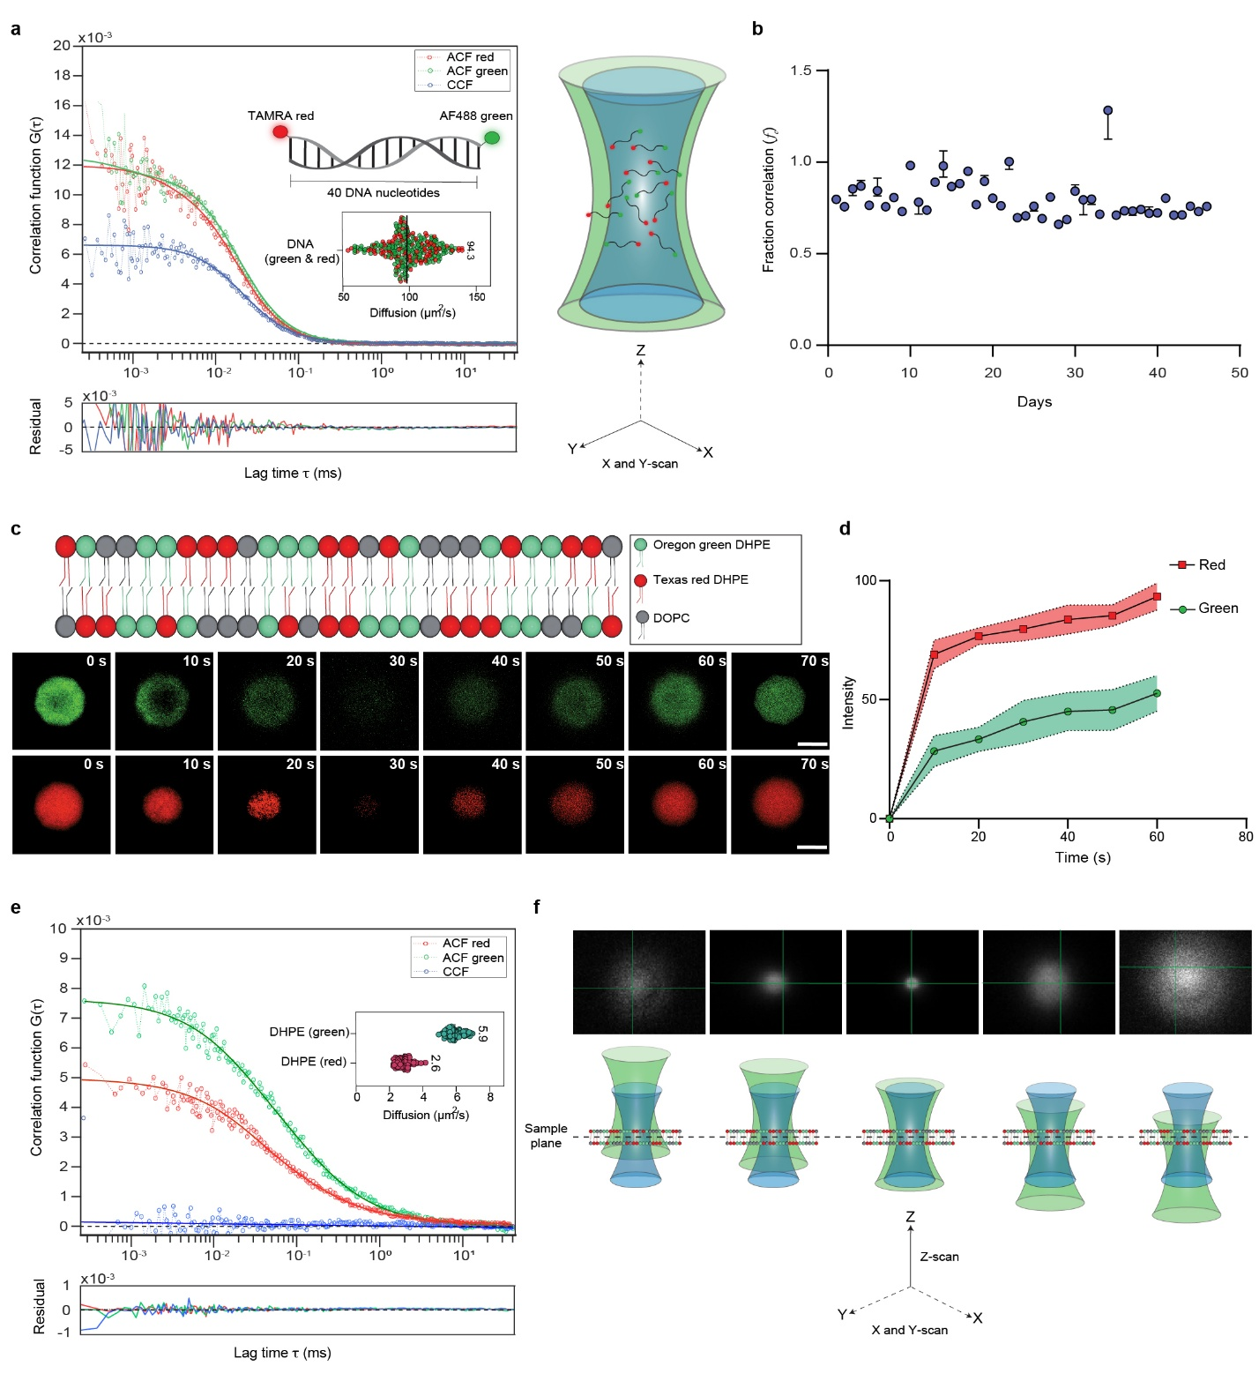
Supplementary Figure 1. Alignment and calibration of the observation volume. a, Left, representative PIE-FCCS trace for a 3D dual-labeled DNA standard showing red/green autocorrelation functions (ACF) and blue cross-correlation function (CCF); inset, fitted diffusion coefficient, D = 94 µm²/s. Right, schematic of dual-labeled DNA oligos diffusing in 3D through the point spread function (PSF), with diffraction-limited waist radii of 199.8 nm (488 nm excitation) and 229.7 nm (561 nm) used to align excitation and detection volumes in x-y axes. b, Day to day variability of f_{c} values after laser and volume alignment. c, Top, cartoon of a supported lipid bilayer (SLB; 99.97 mol% DOPC, 0.01 mol% Texas Red-DHPE, 0.02 mol% Oregon Green-DHPE). Bottom, FRAP time series for green and red lipids; the field diaphragm is set to define the bleach spot. d, FRAP recovery curve from the bleached ROI for both channels over time; intensities are background-subtracted and normalized to the post-bleach baseline. e, Example of PIE-FCCS measurement on a 2D SLB with red/green ACF and blue CCF; inset, fitted diffusion coefficients for Oregon Green- and Texas Red-DHPE (D_green = 5.9 µm²/s, D_red = 2.6 µm²/s). f, Verification of axial co-alignment (illustrated for the 561 nm path; the 488 nm beam was held fixed in z). Top, PSF intensity profiles of membrane dyes acquired while the 561 nm excitation/detection volumes were stepped axially. Bottom, schematic of a dual-labeled SLB with 488- and 561-nm excitation, depicting the overlap of axial excitation and emission volumes (z-scan shown only for 561 nm).

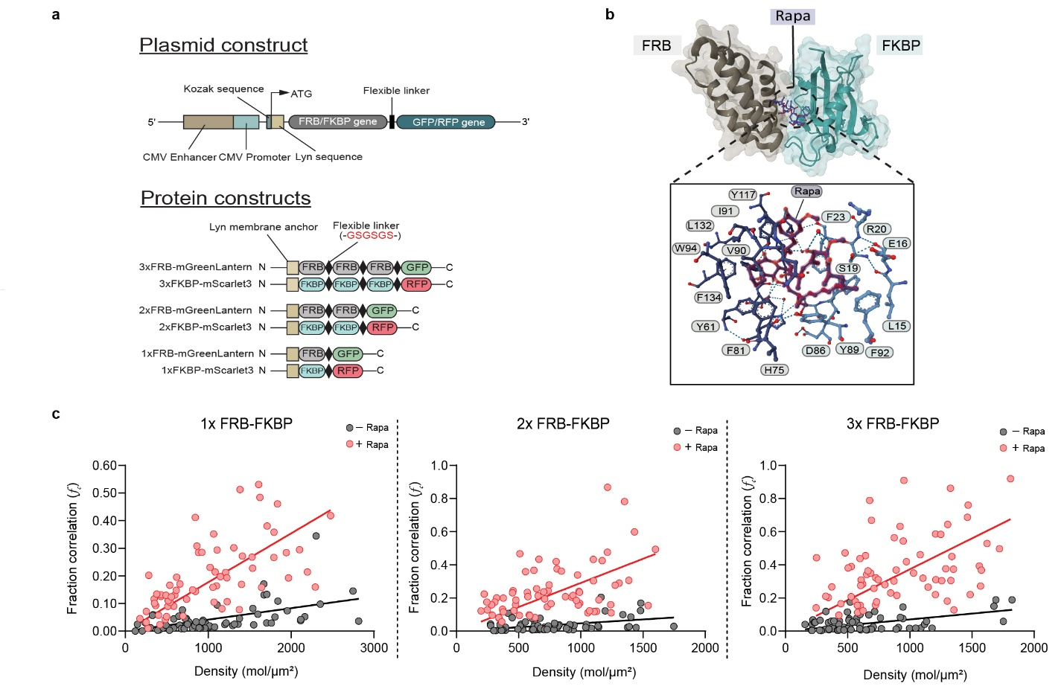

Supplementary Figure 2. FRB-FKBP design and density-dependent oligomerization controls. a, Schematic of the FRB-FKBP constructs showing plasmid maps (top) and the corresponding membrane-anchored protein constructs (bottom) with 1x, 2x, or 3x repeats fused to mGreenLantern (FRB) or mScarlet3 (FKBP). b, Ternary complex of FKBP-rapamycin-FRB (PDB: 2FAP). Inset highlights interface residues from FRB and FKBP that contact rapamycin. c, Fractional cross-correlation (f_{c}) for 1x/2x/3xFRB-FKBP constructs with and without rapamycin, plotted versus their surface molecular density in COS7 cells.

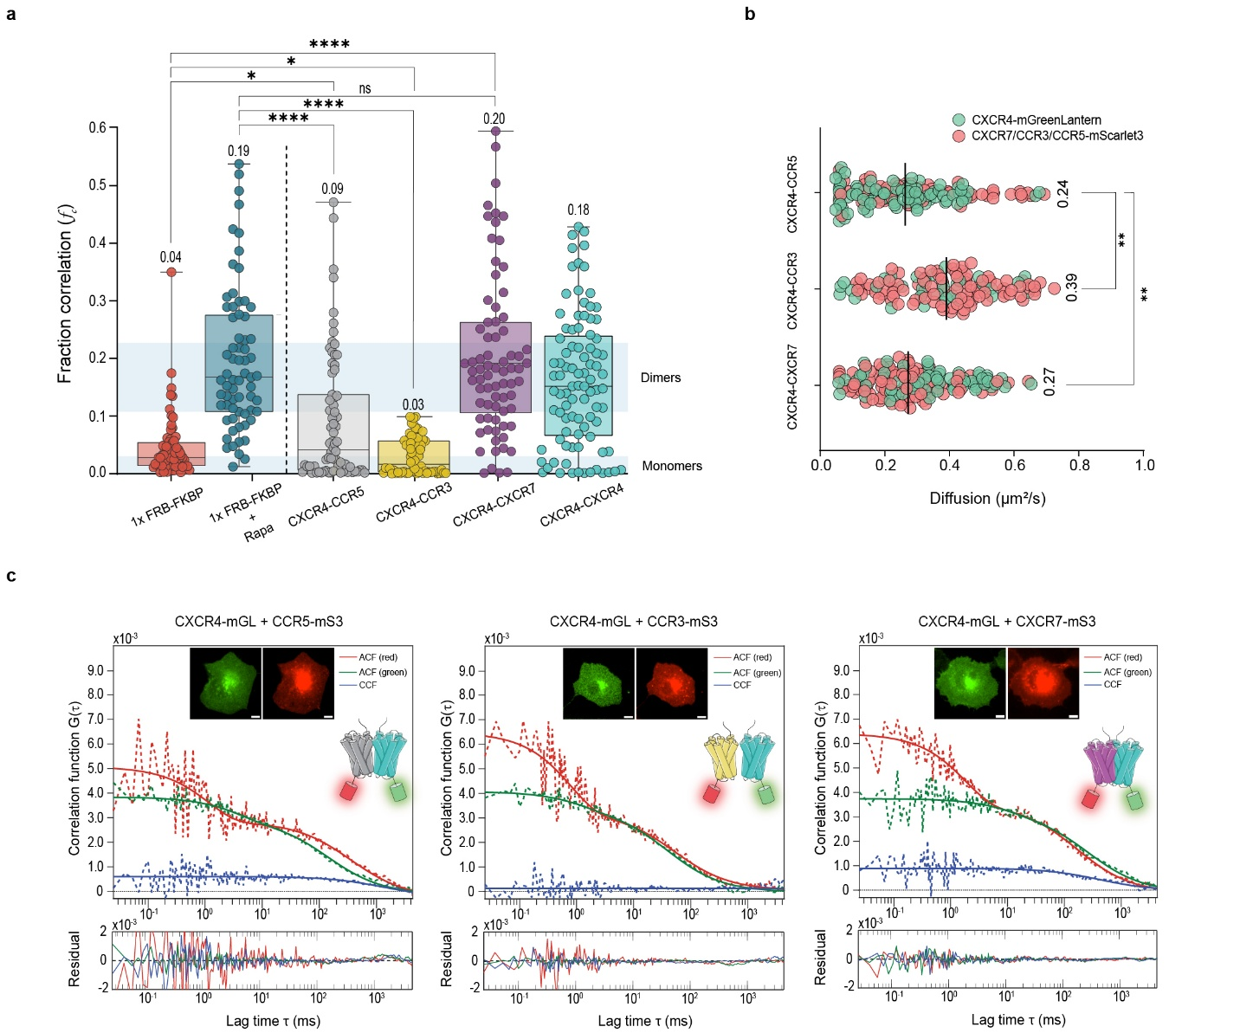

Supplementary Figure 3. Fraction correlation of CXCR4 co-expressed with either CXCR7, CCR3, or CCR5 in COS7 cells shows varying degrees of multimerization. a, Fractional cross-correlation (f_{c}) for CXCR4 co-expressed with CCR5, CCR3, or CXCR7 in COS7 cells, reporting the extent of multimerization. Box-and-whisker plots; boxes denote the 25th-75th percentiles, center lines the median, whiskers the range, and the value above each plot is the mean. b, Apparent diffusion coefficients for the same pairs in COS7 cells. Lines denote medians and numbers indicate means. c, Representative PIE-FCCS ACF/CCF traces (2D fits) from COS7 cells co-expressing CXCR4-mGL with CCR5-mS3, CCR3-mS3, or CXCR7-mGL. Fit residuals are shown below. Data was analyzed using Kruskal-Wallis tests, followed by Dunn’s multiple-comparisons correction;. Data pooled from three independent days; ~30-40 cells were analyzed per day per condition. Scale bars, 10 µm.
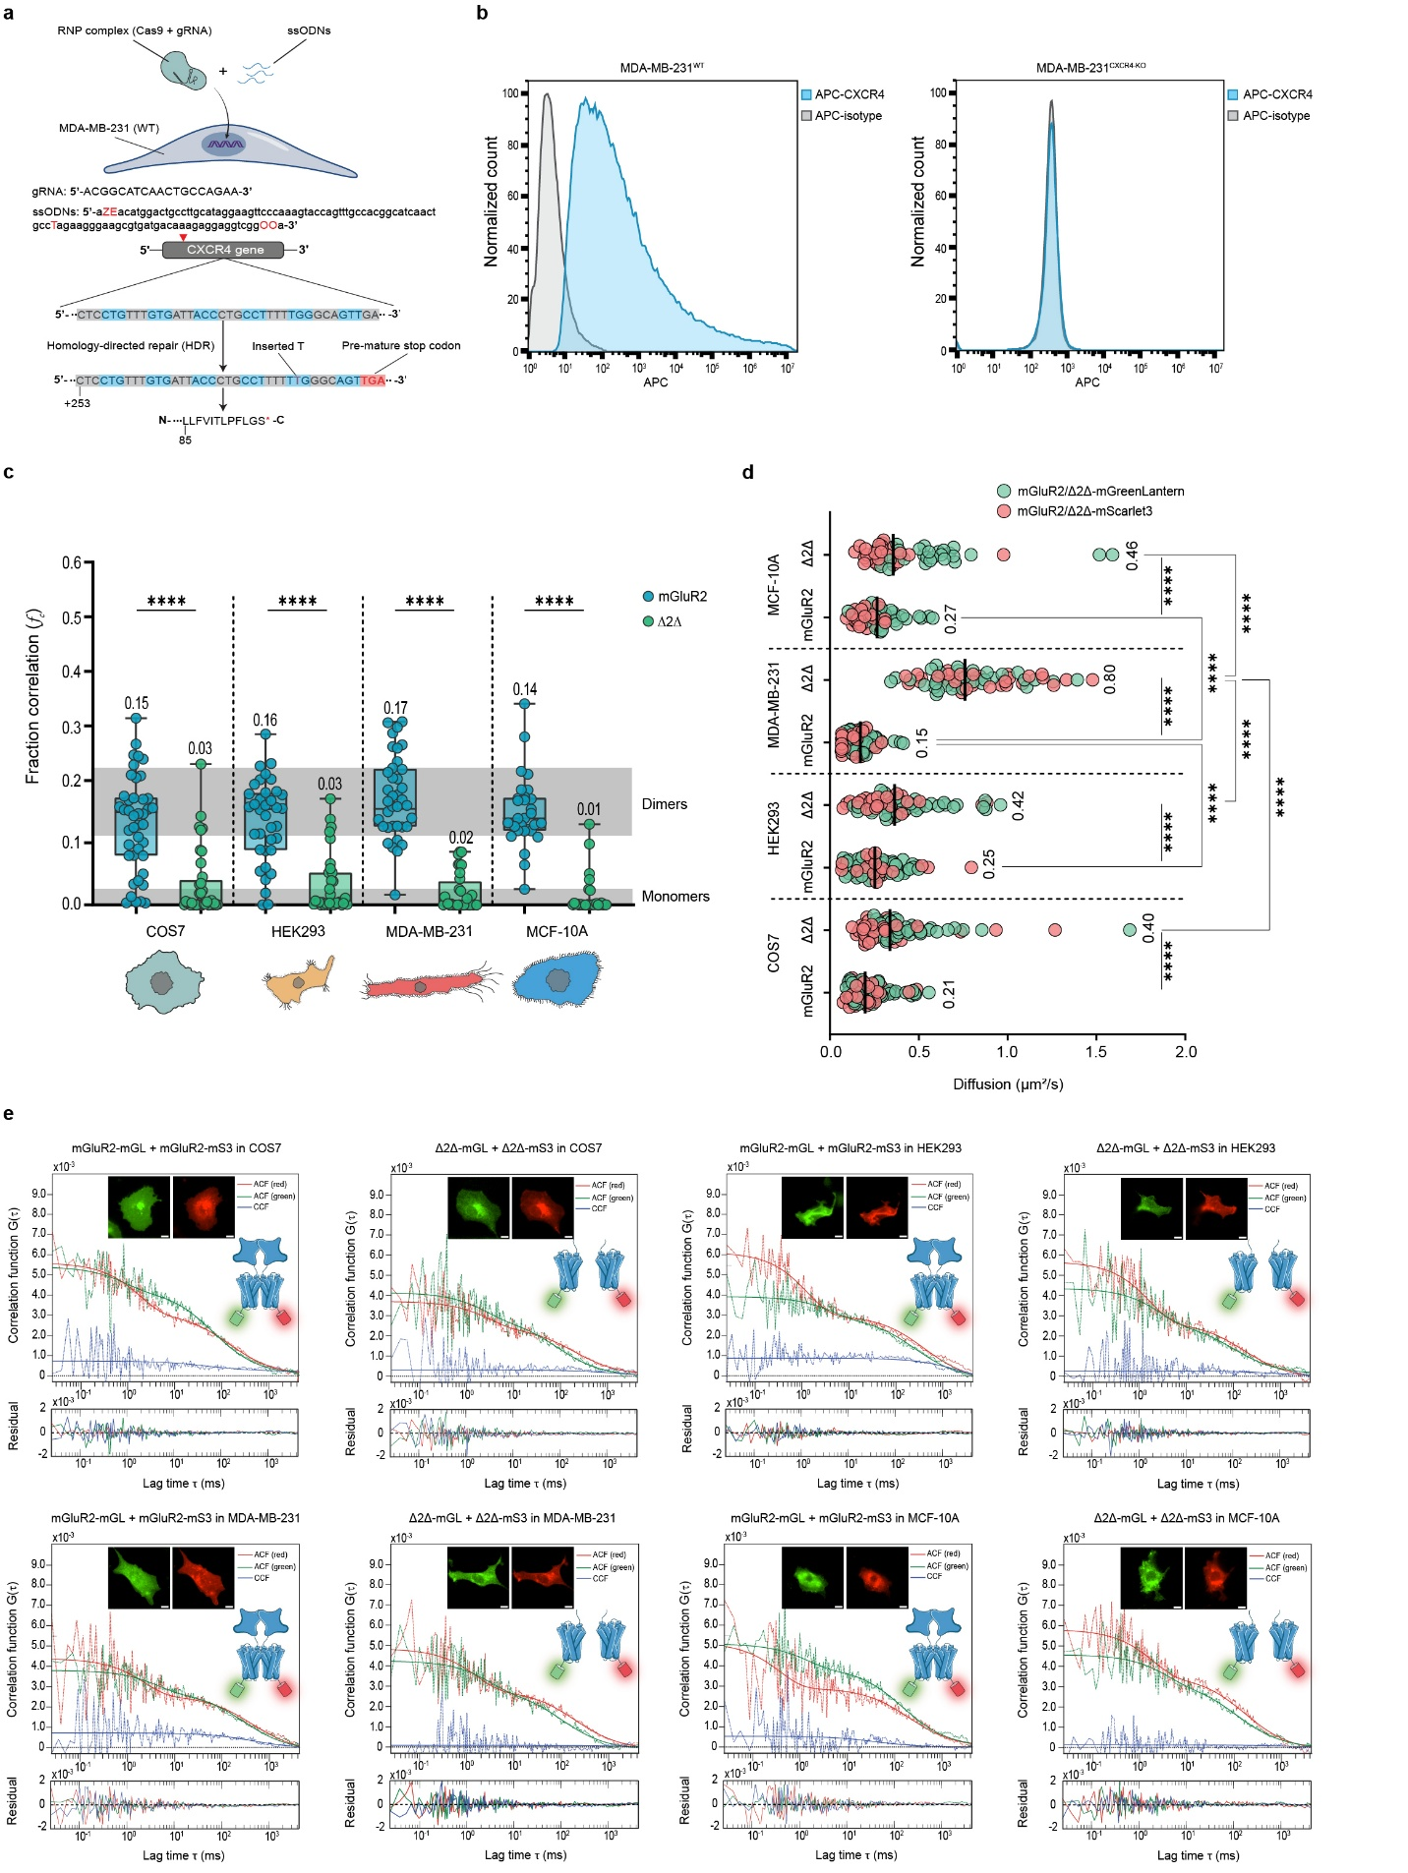

Supplementary Figure 4. CXCR4 knockout in MDA-MB-231 and PIE-FCCS control measurements. a, CXCR4 was disrupted in WT MDA-MB-231 cells using Cas9:gRNA ribonucleoprotein (RNP) and a pool of single-stranded oligodeoxynucleotide (ssODN) donors engineered to introduce an in-frame premature stop codon. b, Surface CXCR4 in WT and CXCR4-KO MDA-MB-231 was quantified by flow cytometry as the percentage of APC-positive cells after staining with APC-conjugated anti-human CXCR4 (5 µL of 100 µg/mL). Controls used APC-conjugated mouse IgG2a, k isotype (5 µL of 100 µg/mL). Unstained WT and KO cells were used for gating. c, Fractional cross-correlation (f_{c}) reporting oligomerization of the dimer control (mGluR2) and monomer control (Δ2Δ) in COS7, HEK293, MDA-MB-231 (CXCR4-KO), and MCF-10A. Box-and-whisker plots; boxes denote the 25th-75th percentiles, center lines the median, whiskers the range, and the value above each plot is the mean. d, Apparent diffusion coefficients for mGluR2 and Δ2Δ in the same cell panel. Lines denote medians and numbers indicate means. e, Representative PIE-FCCS ACF/CCF (2D fits) from COS7, HEK293, MDA-MB-231, and MCF-10A co-expressing mGluR2-mGL with mGluR2-mS3 or Δ2Δ-mGL with Δ2Δ-mS3. Residuals (bottom) indicate fit deviations. Data was analyzed using unpaired Student T-test between mGluR2 and Δ2Δ of the same cell. Across-cell-line comparisons were performed using Kruskal-Wallis tests, followed by Dunn’s multiple-comparisons correction; **** denote P < 0.0001. Data pooled from three independent days; ~30-40 cells were analyzed per day per condition. Scale bars, 10 µm.
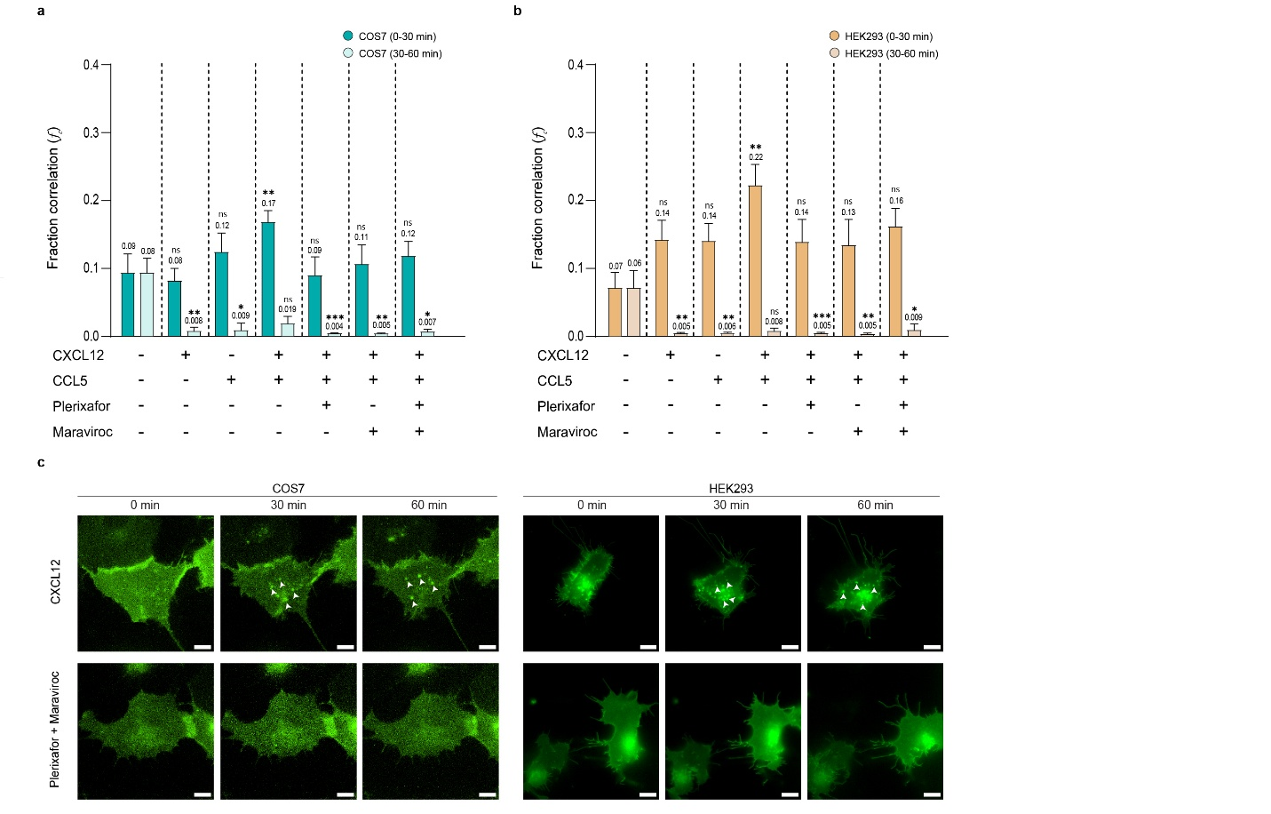
Supplementary Figure 5. Ligand- and time-dependent CXCR4-CCR5 heteromerization in COS7 and HEK293 cells. a,b, Fractional cross-correlation (f_{c}) between CXCR4-mGL and CCR5-mS3 quantified by PIE-FCCS in COS7 (a) and HEK293 (b) cells under the indicated ligand conditions at two post-treatment windows; 0-30 min (a) and 30-60 min (b). Across condition, COS7 and HEK293 exhibited low-amplitude, unstable f_{c} responses, consistent with weak or transient CXCR4-CCR5 co-diffusion . Agonists were added at 100 nM, and antagonists at 1000 nM. Bar plots show mean ± SEM; values above bars indicate means. Statistical significance was assessed with each cell line using Kruskal-Wallis tests with Dunn’s multiple-comparisons correction, comparing each post-treatment window (0-30 min and 30-60 min) to the corresponding basal condition. c, Representative time-lapse live-cell imaging of COS7 and HEK293 co-expressing CXCR4-mGL and CCR5-mS3 following CXCL12 or plerixafor+maraviroc treatment; images were acquired over 60 min (Supplementary Movie 2). Arrowheads mark intracellular puncta consistent with CXCR4 internalization.ns, not significant; *, P < 0.05; ** < 0.01; *** < 0.001; ****; P < 0.0001. Data pooled from three independent days; ~30-40 cells analyzed per condition per day. Scale bars, 10 µm.
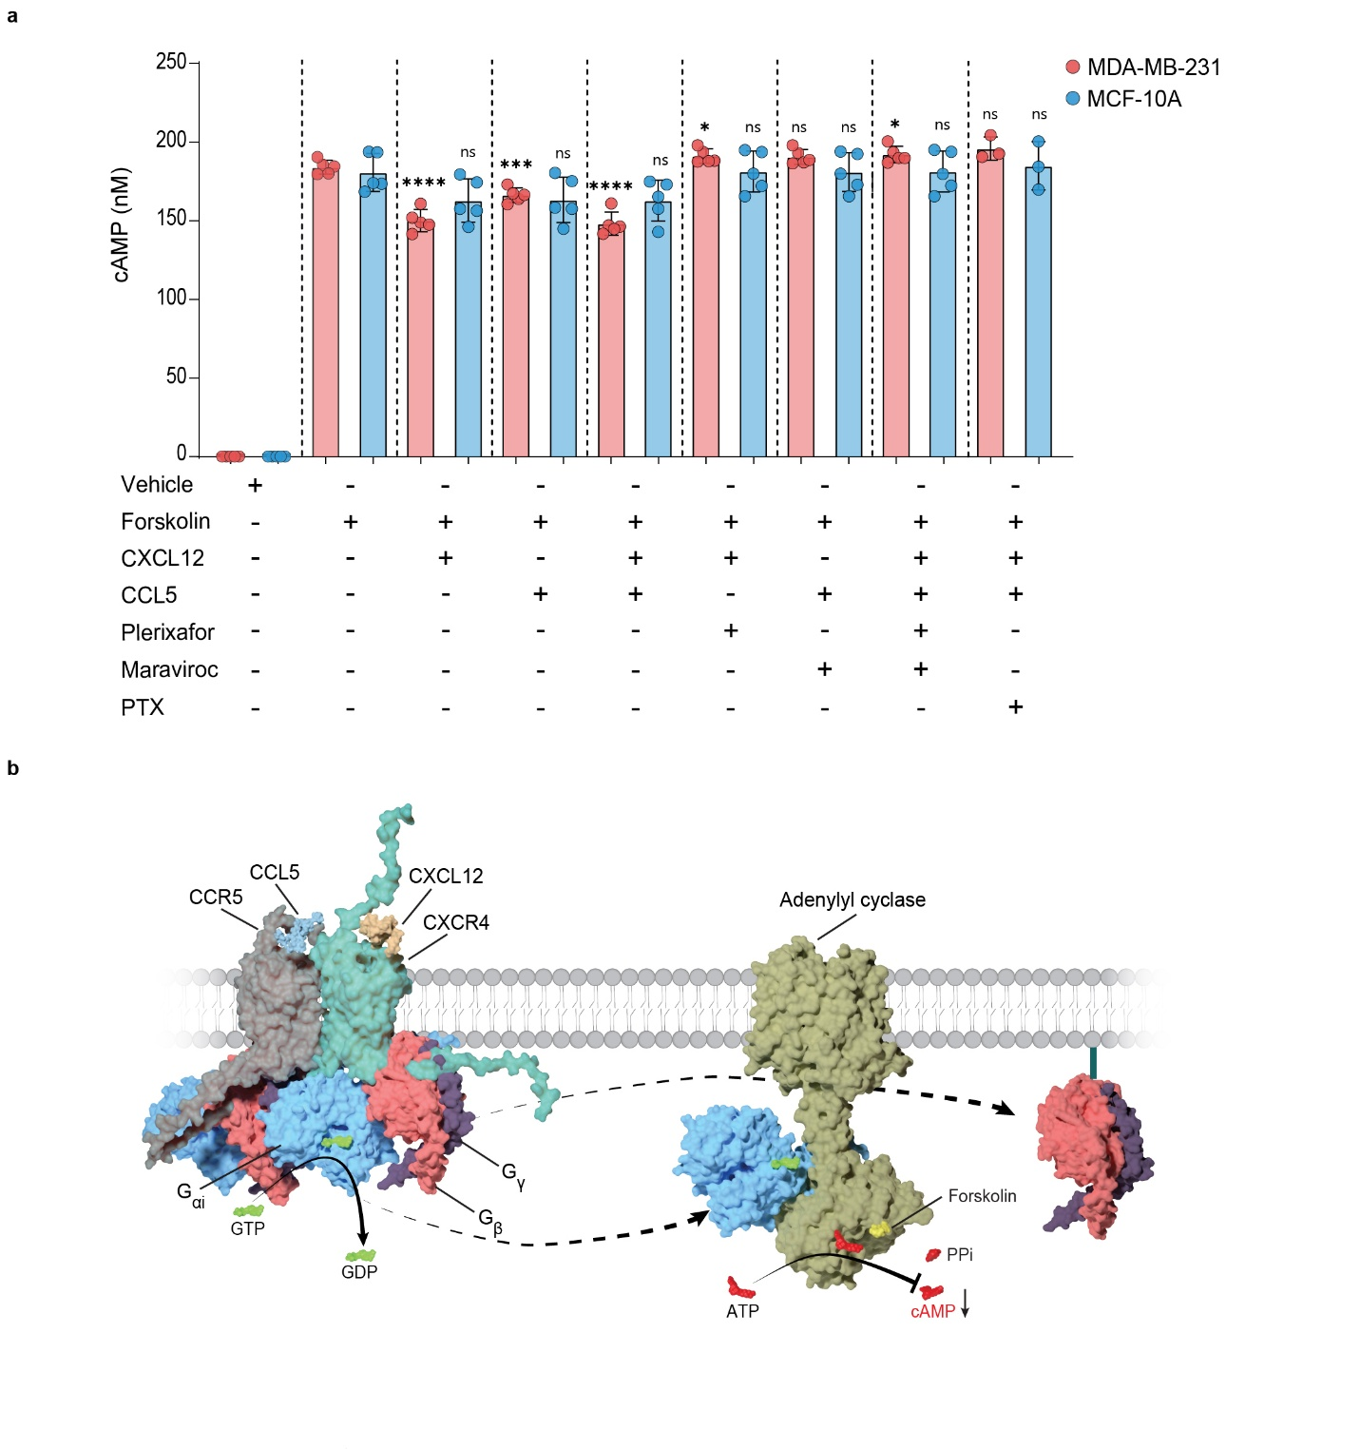
Supplementary Figure 6. CXCR4-CCR5 couples to Gαi to suppress forskolin-stimulated cAMP in a cell- and ligand-dependent manner. a, Intracellular cAMP levels in MDA-MB-231 and MCF-10A cells co-expressing CXCR4 and CCR5 measured by the cAMP-Glo assay after 15 min stimulation at 37 °C withthe indicated combinations of forskolin (10 µM), CXCL12 (100 nM), CCL5 (100 nM), plerixafor (1 µM), maraviroc (1 µM). Pertussis toxin (PTX; 0.95 nM) was applied 16-18 hours before ligand addition. Forskolin alone produced a robust increase in cAMP in both cell types, whereas co-application of CXCL12 and/or CCL5 reduced the forskolin response, consistent with Gαi-mediated inhibition of adenylyl cyclase. Antagonists (plerixafor, maraviroc, or both) largely restored cAMP toward forskolin-only levels, and PTX (Gαi inhibitor) abrogated the chemokine-induced suppression, confirming Gαi dependence. Bars show mean cAMP concentrations; individual points are biological replicates. Statistical significance versus the corresponding forskolin control was assessed by unpaired t-test as ****P < 0.0001, ***P < 0.001, *P < 0.05, and ns (not significant) P ≥ 0.05. b, Structural model illustrating CXCL12/CCL5 engagement of CXCR4-CCR5, activation of the heterotrimeric Gαiβγ complex (GTP loading of Gαi and release of Gβγ), and consequent inhibition of adenylyl cyclase activity that counteracts forskolin-driven cAMP production.
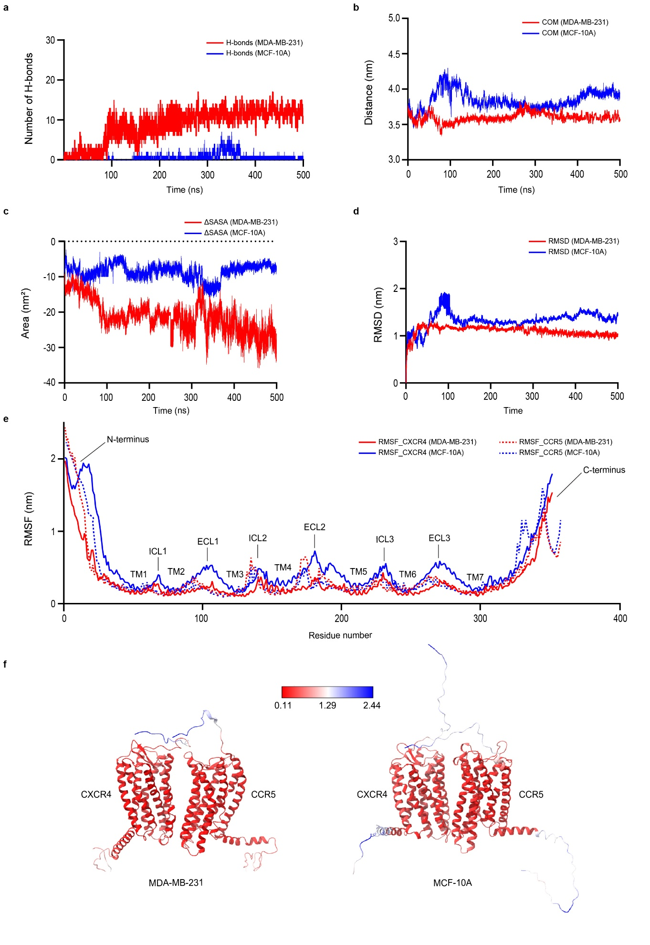
Supplementary Figure 7. Metrics from all-atom CXCR4-CCR5 dimer simulations in MDA-MB-231- and MCF-10A-like membranes. a, Number of inter-protomer hydrogen bonds as a function of time. b, Center-of-mass (COM) separation between CXCR4 and CCR5 over time. c, Time evolution of the change in solvent-accessible area (ΔSASA, nm²). d, Root mean square deviation (RMSD, nm) of the complex over time. e, Per-residue root mean square fluctuation (RMSF, nm) for CXCR4 and CCR5. f, CXCR4-CCR5 dimer cartoons color-coded by RMSF in each membrane system (high RMSF in blue, low RMSF in red).

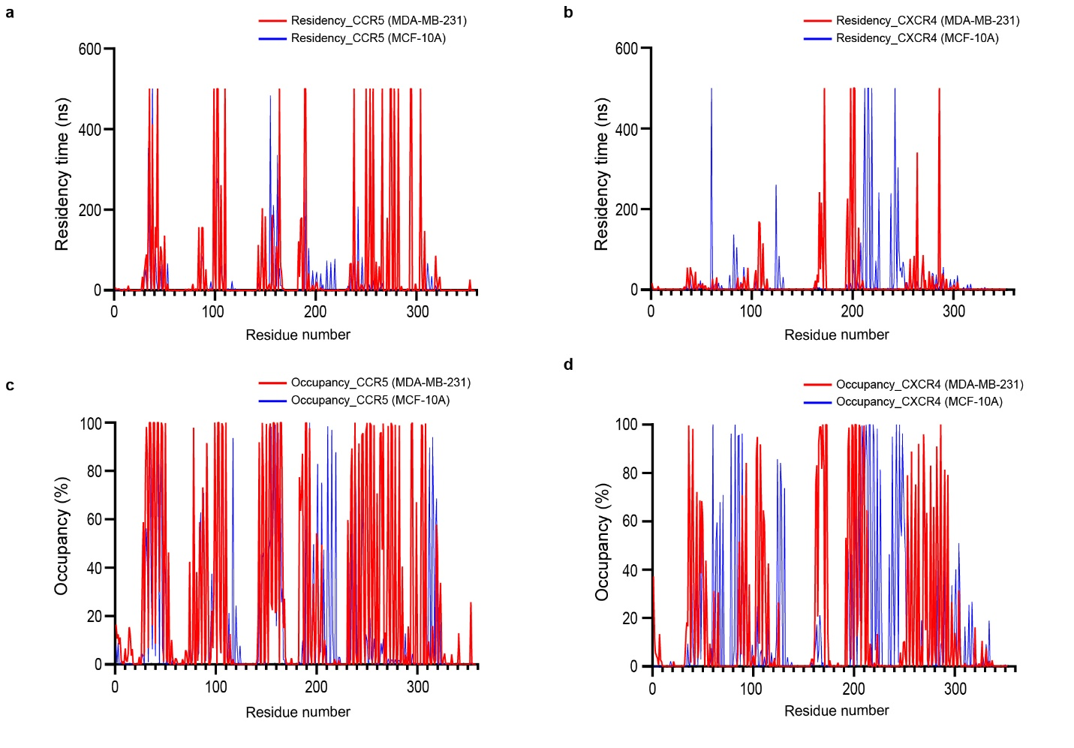

Supplementary Figure 8. PyLipID-derived cholesterol contact profiles from all-atom CXCR4-CCR5 simulations in MDA-MB-231- and MCF-10A-like membranes. a, Per-residue cholesterol residency time (ns) along the CCR5 sequence. b, Per-residue cholesterol residency time (ns) along the CXCR4 sequence. c, Cholesterol occupancy (%) for each CCR5 residue. d, Cholesterol occupancy (%) for each CXCR4 residue.
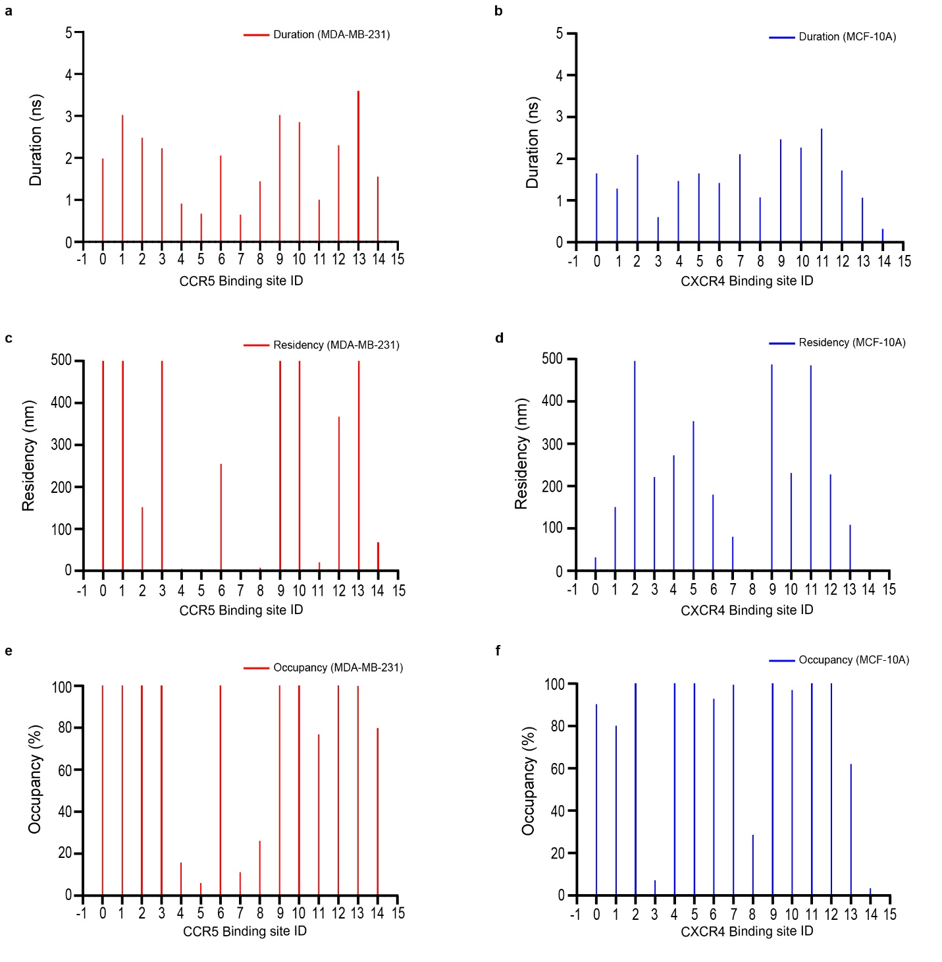

Supplementary Figure 9. PyLipID-derived cholesterol binding-site properties from all-atom CXCR4-CCR5 simulaitons in MDA-MB-231- and MCF-10A-like membranes. a, Mean binding duration (ns) of cholesterol at each CCR5 binding site. b, Mean binding duration (ns) of cholesterol at each CXCR4 binding site. c, Cholesterol residence time (ns) for each CCR5 binding site. d, Cholesterol residence time (ns) for each CXCR4 binding site. e, Cholesterol occupancy (%) at individual CCR5 binding sites. f, Cholesterol occupancy (%) at individual CXCR4 binding sites.
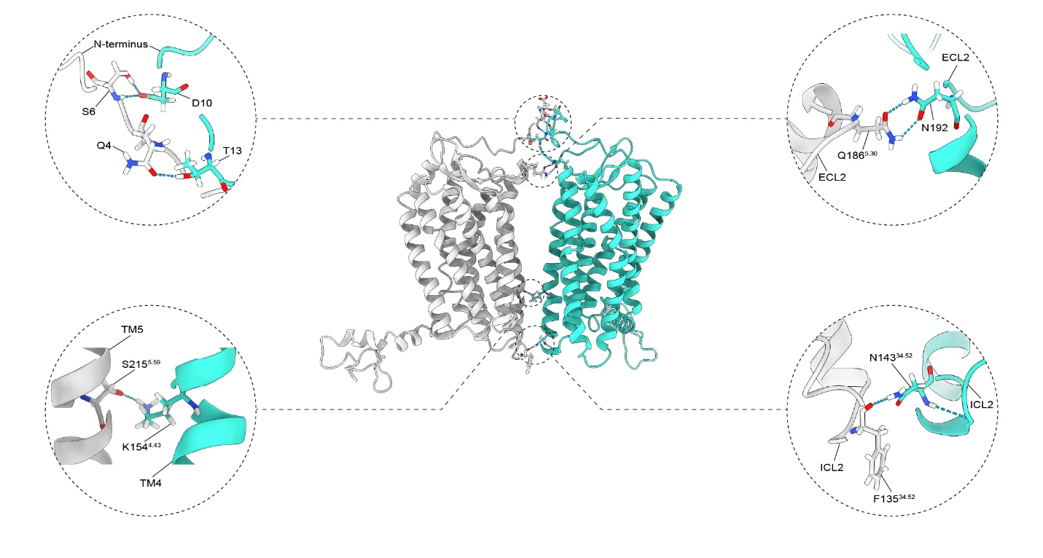

Supplementary Figure 10. Persistent hydrogen-bonding interactions at the CXCR4-CCR5 interface in high-cholesterol membranes. Representative structural model of the CXCR4-CCR5 heteromer highlighting persistent interfacial hydrogen bonds observed in cholesterol-rich membranes. CCR5 is shown in grey and CXCR4 in cyan. Insets show the major polar contacts spanning distinct regions of the interface. These persistent contacts further stabilize the heteromeric assembly in high-cholesterol membranes. Superscripts correspond to Ballesteros-Weinstein numbering.
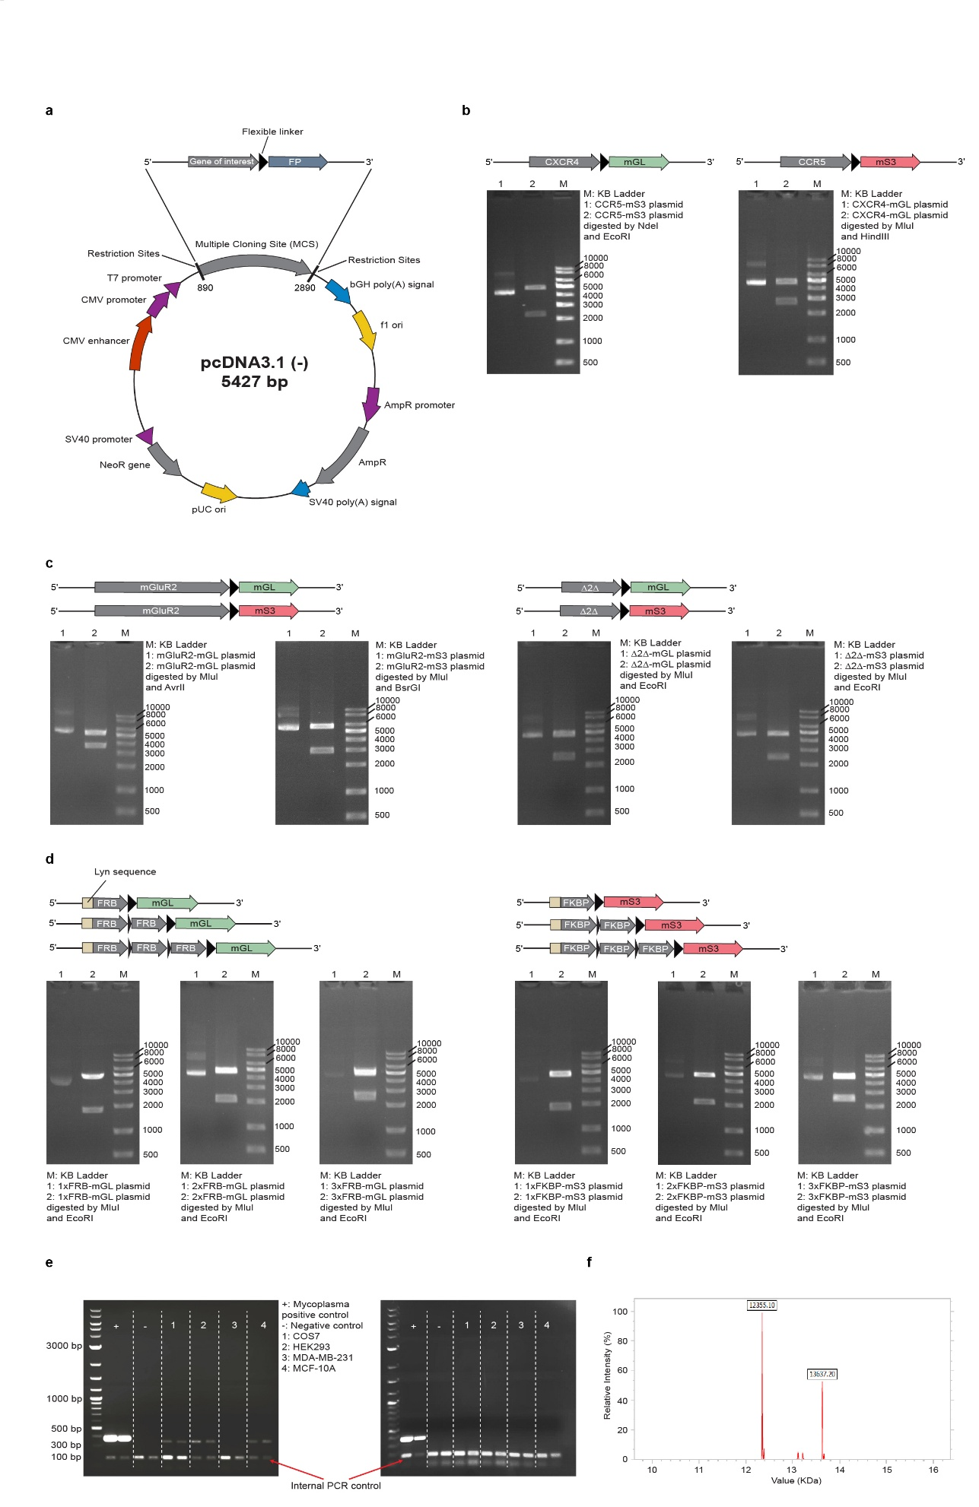
Supplementary Figure 11. Quality control (QC) of constructs, cell lines, and DNA standards. a, pcDNA3.1(-) plasmid backbone used for cloning all PIE-FCCS expression constructs. b-d, Restriction digest analysis of plasmid DNA for (b) CXCR4/CCR5, (c) mGluR2/Δ2Δ, and (d) FRB/FKBP constructs. For each digest, 200-1,000 ng of plasmid was incubated at 37 °C for 30-60 min and resolved on 1% agarose gels. e, Mycoplasma testing of COS7, HEK293, MDA-MB-231, and MCF-10A cells using a PCR-based assay; contaminated cultures (left gel) were treated with MycoAway, yielding mycoplasma-negative status (right gel). f, ESI-MS characterization of the dual-labeled single-stranded DNA standard, showing two peaks corresponding to 5’TAM-40nt-AF4883’ (13,637.20 Da) and its unlabeled complementary stranded 5’40nt3’ (12,355.10 Da).
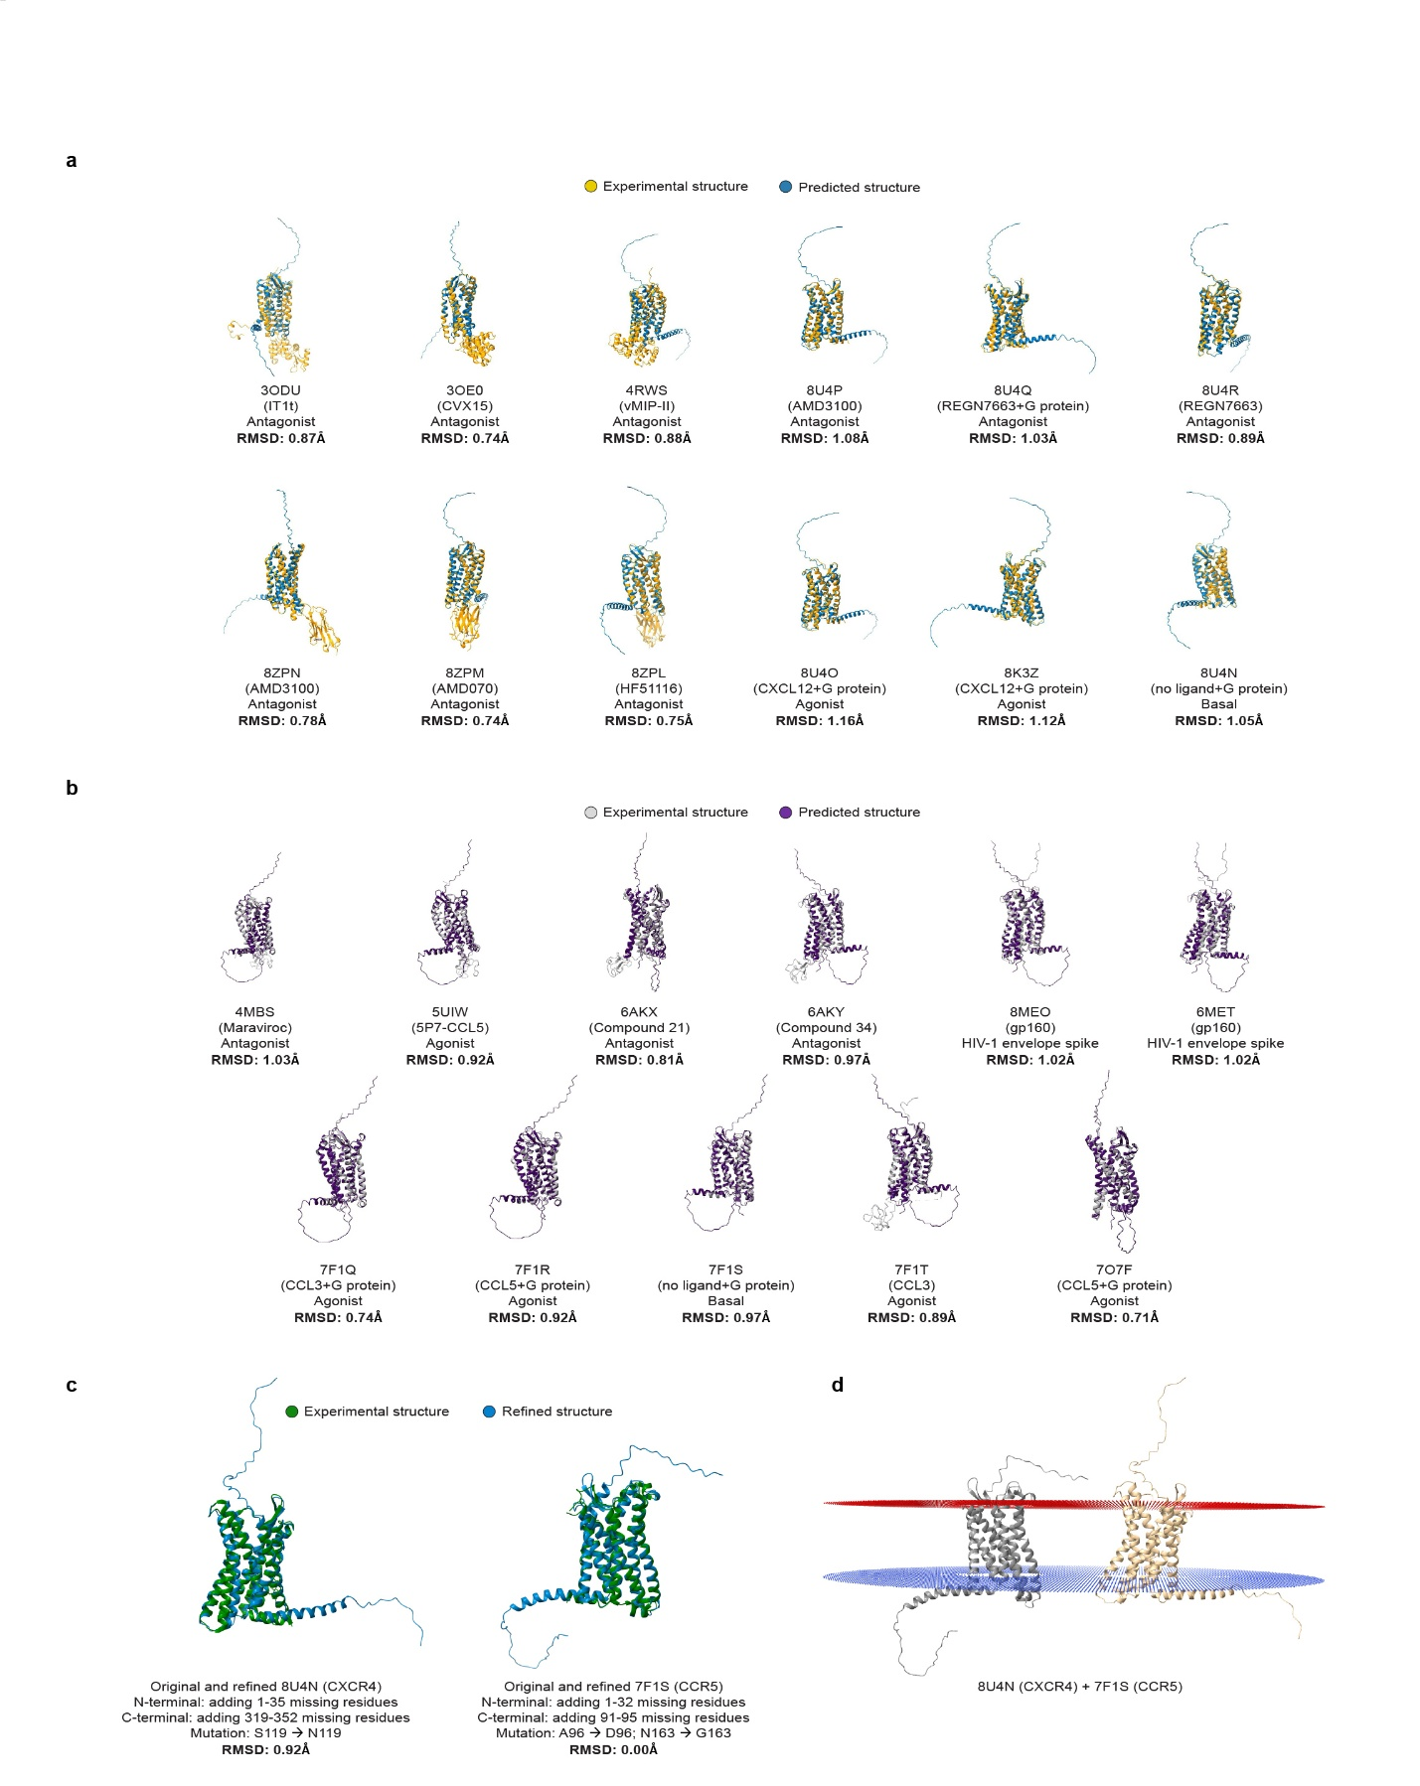

Supplementary Figure 12. CXCR4 and CCR5 model refinement, alignment, and membrane embedding. a,b, Structural overlays of CXCR4 (a) and CCR5 (b) comparing AlphaFold3-predicted models with available experimental structures, with root-mean-square deviation (RMSD) values reported for each alignment. c, Refined CXCR4 and CCR5 models generated with Modeller to rebuild missing segments, together with RMSD values relative to the corresponding starting structures. d, Final Z-axis orientation of the refined CXCR4 and CCR5 models in the membrane, as assigned by the OPM server.

Supplementary Table 1. Experimental parameters obtained from PIE-FCCS measurements of CXCR4-CCR5 hetero-oligomerization under basal conditions in COS-7, HEK293, MDA-MB-231, and MCF-10A cells. Values represent mean ± s.d. (n > 30). Density and brightness were rounded to the nearest integer. Fraction correlated (f_{c}) values were reported as both mean and median, but only median values were plotted in figures.
Parameter | COS-7 | HEK293 | MDA-MB-231 |  | MCF-10A
Parameter | COS-7 | HEK293 | − ^{i} | + ^{j} | MCF-10A
Data points | 72 | 34 | 62 | 32 | 41
f_{c} (median) | 0.02 | 0.02 | 0.19 | 0.04 | 0.07
f_{c} (mean) | 0.08 ± 0.18 | 0.08 ± 0.44 | 0.22 ± 0.24 | 0.07 ± 0.12 | 0.08 ± 0.18
Density_r (mol µm⁻²) ª | 1136 ± 754 | 1126 ± 695 | 1077 ± 736 | 536 ± 191 | 395 ± 211
Density_g (mol µm⁻²) ^{b} | 986 ± 505 | 864 ± 849 | 613 ± 340 | 861 ± 385 | 599 ± 632
Density_rg (mol µm⁻²) ^{c} | 1061 ± 587 | 995 ± 772 | 845 ± 538 | 699 ± 288 | 497 ± 421
D_r (µm² s⁻¹)^{d} | 0.21 ± 0.09 | 0.20 ± 0.10 | 0.15 ± 0.06 | 0.28 ± 0.11 | 0.19 ± 0.21
D_g (µm² s⁻¹)^{e} | 0.27 ± 0.13 | 0.23 ± 0.10 | 0.18 ± 0.07 | 0.19 ± 0.09 | 0.16 ± 0.07
D_rg (µm² s⁻¹)^{f} | 0.22 ± 0.11 | 0.18 ± 0.10 | 0.14 ± 0.06 | 0.27 ± 0.10 | 0.15 ± 0.14
η (cpsm)_r ^{g} | 1405 ± 2222 | 1357 ± 1557 | 2621 ± 9597 | 1910 ± 391 | 1139 ± 375
η (cpsm)_g ^{h} | 1822 ± 1304 | 2045 ± 1582 | 1652 ± 1099 | 1322 ± 397 | 2035 ± 902
a, Receptor density in the red channel. b, Receptor density in the green channel. c, Receptor density in the red and green channels. d, Diffusion coefficient in the red channel. e, Diffusion coefficient in the green channel. f, Diffusion coefficient in the red and green channels. g, Molecular brightness in the red channel (counts per second per molecule, cpsm). h, Molecular brightness in the green channel (counts per second per molecule, cpsm). i, "−" indicates without methyl-β-cyclodextrin (MβCD). j, "+" indicates with methyl-β-cyclodextrin (MβCD).

Supplementary Table 2. PIE-FCCS parameters for CXCR4-CCR5 hetero-oligomerization in COS7 cells under the indicated ligand conditions. Values represent mean ± s.d. (n > 30). Density and brightness were rounded to the nearest integer. Fraction correlated (f_{c}) values were reported as both mean and median, but only median values were plotted in figures.
Time | Parameter | COS7
Time | Parameter | CXCL12 | CCL5 | CXCL12  +  CCL5 | Plerixafor | Maraviroc | Plerixafor  +  Maraviroc
 | Data points (cells) | 52 | 51 | 55 | 47 | 45 | 50
t₁ ª | f_{c} (median)  f_{c} (mean) | 0.07  0.08 ± 0.47 | 0.02  0.08 ± 0.44 | 016  0.17 ± 0.12 | 0.05  0.09 ± 0.09 | 0.08  0.11 ± 0.08 | 0.12  0.12 ± 0.26
t₂ ^{b} | f_{c} (median)  f_{c} (mean) | 0.004  0.008 ± 0.10 | 0.005  0.009 ± 0.02 | 0.01  0.02 ± 0.02 | 0.004  0.004 ± 0.001 | 0.004  0.01 ± 0.001 | 0.005  0.01 ± 0.005
t₁+t₂^{c} | f_{c} (median)  f_{c} (mean) | 0.008  0.04 ± 0.34 | 0.03  0.07 ± 0.15 | 0.09  0.10 ± 0.13 | 0.01  0.05 ± 0.08 | 0.02  0.06 ± 0.08 | 0.02  0.06 ± 0.23
t₁ | Density_r (mol µm⁻²) ^{d}  Density_g (mol µm⁻²) ^{e} Density_rg (mol µm⁻²) ^{f} | 1316 ± 596  1377 ± 1061  2693 ± 1261 | 1126 ± 695  864 ± 849  995 ± 772 | 851 ± 445  995 ± 414  1837 ± 732 | 1188 ± 810  1544 ± 712  2706 ± 1325 | 1070 ± 518  1704 ± 824  2722 ± 1176 | 890 ± 753  1777 ± 929  2592 ± 1395
t₂ | Density_r (mol µm⁻²) Density_g (mol µm⁻²)  Density_rg (mol µm⁻²) | 1328 ± 620  1070 ± 395  2427 ± 798 | 1126 ± 695  864 ± 849  995 ± 772 | 991 ± 383  1348 ± 559  2312 ± 833 | 786 ± 349  1422 ± 442  2155 ± 693 | 909 ± 444  1549 ± 531  2404 ± 896 | 1098 ± 447  2124 ± 1230  3135 ± 1496
t₁+t₂ | Density_r (mol µm⁻²) Density_g (mol µm⁻²)  Density_rg (mol µm⁻²) | 1322 ± 603  1217 ± 779  2554 ± 1033 | 1185 ± 764  1312 ± 598  2491 ± 1112 | 914 ± 421  1154 ± 510  2051 ± 805 | 982 ± 643  1482 ± 590  2424 ± 1074 | 996 ± 485  1632 ± 706  2575 ± 1057 | 998 ± 633  1959 ± 1082  2876 ± 1447
t₁ | D_r (µm² s⁻¹) ^{g}  D_g (µm² s⁻¹) ^{h}  D_rg (µm² s⁻¹) ^{i} | 0.28 ± 0.21  0.16 ± 0.06  0.03 ± 0.05 | 0.20 ± 0.10  0.23 ± 0.10  0.21 ± 0.10 | 0.22 ± 0.09  0.12 ± 0.06  0.16 ± 0.54 | 0.31 ± 0.13  0.23 ± 0.14  0.05 ± 0.06 | 0.26 ± 0.12  0.21 ± 0.12  0.04 ± 0.07 | 0.29 ± 0.61  0.22 ± 0.20  0.64 ± 1.99
t₂ | D_r (µm² s⁻¹)  D_g (µm² s⁻¹)  D_rg (µm² s⁻¹) | 0.34 ± 0.42  0.20 ± 0.09  0.01 ± 0.01 | 0.20 ± 0.10  0.23 ± 0.10  0.21 ± 0.10 | 0.25 ± 0.11  0.21 ± 0.12  0.01 ± 0.01 | 0.31 ± 0.10  0.23 ± 0.12  0.01 ± 0.01 | 0.30 ± 0.09  0.22 ± 0.11  0.01 ± 0.01 | 0.27 ± 0.10  0.22 ± 0.10  0.02 ± 0.01
t₁+t₂ | D_r (µm² s⁻¹)  D_g (µm² s⁻¹)  D_rg (µm² s⁻¹) | 0.31 ± 0.34  0.18 ± 0.08  0.02 ± 0.04 | 0.24 ± 0.12  0.19 ± 0.12  0.07 ± 0.28 | 0.21 ± 0.09  0.14 ± 0.07  0.09 ± 0.42 | 0.31 ± 0.11  0.23 ± 0.13  0.03 ± 0.04 | 0.28 ± 0.11  0.21 ± 0.12  0.03 ± 0.06 | 0.28 ± 0.46  0.22 ± 0.16  0.31 ± 1.50
t₁+t₂ | η (cpsm)_r ^{j}  η (cpsm)_g ^{k} | 1552 ± 480  1964 ± 1119 | 1870 ± 735  1455 ± 580 | 1883 ± 1054  1869 ± 567 | 1488 ± 441  1439 ± 979 | 1441± 509  1295 ± 440 | 1243 ± 799  1354 ± 664
Abbreviations/notes: a, t₁ = 0-30 min. b, t₂ ≈ 60 min. c, t₁+t₂ = pooled data from both intervals. Receptor density in the red channel. d, Receptor density in the red channel. e, Receptor density in the green channel. f, Receptor density in the red and green channels. g, Diffusion coefficient in the red channel. h, Diffusion coefficient in the green channel. i, Diffusion coefficient in the red and green channels. j, Molecular brightness in the red channel (counts per second per molecule, cpsm). k, Molecular brightness in the green channel (counts per second per molecule, cpsm).

Supplementary Table 3. PIE-FCCS parameters for CXCR4-CCR5 hetero-oligomerization in HEK293 cells under the indicated ligand conditions. Values represent mean ± s.d. (n > 30). Density and brightness were rounded to the nearest integer. Fraction correlated (f_{c}) values were reported as both mean and median, but only median values were plotted in figures.
Time | Parameter | HEK293
Time | Parameter | CXCL12 | CCL5 | CXCL12  +  CCL5 | Plerixafor | Maraviroc | Plerixafor  +  Maraviroc
 | Data points (cells) | 76 | 71 | 75 | 50 | 57 | 52
t₁ ª | f_{c} (median)  f_{c} (mean) | 0.15  0.14 ± 0.25 | 0.12  0.14 ± 0.28 | 0.25  0.22 ± 0.25 | 0.15  0.14 ± 0.21 | 0.07  0.13 ± 0.33 | 0.14  0.16 ± 0.19
t₂ ^{b} | f_{c} (median)  f_{c} (mean) | 0.005  0.005 ± 0.002 | 0.006  0.006 ± 0.002 | 0.005  0.008 ± 0.007 | 0.005  0.005 ± 0.002 | 0.004  0.01 ± 0.002 | 0.004  0.009 ± 0.011
t₁+t₂^{c} | f_{c} (median)  f_{c} (mean) | 0.02  0.08 ± 0.23 | 0.01  0.08 ± 0.26 | 0.05  0.13 ± 0.25 | 0.006  0.05 ± 0.19 | 0.007  0.06 ± 0.24 | 0.06  0.10 ± 0.19
t₁ | Density_r (mol µm⁻²) ^{d}  Density_g (mol µm⁻²) ^{e} Density_rg (mol µm⁻²) ^{f} | 1713 ± 1190  1720 ± 1220  3440 ± 2255 | 975 ± 718  2430 ± 1254  3280 ± 1611 | 1341 ± 1348  1695 ± 925  3010 ± 2040 | 1185 ± 1034  1196 ± 776  2385 ± 1605 | 1887 ± 882  1467 ± 723  3399 ± 1516 | 872 ± 598  1304 ± 582  2141 ± 1050
t₂ | Density_r (mol µm⁻²) Density_g (mol µm⁻²)  Density_rg (mol µm⁻²) | 1299 ± 623  1221 ± 509  2532 ± 990 | 857 ± 386  1826 ± 502  2601 ± 602 | 1389 ± 847  1415 ± 515  2808 ± 1180 | 1357 ± 611  1360 ± 646  2723 ± 913 | 1379 ± 541  1163 ± 349  2567 ± 827 | 850 ± 341  1312 ± 409  2125 ± 627
t₁+t₂ | Density_r (mol µm⁻²) Density_g (mol µm⁻²)  Density_rg (mol µm⁻²) | 1524 ± 1039  1492 ± 1025  3025 ± 1922 | 928 ± 621  2137 ± 1094  2961 ± 1384 | 1362 ± 1197  1573 ± 831  2922 ± 1807 | 1295 ± 828  1301 ± 701  2600 ± 1267 | 1588 ± 732  1288 ± 548  2910 ± 1208 | 863 ± 521  1308 ± 525  2134 ± 921
t₁ | D_r (µm² s⁻¹) ^{g}  D_g (µm² s⁻¹) ^{h}  D_rg (µm² s⁻¹) ^{i} | 0.24 ± 0.45  0.19 ± 0.12  0.23 ± 1.85 | 0.25 ± 1.83  0.12 ± 0.34  0.04 ± 1.06 | 0.19 ± 0.26  0.15 ± 0.11  0.58 ± 2.02 | 0.15 ± 5.48  0.25 ± 0.15  0.01 ± 2.29 | 0.20 ± 0.14  0.29 ± 0.19  0.01 ± 0.006 | 0.34 ± 0.27  0.24 ± 0.13  0.03 ± 0.03
t₂ | D_r (µm² s⁻¹)  D_g (µm² s⁻¹)  D_rg (µm² s⁻¹) | 0.34 ± 0.18  0.30 ± 0.17  0.01 ± 0.01 | 0.29 ± 0.18  0.17 ± 0.07  0.01 ± 0.01 | 0.26 ± 0.14  0.19 ± 0.12  0.03 ± 0.08 | 0.07 ± 1.75  0.33 ± 0.27  0.009 ± 0.003 | 0.35 ± 0.23  0.43 ± 0.18  0.01 ± 0.01 | 0.38 ± 0.16  0.24 ± 0.12  0.01 ± 0.01
t₁+t₂ | D_r (µm² s⁻¹)  D_g (µm² s⁻¹)  D_rg (µm² s⁻¹) | 0.28 ± 0.38  0.24 ± 0.16  0.13 ± 1.48 | 0.27 ± 1.48  0.14 ± 0.28  0.03 ± 1.67 | 0.22 ± 0.22  0.16 ± 0.11  0.34 ± 1.64 | 0.50 ± 3.87  0.30 ± 0.23  0.01 ± 1.54 | 0.29 ± 0.21  0.37 ± 0.20  0.01 ± 0.01 | 0.36 ± 0.24  0.24 ± 0.12  0.02 ± 0.03
t₁+t₂ | η (cpsm)_r ^{j}  η (cpsm)_g ^{k} | 1299 ± 549  979 ± 521 | 1182 ± 1665  642 ± 350 | 1090 ± 696  1116 ± 1151 | 1441 ± 1097  1957 ± 1278 | 1910 ± 391  1322 ± 397 | 1927 ± 939  2062 ± 844
Abbreviations/notes: a, t₁ = 0-30 min. b, t₂ ≈ 60 min. c, t₁+t₂ = pooled data from both intervals. Receptor density in the red channel. d, Receptor density in the red channel. e, Receptor density in the green channel. f, Receptor density in the red and green channels. g, Diffusion coefficient in the red channel. h, Diffusion coefficient in the green channel. i, Diffusion coefficient in the red and green channels. j, Molecular brightness in the red channel (counts per second per molecule, cpsm). k, Molecular brightness in the green channel (counts per second per molecule, cpsm).

Supplementary Table 4. PIE-FCCS parameters for CXCR4-CCR5 hetero-oligomerization in MDA-MB-231 cells under the indicated ligand conditions. Values represent mean ± s.d. (n > 30). Density and brightness were rounded to the nearest integer. Fraction correlated (f_{c}) values were reported as both mean and median, but only median values were plotted in figures.
Time | Parameter | MDA-MB-231
Time | Parameter | CXCL12 | CCL5 | CXCL12  +  CCL5 | Plerixafor | Maraviroc | Plerixafor  +  Maraviroc
 | Data points (cells) | 54 | 52 | 55 | 59 | 59 | 60
t₁ ª | f_{c} (median)  f_{c} (mean) | 0.14  0.15 ± 0.14 | 0.16  0.17 ± 0.16 | 0.13  0.14 ± 0.09 | 0.11  0.12 ± 0.06 | 0.14  0.16 ± 0.07 | 0.25  0.26 ± 0.05
t₂ ^{b} | f_{c} (median)  f_{c} (mean) | 0.003  0.007 ± 0.009 | 0.003  0.006 ± 0.008 | 0.004  0.004 ± 0.003 | 0.05  0.05 ± 0.02 | 0.06  0.06 ± 0.03 | 0.15  0.15 ± 0.06
t₁+t₂^{c} | f_{c} (median)  f_{c} (mean) | 0.10  0.10 ± 0.14 | 0.12  0.12 ± 0.17 | 0.008  0.06 ± 0.09 | 0.07  0.09 ± 0.06 | 0.10  0.12 ± 0.08 | 0.21  0.21 ± 0.08
t₁ | Density_r (mol µm⁻²) ^{d}  Density_g (mol µm⁻²) ^{e} Density_rg (mol µm⁻²) ^{f} | 620 ± 289  625 ± 262  1247 ± 516 | 533 ± 291  803 ± 398  1314 ± 495 | 498 ± 501  590 ± 274  1082 ± 710 | 617 ± 259  1017 ± 319  1601 ± 495 | 677 ± 275  1048 ± 365  1695 ± 566 | 583 ± 324  865 ± 400  1426 ± 650
t₂ | Density_r (mol µm⁻²) Density_g (mol µm⁻²)  Density_rg (mol µm⁻²) | 641± 332  683 ± 299  1323 ± 598 | 484 ± 196  839 ± 174  1294 ± 231 | 786 ± 642  910 ± 556  1688 ± 1149 | 482 ± 181  862 ± 397  1313 ± 507 | 523 ± 176  928 ± 431  1417 ± 543 | 432 ± 154  737 ± 260  1144 ± 340
t₁+t₂ | Density_r (mol µm⁻²) Density_g (mol µm⁻²)  Density_rg (mol µm⁻²) | 628 ± 302  645 ± 274  1274 ± 541 | 519 ± 270  813 ± 355  1308 ± 442 | 663 ± 581  773 ± 463  1428 ± 984 | 559 ± 238  950 ± 358  1476 ± 515 | 616 ± 252  1000 ± 392  1585 ± 568 | 519 ± 277  811 ± 350  1306 ± 557
t₁ | D_r (µm² s⁻¹) ^{g}  D_g (µm² s⁻¹) ^{h}  D_rg (µm² s⁻¹) ^{i} | 0.31 ± 0.13  0.18 ± 0.08  0.10 ± 0.11 | 0.33 ± 0.11  0.23 ± 0.10  0.39 ± 1.69 | 0.29 ± 0.11  0.20 ± 0.08  0.05 ± 2.11 | 0.32 ± 0.13  0.20 ± 0.10  0.04 ± 0.11 | 0.35 ± 0.11  0.23 ± 0.09  0.05 ± 0.05 | 0.33 ± 0.09  0.19 ± 0.04  0.09 ± 0.05
t₂ | D_r (µm² s⁻¹)  D_g (µm² s⁻¹)  D_rg (µm² s⁻¹) | 0.31 ± 0.09  0.19 ± 0.10  0.01 ± 0.01 | 0.34 ± 0.08  0.26 ± 0.08  0.02 ± 0.03 | 0.32 ± 0.08  0.21 ± 0.06  0.02 ± 0.02 | 0.34 ± 0.07  0.24 ± 0.08  0.03 ± 0.05 | 0.36 ± 0.11  0.29 ± 0.12  0.02 ± 0.04 | 0.32 ± 0.08  0.20 ± 0.07  0.15 ± 0.19
t₁+t₂ | D_r (µm² s⁻¹)  D_g (µm² s⁻¹)  D_rg (µm² s⁻¹) | 0.31 ± 0.12  0.18 ± 0.08  0.07 ± 0.09 | 0.33 ± 0.11  0.24 ± 0.10  0.28 ± 1.47 | 0.31 ± 0.09  0.21 ± 0.06  0.03 ± 1.48 | 0.33 ± 0.11  0.22 ± 0.09  0.03 ± 0.09 | 0.35 ± 0.11  0.26 ± 0.10  0.04 ± 0.05 | 0.32 ± 0.09  0.20 ± 0.06  0.12 ± 0.13
t₁+t₂ | η (cpsm)_r ^{j}  η (cpsm)_g ^{k} | 2763 ± 1906  2719 ± 1212 | 2829 ± 826  2733 ± 6193 | 2949 ± 1375  3102 ± 1188 | 3370 ± 650  3275 ± 840 | 2571 ± 707  2080 ± 886 | 2241 ± 389  2197 ± 587
Abbreviations/notes: a, t₁ = 0-30 min. b, t₂ ≈ 60 min. c, t₁+t₂ = pooled data from both intervals. Receptor density in the red channel. d, Receptor density in the red channel. e, Receptor density in the green channel. f, Receptor density in the red and green channels. g, Diffusion coefficient in the red channel. h, Diffusion coefficient in the green channel. i, Diffusion coefficient in the red and green channels. j, Molecular brightness in the red channel (counts per second per molecule, cpsm). k, Molecular brightness in the green channel (counts per second per molecule, cpsm).

Supplementary Table 5. PIE-FCCS parameters for CXCR4-CCR5 hetero-oligomerization in MCF-10A cells under the indicated ligand conditions. Values represent mean ± s.d. (n > 30). Density and brightness were rounded to the nearest integer. Fraction correlated (f_{c}) values were reported as both mean and median, but only median values were plotted in figures.
Time | Parameter | MCF-10A
Time | Parameter | CXCL12 | CCL5 | CXCL12  +  CCL5 | Plerixafor | Maraviroc | Plerixafor  +  Maraviroc
 | Data points (cells) | 56 | 56 | 58 | 58 | 59 | 58
t₁ ª | f_{c} (median)  f_{c} (mean) | 0.12  0.11 ± 0.10 | 0.10  0.10 ± 0.07 | 0.15  0.17 ± 0.09 | 0.13  0.16 ± 0.10 | 0.15  0.17 ± 0.12 | 0.14  0.18 ± 0.20
t₂ ^{b} | f_{c} (median)  f_{c} (mean) | 0.003  0.003 ± 0.002 | 0.003  0.004 ± 0.006 | 0.003  0.005 ± 0.006 | 0.04  0.04 ± 0.01 | 0.07  0.07 ± 0.03 | 0.06  0.06 ± 0.03
t₁+t₂^{c} | f_{c} (median)  f_{c} (mean) | 0.005  0.05 ± 0.09 | 0.04  0.06 ± 0.08 | 0.08  0.10 ± 0.11 | 0.07  0.11 ± 0.10 | 0.11  0.13 ± 0.11 | 0.10  0.13 ± 0.18
t₁ | Density_r (mol µm⁻²) ^{d}  Density_g (mol µm⁻²) ^{e} Density_rg (mol µm⁻²) ^{f} | 1036 ± 473  631 ± 197  1708 ± 622 | 613 ± 423  631 ± 259  1245 ± 594 | 720 ± 242  783 ± 308  1500 ± 431 | 1078 ± 347  1758 ± 762  2780 ± 915 | 653 ± 326  1288 ± 549  1887 ± 703 | 1132 ± 672  860 ± 311  2021 ± 950
t₂ | Density_r (mol µm⁻²) Density_g (mol µm⁻²)  Density_rg (mol µm⁻²) | 722 ± 350  640 ± 197  1373 ± 453 | 765 ± 364  653 ± 291  1432 ± 574 | 759 ± 358  772 ± 235  1533 ± 480 | 919 ± 415  1362 ± 629  2246 ± 942 | 799 ± 338  1331 ± 577  2086 ± 791 | 986 ± 544  864 ± 356  1865 ± 841
t₁+t₂ | Density_r (mol µm⁻²) Density_g (mol µm⁻²)  Density_rg (mol µm⁻²) | 854 ± 457  636 ± 196  1513 ± 573 | 677 ± 398  641 ± 270  1323 ± 582 | 737 ± 292  778 ± 279  1514 ± 448 | 1008 ± 379  1583 ± 720  2544 ± 942 | 711 ± 332  1305 ± 555  1966 ± 732 | 1076 ± 628  862 ± 325  1961 ± 907
t₁ | D_r (µm² s⁻¹) ^{g}  D_g (µm² s⁻¹) ^{h}  D_rg (µm² s⁻¹) ^{i} | 0.24 ± 0.06  0.17 ± 0.05  0.04 ± 0.06 | 0.26 ± 0.06  0.22 ± 0.09  0.69 ± 2.09 | 0.21 ± 0.08  0.15 ± 0.07  0.37 ± 1.85 | 0.21 ± 0.07  0.12 ± 0.06  0.01 ± 0.004 | 0.24 ± 0.09  0.11 ± 0.05  0.03 ± 0.04 | 0.20 ± 0.11  0.15 ± 0.06  0.76 ± 3.11
t₂ | D_r (µm² s⁻¹)  D_g (µm² s⁻¹)  D_rg (µm² s⁻¹) | 0.27 ± 0.07  0.18 ± 0.06  0.01 ± 0.01 | 0.26 ± 0.10  0.20 ± 0.08  0.01 ± 0.01 | 0.25 ± 0.07  0.19 ± 0.07  0.01 ± 0.008 | 0.22 ± 0.08  0.16 ± 0.08  0.01 ± 0.006 | 0.22 ± 0.05  0.13 ± 0.06  0.04 ± 0.11 | 0.25 ± 0.08  0.18 ± 0.05  0.03 ± 0.04
t₁+t₂ | D_r (µm² s⁻¹)  D_g (µm² s⁻¹)  D_rg (µm² s⁻¹) | 0.26 ± 0.07  0.17 ± 0.05  0.02 ± 0.04 | 0.26 ± 0.08  0.21 ± 0.08  0.40 ± 1.65 | 0.23 ± 0.08  0.16 ± 0.07  0.22 ± 1.43 | 0.22 ± 0.07  0.14 ± 0.07  0.01 ± 0.005 | 0.23 ± 0.08  0.12 ± 0.05  0.03 ± 0.07 | 0.22 ± 0.10  0.16 ± 0.06  0.48 ± 2.52
t₁+t₂ | η (cpsm)_r ^{j}  η (cpsm)_g ^{k} | 2278 ± 730  1737 ± 795 | 2725 ± 634  1657 ± 453 | 1938 ± 419  1227 ± 432 | 1576 ± 458  1080 ± 311 | 969 ± 343  528 ± 267 | 1326 ± 1005  913 ± 562
Abbreviations/notes: a, t₁ = 0-30 min. b, t₂ ≈ 60 min. c, t₁+t₂ = pooled data from both intervals. Receptor density in the red channel. d, Receptor density in the red channel. e, Receptor density in the green channel. f, Receptor density in the red and green channels. g, Diffusion coefficient in the red channel. h, Diffusion coefficient in the green channel. i, Diffusion coefficient in the red and green channels. j, Molecular brightness in the red channel (counts per second per molecule, cpsm). k, Molecular brightness in the green channel (counts per second per molecule, cpsm).

Supplementary Table 6. Multiple comparisons and significance test results for fc and diffusion values of GPCR controls, mGluR2 and Δ2Δ (Extended Data Fig. 4c,d).

fc values
Dunn’s multiple comparisons test | Mean rank Diff. | Significant? | Summary | Adjusted P value
COS7 mGluR2 vs. HEK293 mGluR2 | -2.433 | No | ns | >0.9999
COS7 mGluR2 vs. MDA mGluR2 | -5.112 | No | ns | >0.9999
COS7 mGluR2 vs. MCF mGluR2 | 14.15 | No | ns | 0.9596
HEK293 mGluR2 vs. MDA mGluR2 | -2.679 | No | ns | >0.9999
HEK293 mGluR2 vs. MCF mGluR2 | 16.59 | No | ns | 0.6663
MDA mGluR2 vs. MCF mGluR2 | 19.26 | No | ns | 0.3755
COS7 Δ2Δ vs. HEK293 Δ2Δ | -11.03 | No | ns | >0.9999
COS7 Δ2Δ vs. MDA Δ2Δ | 14.40 | No | ns | 0.6807
COS7 Δ2Δ vs. MCF Δ2Δ | 14.06 | No | ns | 0.8180
HEK293 Δ2Δ vs. MDA Δ2Δ | 25.43 | Yes | * | 0.0391
HEK293 Δ2Δ vs. MCF Δ2Δ | 25.09 | No | ns | 0.0573
MDA Δ2Δ vs. MCF Δ2Δ | -0.3393 | No | ns | >0.9999

Diffusion
Dunn’s multiple comparisons test | Mean rank Diff. | Significant? | Summary | Adjusted P value
COS7 mGluR2 vs. HEK293 mGluR2 | -32.52 | No | ns | 0.0903
COS7 mGluR2 vs. MDA mGluR2 | 36.81 | Yes | * | 0.0334
COS7 mGluR2 vs. MCF mGluR2 | -38.75 | Yes | * | 0.0385
HEK293 mGluR2 vs. MDA mGluR2 | 69.33 | Yes | **** | <0.0001
HEK293 mGluR2 vs. MCF mGluR2 | -6.234 | No | ns | >0.9999
MDA mGluR2 vs. MCF mGluR2 | -75.56 | Yes | **** | <0.0001
COS7 Δ2Δ vs. HEK293 Δ2Δ | -7.465 | No | ns | >0.9999
COS7 Δ2Δ vs. MDA Δ2Δ | -108.7 | Yes | **** | <0.0001
COS7 Δ2Δ vs. MCF Δ2Δ | -15.92 | No | ns | >0.9999
HEK293 Δ2Δ vs. MDA Δ2Δ | -101.2 | Yes | **** | <0.0001
HEK293 Δ2Δ vs. MCF Δ2Δ | -8.459 | No | ns | >0.9999
MDA Δ2Δ vs. MCF Δ2Δ | 92.74 | Yes | **** | <0.0001

Supplementary Movie 1. Time-lapse imaging of MDA-MB-231 (CXCR4-KO) and MCF-10A cells expressing CXCR4-mGL after treatment with CXCL12 (100 nM) or a combination of plerixafor and maraviroc (each 1,000 nM). Frames were collected for over 60 min. Arrowheads indicate intracellular puncta consistent with CXCR4 internalization. Scale bars, 10 µm.

Supplementary Movie 2. Time-lapse imaging of COS7 and HEK293 cells expressing CXCR4-mGL after treatment with CXCL12 (100 nM) or a combination of plerixafor and maraviroc (each 1,000 nM). Frames were collected for over 60 min. Arrowheads indicate intracellular puncta consistent with CXCR4 internalization. Scale bars, 10 µm.

Supplementary Movie 3. Atomistic MD trajectories of CXCR4-CCR5 dimerization in two bilayer systems mimicking MDA-MB-231 and MCF-10A membranes, simulated in GROMACS for 500 ns. CXCR4 is shown in turquoise, CCR5 in grey, TM4 in orange, TM5 in green, cholesterol in red, and bulk lipids (POPC, POPE, POPS, PIP2, sphingomyelin, GM3) in tan.

