OnTEPT: A multimodal OWL ontology for post-traumatic stress disorder
Supplementary Material
This document provides the detailed supporting content referenced in the main manuscript. Tables S1–S6 and Figures S1–S4 expand on material that is summarized in the main text; each item is labeled to match its citation in the manuscript. Sections are self-contained and can be read independently but should be interpreted in conjunction with the Methods and Results sections of the main paper.

Supplementary Table S1. Comparison with Representative Prior Ontology Efforts
The table below situates OnTEPT relative to the most relevant existing ontological resources for PTSD and mental health. For each resource, the comparison covers the primary scope, the availability of computable DSM-5 and ICD-11 axioms, item-level psychometric representation, and the integration of neurophysiological data. The comparison confirms that no existing resource simultaneously addresses all four dimensions that OnTEPT was designed to cover.

Table S1. Comparison of OnTEPT with prior ontological resources relevant to PTSD and mental health.

Resource | Primary scope | DSM-5 executable axioms | ICD-11 executable axioms | Item-level psychometric modeling | EEG / neurophysiological data
OnTEPT (this work) | PTSD diagnosis, assessment, and multimodal integration across DSM-5 and ICD-11 | Yes — EquivalentTo axioms for criteria A–H, dissociative subtype, and complete profile | Yes — EquivalentTo axioms for criteria 1–6 and complex PTSD (C-PTSD) | Yes — PCL-C, PCL-5, PC-PTSD-5 with item-level properties and operationalized cutoffs; CAPS-5 with item-to-criterion annotation mapping | Yes — 36 quantitative features per frequency band as typed data properties; structural queries supported
Gamble et al. (2014) PTSD Ontology | PTSD symptom vocabulary and clinical NLP annotation for electronic health records | No — symptoms and interventions only; no diagnostic axioms | No — predates ICD-11; no ICD modeling | No | No
Mental Functioning Ontology (MFO) | General human mental functioning: consciousness, perception, cognition, affect | No | No | No | No
Mental Disease Ontology (MFOMD) | Mental illness taxonomy as an extension of MFO; based on BFO; limited to schizophrenia in practice | No (DSM-IV annotations only) | No | No | No
Emotion Ontology (MFOEM) | Taxonomy of affective phenomena: emotions, moods, valuations, subjective feelings | No | No | No | No
Human Disease Ontology (DOID) | Human disease classification by etiology as a directed acyclic graph; integrates MeSH, ICD, NCI, SNOMED CT | No — PTSD is a nominal entry without formalized criteria | No | No | No

Note: Executable axioms refers to OWL EquivalentTo class definitions that allow a reasoner to automatically classify a patient instance as satisfying a specific diagnostic criterion or complete profile, without any logic external to the ontology.

Supplementary Table S2. Full Competency Question Inventory
The 16 competency questions (CQs) listed below were defined through working sessions between the development team and a clinical psychologist specializing in emotional, affective, and stress-related disorders. They guided all design decisions in OnTEPT, from the class hierarchy to the logical constraints and the instantiation strategy. Table 1 of the main manuscript presents a condensed selection of representative questions by thematic category.

Table S2. Complete inventory of competency questions used to guide the development of OnTEPT.

ID | Category | Competency question
CQ1 | Diagnostic criteria | What are the essential diagnostic criteria for PTSD according to DSM-5 (A–H)?
CQ2 | Diagnostic criteria | What are the essential diagnostic criteria for PTSD according to ICD-11 (1–6)?
CQ3 | Diagnostic criteria | What sub-criteria does each DSM-5 criterion specify (e.g., sub-criteria B1–B5 for Criterion B)?
CQ4 | Diagnostic criteria | How do DSM-5 and ICD-11 differ structurally, and what are the diagnostic consequences of those differences?
CQ5 | Symptom representation | Which symptom categories must be represented for DSM-5 and ICD-11?
CQ6 | Symptom representation | How are specific symptoms formally linked to the diagnostic criteria they constitute?
CQ7 | Symptom representation | How are dissociative symptoms (DSM-5) and DSO disturbances (ICD-11) distinguished from core PTSD symptoms?
CQ8 | Clinical assessment | Which psychometric instruments are relevant for PTSD assessment in this domain?
CQ9 | Clinical assessment | How are items and total scores structured within each instrument?
CQ10 | Clinical assessment | How do the classification thresholds of each instrument map to the diagnostic criteria they assess?
CQ11 | EEG data | Which EEG frequency bands and quantitative signal features are clinically relevant in the PTSD biomarker literature?
CQ12 | EEG data | How are EEG recordings and their derived features formally linked to patient instances within the ontology?
CQ13 | Patient–data relationships | How are relationships between patients, traumatic events, and symptoms formally modeled?
CQ14 | Patient–data relationships | What clinical properties are essential to describe a patient in the diagnostic context of PTSD?
CQ15 | Diagnostic inference | What logical rules allow a reasoner to infer that a patient satisfies the complete DSM-5 or ICD-11 PTSD profile?
CQ16 | Diagnostic inference | How are duration, clinical significance, and etiological exclusion encoded as computable constraints in OWL?

Supplementary Table S3. Expanded Ontology Alignment Inventory
The following table provides the complete mapping between OnTEPT classes and their counterparts in external biomedical ontologies. Candidate entities were identified from the domain term inventory and searched in NCBO BioPortal and OBO Foundry by name and known synonyms. Alignment type is classified as exact (full conceptual equivalence), broad (the external class is more general), or new (no satisfactory external equivalent found; class defined in the OnTEPT namespace).

Table S3. Complete ontology alignment inventory for OnTEPT classes and external biomedical resources.

OnTEPT class | Source ontology | Source label | Persistent identifier | Alignment type
Person | SNOMED CT | Person | http://purl.bioontology.org/ontology/SNOMEDCT/125676002 | Exact
Patient | SNOMED CT | Patient | http://purl.bioontology.org/ontology/SNOMEDCT/116154003 | Exact
Event | SNOMED CT | Event | http://purl.bioontology.org/ontology/SNOMEDCT/272379006 | Exact
TraumaticEvent | SNOMED CT | Traumatic event | http://purl.bioontology.org/ontology/SNOMEDCT/773760007 | Exact
NonTraumaticEvent | OnTEPT (new) | — | — | New class
Symptom | Human Disease Ontology | Symptom | http://purl.obolibrary.org/obo/SYMP_0000462 | Exact
AssessmentInstrument | Mental State Assessment Ontology | assessment-instrument | http://neurolog.unice.fr/ontoneurolog/v3.0/instrument.owl#assessment-instrument | Exact
PsychometricAssessmentInstrument | Mental State Assessment Ontology | psychophysical-instrument | http://neurolog.unice.fr/ontoneurolog/v3.0/instrument.owl#psychophysical-instrument | Broad
EEG_Recording | Measurement Method Ontology | EEG recording | http://purl.obolibrary.org/obo/MMO_0000023 | Exact
PTSD | SNOMED CT | Posttraumatic stress disorder | http://purl.bioontology.org/ontology/SNOMEDCT/47505003 | Exact
TraumaAndStressorRelatedDisorders | MeSH | Trauma and Stressor Related Disorders | http://purl.bioontology.org/ontology/MESH/D000068099 | Exact
TraumaticStressDisorders | MeSH (intermediate hierarchy) | Stress Disorders, Traumatic | http://purl.bioontology.org/ontology/MESH/D040921 | Broad

Supplementary Table S4. Logical Constraints for DSM-5 and ICD-11 Inference in Manchester OWL Syntax
The following table presents the complete set of logical constraints implemented in OnTEPT for automated diagnostic inference. Each entry corresponds to an OWL EquivalentTo axiom defined on the indicated Patient_meets(System)_Criterion class. The constraints are organized following the clinical structure of each classification system: trauma exposure, core symptom clusters, cross-sectional criteria, complete profiles, and subtypes. The subsumption axiom encoding formal interoperability between the two systems is also included.

Table S4. Complete logical constraints for OnTEPT diagnostic inference, expressed in Manchester OWL syntax.

System | Criterion / class | Constraint type | Manchester OWL expression
DSM-5 | Criterion A — Trauma exposure | Existential restriction | Patient and (hasEvent some TraumaticEvent)
DSM-5 | Criterion B — Intrusion (min. 1) | Existential restriction | Patient and (meetsCriterionDSM some DSM5_CriterionA_Exposure) and (hasSymptom some IntrusionSymptom)
DSM-5 | Criterion C — Avoidance (min. 1) | Existential restriction | Patient and (meetsCriterionDSM some DSM5_CriterionA_Exposure) and (hasSymptom some AvoidanceSymptom)
DSM-5 | Criterion D — Cognitive-affective (min. 2) | Minimum cardinality | Patient and (meetsCriterionDSM some DSM5_CriterionA_Exposure) and (hasSymptom min 2 AffectiveCognitiveAlteration)
DSM-5 | Criterion E — Hyperarousal (min. 2) | Minimum cardinality | Patient and (meetsCriterionDSM some DSM5_CriterionA_Exposure) and (hasSymptom min 2 ThreatArousalSymptom)
DSM-5 | Criterion F — Duration ≥ 1 month | Data property restriction | Patient and (hasSymptom some (Symptom and (duration some integer[>=1])))
DSM-5 | Criterion G — Clinical significance | Data property value | Patient and (hasSymptom some (Symptom and (disturbanceClinicallySignificant value true)))
DSM-5 | Criterion H — Non-attribution to substances | Data property value | Patient and (hasSymptom some (Symptom and (attributableEffectsSubstance value false)))
DSM-5 | Criterion X — Dissociative symptoms | Existential restriction (disjunctive range) | Patient and (hasDissociativeSymptom some (DepersonalizationSymptom or DerealizationSymptom))
DSM-5 | Patient_meetsPTSD_DSM5 (classic PTSD) | Intersection + negation | Patient_meetsDSM5_A and Patient_meetsDSM5_B and Patient_meetsDSM5_C and Patient_meetsDSM5_D and Patient_meetsDSM5_E and Patient_meetsDSM5_F and Patient_meetsDSM5_G and Patient_meetsDSM5_H and (not Patient_meetsDSM5_XDissociative)
DSM-5 | Patient_meetsPTSD_WithDissociative_DSM5 | Intersection | Patient_meetsDSM5_A and ... and Patient_meetsDSM5_H and Patient_meetsDSM5_XDissociative — disjoint with Patient_meetsPTSD_DSM5
ICD-11 | Criterion 1 — Trauma exposure | Existential restriction | Patient and (hasEvent some TraumaticEvent)
ICD-11 | Criterion 2 — Re-experiencing / intrusion (min. 1) | Existential restriction | Patient and (meetsCriterionICD some ICD11_Criterion1_Exposure) and (hasSymptom some IntrusionSymptom)
ICD-11 | Criterion 3 — Avoidance (min. 1) | Existential restriction | Patient and (meetsCriterionICD some ICD11_Criterion1_Exposure) and (hasSymptom some AvoidanceSymptom)
ICD-11 | Criterion 4 — Sense of current threat / hyperarousal (min. 1) | Existential restriction | Patient and (meetsCriterionICD some ICD11_Criterion1_Exposure) and (hasSymptom some ThreatArousalSymptom)
ICD-11 | Criterion 5 — Duration (several weeks) | Data property restriction | Patient and (hasSymptom some (Symptom and (duration some integer[>=1])))
ICD-11 | Criterion 6 — Functional impairment | Data property value | Patient and (hasSymptom some (Symptom and (disturbanceClinicallySignificant value true)))
ICD-11 | Criterion X — DSO symptoms (complex PTSD) | Minimum cardinality × 3 clusters | Patient and (hasComplexSymptom min 1 AffectiveDysregulationSymptom) and (hasComplexSymptom min 1 NegativeSelfConceptSymptom) and (hasComplexSymptom min 1 RelationalDisturbance)
ICD-11 | Patient_meetsPTSD_ICD11 (classic PTSD) | Intersection + negation | Patient_meetsICD11_1 and Patient_meetsICD11_2 and Patient_meetsICD11_3 and Patient_meetsICD11_4 and Patient_meetsICD11_5 and Patient_meetsICD11_6 and (not Patient_meetsICD11_XComplex)
ICD-11 | Patient_meetsPTSD_Complex_ICD11 | Intersection + DSO | Patient_meetsICD11_1 and ... and Patient_meetsICD11_6 and Patient_meetsICD11_XComplex — disjoint with Patient_meetsPTSD_ICD11
Cross-system | Formal subsumption DSM-5 → ICD-11 | Subsumption axiom | Patient_meetsPTSD_DSM5 SubClassOf Patient_meetsPTSD_ICD11
Cross-system | Psychometric screening — probable PTSD | Disjunction of threshold constraints | isAssessedBy some (PTSD_Checklist_PCL-C and (PCL_totalScore some integer[>=44])) or isAssessedBy some (PTSD_Checklist_PCL5 and (PCL_totalScore some integer[>=33])) or isAssessedBy some (PrimaryCarePTSD_Screen_PC-PTSD-5 and (PC-PTSD_ItemtotalScore some integer[>=3]))

Notes: Criteria F, G, and H are applied over each representative symptom cluster separately (four clusters for DSM-5; three for ICD-11). The duration encoding uses integer[>=1] as a unified representation for both 'more than one month' (DSM-5, Criterion F) and 'at least several weeks' (ICD-11, Criterion 5), reflecting the practical equivalence of these minimum thresholds. ICD-11 has no counterpart to DSM-5 Criterion H; the absence of an etiological exclusion criterion in ICD-11 is one structural source of the diagnostic asymmetry captured by the subsumption axiom. Non-traumatic event detection uses the disjoint axiom: NonTraumaticEvent owl:disjointWith TraumaticEvent, combined with the equivalence TraumaticEvent EquivalentTo Event and (isTraumaticEvent value true).

Supplementary Table S5. Datasets, Provenance, and Governance Notes
The three datasets used to populate OnTEPT with real patient instances are described below. All were obtained from open-access or previously published sources. No new human data were collected for this study. The table includes information on participants, data modalities, instruments and features available, repository access, and reuse conditions to be confirmed before submission.

Table S5. Real datasets used to populate OnTEPT, with participant characteristics, data modalities, and governance notes.

Reference | Year | Participants | Data modalities | Instruments / EEG features | Repository access
du Bois N, et al. [98] | 2022 | 29 — all with PTSD diagnosis | EEG recordings + psychometric data (item-level) | PCL-5 (20 items + total score); PC-PTSD-5 (5 items + total score); multichannel EEG with band-level features | https://data.mendeley.com/datasets/gsxphk87mc/3
Rahmani M, et al. [32] | 2018 | 12 — 6 with PTSD, 6 healthy controls | EEG recordings only (no clinical labels) | 31-channel EEG; 5 frequency bands; 36 quantitative features extracted per band per channel; no psychometric data associated | https://doi.org/10.1371/journal.pone.0199144.s001
Park J, et al. [66] | 2021 | 189 — mixed PTSD and non-PTSD | Psychometric data (item-level) derived from audio interview protocol | PCL-C (17 items + total score); responses extracted from DCAPS audio interview data | https://dcapswoz.ict.usc.edu/

Psychometric responses and EEG features from these datasets were transformed into ontology instances using the ingestion scripts available at https://github.com/AleJo-S-Castro/OnTEPT. Responses were stored as item-level data properties with explicitly typed ranges (PCL_ItemX: integer; PC-PTSD_ItemY: integer; duration: integer in months; disturbanceClinicallySignificant: boolean; attributableEffectsSubstance: boolean). Each instance was formally typed to its specific instrument class (PTSD_Checklist_PCL5, PTSD_Checklist_PCL-C, PrimaryCarePTSD_Screen_PC-PTSD-5) and linked to the corresponding Patient instance via isAssessedBy.

Supplementary Note S1. Synthetic Instance Groups
The 30 synthetic patient instances were generated using a parametric Python script with the Owlready2 library. The naming convention is Patient{n}_{label} for consistent instances and INC0{n}_Patient_{label} for intentionally inconsistent ones. The table below summarizes the composition of each group, the diagnostic profile designed, and the validation objective it addresses.

Supplementary Table S1b. Synthetic patient instance groups and their validation objectives.

Group | n | Diagnostic profile designed | Validation objective
Group 1 | 3 | All DSM-5 criteria (A–H) and all ICD-11 criteria (1–6) satisfied simultaneously | Verify that the reasoner correctly infers the classic PTSD profile under both systems
Group 2 | 10 | Each patient fails exactly one DSM-5 criterion: one per criterion A, B, C, H; two variants for Criterion D (zero vs. one AffectiveCognitiveAlteration); two for Criterion E (zero vs. one ThreatArousalSymptom) | Verify that the absence of any single criterion prevents full DSM-5 classification
Group 3 | 2 | Full A–H profile plus one dissociative symptom: one with DepersonalizationSymptom, one with DerealizationSymptom | Verify classification as dissociative PTSD (DSM-5) and exclusion from the classic DSM-5 class by the disjointWith axiom; verify these patients still meet the ICD-11 classic profile
Group 4 | 1 | Full A–H profile plus all three DSO symptoms (AffectiveDysregulationSymptom, NegativeSelfConceptSymptom, RelationalDisturbance) | Verify simultaneous classification as classic DSM-5 PTSD and ICD-11 complex PTSD (C-PTSD)
Group 5 | 4 | Two patients with exactly one valid hyperarousal symptom; two patients with symptoms flagged as substance-attributable (attributableEffectsSubstance = true) | Verify inter-system asymmetry: the first pair meets ICD-11 Criterion 4 (min. 1) but fails DSM-5 Criterion E (min. 2); the second pair meets ICD-11 (no exclusion criterion) but fails DSM-5 Criterion H
Group 6 | 6 | Each patient fails exactly one ICD-11 criterion: one per criteria 1, 2, 3, 4, 5, 6 | Verify that the absence of any single ICD-11 criterion prevents ICD-11 classification
Group 7 (inconsistent) | 4 | INC01–INC02: TraumaticEventProperty = false, yet explicitly typed as PTSD; INC03: full A–H profile with DepersonalizationSymptom, explicitly labeled as classic PTSD (not dissociative); INC04: simultaneously typed as classic PTSD and complex PTSD | Verify that all three reasoners correctly detect each inconsistency and block erroneous classification

Supplementary Table S6. Manchester OWL Query Blocks and Expected Outputs
Functional validation was conducted using Manchester OWL syntax class-expression queries executed in Protégé 5.6 with HermiT as the primary reasoner. Queries are organized into four blocks. Block 1 tests psychometric threshold retrieval on real instances. Block 2 tests individual and combined diagnostic criterion inference on synthetic instances. Block 3 tests cross-system interoperability. Block 4 tests EEG structural queries. For each query, the table reports the Manchester OWL expression, the expected result from the ontology design, and the observed result during validation.
Block 1 — Psychometric instruments (real dataset instances, n = 220)
Table S6a. Block 1 queries over psychometric assessment instances.

ID | Description | Manchester OWL expression | Expected result | Observed
Q1.1 | Patients assessed with at least one psychometric instrument | Patient and (isAssessedBy some PsychometricAssessmentInstrument) | 220 patients | 220
Q1.2a | PCL-C patients at or above cutoff (≥ 44) | Patient and (isAssessedBy some (PTSD_Checklist_PCL-C and (PCL_totalScore some integer[>=44]))) | 90/189 PCL-C patients | 90
Q1.2b | PCL-5 patients at or above cutoff (≥ 33) | Patient and (isAssessedBy some (PTSD_Checklist_PCL5 and (PCL_totalScore some integer[>=33]))) | 19/29 PCL-5 patients | 19
Q1.2c | PC-PTSD-5 patients at or above cutoff (≥ 3) | Patient and (isAssessedBy some (PrimaryCarePTSD_Screen_PC-PTSD-5 and (PC-PTSD_ItemtotalScore some integer[>=3]))) | 16/29 PC-PTSD-5 patients | 16
Q1.3 | Patients above cutoff in at least one screening instrument (probable PTSD) | Patient_probablyMeets_PTSD_byAssessmentInstrument | 113 unique patients | 113

Q1.3 is semantically equivalent to the EquivalentTo axiom defining Patient_probablyMeets_PTSD_byAssessmentInstrument. The identical result of 113 patients from both the explicit query and the class-level inference constitutes a formal internal consistency check. The 113 unique patients comprise the 90 from Q1.2a plus non-overlapping patients from Q1.2b and Q1.2c (PCL-5 and PC-PTSD-5 were administered to the same 29 participants from du Bois et al. [98], several of whom exceeded thresholds in both instruments).

Block 2 — DSM-5 and ICD-11 diagnostic criteria (synthetic instances, n = 30 consistent)
Group A — Individual criteria
Table S6b-i. Block 2, Group A: individual criterion queries.

ID | Description | Manchester OWL class | Expected DSM-5 | Expected ICD-11 | Observed
Q2.1 | Patients with at least one valid traumatic event | Patient_meetsDSM5_A / Patient_meetsICD11_1 | 24 | 24 | 24/24
Q2.2 | Patients with at least one valid intrusion symptom | Patient_meetsDSM5_B / Patient_meetsICD11_2 | 24 | 24 | 24/24
Q2.3 | Patients with at least one valid avoidance symptom | Patient_meetsDSM5_C / Patient_meetsICD11_3 | 24 | 24 | 24/24
Q2.4 | Patients with at least two cognitive-affective symptoms (DSM-5 only) | Patient_meetsDSM5_D | 16 | N/A | 16
Q2.5 | Patients with min. 2 hyperarousal symptoms (DSM-5) or min. 1 (ICD-11) | Patient_meetsDSM5_E / Patient_meetsICD11_4 | 23 | 25 | 23/25

The difference in Q2.5 (23 for DSM-5 vs. 25 for ICD-11) reflects the cardinality asymmetry: DSM-5 Criterion E requires at least two ThreatArousalSymptom instances, while ICD-11 Criterion 4 requires only one. The two additional ICD-11 patients have exactly one valid hyperarousal symptom. 'Valid' means the symptom instance has duration ≥ 1, disturbanceClinicallySignificant = true, and attributableEffectsSubstance = false.

Q2.1 | 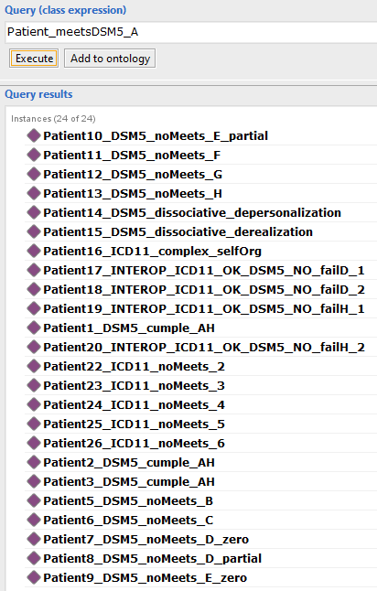 | 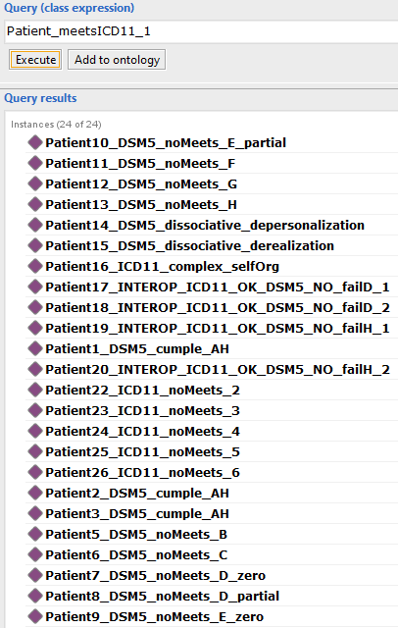
Q2.2 | 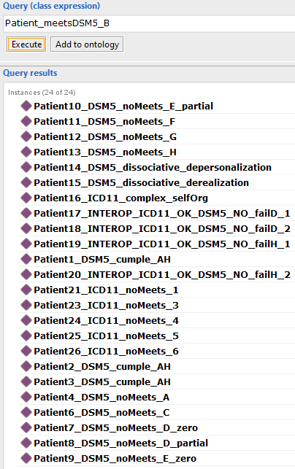 | 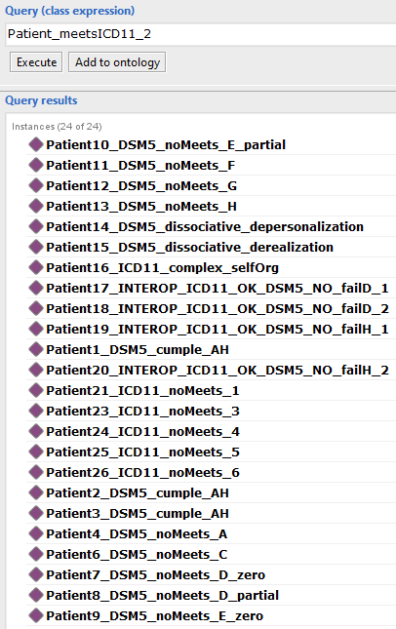
Q2.3 | 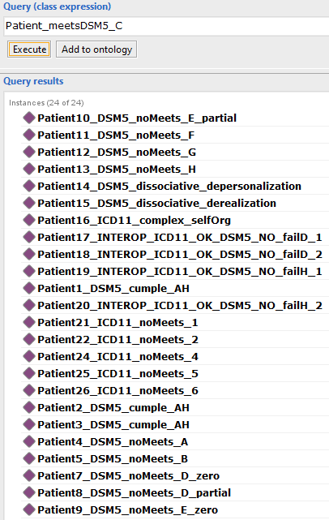 | 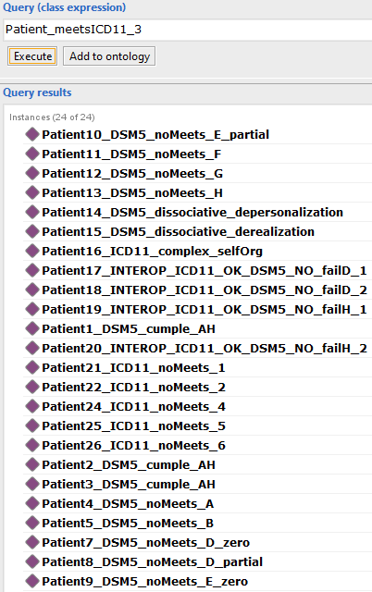
Q2.4 | 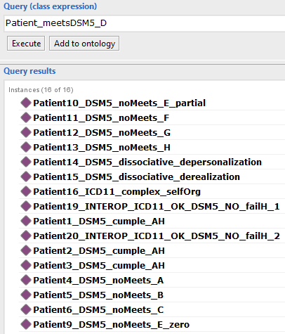 | No aplica
Q2.5 | 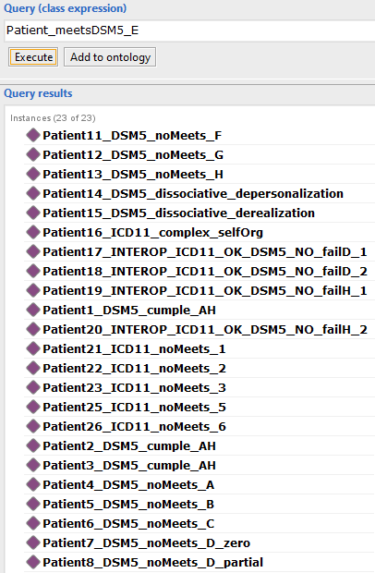 | 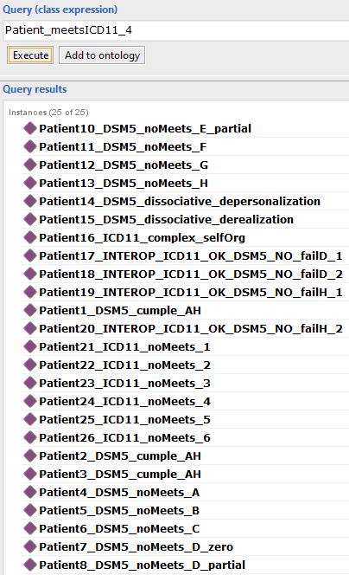

Group B — Combined criteria and full diagnostic profiles
Table S6b-ii. Block 2, Group B: combined criterion and full-profile queries.

ID | Description | Manchester OWL class (simplified) | Expected DSM-5 | Expected ICD-11 | Observed
Q2.6 | Nuclear symptoms only, no cross-sectional criteria | Patient_meetsDSM5_{B,C,D,E} / Patient_meetsICD11_{2,3,4} | 12 | 21 | 12/21
Q2.7 | Trauma + nuclear symptoms, no cross-sectional criteria (F–H / 5–6) | Patient_meetsDSM5_{A–E} / Patient_meetsICD11_{1–4} | 11 | 17 | 11/17
Q2.8 | Full classic PTSD profile (all criteria satisfied) | Patient_meetsPTSD_DSM5 / Patient_meetsPTSD_ICD11 | 3 | 12 | 3/12
Q2.9 | Dissociative PTSD subtype (DSM-5) | Patient_meetsPTSD_WithDissociative_DSM5 | 2 | N/A | 2
Q2.10 | Complex PTSD (ICD-11) | Patient_meetsPTSD_Complex_ICD11 | N/A | 1 | 1

The progressive narrowing from Q2.6 (nuclear symptoms only) through Q2.7 (add trauma exposure) to Q2.8 (add all cross-sectional criteria) confirms that each additional constraint layer correctly reduces the qualifying population. The difference in Q2.8 (12 ICD-11 vs. 3 DSM-5) arises because: (a) ICD-11 does not require AffectiveCognitiveAlteration (no Criterion D equivalent), accounting for patients who fail DSM-5 Criterion D but satisfy all ICD-11 criteria; (b) ICD-11 requires only one hyperarousal symptom vs. two for DSM-5; and (c) ICD-11 has no etiological exclusion criterion (no Criterion H equivalent). The 9 additional ICD-11 patients correspond to profiles that exploit one or more of these three structural differences.

Q2.6 | 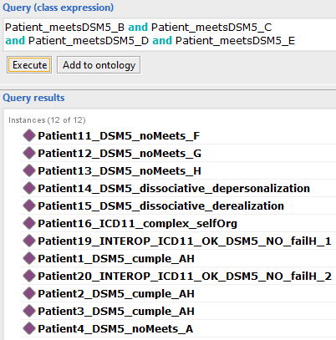 | 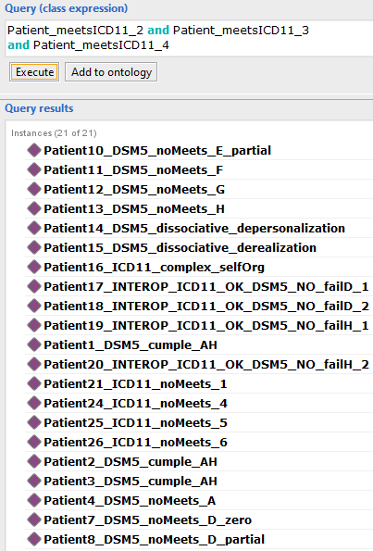
Q2.7 | 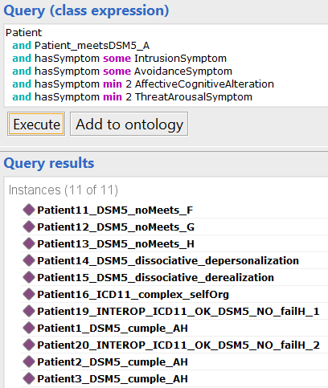 | 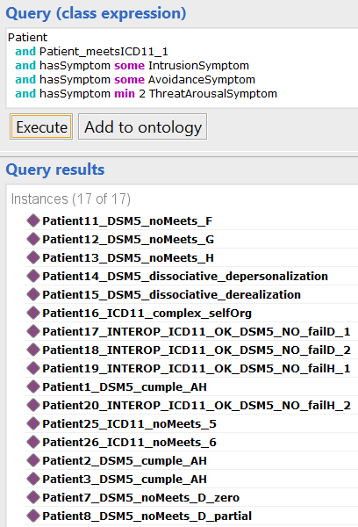
Q2.8 | 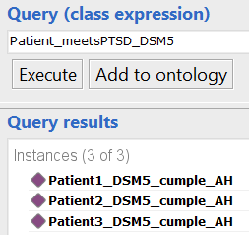 | 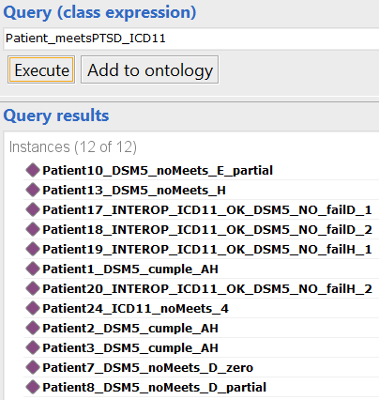
Q2.9 | 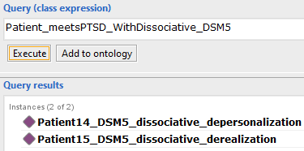 | NA
Q2.10 | NA | 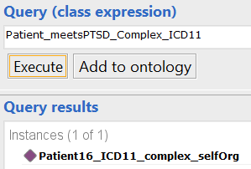

Block 3 — Interoperability and cross-system concordance
Table S6c. Block 3 interoperability queries.

ID | Description | Manchester OWL expression | Expected result | Observed
Q3.1 | Patients concordant under both DSM-5 and ICD-11 | Patient_meetsPTSD_ICD11 and Patient_meetsPTSD_DSM5 | 3 patients | 3
Q3.2 | DSM-5 only — satisfy DSM-5 but not ICD-11 | Patient_meetsPTSD_DSM5 and (not Patient_meetsPTSD_ICD11) | 0 patients | 0
Q3.3 | ICD-11 only — satisfy ICD-11 but not DSM-5 | Patient_meetsPTSD_ICD11 and (not Patient_meetsPTSD_DSM5) | 9 patients | 9
Q3.4 | No diagnosis under either system | Patient and (not Patient_meetsPTSD_DSM5) and (not Patient_meetsPTSD_ICD11) | 6 patients (Group 6 instances) | 6

Q3.2 returning zero patients is the empirical confirmation of the subsumption axiom Patient_meetsPTSD_DSM5 SubClassOf Patient_meetsPTSD_ICD11: every patient satisfying all eight DSM-5 criteria necessarily satisfies the six ICD-11 criteria. Q3.3 confirms the non-axiomatized inverse: nine patients satisfy ICD-11 but not DSM-5, corresponding to the structural flexibility of ICD-11 with respect to Criteria D, E (cardinality), and H. Q3.4 returns the six Group 6 patients, each designed to fail exactly one ICD-11 criterion and none satisfying any complete profile.

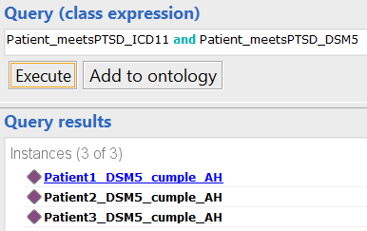 | 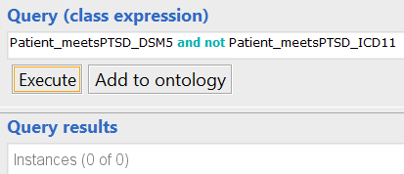
Q3.1 | Q3.2
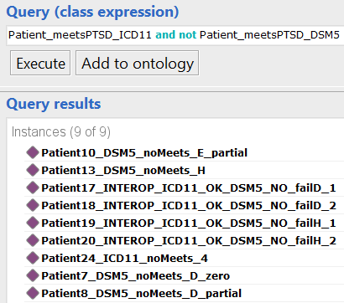
Q3.3 | Q3.4

Supplementary Note S2. Object and Data Property Descriptions
Object properties (18 total)
The following table provides the complete inventory of OnTEPT object properties with domain, range, and inverse (where declared), and a brief description of clinical or semantic purpose. Properties are organized by functional module: assessment, neurophysiological recording, event exposure, symptom representation, and diagnostic determination.
Table S2a. OnTEPT object properties with domain, range, inverse, and semantic purpose.

Property | Domain | Range | Inverse | Purpose
assesses | PsychometricAssessmentInstrument | Patient | isAssessedBy | Links an instrument to the patient it evaluates
isAssessedBy | Patient | PsychometricAssessmentInstrument | assesses | Inverse of assesses
hasEEGRecording | Patient | EEG_Recording | recordsActivityOf | Links a patient to their EEG recording(s)
recordsActivityOf | EEG_Recording | Patient | hasEEGRecording | Inverse of hasEEGRecording
hasEvent | Patient | Event | isExperiencedBy | General event relationship; parent of hasTraumaticEvent
isExperiencedBy | Event | Patient | hasEvent | Inverse of hasEvent
hasTraumaticEvent | Patient | TraumaticEvent | — | Subproperty of hasEvent; range restricted to TraumaticEvent
hasSymptom | Patient | Symptom | isSymptomOfA | General symptom relationship; parent of hasDissociativeSymptom and hasComplexSymptom
isSymptomOfA | Symptom | Patient | hasSymptom | Inverse of hasSymptom
isASymptomOf | Symptom | PTSD_subtypes | — | Links a symptom directly to a PTSD subtype class
hasDissociativeSymptom | Patient | DissociativeSymptom | — | Subproperty of hasSymptom; range restricted to DissociativeSymptom and its subclasses
hasComplexSymptom | Patient | SelfOrganizationDisturbance | — | Subproperty of hasSymptom; range restricted to SelfOrganizationDisturbance and its subclasses
meetsCriterionDSM | Patient | PTSD_DSM_5_DiagnosticCriterion | — | Associates a patient with the DSM-5 criteria they satisfy; used in equivalence axioms
meetsCriterionICD | Patient | PTSD_ICD_11_DiagnosticCriterion | — | Associates a patient with the ICD-11 criteria they satisfy; used in equivalence axioms
meetsDiagnosis | Patient | TraumaAndStressorRelatedDisorders | — | Links a patient to their top-level diagnostic category
evaluatesSymptomCluster | AssessmentInstrument item | DiagnosticCriterion subclass | — | Annotation property mapping instrument items to DSM-5 sub-criteria; does not affect OWL decidability
eegPatternSuggestsCluster | EEG_Recording | Symptom | — | Planned extension property; no axioms defined in current release
hasNonTraumaticEvent | Patient | NonTraumaticEvent | — | Subproperty of hasEvent; used in inconsistency detection via disjointWith axiom

Data properties — demographic (4 properties)
The Person class defines four individual identifying attributes: patientID (string), patientName (string), age (integer), and gender (string). These properties allow consistent identification and integration of clinical, psychometric, and neurophysiological information at the individual level.

Data properties — clinical (7 properties)
The SymptomProperty class defines four attributes with direct diagnostic relevance: duration (integer, expressed in months; used to evaluate DSM-5 Criterion F and ICD-11 Criterion 5), disturbanceClinicallySignificant (boolean; Criteria G and 6), attributableEffectsSubstance (boolean; Criterion H), and description (string; human-readable annotation). The TraumaticEventProperty class adds a Boolean indicator isTraumaticEvent, which distinguishes etiologically valid exposures (true) from non-qualifying events (false). Non-qualifying events are represented by the class NonTraumaticEvent, declared disjoint with TraumaticEvent, enabling the reasoner to detect inconsistencies in patients explicitly typed as PTSD but linked to a non-traumatic event.

Data properties — psychometric items (26 properties)
For PCL-C and PCL-5, a unified naming scheme PCL_ItemX is used. PCL-C activates items PCL_Item1 to PCL_Item17 (integer, range 1–5 per item); PCL-5 activates items PCL_Item1 to PCL_Item20 (integer, range 0–4 per item). A shared total score property PCL_totalScore (integer) is used for both versions, activated according to instrument type. For PC-PTSD-5, properties PC-PTSD_Item1 to PC-PTSD_Item5 (integer, 0 or 1 binary) and PC-PTSD_ItemtotalScore (integer, range 0–5) are defined. For CAPS-5, item-level properties CAPS_ItemX (integer, range 0–4) are defined for all 30 items; these are populated through annotation mappings in the current release rather than by direct scoring instances.

Data properties — EEG features (36 properties under EEGFeatureExtracted, plus structural metadata)
Structural metadata: channel (string), segment (integer), rhythm (string; one of alpha, beta, delta, theta, gamma). Statistical features: mean, median, variance, standardDeviation, kurtosis (all double). Spectral features: fftMaximum, fftMean, fftPeakFrequency, fftVariance (double). Entropy features: shannonEntropy, histogramEntropy, logEnergyEntropy (double). Correlation and asymmetry features: correlationEnergy13, correlationEnergy23, signalAsymmetry, envelopeAsymmetry, asymmetryIndexDecay (double), plus additional asymmetry measures completing the 36-feature set. This inventory was derived from a prior scoping review of quantitative EEG studies in PTSD conducted before ontology construction.

Supplementary Note S3. Reasoner Inconsistency Explanations
The four intentionally inconsistent instances in Group 7 triggered different types of logical contradiction. The descriptions below correspond to the explanations generated by HermiT in Protégé 5.6 for each case. The associated Protégé screenshots are presented in Figures 7–10 of the main manuscript.
INC01 and INC02 — Non-traumatic event with explicit PTSD assertion
Both instances have TraumaticEventProperty = false, which causes them to be classified as NonTraumaticEvent. The ontology declares NonTraumaticEvent owl:disjointWith TraumaticEvent, and the explicit assertion of classic PTSD requires hasEvent some TraumaticEvent. The reasoner identifies a direct contradiction from three axioms: (1) INC01/INC02 rdf:type NonTraumaticEvent; (2) NonTraumaticEvent owl:disjointWith TraumaticEvent; and (3) Patient_meetsPTSD_DSM5 SubClassOf hasEvent some TraumaticEvent. Because no instance can simultaneously belong to two disjoint classes, the reasoner flags both individuals as inconsistent.
INC03 — Explicit classic PTSD label with dissociative symptom
INC03 is explicitly typed as Patient_meetsPTSD_DSM5 (classic PTSD) and has a DepersonalizationSymptom. The EquivalentTo axiom on Patient_meetsDSM5_XDissociative states that any patient with hasDissociativeSymptom some (DepersonalizationSymptom or DerealizationSymptom) belongs to that class. The reasoner infers Patient_meetsPTSD_WithDissociative_DSM5 membership, which is declared disjoint with Patient_meetsPTSD_DSM5. This case demonstrates forward-inference inconsistency detection: the reasoner identifies a contradiction not from a direct assertion, but from the clash between an automatically inferred class membership and an explicit one. The HermiT explanation involves four axioms: the EquivalentTo axiom for Patient_meetsDSM5_XDissociative, the presence of the DepersonalizationSymptom, the EquivalentTo axiom for Patient_meetsPTSD_WithDissociative_DSM5, and the disjointWith declaration.
INC04 — Simultaneous classic and complex PTSD assertion
INC04 is explicitly typed as both Patient_meetsPTSD_DSM5 (classic PTSD) and Patient_meetsPTSD_Complex_ICD11 (complex PTSD). These two classes are declared disjoint because a patient cannot simultaneously meet the DSM-5 classic profile (which excludes dissociative symptoms) and the ICD-11 complex profile (which requires DSO symptoms, a mutually exclusive diagnostic branch). The reasoner detects the violation of the disjointWith axiom directly from the two type assertions. This is the simplest of the four inconsistencies and requires only two axioms for explanation.

Supplementary Figure Descriptions
The following descriptions correspond to supplementary figures referenced in the main text. Image files are included as separate supplementary figure files labeled Figure S1 through Figure S4.

Figure S1. Synthetic patient instance generation scheme
Figure S1 presents the complete set of 30 consistent synthetic patient instances and 4 inconsistent instances generated with Owlready2. The figure is organized by group (1–7 as described in Supplementary Note S1) and shows the diagnostic configuration assigned to each instance, the criteria satisfied and failed, and the expected inference outcome under the DSM-5 and ICD-11 branches. Patient naming follows the convention Patient{n}_{label} for consistent instances and INC0{n}_Patient_{label} for inconsistent ones. The figure corresponds to Figure 1 referenced in the methods section of the main manuscript.
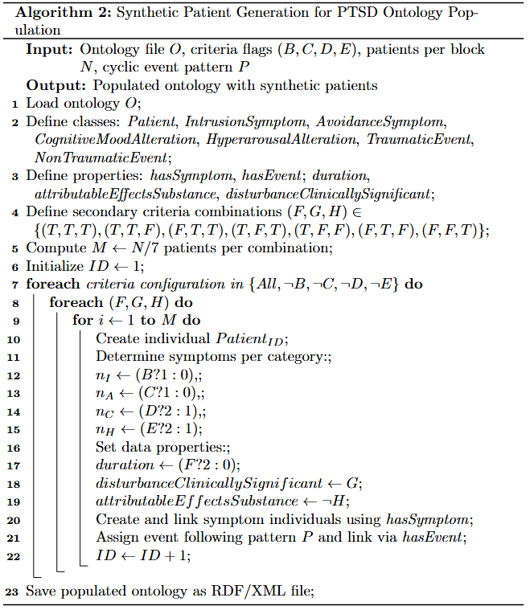

Figure S2. Patient and psychometric instrument instances in Protégé
Figure S2 presents selected instances of the Patient class and the three operationalized psychometric instruments (PCL-C, PCL-5, PC-PTSD-5) as shown in the Protégé 5.6 instance browser. The figure illustrates item-level data property representation: PCL-C instances from Park et al. [66] have properties PCL_Item1 through PCL_Item17 and PCL_totalScore populated; PCL-5 and PC-PTSD-5 instances from du Bois et al. [98] have their corresponding item-level properties populated. The typing of each instance to its specific instrument class (PTSD_Checklist_PCL-C, PTSD_Checklist_PCL5, PrimaryCarePTSD_Screen_PC-PTSD-5) and the linking to Patient via isAssessedBy are also visible.
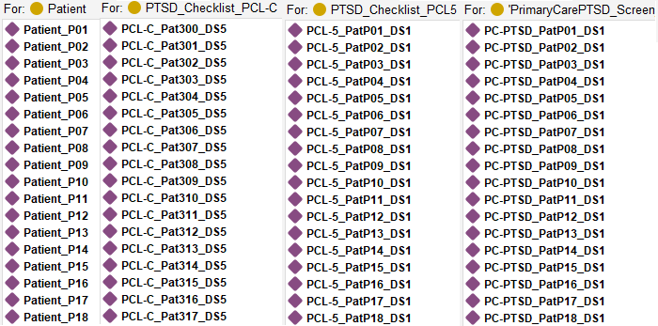

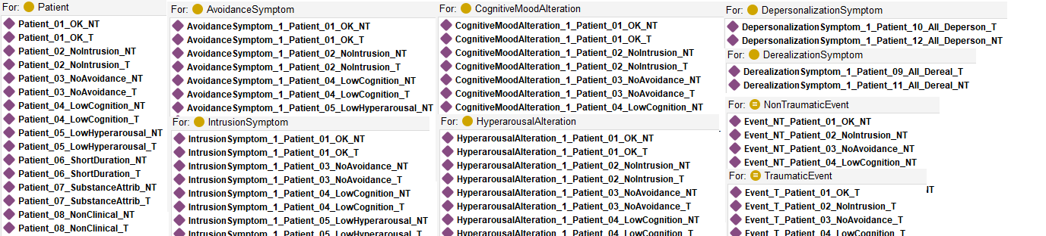

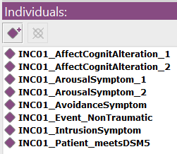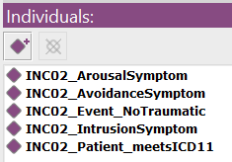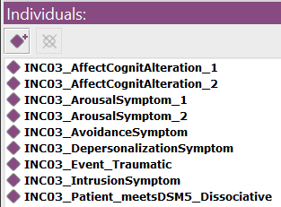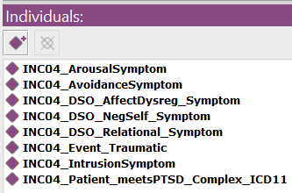
Figure S3. EEG recording instances in Protégé
Figure S3 shows selected EEG_Recording instances linked to Patient instances via hasEEGRecording. Each recording instance displays the band-level structural metadata (channel, segment, rhythm subclass) and a representative selection of the 36 quantitative EEGFeatureExtracted data properties. Instances from Rahmani et al. [32] (12 participants, 31-channel acquisition) and du Bois et al. [98] (29 participants, multichannel) are both represented. The figure confirms the typing of EEG instances to EEG_Recording and to the appropriate rhythm subclass (e.g., AlphaRhythm, BetaRhythm).
