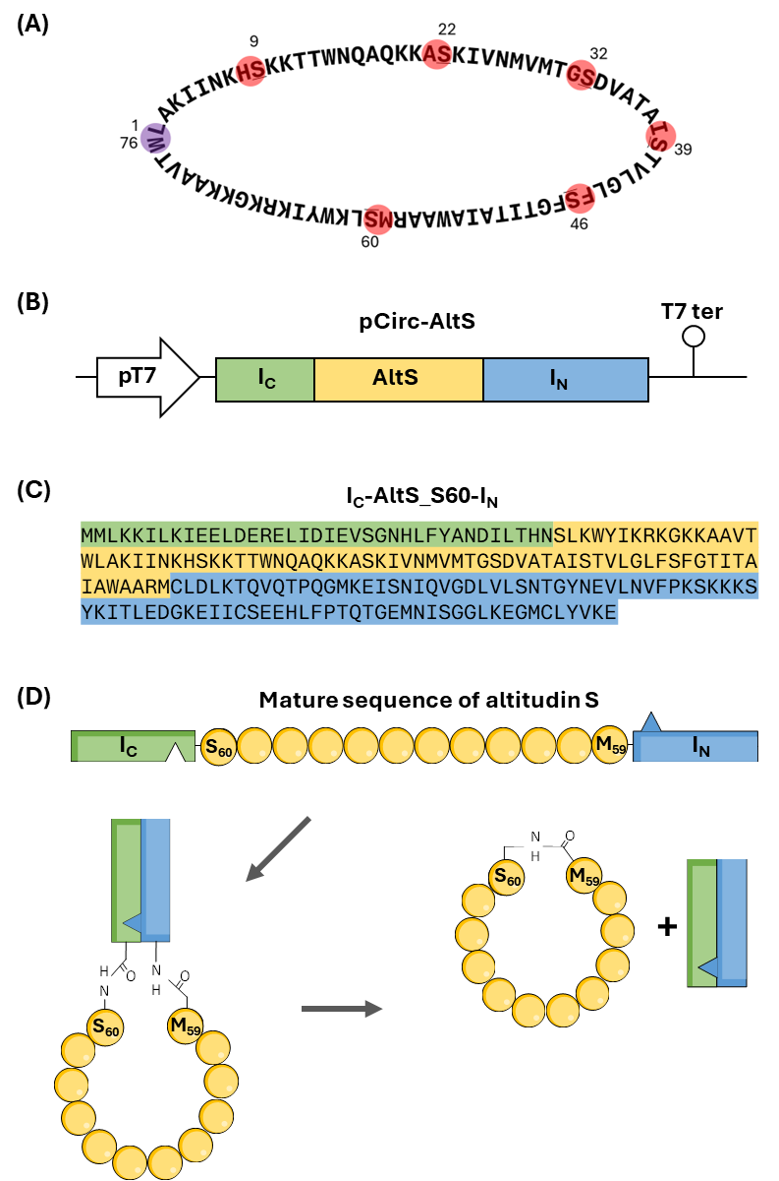

Supplementary Fig. S1 Schematic workflow for the in vitro production of circular altitudin S (AltS) using split Gp41-1 intein and the IV-CFPS/SIML platform. (A) Amino acid sequence of mature AltS. Residues involved in native head-to-tail cyclization are indicated in purple, while those selected for IV-CFPS/SIML-mediated production are shown in red; the serine residue of each pair is underlined and labeled according to its sequence position. (B) Design of the synthetic gene construct, in which the mature AltS sequence is flanked by the C-terminal (I_{C}) and N-terminal (I_{N}) fragments of the split Gp41-1 intein and cloned into a pUC-derived expression vector under the control of a T7 promoter and transcription terminator. (C). Amino acid sequence of the I_{C}-AltS-S60-I_{N} construct encoded by pCirc-AltS-S60. The C-terminal 37-amino acids (I_{C}) and the N-terminal 88-amino acids (I_{N}) of the split Gp41-1 intein are shown in green and blue, respectively, and the AltS sequence is highlighted in yellow. (D) Schematic representation of AltS cyclization mediated by the split Gp41-1 intein. The I_{N} and I_{C} fragments assemble into an active intein that catalyzes protein splicing, resulting in head-to-tail cyclization of the AltS peptide.

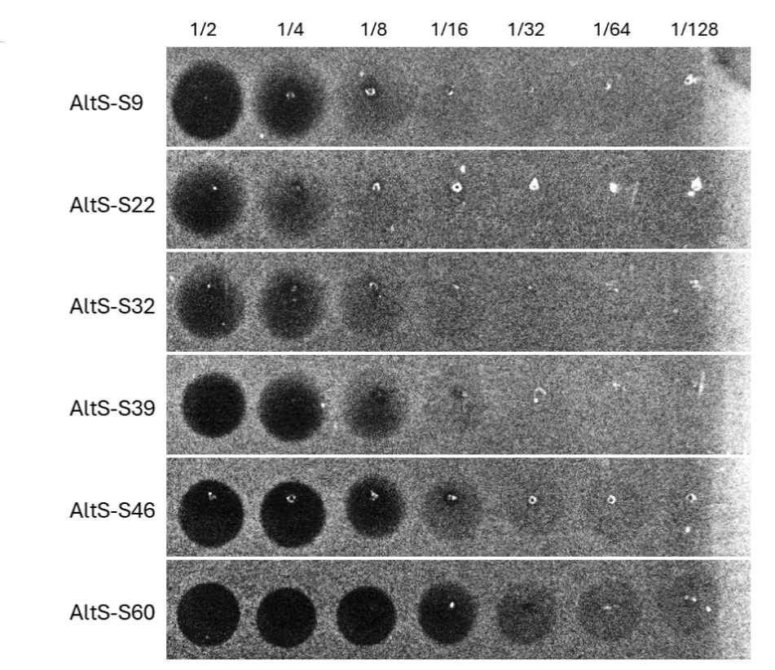
Supplementary Fig. S2 Antimicrobial activity of IV-CFPS/SIML reaction mixtures derived from six pCirc-AltS constructs designed to circularize altitudin S at different serine residues (S9, S22, S32, S39, S46 and S60). Reactions were evaluated against P. damnosus CECT 4797 as the indicator strain by spot-on-agar test (SOAT). Serial twofold dilutions (1:2 to 1:128) were tested. The pCirc-AltS-S60 construct exhibited the highest antimicrobial activity and was selected for subsequent antimicrobial spectrum analysis.

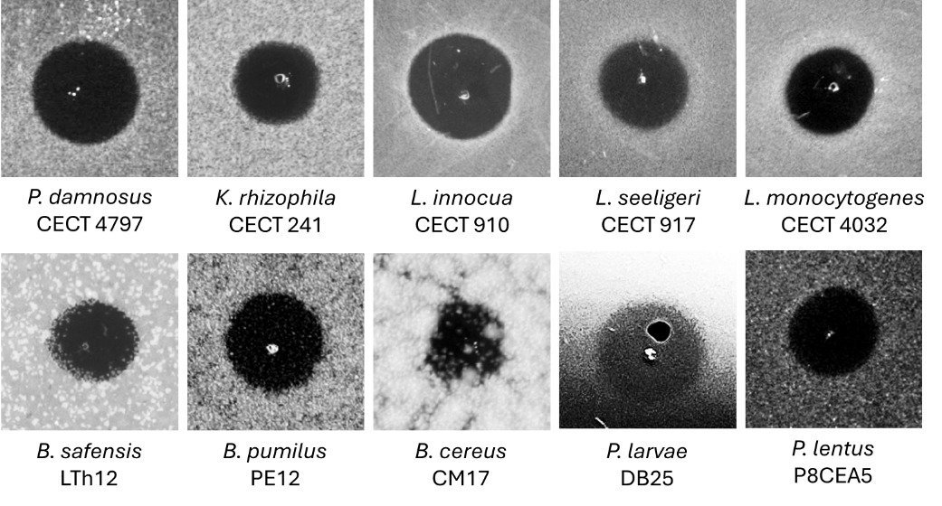
Supplementary Fig. S3 Antimicrobial activity of IV-CFPS/SIML-produced altitudin S derived from the pCir-AltS-S60 construct, evaluated by SOAT against a panel of indicator strains. Samples showing clear inhibition halos were considered positive.

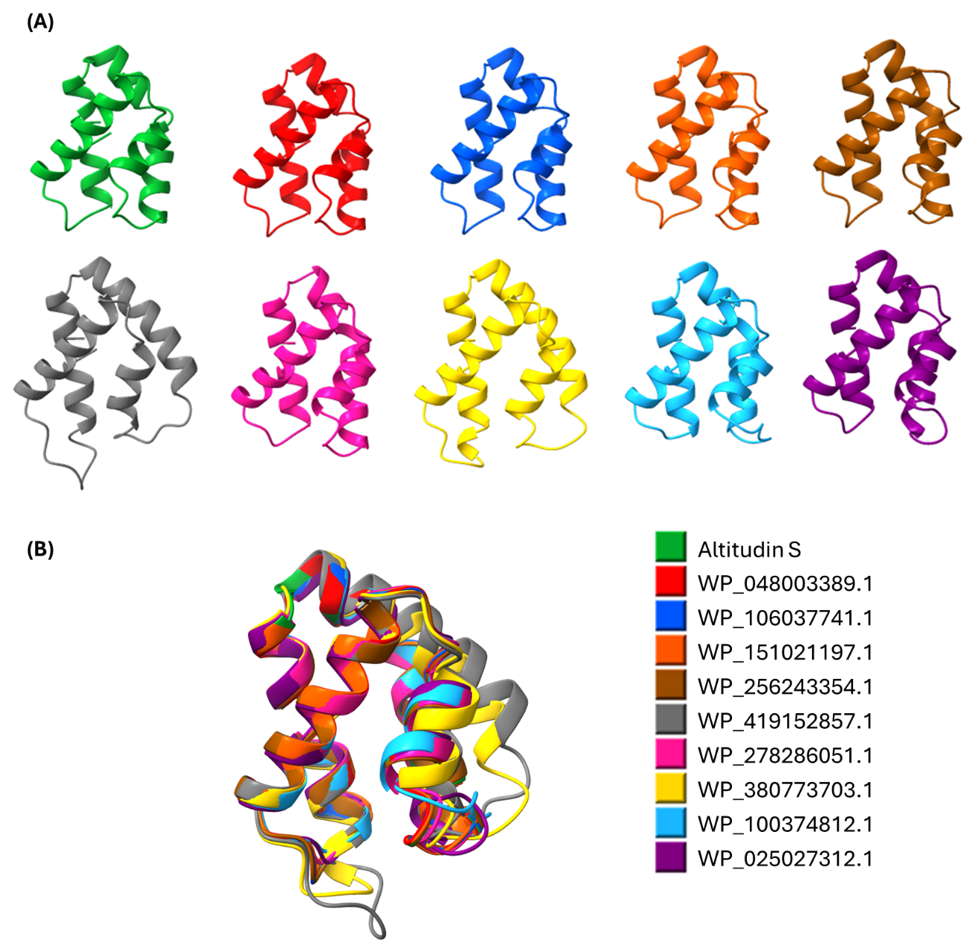

Supplementary Fig. S4 Structural analysis of altitudin S and putative homologs (WP_048003389.1, WP_106037741.1, WP_151021197.1, WP_256243354.1, WP_419152857.1, WP_278286051.1, WP_380773703.1, WP_100374812.1, WP_025027312.1). (A) Predicted 3D structures of altitudin S and homologous circular bacteriocins generated using AlphaFold and rendered in ChimeraX. (B) Structural superposition of the peptides, aligned and rendered in ChimeraX; each peptide is shown in a distinct color.

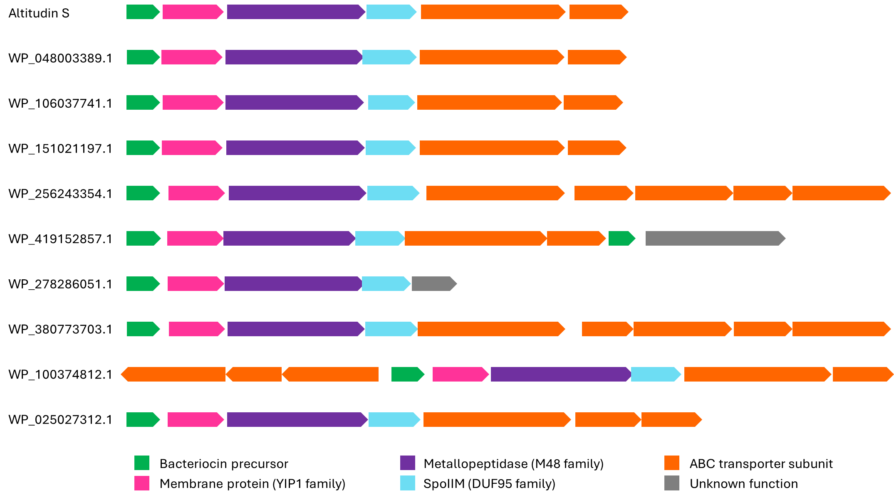
Supplementary Fig. S5 Gene clusters of altitudin S and putative homologs (WP_048003389.1, WP_106037741.1, WP_151021197.1, WP_256243354.1, WP_419152857.1, WP_278286051.1, WP_380773703.1, WP_100374812.1, WP_025027312.1). Open reading frames (ORFs) are represented as arrows and color-coded according to their predicted function.

Supplementary Table S1 Origin, growth media, and incubation conditions of the bacterial indicator strains used in this study.
Strain | Originª | Growth medium | Incubation conditions
Escherichia coli DH5α | Thermofisher | LB | 37 °C/ Agitation
Salmonella paratyphi CECT 554 | CECT | BHI | 37 °C/ Aerobiosis
Salmonella Cholerasuis ZTA18/02215 | VISAVET | BHI | 37 °C/ Aerobiosis
Pseudomonas aeruginosa CECT 108 | CECT | BHI | 37 °C/ Aerobiosis
Acinetobacter baylyi ATCC 33305 | ATCC | BHI | 37 °C/ Aerobiosis
Fusobacterium nucleatum DSMZ 20482 | DSMZ | BHI | 37 °C/ Anaerobiosis
Porphyromonas gingivalis ATCC 33277 | ATCC | BHI | 37 °C/ Anaerobiosis
Staphylococcus aureus ZTA11/00117ST | VISAVET | BHI | 37 °C/ Aerobiosis
Staphylococcus aureus DICM10/00243 | VISAVET | BHI | 37 °C/ Aerobiosis
Enterococcus faecium ER46 | VISAVET | MRS | 37 °C/ Aerobiosis
Enterococcus faecalis 12Ep11 | DNBTA | MRS | 37 °C/ Aerobiosis
Lactococcus garvieae CECT 5806 | CECT | MRS | 32 °C/ Aerobiosis
Lactococcus lactis IL1403 | DNBTA | MRS | 32 °C/ Aerobiosis
Pediococcus damnosus CECT 4797 | CECT | MRS | 32 °C/ Aerobiosis
Pediococcus pentosaceus FBB61 | DNBTA | BHI | 32 °C/ Aerobiosis
Listeria monocytogenes CECT 4032 | CECT | BHI | 37 °C/ Aerobiosis
Listeria innocua CECT 910 | CECT | BHI | 37 °C/ Aerobiosis
Listeria seeligeri CECT 917 | CECT | BHI | 37 °C/ Aerobiosis
Bacillus pumilus PE12 | DNBTA | BHI | 37 °C/ Aerobiosis
Bacillus safensis LTh12 | DNBTA | BHI | 37 °C/ Aerobiosis
Bacillus cereus CM7 | DNBTA | BHI | 37 °C/ Aerobiosis
Bacillus toyonensis NM11 | DNBTA | BHI | 37 °C/ Aerobiosis
Paenibacillus larvae DB25 | DNBTA | BHI | 37 °C/ Aerobiosis
Paenibacillus dendritiformis P1CEA1 | DNBTA | BHI | 37 °C/ Aerobiosis
Paenibacillus lentus P8CEA5 | DNBTA | BHI | 37 °C/ Aerobiosis
Paenibacillus polymyxa SFU2431 | DNBTA | BHI | 37 °C/ Aerobiosis
Kocuria rhizophila CECT 241 | CECT | BHI | 37 °C/ Aerobiosis
Streptococcus suis CECT 958 | CECT | BHI | 37 °C/ Aerobiosis
Streptococcus agalactiae ICM21/01900 | VISAVET | BHI | 37 °C/ Aerobiosis
Streptococcus mutans ATCC 25175 | ATCC | BHI | 37 °C/ Aerobiosis
Clostridium perfringens DICM15/00067-5A | VISAVET | BHI | 37 °C/ Anaerobiosis
Erysipelothrix rhusiopathiae ICM21/01900 | VISAVET | BHI | 37 °C/ 5% CO₂
Corynebacterium pseudotuberculosis Cam2 | VISAVET | BHI | 37 °C/ Aerobiosis
Trueperella pyogenes ICM17/02091-1 | VISAVET | BHI | 37 °C/ 5% CO₂
ª DNBTA: Departamento de Nutrición, Bromatología y Tecnología de los Alimentos, Facultad de Veterinaria, Universidad Complutense de Madrid (UCM), Madrid, (Spain). VISAVET: Centro de Vigilancia Sanitaria Veterinaria, Universidad Complutense de Madrid (UCM), Madrid, (Spain). CECT: Colección Española de Cultivos Tipo, Valencia, (Spain). ATCC: American Type Culture Collection. DSMZ: Leibniz Institute DSMZ - German Collection of Microorganisms and Cell Culture.

Supplementary Table S2 LC–MS/MS identification of altitudin S-derived peptides. Tryptic peptides detected in purified CFS from B. altitudinis ECC22 were analyzed by LC–MS/MS. Two peptides, TTWNQAQK and AAVTWLAK, were identified, both mapping to the predicted mature sequence of altitudin S (highlighted in yellow). Notably, AAVTWLAK spans residues L1 and W76, confirming the head-to-tail cyclization junction. Theoretical MH⁺ values and corresponding observed m/z are reported.

LAKIINKHSKKTTWNQAQKKASKIVNMVMTGSDVATAISTVLGLFSFGTITAIAWAARMSLKWYIKRKGKKAAVTW

Peptide Sequence | Theoretical MH+ (Da) | Detected m/z
AAVTWLAK | 859.50361 | 430.25534
TTWNQAQK | 976.48467 | 488.74573

Supplementary Table S3 General properties of altitudin S homologs identified by BLASTp. Amino acid sequences and predicted physicochemical parameters of altitudin S and its homologs identified across diverse Bacillales species. Reported properties include mature peptide length (aa), molecular mass (Da; corrected for circularization by subtracting 18 Da), theoretical isoelectric point (pI), net charge at pH 7.0, aliphatic index, and GRAVY (Grand Average of Hydropathy). Homologs were retrieved from GenBank, and corresponding accession numbers and producer organisms are indicated.
Bacteriocin | Producer organism | Mature sequence | Length of mature sequence (aa) | Molecular mass (Da) | Theore-tical pI | Net charge | Aliphatic index | GRAVY | Genome GenBank
Altitudin S | Bacillus altitudinis | LAKIINKHSKKTTWNQAQKKASKIVNMVMTGSDVATAISTVLGLFSFGTITAIAWAARMSLKWYIKRKGKKAAVTW | 76 | 8379 | 11.00 | 13 | 90.00 | 0.025 | CP137888
WP_048003389.1 | Bacillus altitudinis | LAKIINKYSKKTTWNQAQKKASKIVNMVMTGSDVASAISIVLGAFSFGTITAIAWAARMSLKWYIKRKGKKAAVTW | 76 | 8361 | 10.75 | 13 | 91.32 | 0.091 | JAWVNE010000001
WP_106037741.1 | Bacillus pumilus | LAKIINKYSKKTTWNQAQKKASKIVNMVMTGSDVASAISIVLGAFSFGTVTAIAWAARMSLKWYIKRKGKKAAVTW | 76 | 8347 | 10.75 | 13 | 90.00 | 0.087 | VKQA01000100
WP_151021197.1 | Bacillus pumilus | LAKIINKYSKKTTWNQAQKQASKIVNMVMTGSDVASAISIVLGAFSFGTVTAIAWAARMSLKWYIKRKGKKAAVTW | 76 | 8347 | 10.72 | 12 | 90.00 | 0.092 | JAKOBC010000001
WP_256243354.1 | Bacillus spp. | LAKIINKYSKKTTWNQAQQKAKKIVNLVMTGSDIAAAVSLVLGFFSFGTITAIAWVARMSLKYYIKRKGRRAAVTW | 76 | 8505 | 10.95 | 13 | 98.95 | 0.129 | JAETXM010000001
WP_419152857.1 | Aeribacillus alveayuensis | LAQVIYKYSRKDKNDKRITWNESQQKASKIVNMVLTGSDVASAISVVLGFFSFGTVTAIAWAARMTLKWYIKKKGRKKAVTW | 82 | 9311 | 10.42 | 12 | 86.83 | -0.177 | JAUSTR010000001
WP_380773703.1 | Siminovitchia sediminis | LAQVIYKYGKKNKKITWNESQKRASKIVNLVITGSDIASAISIVLGFLSFGIVTAIAWAARMTLKWYIKKKGRQKAVTW | 79 | 8883 | 10.58 | 13 | 107.47 | 0.086 | JBHUEO010000001
WP_278286051.1 | Evansella spp. | LARVINNHTKYTWNQSQSYASRIVNMVMVGSDIAAAVSIVLGFLSFGVVTAITWAARMSLKWYINRKGRREAVLW | 75 | 8471 | 11.00 | 7 | 104.00 | 0.272 | JARUKY010000001
WP_100374812.1 | Bacillus spp. | LAQQINKHSKKTWNQSQTQASKIVNLVMNGSDVYTAVTAVIGVFTFGWGFAIISAAQLSLKWYIKKKGRKAAVTW | 75 | 8311 | 10.42 | 9 | 91.07 | -0.005 | KZ454938
WP_025027312.1 | Caldalkalibacillus mannanilyticus | LAQQINKLSSKTWNQSQTMASKIVNLIMNGHDVYTAISAVVGIVTFGWGFALITVAQLSLKWYIKRKGKKAAVTW | 75 | 8307 | 10.36 | 8 | 105.33 | 0.219 | BAMO01000108

Supplementary Table S4 General physicochemical properties of circular bacteriocins, including producer organisms and GenBank accession numbers.
Bacteriocin | Sub-group | Length of leader sequence (aa) | Length of mature sequence (aa) | Molecular mass (Da) | Theore-tical pI | Net charge | Aliphatic index | GRAVY | Producer organism/ strain | Isolation sourceª | Reference
Altitudin S |  | 56 | 76 | 8379 | 11.0 | 13 | 90.0 | 0.025 | Bacillus altitudinis ECC22 | Soil | Present study
Garvicin ML | i | 3 | 60 | 6007 | 10.1 | 5 | 115.8 | 0.887 | Lactococcus garvieae DCC43 | Duck intestines | [1]
Carnocyclin A | i | 4 | 60 | 5862 | 10.0 | 4 | 144.7 | 1.058 | Carnobacterium maltaromaticum UAL307 | Fresh pork | [2]
Bacicyclicin XIN-1 | i | 4 | 60 | 5852 | 10.3 | 3 | 115.8 | 0.877 | Bacillus sp. Xin1 | Soil | [3]
Aureocyclicin 4185 | i | 4 | 60 | 5608 | 10.0 | 3 | 125.5 | 0.973 | Staphylococcus aureus 4185 | Bovine mastitis | [4]
Raffinocyclicin | i | 3 | 61 | 6092 | 9.5 | 2 | 117.1 | 0.872 | Lactococcus raffinolactis APC 3967 | Raw milk | [5]
Leucocyclicin Q | i | 2 | 61 | 6115 | 9.5 | 2 | 131.5 | 0.744 | Leuconostoc mesenteroides TK41401 | Japanese pickles | [6]
Lactocyclicin Q | i | 2 | 61 | 6060 | 9.7 | 2 | 126.7 | 0.826 | Lactococcus sp. QU 12 | Cheese | [7]
Amylocyclicin | i | 48 | 64 | 6382 | 9.8 | 5 | 125.5 | 0.850 | Bacillus amyloliquefaciens FZB42 | Soil | [8]
Amylocyclicin CMW1 | i | 47 | 64 | 6352 | 9.8 | 5 | 127.0 | 0.889 | Bacillus amyloliquefaciens CMW1 | Japanese fermented soybean paste | [9]
Enterocin NKR-5-3B | i | 23 | 64 | 6317 | 9.9 | 5 | 134.4 | 0.953 | Enterococcus faecium NKR-5-3B | Thai fermented fish | [10]
Altitudin A | i | 49 | 65 | 6598 | 10.0 | 5 | 123.2 | 0.723 | Bacillus altitudinis ECC22 | Soil | [11]
Pneumocyclicin | i | 34 | 64 | 6156 | 10.1 | 5 | 137.3 | 1.128 | Streptococcus pneumoniae (various) | ND | [12]
Caledonicin | i | 32 | 64 | 6077 | 10 | 3 | 120.8 | 0.995 | Staphylococcus caledonicus APC 4137 | Healthy domestic dog | [13]
Flexusin A | i | 6 | 60 | 6098 | 9.6 | 3 | 130.3 | 0.992 | Bacillus flexus R29-2 | Marine environment | [14]
Enterocin AS-48 | i | 35 | 70 | 7150 | 10.1 | 6 | 117.1 | 0.539 | Enterococcus faecalis subsp. liquefaciens S-48 | Human wound exudate | [15]
Pumilarin | i | 38 | 70 | 7087 | 10.0 | 5 | 125.4 | 0.579 | Bacillus pumilus B4107 | Reisentopf with chicken | [16]
Uberolysin A | i | 6 | 70 | 7048 | 9.6 | 3 | 132.6 | 0.937 | Streptococcus uberis 42 | Cow mammary secretion | [17]
Circularin A | i | 3 | 69 | 6771 | 10.5 | 4 | 124.6 | 1.007 | Clostridium beijerinckii ATCC 25752 | Soil | [18]
Plantaricyclin A | ii | 33 | 58 | 5571 | 8.6 | 1 | 128.1 | 1.057 | Lactobacillus plantarum NI326 | Olives | [19]
Plantacyclin B21AG | ii | 33 | 58 | 5668 | 10.0 | 2 | 131.4 | 1.002 | Lactobacillus plantarum B21 | Vietnamese fermented sausage | [20]
Acidocin B | ii | 33 | 58 | 5622 | 6.8 | 0 | 121.7 | 1.036 | Lactobacillus acidophilus M46 | Human feces | [21]
Paracyclicin | ii | 24 | 58 | 5907 | 6.7 | 0 | 114.5 | 1.003 | Lactobacillus paracasei subsp. paracasei DSM 5622 | ND | [22]
Butyrivibriocin AR10 | ii | 22 | 58 | 5982 | 4.0 | -2 | 114.7 | 1.002 | Butyrivibrio fibrisolvens AR10 | Rumen | [23]
Safencin E | ii | 35 | 58 | 5998 | 4.4 | -1 | 118.3 | 0.979 | Bacillus safensis APC 4099 | Bees' gut | [24]
ª ND: no dated

References
1. Borrero J, Brede DA, Skaugen M, et al (2011) Characterization of garvicin ML, a novel circular bacteriocin produced by lactococcus garvieae DCC43, isolated from mallard ducks (Anas platyrhynchos). Appl Environ Microbiol 77:369–373. https://doi.org/10.1128/AEM.01173-10
2. Martin-Visscher LA, Van Belkum MJ, Garneau-Tsodikova S, et al (2008) Isolation and characterization of carnocyclin A, a novel circular bacteriocin produced by Carnobacterium maltaromaticum UAL307. Appl Environ Microbiol 74:4756–4763. https://doi.org/10.1128/AEM.00817-08
3. Xin B, Xu H, Liu H, et al (2021) Identification and characterization of a novel circular bacteriocin, bacicyclicin XIN-1, from Bacillus sp. Xin1. Food Control 121:107696. https://doi.org/10.1016/J.FOODCONT.2020.107696
4. Potter A, Ceotto H, Coelho MLV, et al (2014) The gene cluster of aureocyclicin 4185: The first cyclic bacteriocin of Staphylococcus aureus. Microbiology (United Kingdom) 160:917–928. https://doi.org/10.1099/MIC.0.075689-0
5. Farias FM de, O’Connor PM, Buttimer C, et al (2024) Raffinocyclicin is a novel plasmid-encoded circular bacteriocin produced by Lactococcus raffinolactis with broad-spectrum activity against many gram-positive food pathogens. Appl Environ Microbiol 90. https://doi.org/10.1128/AEM.00809-24
6. de Farias FM, Soria MC, O’Connor PM, et al (2025) Leuconostoc lactis strain APC 3969 produces a new variant of cyclic bacteriocin leucocyclicin Q and displays potent anti-Clostridium perfringens activity. Sci Rep 15:1–14. https://doi.org/10.1038/S41598-025-89450-X
7. Sawa N, Zendo T, Kiyofuji J, et al (2009) Identification and characterization of lactocyclicin Q, a novel cyclic bacteriocin produced by lactococcus sp. strain QU 12. Appl Environ Microbiol 75:1552–1558. https://doi.org/10.1128/AEM.02299-08
8. Scholz R, Vater J, Budiharjo A, et al (2014) Amylocyclicin, a novel circular bacteriocin produced by Bacillus amyloliquefaciens FZB42. J Bacteriol 196:1842–1852. https://doi.org/10.1128/JB.01474-14
9. Kurata A, Yamaguchi T, Kira M, Kishimoto N (2019) Characterization and heterologous expression of an antimicrobial peptide from Bacillus amyloliquefaciens CMW1. Biotechnology and Biotechnological Equipment 33:886–893. https://doi.org/10.1080/13102818.2019.1627246
10. Ishibashi N, Himeno K, Fujita K, et al (2012) Purification and characterization of multiple bacteriocins and an inducing peptide produced by Enterococcus faecium NKR-5-3 from Thai fermented fish. Biosci Biotechnol Biochem 76:947–953. https://doi.org/10.1271/BBB.110972
11. Lafuente I, Sevillano E, Peña N, et al (2024) Production of Pumilarin and a Novel Circular Bacteriocin, Altitudin A, by Bacillus altitudinis ECC22, a Soil-Derived Bacteriocin Producer. Int J Mol Sci 25:2020. https://doi.org/10.3390/IJMS25042020
12. Bogaardt C, van Tonder AJ, Brueggemann AB (2015) Genomic analyses of pneumococci reveal a wide diversity of bacteriocins - including pneumocyclicin, a novel circular bacteriocin. BMC Genomics 16:1–16. https://doi.org/10.1186/S12864-015-1729-4
13. O’Connor M, O’Connor PM, Hourigan D, et al (2024) Screening canine sources for novel antimicrobials reveals the circular broad-spectrum bacteriocin, caledonicin, produced by Staphylococcus caledonicus. Front Microbiol 15:1470988. https://doi.org/10.3389/FMICB.2024.1470988
14. Qiao X, Sun X, Wang S, et al (2025) Characterization of Flexusin A, a Novel Circular Bacteriocin Produced by Marine Bacterium Bacillus flexus R29-2. Mar Drugs 23:95. https://doi.org/10.3390/MD23030095
15. Galvez A, Maqueda M, Valdivia E, et al (1986) Characterization and partial purification of a broad spectrum antibiotic AS-48 produced by Streptococcus faecalis. Can J Microbiol 32:765–771. https://doi.org/10.1139/M86-141
16. van Heel AJ, Montalban-Lopez M, Oliveau Q, Kuipers OP (2017) Genome-guided identification of novel head-to-tail cyclized antimicrobial peptides, exemplified by the discovery of pumilarin. Microb Genom 3:e000134. https://doi.org/10.1099/MGEN.0.000134
17. Wirawan RE, Swanson KM, Kleffmann T, et al (2007) Uberolysin: a novel cyclic bacteriocin produced by Streptococcus uberis. Microbiology (N Y) 153:1619–1630. https://doi.org/10.1099/MIC.0.2006/005967-0
18. Kemperman R, Kuipers A, Karsens H, et al (2003) Identification and characterization of two novel clostridial bacteriocins, circularin A and closticin 574. Appl Environ Microbiol 69:1589–1597. https://doi.org/10.1128/AEM.69.3.1589-1597.2003
19. Borrero J, Kelly E, O’Connor PM, et al (2017) Plantaricyclin A, a Novel Circular Bacteriocin Produced by Lactobacillus plantarum NI326: Purification, Characterization, and Heterologous Production. Appl Environ Microbiol 84:. https://doi.org/10.1128/AEM.01801-17
20. Golneshin A, Gor MC, Williamson N, et al (2020) Discovery and characterisation of circular bacteriocin plantacyclin B21AG from Lactiplantibacillus plantarum B21. Heliyon 6:e04715. https://doi.org/10.1016/J.HELIYON.2020.E04715
21. Brink B ten, Minekus M, van der Vossen JMBM, et al (1994) Antimicrobial activity of lactobacilli: preliminary characterization and optimization of production of acidocin B, a novel bacteriocin produced by Lactobacillus acidophilus M46. Journal of Applied Bacteriology 77:140–148. https://doi.org/10.1111/J.1365-2672.1994.TB03057.X
22. Collins FWJ, O’Connor PM, O’Sullivan O, et al (2017) Bacteriocin Gene-Trait matching across the complete Lactobacillus Pan-genome. Sci Rep 7:1–14. https://doi.org/10.1038/S41598-017-03339-Y
23. Kalmokoff ML, Teather RM (1997) Isolation and characterization of a bacteriocin (butyrivibriocin AR10) from the ruminal anaerobe Butyrivibrio fibrisolvens AR10: Evidence in support of the widespread occurrence of bacteriocin-like activity among ruminal isolates of B. fibrisolvens. Appl Environ Microbiol 63:394–402. https://doi.org/10.1128/AEM.63.2.394-402.1997
24. Kamilari E, O’Connor PM, de Farias FM, et al (2025) Bacillus safensis APC 4099 has broad-spectrum antimicrobial activity against both bacteria and fungi and produces several antimicrobial peptides, including the novel circular bacteriocin safencin E. Appl Environ Microbiol 91:. https://doi.org/10.1128/AEM.01942-24

