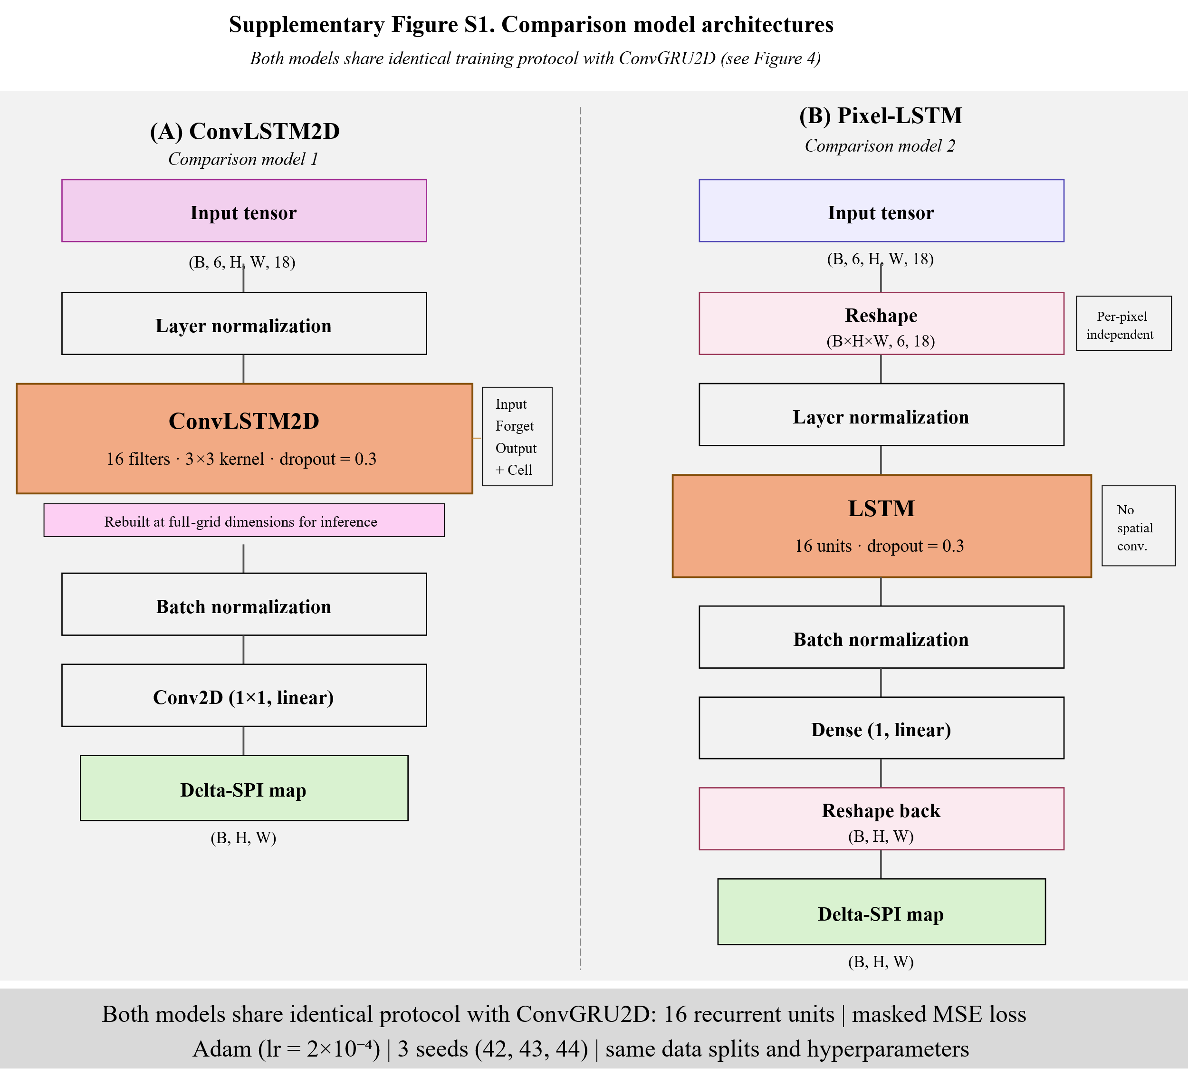
Figure S1. Comparison model architectures. (A) ConvLSTM2D replaces the two-gate ConvGRU cell with a three-gate ConvLSTM cell (input, forget, output) maintaining an additional cell state. The model is rebuilt at full-grid dimensions for test-time inference with trained weights transferred. (B) Pixel-LSTM removes spatial convolution by reshaping the input into per-pixel temporal sequences, applying a standard LSTM independently at each grid cell, and reshaping the output back to map form. Both models share identical training protocols with ConvGRU2D: 16 recurrent units, masked MSE loss, Adam optimizer (lr = 2x10⁻⁴), three random seeds (42, 43, 44), and identical data splits.
Supplementary material

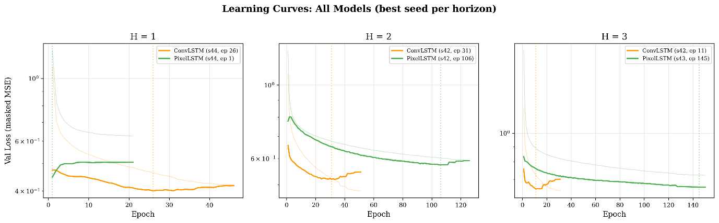
Figure S2. Validation loss curves for ConvLSTM2D and Pixel-LSTM (best seed per horizon). ConvLSTM2D exhibits erratic convergence behavior at H = 3, while several Pixel-LSTM runs failed to train beyond epoch 1, reflecting training instability when spatial context is removed.

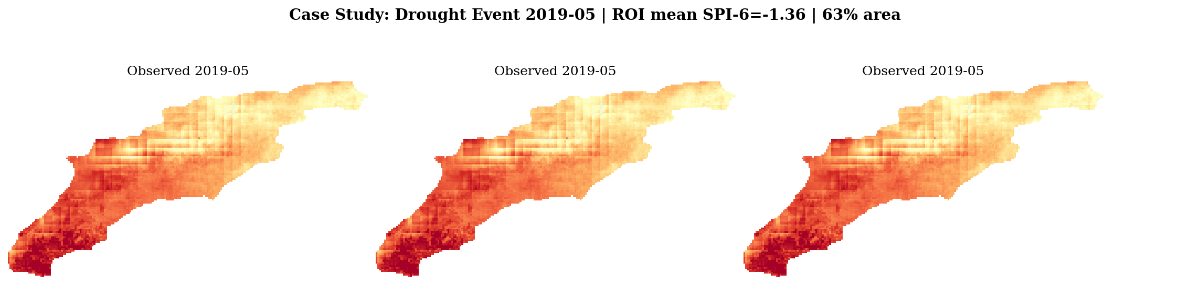
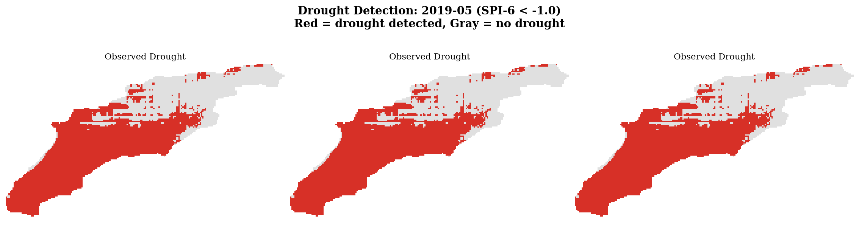
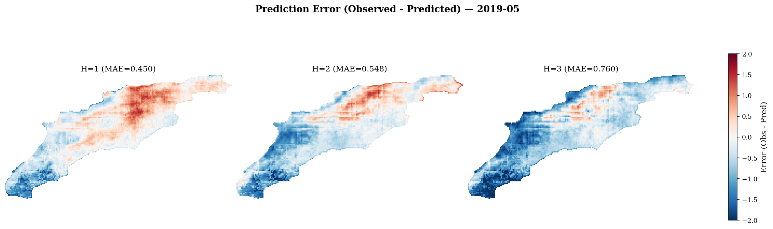
Figure S3. Case study: May 2019 drought event (validation period, ROI-mean SPI-6 = -1.36, 63% area under moderate drought). (A) Continuous SPI-6 fields: observed (top row), damped-persistence predictions (middle row), and ConvGRU predictions (bottom row) at H = 1, 2, and 3. Per-panel metrics (RMSE, correlation, POD) are annotated. (B) Binary drought detection (SPI-6 < -1.0): same layout, with per-panel POD and CSI annotated. The ConvGRU detects 90% of the drought area at H = 1 (POD = 0.90, CSI = 0.79), while damped persistence detects less than 2% at all lead times.

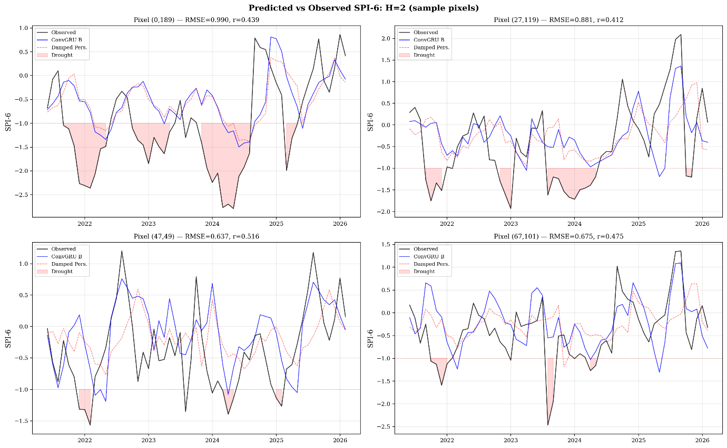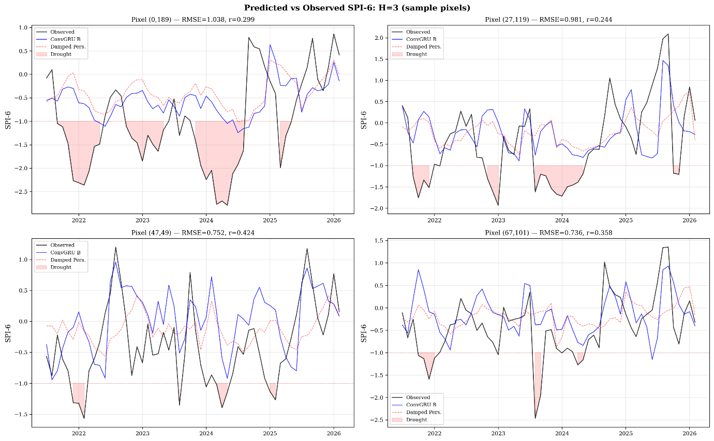
Figure S4. Predicted versus observed SPI-6 time series at four representative pixels for H = 2 and H = 3. Black: observed; blue: ConvGRU; red dashed: damped persistence. Pink shading indicates observed drought periods (SPI-6 < -1.0). Per-pixel RMSE and correlation are shown above each panel. Forecast skill degrades with increasing lead time, consistent with the predictability boundary established in the main text.

