Supplementary material
Table 1: Marine litter items tested with reference codes from OSPAR, TSG-ML, geographical origin and sample ID
 |  |  |  | sample ID
Item class | Material | OSPAR | TSG-ML | Baltic Sea | Morocco | Egypt | Tunisia | Galicia | Italy | NE Atlantic
Strings & Cords | Plastic | 32 | G50 | 136A | 157B | 160B | 161B | 153E
Plastic Caps | Plastic | 15 | G21–G23 | 136C | 157A | 160A | 161A | 153A
Foam (Packaging, Insulation, Polyurethane) | Plastic | 45 | G73–G74 | 136D | 157C | 160C | 161C | 153B |  | REP-05
Cigarette Butts and Filters | Plastic | 64 | G27 | 136E | 157D | 160D | 161D | 153C
Bottle Caps, Lids, Pull Tabs | Metal | 77 | G178 | 136G |  |  |  | 153D
Plastic bottles | Plastic | 4 | G6 |  |  |  |  |  | ID094-RSP | REP-01
Aquaculture - Fisheries | Plastic | 28 | G45 |  |  |  |  |  | ID091-RSP | REP-02,  REP-03,  REP-04

Figure A: Photos of tested items
*Photos for items: REP-05 (piece of insulating cork) & REP-04 (buoy) are missing.

Strings & Cords
136A
157B
160B
161B
153E

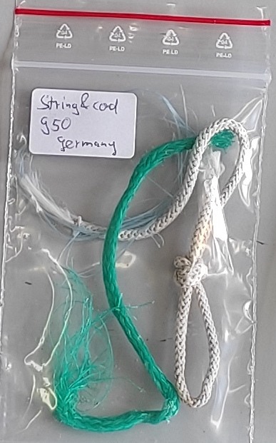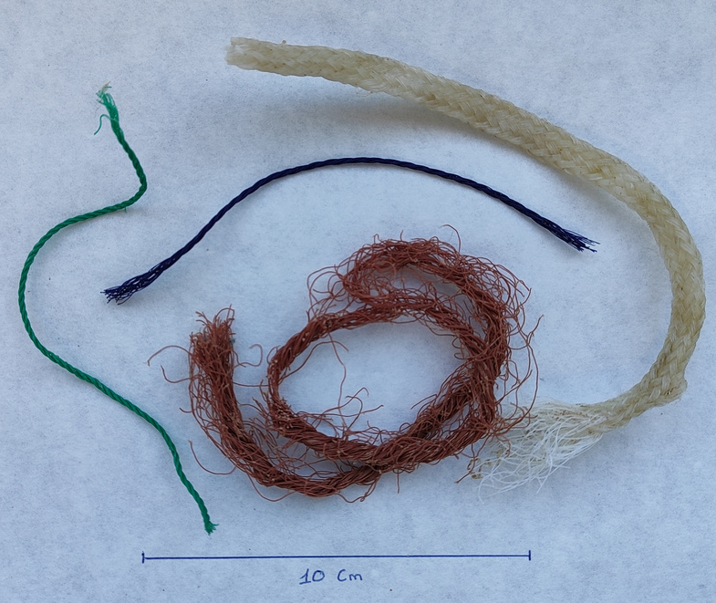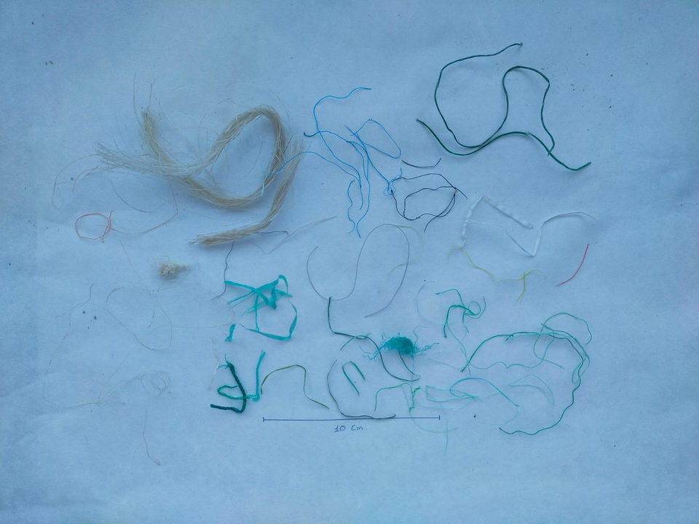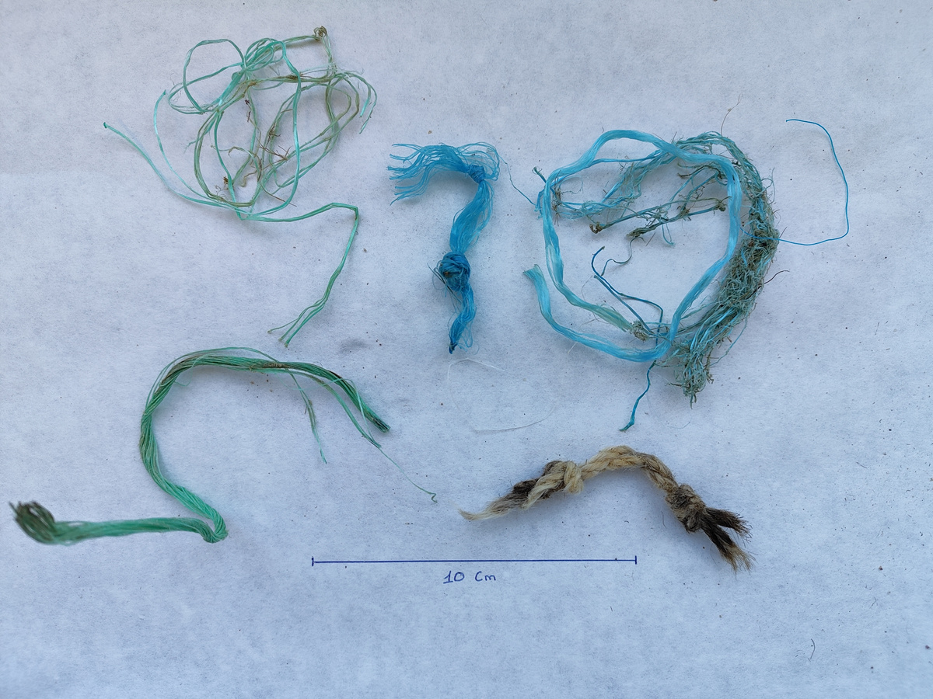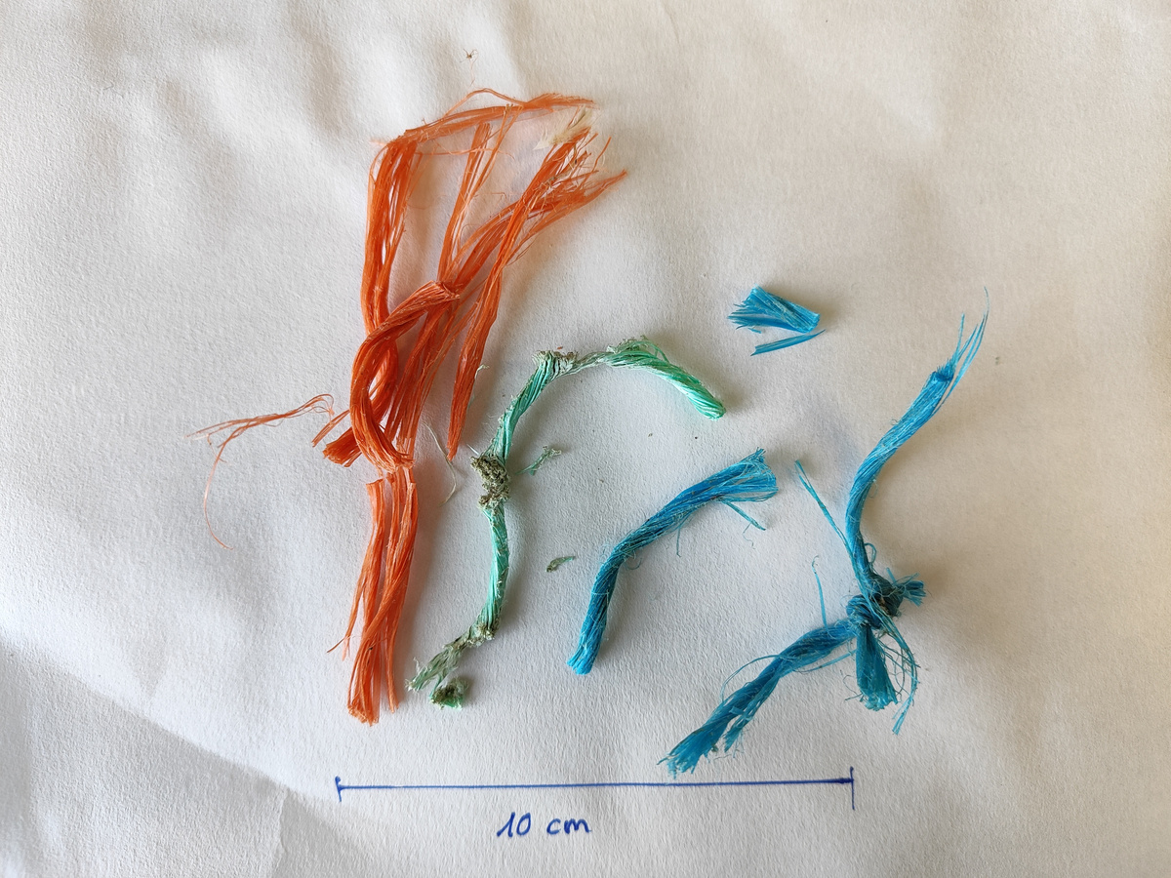
Plastic Caps
157A
160A
136C
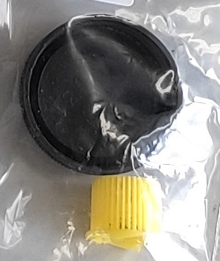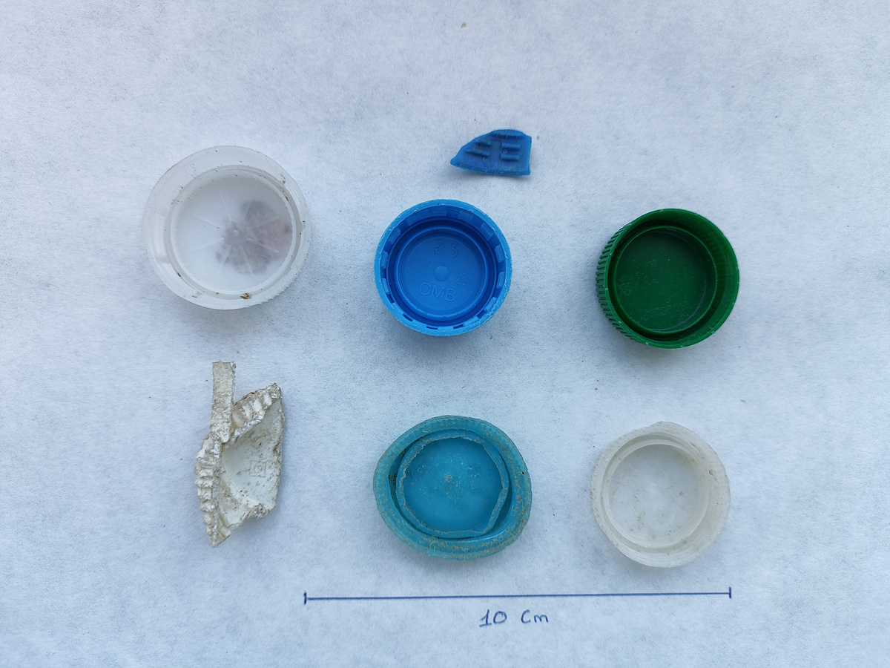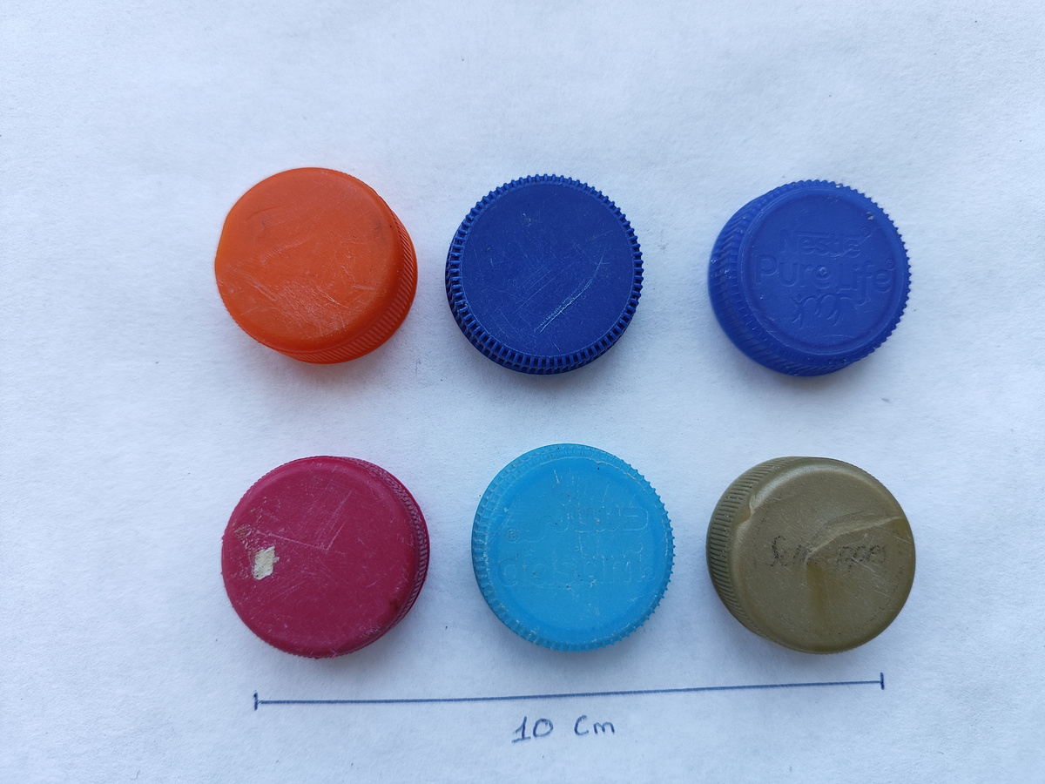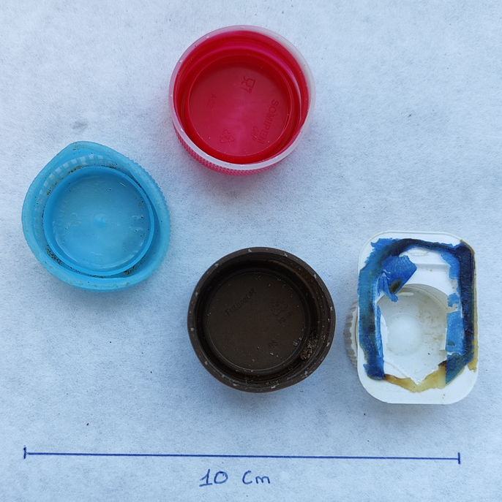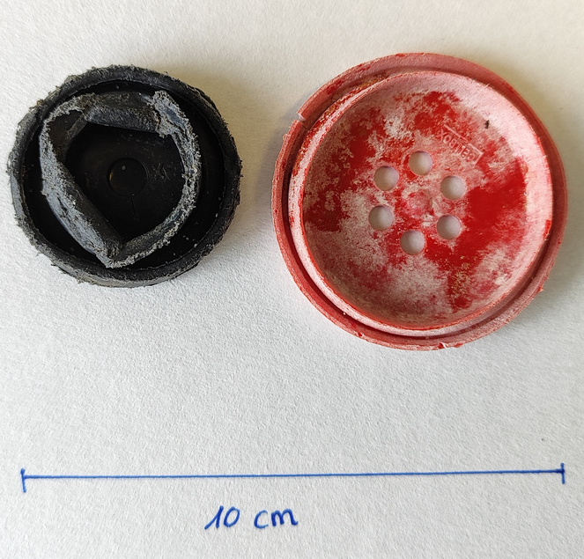
153A
161A
Foam (Packaging, Insulation, Polyurethane)
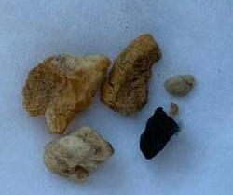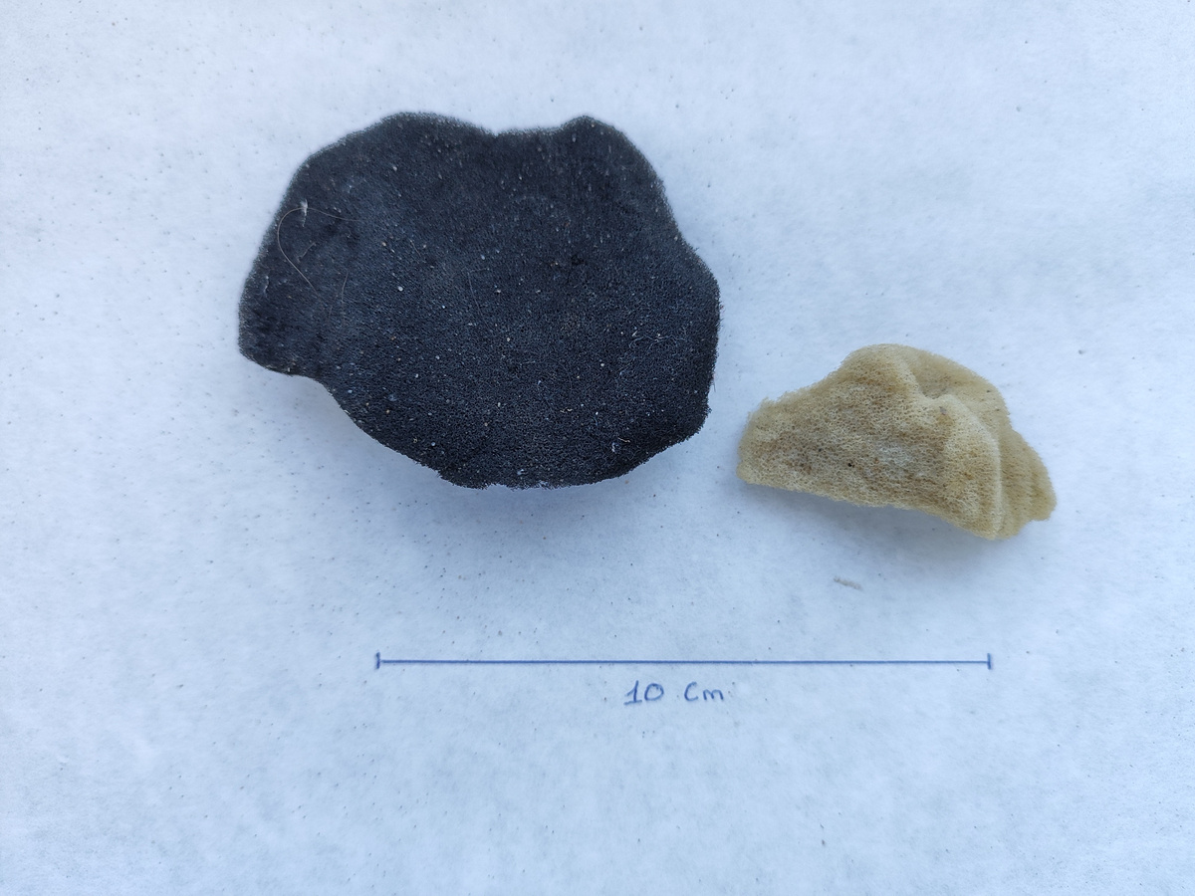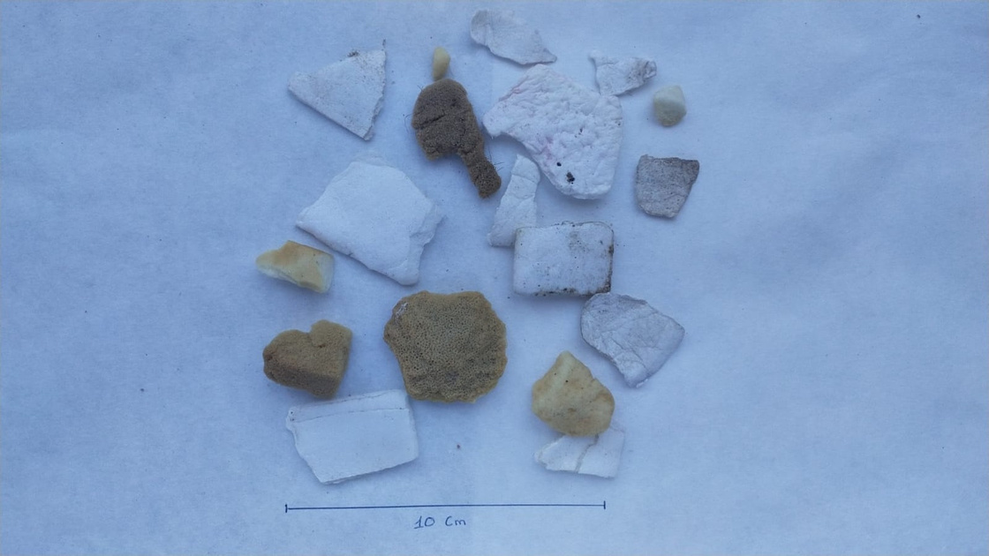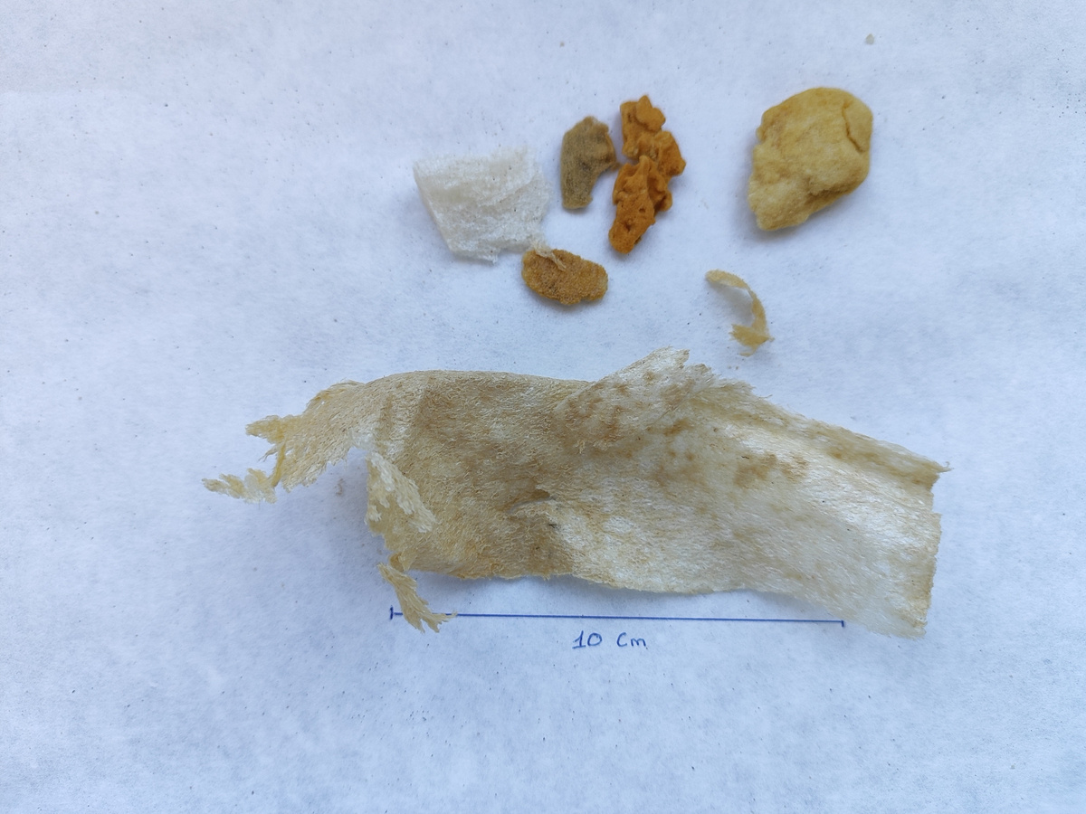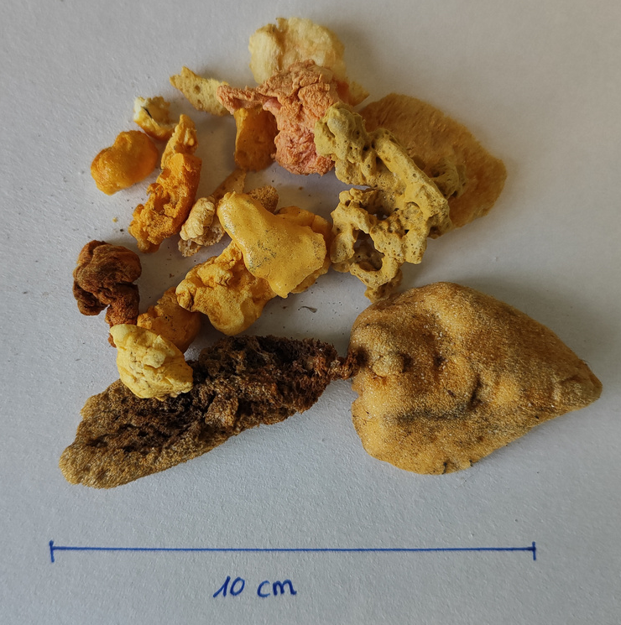
153B
161C
160C
157C
136D
Cigarette Butts and Filters
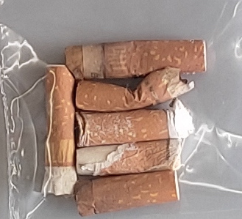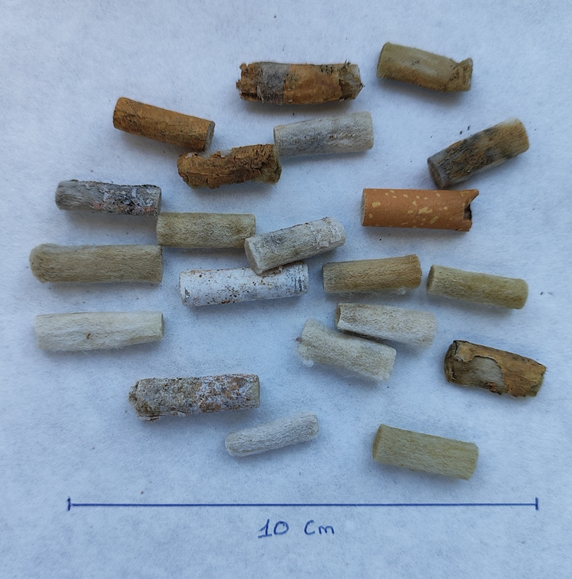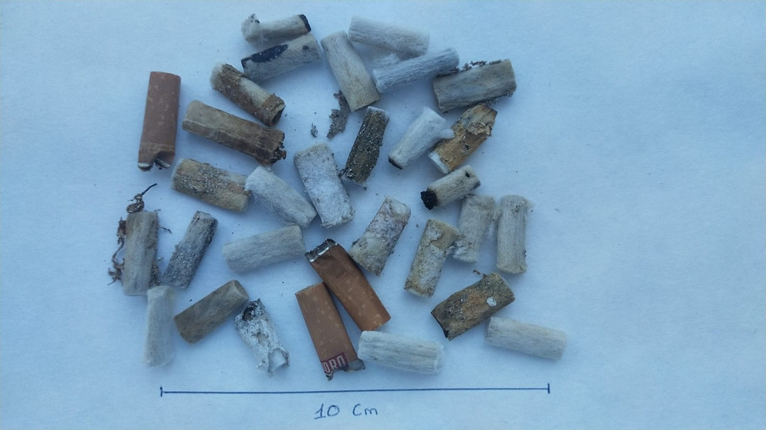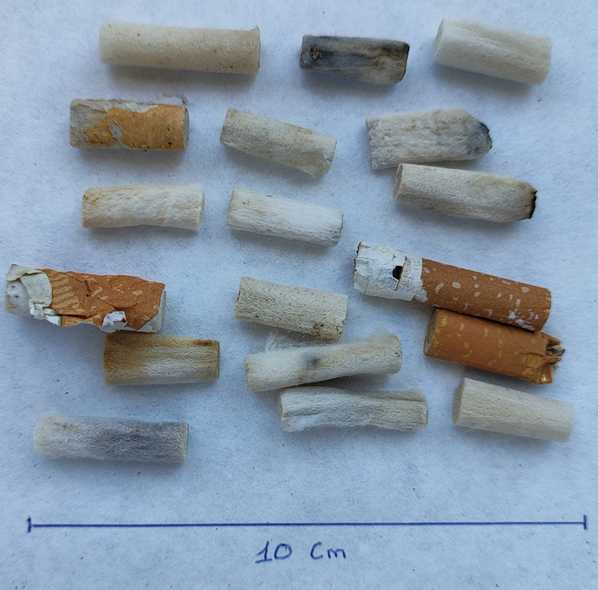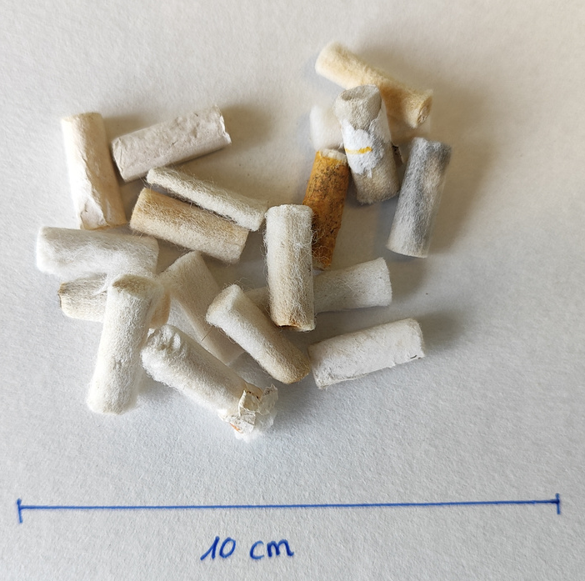
153C
161D
160D
157D
136E
Bottle Caps, Lids, Pull Tabs. Plastic bottles
ID094-RSP

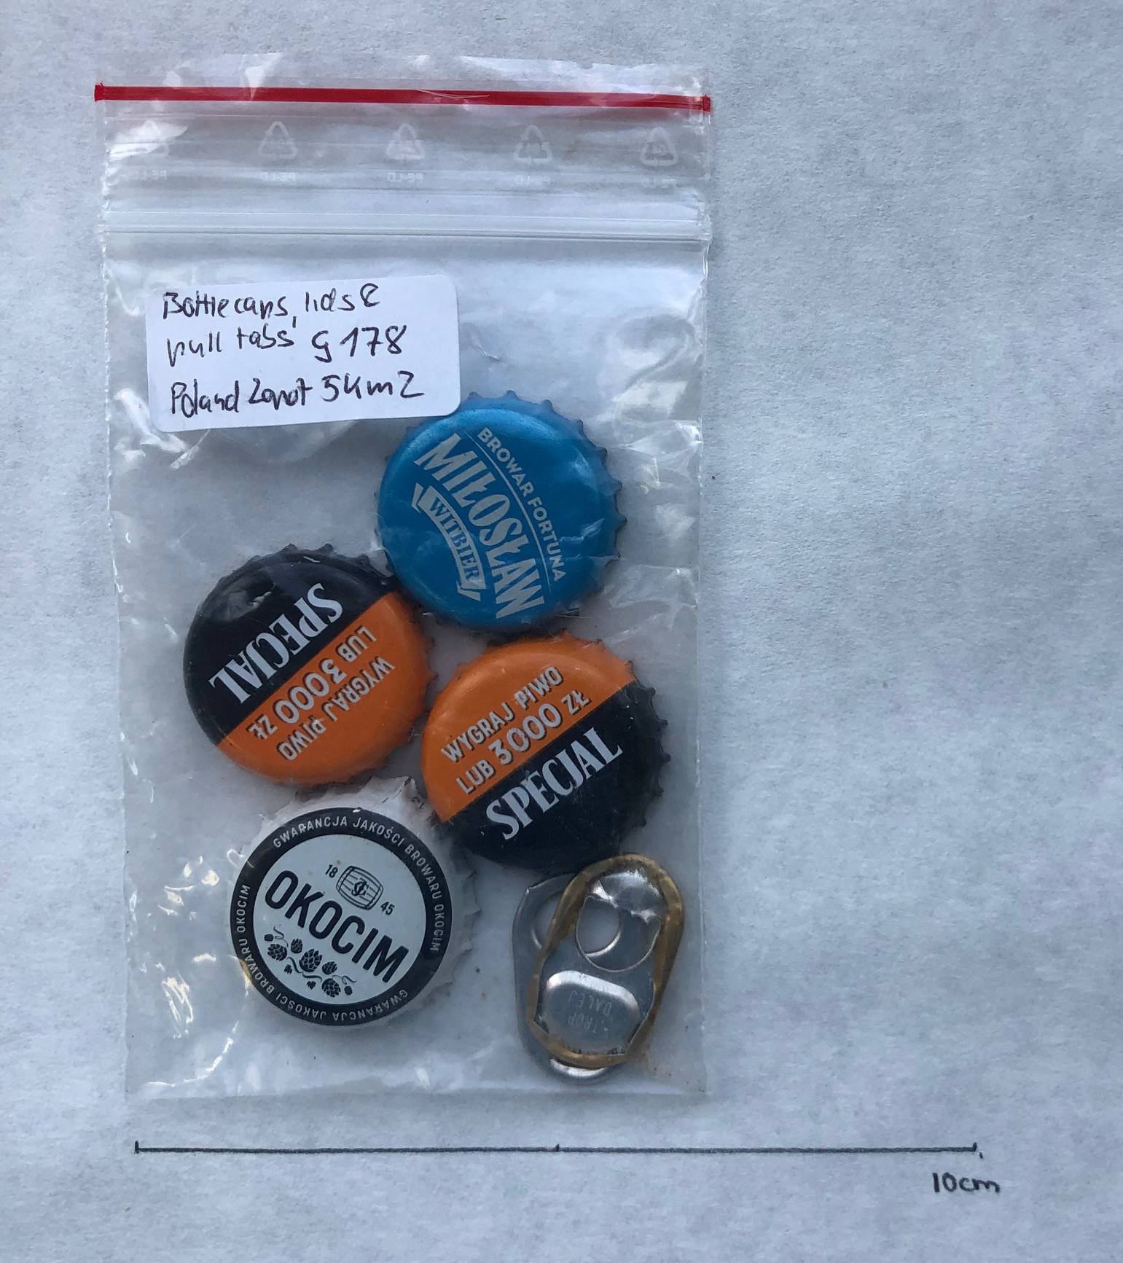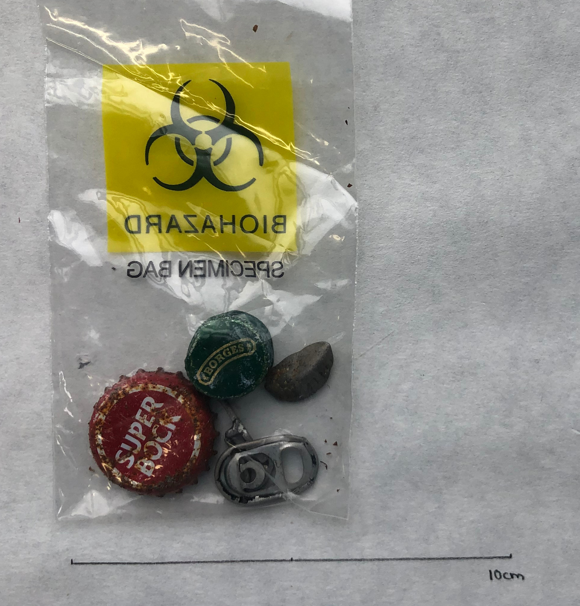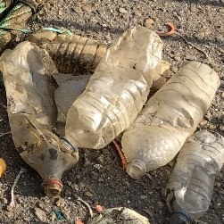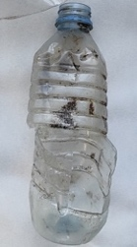
REP-01
153D
136G

Aquaculture – Fisheries
REP-02
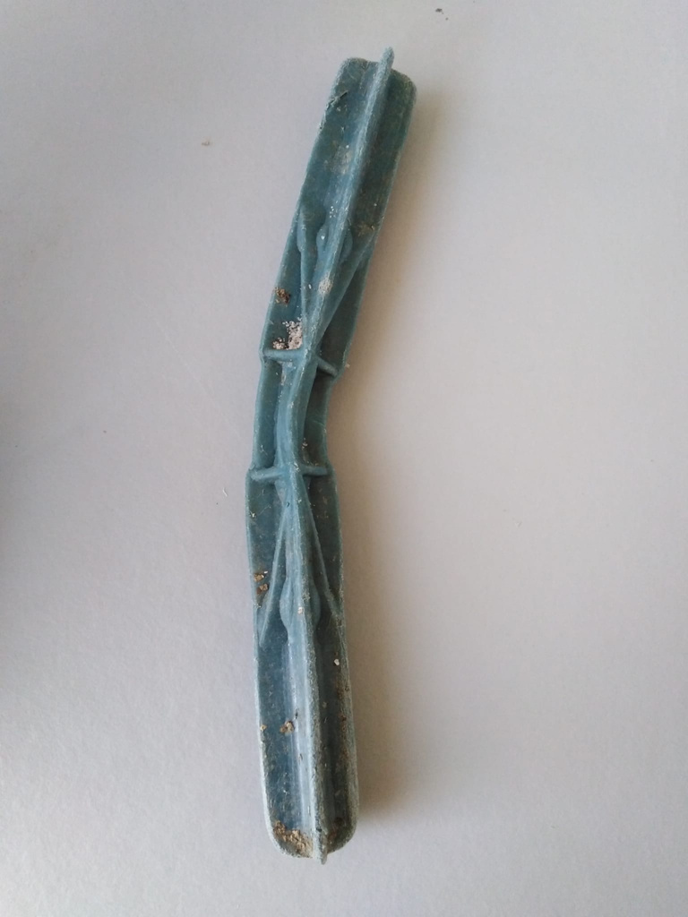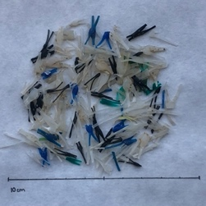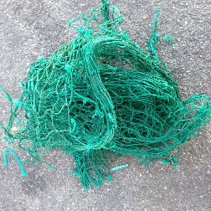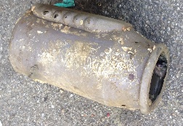
REP-03
082
ID091
Figure B: Unsmoked Cigarette Filters and Unsmoked Biodegradable Filters tested
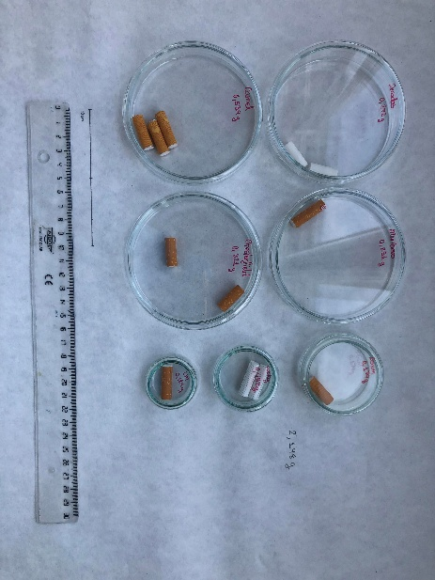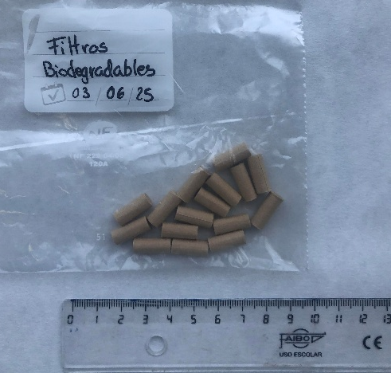

Figure C: Unsmoked Cigarette Filters (UCF) vs Unsmoked Biodegradable Filters (UBF)
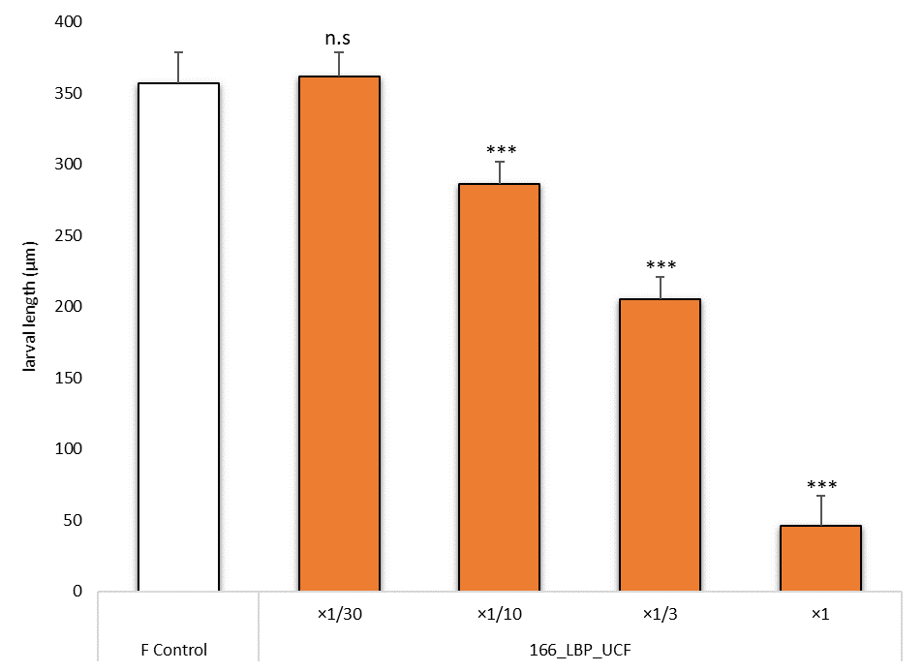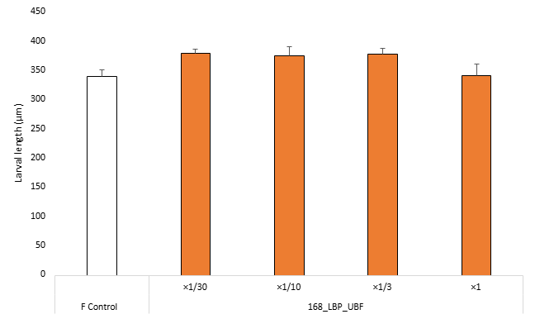

Item | Dilutions tested | NOEC | LOEC | EC₁₀ (mg/L) | EC₅₀ (mg/L) | TU
166 | ×1/30, ×1/10, ×1/3, ×1 | ×1/30 | ×1/10 | 764 | 3257 | 3.07  (2.54 – 3.66)
168 | ×1/30, ×1/10, ×1/3, ×1 | ×1 | n.c | n.c | n.c | < 1  (n.c)

