Supplementary Table 1. Colony-forming ability of bacteria and yeast after 4-h and 24-h exposure to nanocomposites and respective positive controls (CTAB and CuSO₄*5H₂O) to bacteria and yeast in deionized water at 30ºC. After exposure, cells (3μL) were transferred onto toxicant-free agarized growth medium. All experiments were performed in at least three independent replicates; images shown are representative.
Compound or material | E. coli ATCC 25922: 4-h  Concentrations: µg compound/mL (µg Cu/mL) | E. coli ATCC 25922: 24-h  Concentrations: µg compound/mL (µg Cu/mL)
 | 0 0.8 1.6 3.1 6.3 12.5 25 50 100 200  0 (0.05) (0.09) (0.19) (0.4) (0.8) (1.5) (3) (6) (12) | 0 0.8 1.6 3.1 6.3 12.5 25 50 100 200  0 (0.05) (0.09) (0.19) (0.4) (0.8) (1.5) (3) (6) (12)
[Cu(NH₃)₄]²⁺@SiO₂ (5.5%)
[Cu(NH₃)₄]²⁺@SiO₂ (5.5%)  24h leached | 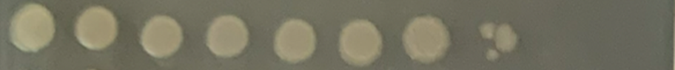
 | 0 0.8 1.6 3.1 6.3 12.5 25 50 100 200  0 (0.05) (0.1) (0.2) (0.4) (0.8) (1.6) (3.2) (6.4) (12.8) | 0 0.8 1.6 3.1 6.3 12.5 25 50 100 200  0 (0.05) (0.1) (0.2) (0.4) (0.8) (1.6) (3.2) (6.4) (12.8)
Cu_{x}O@SiO₂
(5.5%)
Cu_{x}O@SiO₂
(5.5%)
24h leached
 | 0 3.1 6.3 12.5 25 50 100 200 | 0 3.1 6.3 12.5 25 50 100 200
SiO₂ as prepared
 | 0 3.1 6.3 12.5 25 50 100 200 | 0 3.1 6.3 12.5 25 50 100 200
SiO₂ calcined | 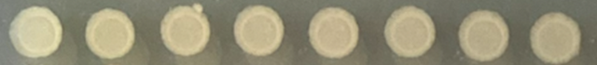 | 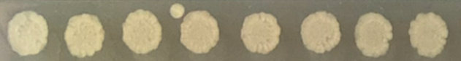
 | 0 0.1 0.5 1.0 2.5 5 10 | 0 0.1 0.5 1.0 2.5 5 10
CTAB |  | 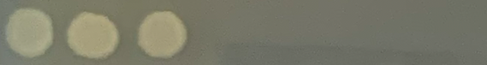
 | 0 0.20 0.4 1.0 2.0 3.9 9.8 19.6 39.3  0 (0.05) (0.1) (0.25) (0.5) (1.0) (2.5) (5.0) (10) | 0 0.20 0.4 1.0 2.0 3.9 9.8 19.6 39.3  0 (0.05) (0.1) (0.25) (0.5) (1.0) (2.5) (5.0) (10)
CuSO₄·5H₂O

Compound or material | P. aeruginosa ATCC 27853: 4-h  Concentrations: µg compound/mL (µg Cu/mL) | P. aeruginosa ATCC 27853: 24-h  Concentrations: µg compound/mL (µg Cu/mL)
 | 0 0.8 1.6 3.1 6.3 12.5 25 50 100 200  0 (0.05) (0.09) (0.19) (0.4) (0.8) (1.5) (3) (6) (12) | 0 0.8 1.6 3.1 6.3 12.5 25 50 100 200  0 (0.05) (0.09) (0.19) (0.4) (0.8) (1.5) (3) (6) (12)
[Cu(NH₃)₄]²⁺@SiO₂ (5.5%) |  | 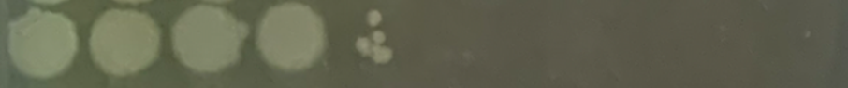
[Cu(NH₃)₄]²⁺@SiO₂ (5.5%)  24h leached |  | 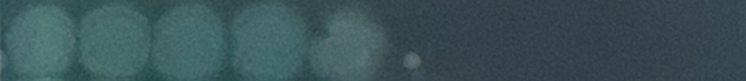
 | 0 0.8 1.6 3.1 6.3 12.5 25 50 100 200  0 (0.05) (0.1) (0.2) (0.4) (0.8) (1.6) (3.2) (6.4) (12.8) | 0 0.8 1.6 3.1 6.3 12.5 25 50 100 200  0 (0.05) (0.1) (0.2) (0.4) (0.8) (1.6) (3.2) (6.4) (12.8)
Cu_{x}O@SiO₂  (5.5%) | 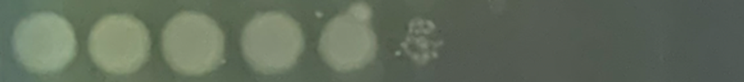 | 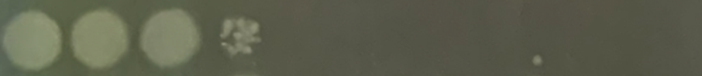
Cu_{x}O@SiO₂  (5.5%)  24h leached |  | 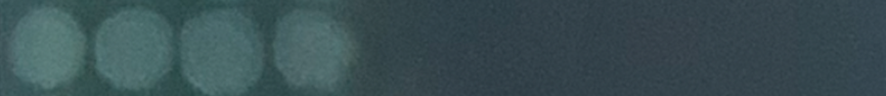
 | 0 3.1 6.3 12.5 25 50 100 200 | 0 3.1 6.3 12.5 25 50 100 200
SiO₂ as prepared | 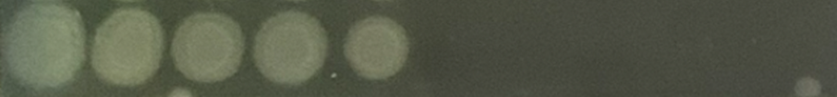 | 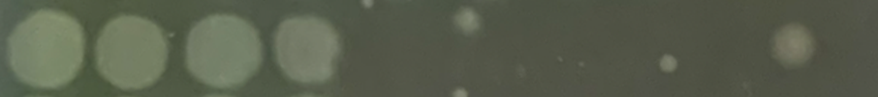
 | 0 3.1 6.3 12.5 25 50 100 200 | 0 3.1 6.3 12.5 25 50 100 200
SiO₂ calcined | 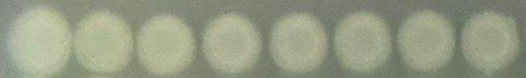 | 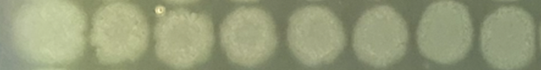
 | 0 0.1 0.5 1.0 2.5 5 10 | 0 0.1 0.5 1.0 2.5 5 10
CTAB | 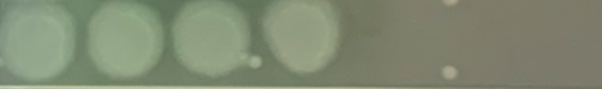 | 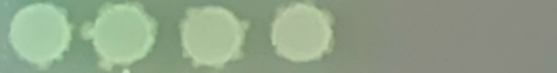
 | 0 0.20 0.4 1.0 2.0 3.9 9.8 19.6 39.3  0 (0.05) (0.1) (0.25) (0.5) (1.0) (2.5) (5.0) (10) | 0 0.20 0.4 1.0 2.0 3.9 9.8 19.6 39.3  0 (0.05) (0.1) (0.25) (0.5) (1.0) (2.5) (5.0) (10)
CuSO₄·5H₂O |  | 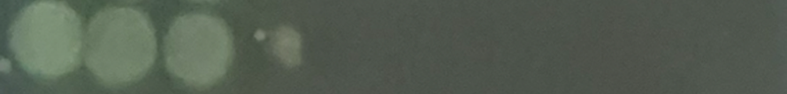

Compound or material | S. aureus ATCC 6538: 4-h  Concentrations: µg compound/mL (µg Cu/mL) | S. aureus ATCC 6538: 24-h  Concentrations: µg compound/mL (µg Cu/mL)
 | 0 0.8 1.6 3.1 6.3 12.5 25 50 100 200  0 (0.05) (0.09) (0.19) (0.4) (0.8) (1.5) (3) (6) (12) | 0 0.8 1.6 3.1 6.3 12.5 25 50 100 200  0 (0.05) (0.09) (0.19) (0.4) (0.8) (1.5) (3) (6) (12)
[Cu(NH₃)₄]²⁺@SiO₂ (5.5%)
[Cu(NH₃)₄]²⁺@SiO₂ (5.5%)
24h leached
 | 0 0.8 1.6 3.1 6.3 12.5 25 50 100 200  0 (0.05) (0.1) (0.2) (0.4) (0.8) (1.6) (3.2) (6.4) (12.8) | 0 0.8 1.6 3.1 6.3 12.5 25 50 100 200  0 (0.05) (0.1) (0.2) (0.4) (0.8) (1.6) (3.2) (6.4) (12.8)
Cu_{x}O@SiO₂
(5.5%)
Cu_{x}O@SiO₂
(5.5%)
24h leached
 | 0 3.1 6.3 12.5 25 50 100 200 | 0 3.1 6.3 12.5 25 50 100 200
SiO₂ as prepared
 | 0 3.1 6.3 12.5 25 50 100 200 | 0 3.1 6.3 12.5 25 50 100 200
SiO₂ calcined | 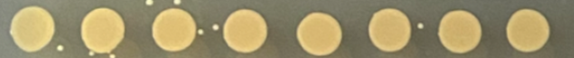 | 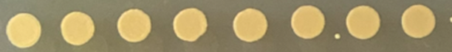
 | 0 0.1 0.5 1.0 2.5 5 10 | 0 0.1 0.5 1.0 2.5 5 10
CTAB | 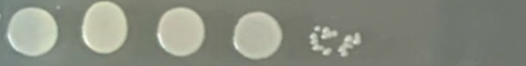
 | 0 0.20 0.4 1.0 2.0 3.9 9.8 19.6 39.3  0 (0.05) (0.1) (0.25) (0.5) (1.0) (2.5) (5.0) (10) | 0 0.20 0.4 1.0 2.0 3.9 9.8 19.6 39.3  0 (0.05) (0.1) (0.25) (0.5) (1.0) (2.5) (5.0) (10)
CuSO₄·5H₂O

Compound or material | C. albicans ATCC 10231: 4-h  Concentrations: µg compound/mL (µg Cu/mL) | C. albicans ATCC 10231: 24-h  Concentrations: µg compound/mL (µg Cu/mL)
 | 0 7.8 15.6 31.3 62.5 125 250 500  0 (0.5) (0.9) (1.8) (3.6) (7.3) (15) (29) | 0 7.8 15.6 31.3 62.5 125 250 500  0 (0.5) (0.9) (1.8) (3.6) (7.3) (15) (29)
[Cu(NH₃)₄]²⁺@SiO₂ (5.5%) | 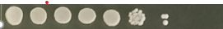 | 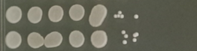
 | 0 7.8 15.6 31.3 62.5 125 250 500  0 (0.5) (0.9) (1.9) (3.8) (7.5) (15) (30) | 0 7.8 15.6 31.3 62.5 125 250 500  0 (0.5) (0.9) (1.9) (3.8) (7.5) (15) (30)
Cu_{x}O@SiO₂  (5.5%) | 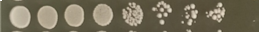
 | 0 7.8 15.6 31.3 62.5 125 250 500 | 0 7.8 15.6 31.3 62.5 125 250 500
SiO₂ as prepared | 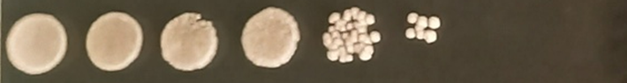 | 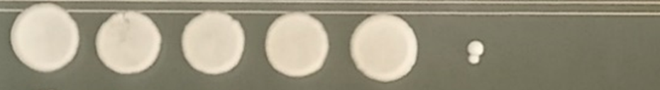
 | 0 7.8 15.6 31.3 62.5 125 250 500 | 0 7.8 15.6 31.3 62.5 125 250 500
SiO₂ calcined | 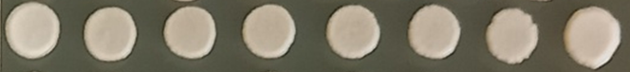 | 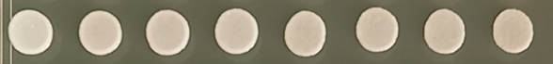
 | 0 3.9 7.8 15.6 31.3 62.5 125 250 | 0 3.9 7.8 15.6 31.3 62.5 125 250
CTAB | 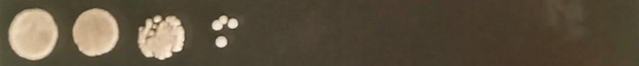
 | 0 2.5 4.9 9.8 20 39 79 157  0 (0.6) (1.3) (2.5) (5) (10) (20) (40) | 0 2.5 4.9 9.8 20 39 79 157  0 (0.6) (1.3) (2.5) (5) (10) (20) (40)
CuSO₄·5H₂O | 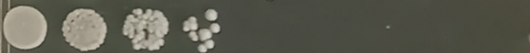 | 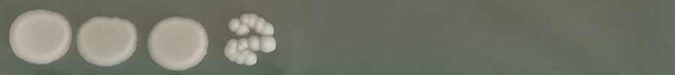

Compound or material | C. auris ATCC MYA 5001: 4-h  Concentrations: µg compound/mL (µg Cu/mL) | C. auris ATCC MYA 5001: 24-h  Concentrations: µg compound/mL (µg Cu/mL)
 | 0 7.8 15.6 31.3 62.5 125 250 500  0 (0.5) (0.9) (1.8) (3.6) (7.3) (15) (29) | 0 7.8 15.6 31.3 62.5 125 250 500  0 (0.5) (0.9) (1.8) (3.6) (7.3) (15) (29)
[Cu(NH₃)₄]²⁺@SiO₂ (5.5%)
 | 0 7.8 15.6 31.3 62.5 125 250 500  0 (0.5) (0.9) (1.9) (3.8) (7.5) (15) (30) | 0 7.8 15.6 31.3 62.5 125 250 500  0 (0.5) (0.9) (1.9) (3.8) (7.5) (15) (30)
Cu_{x}O@SiO₂
(5.5%)
 | 0 7.8 15.6 31.3 62.5 125 250 500 | 0 7.8 15.6 31.3 62.5 125 250 500
SiO₂ as prepared | 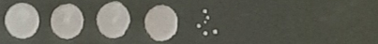 | 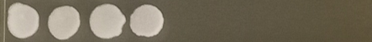
 | 0 7.8 15.6 31.3 62.5 125 250 500 | 0 7.8 15.6 31.3 62.5 125 250 500
SiO₂ calcined | 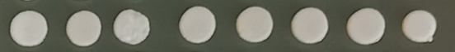 | 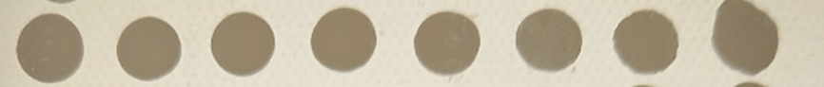
 | 0 1.0 1.95 3.9 7.8 15.6 31.3 62.5 | 0 1.0 1.95 3.9 7.8 15.6 31.3 62.5
CTAB | 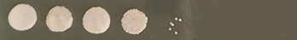 | 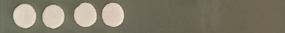
 | 0 2.5 4.9 9.8 20 39 79 157  0 (0.6) (1.3) (2.5) (5) (10) (20) (40) | 0 2.5 4.9 9.8 20 39 79 157  0 (0.6) (1.3) (2.5) (5) (10) (20) (40)
CuSO₄·5H₂O | 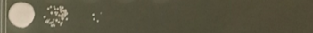 | 