Supporting Material

- Kabul LULC classes 1990-2023
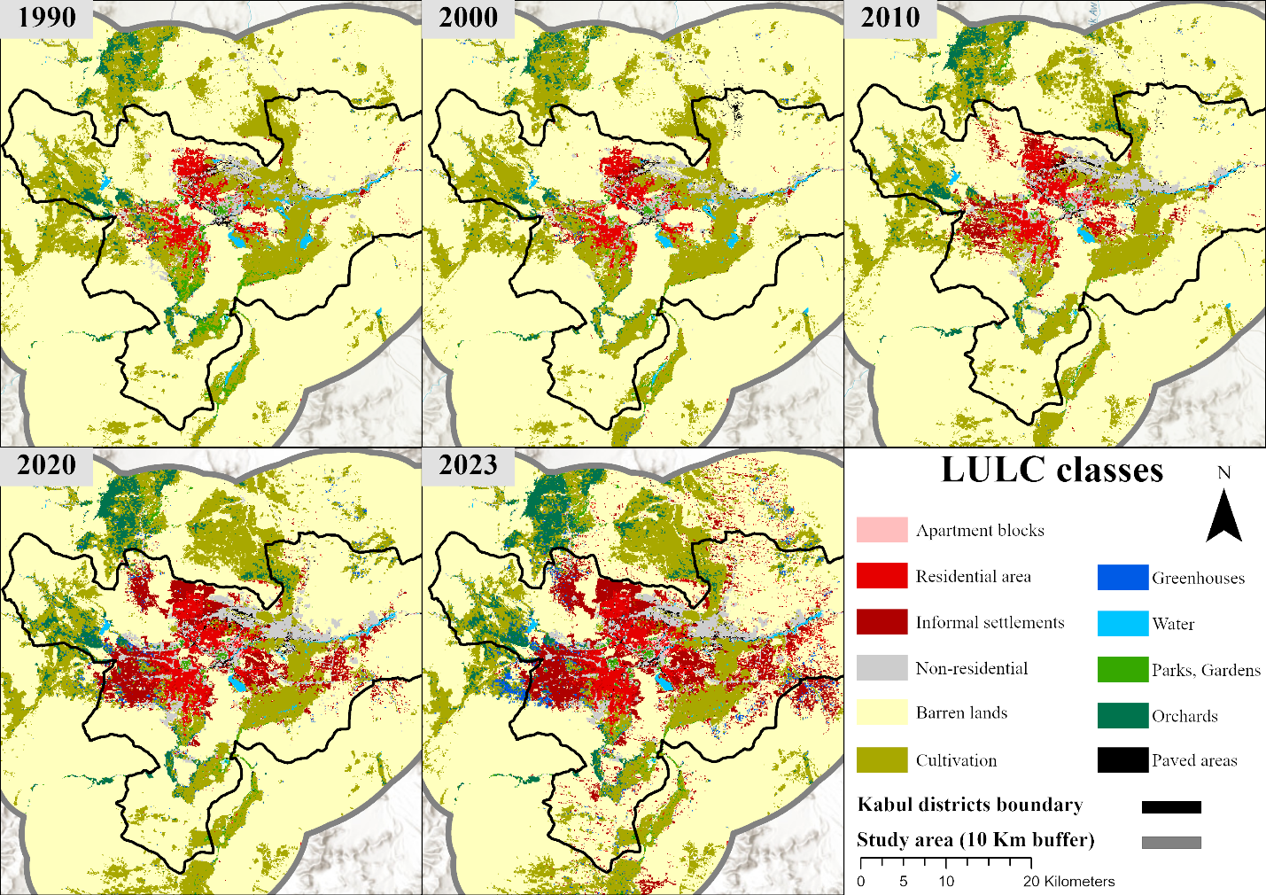
Figure SM7: Land Use and Land Cover evolution in the city of Kabul (black line admin boundaries) and the buffer zone of the study area (grey line) between 1990 and 2023. The full yearly dataset is accessible at https://doi.org/10.5281/zenodo.18979399.
- XGBoost specification and classification performance
Table SM1: XGBoost Hyperparameters range and selected optimal parameter following Bayesian optimization process.
Hyperparameters | range | Selected pttimal value
Eta | 0.0001 - 1 | 0.41
Maximum depth | 1-400 | 195
Minimum child weight | 0.1 - 100 | 0.1
subsample | 0.1 - 1 | 0.62
lambda | 0.1 - 100 | 0.1
alpha | 0.1 - 100 | 0.1
gamma | 0 - 100 | 0
Subsample ratio by feature | 0 -1 | 1

Table SM2: Performance metrics for each class of the XGBoost model
 | Class
 | 1 | 2 | 3 | 4 | 5 | 6 | 7 | 8 | 9 | 10 | 11
Sensitivity | 0.94 | 0.96 | 0.97 | 0.97 | 1.00 | 0.98 | 0.94 | 0.99 | 0.90 | 0.91 | 0.88
Specificity | 1.00 | 1.00 | 1.00 | 1.00 | 0.99 | 1.00 | 1.00 | 1.00 | 1.00 | 1.00 | 1.00
Pos Pred Value | 0.98 | 0.95 | 0.97 | 0.95 | 1.00 | 0.97 | 0.96 | 0.99 | 0.95 | 0.93 | 0.96
Neg Pred Value | 1.00 | 1.00 | 1.00 | 1.00 | 1.00 | 1.00 | 1.00 | 1.00 | 1.00 | 1.00 | 1.00
Precision | 0.98 | 0.95 | 0.97 | 0.95 | 1.00 | 0.97 | 0.96 | 0.99 | 0.95 | 0.93 | 0.96
Recall | 0.94 | 0.96 | 0.97 | 0.97 | 1.00 | 0.98 | 0.94 | 0.99 | 0.90 | 0.91 | 0.88
F1 | 0.96 | 0.96 | 0.97 | 0.96 | 1.00 | 0.98 | 0.95 | 0.99 | 0.92 | 0.92 | 0.92
Prevalence | 0.01 | 0.03 | 0.07 | 0.07 | 0.68 | 0.07 | 0.01 | 0.01 | 0.01 | 0.02 | 0.02
Detection Rate | 0.01 | 0.03 | 0.06 | 0.07 | 0.67 | 0.07 | 0.01 | 0.01 | 0.01 | 0.01 | 0.01
Detection Prevalence | 0.01 | 0.03 | 0.07 | 0.07 | 0.68 | 0.07 | 0.01 | 0.01 | 0.01 | 0.01 | 0.01
Balanced Accuracy | 0.97 | 0.98 | 0.98 | 0.98 | 1.00 | 0.99 | 0.97 | 1.00 | 0.95 | 0.95 | 0.94

Below is reported the importance of the first 10 feature for each LULC class. Importnace has been compjuted based on SHAP values through the shapviz package in Rstudio. Slope and elev refer to terrain slope and elevation extracted from Copernicus DEM GLO-30. SR ans ST refer respectively to Landsat radiometric and thermal bands. Refer to Material and Method 1.1 for the list all predictor computed

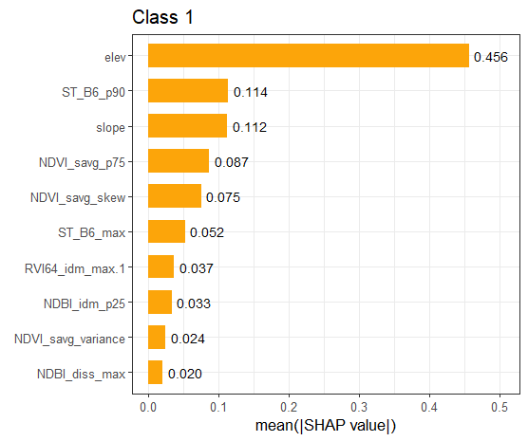 | 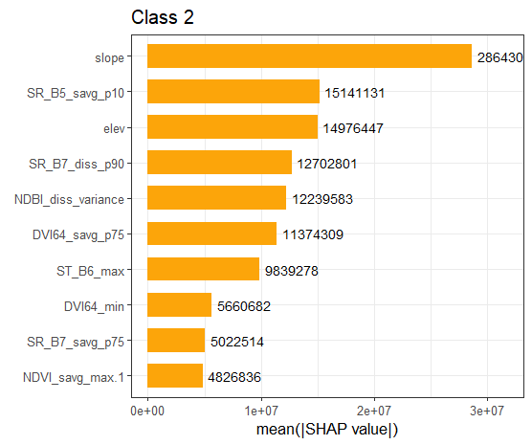
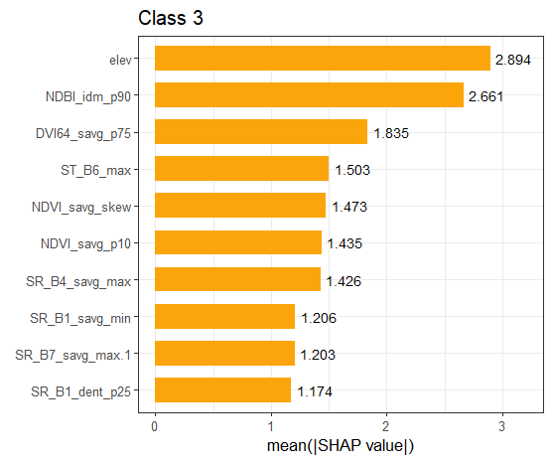 | 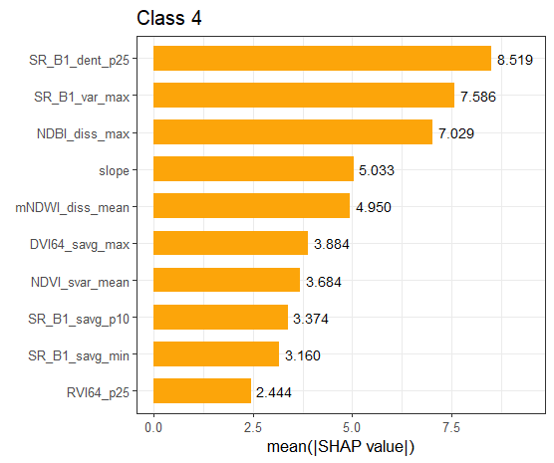
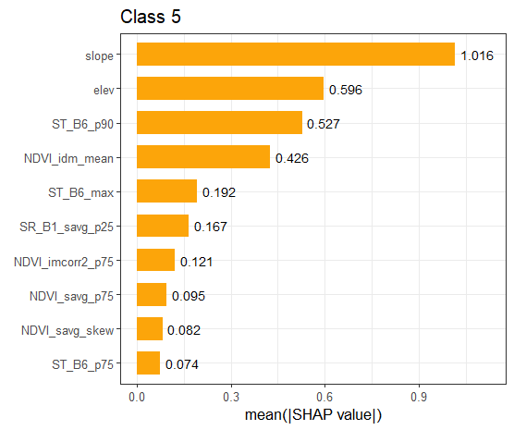 | 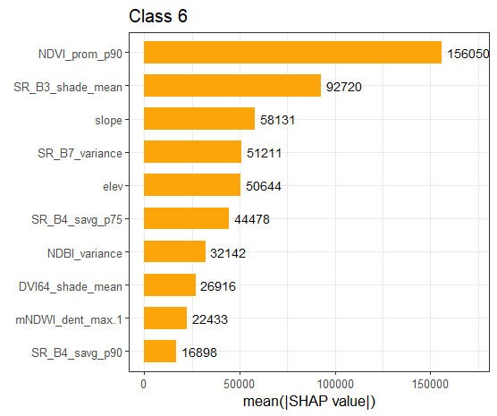
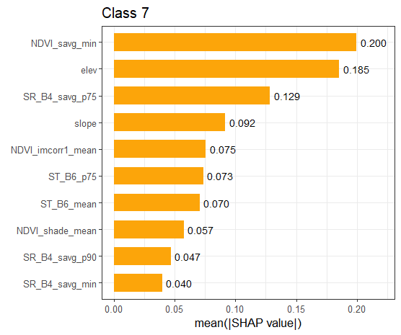 | 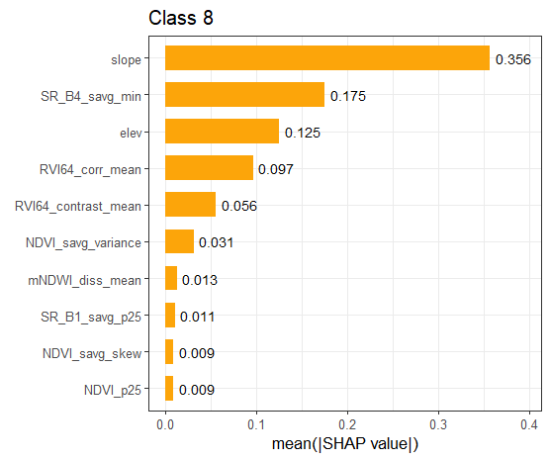
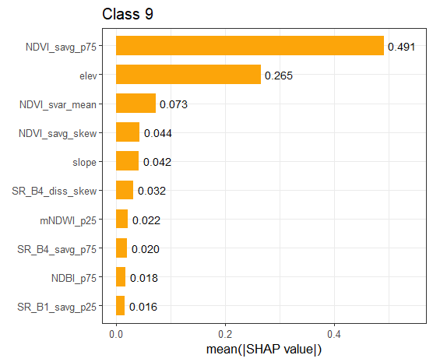 | 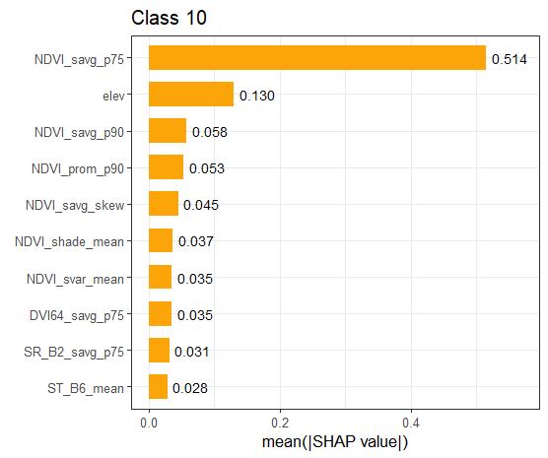
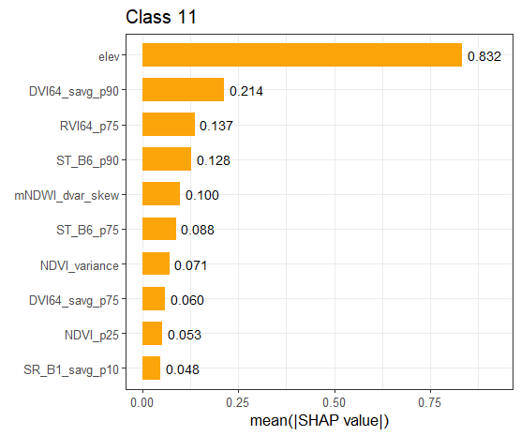
Figure 8:first 10 feature importance for each LULC class based on mean SHAP values.

- Linear models statistics, parameters and AIC

The following tables report for each class the best model and respective statistic, including ß estimate and within brackets the standard error

Class 1 – Apartment blocks
(Intercept) | -17.465+
 | (9.229)
casualties_outKabul_l2 | -0.000
 | (0.001)
ODA_grants_tot_billions_l1 | 0.009**
 | (0.002)
ODA_loan_tot_billions_l2 | 0.050**
 | (0.013)
Tech_coop_l1 | -0.042**
 | (0.012)
Num.Obs. | 15
R2 | 0.855
R2 Adj. | 0.797
AIC | 89.1
BIC | 93.3
Log.Lik. | -38.536
RMSE | 3.16
- p < 0.1, * p < 0.05, ** p < 0.01, *** p < 0.001

Class 2 – Residential area
(Intercept) | 22.830**
 | (6.929)
casualties_inKabul_l2 | 0.003
 | (0.003)
casualties_outKabul | -0.002*
 | (0.001)
ODA_grants_tot_billions | -0.002
 | (0.001)
ODA_loan_tot_billions | 0.031**
 | (0.009)
Num.Obs. | 15
R2 | 0.849
R2 Adj. | 0.788
AIC | 82.1
BIC | 86.4
Log.Lik. | -35.067
RMSE | 2.51
- p < 0.1, * p < 0.05, ** p < 0.01, *** p < 0.001

Class 3 – Informal settlement
(Intercept) | -3.227
 | (9.730)
TOT_IMM_l2 | 0.000*
 | (0.000)
casualties_inKabul_l2 | -0.023*
 | (0.008)
casualties_outKabul | 0.004*
 | (0.001)
ODA_loan_tot_billions_l1 | 0.161***
 | (0.030)
Num.Obs. | 15
R2 | 0.800
R2 Adj. | 0.721
AIC | 120.1
BIC | 124.3
Log.Lik. | -54.039
RMSE | 8.88
- p < 0.1, * p < 0.05, ** p < 0.01, *** p < 0.001

Class 4 – non residential area
(Intercept) | -2.015
 | (2.610)
casualties_inKabul_l2 | 0.003+
 | (0.001)
casualties_outKabul_l1 | -0.001+
 | (0.000)
ODA_grants_tot_billions_l2 | 0.000
 | (0.001)
Tech_coop_l1 | 0.007*
 | (0.003)
Num.Obs. | 15
R2 | 0.750
R2 Adj. | 0.651
AIC | 58.7
BIC | 63.0
Log.Lik. | -23.367
RMSE | 1.15
- p < 0.1, * p < 0.05, ** p < 0.01, *** p < 0.001

