Supplementary Material

GliaMimic: a longitudinal, multimodal in vitro platform for assessing Glioblastoma treatment response and relapse in patient-derived organoids and spheroids
Selina Camenisch¹, Luisa Bell², Nadine Stokar-Regenscheit², Natalia Vélez Char³, Wolfram Jochum³, Simon Heinze⁴, Anna Maria Zeitlberger⁵, Thomas Hundsberger⁶, Marian Neidert⁵, Peter Wick^{1*}, Vanesa Ayala-Nunez^{1*}

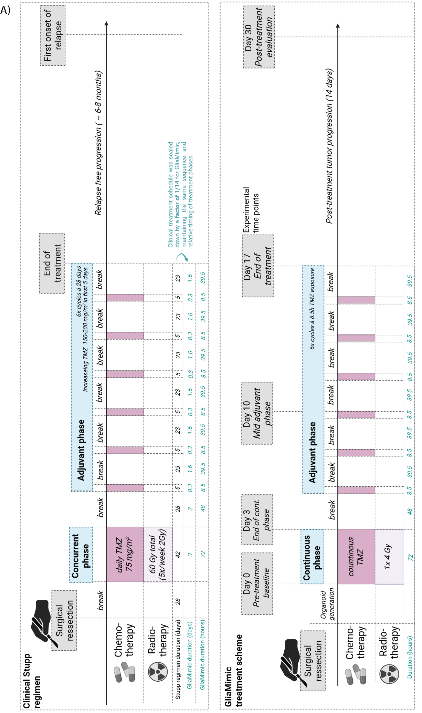
Supplementary Figure S1. Comparative treatment schematics of the clinical Stupp regimen and in vitro GliaMimic protocol. A) The clinical Stupp regimen is shown at the top, beginning with surgical resection followed by a 28-day healing period. The concurrent phase consists of 6 weeks of daily temozolomide (TMZ, 75 mg/m², dark violet) alongside radiotherapy (2Gy, 5x/week, light rose). After a treatment break, the adjuvant phase comprises six 28-day cycles, with continuous TMZ administered at escalating doses (150 – 200 mg/m²) on the first 5 days of each cycle. Post-treatment, patients typically remain tumor-free for 6 – 8 months before relapse. A timeline of the Stupp regimen is displayed in the middle, with the corresponding 1/14 down-scaled phase durations calculated for the GliaMimic model in days and hours (depicted in turquoise), preserving the same sequence and relative duration of treatment phases. Below, the GliaMimic treatment protocol is visualized. Following surgery, organoids are grown from the tumor biopsy, after which a 72-hour continuous treatment phase is initiated, comprising continuous TMZ and a single 4Gy irradiation exposure (logistically reduced from fractionated dosing). After a break, six cycles of 8.5 hours of TMZ followed by 39.5-hour breaks simulate the clinical adjuvant phase. Post-treatment tumor progression is evaluated at 14 days. Created in BioRender. C, S. (2026) https://BioRender.com/m2elf5q

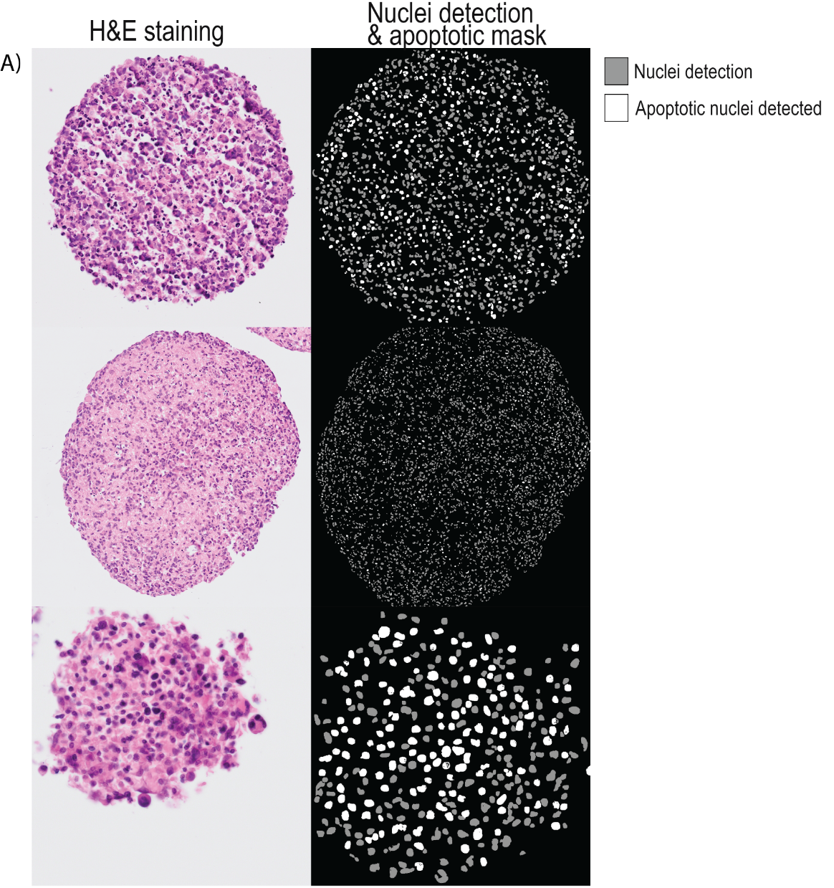
Supplementary Figure S2. Automated morphometric detection of apoptotic tumor cells in H&E-stained tissue sections. A) H&E-stained sections (left) were subjected to analysis using a previously developed and validated morphometric algorithm(Bell et al., 2025) (Visiopharm), designed to detect single-cell apoptotic events. The output mask (right) shows all detected nuclei in gray, with apoptotic nuclei segmented in white.
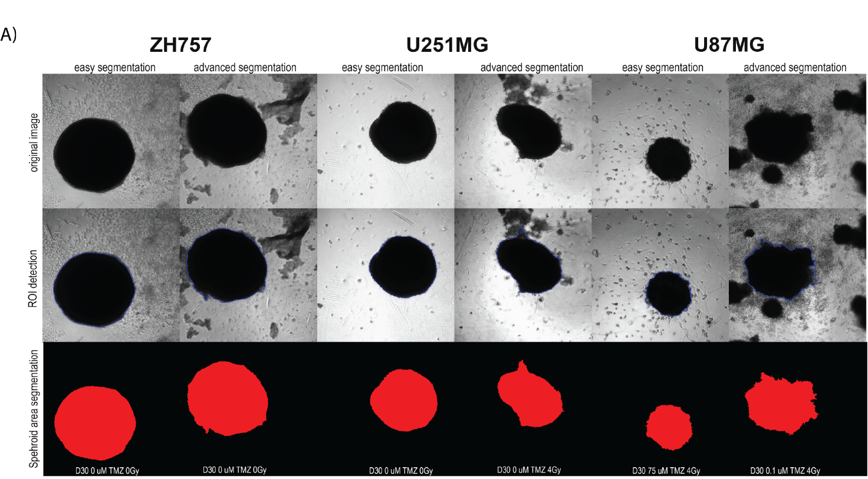

Supplementary Figure S2. Segmentation strategy for GBM spheroids and PDOs using OrganoSeg. A) Bright‑field images of ZH757, U251MG and U87MG spheroids show the OrganoSeg workflow. Top row: original image; middle row: ROI detection (blue); bottom row: final spheroid mask indicating detected spheroid area (red). The pipeline selects the main contiguous spheroid body and excludes small, disconnected objects (debris, migratory/invasive cells, secondary aggregates), yielding stable area measurements across treatments and time points. Images include both easy and challenging examples to illustrate robustness.

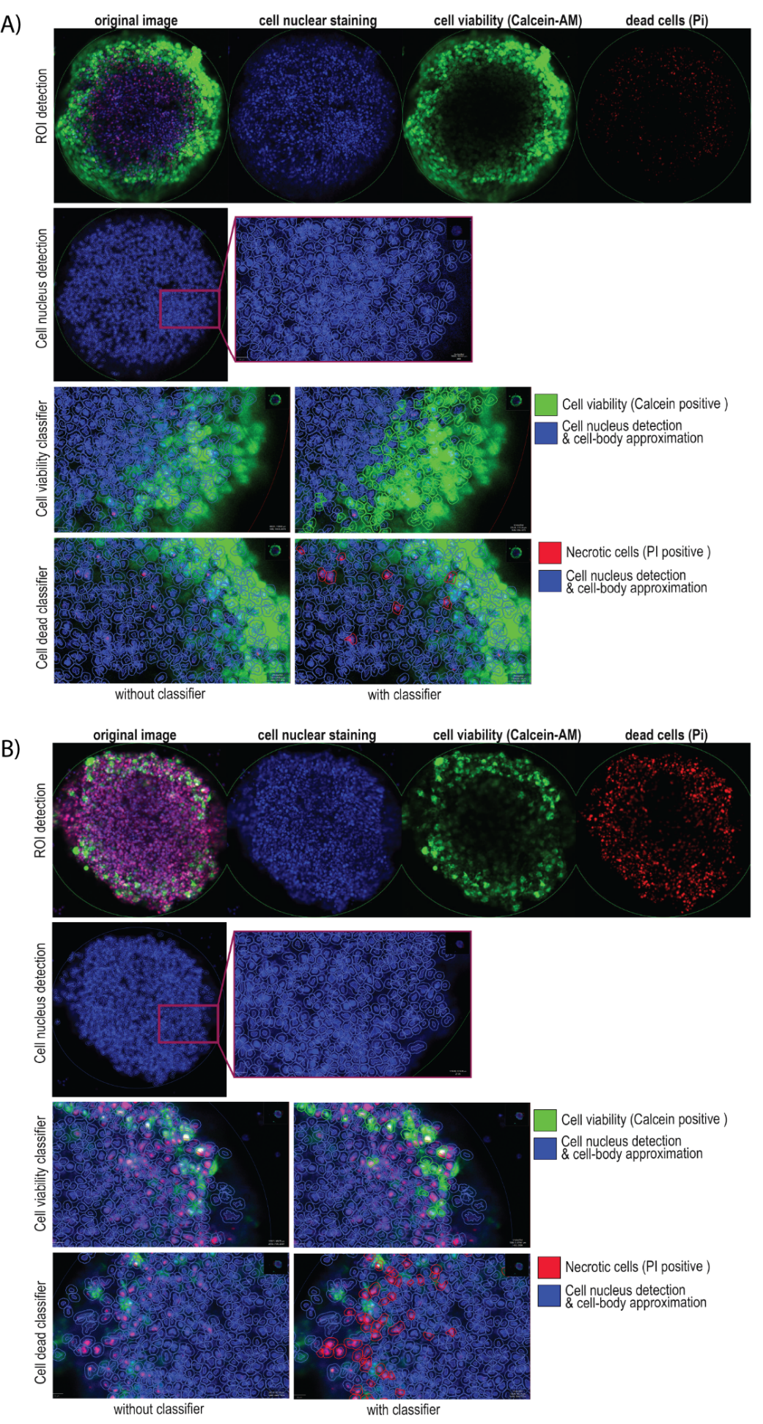
Supplementary Figure S4. Segmentation strategy for viable and necrotic cell fraction using
QuPath. A) Fluorescent cross-section images (taken at one-third spheroid/PDO height) illustrate the QuPath workflow. Top row: original composite and separate channels (nuclei, viable Calcein-AM, necrotic PI) with the manually drawn ROI (faint green). Middle row: detected nuclei with an assumed 5 µm cell body around each nucleus (example crop shown). Bottom: Classifier output distinguishing viable cells (Calcein-positive, green) and necrotic cells (PI-positive, red) with a cropped view of the segmented spheroid. B) shows the same workflow for a D3 spheroid treated with 1000 µM TMZ + 4 Gy and in A the untreated D3 control is depicted.
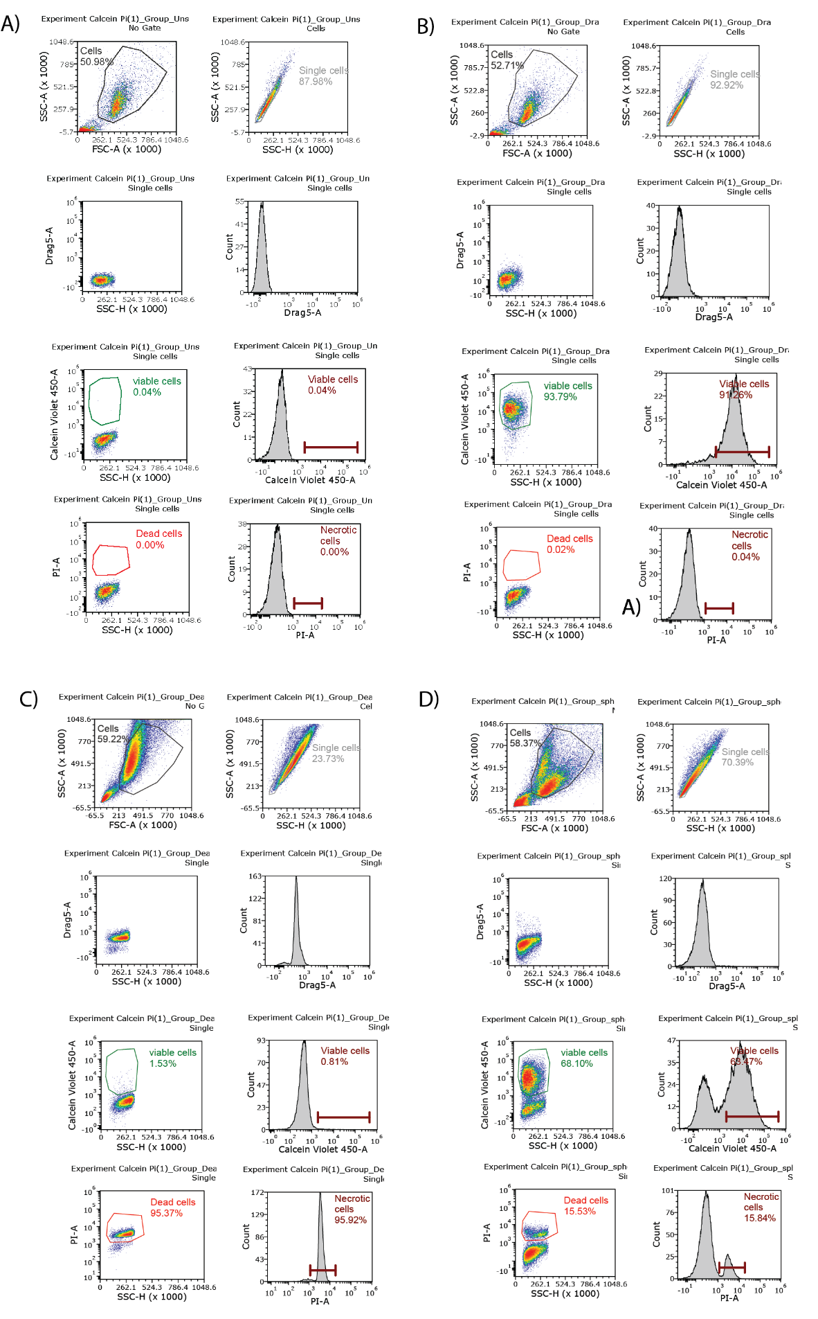
Supplementary Figure S5. Flow cytometry gating strategy. A) Gating strategy depicted for A) untreated single U87 cells, B) calcein violet 450 AM and Draq5 stained single U87 cells, C) positive dead control (24h CdSO4 10 µM) stained with Draq5, calcein violet 450 and PI and D) dissociated spheroids (N=12 / treatment condition) after 17 days of treatment with 50 µM TMZ. Cells (SSC-A vs. FSC-A) and single cells (SSC-A vs. SSC-H) were gated to exclude debris, doublets and aggregates. Single-stained controls and the dead-cell control (CdSO₄-treated) were used to define positive and negative populations for gating. Viability was assessed by gating on single cells and evaluating Calcein violet 450 (live) and PI (dead) positive cell fraction.
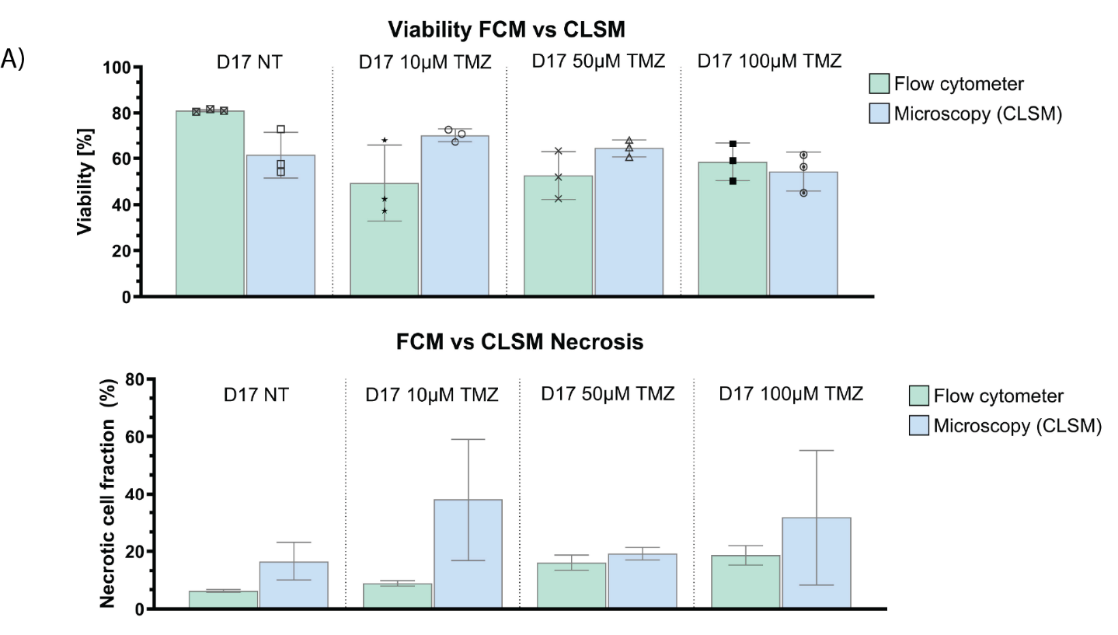
Supplementary Figure S6. Comparing viability and necrotic cell fraction obtained from FCM and CLSM. A) Depicted are viable and necrotic cell fractions (%) obtained in U87MG spheroids after 17 days of cultivation under different treatments (NT, 10 µM. 50 µM, 100 µM TMZ) from flow cytometry measurements of the whole spheroid disintegrated into single cells or fluorescent microscopy image analysis of a cross section though a spheroid at 1/3 of its height. Data is represented as bar plots showing individual values and mean ± SD consisting of three technical (n = 1) (N = 3 spheroids / treatment concentration for each cell line).

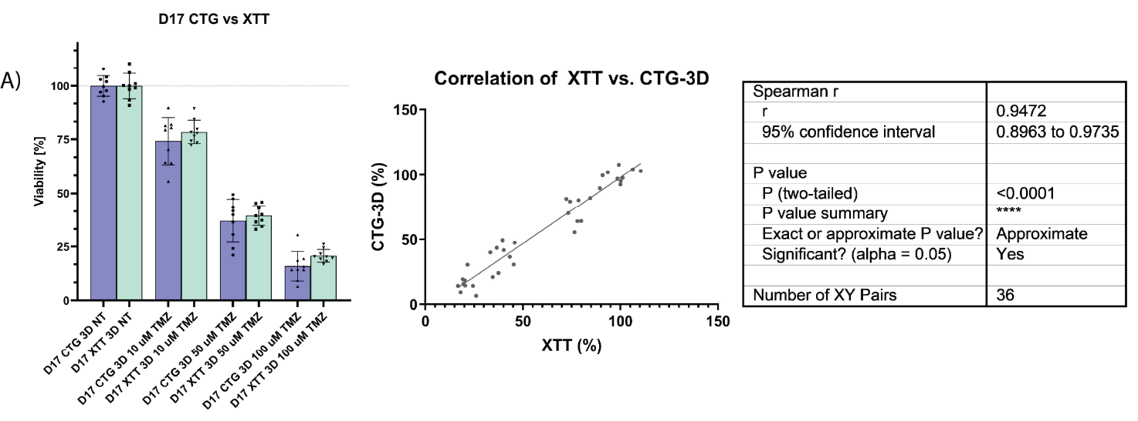
Supplementary Figure S7. Segmentation strategy for viable and necrotic cell fraction using
QuPath. A) Metabolic activity was measured after 17 days of cultivation upon various treatments (10 µM, 50 µM and 100 µM TMZ). Data is represented as bar plots showing individual values and mean ± SD consisting of three technical and three biological replicates (n = 3) (N = 3 spheroids / treatment concentration for each cell line). Due to non-normal distribution of the data, statistical analysis was performed using Spearman's rank correlation in GraphPad Prism (v10, GraphPad Software) and a two-tailed p-value < 0.05 was considered statistically significant. Correlative analysis revealed a very strong positive correlation between XTT and CTG 3D values (ρ = 0.94, 95% CI [0.89–0.97], p < 0.0001), confirming that XTT reliably reflects metabolic activity even in complex 3D spheroid structures.

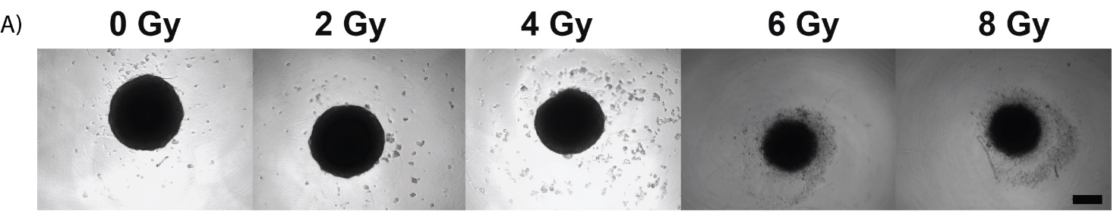
Supplementary Figure S8. Irradiation and long-term treatment efficacy in GBM. A) The structural integrity and spheroid morphology were assessed for irradiated GBM spheroids (U87MG) (2, 4, 6, 8 Gy) after 3 days to determine the maximum tolerable radiation dose. 4 Gy was identified as optimal irradiation dose, as higher doses led to spheroid disintegration and did not ensure sustained experimental utility. Scale bar: 200 µm.
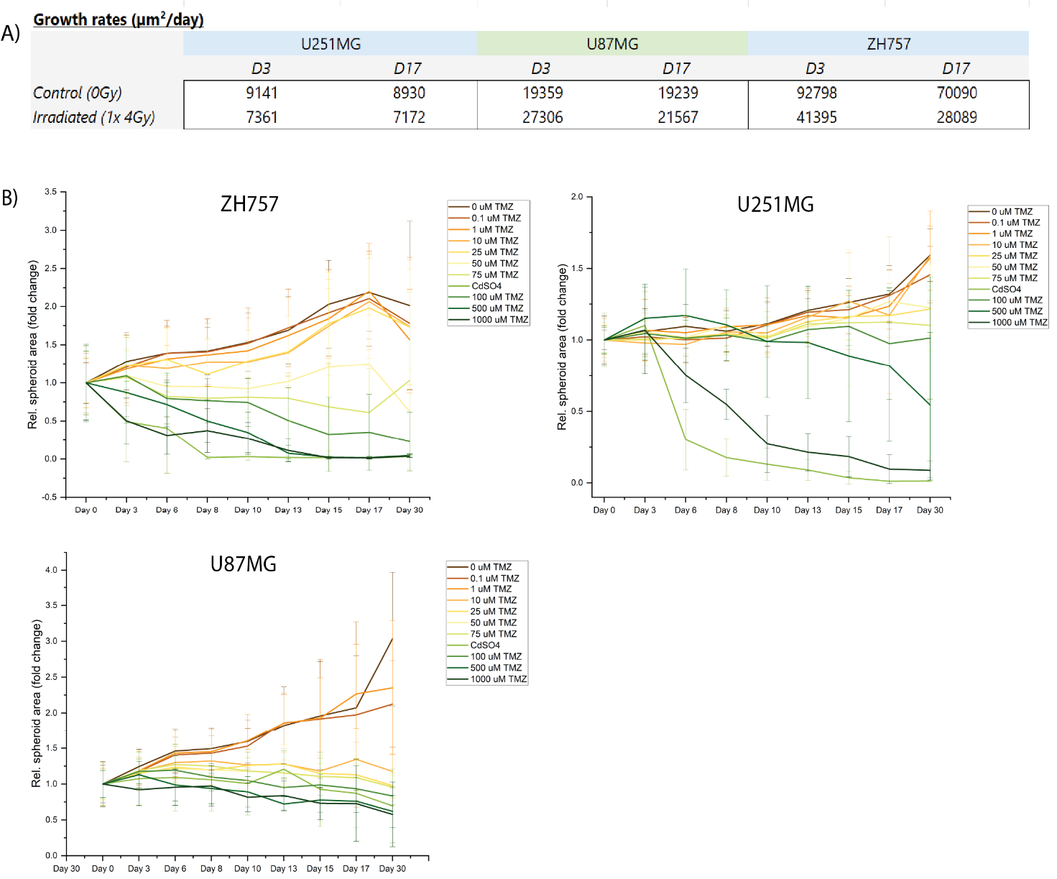
Supplementary Figure S9. Relative spheroid area fold change over 30 days of treatment. A) Tabular depiction of GBM spheroid growth rates for U87MG, U251MG and ZH757 in µm²/day. B) Bright-field imaging was performed every two to three days to assess spheroid growth in ZH757, U251MG, and U251MG cell lines under increasing concentrations of TMZ (0, 0.1, 1, 10, 25, 50, 75, 100, 500, and 1000 µM), alongside a CdSO₄ control. The fold change in spheroid area was normalized to baseline measurements of each treatment condition (day 0) and data represent mean ± SD calculated from three technical and three biological replicates (n = 3) (N = 9 spheroids / timepoint / treatment concentration for each cell line).

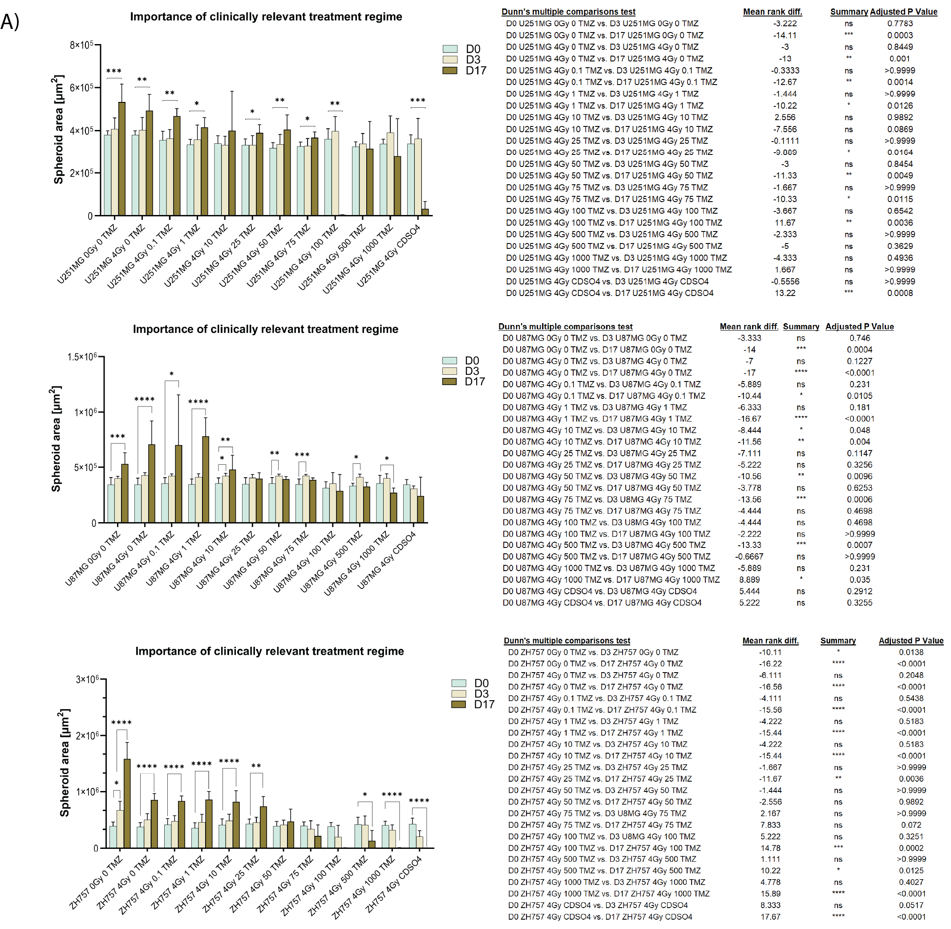
Supplementary Figure S10. Long-term treatment efficacy in spheroid size. A) The impact of prolonged TMZ treatment on GBM spheroid growth is depicted. Spheroid area was quantified from bright-field images for U251MG, U87MG, and ZH757 under various TMZ doses (0, 0.1, 1, 10, 25, 50, 75, 100, 500, 1000 µM) and CdSO₄ control, comparing baseline (day 0), end of GliaMimic’s continuous treatment (day 3), and GliaMimic’s end of treatment (day 17). Data is represented as bar plots showing mean ± SD with three technical and three biological replicates (n = 3) (N = 9 spheroids / treatment concentration for each cell line). Statistical analysis was performed using Kruskal-Wallis test followed by Dunn's multiple comparisons test in GraphPad Prism (v10, GraphPad Software). Significance was predominantly observed between day 0 and day 17, underscoring the importance of clinically relevant and extended treatment regimes. All statistical results are presented as bar plots with the following significance notation: *p < 0.05, **p < 0.01, ***p < 0.001, and ****p < 0.0001; nonsignificant differences (p ≥ 0.05).

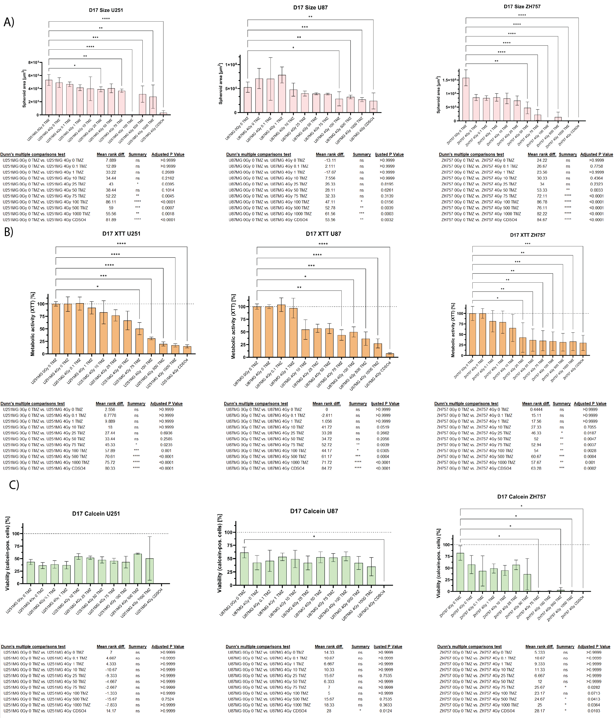
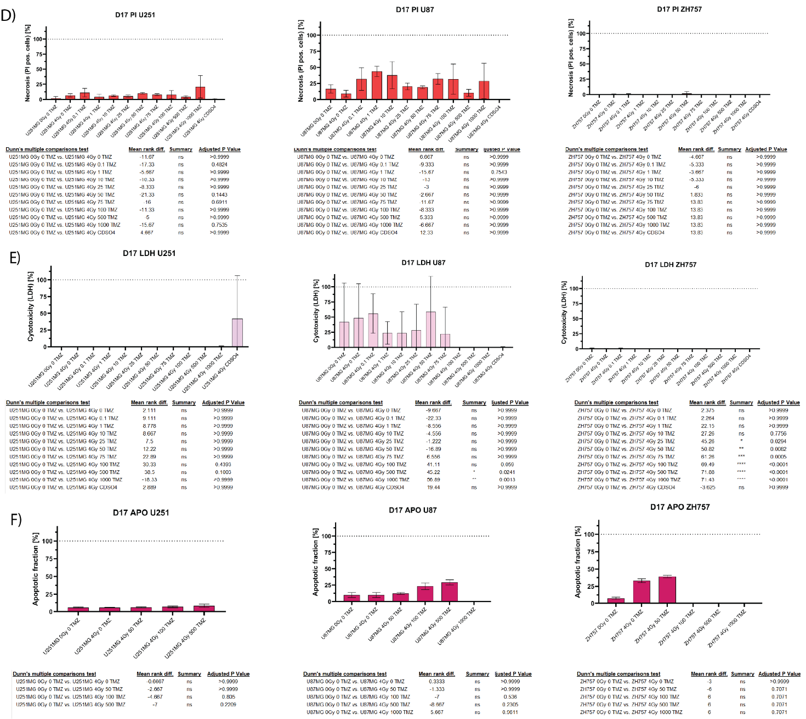

Supplementary Figure S11. Capturing treatment effects at end of GliaMimic treatment in spheroids. Bar plots are capturing treatment progression were calculated from three technical and three biological replicates across A) spheroid area (n = 3) (N = 9 spheroids / timepoint / treatment concentration for each cell line), B) metabolic activity (XTT assay) (N = 9 spheroids / timepoint / treatment concentration for each cell line), C) viable cell fraction (calcein+) (N = 3 spheroids / timepoint / treatment concentration for each cell line), D) necrotic cell fraction (PI+) (N = 3 spheroids / timepoint / treatment concentration for each cell line), E) cytotoxicity (LDH release) (N = 9 spheroids / timepoint / treatment concentration for each cell line), and F) apoptotic fraction (N = 3 spheroids / timepoint / treatment concentration for each cell line) at the end of treatment (day 17) in U251, U87MG, and ZH757 GBM models. Bar plots are representing mean ± SD. Treatment conditions (0, 0.1, 1, 10, 25, 50, 75, 100, 500, 1000 μM TMZ) and a CdSO₄ control were compared to the no treatment (NT) control. Statistical analysis was performed using Kruskal-Wallis test followed by Dunn's multiple comparisons test in GraphPad Prism (v10, GraphPad Software). All results are presented as bar plots with the following significance notation: *p < 0.05, **p < 0.01, ***p < 0.001, and ****p < 0.0001; non-significant differences (p ≥ 0.05).

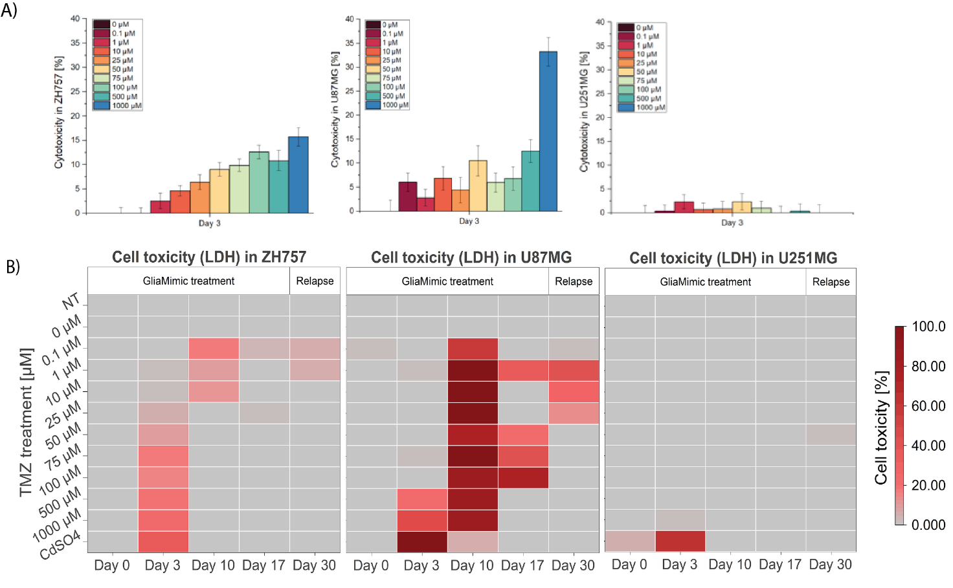
Supplementary Figure S12. Dose-dependent cytotoxicity (LDH release) in GBM cell lines after 3 days of continuous treatment and during GliaMimic. A) Bar plots show mean ± SD for U251MG, U87MG, and ZH757 calculated from three technical and three biological replicates (n = 3) (N = 9 spheroids / treatment concentration for each cell line) and demonstrating a clear dose-response relationship in U87MG and ZH757. B) The cytotoxicity of GBM spheroids under GliaMimic treatment are displayed as heatmaps. Data are shown as mean cytotoxicity (%)and was calculated from three technical and three biological replicates (n = 3) (N = 9 spheroids / timepoint / treatment concentration for each cell line), demonstrating cell line-specific treatment sensitivities to GliaMimic therapy.

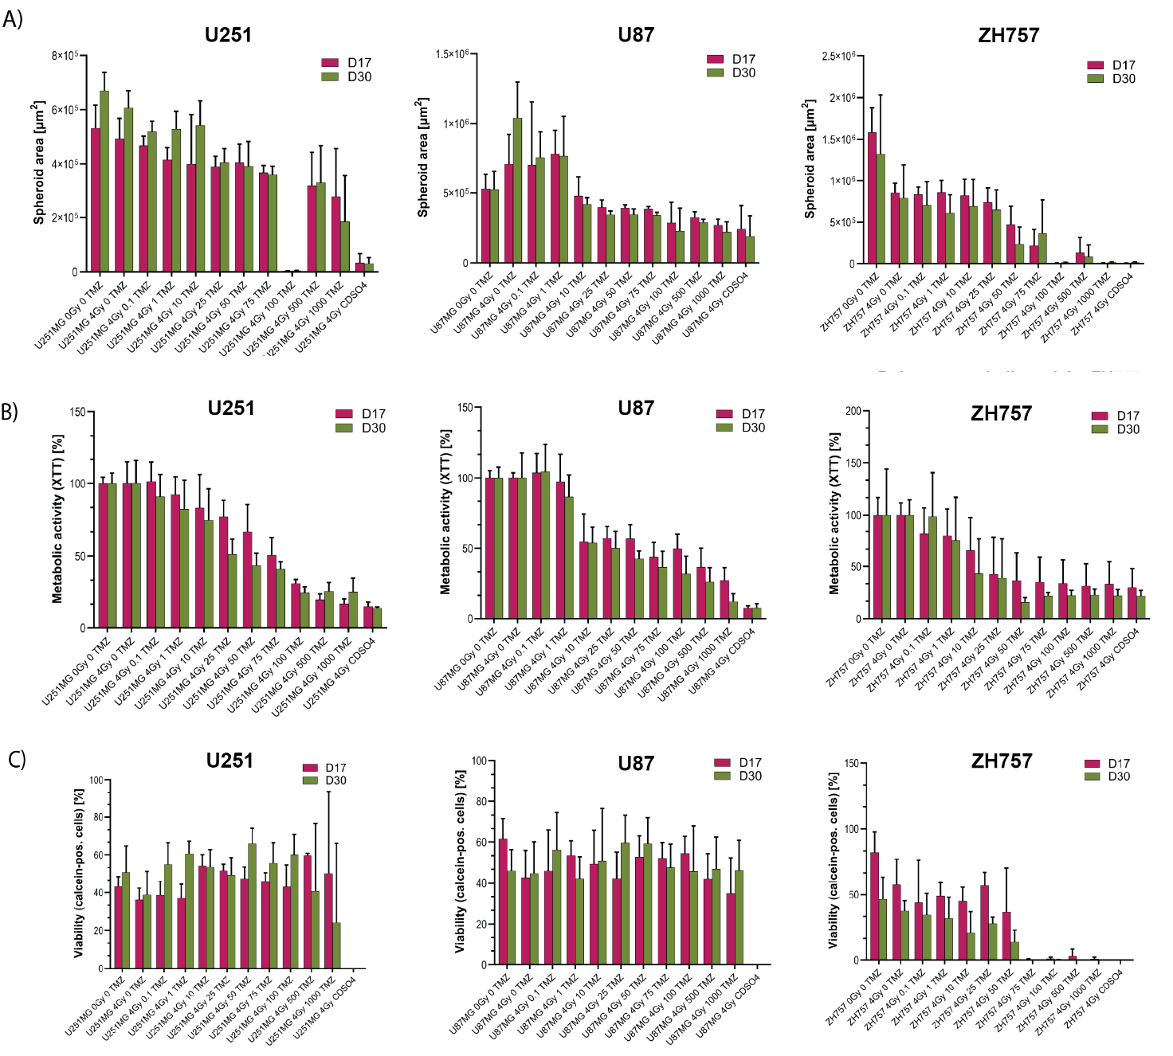

Supplementary Figure S13. Evaluation of GliaMimic post-treatment treatment efficacy and tumor progression in GBM spheroid models. Bar plots were calculated from three technical and three biological replicates (n=3) and depict A) spheroid area (N = 9 spheroids / timepoint / treatment concentration for each cell line), B) metabolic activity (XTT assay) (N = 9 spheroids / timepoint / treatment concentration for each cell line), and C) viable cell fraction (calcein+) (N = 3 spheroids / timepoint / treatment concentration for each cell line) for ZH757, U87MG, and U251MG at the end of treatment (day 17) and after 2 weeks of discontinuation (day 30). Data represent mean ± SD.

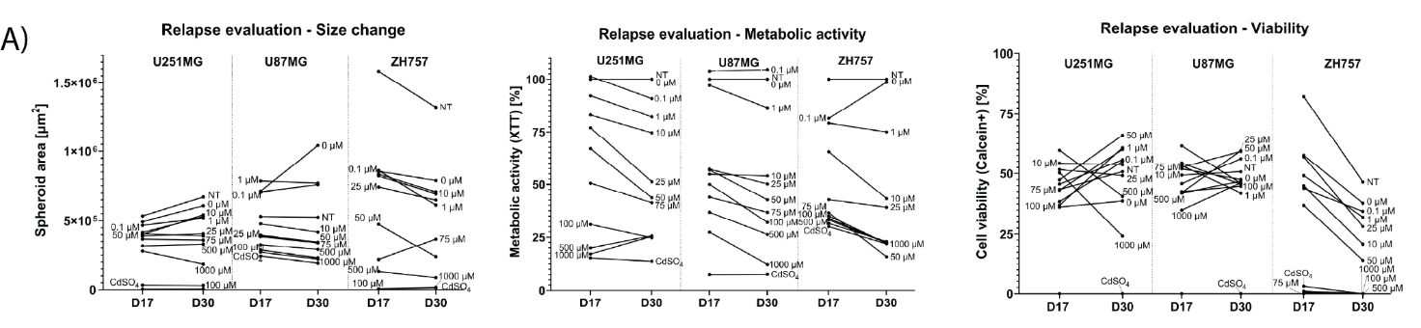
Supplementary Figure S14. Absolute values for post-treatment fold change calculations. A) Shown are the absolute values at the end of treatment (d17) versus those after the treatment break (d30) for spheroid size alterations, metabolic activity, and viability post-treatment in ZH757, U251MG, and U87MG.

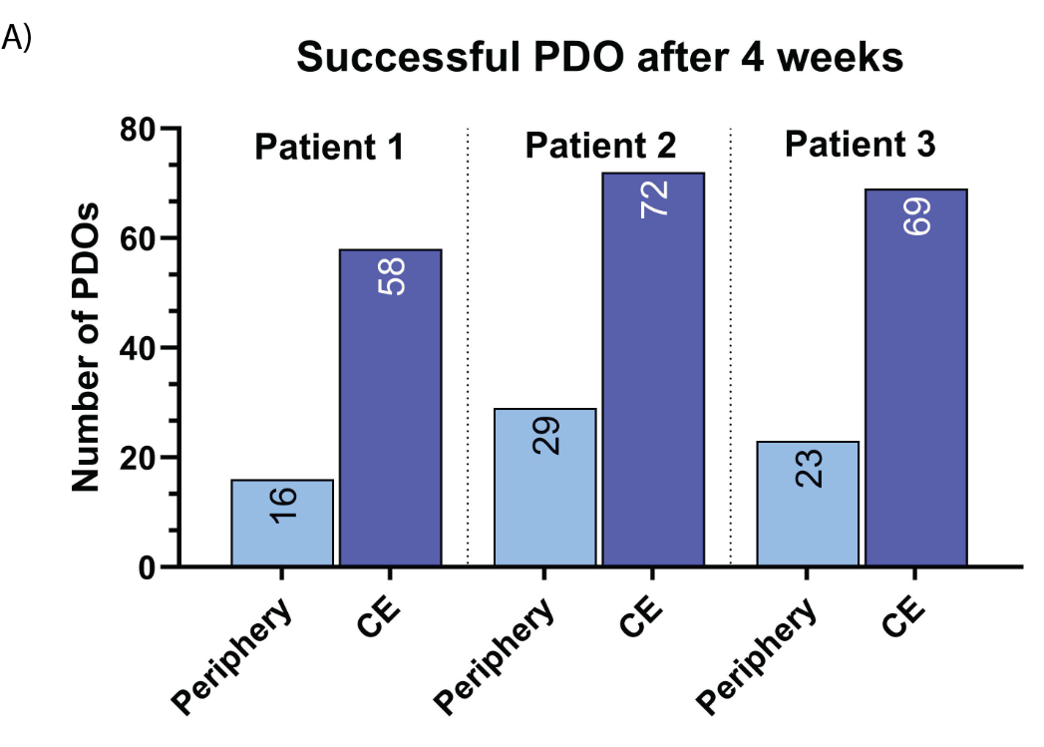

Supplementary Figure S15. Amount of successful PDOs. A) Shown is the number of successfully grown patient-derived organoids (PDOs) for patients 1, 2, and 3 after 4 weeks of cultivation, derived from biopsies of either the peripheral area or the contrast-enhancing area. The peripheral area yielded a substantially lower number of successfully generated PDOs compared to the contrast-enhancing area.
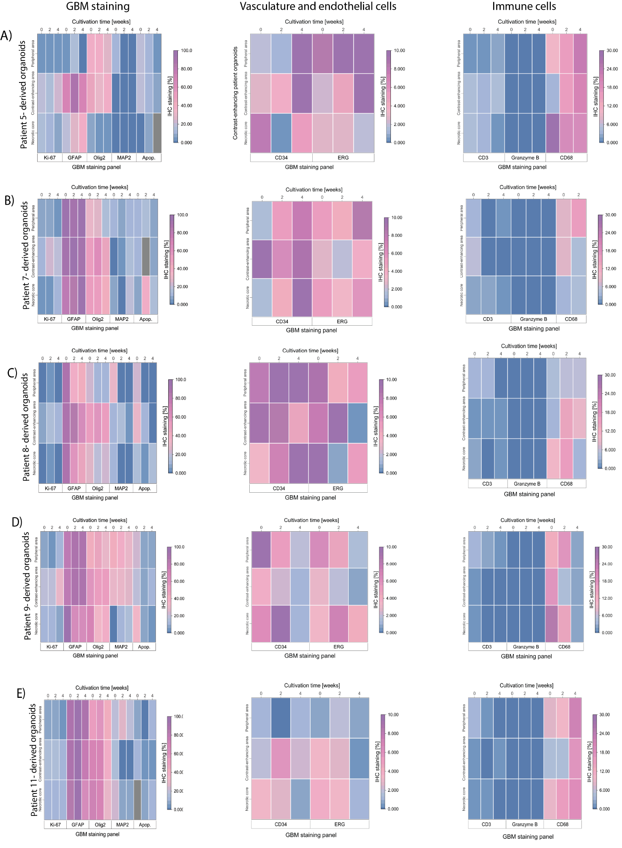
Supplementary Figure S16. Immunohistochemical characterization of patient-derived GBM organoids over 4 weeks of cultivation. Heatmaps A-E) display mean expression levels of endothelial and vascular markers (CD34, ERG), immune cell populations (CD3, Granzyme B, CD68), and a tumor cell panel (Ki-67, GFAP, Olig2, MAP2, apoptotic fraction) across PDOs from 5 GBM patients (N = 3 organoids / staining for each patient). Measurements were taken after 2 and 4 weeks, with additional comparison to the patient’s original tumor tissue (surgery day). PDOs exhibited pronounced inter- and intratumoral heterogeneity, including GBM cells, vasculature, and immune infiltrates. Notably, organoids closely mirrored the patient-matched tissue, supporting their clinical relevance as a tumor model. Statistical comparisons between timepoints were omitted due to the descriptive nature of the analysis.

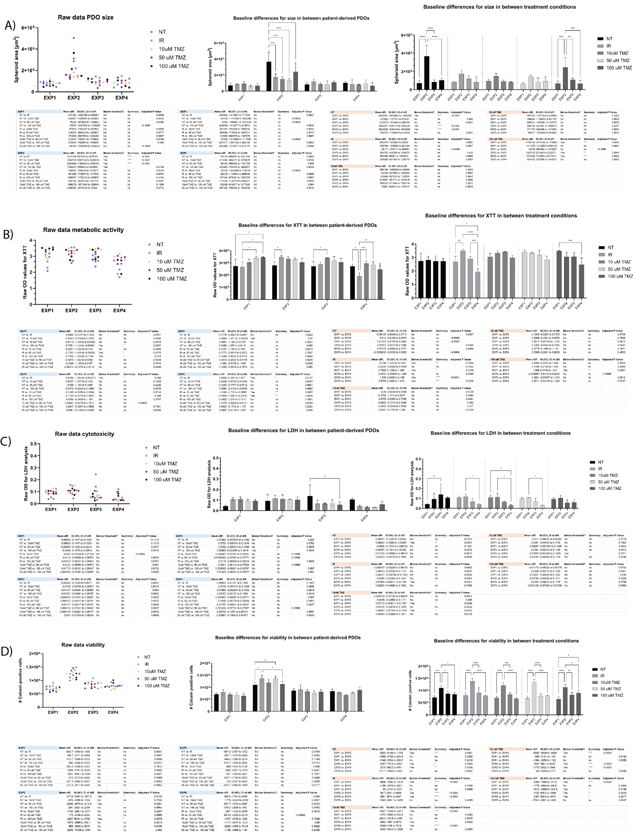
Supplementary Figure S17. Baseline characterization of patient-derived PDOs prior to treatment initiation. Left column: Scatter plots showing raw data for baseline values (D0) for each patient-derived PDO model across four experimental readouts: (A) PDO size (µm²), (B) metabolic activity (XTT, raw OD), (C) cytotoxicity (LDH, raw OD), and (D) viability (number of calcein-positive cells). Data are grouped by patient (EXP1 = Patient 6, EXP2 = Patient 7, EXP3 = Patient 8, EXP4 = Patient 9) and color-coded by treatment condition to visualize initial inter-patient and inter-condition variability. Middle column (within-patient baseline comparison): Bar plots showing mean ± SD from three technical replicates (N = 3 PDOs per timepoint per treatment concentration for each patient). Statistical analysis compares initial baseline performance within each PDO model. Two-way ANOVA with Tukey's multiple comparisons test was performed using GraphPad Prism (v10). Significance notation: *p < 0.05, **p < 0.01, ***p < 0.001, ****p < 0.0001; ns = non-significant (p ≥ 0.05). Right column (cross-patient baseline comparison): Bar plots analyzing baseline differences between treatment conditions across all four patient-derived PDO models. Statistical analysis was performed using two-way ANOVA with Tukey's multiple comparisons test in GraphPad Prism (v10). Significance notation: *p < 0.05, **p < 0.01, ***p < 0.001, ****p < 0.0001; ns = non-significant (p ≥ 0.05).

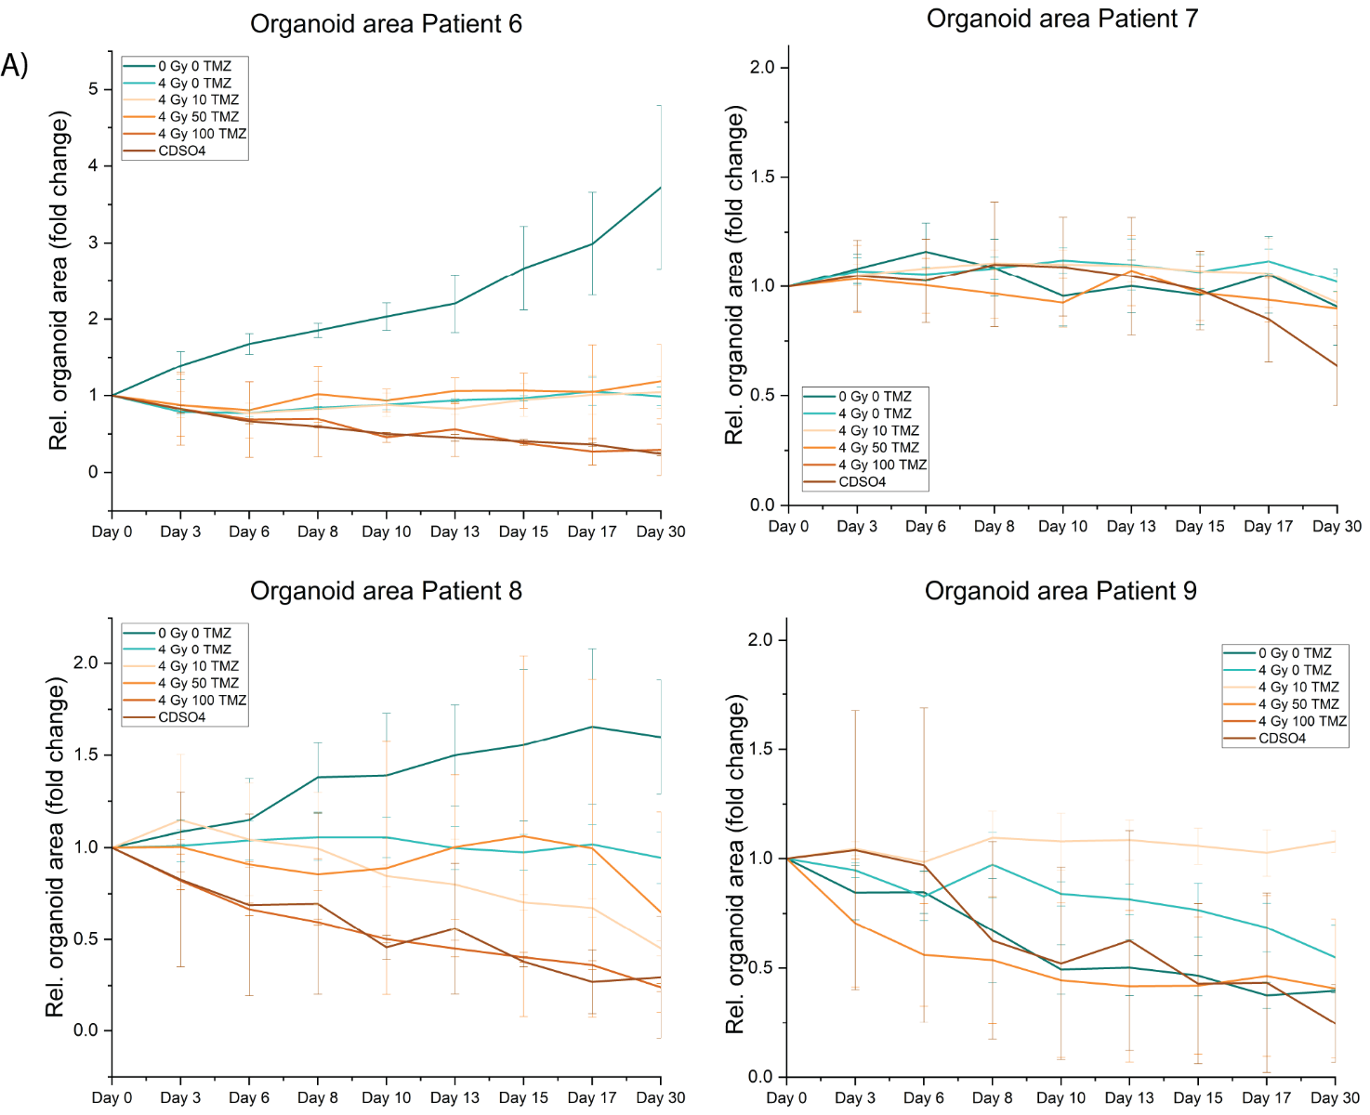
Supplementary Figure S18. Relative spheroid area fold change over 30 days of treatment. Bright-field imaging was performed every two to three days to assess organoid growth in A) patient 6, B) patient 7, C) patient 8 and D) patient 9 under increasing concentrations of TMZ (NT, 0,10, 50, 100 µM). The fold change in spheroid area was normalized to baseline measurements of each treatment condition (day 0) and data represent mean ± SD of three technical replicates (N = 3 organoids / timepoint / treatment concentration for each patient).

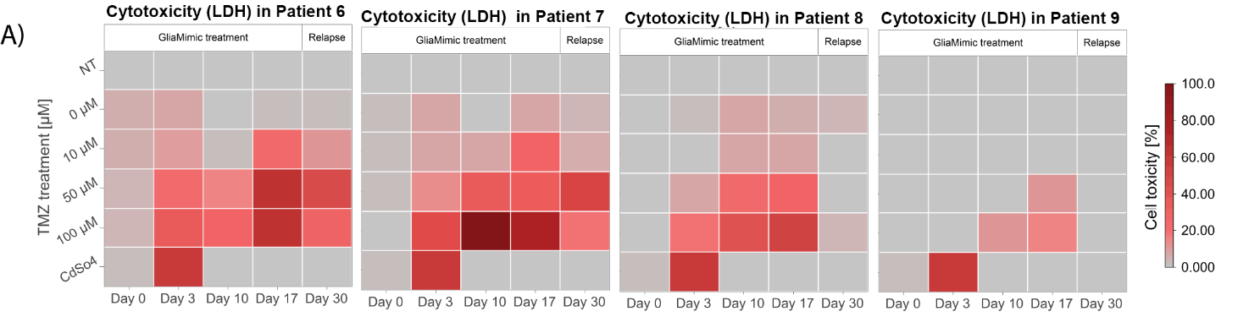
Supplementary Figure S19. Long-term cytotoxicity data for PDOs. Cytotoxicity (LDH assay) profiles of the four GBM organoid models, revealing distinct treatment-induced toxicity patterns. Heatmap show mean LDH release (%) calculated from three technical replicates (N = 3 PDOs / timepoint / treatment concentration for each patient).
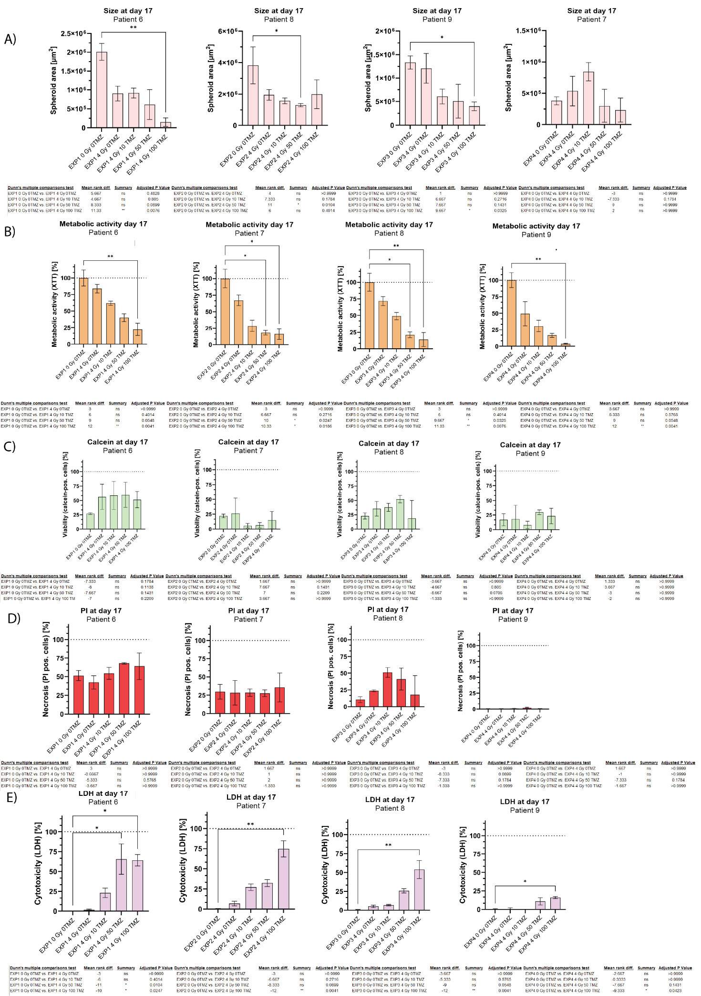
Supplementary Figure S20. Capturing treatment effects at end of GliaMimic treatment in PDOs. Bar plots comparing the effects of GliaMimic treatment across A) GBM organoid size, B) metabolic activity (XTT assay), C) viable cell fraction (calcein+), D) necrotic cell fraction (PI+), E) cytotoxicity (LDH release) at the end of treatment (day 17) in patient-derived organoids from 4 different patients. Bar plots are representing mean ± SD calculated from three technical replicates (N = 3 PDOs / timepoint / treatment concentration for each patient). Treatment conditions (0, 10, 50, 100 μM TMZ) were compared to the no treatment (NT) control. Statistical analysis was performed using Kruskal-Wallis test followed by Dunn's multiple comparisons test in GraphPad Prism (v10, GraphPad Software). All results are presented as bar plots with the following significance notation: *p < 0.05, **p < 0.01, ***p < 0.001, and ****p < 0.0001; non-significant differences (p ≥ 0.05).

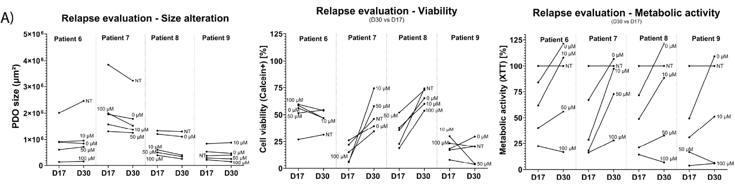
Supplementary Figure S21. Absolute values for post-treatment fold chance interpretation. A) Shown are the absolute values at the end of treatment (d17) versus those after the treatment break (d30) for PDO size alterations, metabolic activity, and viability post-treatment in 4 different patient-derived PDO models.

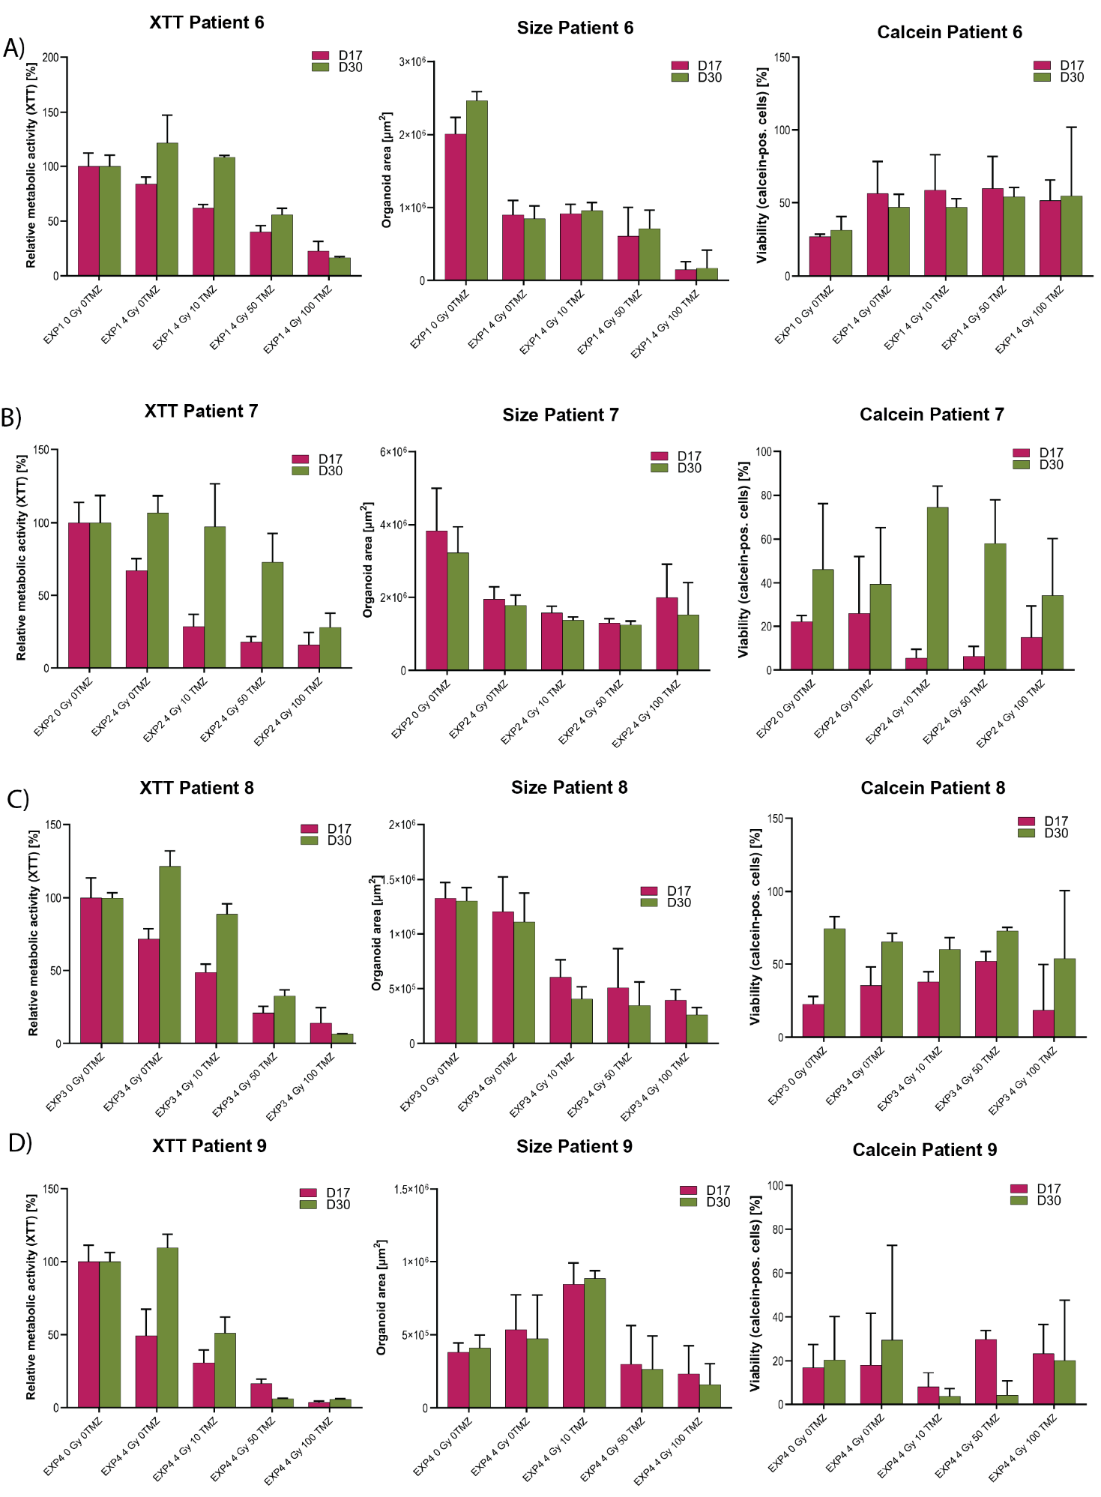
Supplementary Figure S22. Evaluation of GliaMimic treatment discontinuation and post-treatment dynamics in GBM PDOs. Bar plots depict A) patient-derived organoid area, B) metabolic activity (XTT assay), and C) viable cell fraction (calcein AM+). GBM PDOs derived from four patients at the end of treatment (day 17) and after two weeks of discontinuation (day 30, post-treatment timepoint). Data represents mean ± SD and were calculated from three technical replicates (N = 3 PDOs / timepoint / treatment concentration for each patient).

Tables
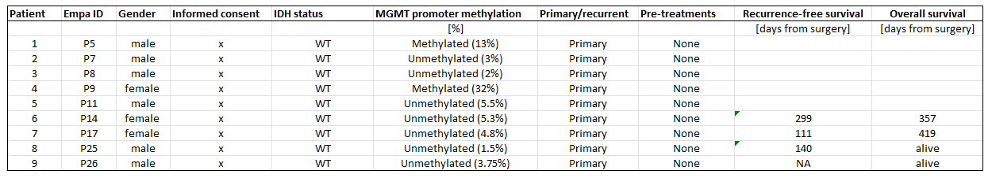
Supplementary Table 1 Patient information. Clinical indications (Patient #, GBO ID, HOCH Patient ID donor age, gender, informed consent, MGMT promoter methylation status, IDH status, pretreatments, primary/recurrent) about GBM patients used for the generation of patient-derived organoids is provided in a tabular form.

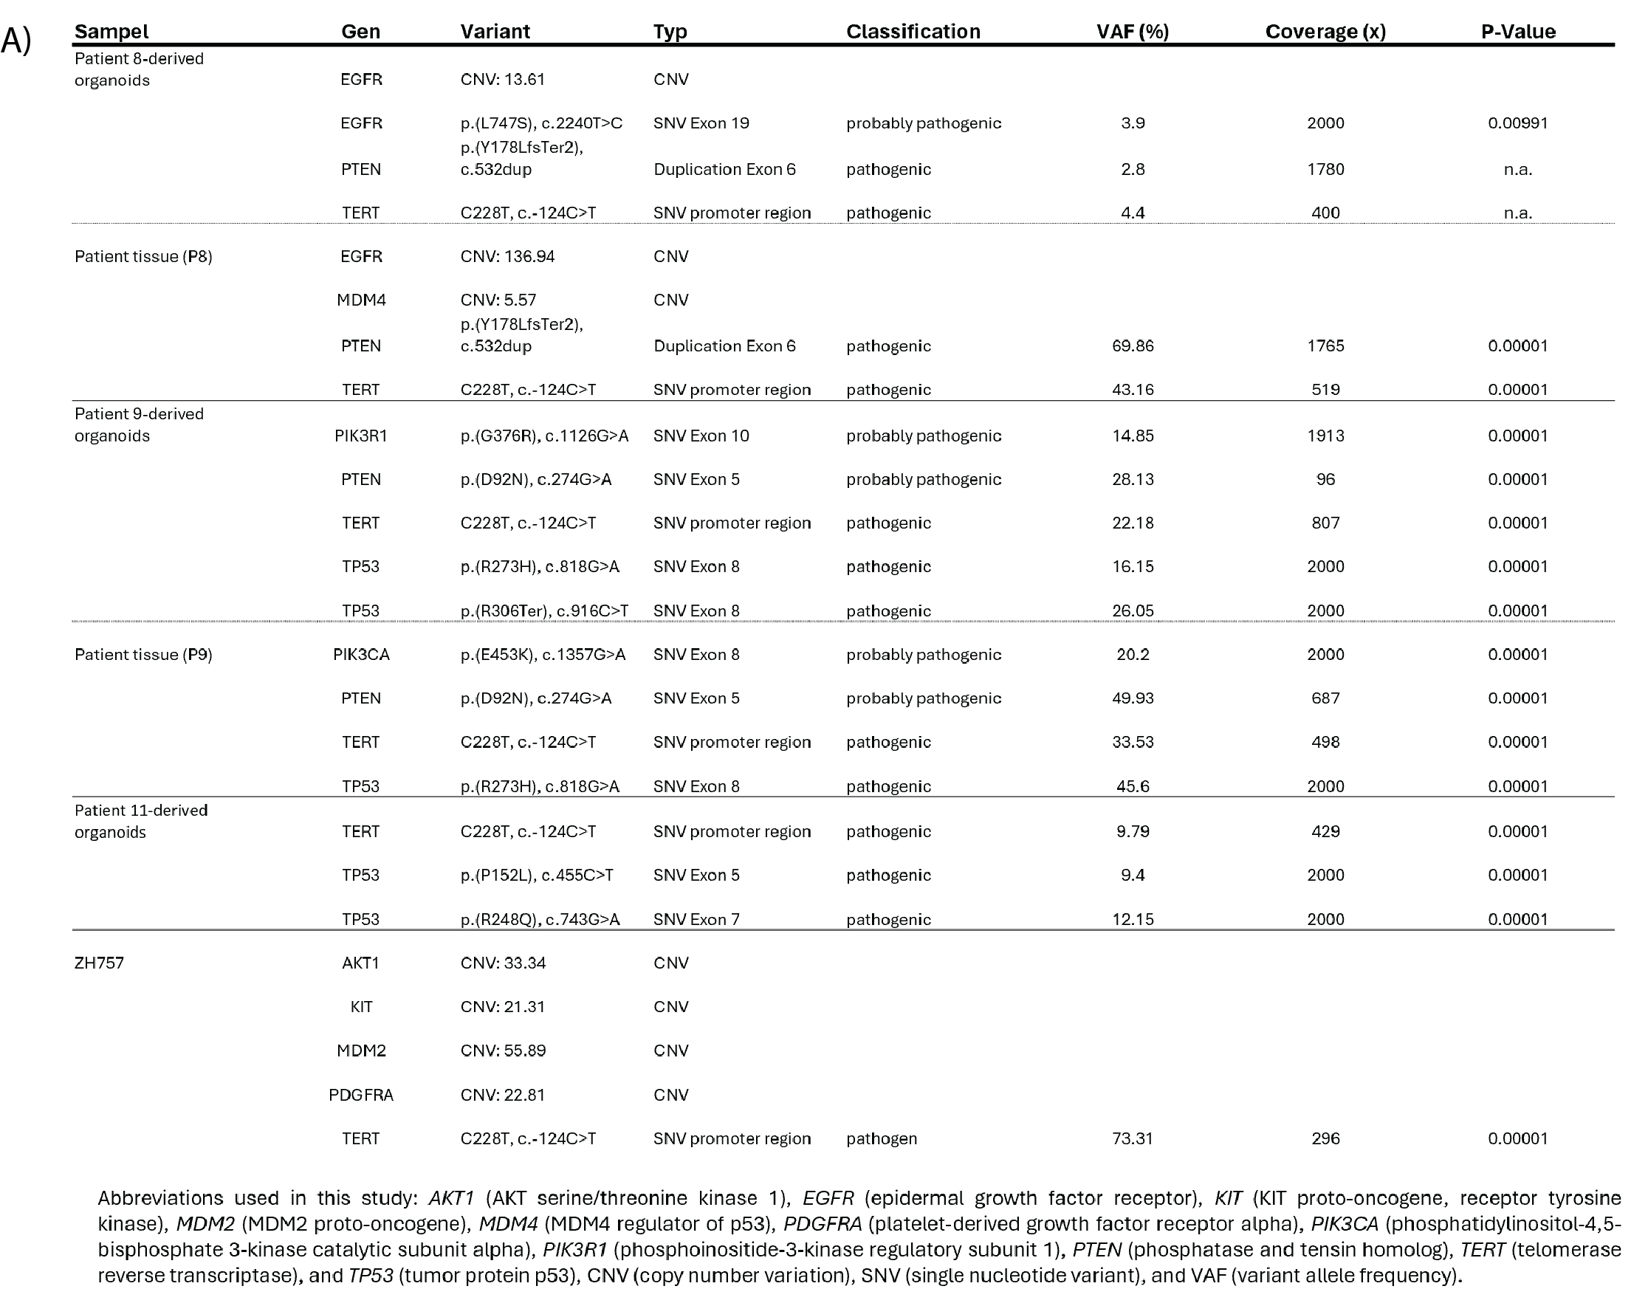
Supplementary Table 2. Mutational profiling (whole genome sequencing) of GBM PDOs derived from patient 8, 9 and 11, with corresponding patient tumor tissue available for comparison in patient 8 and 9. Tumor DNA was profiled using the Oncomine Comprehensive Assay v3 (ThermoFisher) on an Ion Torrent sequencing platform. Abbreviations used: AKT1 (AKT serine/threonine kinase 1), EGFR (epidermal growth factor receptor), KIT (KIT proto-oncogene, receptor tyrosine kinase), MDM2 (MDM2 proto-oncogene), MDM4 (MDM4 regulator of p53), PDGFRA (platelet-derived growth factor receptor alpha), PIK3CA (phosphatidylinositol-4,5-bisphosphate 3-kinase catalytic subunit alpha), PIK3R1 (phosphoinositide-3-kinase regulatory subunit 1), PTEN (phosphatase and tensin homolog), TERT (telomerase reverse transcriptase), TP53 (tumor protein p53), CNV (copy number variation), SNV (single nucleotide variant), and VAF (variant allele frequency).

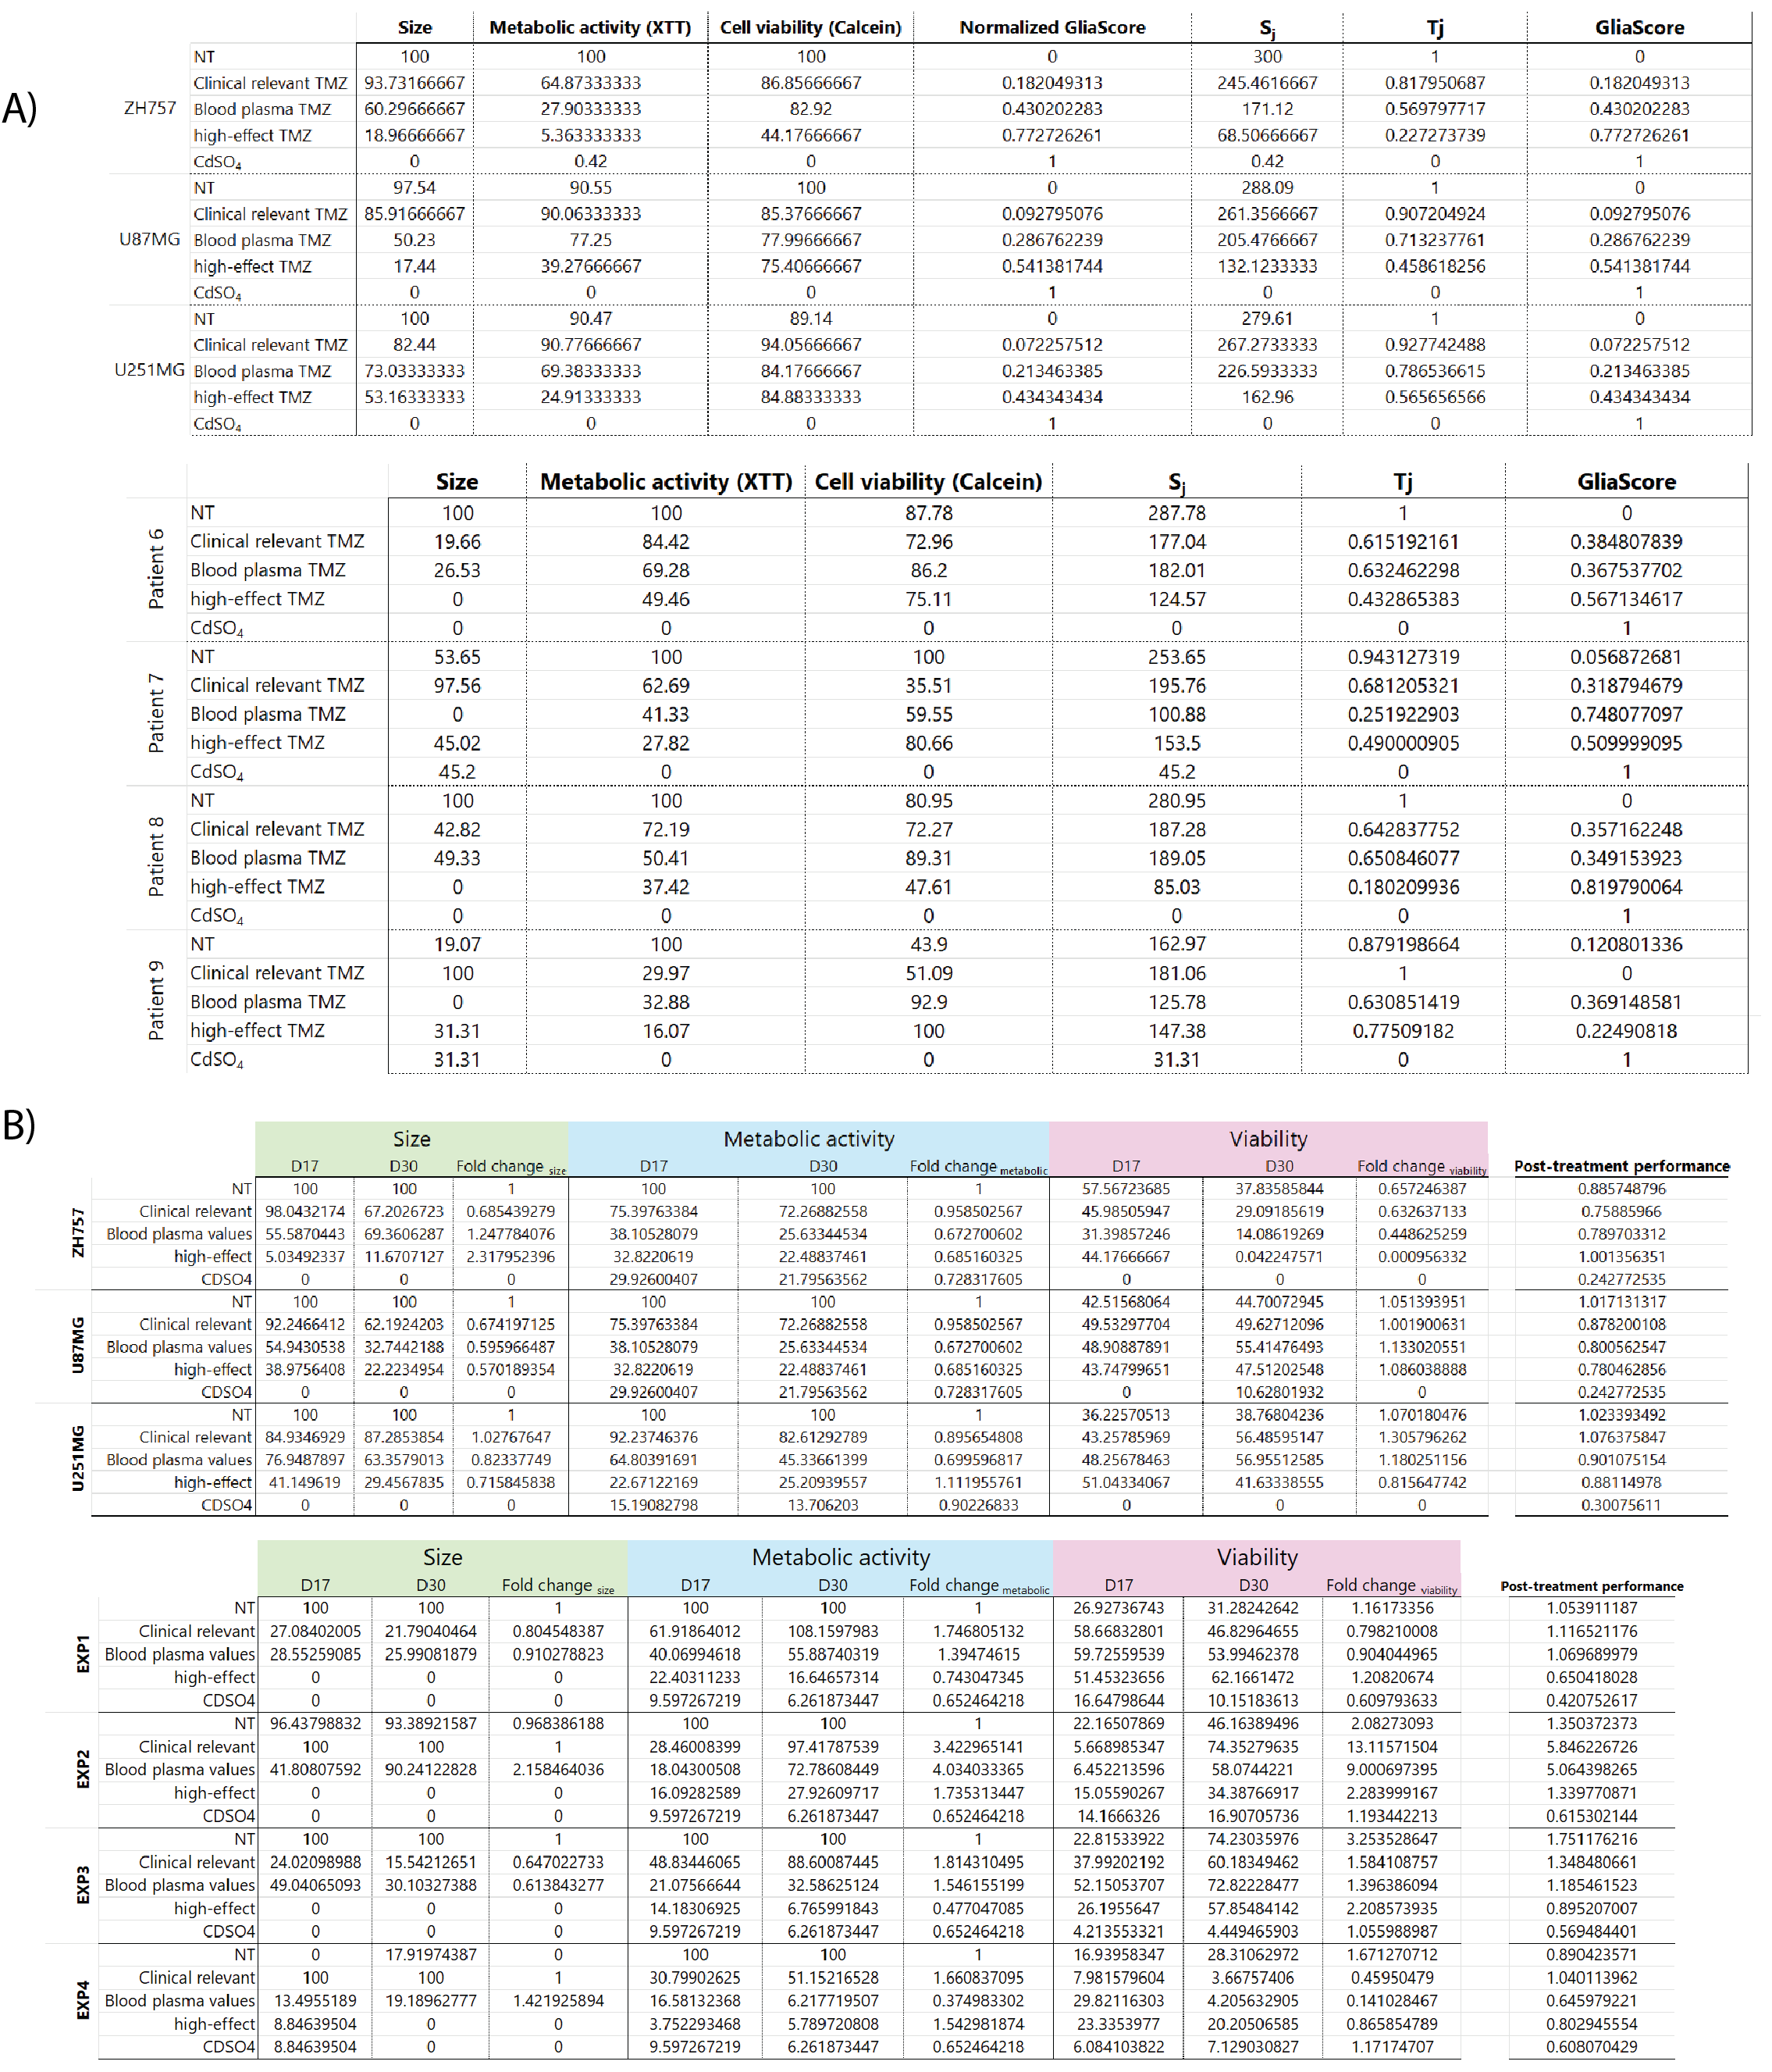
Supplementary Table 3 Calculation of GliaScore and post-treatment performance score. In A) is showing the intermediate calculation septs of GliaMimic score including the scaled values ($Rescaled {AUC}_{i}$) for size, metabolic activity and cell viability for the three spheroid cell lines (ZH757, U87MG and U251MG) as well as for the PDOs (patient 6 - 9). $S_{j}$ depicts the summed treatment conditions and $T_{j}$ is scaling the summed values from 0 to 1. The overall final GliaScore value is shown in the last column with scores ranging from 0 (showing baseline values in the NT control) to 1 (indicating maximal possible treatment response). In B) the calculation steps for the post-treatment performance values are depicted. Scaled values for end of treatment (day 17) and relapse time point (day 30) as well as fold change for each readout are shown. In the last column, the post-treatment performance of the GBM spheroids and PDOs are shown with values greater than 1 indicating disease progression following treatment.

