Table 1. Sample characteristics of EQ-DAPHNIE respondents across 15 selected countries
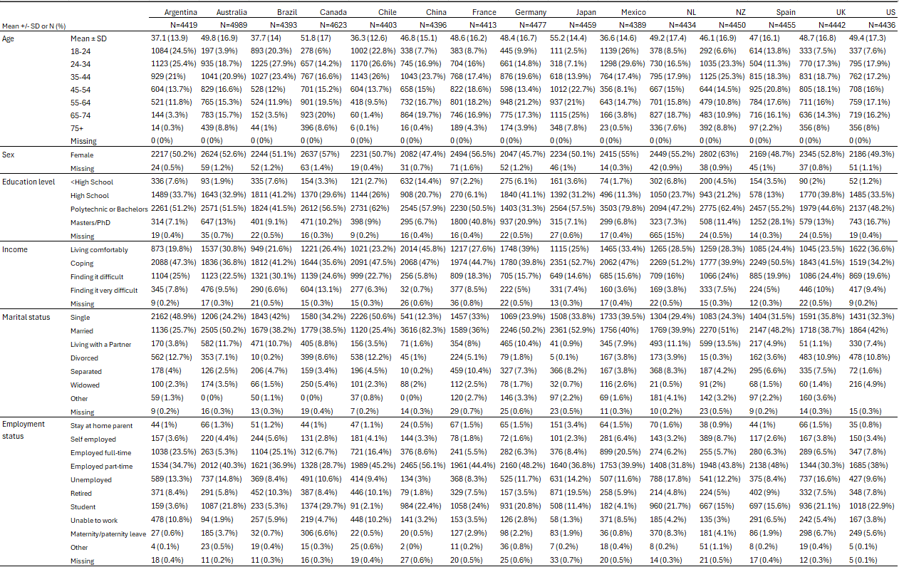
NL Netherlands, NZ New Zealand, UK United Kingdom, US United States, SD standard deviation

Table 2. Spearman rank correlations between macro-level indicators and EQ-5D-5L outcomes
 | Economic indicators |  | Socioeconomic indicators |  | Health system indicators
 | GDP per capita | Median income | Unemployment rate | Gini index | Health expenditure  (% of GDP) | Health expenditure per capita | Hospital beds per 1000 people | Physicians per 1000 people
Mobility | 0.81 | 0.79 | -0.24 | -0.66 | 0.47 | 0.76 | -0.20 | 0.27
Self-care | 0.75 | 0.66 | -0.30 | -0.48 | 0.46 | 0.68 | -0.03 | 0.17
Usual activities | 0.79 | 0.74 | -0.23 | -0.63 | 0.42 | 0.72 | -0.26 | 0.19
Pain/discomfort | 0.80 | 0.86 | -0.08 | -0.66 | 0.64 | 0.84 | 0.01 | 0.19
Anxiety/depression | 0.33 | 0.29 | 0.25 | 0.02 | 0.53 | 0.35 | -0.20 | 0.05
EQ VAS | -0.63 | -0.66 | 0.00 | 0.64 | -0.72 | -0.73 | -0.25 | -0.13
EQ-5D-5L LSS | 0.80 | 0.78 | -0.16 | -0.54 | 0.58 | 0.78 | -0.13 | 0.17
GDP gross domestic product, LSS level sum score
Bold numbers indicate significant results (p<0.05)

