SUPPLEMENTARY MATERIALS

Synthesis and In Vitro Evaluation of a Novel Tyrosinase-Targeting Cyclic Peptide with Radical Scavenging Activity

Table of contents
MALDI-TOF mass spectrum of the synthesized cyclic peptide CYGSR. 3
Analytical HPLC chromatograms of CV5 monitored at different wavelengths. 4-5
Tyrosinase inhibition activity of arbutin as a positive control. 6
DPPH radical scavenging activity of Ascorbic acid as a positive control. 7
Preparative HPLC purification conditions. 8
Analytical HPLC conditions. 9
Cell viability of CV5 in RAW 264.7 cells. 10
Raw absorbance data for tyrosinase inhibition analysis of CV5. 11
Raw absorbance data for tyrosinase inhibition analysis of arbutin. 12
Raw absorbance data for DPPH radical scavenging assay of CV5. 13
Raw absorbance data for DPPH radical scavenging assay of Ascorbic acid. 14

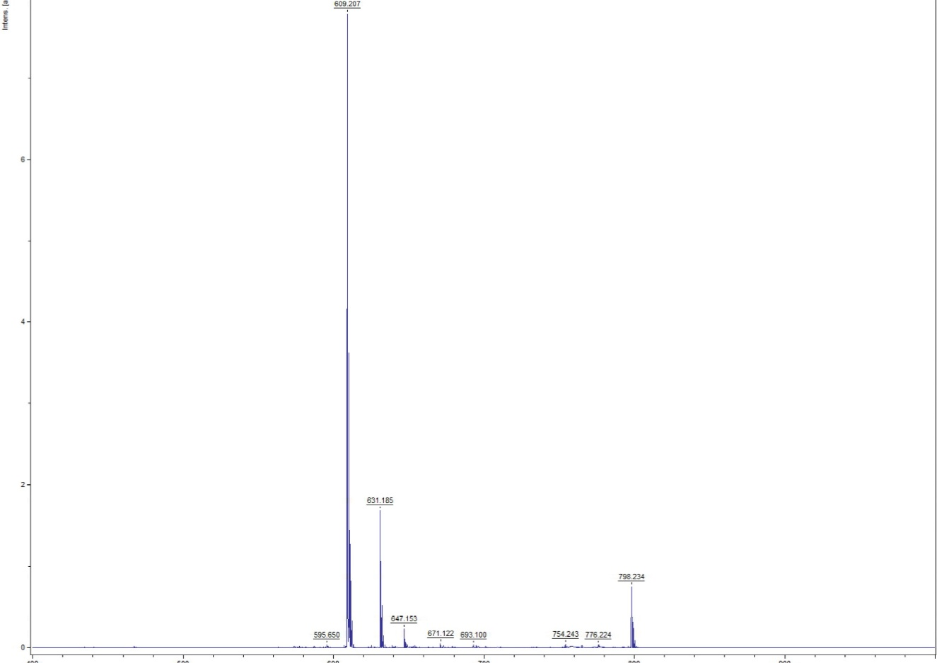
Fig. S1 MALDI-TOF mass spectrum of the synthesized cyclic peptide CYGSR. The calculated molecular weight was 608.64 Da, and a major peak observed at m/z 609.2 corresponds to the [M + H]⁺ ion, confirming the expected molecular weight. Additional peaks at m/z 631.1 and 647.1 were assigned to the [M + Na]⁺ and [M + K]⁺ adduct ions, respectively.

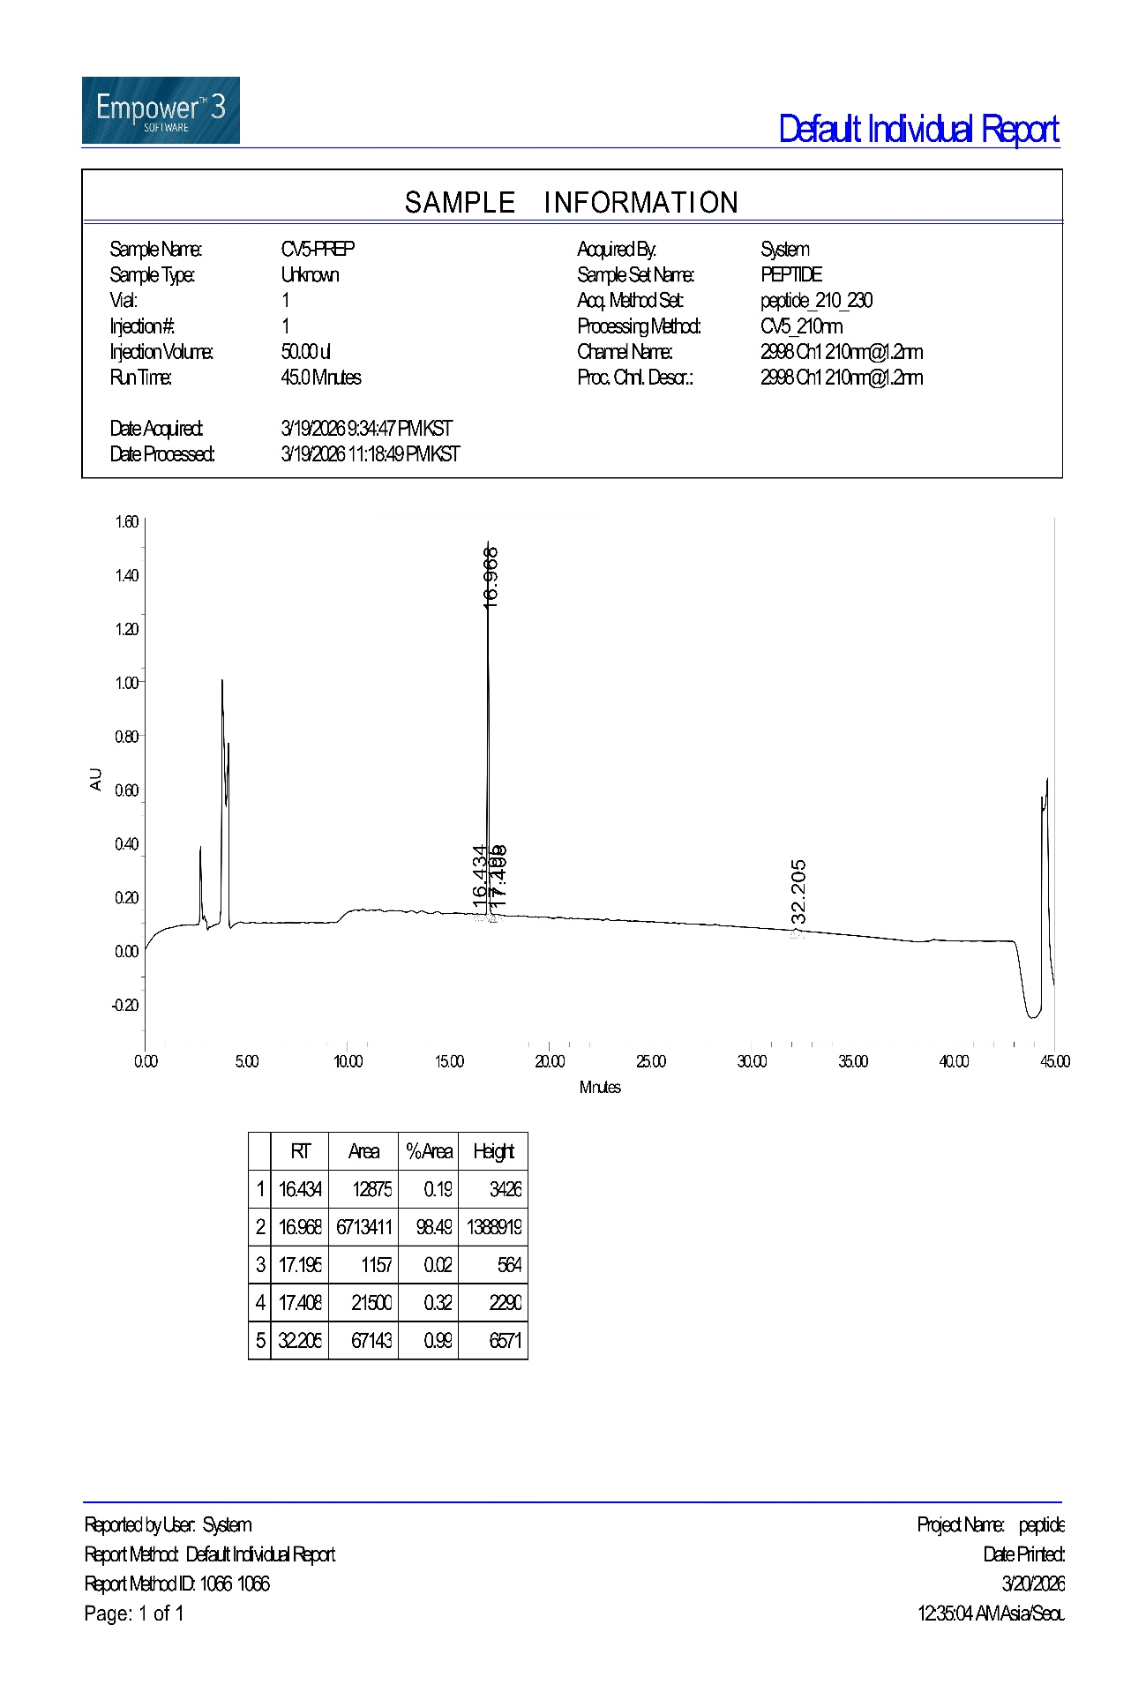
(a)

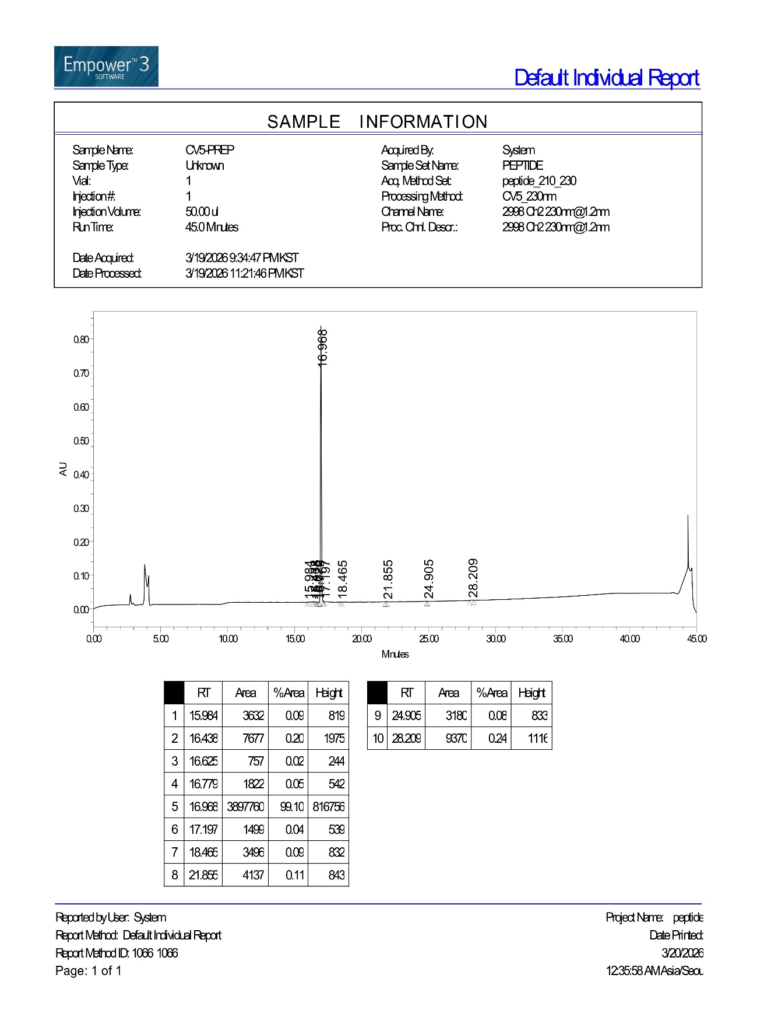
(b)
Fig. S2 Analytical HPLC chromatograms of CV5 monitored at different wavelengths. (a) Chromatogram recorded at 210 nm. (b) Chromatogram recorded at 230 nm.

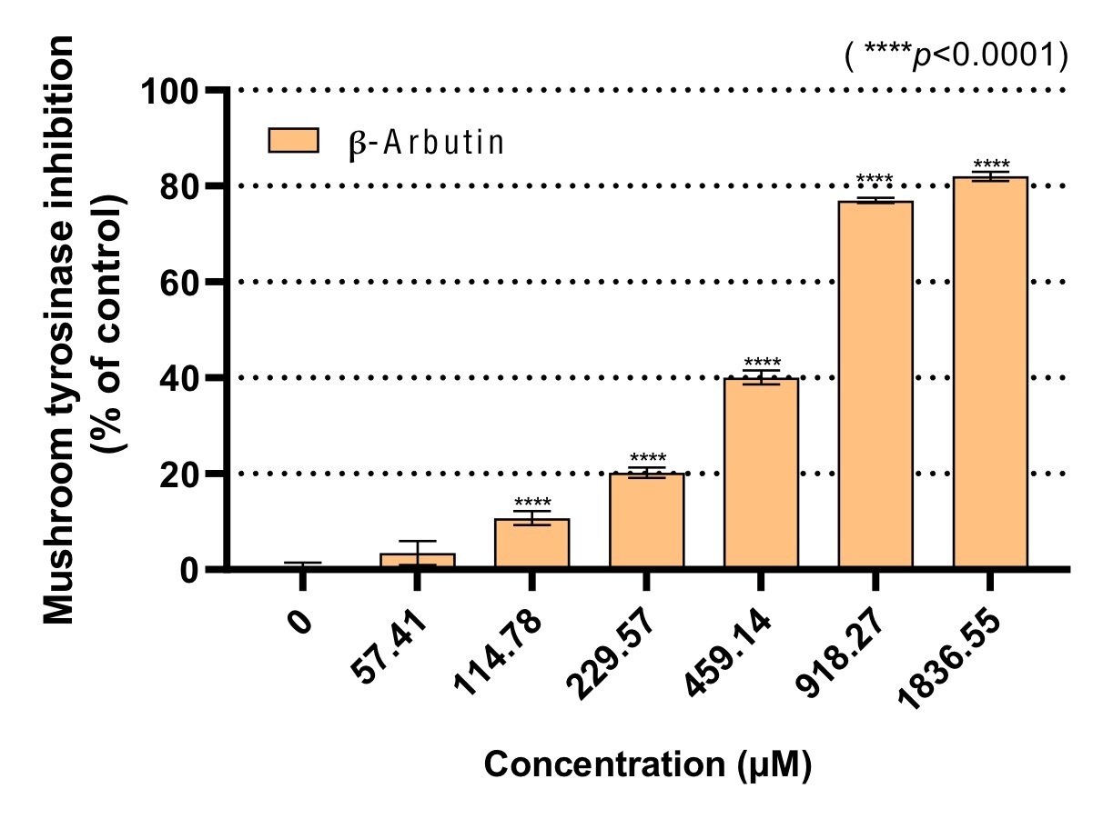
Fig. S3 Tyrosinase inhibition activity of arbutin as a positive control.

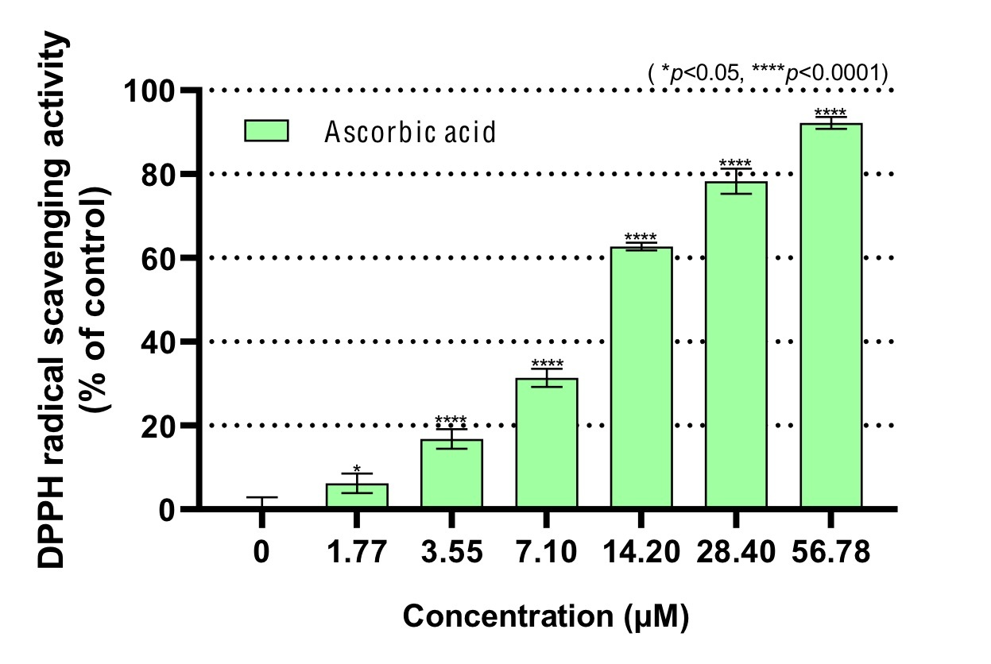
Fig. S4 DPPH radical scavenging activity of Ascorbic acid as a positive control.

Conditions
HPLC system | Water 2545
Mobile Phase | Solvent A: H₂O + 0.10% TFA  Solvent B: Acetonitrile + 0.10% TFA
Time (min) | Solvent A (%) | Solvent B (%)
0.0 | 95 | 5
5.0 | 95 | 5
45.0 | 35 | 65
50.0 | 35 | 65
50.1 | 0 | 100
51.0 | 0 | 100
51.1 | 95 | 5
55.0 | 95 | 5
Flow Rate | 20.00 mL
Detection Wavelength | 210 nm or 230 nm

Table S1. Preparative HPLC purification conditions.

Conditions
HPLC system | Water e2695
Mobile Phase | Solvent A: H₂O + 0.10% TFA  Solvent B: Acetonitrile + 0.10% TFA
Time (min) | Solvent A (%) | Solvent B (%)
0.0 | 95 | 5
10.0 | 95 | 5
35.0 | 35 | 65
40.0 | 35 | 65
40.1 | 0 | 100
41.0 | 0 | 100
41.1 | 95 | 5
45.0 | 95 | 5
Flow Rate | 1.00 mL
Detection Wavelength | 210 nm or 230 nm

Table S2. Analytical HPLC conditions.

Table S3. Cell viability of CV5 in RAW 264.7 cells.

Table S4. Raw absorbance data for tyrosinase inhibition analysis of CV5.

Table S5. Raw absorbance data for tyrosinase inhibition analysis of arbutin.

Table S6. Raw absorbance data for DPPH radical scavenging assay of CV5.

Table S7. Raw absorbance data for DPPH radical scavenging assay of Ascorbic acid.

