Appendix A. Supplementary data
The following are the Supplementary data to this article:
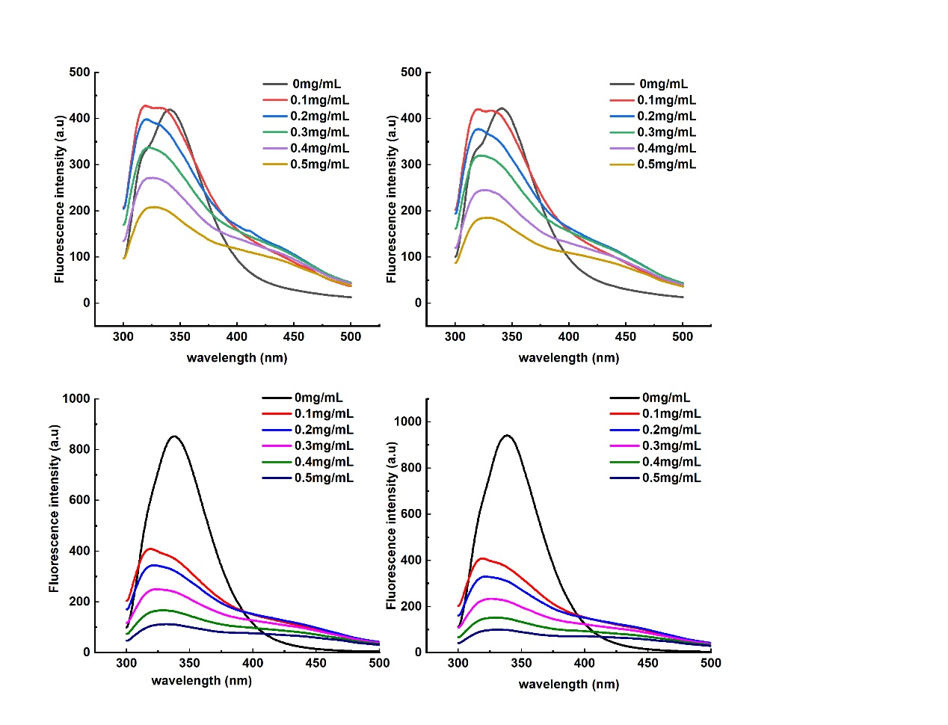
Figure S1. Fluorescence spectra of α-amylase (A: 298K, B: 310K) and α-glucosidase (C: 298K, B: 310K)

Table S1. Identification of acorn shells extract by HRLC-TOF-MS
Compounds | Formula | Intensity | Expected m/z | Found at m/z | Error/ppm | Found RT/min | Isotope diff/%
Quinic Acid | C₇H₁₂O₆ | 91475 | 191.0561 | 191.0559 | -1.2 | 0.79 | 1.70%
Gallic Acid | C₇H₆O₅ | 26845 | 169.0143 | 169.0143 | 0 | 2.44 | 1.30%
Protocatechuic aldehyde | C₇H₆O₃ | 36844 | 137.0244 | 137.0244 | -0.1 | 4.04 | 0.70%
Calycosin | C₁₆H₁₂O₅ | 453 | 283.0612 | 283.0613 | 0.3 | 8.66 | 2.5%
p-counaric acid | C₉H₈O₃ | 9102 | 163.0401 | 163.0401 | 0 | 4.89 | 2.10%
Ellagic Acid | C₁₄H₆O₈ | 623416 | 300.999 | 300.9987 | -1 | 5.29 | 0.80%
Asiatic Acid | C₃₀H₄₈O₅ | 333303 | 487.3429 | 487.3417 | -2.6 | 9.65 | 1.10%
Sclareol Glycol | C₁₆H₃₀O₂ | 24806 | 253.2173 | 253.2173 | 0.2 | 11.59 | 2.0%
Myricetin | C₁₅H₁₀O₈ | 9880 | 363.0347 | 363.0348 | 0.4 | 5.29 | 3.6%
Genistin | C₂₁H₂₀O₁₀ | 6286 | 431.0984 | 431.0971 | -2.9 | 5 | 4.70%
Phloridzin | C₂₁H₂₄O₁₀ | 5831 | 435.1297 | 435.1288 | -2 | 5.07 | 4.80%
Epicatechin gallate | C₂₂H₁₈O₁ | 6054 | 487.0871 | 487.0892 | 4.3 | 4.52 | 9.5%

 | Extract (mg/mL) | Double reciprocal equation | K_{m} | V_{max} | K_{i} | K_{is} | Inhibition type
α-amylase | 0 | $\frac{1}{v}$=151.32$\frac{1}{S}$+11.514 | 13.1423 | 0.0869 | 0.62536 | 0.34406 | mixed inhibition
α-amylase | 0.2 | $\frac{1}{v}$=268.84$\frac{1}{S}$+30.055 | 8.9449 | 0.03327 | 0.62536 | 0.34406 | mixed inhibition
α-amylase | 0.5 | $\frac{1}{v}$=298.53$\frac{1}{S}$+34.764 | 8.5873 | 0.02877 | 0.62536 | 0.34406 | mixed inhibition
α-glucosidase | 0 | $\frac{1}{v}$=0.6264$\frac{1}{\left[S\right]}$+0.119 | 5.2639 | 8.4033 | 0.13624 | 0.04471 | mixed inhibition
α-glucosidase | 0.1 | $\frac{1}{v}$=1.3576$\frac{1}{\left[S\right]}$+0.6759 | 2.0086 | 1.4795 | 0.13624 | 0.04471 | mixed inhibition
α-glucosidase | 0.2 | $\frac{1}{v}$=1.6527$\frac{1}{\left[S\right]}$+0.8996 | 1.8372 | 1.1116 | 0.13624 | 0.04471 | mixed inhibition
Table S2. Kinetic parameters of acorn shells extract on α-amylase and α-glucosidase

