Synthesis of SYX-PKM-A

6-bromo-2-((6-methylpyridin-2-yl)methyl)phthalazin-1(2H)-one
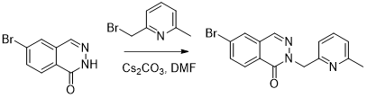
A suspension of 6-bromophthalazin-1(2H)-one (1.23 g, 98% Wt, 1 Eq, 5.37 mmol) and cesium carbonate (3.50 g, 2.0 Eq, 10.7 mmol) in DMF (23.0 mL) was stirred at 80 °C for 2 h then cooled to room temperature, before adding a solution of 2-(Bromomethyl)-6-methyl-pyridine (1.00 g, 1.00 Eq, 5.37 mmol) in DMF (7.0 mL). The reaction was stirred at room temperature for 21 h. The reaction mixture was diluted in EtOAc (100 mL) and washed with water (100 mL). The aqueous was extracted with EtOAc (100 mL x3). The combined organics were washed with a 1:1 mixture of brine and water (100 mL x 4), dried with MgSO4, filtered and concentrated under reduced pressure to give a dark beige thin powder (1.59 g). The crude product was purified by chromatography on high performance silica gel (40 g cartridge, 0-100% EtOAc/DCM) to afford 6-bromo-2-((6-methylpyridin-2-yl)methyl)phthalazin-1(2H)-one (1.189 g, 3.5 mmol, 65 %, 97% Purity) as a off-white solid. 1H NMR (400 MHz, DMSO) δ 8.44 (s, 1H), 8.28 (d, J = 1.9 Hz, 1H), 8.18 (d, J = 8.6 Hz, 1H), 8.04 (dd, J = 8.5, 1.9 Hz, 1H), 7.60 (t, J = 7.7 Hz, 1H), 7.13 (d, J = 7.6 Hz, 1H), 6.94 (d, J = 7.7 Hz, 1H), 5.37 (s, 2H), 2.41 (s, 3H). MS (ES+): 330.0/332.0 (M+H)+

2-ethylhexyl 3-((2-((6-methylpyridin-2-yl)methyl)-1-oxo-1,2-dihydrophthalazin-6-yl)thio)propanoate
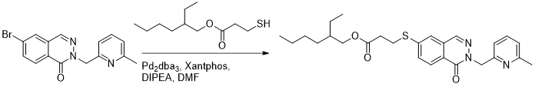
A solution of 6-bromo-2-((6-methylpyridin-2-yl)methyl)phthalazin-1(2H)-one (980 mg, 97% Wt, 1 Eq, 2.88 mmol) in DMF (25.0 mL) was sparged with nitrogen for 5 minutes. DIPEA (744 mg, 1.00 mL, 2.00 Eq, 5.76 mmol), xantphos (167 mg, 0.10 Eq, 288 µmol), Pd2(dba)3 (132 mg, 0.05 Eq, 144 µmol) and 2-ethylhexyl 3-mercaptopropanoate (754 mg, 788 µL, 1.20 Eq, 3.45 mmol) were added sequentially and the reaction mixture was stirred at 100 °C for 2 h. The reaction mixture was diluted in PhMe and concentrated under reduced pressure. The residue was partitioned between EtOAc (30 mL) and water (30 mL). The aqueous was extracted with EtOAc (50 mL x 3) and the combined organics were washed with a 1:1 mixture of brine and water (50 mL x 3), dried with MgSO4, filtered and concentrated under reduced pressure to give a dark orange thick oil (1.82 g). The crude was dissolved in DCM (10 mL), concentrated onto silica and purified by chromatography on high performance silica gel (80 g cartridge, 0-100% (3:1 EtOAc/EtOH)/ iso-hexane) to afford 2-ethylhexyl 3-((2-((6-methylpyridin-2-yl)methyl)-1-oxo-1,2-dihydrophthalazin-6-yl)thio)propanoate (1.264 g, 2.7 mmol, 93 %, 99% Purity) as a yellow oil. 1H NMR (400 MHz, DMSO) δ 8.39 (d, J = 0.7 Hz, 1H), 8.14 (d, J = 8.5 Hz, 1H), 7.87 (d, J = 1.9 Hz, 1H), 7.74 (dd, J = 8.5, 1.9 Hz, 1H), 7.59 (d, J = 7.7 Hz, 1H), 7.13 (d, J = 7.6 Hz, 1H), 6.90 (d, J = 7.7 Hz, 1H), 5.36 (s, 2H), 3.96 (d, J = 5.7 Hz, 2H), 3.37 (t, J = 6.8 Hz, 2H), 2.76 (t, J = 6.8 Hz, 2H), 2.42 (s, 3H), 1.56 – 1.47 (m, 1H), 1.34 – 1.25 (m, 2H), 1.24 – 1.18 (m, 6H), 0.87 – 0.79 (m, 6H). MS (ES+): 468.2 (M+H)+

6-mercapto-2-((6-methylpyridin-2-yl)methyl)phthalazin-1(2H)-one 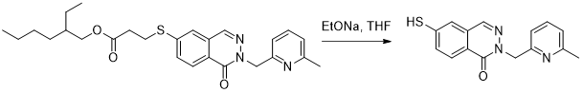
A solution of 2-ethylhexyl 3-((2-((6-methylpyridin-2-yl)methyl)-1-oxo-1,2-dihydrophthalazin-6-yl)thio)propanoate (2.02 g, 1 Eq, 4.32 mmol) in THF (50.0 mL) at 0 °C was treated with sodium ethoxide (3.50 g, 4.03 mL, 21% Wt, 2.5 Eq, 10.8 mmol). The reaction mixture was stirred for 1.5 h at 0 °C before adding water (50 mL). The mixture was acidified with 1 M HCl(aq) (~ 6-8 mL; reaching pH 4) then warmed to room temperature and extracted with EtOAc (3 x 40 mL). The combined organics were washed with brine (60 mL x 2) then water (60 mL). The resulting suspension was concentrated under reduced pressure to give a light brown solid (3.79 g). The crude was dissolved in DCM (20 mL), concentrated onto silica and purified by chromatography on silica gel (80 g cartridge, 0-10% MeOH/DCM) to afford 6-mercapto-2-((6-methylpyridin-2-yl)methyl)phthalazin-1(2H)-one (894.2 mg, 3.1 mmol, 72 %, 98% Purity) as a pale orange solid. 1H NMR (400 MHz, DMSO) δ 8.33 (s, 1H), 8.10 (d, J = 8.4 Hz, 1H), 7.84 (d, J = 1.9 Hz, 1H), 7.77 (dd, J = 8.3, 1.9 Hz, 1H), 7.60 (t, J = 7.7 Hz, 1H), 7.13 (d, J = 7.6 Hz, 1H), 6.90 (d, J = 7.7 Hz, 1H), 6.35 (s, 1H), 5.34 (s, 2H), 2.42 (s, 3H). MS (ES+): 284.1 (M+H)+

6-((1H-pyrazol-4-yl)thio)-2-((6-methylpyridin-2-yl)methyl)phthalazin-1(2H)-one 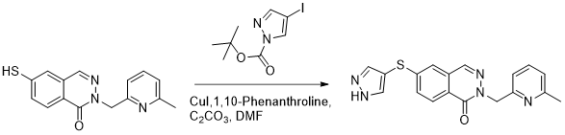
A solution of 6-mercapto-2-((6-methylpyridin-2-yl)methyl)phthalazin-1(2H)-one (100 mg, 97% Wt, 1.0 Eq, 342 µmol), tert-butyl 4-iodo-1H-pyrazole-1-carboxylate (154 mg, 98% Wt, 1.5 Eq, 513 µmol), 1, 10-Phenanthroline (24.7 mg, 0.40 Eq, 137 µmol), CuI (13.0 mg, 0.20 Eq, 68.5 µmol) and cesium carbonate (223 mg, 2.0 Eq, 685 µmol) in DMF (4.0 mL) was heated at 120 °C overnight. The reaction mixture was diluted with DCM (20 mL), adsorbed onto silica gel and concentrated under reduced pressure. The crude product was purified by chromatography on silica gel (12 g cartridge, 0-10% MeOH/DCM) to afford 6-((1H-pyrazol-4-yl)thio)-2-((6-methylpyridin-2-yl)methyl)phthalazin-1(2H)-one (66 mg, 0.17 mmol, 50 %, 90% Purity) as a pale orange solid. MS (ES+): 350.1 (M+H)+

6-((1H-pyrazol-4-yl)sulfonyl)-2-((6-methylpyridin-2-yl)methyl)phthalazin-1(2H)-one
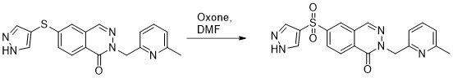
Oone (0.31 g, 3 Eq, 0.51 mmol) was added to a solution of 6-((1H-pyrazol-4-yl)thio)-2-((6-methylpyridin-2-yl)methyl)phthalazin-1(2H)-one (66 mg, 90% Wt, 1 Eq, 0.17 mmol)in DMF (3 mL) at room temperature and the reaction mixture was left to stir for 23 hours. The reaction mixture was diluted with DCM (20 mL) and washed with water (20 mL). The organic phase was collected, dried (phase separator) and evaporated under reduced pressure. The crude product was dissolved in DMSO (1.4 ml), filtered and purified by reversed phase preparative HPLC (Waters 2767 Sample Manager, Waters 2545 Binary Gradient Module, Waters Systems Fluidics Organiser, Waters 515 ACD pump, Waters 515 Makeup pump, Waters 2998 Photodiode Array Detector, Waters QDa) on a Waters XBridge BEH C18 ODB prep column, 130Å, 5 µm, 30 mm X 100 mm, flow rate 40 mL min-1 eluting with a 0.3% Ammonia in water-MeCN gradient over 12.5 mins using UV across all wavelengths with PDA as well as a QDA and ELS detector. At-column dilution pump gives 2 mL min-1 Methanol over the entire method, which is included in the following MeCN percentages. Gradient information: 0.0-0.5 min, 5% MeCN; 0.5-10.5 min, ramped from 5% MeCN to 35% MeCN; 10.5-10.6 min, ramped from 35% MeCN to 100% MeCN; 10.6-12.5 min, held at 100% MeCN. The clean fractions were evaporated in a Genevac, giving 6-((1H-pyrazol-4-yl)sulfonyl)-2-((6-methylpyridin-2-yl)methyl)phthalazin-1(2H)-one (11 mg, 29 µmol, 17 %, 99% Purity) as a clear white solid. 1H NMR (400 MHz, DMSO) δ 8.64 (s, 1H), 8.61 (d, J = 1.8 Hz, 1H), 8.43 (d, J = 8.4 Hz, 1H), 8.30 (dd, J = 8.4, 1.9 Hz, 1H), 8.28 (s, 2H), 7.58 (t, J = 7.7 Hz, 1H), 7.13 (d, J = 7.7 Hz, 1H), 6.94 (d, J = 7.7 Hz, 1H), 5.38 (s, 2H), 2.40 (s, 3H). (exchangeable NH not obsverved). MS (ES+): 382.1 (M+H)+

