Supplementary Figure 1. (A) The relationship between BMI and biochemical pregnancy. A nonlinear relationship between them was detected. (B) The relationship between BMI and clinical pregnancy. A nonlinear relationship between them was detected

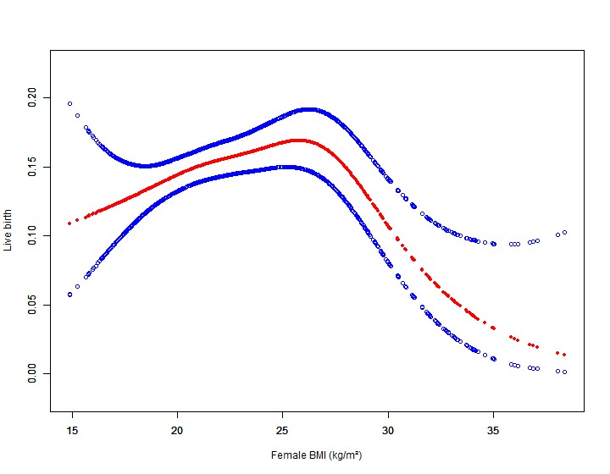
Supplementary Figure 2.The relationship between BMI and live birth in women with single ovulated follicle (n =5,011). A nonlinear relationship between them was detected after adjusting for female age, male age, basal FSH, AFC, male factor infertility, anovulatory infertility, unexplained infertility, IUI regimens.

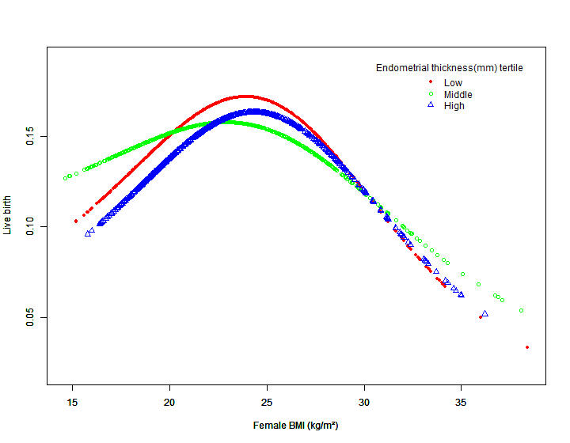
Supplementary Figure 3. The relationship between BMI and live birth (conducted by dividing endometrial thickness into tertiles). A nonlinear relationship between them persisted.

