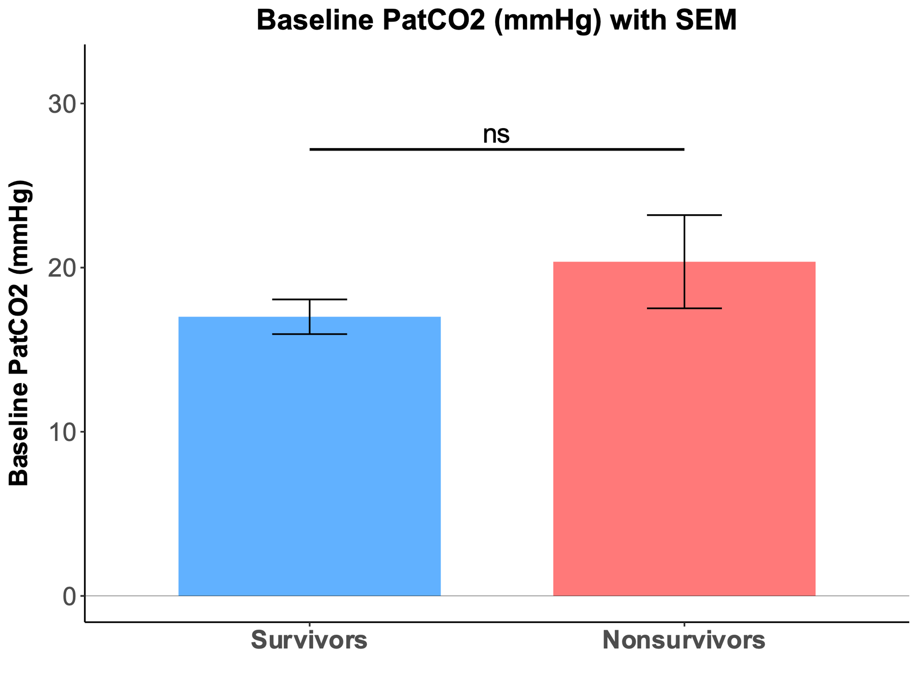
SUPPLEMENTARY DATA
Supplementary figure 1. Survivors and nonsurvivors have similar PatCO₂ at baseline
Comparison of mean PatCO₂ at baseline between survivors and nonsurvivors. Baseline PatCO₂ is not significantly different between those groups (17.0 vs. 20.4 mmHg, p > 0.05)
Data are expressed as mean ± SEM. PatCO₂ = arterio-tissular gradient in CO₂ ; ns : nonsignificant.
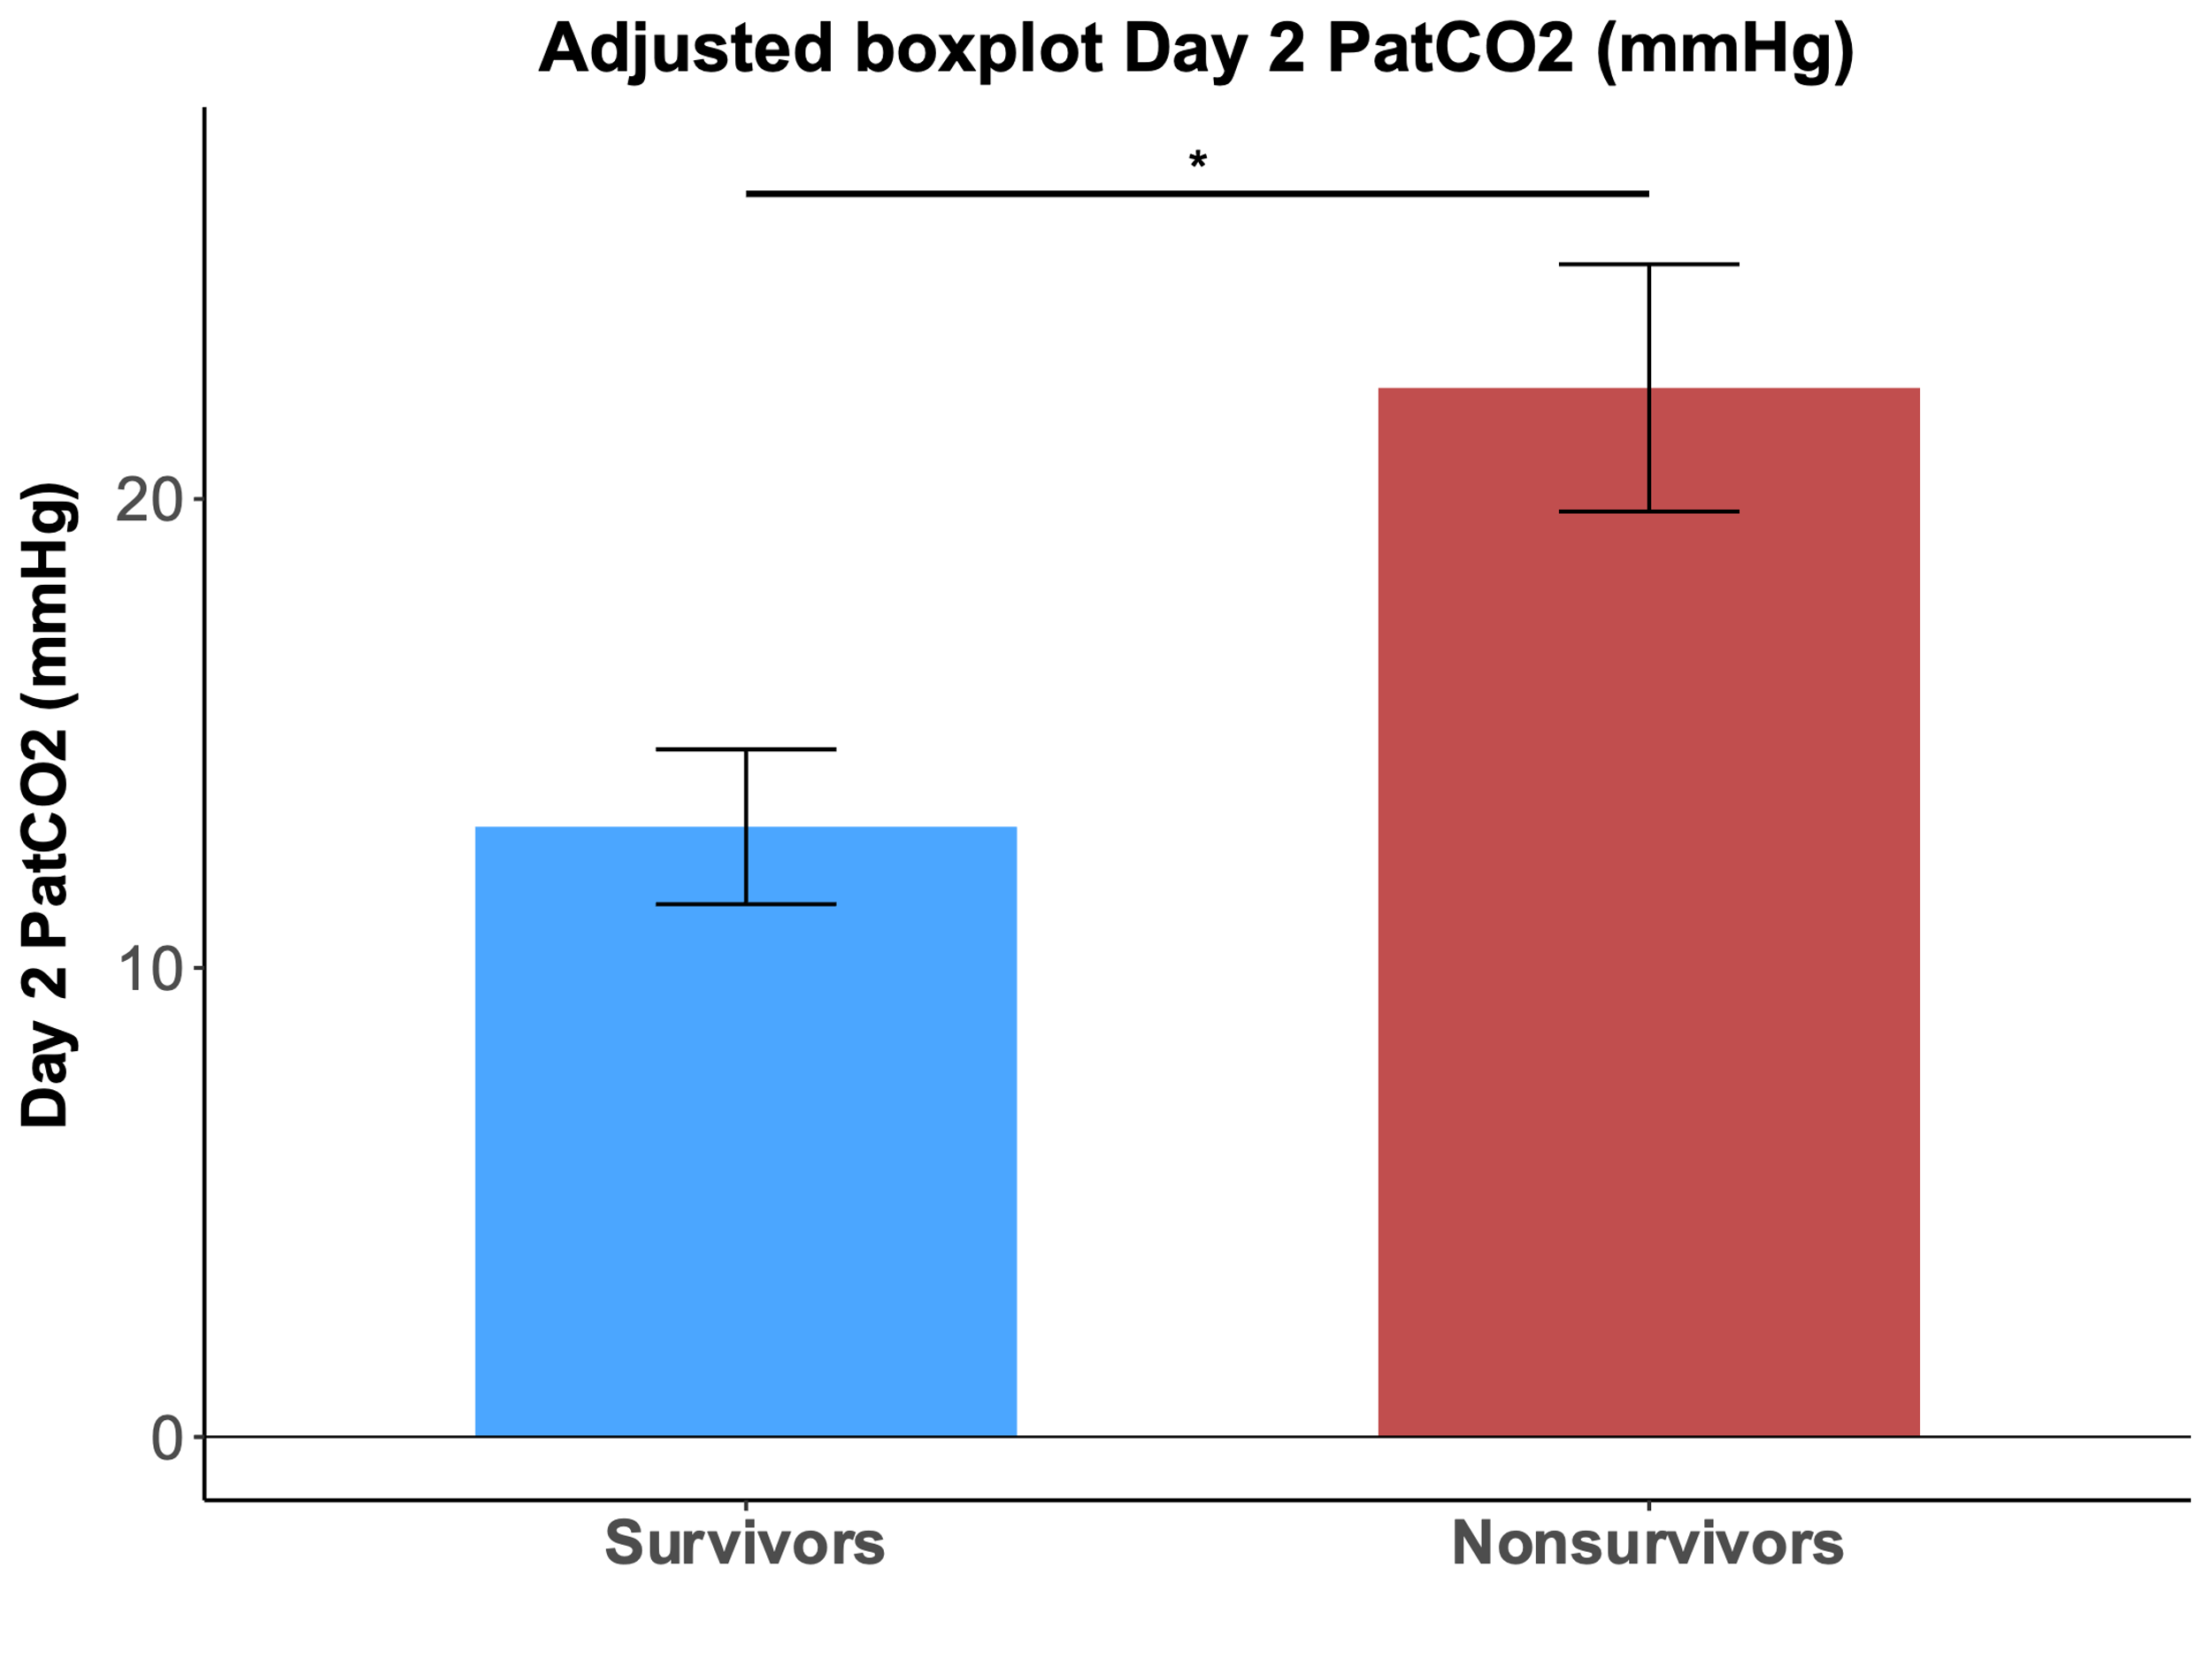
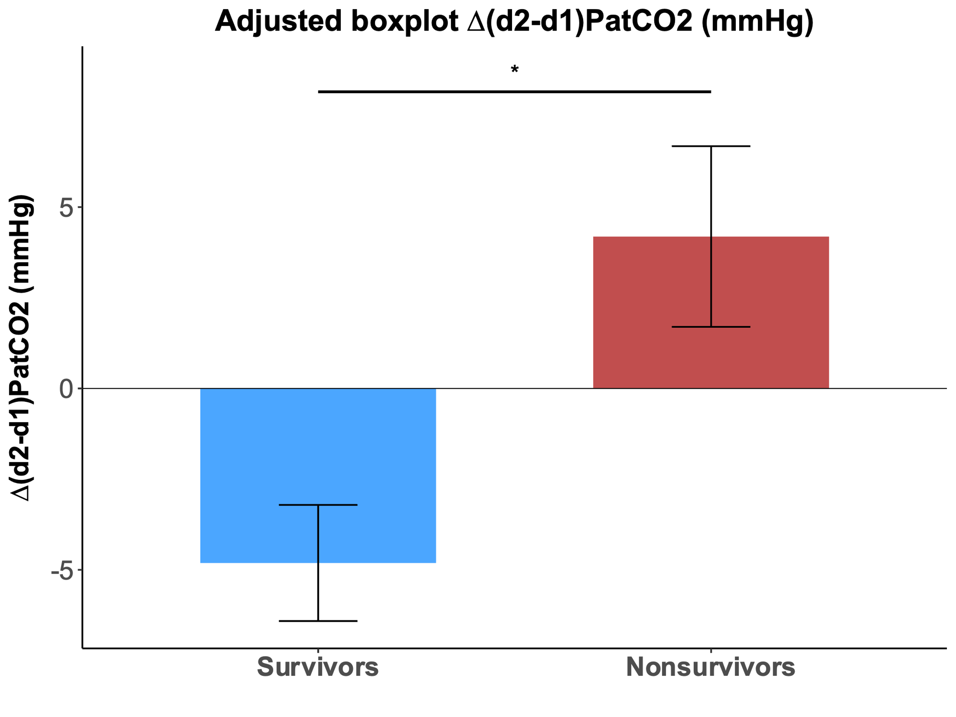
A
B
B
Supplementary figure 2. ∆_{(d2-d1)}PatCO₂ and mean day 2 PatCO₂ after statistical adjustment on 24-hour SOFA score.
A. Comparison of adjusted ∆_{(d2-d1)}PatCO₂, mmHg between Survivors and Nonsurvivors. ∆_{(d2-d1)}PatCO₂ is significantly higher in nonsurvivors than in survivors (+ 4.2 vs. - 4.8 mmHg, p < 0.05).
B. Comparison of adjusted mean PatCO₂ during day 2 between Survivors and Nonsurvivors. Day 2 mean PatCO₂ is significantly higher in nonsurvivors than survivors (13.0 vs. 22.4 mmHg, p < 0.05).
Data are expressed as mean ± SEM. PatCO₂ = arterio-tissular gradient in CO₂, ∆_{(d2-d1)}PatCO₂ : PatCO₂ variation between day 1 and day 2. ∗ : p-value < 0.05 ; ns : nonsignificant.
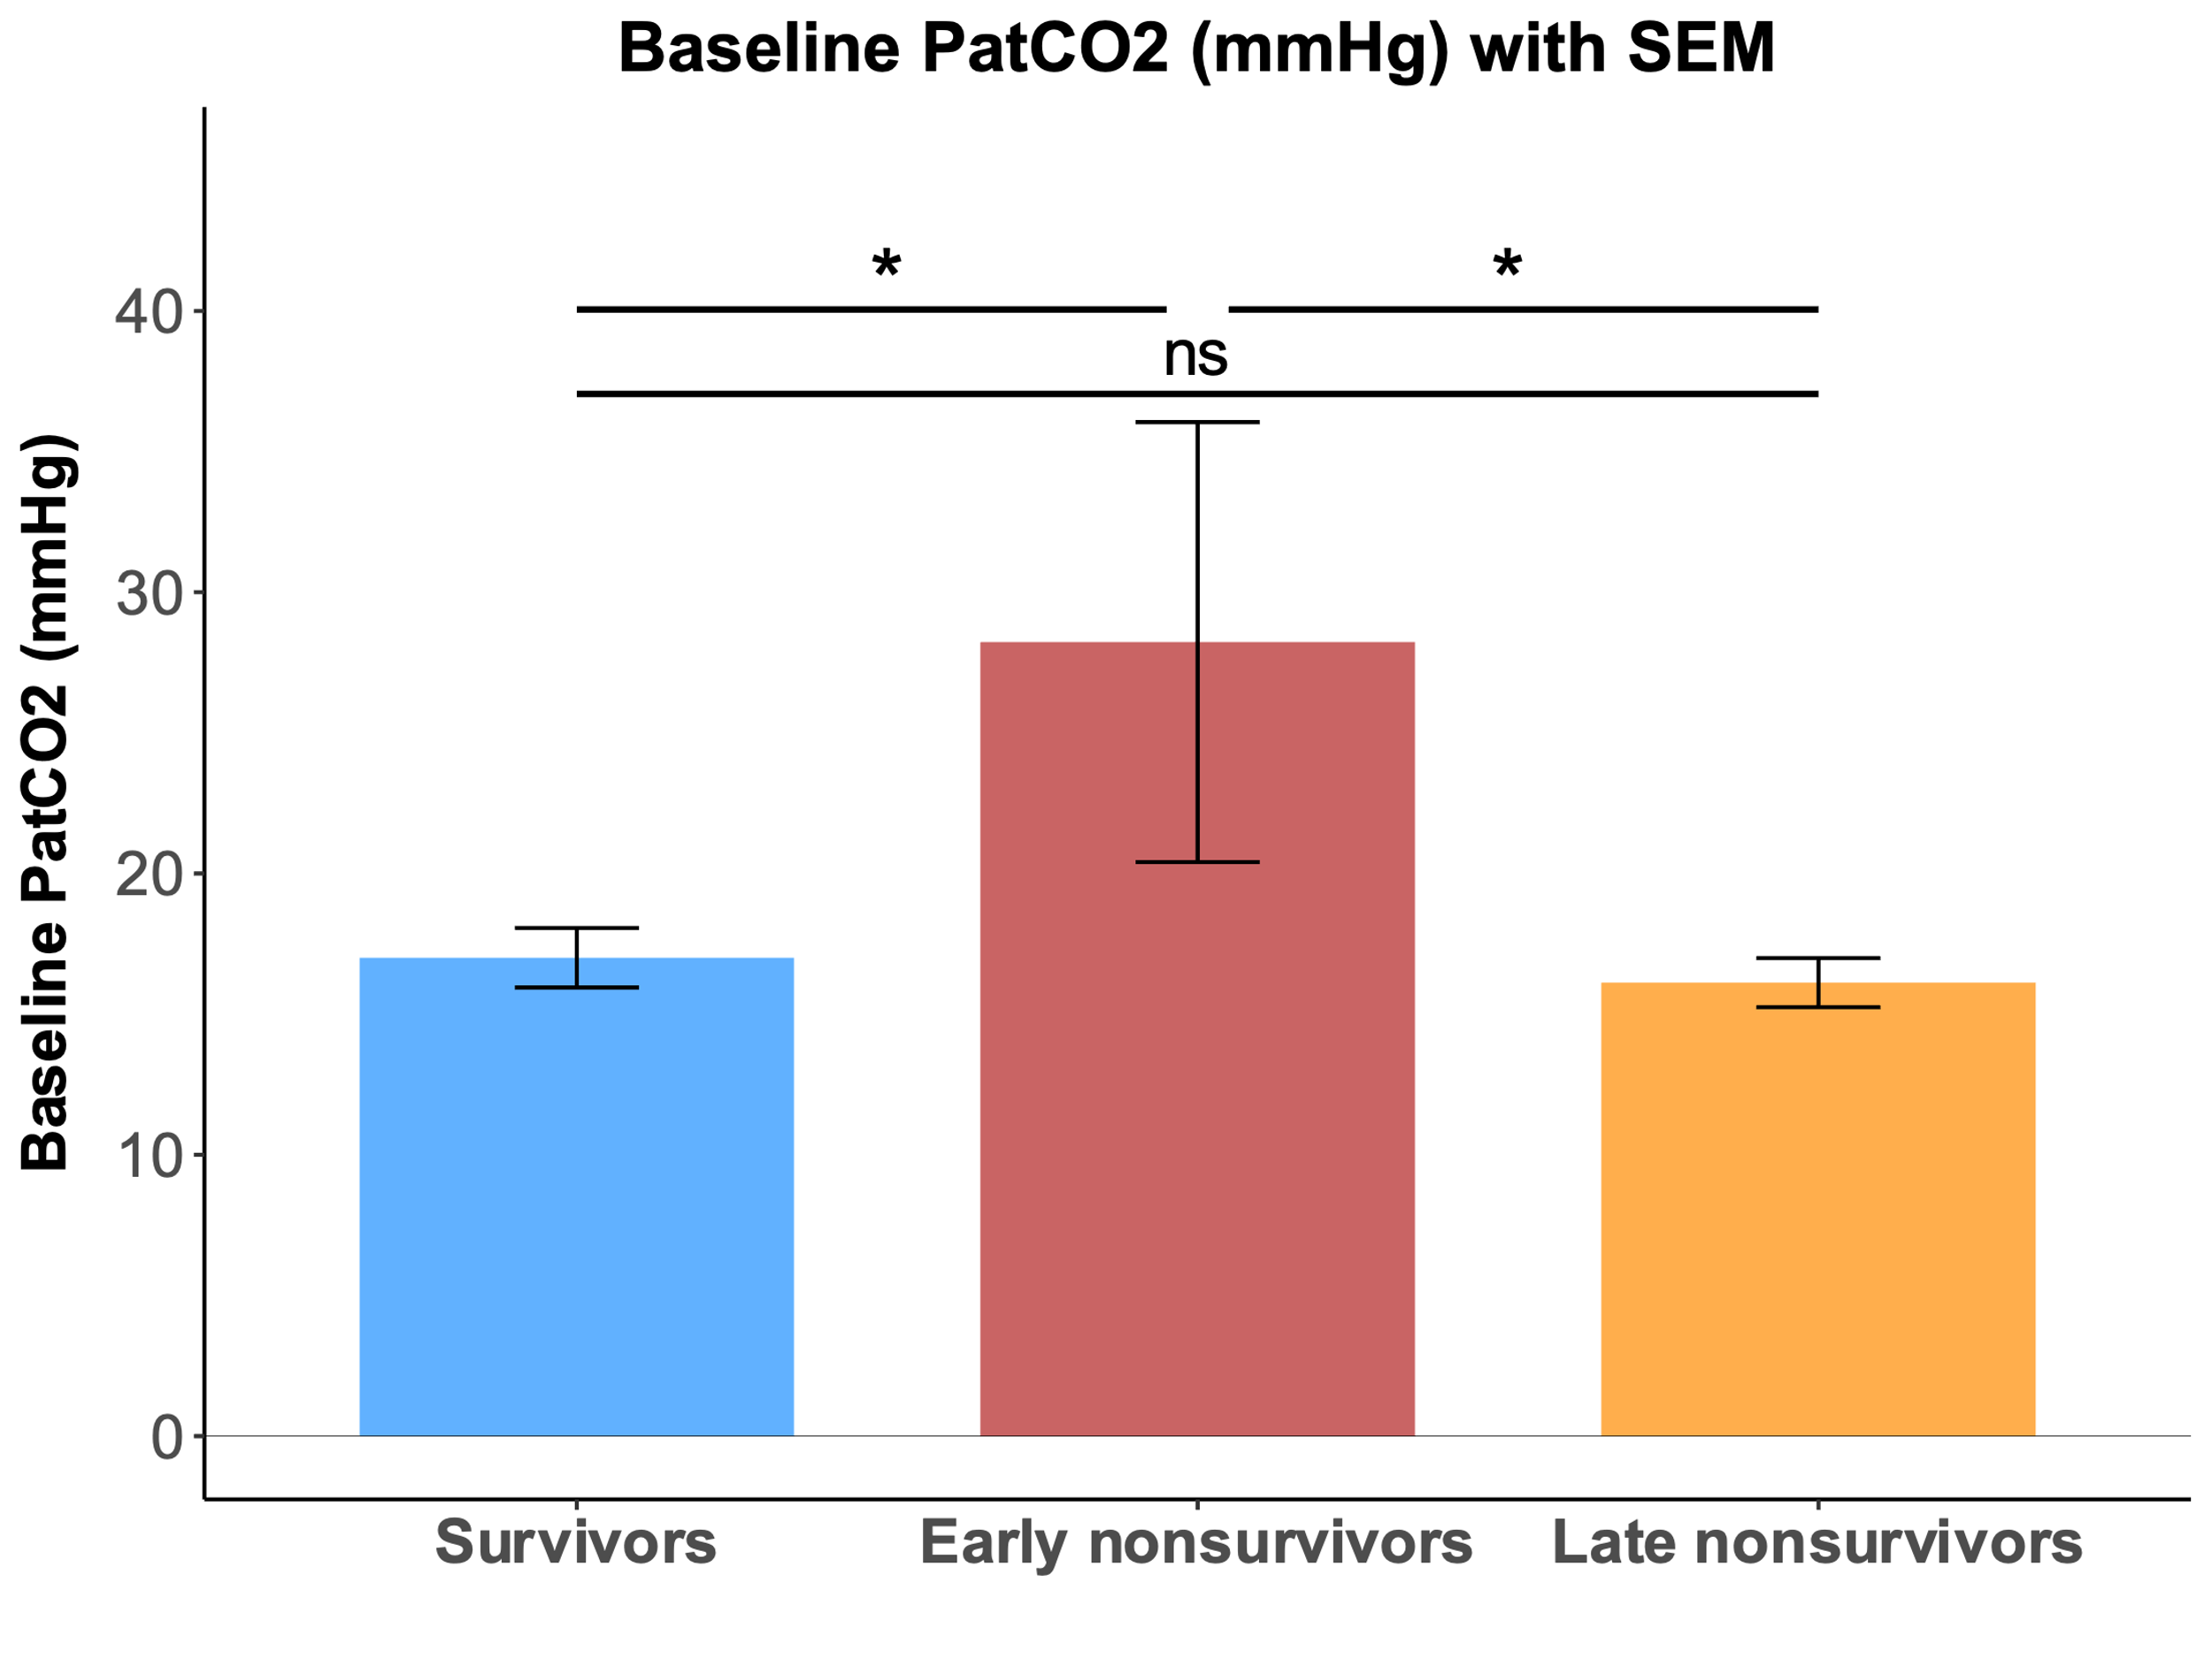
Supplementary figure 3. Baseline PatCO₂ of survivors, early nonsurvivors and late nonsurvivors
Comparison of mean PatCO₂ at baseline between survivors, early nonsurvivors and late nonsurvivors. Baseline PatCO₂ is significantly higher in early nonsurvivors in comparison of the two other subgroups (28.2 vs. 16.1 mmHg and 17.0 mmHg, p < 0.05).
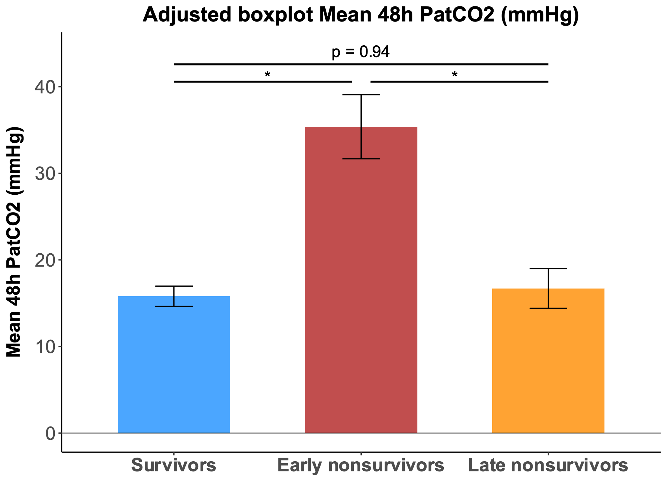
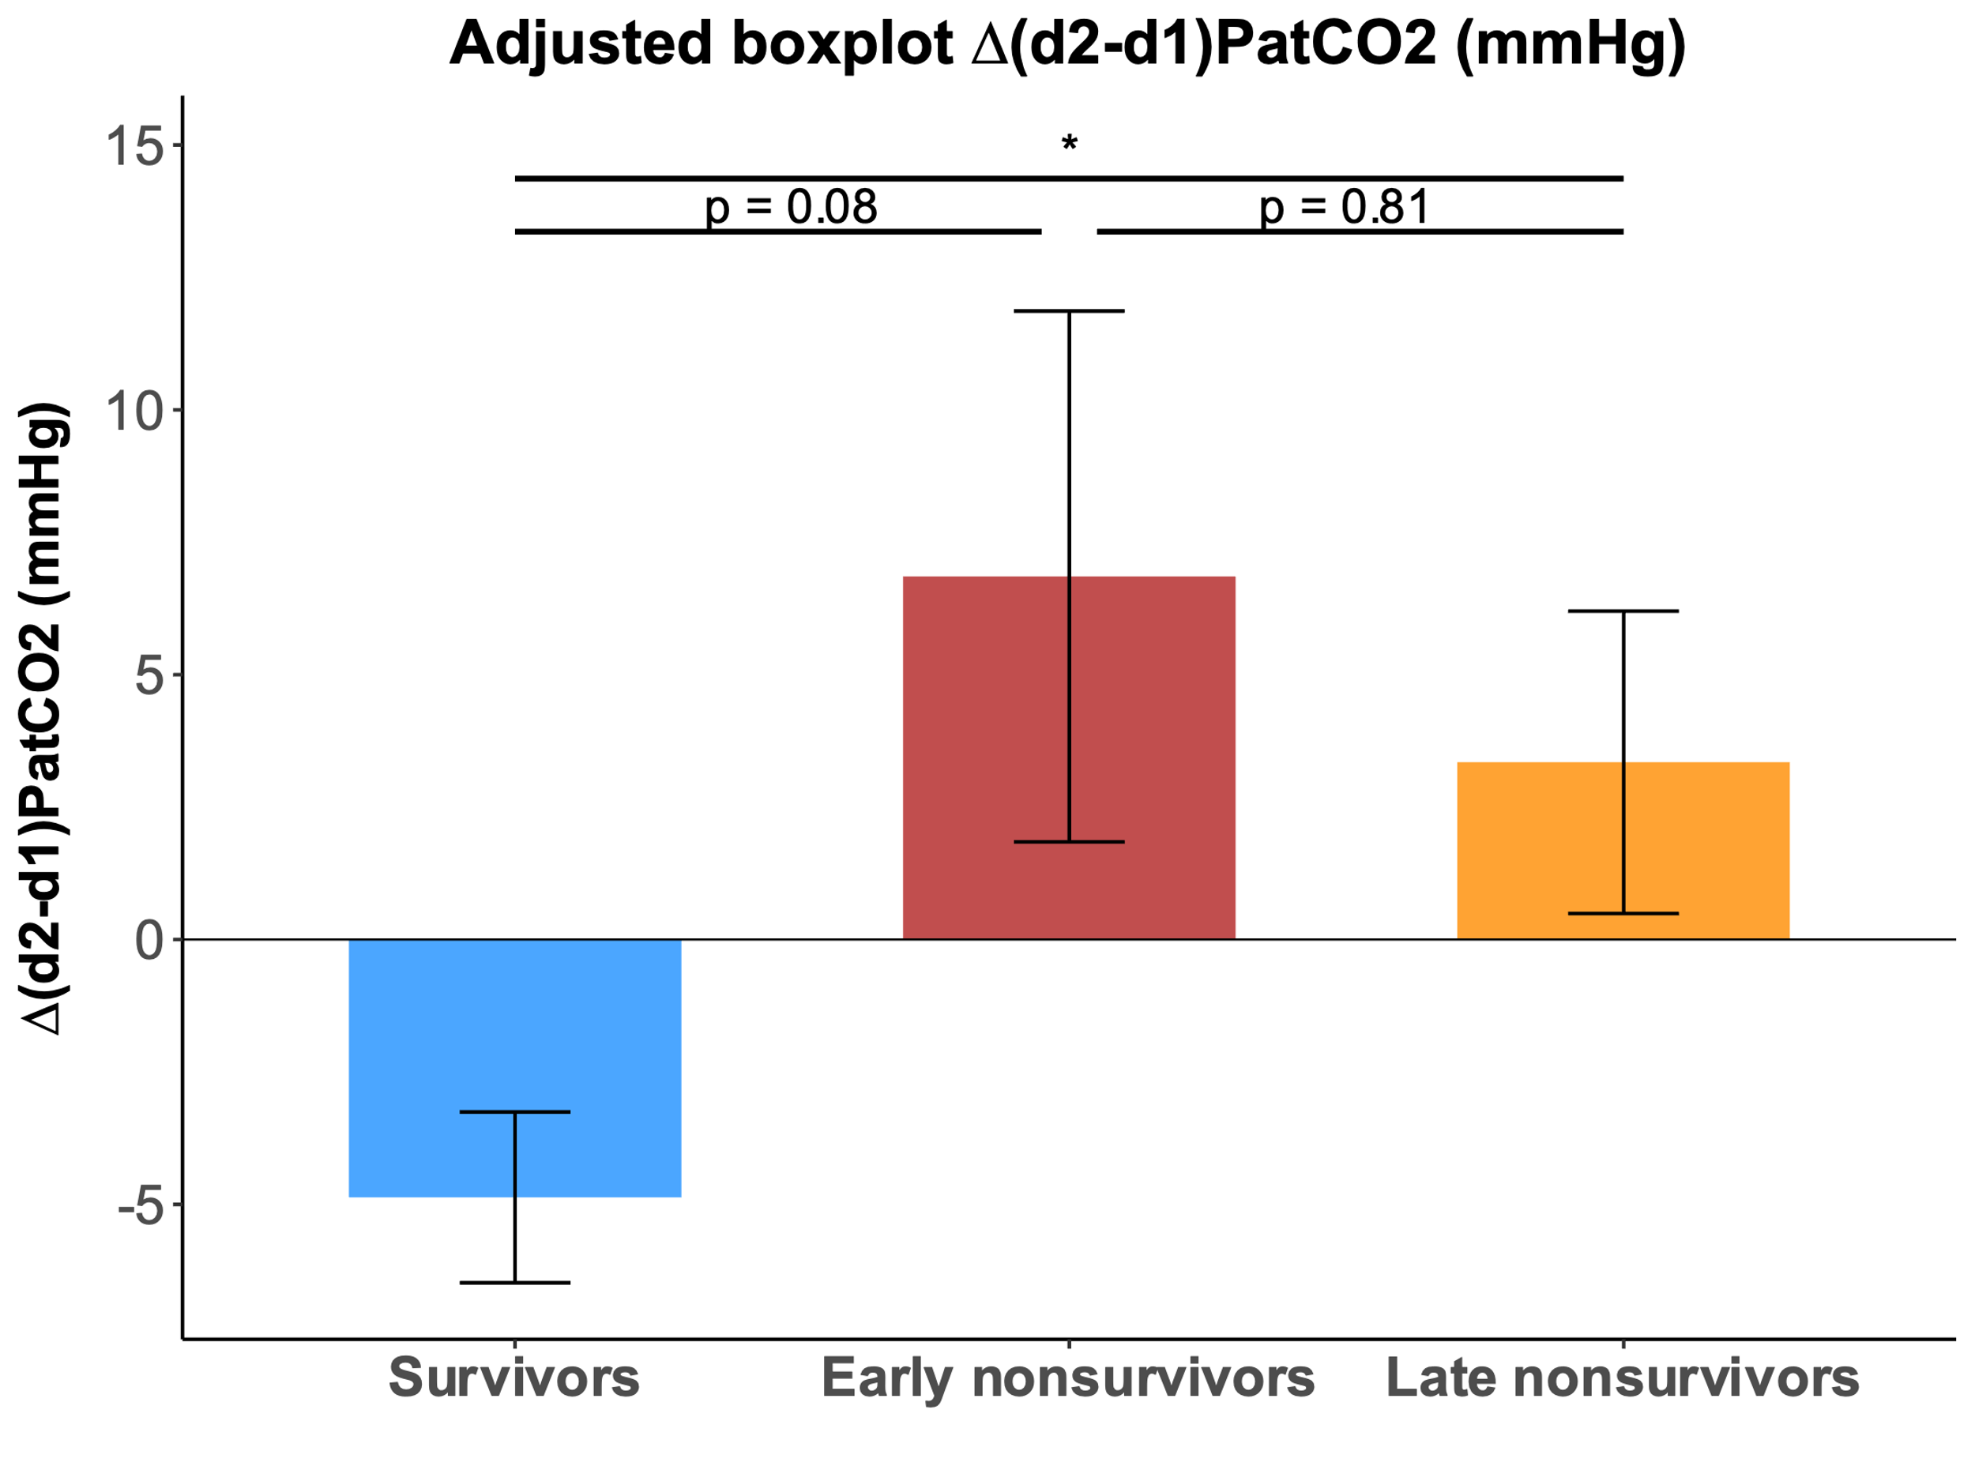
Data are expressed as mean ± SEM. PatCO₂ = arterio-tissular gradient in CO₂ ; ∗ : p-value < 0.05 ; ns : nonsignificant.
A
B
ns
ns
ns
Supplementary figure 4. Mean 48 hour PatCO₂ and ∆_{(d2-d1)}PatCO₂ after statistical adjustment on 24-hour SOFA score.
A. Comparison of adjusted mean 48 hour PatCO₂ between survivors, early nonsurvivors and late nonsurvivors. 48 hour mean PatCO₂ is significantly higher in early nonsurvivors than survivors and late nonsurvivors (35.4 vs. 15.8 mmHg and 16.7 mmHg, p < 0.05).
B. Comparison of adjusted ∆_{(d2-d1)}PatCO₂ (mmHg) between survivors, early nonsurvivors and late nonsurvivors. ∆_{(d2-d1)}PatCO₂ is significantly higher in late nonsurvivors than in survivors (+3.3 vs. -4.9 mmHg, p < 0.05).
Data are expressed as mean ± SEM. PatCO₂ = arterio-tissular gradient in CO₂, ∆_{(d2-d1)}PatCO₂ : PatCO₂ variation between day 1 and day 2. ∗ : p-value < 0.05 ; ns : nonsignificant.

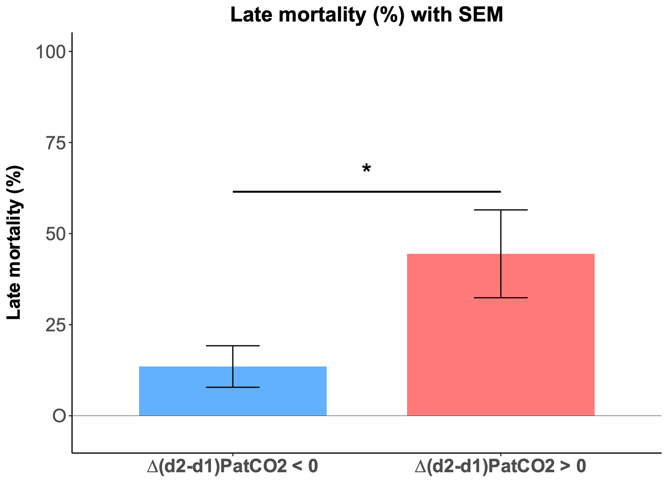
Supplementary figure 5. Late mortality rates (day 7-28) are significantly higher when PatCO₂ is increasing between day 1 and day 2.
Comparison of late mortality rates between patients presenting a negative or positive ∆_{(d2-d1)} PatCO₂. A rise in PatCO₂ between day 1 and day 2 is associated with significantly higher death rates between day 7 and day 28 (44% vs. 14%, p < 0.05).
Early nonsurvivors (death before day 7) are excluded from this analysis.
Data are expressed as mean ± SEM. PatCO₂ = arterio-tissular gradient in CO₂, ∆_{(d2-d1)}PatCO₂ : PatCO₂ variation between day 1 and day 2. ∗ : p-value < 0.05.
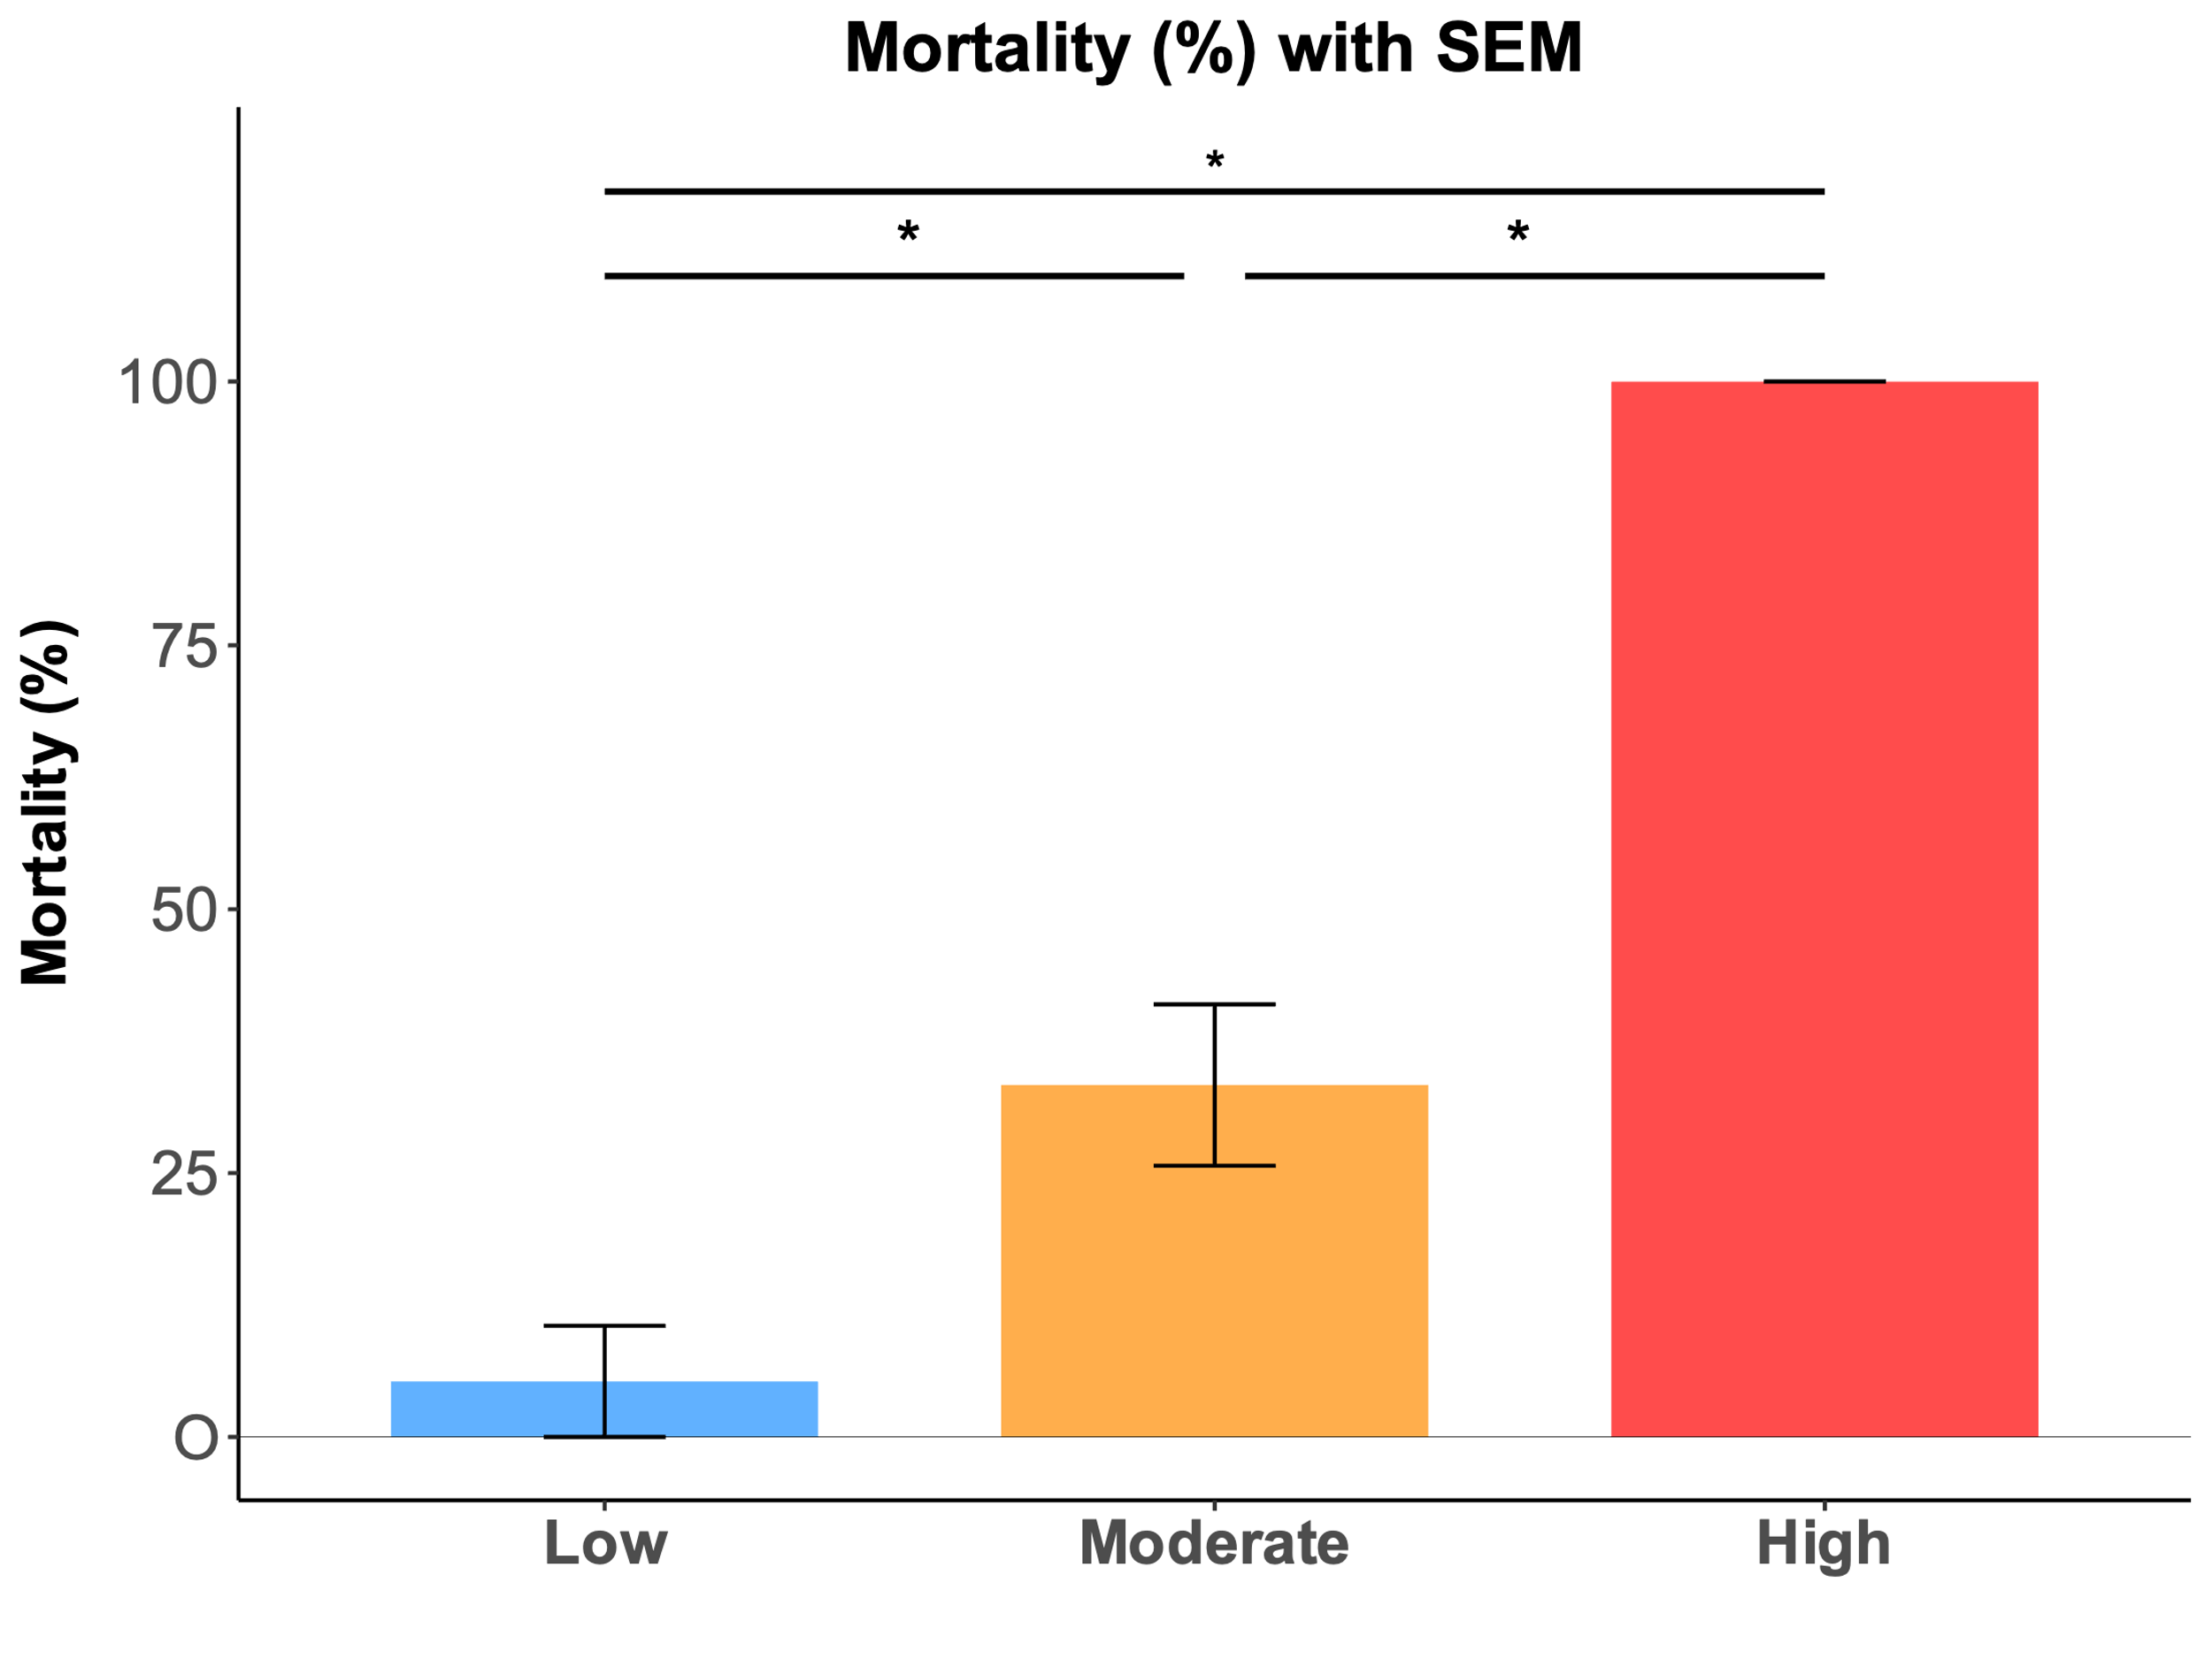

Supplementary figure 6. Mortality rates are significantly different between SkinScore categories.
Mortality rates are respectively 5%, 31% and 100% for Low, Moderate, and High SkinScore, respectively.
Data are expressed as mean±SEM. ∗ : p-value < 0.05 ; ns : nonsignificant.
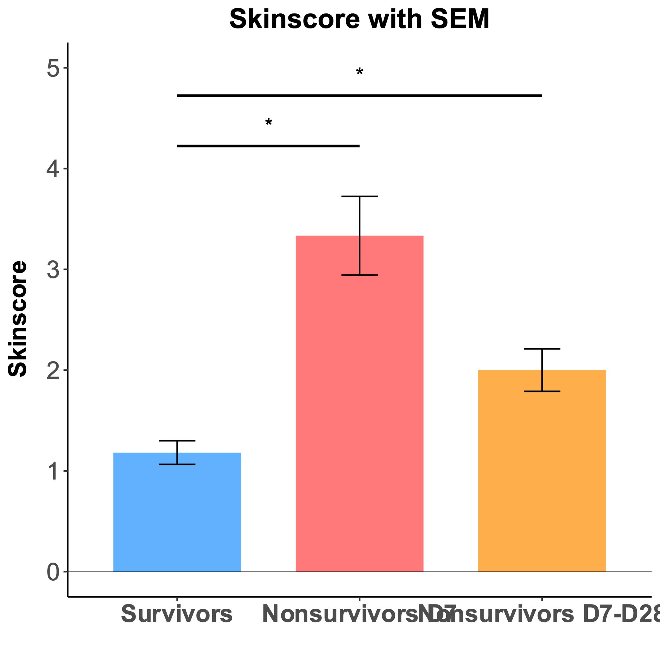
Supplementary figure 7. Mean SkinScore is significantly different between survivors and early or late nonsurvivors.
Mean SkinScore are respectively 1.18, 3.33, and 2.0 for survivors, early nonsurvivors, and late non survivors.
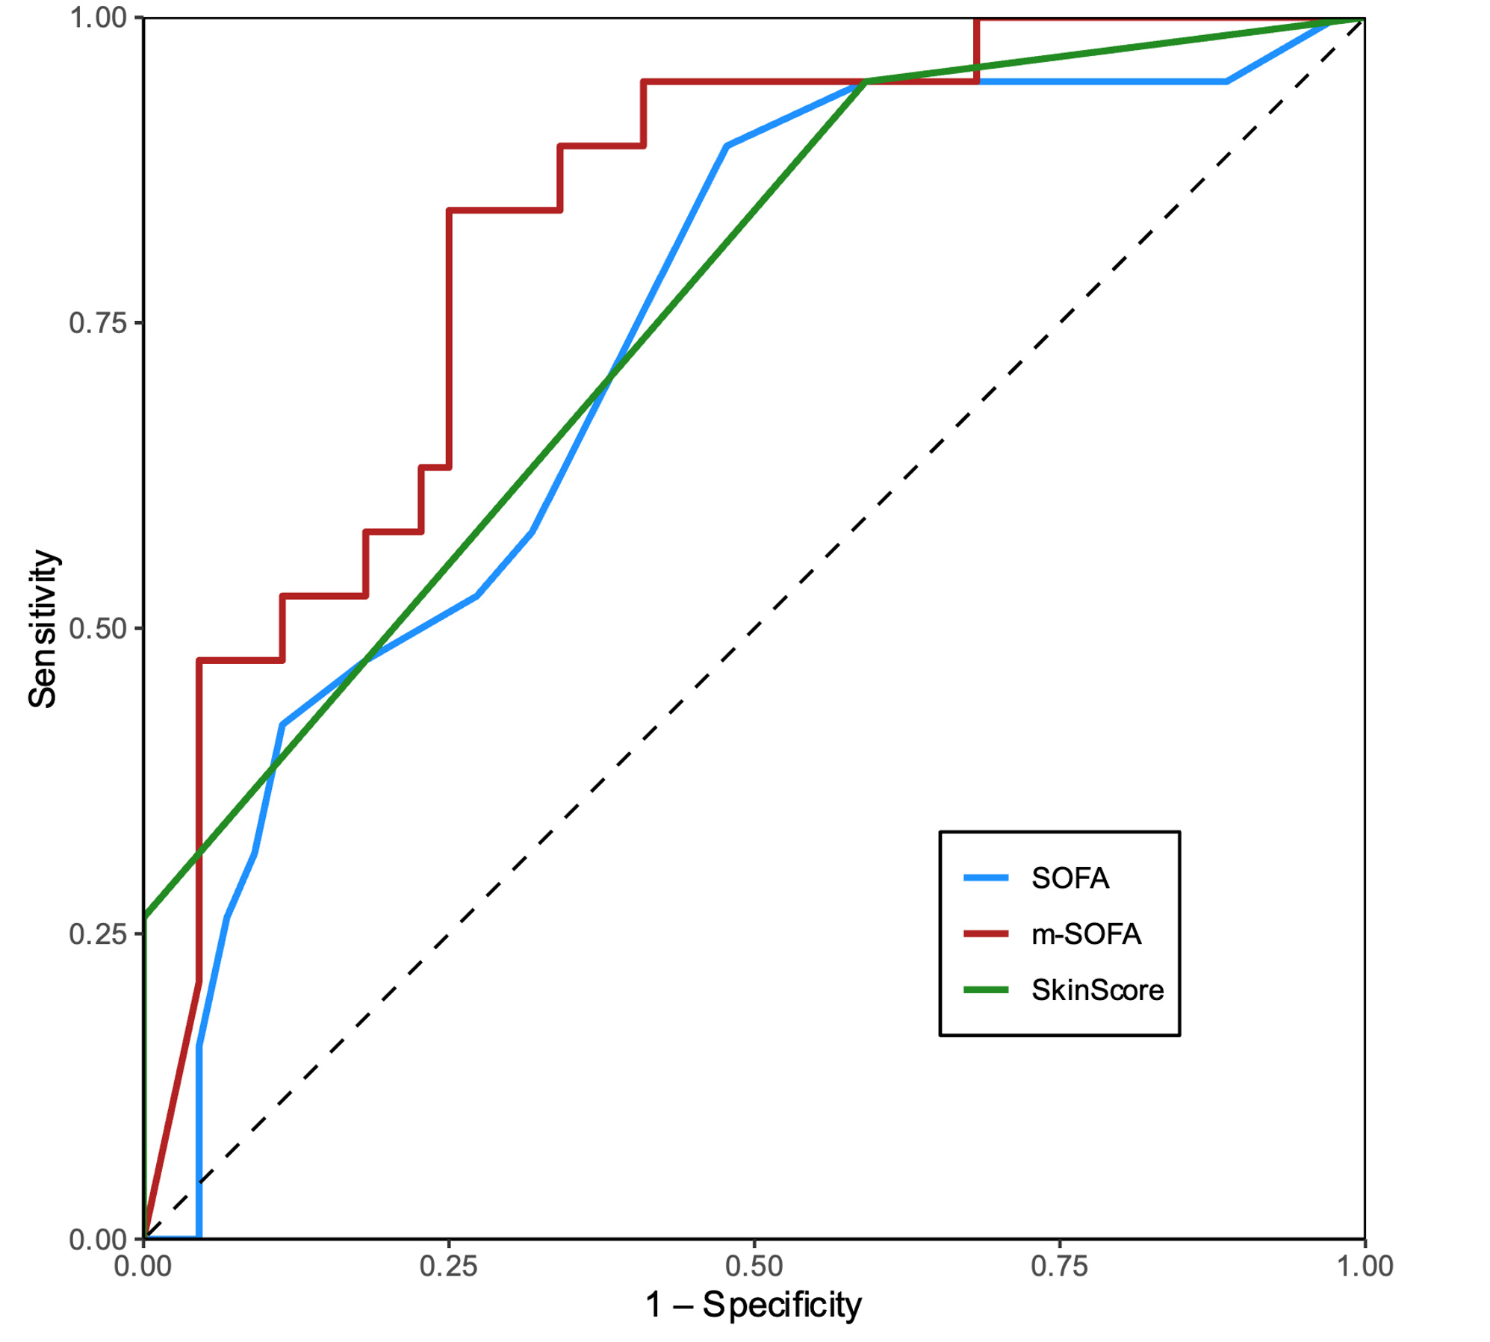
Data are expressed as mean±SEM. ∗ : p-value < 0.05 ; ns : nonsignificant.
Supplementary figure 8. Univariate ROC curves for day-28 mortality prediction using 24h SOFA, SkinScore alone, or modified SOFA
Modified SOFA, consisting of the addition of 24-hour SOFA and SkinScore, displays a significantly greater AUC than 24-hour SOFA alone (0.83 [0.72–0.92] vs. 0.74[0.60-0.86]).
SkinScore alone has a similar AUC than SOFA alone (0.76 [0.65-0.85]).
SOFA Score = Sequential Organ Failure Assessment Score. AUC : Area Under the receiver operating characteristic Curve
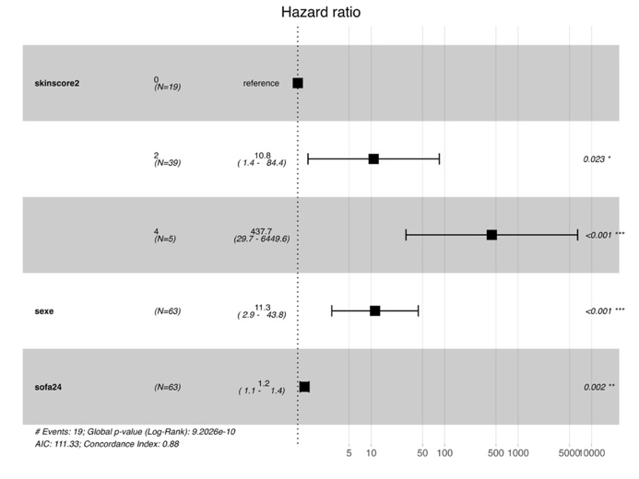
Supplementary figure 9. Forest plot comparing adjusted hazard ratios for 28-day mortality across SkinScore categories.
Data are expressed as hazard ratio (confidence interval). Numbers on the right represent Wald test p-values.
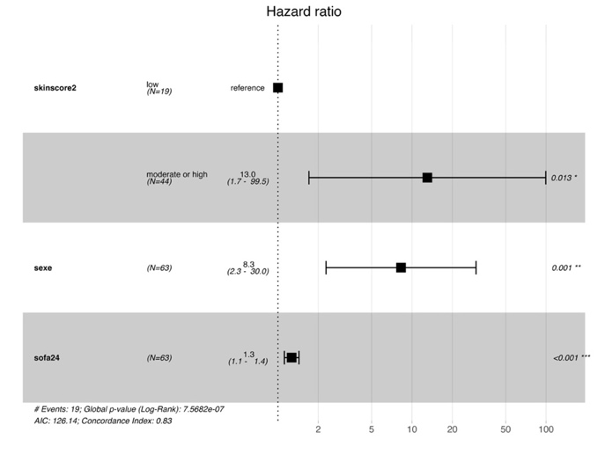
Supplementary figure 10. Forest plot comparing moderate or high vs. low SkinScore adjusted hazard ratios for 28-day.
Data are expressed as hazard ratio (confidence interval). Numbers on the right represent Wald test p-values.

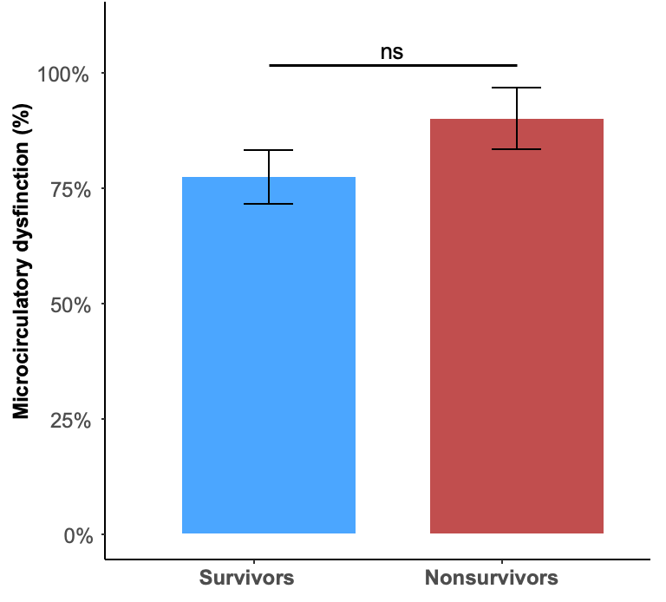
Supplementary figure 11. Proportion of patients with microcirculatory dysfunction at baseline among survivors and nonsurvivors.

Supplementary Table 1. Lactatemia values during the first 48h following admission.
 | All  (n = 94) | Survivors  (n= 72) | Nonsurvivors  (n= 22) | p-val
Lactatemia at baseline (mM) | 2.0 (2.4) | 1.4 (1.1) | 3.4 (4.0) | 0.04
Day 1 mean lactatemia (mM) | 1.7 (1.9) | 1.2 (0.7) | 3.0 (3.2) | 0.02
Day 2 mean lactatemia (mM) | 1.6 (1.9) | 1.2 (1.1) | 2.6 (2.9) | 0.04
48h mean lactatemia (mM) | 1.6 (1.8) | 1.2 (0.8) | 2.9 (3.0) | 0.01
Lactatemia mean ± SD values at baseline, during day 1, day 2, the first 48h following admission, expressed in mmol/L). Reported p-values refer to the comparison between survivors and nonsurvivors. NS : nonsurvivors.

Supplementary Table 2. Macrocirculatory parameters at day 1 and day 2 following admission.
 | Survivors | Non Survivors | p-val
Day 1 Cardiac output (L/min) | 4.39 (1.65) | 4.88 (1.59) | 0.24
Day 2 Cardiac output (L/min) | 4.53 (1.08) | 4.46 (1.56) | 0.89
Day 1 Stroke volume (mL) | 51.1 (22.3) | 49.9 (14.6) | 0.81
Day 2 Stroke volume (mL) | 55.6 (11.6) | 49.9 (14.5) | 0.26
Day 1 Heart rate (bpm) | 82 (19) | 94 (23) | 0.00
Day 2 Heart rate (bpm) | 84 (20) | 90 (21) | 0.13
Day 1 DBP (mmHg) | 63 (14) | 60 (14) | 0.06
Day 2 DBP (mmHg) | 64 (11) | 62 (14) | 0.27
Day 1 MBP (mmHg) | 82 (14) | 78 (16) | 0.06
Day 2 MBP (mmHg) | 83 (13) | 79 (14) | 0.19
Day 1 SBP (mmHg) | 125 (20) | 119 (24) | 0.08
Day 2 SBP (mmHg) | 125 (20) | 120 (20) | 0.07
Day 1 SvcO2 (%) | 69.9 (8.4) | 67.7 (10.1) | 0.16
Day 2 SvcO2 (%) | 68.6 (8.9) | 70.5 (8.8) | 0.30
Day 1 ∆P(v-a)CO₂ (mmHg) | 5.6 (3.0) | 5.9 (2.9) | 0.58
Day 2 ∆P(v-a)CO₂ (mmHg) | 5.5 (4.5) | 4.8 (2.2) | 0.31
Macrocirculatory parameters mean (SD) day 1 and day 2 values DBP : Diastolic Blood Pressure ; MBP : Mean Blood Pressure ; SBP : Systolic Blood Pressure ; SvcO2 : Central venous oxygen saturation ; ∆P(v-a)CO₂ : Arterio-venous gap in CO₂

