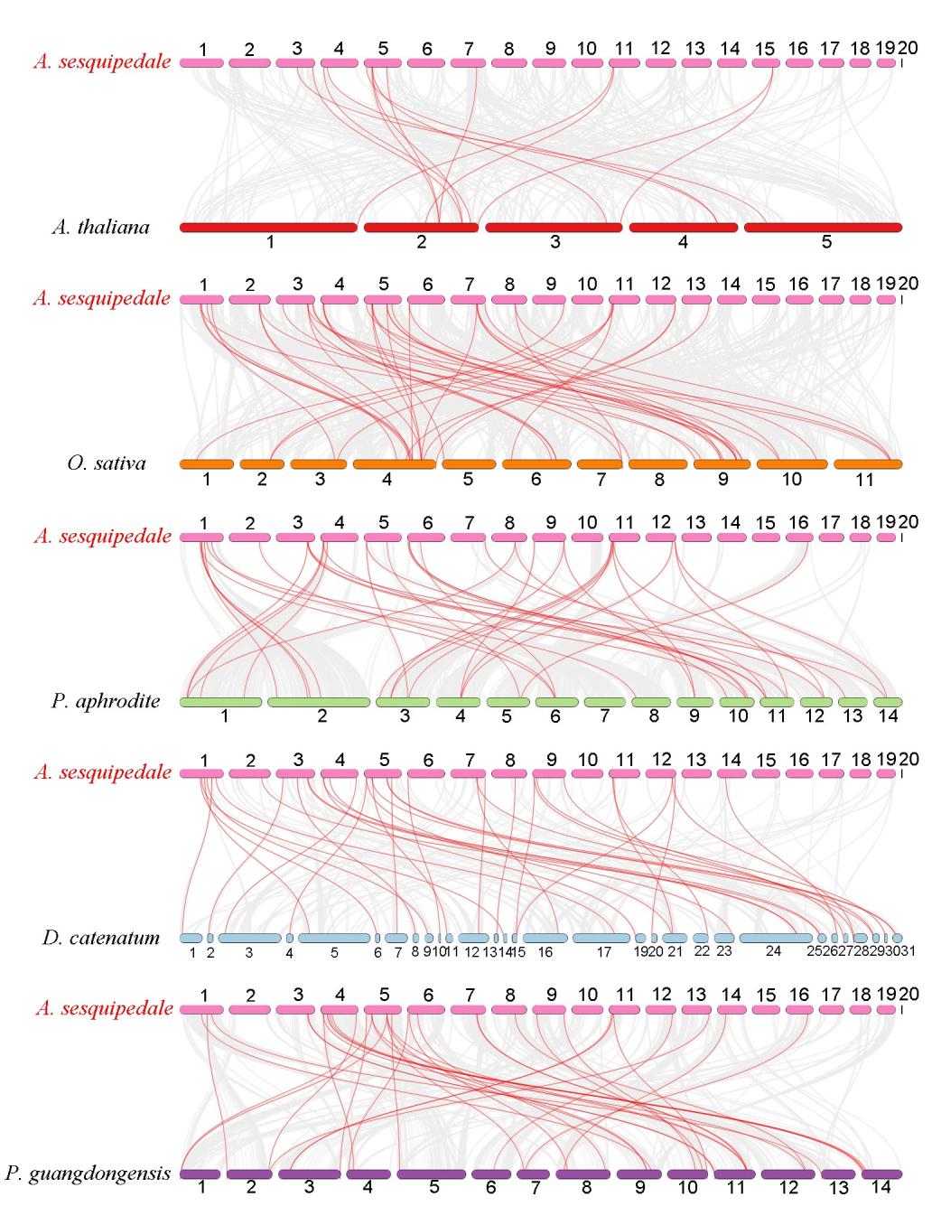
Figure S1. Synteny analysis of WRKYs between A. sesquipedale and other plant species. The collinear blocks are marked by gray lines, while the collinear gene pairs with WRKY genes are highlighted in the red lines.

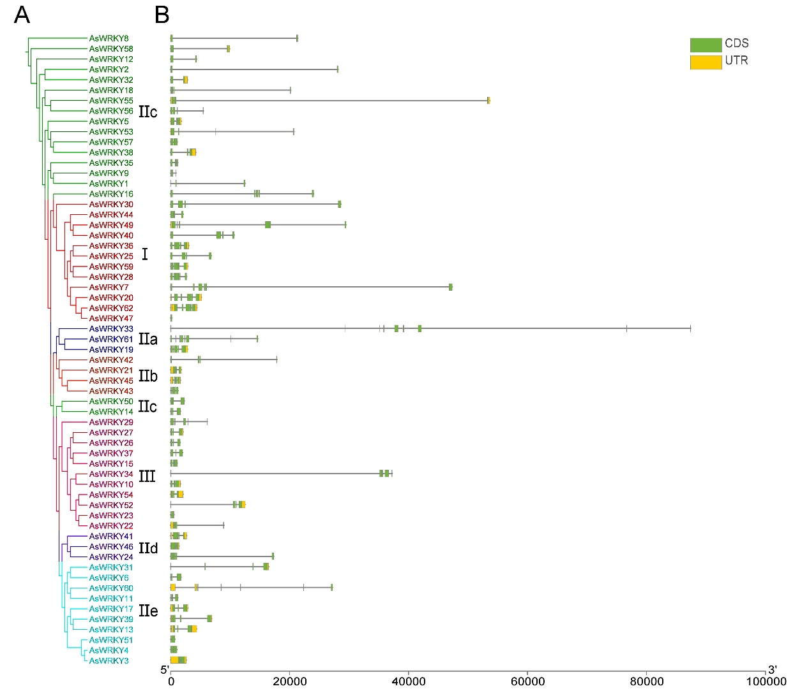
Figure S2. Gene structure distribution of 62 AsWRKY genes. (A) The phylogenetic tree of 62 AsWRKY genes was constructed using the identical parameters described in Figure 5. (B) Gene structures of 62 AsWRKY genes, in which exons and UTRs are represented by yellow and green bars, respectivel.
Table S1. qRT-PCR primer sequences and product lengths.
Gene ID | Primer name | Primer sequence | Product lengths (bp)
As-actin | As-Actin-F | GGGATGATATGGAGAAA | 296
As-actin | As-Actin-R | CCTAAGAATTGCGTGT | 296
AsWRKY4 | AsWRKY4-F | AGCCAAAGCCGTCTCC | 232
AsWRKY4 | AsWRKY4-R | CCCTTGATGGGTTTCTGT | 232
AsWRKY15 | AsWRKY15-F | GAAGTATGGGCAGAAAG | 295
AsWRKY15 | AsWRKY15-R | ATTGAAGGAGGTGAGGT | 295
AsWRKY19 | AsWRKY19-F | GTTGGATGAGGGTATGTC | 212
AsWRKY19 | AsWRKY19-R | CAAGTGGGAAGTTGTTTT | 212
AsWRKY21 | AsWRKY21-F | AAAGCGTAAGATTCCTG | 176
AsWRKY21 | AsWRKY21-R | CATACTTCCTCCATTGATA | 176
AsWRKY23 | AsWRKY23-F | CCGCATGAAGAACGCACAG | 149
AsWRKY23 | AsWRKY23-R | TCCAAGCCCGACCAGCA | 149
AsWRKY28 | AsWRKY28-F | GAACTCACAGCCACCCTA | 297
AsWRKY28 | AsWRKY28-R | CACCGTCGTTATCTCCC | 297
AsWRKY30 | AsWRKY30-F | ACAAGTGGCGTAAGTATGG | 201
AsWRKY30 | AsWRKY30-R | CGATGGCAGTTGGAAGA | 201
AsWRKY34 | AsWRKY34-F | AGAATCAAGACCCAACC | 253
AsWRKY34 | AsWRKY34-R | ATCGGCGAATCTATCAA | 253
AsWRKY35 | AsWRKY35-F | AGACGGACGAGGATAAT | 259
AsWRKY35 | AsWRKY35-R | GAACCCGATAAGTGAAA | 259
AsWRKY38 | AsWRKY38-F | ATTGTAAAGAAGCGTGTTG | 203
AsWRKY38 | AsWRKY38-R | GCTGTAGTCGCCTGAAA | 203
AsWRKY41 | AsWRKY41-F | GGTGGAGGCGGCTAATA | 205
AsWRKY41 | AsWRKY41-R | ATGCGGAGATGGTTTCG | 205
AsWRKY46 | AsWRKY46-F | GCTCGCAGCCTACAAGA | 134
AsWRKY46 | AsWRKY46-R | GAACCCGAATCGTCCTC | 134
AsWRKY52 | AsWRKY52-F | CCAGCAAAGTTCAGTCT | 210
AsWRKY52 | AsWRKY52-R | TATGCCCATCATCTATT | 210
AsWRKY54 | AsWRKY54-F | CCAAGGCAACGAAGATA | 141
AsWRKY54 | AsWRKY54-R | CTGGCTGGCTCAAGTAG | 141
AsWRKY55 | AsWRKY55-F | TAGAAGGAAGATAAGGGAG | 123
AsWRKY55 | AsWRKY55-R | CTTGGGTGCTGAGTGTT | 123
AsWRKY57 | AsWRKY57-F | CTCACCCAAGCCCAATA | 293
AsWRKY57 | AsWRKY57-R | CTCCCTCTTCATCATCACC | 293
AsWRKY60 | AsWRKY60-F | CTCCGTCTTATCTGGT | 115
AsWRKY60 | AsWRKY60-R | CTTGAGTTGGGTTTGA | 115

Table S2. Physicochemical properties and subcellular localization predictions of AsWRKY genes.
gene ID | sequence | Group | Number of Amino Acid | Molecular Weight | Theoretical pI | Instability Index | Aliphatic Index | Grand Average of Hydropathicity | Subcellular Localization
AsWRKY1 | ASE01G00403 | IIc | 117 | 13641.4 | 9.48 | 51.91 | 52.39 | -1.004 | Cytoplasm
AsWRKY2 | ASE01G00448 | IIc | 145 | 16399.63 | 9.26 | 51.3 | 57.72 | -0.733 | Nucleus
AsWRKY3 | ASE01G00462 | IIe | 301 | 32819.32 | 5.37 | 59.81 | 49.4 | -0.702 | Nucleus
AsWRKY4 | ASE01G00463 | IIe | 308 | 33723.45 | 5.49 | 63.28 | 51.75 | -0.693 | Nucleus
AsWRKY5 | ASE01G00613 | IIc | 316 | 35061.7 | 6.52 | 61.39 | 46.93 | -0.833 | Nucleus
AsWRKY6 | ASE01G00766 | IIe | 275 | 29645.52 | 5.3 | 67.03 | 49.13 | -0.784 | Nucleus
AsWRKY7 | ASE01G01171 | I | 592 | 64081.68 | 5.97 | 51.7 | 63.6 | -0.658 | Nucleus
AsWRKY8 | ASE01G01456 | IIc | 162 | 19129.81 | 9.34 | 43.37 | 57.72 | -1.041 | Nucleus
AsWRKY9 | ASE02G01119 | IIc | 126 | 14436.05 | 9.55 | 33.42 | 64.92 | -0.918 | Nucleus
AsWRKY10 | ASE02G01178 | III | 320 | 35933.92 | 4.8 | 55.01 | 64.28 | -0.628 | Nucleus
AsWRKY11 | ASE03G00301 | IIe | 229 | 25842.39 | 8.73 | 55.51 | 68.17 | -0.786 | Nucleus
AsWRKY12 | ASE03G00552 | IIc | 201 | 22930.29 | 8.77 | 36.22 | 64.48 | -1.047 | Nucleus
AsWRKY13 | ASE03G01109 | IIe | 324 | 35812.85 | 6.67 | 60.68 | 54.2 | -0.79 | Nucleus
AsWRKY14 | ASE03G01227 | IIc | 302 | 34193.61 | 6.26 | 50.69 | 70.66 | -0.618 | Nucleus
AsWRKY15 | ASE03G01626 | III | 270 | 30707.43 | 5.62 | 59.11 | 64 | -0.736 | Nucleus
AsWRKY16 | ASE03G01689 | I | 384 | 43163.34 | 5.56 | 46.43 | 69.53 | -0.696 | Nucleus
AsWRKY17 | ASE04G00195 | IIe | 353 | 38836.02 | 5.5 | 49.24 | 56.37 | -0.739 | Nucleus
AsWRKY19 | ASE04G00437 | IIb | 554 | 59485.63 | 6.71 | 50.73 | 63.54 | -0.53 | Nucleus
AsWRKY20 | ASE04G00523 | I | 637 | 69686.93 | 5.64 | 57.48 | 57 | -0.763 | Nucleus
AsWRKY21 | ASE04G00602 | IIa | 277 | 29944.69 | 7.55 | 46.61 | 67.65 | -0.555 | Nucleus
AsWRKY22 | ASE04G01204 | III | 198 | 22189.82 | 5.05 | 63.88 | 58.13 | -0.599 | Nucleus
Table S2. Physicochemical properties and subcellular localization predictions of AsWRKY genes (continued 1).
gene ID | sequence | Group | Number of Amino Acid | Molecular Weight | Theoretical pI | Instability Index | Aliphatic Index | Grand Average of Hydropathicity | Subcellular Localization
AsWRKY23 | ASE04G01206 | III | 165 | 18962.64 | 10.17 | 56.82 | 63.27 | -0.548 | Chloroplast
AsWRKY24 | ASE05G00225 | IId | 362 | 40641.85 | 9.71 | 50.76 | 77.29 | -0.444 | Cytoplasm
AsWRKY25 | ASE05G00551 | I | 445 | 49942.28 | 8.95 | 50.52 | 48.65 | -0.905 | Nucleus
AsWRKY26 | ASE05G00584 | III | 265 | 29694.42 | 5.93 | 68.01 | 75.13 | -0.494 | Nucleus
AsWRKY27 | ASE05G00585 | III | 262 | 28877.32 | 6.59 | 58.15 | 63.4 | -0.54 | Nucleus
AsWRKY28 | ASE05G00930 | I | 494 | 54095.19 | 7.69 | 54.26 | 52.15 | -0.864 | Nucleus
AsWRKY29 | ASE05G01101 | III | 313 | 33643.62 | 5.9 | 59.36 | 74.28 | -0.318 | Nucleus
AsWRKY30 | ASE06G00055 | I | 556 | 59852.61 | 6.46 | 51.63 | 65.47 | -0.705 | Nucleus
AsWRKY31 | ASE06G00148 | IIe | 316 | 34665.04 | 7.09 | 52.01 | 69.3 | -0.522 | Chloroplast
AsWRKY32 | ASE06G00160 | IIc | 190 | 21402.28 | 9.26 | 44.95 | 67.21 | -0.684 | Nucleus
AsWRKY33 | ASE06G00423 | IIb | 485 | 53857.46 | 7.54 | 56.07 | 63.61 | -0.692 | Nucleus
AsWRKY34 | ASE06G00487 | III | 400 | 44991.47 | 5.63 | 45.38 | 65.35 | -0.633 | Nucleus
AsWRKY35 | ASE06G00562 | IIc | 221 | 24764.42 | 5.12 | 45.62 | 62.67 | -0.649 | Chloroplast
AsWRKY36 | ASE07G00718 | I | 555 | 62329.54 | 8.51 | 60.07 | 52.7 | -0.881 | Nucleus
AsWRKY37 | ASE07G00760 | III | 297 | 32874.48 | 5.2 | 50.62 | 61.41 | -0.608 | Nucleus
AsWRKY38 | ASE07G01323 | IIc | 254 | 27555.56 | 6.08 | 54.83 | 57.2 | -0.728 | Nucleus
AsWRKY39 | ASE08G00529 | IIe | 393 | 43640.57 | 6.29 | 55.15 | 53.18 | -0.826 | Nucleus
AsWRKY40 | ASE09G00203 | I | 502 | 54552.03 | 6.84 | 57.91 | 60.48 | -0.791 | Nucleus
AsWRKY41 | ASE09G00364 | IId | 340 | 37658.65 | 9.97 | 57.05 | 66.32 | -0.756 | Nucleus
AsWRKY42 | ASE09G01276 | IIa | 164 | 18544.6 | 6.95 | 44.98 | 106.95 | -0.03 | Plasma Membrane
Table S2. Physicochemical properties and subcellular localization predictions of AsWRKY genes (continued 2).
gene ID | sequence | Group | Number of Amino Acid | Molecular Weight | Theoretical pI | Instability Index | Aliphatic Index | Grand Average of Hydropathicity | Subcellular Localization
AsWRKY43 | ASE09G01277 | IIa | 312 | 34629.67 | 8.95 | 55.7 | 65.93 | -0.743 | Nucleus
AsWRKY44 | ASE11G00222 | I | 296 | 33010.79 | 9.06 | 38.92 | 60.57 | -0.974 | Nucleus
AsWRKY45 | ASE11G00289 | IIa | 240 | 26270.49 | 6.35 | 51.36 | 72.42 | -0.539 | Nucleus
AsWRKY46 | ASE11G00380 | IId | 331 | 35453.54 | 9.76 | 48.81 | 73.17 | -0.312 | Nucleus
AsWRKY47 | ASE11G00877 | I | 73 | 8481.69 | 9.07 | 29.86 | 53.42 | -0.774 | Nucleus
AsWRKY48 | ASE11G00976 | I | 627 | 69104.42 | 5.45 | 54.76 | 59.11 | -0.636 | Nucleus
AsWRKY49 | ASE12G00803 | I | 554 | 59693.79 | 7.71 | 52.93 | 68 | -0.577 | Nucleus
AsWRKY50 | ASE12G01033 | IIc | 325 | 36911.56 | 6.34 | 60.19 | 74.68 | -0.797 | Nucleus
AsWRKY51 | ASE13G00726 | IIe | 208 | 22658.02 | 4.76 | 44.71 | 60 | -0.748 | Nucleus
AsWRKY52 | ASE13G00824 | III | 302 | 34304.39 | 6.42 | 57.8 | 58.48 | -0.746 | Nucleus
AsWRKY53 | ASE14G00609 | IIc | 266 | 29166.56 | 6.99 | 58.26 | 59.06 | -0.788 | Nucleus
AsWRKY54 | ASE14G00870 | III | 228 | 25672.81 | 8.42 | 44.67 | 63.38 | -0.809 | Nucleus
AsWRKY55 | ASE14G00949 | IIc | 241 | 27199.86 | 9.61 | 42.69 | 68.38 | -0.63 | Nucleus
AsWRKY56 | ASE14G00951 | IIc | 244 | 27762.92 | 9.75 | 47.88 | 82.7 | -0.463 | Nucleus
AsWRKY57 | ASE15G00410 | IIc | 316 | 35602.67 | 9.53 | 73.33 | 73.48 | -0.525 | Nucleus
AsWRKY58 | ASE16G00074 | IIc | 193 | 22366.5 | 9.8 | 41.42 | 52.95 | -1.01 | Nucleus
AsWRKY59 | ASE16G00348 | I | 532 | 58202.17 | 8.33 | 58.36 | 53.78 | -0.816 | Nucleus
AsWRKY60 | ASE18G00298 | IIe | 187 | 21848.51 | 9.5 | 37.77 | 81.93 | -0.322 | Nucleus
AsWRKY61 | ASE18G00609 | IIb | 458 | 49888.18 | 5.39 | 52.59 | 67.42 | -0.483 | Nucleus
AsWRKY62 | ASE00G00338 | I | 665 | 72967.68 | 5.73 | 56.36 | 56.2 | -0.666 | Nucleus

