Supplementary Material

Supplementary Figures
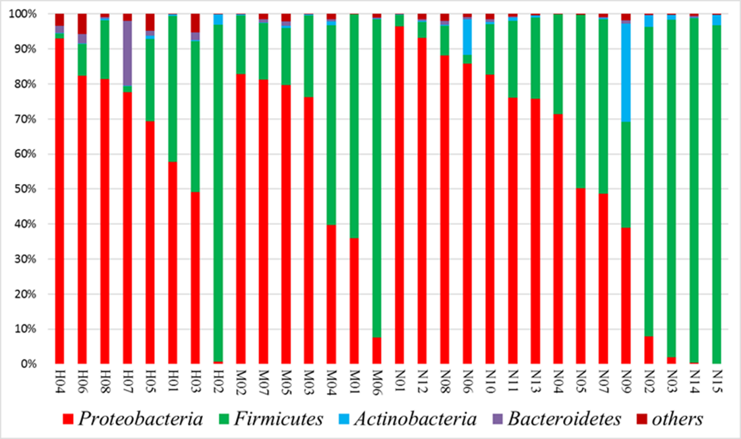
A

B
Supplementary Figure 1. A, Microbial communities in infants with ileostomy. The figure shows the relative abundance of the four dominant taxonomic phyla in patients with HD (H01-H08), MP (M01-M07), and NEC (N01-N15). HD: Hirschsprung's disease; MP: meconium peritonitis; NEC: necrotizing enterocolitis. B, Shannon index of all samples.

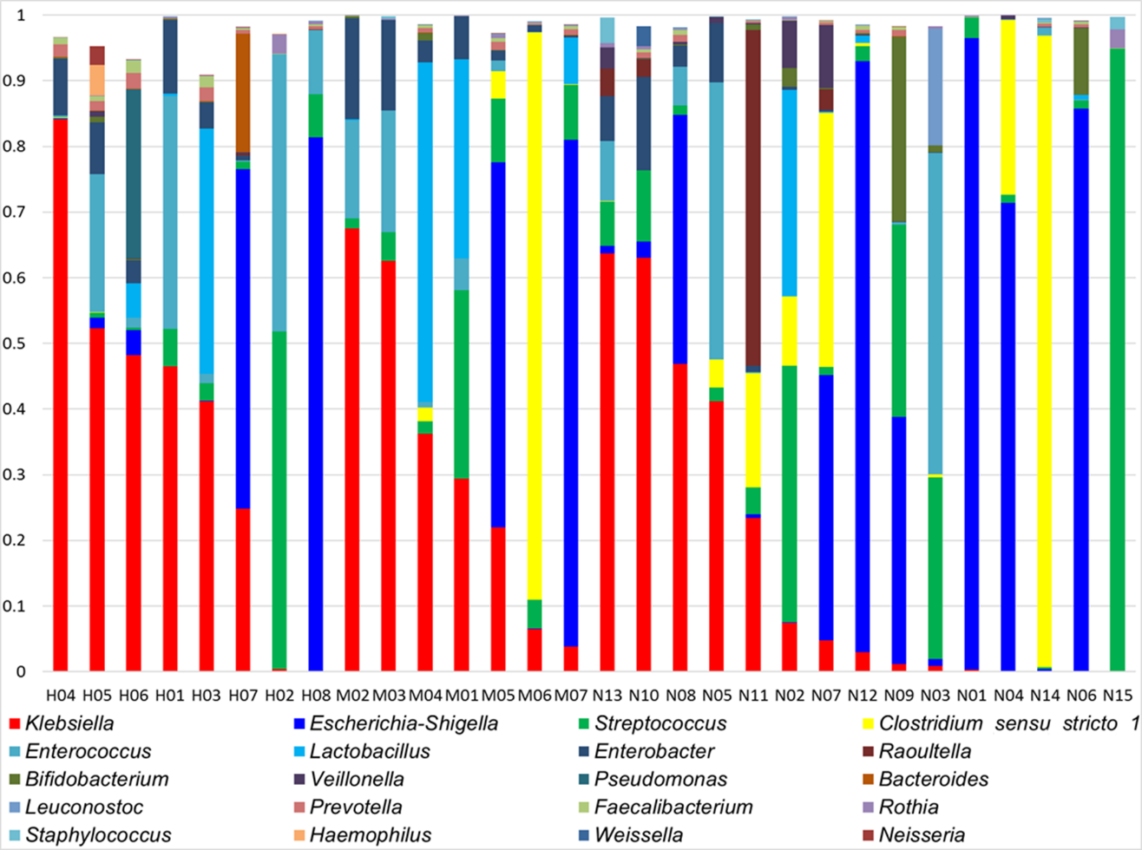
Supplementary Figure 2. Microbial communities in infants with ileostomy. The figure shows the relative abundance of the 20 taxonomic genera in patients with HD (H01-H08), MP (M01-M07), and NEC (N01-N15). HD: Hirschsprung's disease; MP: meconium peritonitis; NEC: necrotizing enterocolitis.

