S1. Measurement models
Measurement properties were examined at the item level via confirmatory factor analysis (CFA) for two complementary purposes: (a) to evaluate measurement quality in the present sample, and (b) to assess whether the use of aggregated scale scores and higher-order latent constructs in the structural equation models (SEM) was empirically supported.
Consistent with the positive psychology framework underlying our theoretical model, we focused on the Intrinsic Goals (IG) subscale of the Aspiration Index [27, 50] and on the Basic Psychological Need Satisfaction (BPN-S) subscale of the Basic Psychological Need Satisfaction and Frustration Scale [46, 47], rather than on the full multidimensional structures of these instruments. Both IG and BPN-S were modeled as single latent factors at the item level.
With regard to Academic Engagement (AE), we focused on three of the six scales from the SInAPSi Academic Engagement Scale (SAES) [35]: (1) perceived ability to persist in the chosen university pathway, (2) perceived value of the university and sense of belonging, and (3) perceived value of the university course. These dimensions were conceptualized as reflecting core motivational and academic components of engagement more proximally linked to academic achievement. The remaining AE scales (i.e., engagement with one’s relational network, engagement with peers, and engagement with professors) were expected to primarily capture relational and contextual aspects of engagement that may be less directly linked to academic achievement. A second-order CFA model was specified to examine whether the three selected dimensions could plausibly be represented as indicators of a higher-order AE construct within the present sample.
Well-Being (WB) was also modeled as a second-order construct, reflected by emotional, social, and psychological well-being, as assessed by the Mental Health Continuum–Short Form (MHC-SF) [52].
CFA fit indices and standardized loadings and reliability estimates for each tested model are reported in Table S1 and Table S2, respectively.

Table S1
CFA Fit Indices
Model | CFI | TLI | RMSEA | SRMR
IG (1 factor) | 0.94 | 0.91 | 0.19 | 0.12
PBN-S (1 factor) | 0.93 | 0.88 | 0.24 | 0.13
AE (2nd order latent construct) | 0.99 | 0.99 | 0.07 | 0.05
WB (2nd order latent construct) | 0.99 | 0.99 | 0.09 | 0.05
Note. IG = Intrinsic Goals; PBN-S = Basic Psychological Need Satisfaction; AE = Academic Engagement; WB = Well-Being; CFI = Comparative Fit Index; TLI = Tucker–Lewis Index; RMSEA = Root Mean Square Error of Approximation; SRMR = Standardized Root Mean Square Residual.

Table S2
Standardized Loadings and Reliability
Construct | k | Loading Range | CR | AVE
IG | 6 | .59–.85 | 0.88 | 0.54
PBN-S | 6 | .45–.85 | 0.83 | 0.47
AE – Persistence in Study Choice | 4 | .70–.81 | 0.84 | 0.57
AE – University Value & Belonging | 6 | .45–.86 | 0.90 | 0.60
AE – University Course Value | 7 | .72–.93 | 0.95 | 0.72
AE (2nd order latent construct) | 3 | .83–.95 | 0.91 | 0.77
E-WB | 3 | .77–.88 | 0.87 | 0.70
S-WB | 5 | .67–.78 | 0.85 | 0.53
P-WB | 6 | .69–.84 | 0.89 | 0.57
WB (2nd order latent construct) | 3 | .81–.94 | 0.92 | 0.79
Note. IG = Intrinsic Goals; PBN-S = Basic Psychological Need Satisfaction; AE = Academic Engagement; WB = Well-Being; E-WB = Emotional Well-Being; S-WB = Social Well-Being; P-WB = Psychological Well-Being; CR = Composite Reliability; AVE = Average Variance Extracted.

The one-factor IG model demonstrated acceptable Comparative Fit Index (CFI) and Tucker-Lewis Index (TLI). Standardized factor loadings ranged from .59 to .85, indicating moderate to strong associations between items and the latent construct. Composite reliability (CR) was high, and Average Variance Extracted (AVE) exceeded the conventional .50 threshold, supporting adequate internal consistency and convergent validity.
The one-factor BPN-S model showed acceptable CFI and TLI. Standardized loadings ranged from .45 to .85. Composite reliability was satisfactory, and AVE approached the .50 benchmark.
The second-order CFA model specified for AE demonstrated excellent CFI and TLI. Standardized loadings for the first-order factors were generally strong, and the three first-order dimensions loaded strongly onto the higher-order factor (standardized loadings = .83–.95). CR was high for each first-order factor and for the second-order construct, with AVE values exceeding .50.
The second-order construct modeled for WB also demonstrated excellent CFI and TLI. Standardized loadings for first-order factors ranged from .67 to .88, and the three dimensions loaded strongly onto the higher-order WB construct (standardized loadings = .81–.94). CR was high for each first-order dimension and for the second-order construct, with AVE values above .50.
Overall, item-level analyses supported the specified measurement structures and confirmed satisfactory internal consistency and convergent validity for all constructs. Specifically, the CFAs supported representing IG and BPN-S as aggregated observed scale scores, and AE and WB as second-order latent constructs in the structural equation modeling (SEM). This modeling strategy ensured parsimony, improved estimator stability under WLSMV estimation, and maintained consistency in the level of construct aggregation across variables.
.
S2. Structural models: rationale and model families
Two competing families of structural equation models (SEMs) were estimated to examine the structural relations among Intrinsic Goals (IG), Psychological Basic Need Satisfaction (PBN-S), Well-Being (WB), Academic Engagement (AE), and academic achievement (mean exam grade coded as a four-level ordinal variable). The two families differed in the assumptions about the ordering of WB and AE (WB→AE vs AE→WB).
In the WB→AE family, IG and PBN-S were specified as predictors of WB, WB was specified as a predictor of AE, and AE was specified as the proximal predictor of mean exam grade.
In the AE→WB family, IG and PBN-S predicted AE, AE predicted WB, and WB was specified as the proximal predictor of mean exam grade.
Across all models, IG and PBN-S were modeled as single-indicator latent variables (factor loading fixed to 1) to account for measurement error in the observed scale scores. Indicator residual variances were fixed using composite reliability (CR) estimates from the item-level CFAs, such that the error variance was set to (1 – CR) x Var(X) and the corresponding latent variance to CR x Var(X) [60]. IG and PBN-S were allowed to covary. WB and AE were modeled as latent constructs indicated, respectively, by the emotional, social, and psychological well-being dimensions, and by the persistence in study choice, university value and belonging, and perceived course value dimensions, consistent with the CFA results (Supplementary Materials, Section S1). Age and gender (0 = male; 1 = female) were included as covariates predicting the mediators and the outcome.
Within each SEM family, we estimated a theoretically guided sequence of nested structural models that differed in the inclusion of direct effects among constructs.
Within the WB→AE family, three nested structural models were estimated.
First, a direct-effects structural model (least constrained model) was estimated. In this specification, IG and PBN-S were specified as predictors of both WB and AE, and all constructs (IG, PBN-S, WB, and AE) were specified as direct predictors of mean exam grade. This model allowed simultaneous estimation of both direct and indirect pathways linking motivational and psychological factors to academic achievement.
Second, a partially mediated structural model was estimated. In this model, IG and PBN-S were specified as predictors of both WB and AE, and AE was specified as the sole direct predictor of mean exam grade. Direct effects from IG, PBN-S, and WB to mean exam grade were constrained to zero, so that their influence on academic achievement was mediated by AE.
Third, a fully mediated structural model (most constrained model) was estimated. In this specification, IG and PBN-S predicted WB, WB predicted AE, and AE predicted mean exam grade. Direct effects from IG and PBN-S to AE were constrained to zero, yielding a fully sequential mediation structure.
An analogous sequence of nested models was estimated within the alternative AE→WB family.
First, a direct-effects structural model (least constrained model) was estimated in which IG and PBN-S predicted both AE and WB, and all constructs were specified as direct predictors of mean exam grade.
Second, a partially mediated structural model was estimated in which IG and PBN-S predicted both AE and WB, and WB was specified as the sole direct predictor of mean exam grade, with direct paths from IG, PBN-S, and AE to mean exam grade constrained to zero.
Finally, a fully mediated structural model (most constrained model) was estimated in which IG and PBN-S predicted AE, AE predicted WB, and WB predicted mean exam grade, yielding a fully sequential mediation structure.
Within each SEM family, the best-fitting model was selected based on nested model comparisons evaluated using the WLSMV scaled (shifted) chi-square difference test [62, 58], together with global fit indices and parsimony considerations [60, 61].
Because the best-fitting models from the WB→AE and AE→WB families were not nested with respect to one another, between-family comparisons were based on descriptive evaluation of global fit, explained variance, parsimony, and theoretical coherence [61].
Model fit indices, explained variance for endogenous variables, and nested comparisons for the WB→AE family are reported in Tables S3-S5. The same information for the AE→WB family is provided in Tables S6-S8.

Table S3.
Well-Being → Academic Engagement Model Family: Model Fit Indices
Model | df | χ² | CFI | TLI | RMSEA | SRMR
WB → AE direct-effects model | 34 | 147.15 | 0.95 | 0.95 | 0.05 | 0.02
WB → AE partially mediated model | 37 | 152.07 | 0.95 | 0.96 | 0.05 | 0.02
WB → AE fully mediated model | 39 | 332.25 | 0.90 | 0.90 | 0.07 | 0.05
Note. CFI = Comparative Fit Index; TLI = Tucker–Lewis Index; RMSEA = Root Mean Square Error of Approximation; SRMR = Standardized Root Mean Square Residual. Reported CFI/TLI/RMSEA correspond to the robust values provided under WLSMV estimation.

Table S4
Well-Being → Academic Engagement Model Family: Explained Variance for Endogenous Variables
Endogenous variable | Direct-effects model R² | Partially mediated model R² | Fully mediated model R²
Well-Being | 0.43 | 0.43 | 0.60
Academic Engagement | 0.37 | 0.37 | 0.41
Mean exam grade | 0.05 | 0.05 | 0.05
Note. R² values refer to the proportion of variance explained in each endogenous construct/outcome.

Table S5
Well-Being → Academic Engagement Model Family: Nested Model Comparisons
Comparison | Δdf | Δχ² | p
Direct-effects Model vs Partially mediated model | 3 | 5.22 | .156
Partially mediated model vs Fully Mediated Model | 2 | 221.64 | < .001
Note. Nested model comparisons were conducted using the WLSMV scaled (shifted) chi-square difference test.

Within the WB→AE SEM family, the direct-effects model and the partially mediated model showed both good-to-excellent and highly comparable global fit, whereas the fully mediated model fit the data substantially worse (Table S3).
Regarding explained variance (Table S4), moving from the direct-effects model to the partially mediated model did not meaningfully alter the proportion of variance explained in the endogenous constructs. Both models accounted for approximately 43% of the variance in WB, 37% in AE, and 5% in mean exam grade. Thus, removing the direct predictors of the outcome did not reduce explanatory power at the level of mean exam grade.
By contrast, further constraining the model to impose full serial mediation altered the internal structural relations and was associated with increased explained variance in WB and AE, but at the cost of a marked deterioration in global model fit (Table S3).
Nested model comparisons (Table S5) further indicated that constraining to zero the direct paths to the outcome did not significantly worsen fit relative to the direct-effects model, Δχ²(3) = 5.22, p = .156. In contrast, imposing full serial mediation resulted in a substantial decrement in fit relative to the partially mediated model, Δχ²(2) = 221.64, p < .001.
Taken together, converging evidence from global fit indices, explained variance, and nested comparisons supported selecting the partially mediated model as the best-fitting and most parsimonious specification within the WB→AE family (see Figure S1).

Figure S1
Structural equation model corresponding to the Well-Being → Academic Engagement partially mediated model

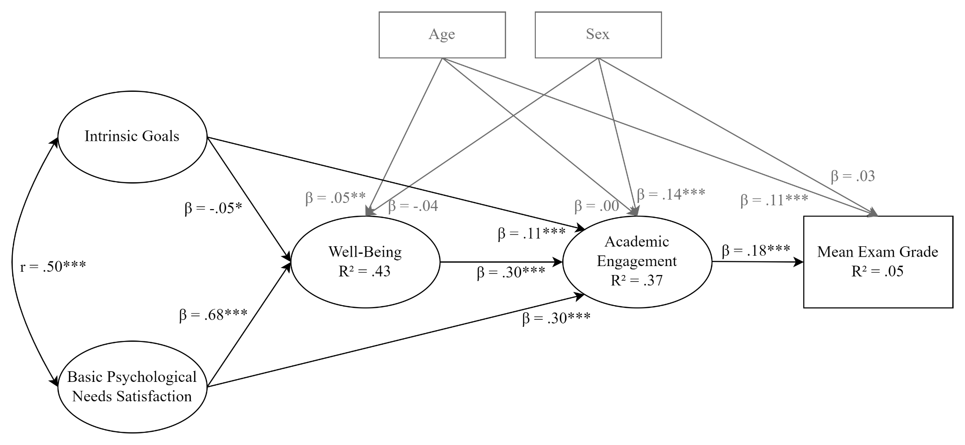
Note. Values on structural paths represent standardized coefficients (β), whereas the correlation between exogenous variables is reported as Pearson’s correlation (r). Age and sex were included as control variables and are displayed in grey.

Within the AE→WB family, the direct-effects model showed good-to-excellent global fit, the partially mediated model showed slightly lower but still acceptable fit indices, and the fully mediated model fitted the data substantially poorer (see Table S6).

Table S6
Academic Engagement → Well-Being SEMs: Model Fit Indices
Model | df | χ² | CFI | TLI | RMSEA | SRMR
AE → WB direct-effects model | 34 | 147.15 | .95 | .95 | .05 | .02
AE → WB partially mediated model | 37 | 241.76 | .92 | .93 | .06 | .04
AE → WB fully mediated model | 39 | 521.57 | .83 | .85 | .09 | .06
Note. CFI = Comparative Fit Index; TLI = Tucker–Lewis Index; RMSEA = Root Mean Square Error of Approximation; SRMR = Standardized Root Mean Square Residual. Reported CFI/TLI/RMSEA correspond to the robust values provided under WLSMV estimation.

Considering the explained variance of endogenous variables (Table S7), the direct-effects model explained approximately 31% of the variance in AE, 47% in WB, and 5% in mean exam grade. The partially mediated model showed comparable explained variance in AE (31%), similar in WB (49%), but lower in mean exam grade (3%). The fully mediated model increased the proportion of variance explained in AE (53%), but at the cost of substantially poorer global fit and without meaningful improvement in outcome prediction.

Table S7
Academic Engagement → Well-Being SEMs: Explained Variance of Endogenous Variables
Endogenous Variable | Direct-effects model R² | Partially mediated model R² | Fully mediated model R²
Academic Engagement | .31 | .31 | .53
Well-Being | .47 | .49 | .46
Mean exam grade | .05 | .03 | .04

Nested comparisons (Table S8) additionally indicated that constraining to zero the direct paths from IG and BPN-S to mean exam grade (direct-effects model vs. partially mediated model) resulted in a significant deterioration in model fit, Δχ²(3) = 96.24, p < .001. Further constraining the model to impose full serial mediation (partially mediated model vs. fully mediated model) also led to a substantial decrement in fit, Δχ²(2) = 355.34, p < .001.
Overall, the pattern of results across model fit indices, explained variance, and nested comparisons indicated that the direct-effects model provided the most adequate representation of the data within the AE→WB family (see Figure S2).

Table S8
Academic Engagement → Well-Being SEMs: Nested Model Comparisons
Comparison | Δdf | Δχ² | p
Direct-effects Model vs Partially mediated model | 3 | 96.24 | < .001
Partially mediated model vs Fully Mediated Model | 2 | 355.34 | < .001

Figure S2
Structural equation model corresponding to the Academic Engagement → Well-Being direct-effects model
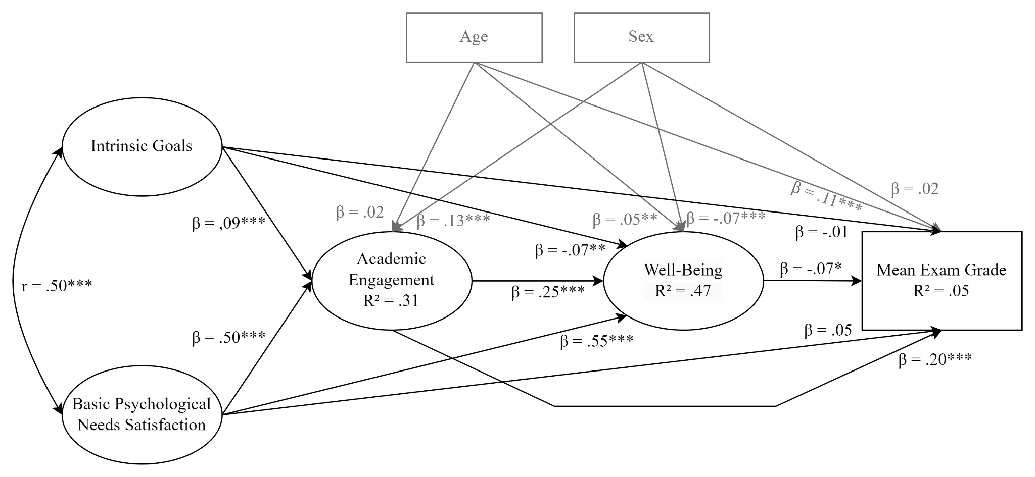
Note. Values on structural paths represent standardized coefficients (β), whereas the correlation between exogenous variables is reported as Pearson’s correlation (r). Age and sex were included as control variables and are displayed in grey.

Finally, moving to the descriptive comparison of the best-supported models from the two SEM families, the partially mediated WB→AE model and the direct-effects AE→WB model showed comparably acceptable global fit (see Tables S3 and S6). However, the partially mediated WB→AE model represented a more parsimonious structural specification and achieved comparable explanatory power for mean exam grade without requiring additional direct paths. This model was also broadly consistent with theoretical expectations derived from Self-Determination Theory and prior empirical findings. In light of considerations of parsimony and theoretical interpretability, the WB→AE family was retained as the primary structural framework for interpretation in the main text.
-------------------

The instruments employed in the present study are based on previously validated measures or adapted versions of established scales (see Method, section Measures). Accordingly, the CFAs were conducted as a measurement quality check in the current sample rather than as a full validation exercise.

