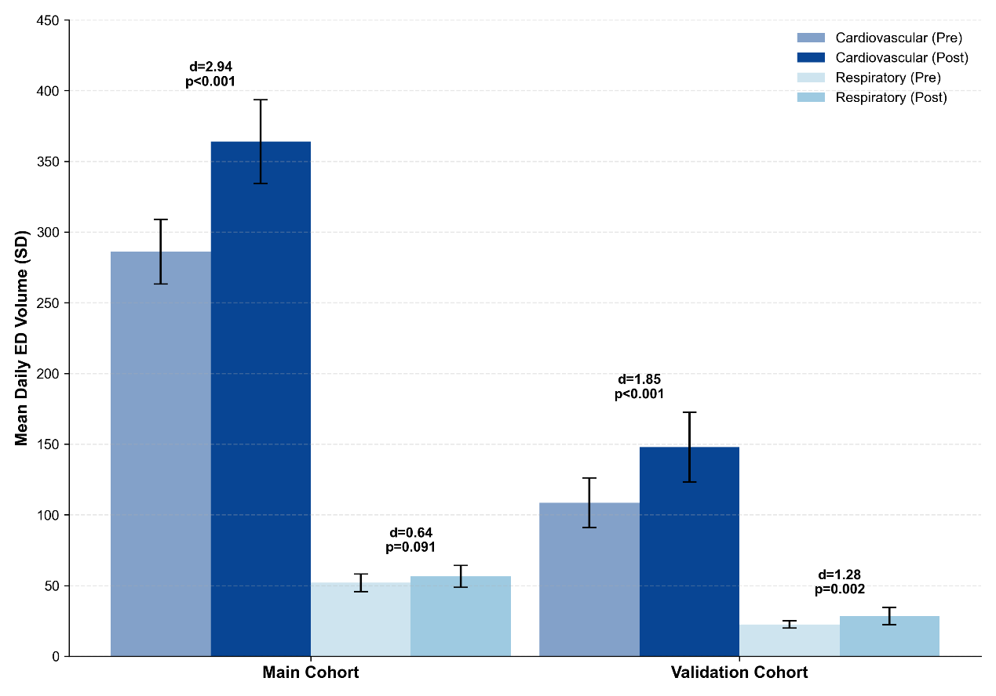
Supplementary Figure S1. Quantitative Comparison of Daily Emergency Department Volume Changes Across Specialized Departments.
Notes: This figure illustrates the distinct departmental patterns of the healthcare-seeking surge across the Main and Validation cohorts.
Bars: Dark blue bars represent the cardiovascular department, and light blue bars represent the respiratory department. Shaded bars (alpha 0.5) denote the 15-day baseline period (Pre), and solid bars denote the 15-day post-event period (Post). Error bars represent the standard deviation (SD) of daily visit volumes.
Statistical Annotations: Independent samples t-tests were performed to calculate p-values, and Cohen’s d was used as the effect size to quantify the magnitude of the level shift relative to baseline fluctuations.
Interpretation: The post-event surge was characterized by an overwhelming expansion of cardiovascular service demand (Main: d=2.94; Validation: d=1.85). In contrast, the respiratory department-the only other emergency department in the center—showed no significant change in the Main cohort (p=0.091) and a much smaller absolute increase in the validation cohort. This striking divergence confirms the specialty-specific nature of the surge, effectively ruling out generalized hospital-wide crowding or non-specific seasonal effects.

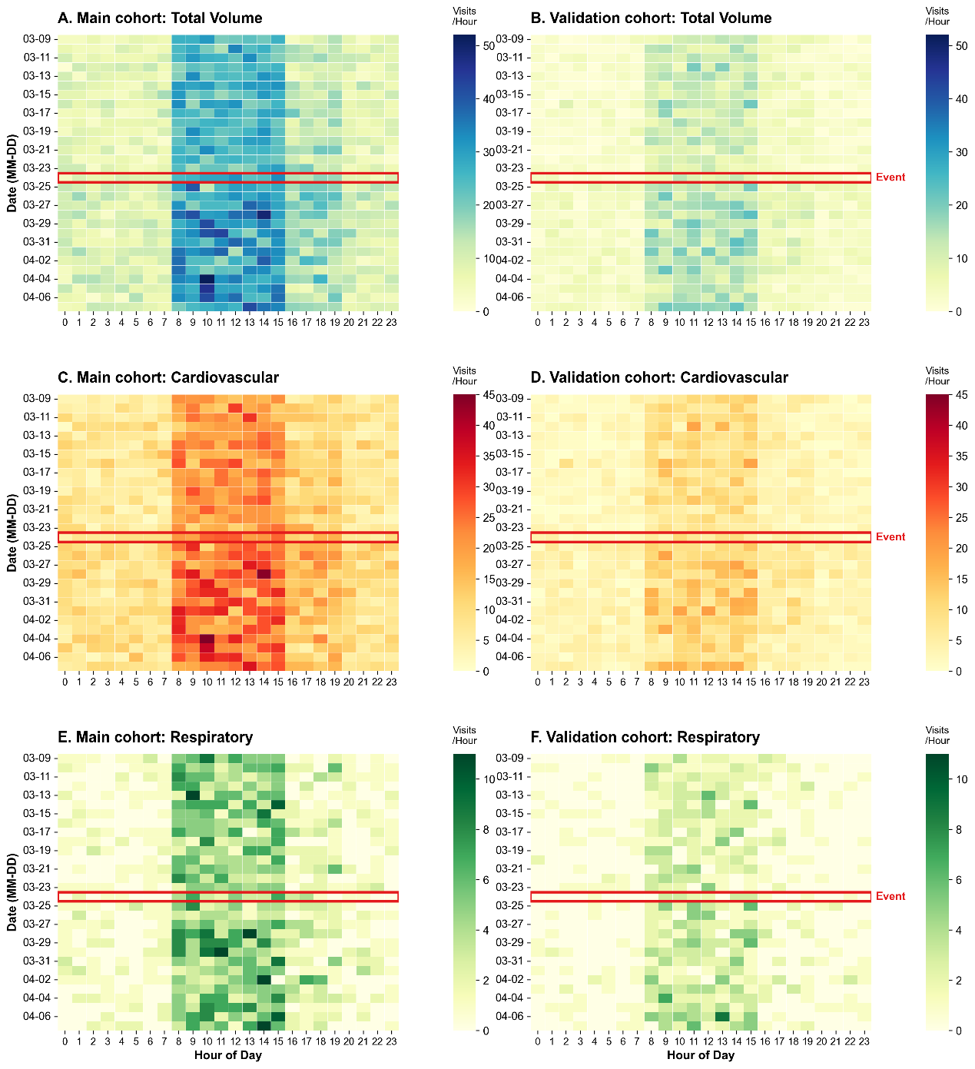
Supplementary Figure S2. Spatiotemporal Distribution of Emergency Department Presentations Across Hospital cohorts and Specialties.
Notes: This 30-day calendar heatmap visualizes the granular hourly distribution of emergency department (ED) visits (15 days pre-event and 15 days post-event).
Panels (A, B): Total ED volume for the Main and Validation cohorts, respectively.
Panels (C, D): Cardiovascular department presentations, showing a prominent and sustained nocturnal surge following the SCD event announcement.
Panels (E, F): Respiratory department presentations, which served as an internal control group, demonstrating stable, baseline-level activity throughout the study period.
The x-axis represents the hour of the day (00:00-23:00); the y-axis represents the date (MM-DD, year omitted for clarity). Color intensity corresponds to hourly visit volume, with darker red indicating higher density. The blue rectangles highlight March 24, 2026, the date of the public event announcement. The distinct divergence between the explosive cardiovascular surge and respiratory stability across both cohorts provides robust visual evidence for the specialty-specific impact of media-associated cardiac-related health concerns.

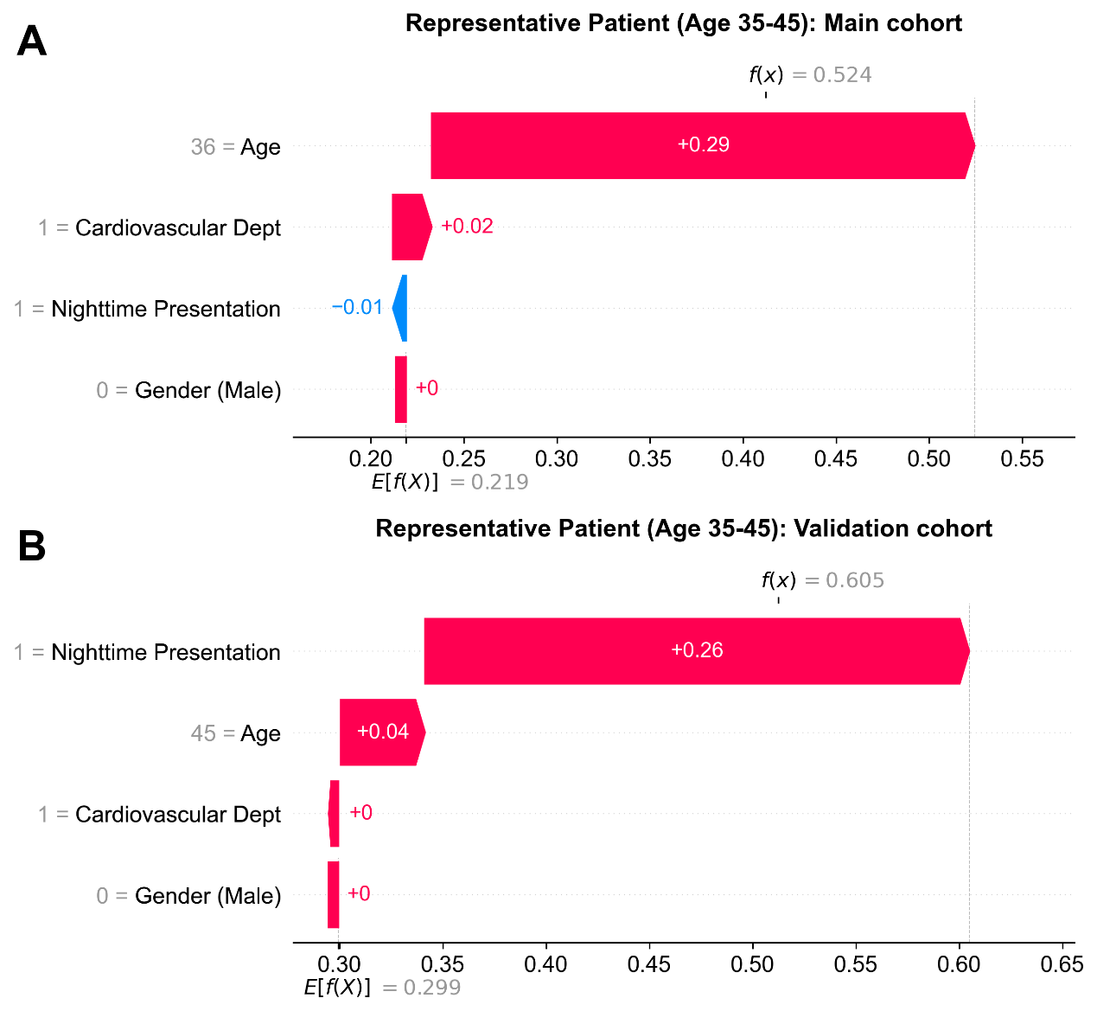
Supplementary Figure S3. Exploratory Individual-level Phenotyping (SHAP Waterfall Plots) of Typical Surge-Period Presentations Across Main and Validation cohorts.
Notes: This figure illustrates the interpretative logic of the XGBoost model in characterizing the surge-associated phenotype within healthcare-seeking surge within two independent cohorts. According to Table 1, the under-45 age group exhibited the most significant proportional increase (+5.1%) following the SCD event; thus, representative patients aged 35–45 years were selected for granular phenotyping analysis.
Panel (A): Waterfall plot for a representative patient in the Main cohort during the post-event surge period.
Panel (B): Waterfall plot for a representative patient in the Validation cohort during the same period.
Statistical Framework: Each plot deconstructs the shift from the baseline expected value E[f(X)] (the average predicted probability across the study population) to the specific case output f(x) (the predicted log-odds of a visit being part of the event-driven surge).
Visual Representation: Red bars denote features that positively contribute to the surge classification (positive SHAP values), while blue bars indicate negative contributions. The length of each bar represents the magnitude of the feature’s influence.
Interpretation of Findings: Notably, 'Age' serves as a consistent and predominant positive driver across both representative cases, reinforcing the demographic shift toward younger and middle-aged populations observed in the population-level data. The directional contribution of 'Nighttime Presentation' varies between the two cases (positive in Panel A, negative in Panel B), highlighting the model’s capacity to integrate nuanced individual-level feature interactions while maintaining consistent global attribution patterns.
Standardization: To ensure direct comparability of feature magnitudes between cohorts, the X-axes of both panels are aligned to a fixed log-odds scale (range: -2.5 to 2.5).

Supplementary Table S1. XGBoost Model Configuration and Technical Specifications
Parameter / Metric | Specification / Value
Algorithm | eXtreme Gradient Boosting (XGBoost)
Data Partitioning | 70% Training / 30% Internal Validation
Hyperparameter: learning_rate | 0.1
Hyperparameter: max_depth | 3 (Optimized to prevent overfitting)
Hyperparameter: n_estimators | 100
Hyperparameter: subsample | 0.8
Implementation | Python v3.10; XGBoost library v1.7.1
Notes: This table summarizes the technical configuration and hyperparameter settings of the XGBoost model. The model was optimized for exploratory feature attribution rather than predictive performance. Consistent parameters were applied across both the main and validation cohorts to ensure the stability of the identified clinical phenotypes.

