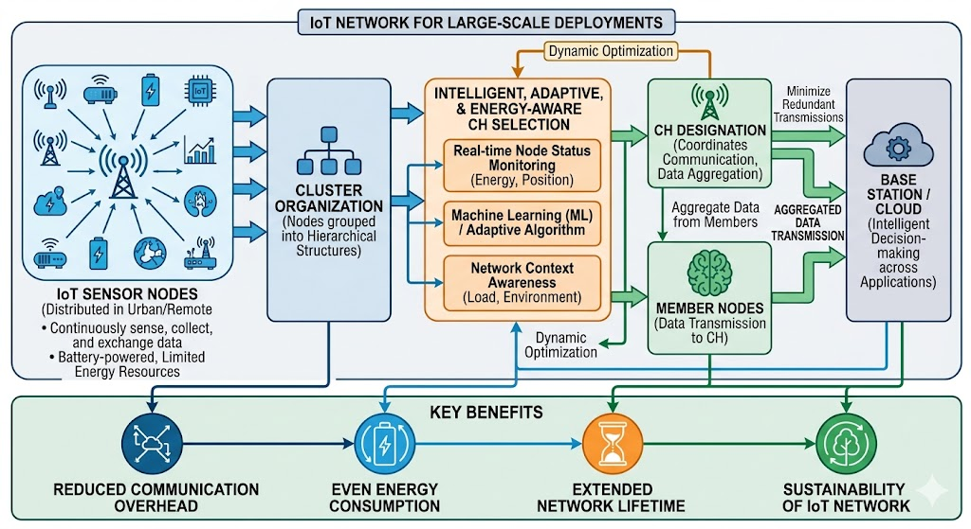
Figure 1. Network formation of Vast sized IoT infrastructure.
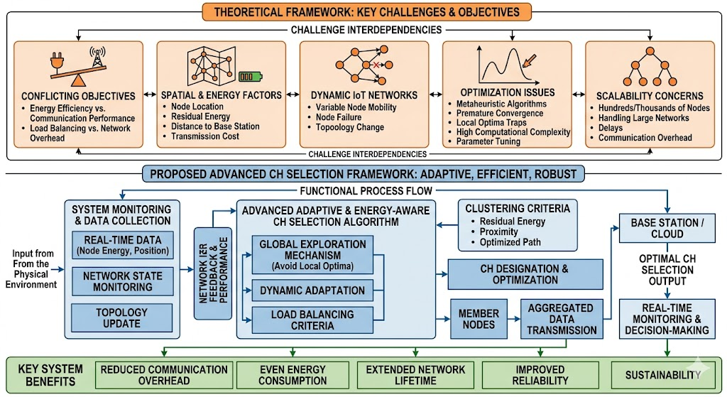
Figure 2. Contribution of Proposed framework

AQISL Algorithm For Selecting a Cluster Head Using Adaptive Quantum-Inspired Swarm Learning Methodology
Step 1: Configure network parameters.
First we must define the following variables: number of nodes N, initial energy E_initial, number of iterations N_iter, and required probability of becoming a Cluster Head, P_ch. Then we will compute all nodes' initial energy values according to Eqn (2), and also residual energy according to Eqn (3).
Step 2: Generate the Candidate Solutions Population.
Candidates Solution Population (PSW) represents the configuration of Cluster Heads. To create candidates, we must assign quantum probability for each candidate solution ( χ_ch ) according to Eqn (5).
Step 3: Compute Initial Probabilities of the Candidates
The probability of becoming a Cluster Head must be determined by Eqn (4), and then either Cluster Head candidates or no Cluster Head candidates calculated by applying the Threshold Condition for Candidates based on Eqn (8).
Step 4: Evaluate Initial Fitness Value for Each Candidate.
The fitness function for each candidate solution must be calculated using the formula for calculating distance to the Base Station (Eqn (15)) to calculate Node Density (Eqn (16)) and communication energy (Eqn's (17), (18), and 19)). The evaluation of a candidate solution's fitness function is calculated by Eqn (14).
Step 5: Setting Initial Swarm Parameters
A Candidate Solutions Swarm must be configured as per the Initial Swarm Velocity and Initial Swarm Position. A Swarm must also be assigned an Inertia Weight (ω) as per Eqn (11). Each Cluster Head must store both their local and global best personal virtues of their Swarm Fitness Values as opportunities to optimize in future iterations of the optimization algorithm based upon the fixed fitness for Cluster Head candidates using Eqn (14).
Step 6: Update Quantum State of Each Candidate
The state of quantum candidates is updated using Equations (6) and (7). Then each candidate must be determined as a better solution (i.e., new probabilities) using Eqn (4).
Step 7: Update Swarms Position and Velocity
The Swarm's velocity is updated using Eqn (10) while the Candidate's Position is updated according to Eqn (9). Subsequently, candidates will need to determine the new distance to the Base Station and the average distance to the Base Station using Eqn (12) and the average distance to the Base Station.
Step 8: Re-evaluate fitness
Update residual energy calculations using equation 3.
Use equation 14 to update fitness.
If a solution has improved, then update P_best and G_best.
Step 9: Compute CH selection probability
Calculate each node’s selection probability using equation 20.
Calculate the threshold from equation 21.
Estimate the number of CHs to be created using equation 22.
Step 10: Select cluster heads
Select each node to be designated as a CH based on their probability: compare the threshold from equation 20 and 21 first. Once the CHs are selected the optimal CH candidate set can be updated according to equation 30.
Step 11: Evaluate performance metrics
Use equation 23 to calculate load balancing factor. Use equation 24 to calculate the network’s life. Use equation 25 to calculate throughput. Use equation 26 to calculate energy efficiency. Use equation 27 to determine stochastic survival rate of nodes. Use equation 29 to calculate average energy of all nodes and equation 28 for energy's variance.
Step 12: Check termination condition
If t < T, then calculate new inertia using equation 11 and go to step 6. Else, complete the process.
Step 13: Final Result Output
Return the optimal CH candidate set (ch_opt via equation 30) along with the calculated performance metrics such as energy efficiency, life, and throughput.

