Graphical abstract:
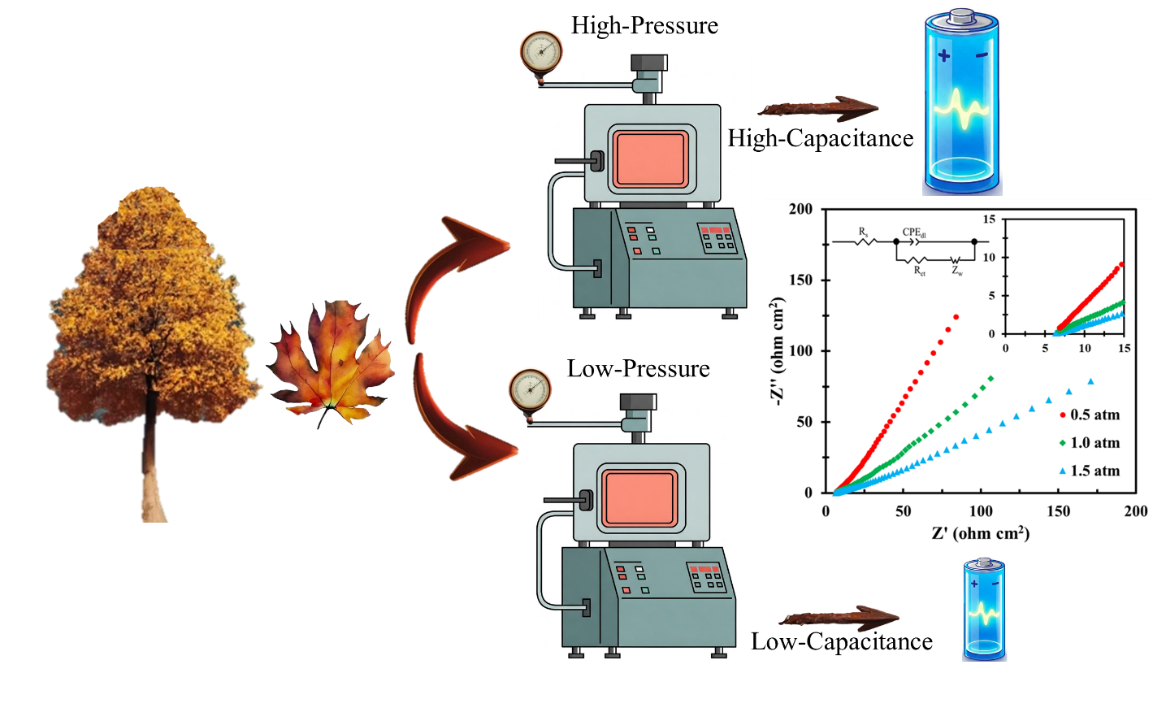

Graphical abstract: Reducing the pressure of the biomass pyrolysis process increases the porosity and capacitance of the produced biochar.

