Annexure 1:
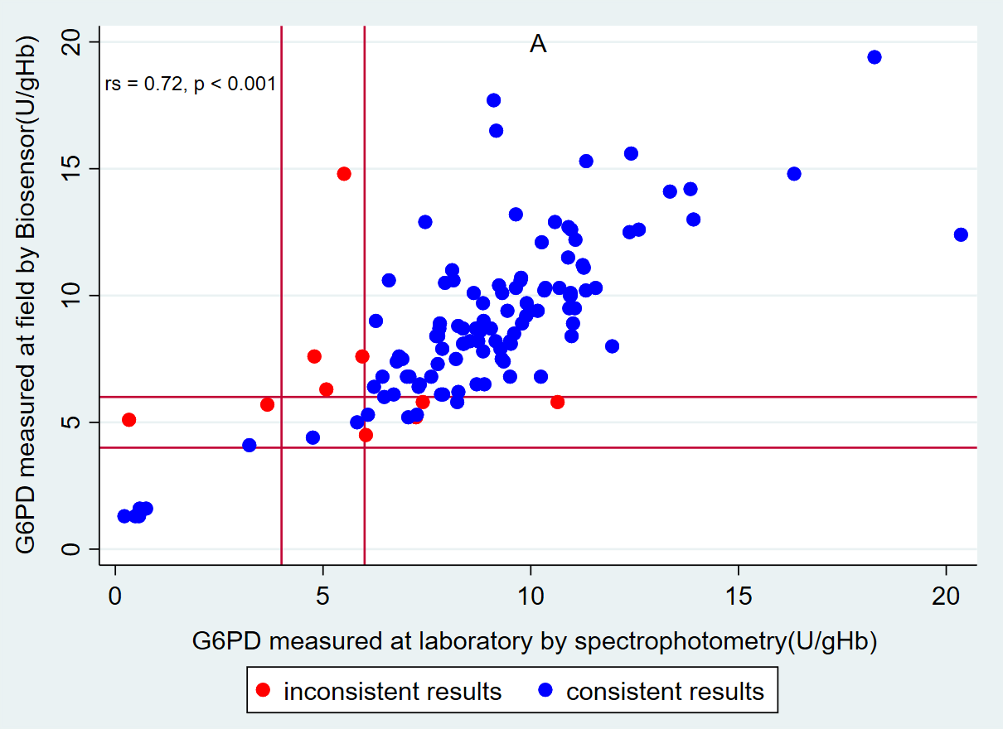
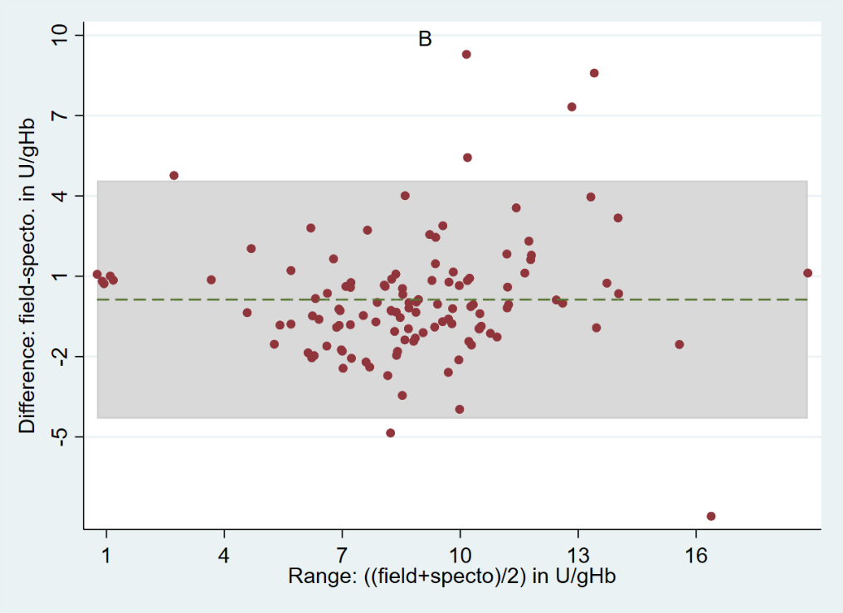

Fig. S1. Comparison of the field Biosensor with reference laboratory spectrophotometry A) Scatter plot and B) Bland-Altman plot. Inconsistent results: results with field not similar to laboratory; A) r_{s} = 0.73; p<0.001, n = 120, red lines indicate 4U/gHb and 6U/gHb cut off. B) Mean difference: 0.13 U/gHb, 95% LoA: -4.31 to 4.57 U/gHb (grey shaded area), green dashed line indicates mean difference.
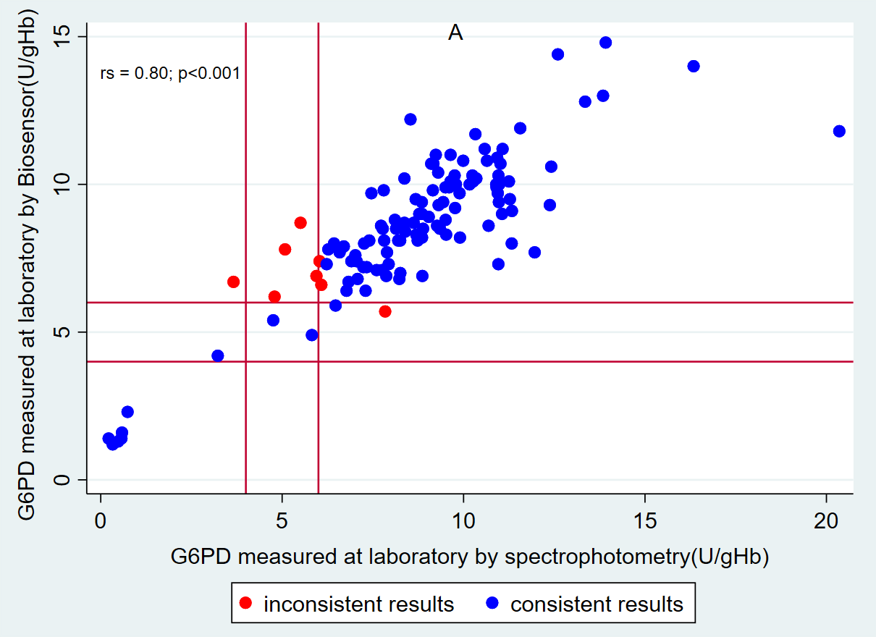
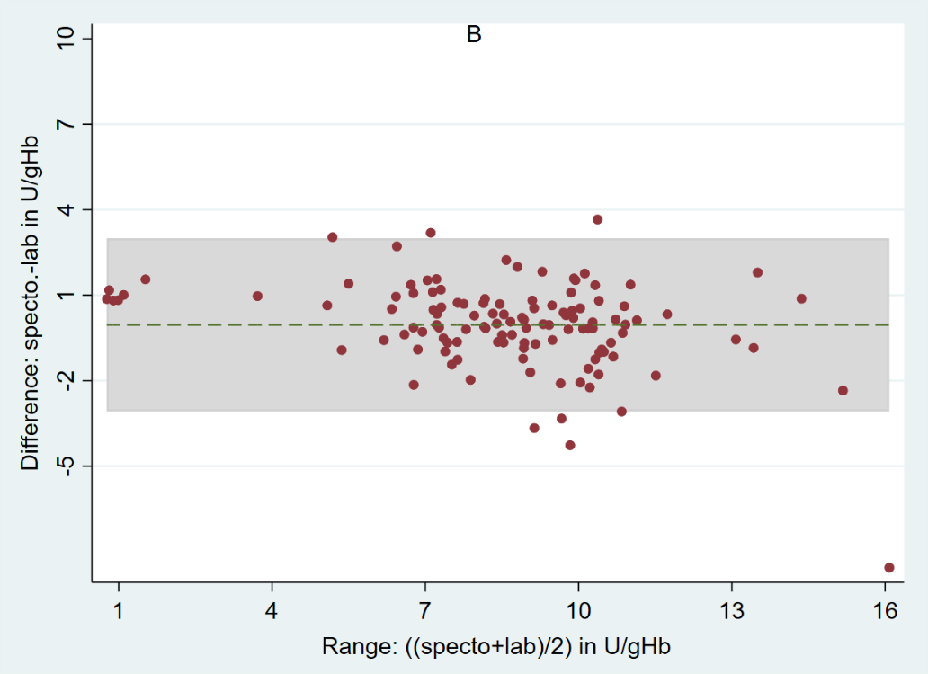
Fig. S2. Comparison of the field Biosensor with reference laboratory spectrophotometry A) Scatter plot and B) Bland-Altman plot. Inconsistent results: results with field not similar to laboratory; A) r_{s} = 0.80; p<0.001, n = 119, red lines indicate 4U/gHb and 6U/gHb cut off. B) Mean difference: -0.04 U/gHb, 95% LoA: -3.08 to 2.99 U/gHb (grey shaded area), green dashed line indicates mean difference.
Table S1 Discordant categorical G6PD results by assay

Sex | Field Biosensor in U/gHb (category) | Laboratory Biosensor in U/gHb (category) | Spectrophotometry in U/gHb (category)
Male | 5.1 (Normal) | 1.2 (Deficient) | 0.33 (Deficient)
Female | 5.3 (Intermediate) | 6.6 (Normal) | 6.1 (Normal)
Female | 5.0 (Intermediate) | 4.9 (Intermediate) | 5.8 (Normal)
Female | 5.2 (Intermediate) | 7.2 (Normal) | 7.2 (Normal)
Female | 5.8 (Intermediate) | 10.8 (Normal) | 10.7 (Normal)
Female | 5.8 (Intermediate) | 8.1 (Normal) | 7.4 (Normal)
Female | 6.1 (Normal) | 5.7 (Intermediate) | 7.8 (Normal)
Female | 7.6 (Normal) | 6.2 (Normal) | 4.8 (Intermediate)
Biosensor categories: deficient: <4.1 U/gHb, intermediate: 4.1 to 6.0 U/gHb, normal: >6.0U/gHb
Spectrophotometry categories: deficient: <2.1 U/gHb, intermediate: 2.1 to 4.9 U/gHb, normal: >4.9 U/gHb.

