Supporting Information
  - Rapid Urease Test Performance in Advanced Gastric Atrophy: A Diagnostic Accuracy Study Using OLGA Staging

Supplementary Table S1
Table 1: Supplementary Table S1. Multivariable Firth penalized logistic regression for false-negative rapid urease test results among histopathology-positive patients with available OLGA and covariate data (n = 202; false-negative events = 21). Firth penalization was used to address sparse-data bias.
Variable | Adjusted OR (95% CI) | p-value
OLGA III–IV vs OLGA 0–II | 4.41 (1.25–14.99) | 0.022
Age, per year | 1.00 (0.96–1.05) | 0.904
Male vs Female | 1.30 (0.49–3.46) | 0.595
Endoscopic atrophic gastropathy present vs absent | 3.41 (1.31–9.09) | 0.012

OR, odds ratio; CI, confidence interval.

Supplementary Tables S2A–S2C
Table 2: Supplementary Table S2A. Descriptive diagnostic performance of the rapid urease test across sex subgroups.
Group | Total | H. pylori + | Sensitivity | Specificity
Female | 454 | 115 | 89.6% (82.6–93.9) | 93.2% (90.0–95.4)
Male | 270 | 88 | 88.6% (80.3–93.7) | 89.6% (84.3–93.2)

Table 3: Supplementary Table S2B. Descriptive diagnostic performance of the rapid urease test across age-group subgroups.
Group | Total | H. pylori + | Sensitivity | Specificity
18–40 | 66 | 30 | 100.0% (88.6–100.0) | 80.6% (65.0–90.2)
41–60 | 368 | 128 | 87.5% (80.7–92.2) | 91.2% (87.0–94.2)
>60 | 310 | 52 | 88.5% (77.0–94.6) | 94.2% (90.6–96.4)

Table 4: Supplementary Table S2C. Descriptive diagnostic performance of the rapid urease test across clinical-indication subgroups.
Group | Total | H. pylori + | Sensitivity | Specificity
Dyspepsia/abdominal pain | 170 | 59 | 91.5% (81.6–96.3) | 92.8% (86.4–96.3)
Follow-up gastric lesions | 49 | 8 | 75.0% (40.9–92.9) | 100.0% (91.4–100.0)
Gastric cancer screening | 114 | 25 | 88.0% (70.0–95.8) | 88.8% (80.5–93.8)
Gastroesophageal reflux | 54 | 10 | 90.0% (59.6–98.2) | 93.2% (81.8–97.7)
Other/unspecified | 341 | 97 | 89.7% (82.1–94.3) | 91.4% (87.2–94.3)
Pre-bariatric evaluation | 16 | 11 | 90.9% (62.3–98.4) | 80.0% (37.6–96.4)

Supplementary Figure S1
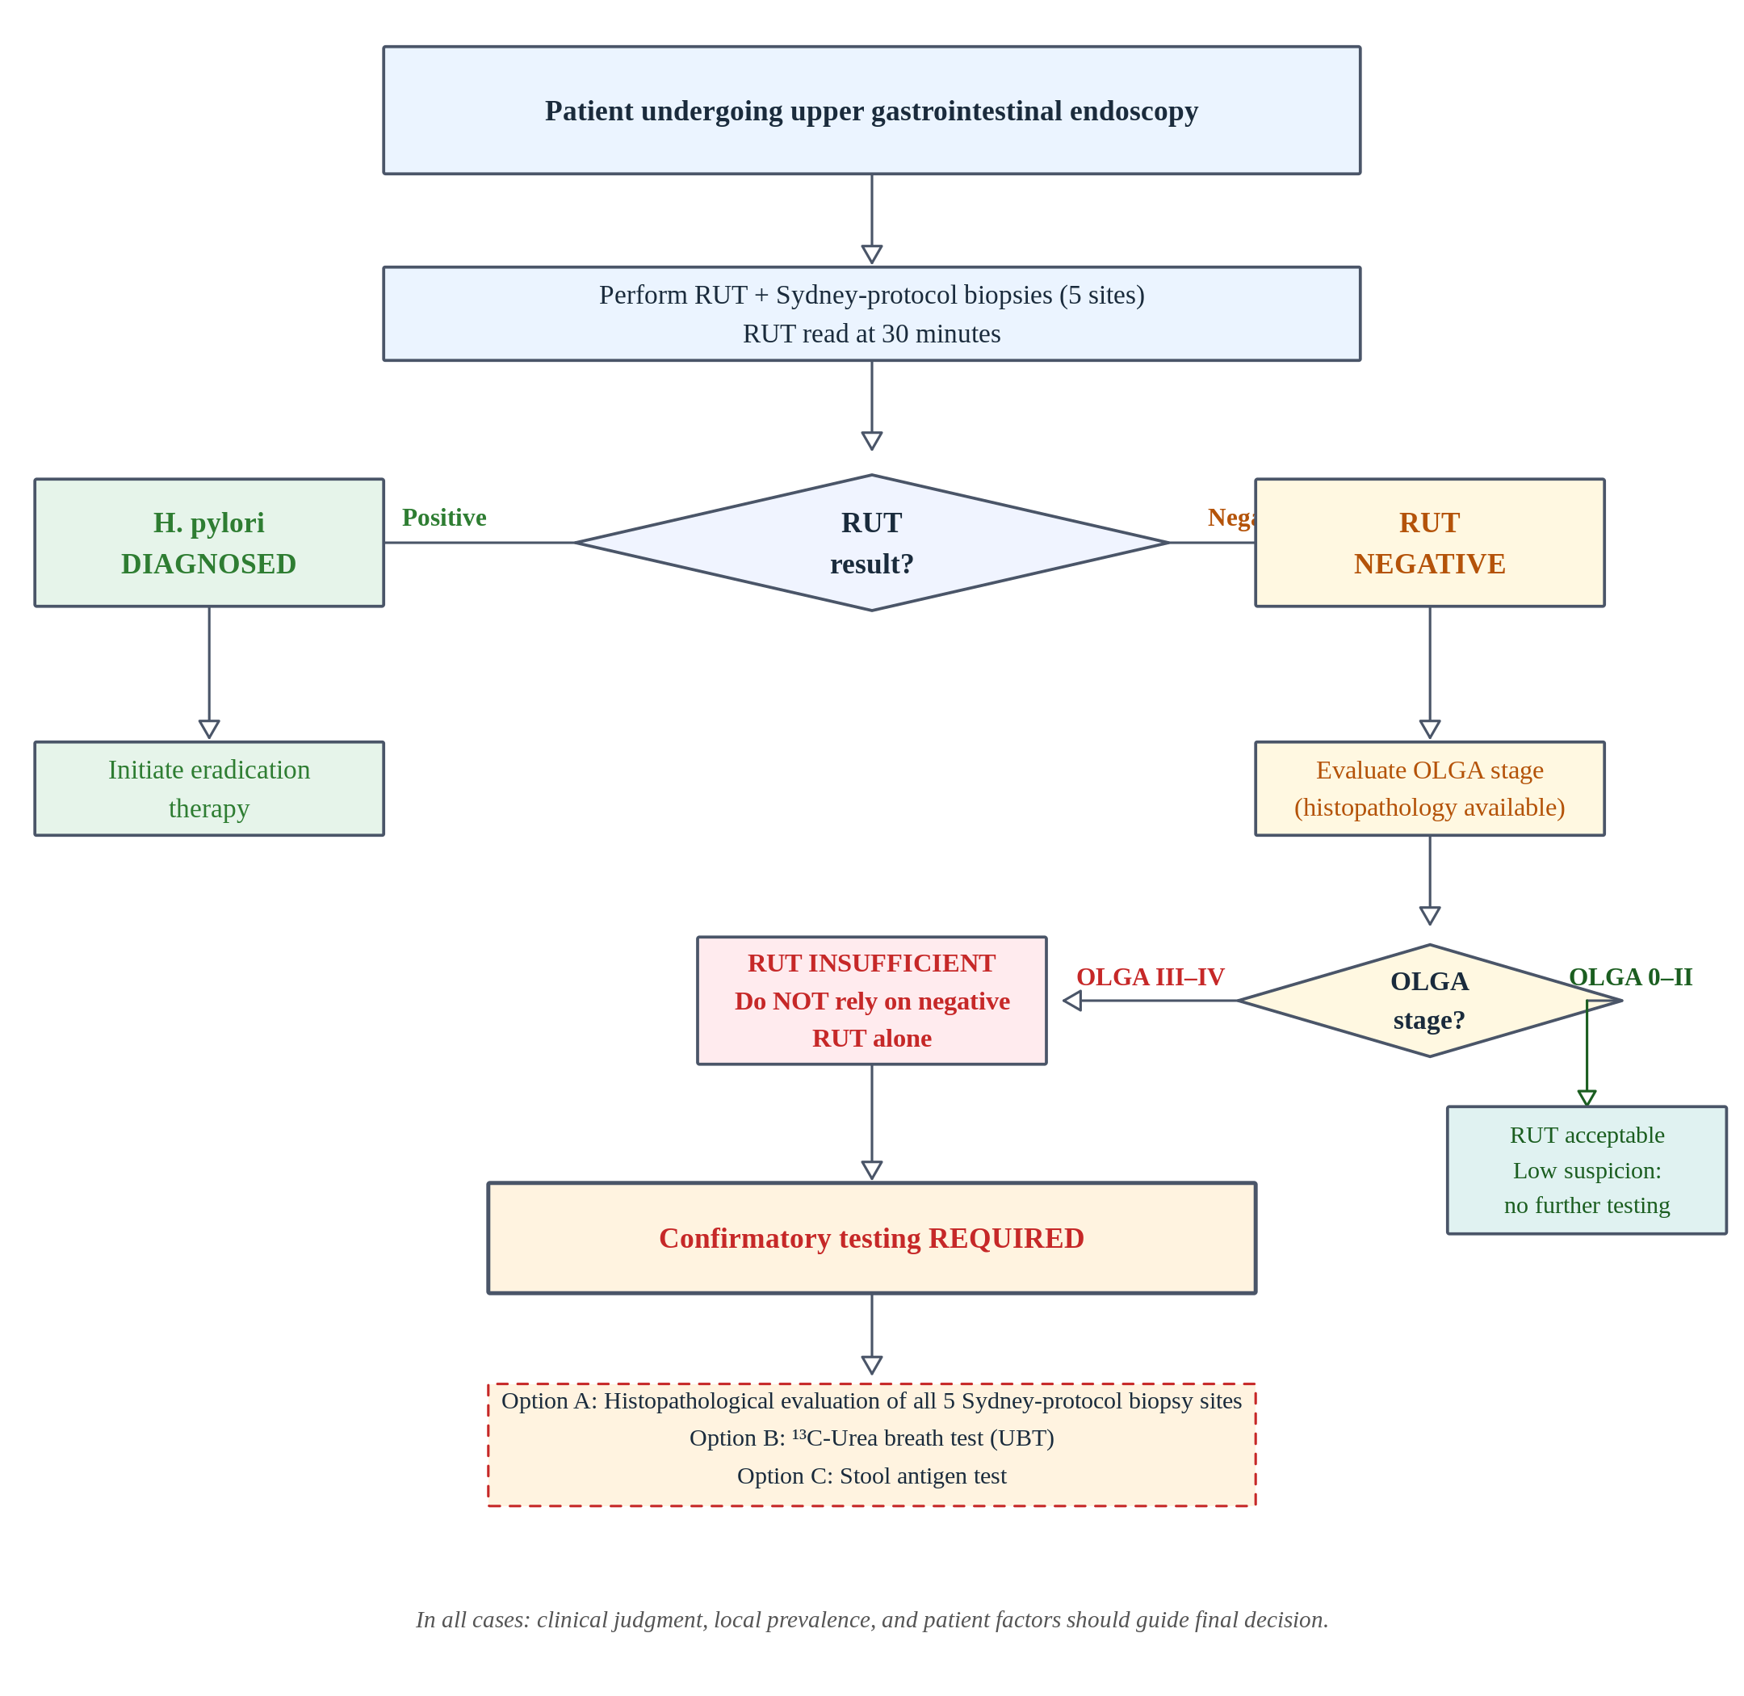
Figure 1: Supplementary Figure S1. Clinical decision algorithm for Helicobacter pylori diagnosis based on rapid urease test result and OLGA stage at upper gastrointestinal endoscopy. OLGA, Operative Link on Gastritis Assessment; RUT, rapid urease test; UBT, 13C-urea breath test.

STARD 2015 Checklist
Manuscript: Rapid Urease Test Performance in Advanced Gastric Atrophy: A Diagnostic Accuracy Study Using OLGA Staging
Reported following: Bossuyt PM, et al. STARD 2015: an updated list of essential items for reporting diagnostic accuracy studies. BMJ. 2015;351:h5527.
# | Section | Item | Reported | Location in manuscript
TITLE AND ABSTRACT
1 | Title | Identification as a study of diagnostic accuracy (sensitivity, specificity, predictive values, AUC, etc.) | Yes | Title: “…A Diagnostic Accuracy Study…”
2 | Abstract | Structured summary of study design, methods, results, and conclusions | Yes | Abstract (Background / Materials and Methods / Results / Conclusions)
INTRODUCTION
3 | Introduction | Scientific and clinical background, including the intended use and clinical role of the index test | Yes | Introduction, paragraphs 1–3
4 | Introduction | Study objectives and hypotheses | Yes | Introduction, final paragraph
METHODS
5 | Study design | Whether data collection was planned before the index test and reference standard were performed (prospective study) or after (retrospective study) | Yes | M&M: Study design — “retrospective cross-sectional”
6 | Participants | Eligibility criteria | Yes | M&M: Study population — adults ≥18 y, simultaneous RUT + Sydney biopsies
7 | Participants | How potentially eligible participants were identified (consecutive, random, convenience sample) | Yes | M&M: Study population — “non-consecutive”; endoscopist-selected
8 | Participants | Where and when potentially eligible participants were identified (setting, location and dates) | Yes | M&M: “Clínica Dávila, Santiago, Chile, January 2024–October 2025”
9 | Test methods | Index test, in sufficient detail to allow replication | Yes | M&M: Rapid urease test — HelicotecUT+ Plus, single antral biopsy, read at 30 min, dichotomous result
10 | Test methods | Reference standard, in sufficient detail to allow replication | Yes | M&M: Histopathological analysis — H&E + modified Giemsa, GI pathologists blinded to RUT
11 | Test methods | Rationale for choosing the reference standard (if alternatives exist) | Yes | M&M: “Histopathology served as the reference standard”; justified as clinically standard
12 | Test methods | Definition of and rationale for test positivity cut-offs or result categories | Yes | M&M: RUT positive = color change to pink/magenta at 30 min; histopathology: direct visualization of H. pylori organisms
13 | Test methods | Whether clinical information and reference standard results were available to the performers of the index test, and vice versa | Yes | M&M: “Pathologist blinded to RUT result”; “RUT result not disclosed to the pathologist”
14 | Statistical methods | Methods for estimating or comparing measures of diagnostic accuracy | Yes | M&M: Statistical analysis — Wilson CIs, Cohen’s kappa, Firth penalized logistic regression
15 | Statistical methods | How indeterminate index test or reference standard results were handled | Yes | M&M: RUT is dichotomous (no indeterminate category); missing histopathology = exclusion
16 | Statistical methods | How missing data on the index test and reference standard were handled | Yes | M&M: “No imputation was performed; complete-case data”
17 | Statistical methods | Intended sample size and how it was determined | Yes | M&M: “No formal sample size calculation was performed; all available cases used”
RESULTS
18 | Participants | Flow of participants, using a diagram | Yes | Figure 1 (flow diagram)
19 | Participants | Baseline characteristics, including clinical and demographic details | Yes | Table 1
20 | Test results | Distribution of severity of disease in those with the target condition; other diagnoses in those without | Yes | Table 1 and Table 3 (OLGA strata)
21 | Test results | Cross-tabulation of the index test results (including indeterminate and missing results) by the results of the reference standard | Yes | Table 2 (TP, FP, FN, TN reported)
22 | Estimates of diagnostic accuracy | Estimates of diagnostic accuracy and their precision (such as 95% CIs) | Yes | Table 2 (overall); Table 3 (OLGA strata); Wilson 95% CIs throughout
23 | Estimates of diagnostic accuracy | Any adverse events from performing the index test or the reference standard | N/A | No adverse events expected or observed from biopsy-based procedures in this dataset
DISCUSSION
24 | Discussion | A discussion of the clinical implications of the study results, including the intended use and clinical role of the index test | Yes | Discussion, paragraphs 4–5
25 | Discussion | Limitations of the study, including sources of potential bias, statistical uncertainty, and generalisability | Yes | Discussion: Limitations paragraph (retrospective design, non-consecutive sample, PPI adherence, reference standard imperfection, small OLGA IV stratum)
OTHER INFORMATION
26 | Registration | Registration number and name of registry | No | This retrospective study was not registered. Authors note this limitation.
27 | Protocol | Where the full study protocol can be accessed | N/A | No prospectively registered protocol exists for this retrospective study
28 | Funding | Sources of funding and other support; role of funders | Yes | Funding: “no specific grant from any funding agency”

Note on item 26 (Registration): This was a retrospective diagnostic accuracy study conducted using data collected during routine clinical care. Prospective registration was not performed. The retrospective nature and absence of registration are acknowledged as limitations. Reviewers may wish to note that registration of retrospective diagnostic accuracy studies, while encouraged, is not universally mandated.

