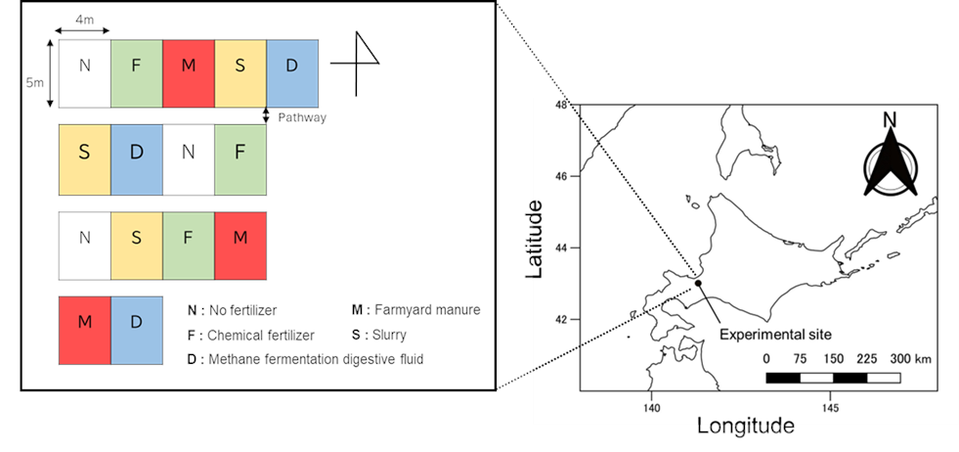
Fig.S1 Field place and design.

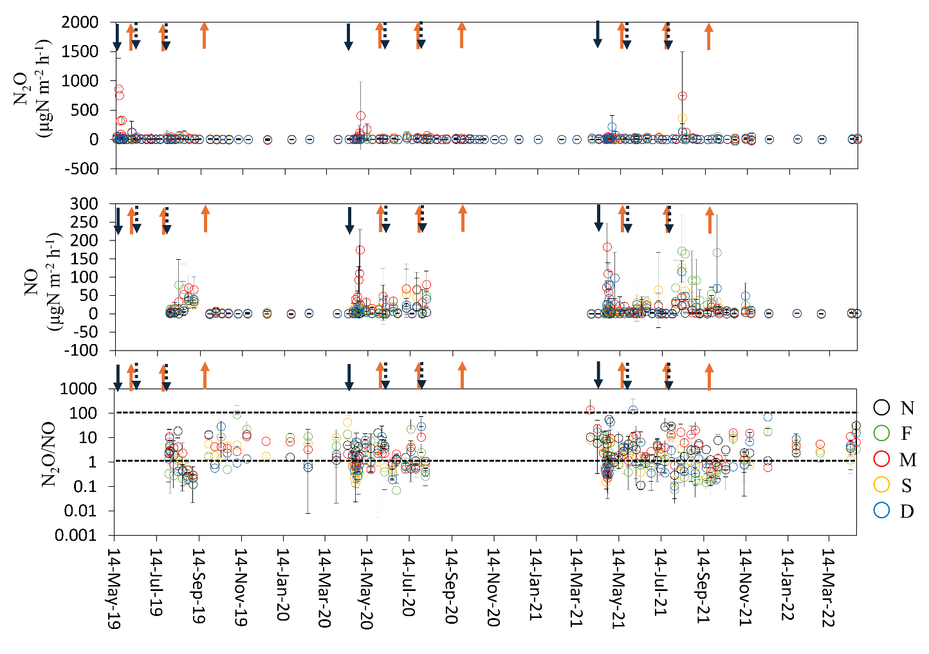
Fig.S2 Seasonal variation of N₂O flux, NO flux, and N₂O/ NO from 2019 to 2021.
The black arrow at the top of the figure indicates organic fertilizer. The black dotted arrows indicate the chemical fertilizer. The orange arrow indicates harvest. Plots of N, F, M, S and D are no fertilizer, chemical fertilizer, farmyard manure, slurry and methane fermentation digestive fluid respectively. Error bars indicate standard deviation.

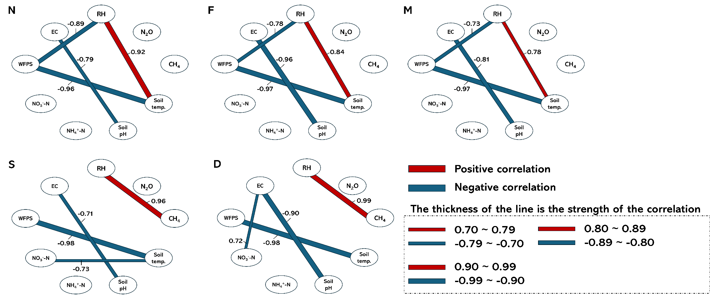

Fig.S3 Peason’s correlation among GHG flux and soil environmental factors (correlation coefficient ≥ 0.6).
Plots of N, F, M, S, and D are no fertilizer, chemical fertilizer, farmyard manure, slurry, and methane fermentation digestive fluid, respectively.

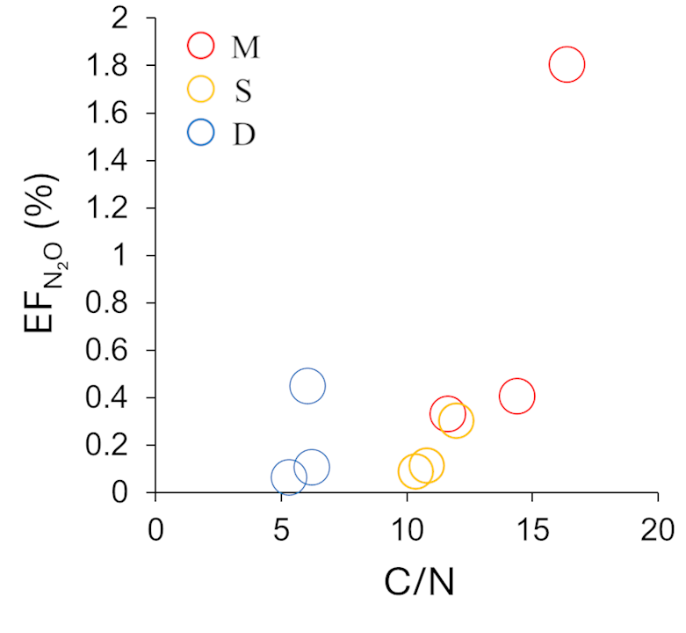
Fig.S4 Correlation between EFN₂O and C/N.
Plots of M, S and D are farmyard manure, slurry and methane fermentation digestive fluid respectively.

Table S1 Pearson's correlation among GHG flux and soil environmental factors in N (no fertilizer) plot.
 | RH | N₂O | CH₄ | Soil temp. | Soil pH | NH₄⁺-N | NO₃⁻-N | WFPS | EC
RH | 1.00
N₂O | 0.26 | 1.00
CH₄ | -0.04 | -0.08 | 1.00
Soil temp. | 0.92* | 0.35 | -0.14 | 1.00
Soil pH | -0.14 | 0.00 | 0.35 | -0.20 | 1.00
NH₄⁺-N | -0.50 | -0.20 | 0.33 | -0.53 | 0.27 | 1.00
NO₃⁻-N | -0.54 | -0.30 | -0.46 | -0.51 | -0.48 | -0.12 | 1.00
WFPS | -0.89* | -0.22 | 0.26 | -0.96* | 0.21 | 0.54 | 0.37 | 1.00
EC | -0.01 | -0.10 | -0.48 | 0.07 | -0.79* | -0.16 | 0.36 | -0.14 | 1.00
The asterisk (*) indicates a statistically significant correlation (p < 0.05).

Table S2 Pearson's correlation among GHG flux and soil environmental factors in F (chemical fertilizer) plot.
 | RH | N₂O | CH₄ | Soil temp. | Soil pH | NH₄⁺-N | NO₃⁻-N | WFPS | EC
RH | 1.00
N₂O | 0.41 | 1.00
CH₄ | -0.55 | -0.01 | 1.00
Soil temp. | 0.84* | 0.38 | -0.52 | 1.00
Soil pH | -0.27 | -0.14 | 0.07 | -0.50 | 1.00
NH₄⁺-N | -0.19 | -0.31 | 0.03 | -0.04 | -0.39 | 1.00
NO₃⁻-N | -0.40 | -0.17 | -0.08 | -0.28 | -0.25 | -0.16 | 1.00
WFPS | -0.78* | -0.24 | 0.53 | -0.97* | 0.41 | 0.01 | 0.26 | 1.00
EC | 0.36 | 0.06 | -0.20 | 0.59 | -0.96* | 0.32 | 0.19 | -0.52 | 1.00
The asterisk (*) indicates a statistically significant correlation (p < 0.05).

Table S3 Pearson's correlation among GHG flux and soil environmental factors in M (manure) plot.
 | RH | N₂O | CH₄ | Soil temp. | Soil pH | NH₄⁺-N | NO₃⁻-N | WFPS | EC
RH | 1.00
N₂O | 0.20 | 1.00
CH₄ | -0.02 | -0.45 | 1.00
Soil temp. | 0.78* | 0.21 | -0.19 | 1.00
Soil pH | -0.37 | 0.18 | 0.08 | -0.39 | 1.00
NH₄⁺-N | 0.04 | -0.34 | 0.03 | 0.01 | -0.39 | 1.00
NO₃⁻-N | -0.59 | -0.19 | -0.23 | -0.57 | -0.02 | -0.41 | 1.00
WFPS | -0.73* | -0.18 | 0.05 | -0.97* | 0.40 | 0.00 | 0.53 | 1.00
EC | 0.24 | -0.46 | -0.06 | 0.26 | -0.81* | 0.59 | -0.02 | -0.27 | 1.00
The asterisk (*) indicates a statistically significant correlation (p < 0.05).

Table S4 Pearson's correlation among GHG flux and soil environmental factors in S (slurry) plot.
 | RH | N₂O | CH₄ | Soil temp. | Soil pH | NH₄⁺-N | NO₃⁻-N | WFPS | EC
RH | 1.00
N₂O | -0.22 | 1.00
CH₄ | 0.96* | -0.26 | 1.00
Soil temp. | 0.13 | 0.23 | -0.05 | 1.00
Soil pH | 0.12 | -0.14 | 0.17 | -0.17 | 1.00
NH₄⁺-N | -0.20 | -0.00 | -0.26 | 0.09 | -0.33 | 1.00
NO₃⁻-N | -0.43 | -0.14 | -0.31 | -0.63* | -0.31 | -0.27 | 1.00
WFPS | -0.20 | -0.18 | -0.03 | -0.98* | 0.25 | -0.19 | 0.59 | 1.00
EC | -0.56 | 0.02 | -0.60 | -0.04 | -0.71* | 0.15 | 0.59 | 0.01 | 1.00
The asterisk (*) indicates a statistically significant correlation (p < 0.05).

Table S5 Pearson's correlation among GHG flux and soil environmental factors in D (methane fermentation digestive fluid) plot.
 | RH | N₂O | CH₄ | Soil temp. | Soil pH | NH₄⁺-N | NO₃⁻-N | WFPS | EC
RH | 1.00
N₂O | -0.36 | 1.00
CH₄ | 0.99* | -0.31 | 1.00
Soil temp. | -0.01 | -0.29 | -0.15 | 1.00
Soil pH | 0.17 | -0.46 | 0.16 | 0.04 | 1.00
NH₄⁺-N | -0.27 | 0.06 | -0.26 | -0.14 | -0.46 | 1.00
NO₃⁻-N | -0.21 | 0.42 | -0.01 | -0.58 | -0.59 | -0.06 | 1.00
WFPS | -0.04 | 0.29 | 0.09 | -0.98* | 0.06 | 0.10 | 0.49 | 1.00
EC | -0.41 | 0.47 | -0.37 | -0.23 | -0.90* | 0.44 | 0.72* | 0.15 | 1.00
The asterisk (*) indicates a statistically significant correlation (p < 0.05).

Table S6 Annual cumulative of grass yields each season from 2019 to 2021.
Year | Plot* | First harvest |  |  |  | Second harvest |  |  |  | Third harvest |  |  |  | Total
Year | Plot* | Mg DM ha⁻¹
2019 | N | 1.40^{δ} | ±0.66 | BCDE |  | 0.36 | ±0.46 | B |  | 0.56 | ±0.36 | CD |  | 2.32 | ±1.22 | CD
(344 days) | F | 1.63 | ±0.44 | ABCD |  | 1.54 | ±0.19 | A |  | 1.41 | ±0.20 | AB |  | 4.57 | ±0.46 | AB
 | M | 0.83 | ±0.09 | DE |  | 1.24 | ±0.20 | A |  | 1.38 | ±0.08 | AB |  | 3.45 | ±0.17 | BC
 | S | 1.07 | ±0.16 | CDE |  | 1.06 | ±0.12 | A |  | 1.38 | ±0.11 | AB |  | 3.51 | ±0.04 | BC
 | D | 1.19 | ±0.13 | CDE |  | 1.42 | ±0.07 | A |  | 1.42 | ±0.15 | A |  | 4.04 | ±0.22 | AB
2020 | N | 0.60 | ±0.17 | E |  | 0.37 | ±0.03 | B |  | 0.60 | ±0.08 | CD |  | 1.56 | ±0.22 | D
(365 days) | F | 1.99 | ±0.26 | ABC |  | 1.39 | ±0.18 | A |  | 1.37 | ±0.23 | AB |  | 4.75 | ±0.42 | AB
 | M | 1.84 | ±0.60 | ABC |  | 1.39 | ±0.26 | A |  | 1.34 | ±0.23 | AB |  | 4.57 | ±1.06 | AB
 | S | 2.38 | ±0.22 | A |  | 1.50 | ±0.22 | A |  | 1.15 | ±0.29 | AB |  | 5.03 | ±0.45 | A
 | D | 2.50 | ±0.55 | A |  | 1.35 | ±0.38 | A |  | 0.96 | ±0.19 | ABC |  | 4.82 | ±0.49 | AB
2021 | N | 0.72 | ±0.21 | DE |  | 0.37 | ±0.07 | B |  | 0.38 | ±0.14 | D |  | 1.47 | ±0.29 | D
(363 days) | F | 1.65 | ±0.27 | ABCD |  | 1.28 | ±0.43 | A |  | 1.05 | ±0.05 | ABC |  | 3.98 | ±0.67 | AB
 | M | 1.91 | ±0.12 | ABC |  | 1.40 | ±0.30 | A |  | 1.26 | ±0.22 | AB |  | 4.56 | ±0.24 | AB
 | S | 2.29 | ±0.22 | AB |  | 1.51 | ±0.13 | A |  | 1.19 | ±0.06 | AB |  | 4.99 | ±0.08 | A
 | D | 1.91 | ±0.23 | ABC |  | 1.35 | ±0.29 | A |  | 0.90 | ±0.09 | BC |  | 4.28 | ±0.61 | AB
ANOVA | d.f. | F-value |  | p-value |  | F-value |  | p-value |  | F-value |  | p-value |  | F-value |  | p-value
Year (Y) | 2 | 16 |  | < 0.05 |  | 0.450 |  | 0.64 |  | 9.47 |  | < 0.05 |  | 5.42 |  | < 0.05
Plot (P) | 4 | 15.1 |  | < 0.05 |  | 35.7 |  | < 0.05 |  | 34.2 |  | < 0.05 |  | 54.7 |  | < 0.05
Y x P | 8 | 7.21 |  | < 0.05 |  | 1.22 |  | 0.32 |  | 1.53 |  | 0.19 |  | 4.37 |  | < 0.05
* N, F, M, S, D indicate no fertilizer, chemical fertilizer, farmyard manure, slurry, and methane fermentation digestive fluid plots, respectively.
^{δ} Values represent mean ± standard deviation and value with the same letter is not significantly different in each column (p < 0.05).
Table S7 Annual cumulative of NECB(Net Ecosystem Carbon Balance) each year from 2019 to 2021.
Year | Plot* | C input | ANPP |  |  | BNPP |  |  | C output |  |  | RH |  |  | CH₄ |  |  | NECB
Year | Plot* | Mg C ha⁻¹
2019 | N | 0.00 | 2.17^{δ} | ±0.30 | BC | -2.93 | ±0.06 | A | 2.32 | ±0.55 | CD | 4.94 | ±1.50 | A | -1.21 | ±1.04 | B | -6.81 | ±2.28 | AB
 | F | 0.00 | 5.07 | ±0.81 | A | -1.18 | ±0.07 | A | 4.57 | ±0.46 | AB | 4.76 | ±0.27 | A | -0.99 | ±0.70 | B | -4.44 | ±0.65 | AB
 | M | 4.05 | 3.69 | ±0.50 | AB | -0.93 | ±1.53 | A | 3.44 | ±0.17 | AC | 4.23 | ±1.13 | A | -0.41 | ±0.45 | B | -0.45 | ±1.49 | B
 | S | 3.00 | 3.73 | ±0.39 | AB | -0.70 | ±1.72 | A | 3.51 | ±0.04 | AC | 4.96 | ±1.44 | A | 2.85 | ±2.02 | A | -5.29 | ±4.99 | AB
 | D | 1.44 | 4.42 | ±0.22 | A | -1.18 | ±1.25 | A | 4.04 | ±0.22 | AB | 4.68 | ±0.96 | A | -0.39 | ±1.87 | B | -3.65 | ±2.98 | AB
2020 | N | 0.00 | 1.08 | ±0.41 | C | 0.09 | ±1.53 | A | 1.56 | ±0.22 | D | 5.25 | ±1.36 | A | 0.44 | ±0.40 | AB | -6.09 | ±2.95 | AB
 | F | 0.00 | 3.59 | ±0.39 | AB | -1.91 | ±1.08 | A | 4.75 | ±0.42 | AB | 5.30 | ±1.36 | A | 0.09 | ±0.27 | AB | -8.46 | ±2.45 | A
 | M | 5.05 | 3.68 | ±1.10 | AB | -1.39 | ±1.80 | A | 4.57 | ±1.06 | AB | 5.18 | ±1.02 | A | 0.22 | ±0.40 | AB | -2.63 | ±1.40 | AB
 | S | 2.74 | 4.14 | ±0.36 | A | -1.48 | ±2.03 | A | 5.02 | ±0.45 | A | 6.82 | ±1.13 | A | 1.76 | ±0.96 | AB | -8.20 | ±2.92 | A
 | D | 1.17 | 3.91 | ±0.14 | A | -0.50 | ±1.46 | A | 4.82 | ±0.49 | AB | 5.42 | ±2.46 | A | -0.19 | ±1.80 | AB | -5.46 | ±1.67 | AB
2021 | N | 0.00 | 1.42 | ±0.19 | C | -0.92 | ±1.68 | A | 1.47 | ±0.29 | D | 5.78 | ±1.99 | A | -0.30 | ±0.78 | AB | -6.45 | ±1.03 | AB
 | F | 0.00 | 4.26 | ±0.72 | A | 0.83 | ±1.53 | A | 3.98 | ±0.67 | AB | 5.47 | ±0.81 | A | -0.54 | ±0.47 | B | -3.82 | ±2.12 | AB
 | M | 1.40 | 4.47 | ±0.11 | A | -0.51 | ±1.15 | A | 4.56 | ±0.24 | AB | 5.19 | ±0.88 | A | 0.31 | ±1.37 | AB | -4.70 | ±1.79 | AB
 | S | 3.01 | 4.79 | ±0.19 | A | -1.28 | ±0.79 | A | 4.99 | ±0.08 | A | 7.00 | ±0.64 | A | 1.10 | ±0.57 | AB | -6.56 | ±0.93 | AB
 | D | 1.31 | 4.50 | ±1.12 | A | -1.35 | ±1.39 | A | 4.28 | ±0.61 | AB | 4.74 | ±2.29 | A | -0.44 | ±0.31 | B | -4.12 | ±3.44 | AB
ANOVA | d.f. | - | F-value | p-value |  | F-value | p-value |  | F-value | p-value |  | F-value | p-value |  | F-value | p-value |  | F-value | p-value
Year (Y) | 2 | - | 5.25 | < 0.05 |  | 1.06 | 0.36 |  | 5.42 | < 0.05 |  | 2.05 | 0.15 |  | 0.97 | 0.39 |  | 2.57 | 0.09
Plot (P) | 4 | - | 40.2 | < 0.05 |  | 0.18 | 0.95 |  | 54.7 | < 0.05 |  | 1.42 | 0.25 |  | 7.90 | <0.05 |  | 4.19 | < 0.05
Y x P | 8 | - | 2.16 | 0.06 |  | 1.66 | 0.15 |  | 4.37 | < 0.05 |  | 0.27 | 0.97 |  | 1.04 | 0.43 |  | 1.09 | 0.40
* N, F, M, S, D indicate no fertilizer, chemical fertilizer, farmyard manure, slurry, and methane fermentation digestive fluid plots, respectively.
^{δ} Values represent mean ± standard deviation and value with the same letter is not significantly different in each column (p < 0.05).
Table S8 Three-year results of the carbon budget in each treatment.
Plot* | C input | ANPP |  |  | BNPP |  |  | C output |  |  | RH |  |  | CH₄ |  |  | NECB
Plot* | Mg C ha⁻¹
N | 0 | 4.67^{δ} | ±0.50 | B | -3.76 | ±0.88 | A | 5.35 | ±0.27 | B | 16.0 | ±4.82 | A | -1.07 | ±1.33 | B | -19.3 | ±6.10 | A
F | 0 | 12.9 | ±1.48 | A | -2.26 | ±1.48 | A | 13.3 | ±1.42 | A | 15.6 | ±2.34 | A | -1.44 | ±1.11 | B | -16.8 | ±4.11 | A
M | 10.5 | 11.9 | ±1.45 | A | -2.83 | ±0.81 | A | 12.6 | ±1.40 | A | 14.6 | ±2.67 | A | 0.11 | ±1.69 | B | -7.77 | ±0.84 | A
S | 8.75 | 12.7 | ±0.26 | A | -3.46 | ±0.38 | A | 13.5 | ±0.47 | A | 18.8 | ±2.54 | A | 5.70 | ±0.90 | A | -20.1 | ±2.59 | A
D | 3.92 | 12.8 | ±1.42 | A | -3.03 | ±1.12 | A | 13.1 | ±1.26 | A | 14.8 | ±5.31 | A | -1.03 | ±1.84 | B | -13.2 | ±7.48 | A
* N, F, M, S, D indicate no fertilizer, chemical fertilizer, farmyard manure, slurry, and methane fermentation digestive fluid plots, respectively.
^{δ} Values represent mean ± standard deviation and value with the same letter is not significantly different in each column (p < 0.05).

