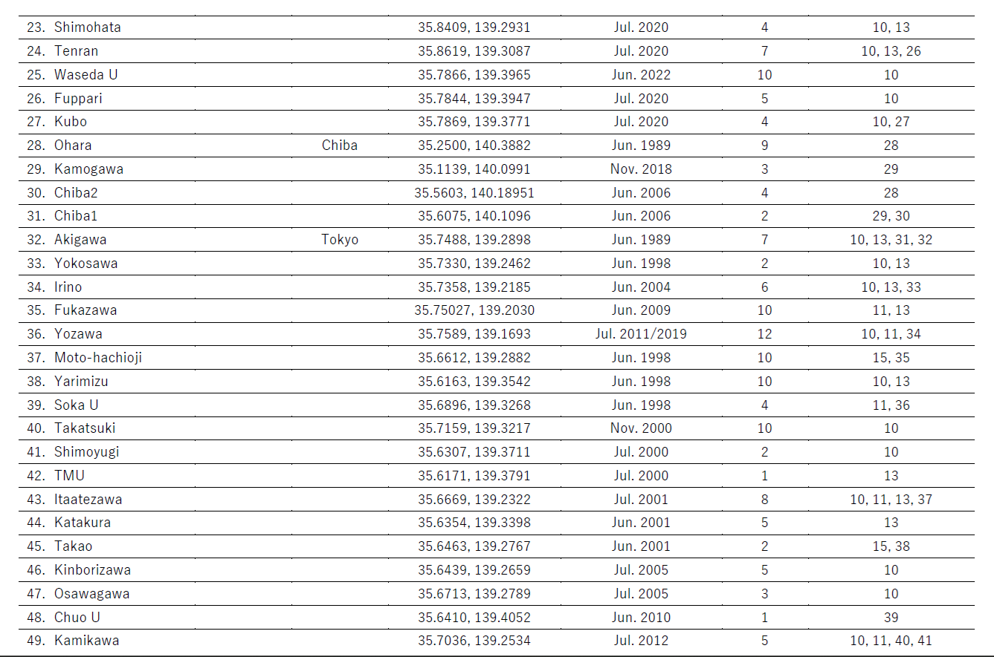
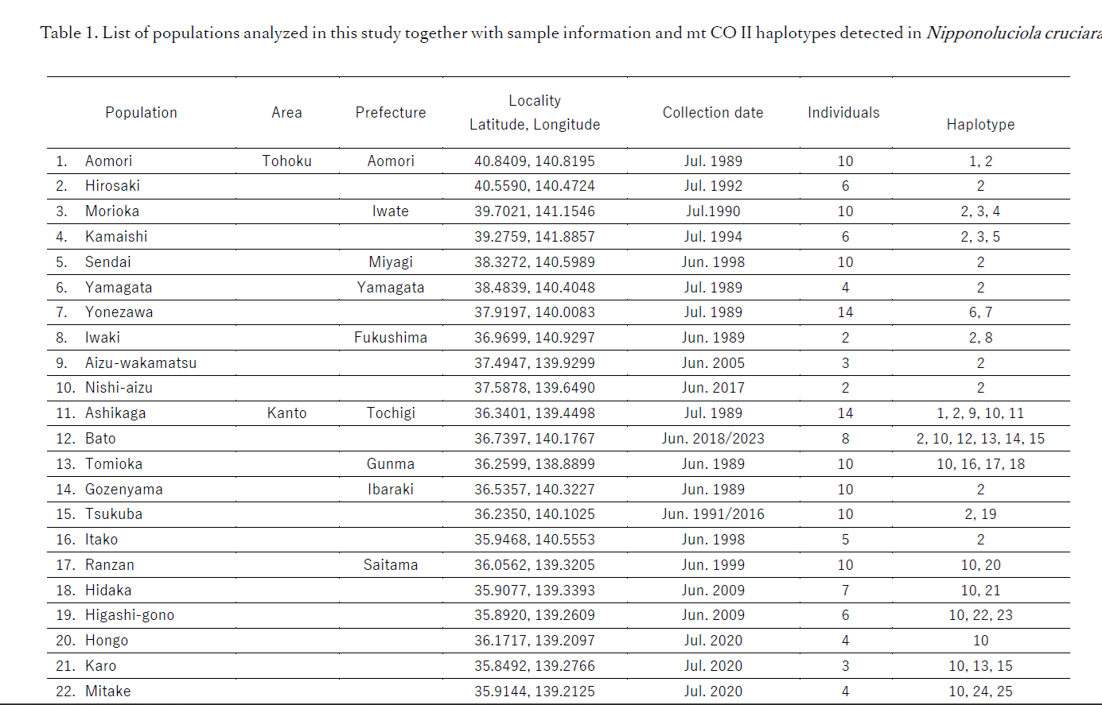
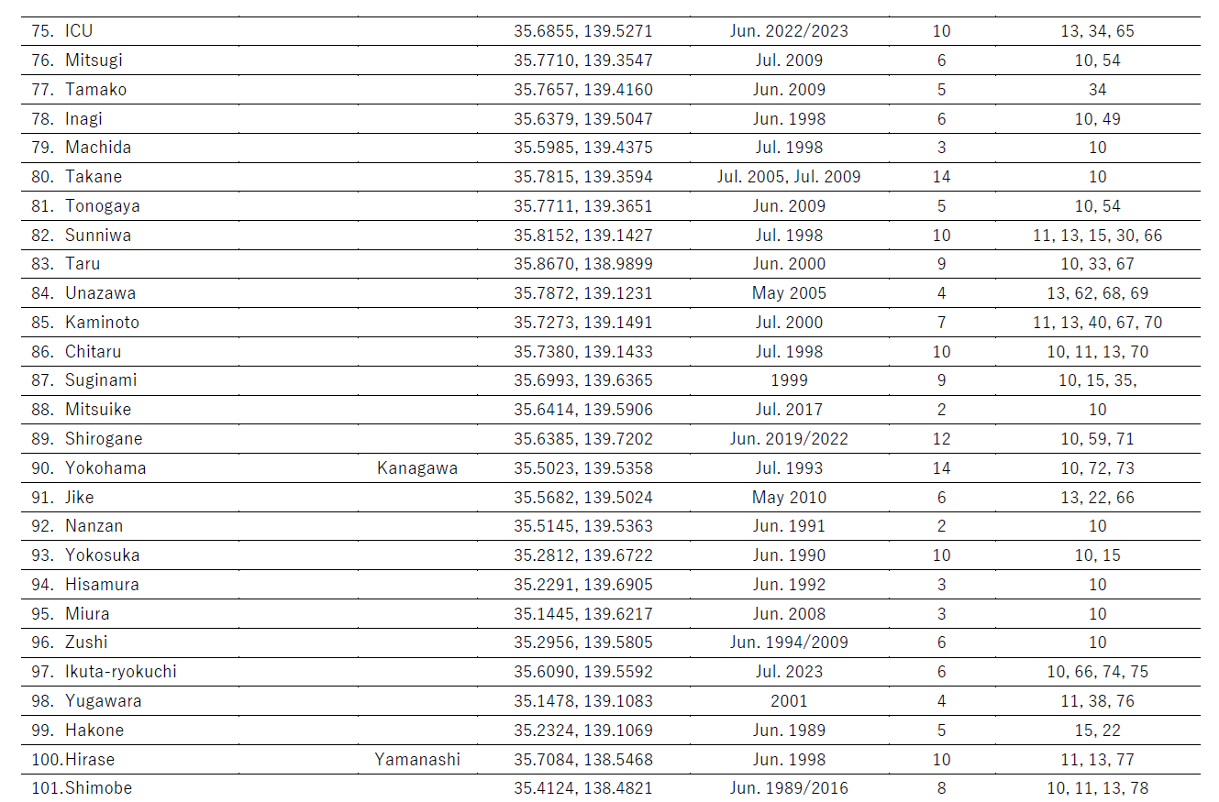
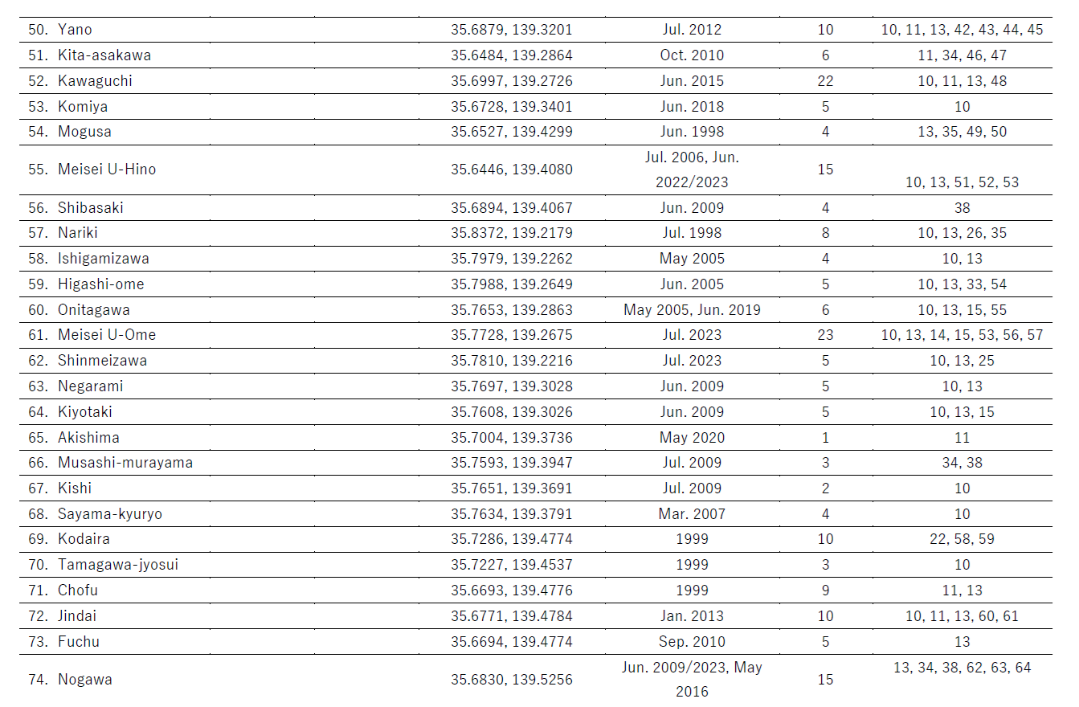
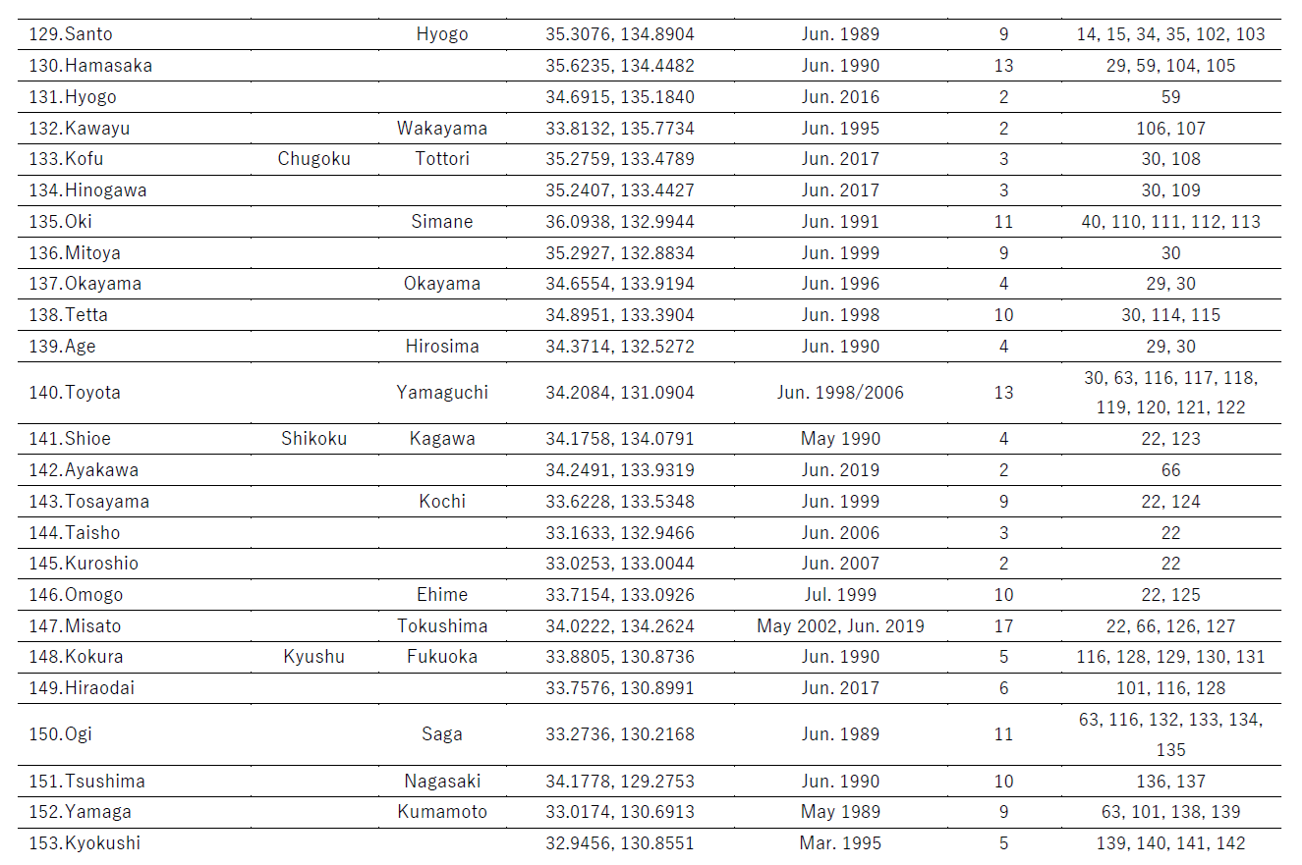
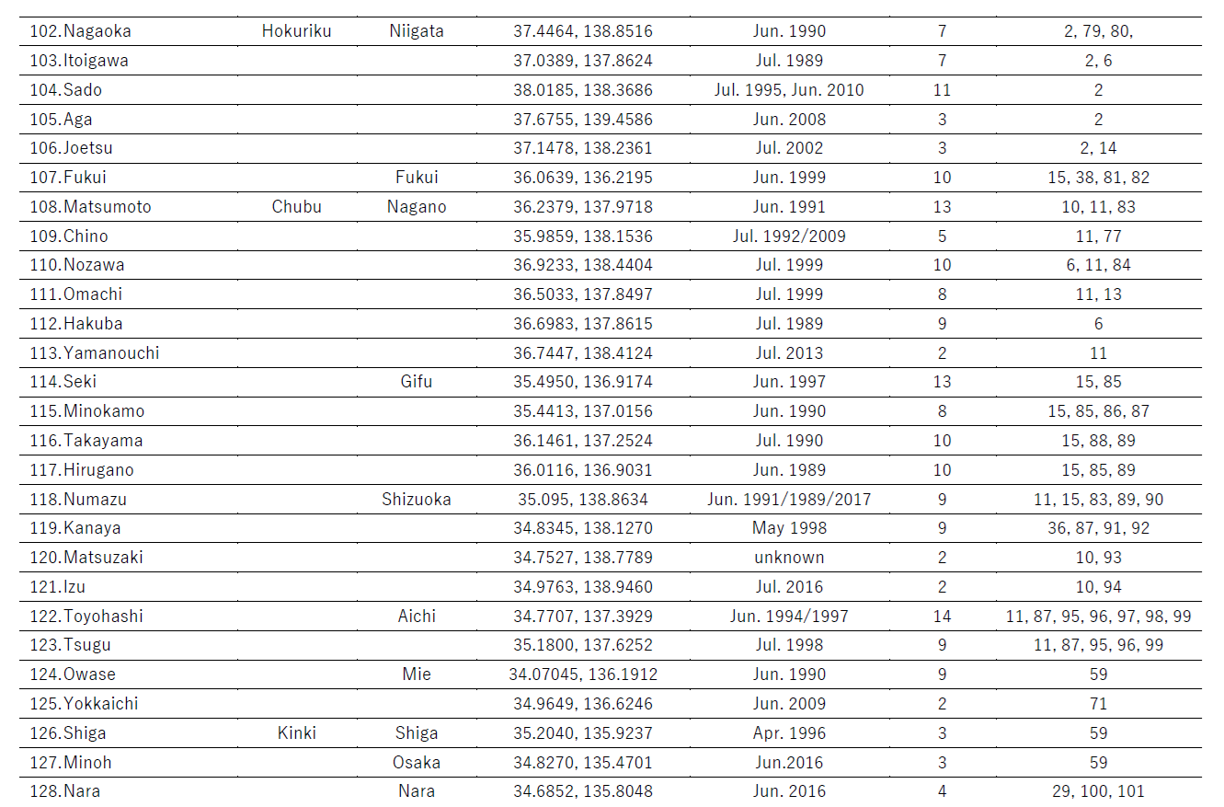
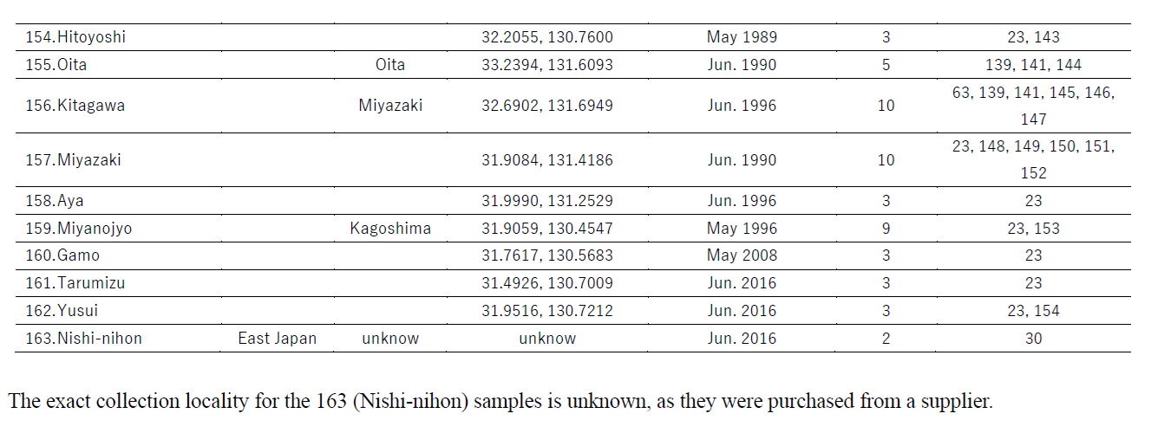

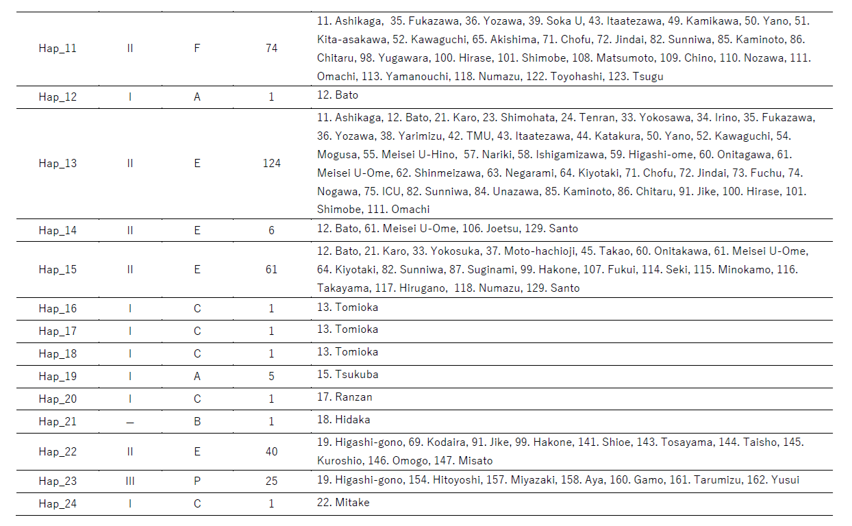
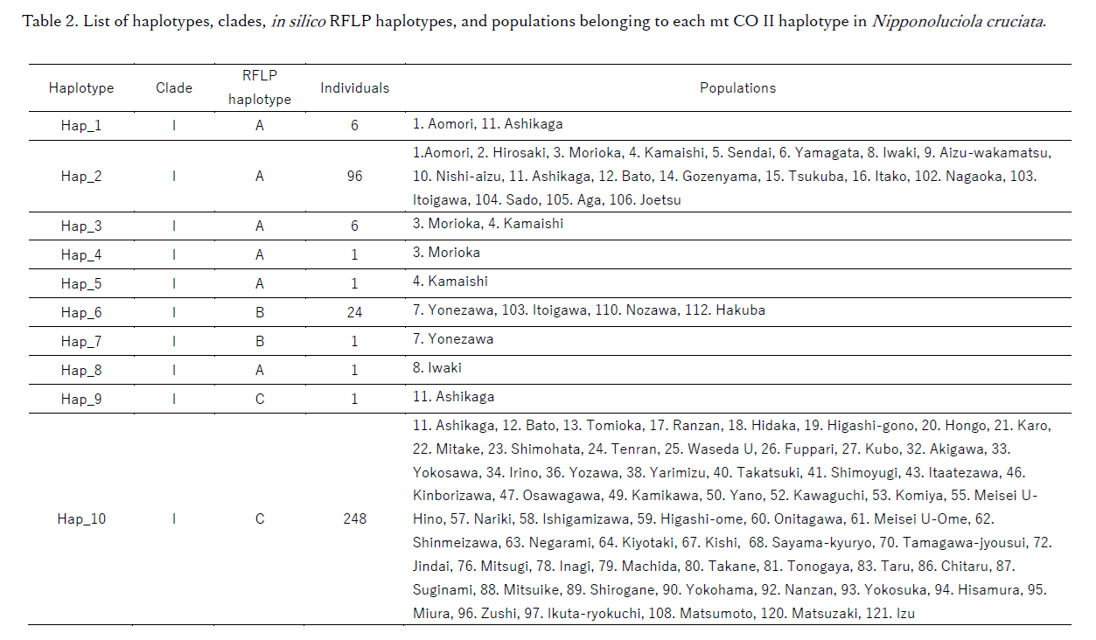

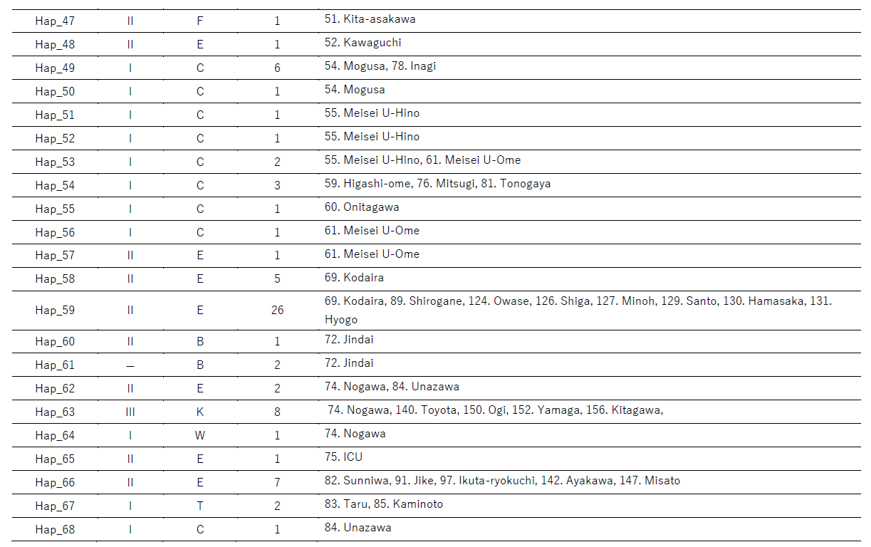
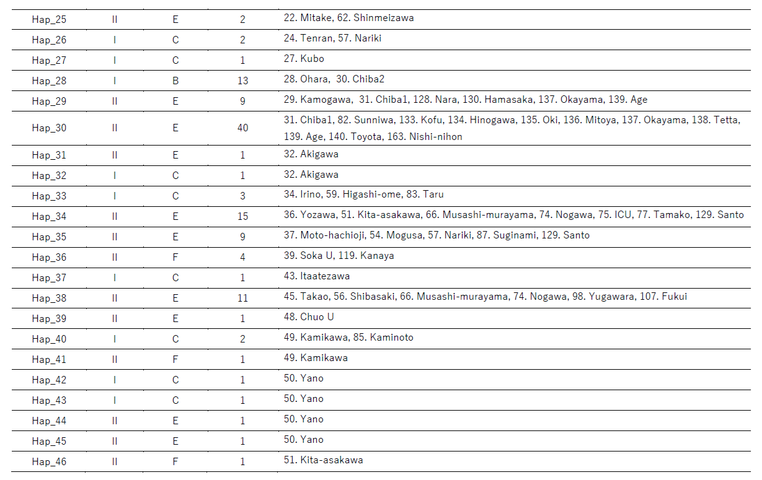

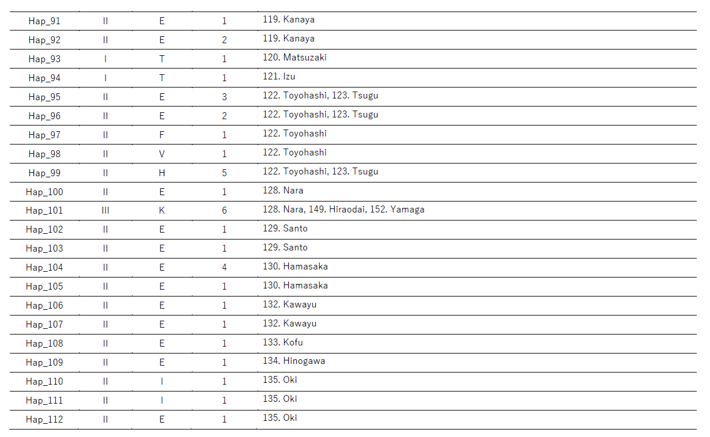
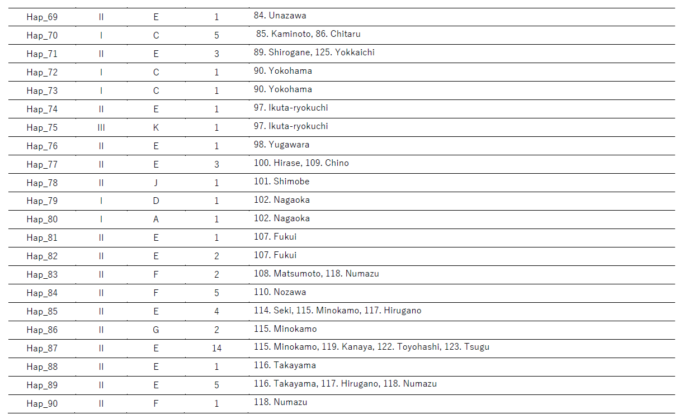

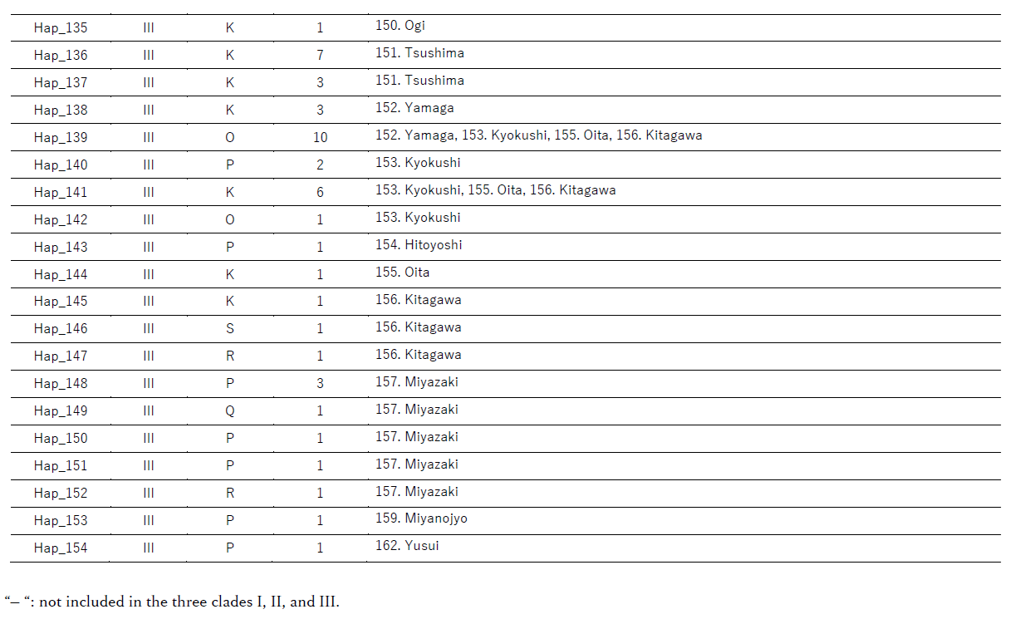
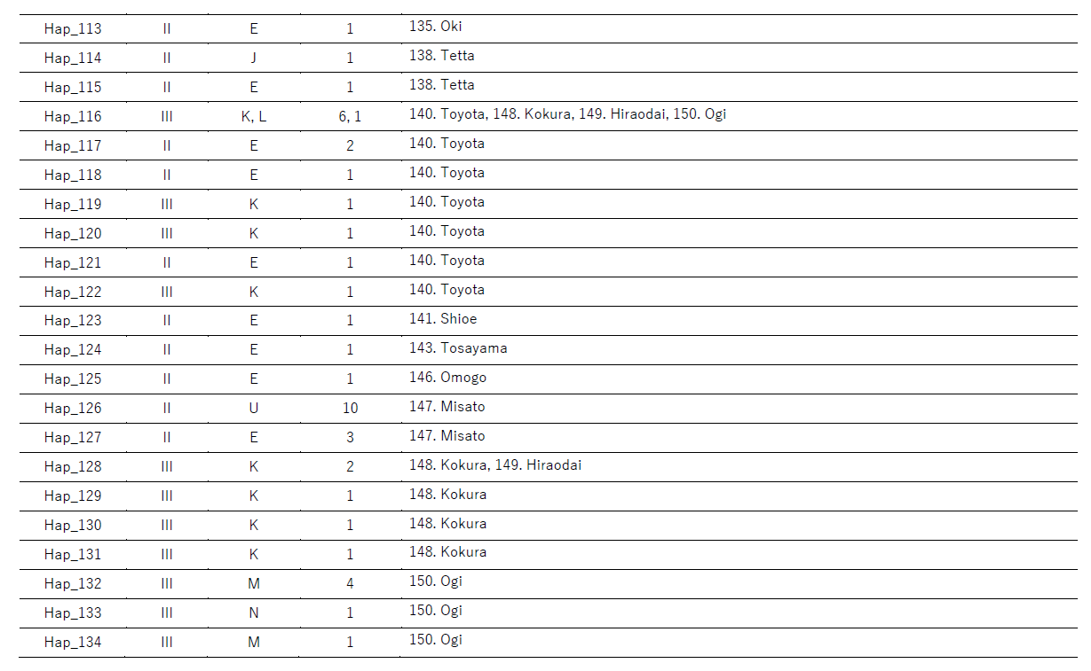

Table 3. Genetic differentiation matrix (Kst) among four population groups, East Honshu, Tokyo, West Honshu-Shikoku, and Kyushu in Nipponoluciola cruciata.

Kst | East Honshu | Tokyo | West Honshu-Shikoku
Tokyo | 0.1247 | –
West Honshu-Shikoku | 0.4366 | 0.1555 | –
Kyushu | 0.4725 | 0.3863 | 0.4866

All Kst values were significant (p < 0.001) based on permutation tests with 1,000 replicates.

Table 4. Gene flow matrix (Nm) among four population groups, East Honshu, Tokyo, West Honshu-Shikoku, and Kyushu in Nipponoluciola cruciata.

Nm | East Honshu | Tokyo | West Honshu-Shikoku
Tokyo | 3.47 | –
West Honshu-Shikoku | 0.64 | 2.69 | –
Kyushu | 0.56 | 0.79 | 0.52

